🥩 Meat Day (Niku no Hi) Worksheet
The Day of Two and Nine
Read the story. 英文を読もう。
Class ______ No. ____ Name ______________________________

🔊 音声を聞こう（スマホで読みとってね）
1 In Japan, numbers can be read in more than one way. The number 2 can be ni, and 9 can be ku. Put them together, and you get niku. Niku means meat in Japanese. So the 29th of every month is Meat Day, and meat shops have special sales.
2 But there is a problem. February usually has only 28 days. So February 9 became a meat day, too. It started in 2017. In the Japanese calendar, that was the year 29, so people called it the Year of Meat. Meat shops hold a prize drawing, and lucky winners can get top-quality beef.
3 Today, many people in Japan love beef, pork, and chicken. But for a long time, eating meat was not common. In 675, an emperor said people must not eat cows, horses, dogs, monkeys, or chickens. Deer and wild boar were not on the list, so some people still ate them. In 1872, newspapers said that Emperor Meiji ate beef. Around this time, beef hot pot restaurants became very popular in Tokyo.
4 Japan has other meat days, too. August 29 is Yakiniku Day, a day for Japanese barbecue. November 29 is Good Meat Day, because 11 can be read ii, which means good. Number games like this are everywhere in Japan. Next time you see a date, try to read it in Japanese. It might be a hidden message!
Words 単語
meat（肉） / sale（特売、販売） / beef（牛肉） / pork（豚肉） / common（ふつうの、よくある） / wild boar（イノシシ） / hot pot（鍋料理） / hidden（かくれた）

🥩 Meat Day (Niku no Hi) Worksheet
Reading Check
Choose the best answer. 正しいものを選ぼう。
Class ______ No. ____ Name ______________________________
1. What is the main idea of the passage?
(A) Japanese people have always eaten a lot of beef. (B) Meat Day is a national holiday in Japan. (C) Meat Day comes from a number game, and meat has an interesting history in Japan. (D) Meat shops in Japan close on the 29th.
2. Why did February 9 become a meat day?
(A) Because February usually has no 29th. (B) Because an emperor ate beef on that day. (C) Because it is the coldest day of the year. (D) Because it is Yakiniku Day.
3. Which animal was NOT on the list in 675?
(A) horse (B) monkey (C) chicken (D) deer
4. In paragraph 3, what does common mean in eating meat was not common?
(A) expensive (B) usual (C) dangerous (D) delicious
5. What will Ethan probably do tonight?
(A) He will cook fish at home. (B) He will eat yakiniku with Aoi. (C) He will go to a meat museum. (D) He will wait until February 9.
True or False? T か F に○
1. The 29th of every month is Meat Day in Japan. T / F
2. Meat Day is a national holiday. T / F
3. February 9 is a meat day, too. T / F
4. In 675, people were told not to eat deer. T / F

🥩 Meat Day (Niku no Hi) Worksheet
Word Work
単語のれんしゅう
Class ______ No. ____ Name ______________________________
① Match the pictures and the words. 絵と単語を線でむすぼう。
🥩 | ● | ● | chicken
🐄 | ● | ● | fire
🐖 | ● | ● | deer
🐔 | ● | ● | pig
🦌 | ● | ● | meat
🔥 | ● | ● | cow
③ Fill in the blanks. 語群から選んで入れよう。
[ shop / winter / nine / pork / number / beef / 29th / yakiniku / fish ]
Today is the (1) __________ . It is Meat Day in Japan. Taro goes to the (2) __________ with his father. The (3) __________ is on sale. They also buy some (4) __________ and vegetables. At night, the family has (5) __________ at home. Taro says, "Two and (6) __________ make niku. I love this (7) __________ game!"

🥩 Meat Day (Niku no Hi) Worksheet
Crossword Puzzle
ヒントを読んでクロスワードを完成させよう。
Class ______ No. ____ Name ______________________________
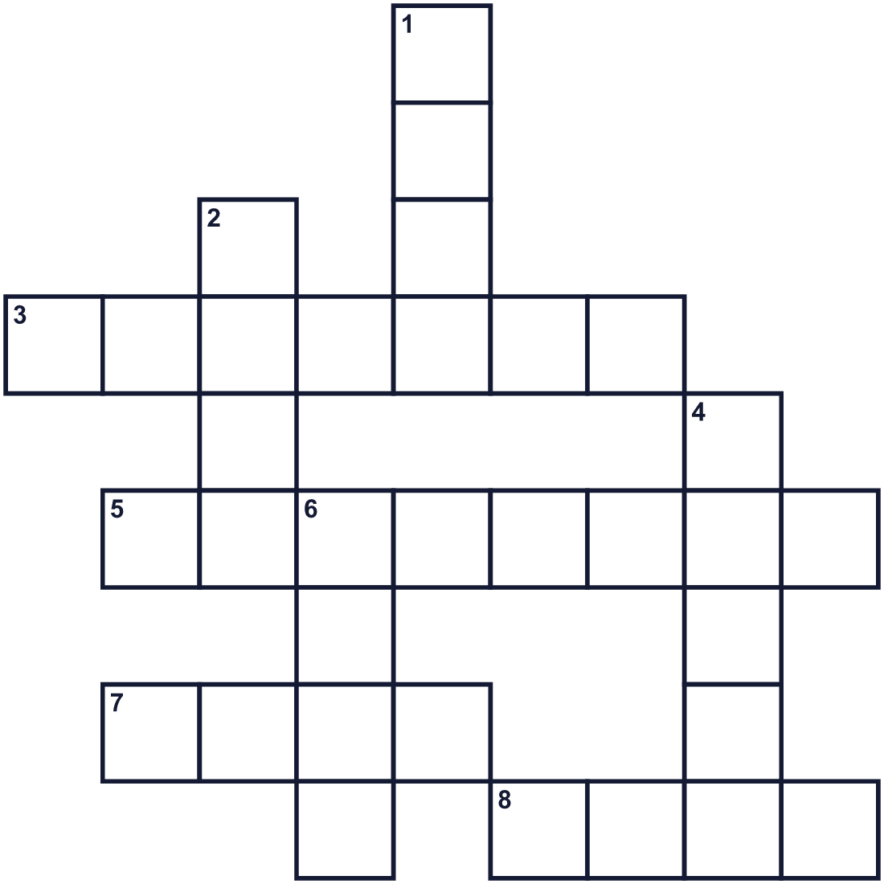
Across →
3. A bird. Its eggs are good for breakfast. (7)
5. The shortest month of the year. (8)
7. A wild animal with long legs. Some have antlers. (4)
8. Things are cheap at the shop. There is a ___. (4)
Down ↓
1. Meat from a pig. (4)
2. The number after eight. (4)
4. To cook food over a fire. (5)
6. Meat from a cow. (4)

🥩 Meat Day (Niku no Hi) Worksheet
Word Search
かくれた単語をさがそう（→ ↓ ↘ ↗）
Class ______ No. ____ Name ______________________________
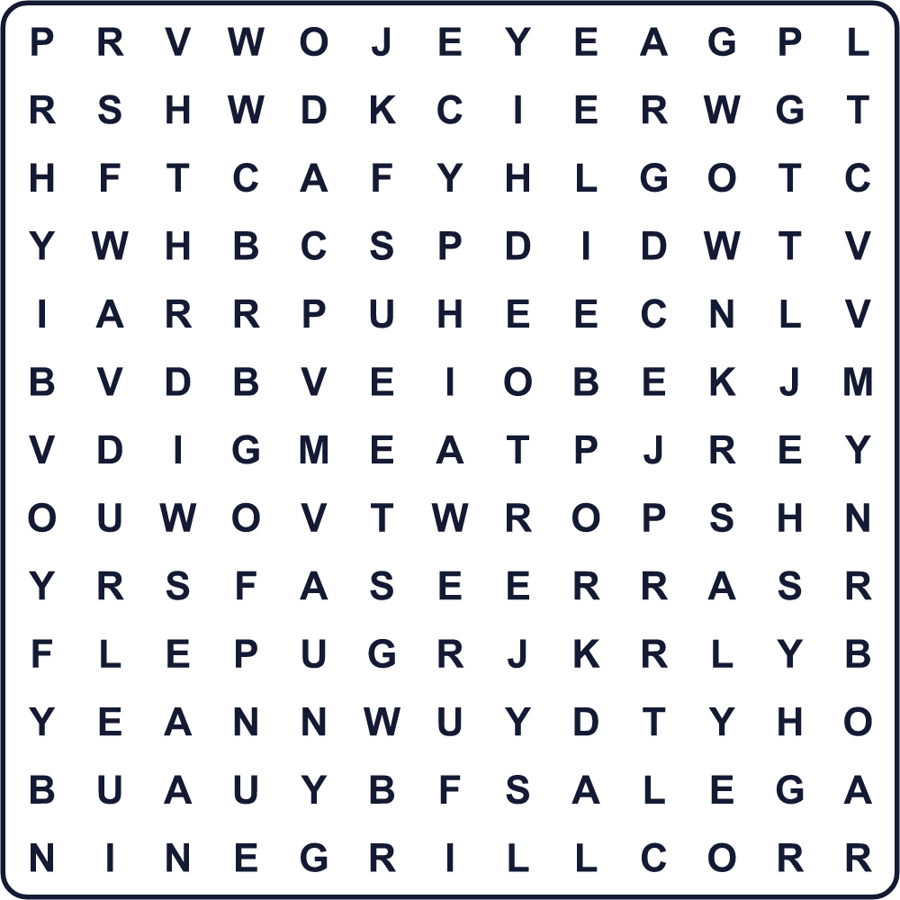
BEEF BOAR CHICKEN DEER GRILL MEAT NINE PORK SALE TWO

🥩 Meat Day (Niku no Hi) Worksheet
Maze & Sentences
Class ______ No. ____ Name ______________________________
Help Taro get to the yakiniku table! タロウが焼肉のテーブルに着けるように助けよう！
正しい道の文字を集めると、ひみつの言葉になるよ。 START 👦 → GOAL 🥩
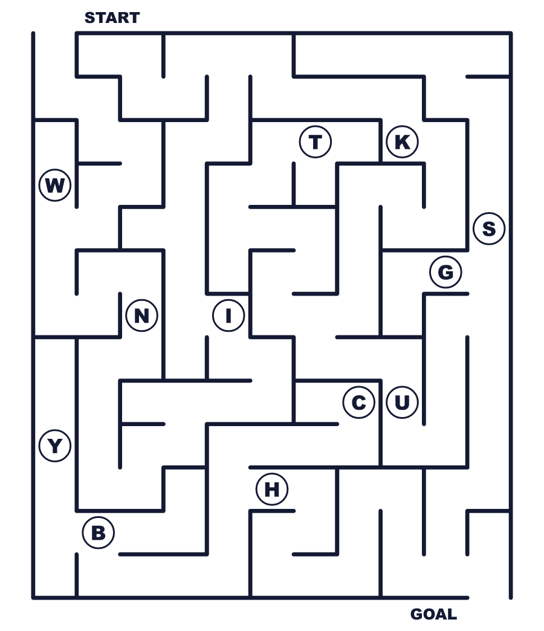
Secret word: ＿ ＿ ＿ ＿

🥩 Meat Day (Niku no Hi) Worksheet
Class Activity & Writing
Class ______ No. ____ Name ______________________________
Let's Write! 英語で書いてみよう。
My favorite meat dish is ______ because ______.
私の好きな肉料理は______です。なぜなら______だからです。
______________________________________________________________
______________________________________________________________
If I made a new number day, it would be ______ because ______.
新しい語呂合わせの記念日を作るなら、______にします。なぜなら______だからです。
______________________________________________________________
______________________________________________________________

🥩 Meat Day (Niku no Hi) Worksheet
Trace & Color
なぞって書こう。絵に色をぬろう。
Class ______ No. ____ Name ______________________________
🥩 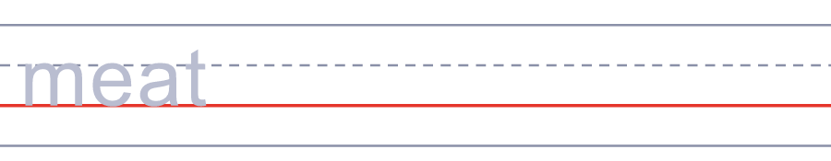

🐄 
🐖 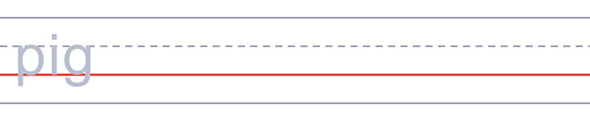
🐔 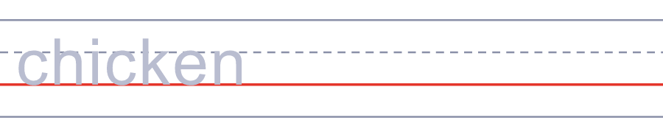
🦌 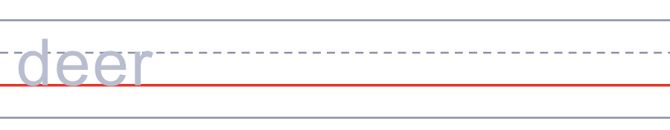

🥩 Meat Day (Niku no Hi) Worksheet
Answer Key 解答
Reading Check: 1.C 2.A 3.D 4.B 5.B
True or False: 1.T 2.F 3.T 4.F
Match: 🥩=meat 🐄=cow 🐖=pig 🐔=chicken 🦌=deer 🔥=fire
Fill in the blanks: (1)29th (2)shop (3)beef (4)pork (5)yakiniku (6)nine (7)number
Maze: NIKU
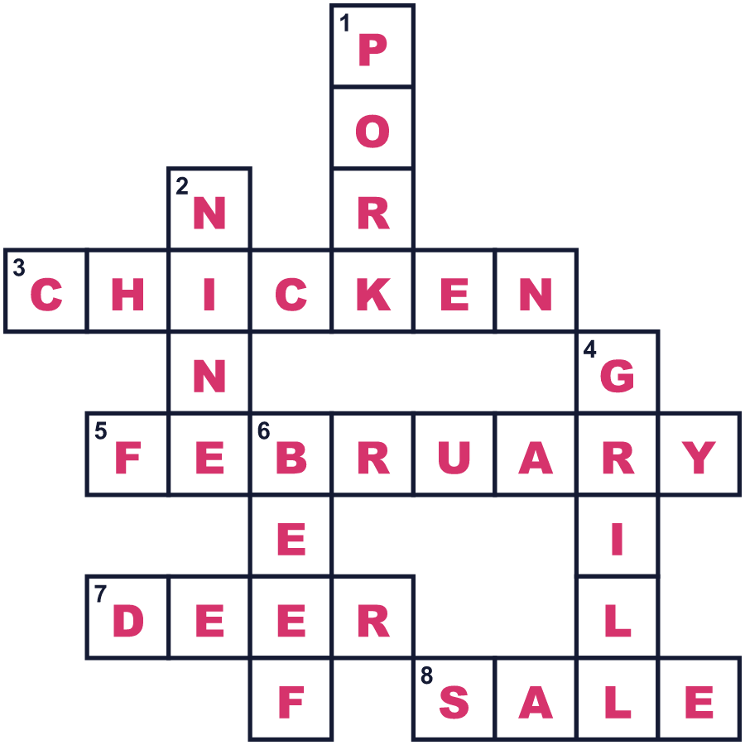
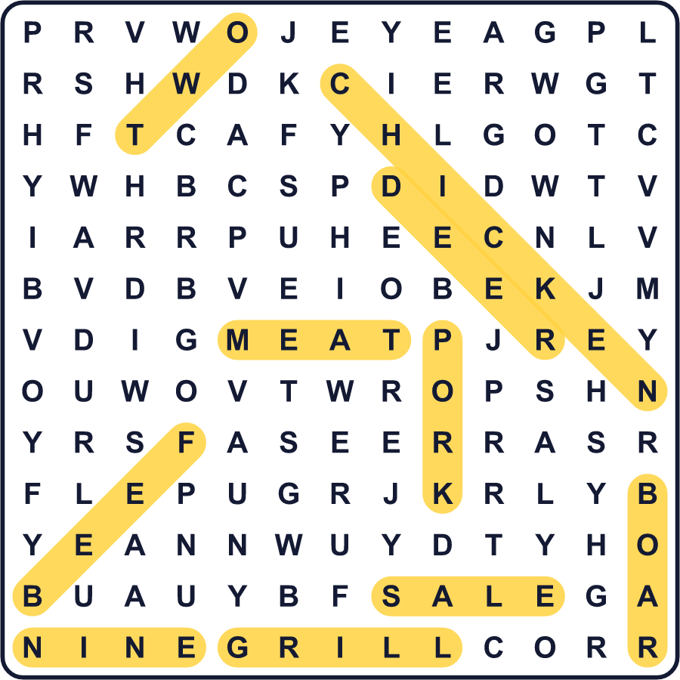
全訳
1 日本では、数字を何通りもの読み方で読むことができます。2は「に」、9は「く」と読めます。並べると「にく」になります。「にく」は日本語で肉という意味です。だから毎月29日は肉の日で、お肉屋さんでは特売があります。
2 でも、問題があります。2月はふつう28日までしかありません。そこで2月9日も肉の日になりました。それは2017年に始まりました。日本の暦（和暦）ではその年は平成29年だったので、「肉の年」と呼ばれました。お肉屋さんでは抽選があり、運のいい人は上等な牛肉が当たります。
3 今、日本の多くの人は牛肉や豚肉、鶏肉が大好きです。でも長いあいだ、肉を食べることは一般的ではありませんでした。675年、ある天皇が、牛・馬・犬・猿・鶏を食べてはいけないと命じました。鹿と猪はその中に入っていなかったので、それらを食べる人もいました。1872年、明治天皇が牛肉を食べたというニュースが伝えられました。このころ、東京では牛鍋の店がとても人気になりました。
4 日本には、ほかにも肉の日があります。8月29日は焼肉の日、日本式バーベキューの日です。11月29日は「いい肉の日」です。11は「いい」と読めるからです。こうした数字遊びは、日本のいたるところにあります。今度日付を見たら、日本語で読んでみてください。かくれたメッセージかもしれません！

