🎆 New Year's Eve Worksheet
The New Year Travels Around the World
Read the story. 英文を読もう。
Class ______ No. ____ Name ______________________________

🔊 音声を聞こう（スマホで読みとってね）
1 The new year does not come to everyone at the same time. It moves around the world like a relay race. The first people to see it live on Kiritimati, a small island in the Pacific Ocean. About 25 hours later, people in American Samoa finally say goodbye to the old year.
2 In Sydney, more than one million people watch fireworks over the Harbour Bridge. Later, in Madrid, people hold twelve green grapes in their hands. When the big clock rings twelve times, they eat one grape with each sound. It is not easy, because the bells are fast! People say that if you finish all twelve, you will have good luck for twelve months.
3 In Rio de Janeiro, people wear white clothes and go to the beach. Many of them jump over seven waves and make a wish each time. Some people also put white flowers into the sea as a gift for a goddess of the sea.
4 Then the new year reaches New York. Since 1907, a big ball has come down a pole in Times Square at midnight. Why a ball? Long ago, ships checked the time by watching a falling ball. The first ball was made of iron and wood, and it had 100 light bulbs. As the ball falls, the crowd shouts, "Ten, nine, eight..." and paper confetti fills the air.
5 After midnight, many people sing an old Scottish song, "Auld Lang Syne." It is a song about old friends and good times. Japanese people know the same melody as "Hotaru no Hikari." So next time you hear it in a store at closing time, smile. Somewhere in the world, people sing it to welcome a brand-new year.
Words 単語
relay race（リレー競走） / island（島） / fireworks（花火） / grape（ぶどう（の1粒）） / midnight（真夜中、夜の12時） / wish（願い／願う） / goddess（女神） / pole（柱、さお） / crowd（群衆、人ごみ） / confetti（紙吹雪） / melody（メロディー、旋律） / brand-new（真新しい）

🎆 New Year's Eve Worksheet
Reading Check
Choose the best answer. 正しいものを選ぼう。
Class ______ No. ____ Name ______________________________
1. What is the main idea of the reading?
(A) Fireworks are dangerous on New Year's Eve. (B) People welcome the new year in different ways as it moves around the world. (C) Spain is the first country to see the new year. (D) Japanese people do not celebrate New Year's Eve.
2. Where do the first people see the new year?
(A) In Sydney (B) In New York (C) On Kiritimati (D) In American Samoa
3. How many grapes do people in Madrid eat at midnight?
(A) Seven (B) Twelve (C) One hundred (D) Twenty-five
4. Why was a ball used in Times Square?
(A) Because ships once checked the time with falling balls (B) Because people liked soccer (C) Because grapes are round (D) Because the bridge was too high
5. In paragraph 4, what does "crowd" mean?
(A) A large group of people (B) A kind of clock (C) A small piece of paper (D) A Scottish song
6. Which sentence is true about the reading?
(A) People in Rio wear black clothes. (B) The first Times Square ball had 1,000 light bulbs. (C) Auld Lang Syne is a song about old friends. (D) People in Madrid eat grapes before the bells.
7. Why should you smile when you hear "Hotaru no Hikari" in a store?
(A) Because the store is giving free gifts (B) Because it is the end of the school year (C) Because the song is very funny (D) Because people around the world use the same melody to welcome the new year
8. In the dialogue, why do people in the Canary Islands eat their grapes later?
(A) Because they don't like grapes (B) Because of the time difference (C) Because the bells are broken (D) Because farmers told them to
True or False? T か F に○
1. The first Times Square ball drop was in 1907. T / F
2. In Spain, people eat seven grapes at midnight. T / F
3. In Brazil, many people wear white on New Year's Eve. T / F
4. New York is the first city to see the new year. T / F
5. Auld Lang Syne and Hotaru no Hikari have the same melody. T / F
6. In Denmark, people jump into the sea at midnight. T / F

🎆 New Year's Eve Worksheet
Word Work
単語のれんしゅう
Class ______ No. ____ Name ______________________________
① Match the pictures and the words. 絵と単語を線でむすぼう。
🎆 | ● | ● | chair
🍇 | ● | ● | grapes
🕛 | ● | ● | confetti
🔔 | ● | ● | wave
🌊 | ● | ● | bell
🪑 | ● | ● | fireworks
🧳 | ● | ● | suitcase
🎊 | ● | ● | midnight
② Unscramble the words. 並べかえて単語にしよう。
1. M N I D G T H I (真夜中) → ____________________
2. G P A S E R (ぶどう) → ____________________
3. D I S L N A (島) → ____________________
4. D W R O C (群衆) → ____________________
5. M O L D Y E (メロディー) → ____________________
6. S D D O S G E (女神) → ____________________
③ Fill in the blanks. 語群から選んで入れよう。
[ morning / bottle / midnight / beach / shout / year / fireworks / clock / sleep / chairs / show / dinner / counts ]
It is December 31 in Copenhagen. Freja's family has a big (1) __________ with fish and cake. At 11:45, they watch a funny old (2) __________ on TV. Then everyone looks at the (3) __________ . Freja and her brother stand on their (4) __________ . Ten, nine, eight... The whole family (5) __________ together. At (6) __________ , they all jump down to the floor. "We jumped into the new (7) __________ !" Freja laughs. Outside, colorful (8) __________ light up the sky. Her father opens a (9) __________ of juice for the children. "Happy New Year!" they (10) __________ .

🎆 New Year's Eve Worksheet
Crossword Puzzle
ヒントを読んでクロスワードを完成させよう。
Class ______ No. ____ Name ______________________________
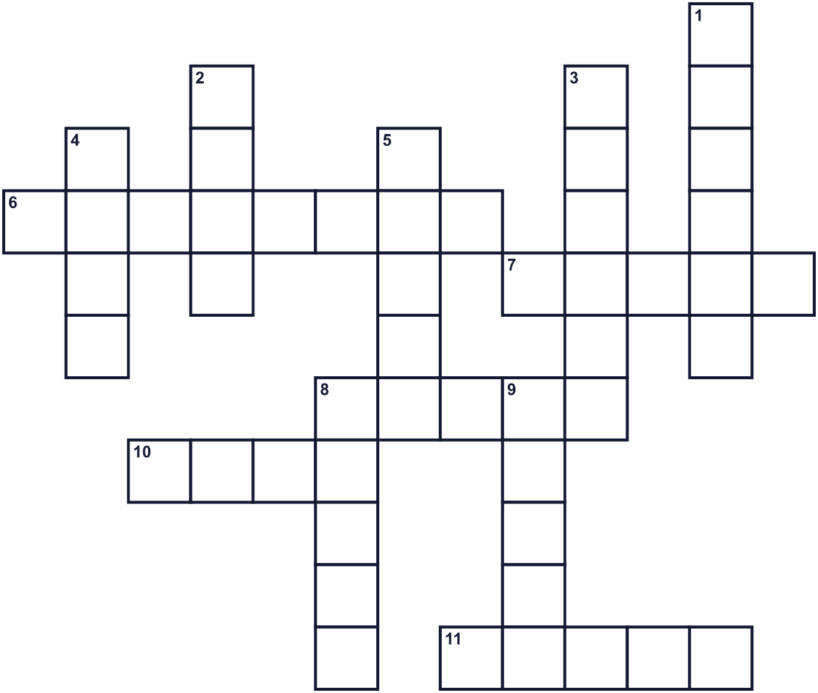
Across →
6. Twelve o'clock at night. (8)
7. People in Brazil jump over seven of these at the beach. (5)
8. A very large group of people. (5)
10. It comes down a pole in Times Square. (4)
11. Temples in Japan ring these 108 times. (5)
Down ↓
1. People in Spain eat twelve of these small fruits. (6)
2. Auld Lang Syne is an old Scottish one. (4)
3. Land with water all around it. (6)
4. You make one and hope it comes true. (4)
5. Danish people jump off this at midnight. (5)
8. It tells the time. In Madrid, it rings twelve times. (5)
9. The color of clothes on the beach in Rio. (5)

🎆 New Year's Eve Worksheet
Word Search
かくれた単語をさがそう（→ ↓ ↘ ↗）
Class ______ No. ____ Name ______________________________
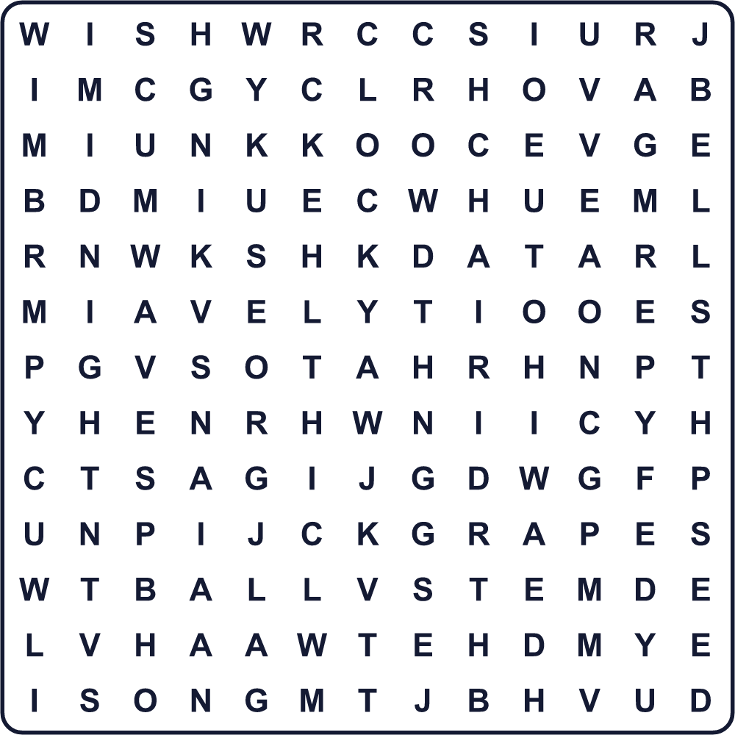
BALL BELLS CHAIR CHEERS CLOCK CROWD GRAPES ISLAND MIDNIGHT PARTY SONG WAVES WHITE WISH
Secret Code 暗号を解こう
♦=E ⚑=G ◎=H ●=I ☾=N ♣=T
♣ ♦ ☾ ☾ ● ☾ ♦ ♦ ● ⚑ ◎ ♣
______________________________________________________________

🎆 New Year's Eve Worksheet
Maze & Sentences
Class ______ No. ____ Name ______________________________
Help Kenta get to the twelve grapes before midnight! 真夜中までにケンタを12粒のぶどうのところへ！
正しい道の文字を集めると、ひみつの言葉になるよ。 START 🧑 → GOAL 🍇
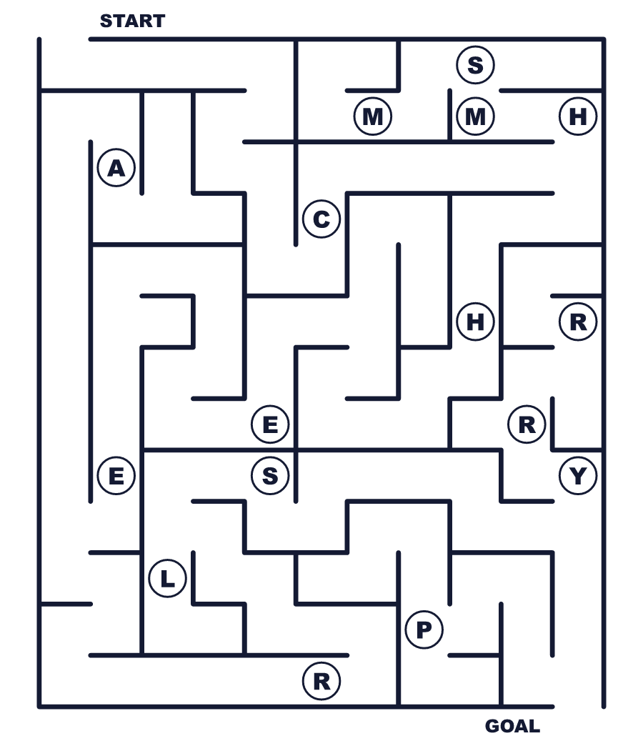
Secret word: ＿ ＿ ＿ ＿ ＿ ＿
Put the words in order. 並べかえよう。
1. the / The / world / new / year / moves / around . (新年は世界を回ります。)
______________________________________________________________
2. grapes / Spain / People / in / twelve / eat . (スペインの人々はぶどうを12粒食べます。)
______________________________________________________________
3. in / white / clothes / Many / Brazil / people / wear . (ブラジルの多くの人は白い服を着ます。)
______________________________________________________________
4. down / ball / at / A / big / comes / midnight . (真夜中に大きなボールが下りてきます。)
______________________________________________________________
5. an / We / midnight / after / song / old / sing . (真夜中のあとに古い歌を歌います。)
______________________________________________________________

🎆 New Year's Eve Worksheet
Class Activity & Writing
Class ______ No. ____ Name ______________________________
Find Someone Who… クラスで聞いて回ろう！
Find someone who … | Name
… has stayed up until midnight on New Year's Eve 大みそかに真夜中まで起きていたことがある
… has heard temple bells on New Year's Eve 大みそかに除夜の鐘を聞いたことがある
… can sing Hotaru no Hikari 「蛍の光」が歌える
… likes grapes ぶどうが好き
… has seen big fireworks 大きな花火を見たことがある
… knows the name of the first country to see the new year 最初に新年を迎える国の名前を知っている
… has eaten toshikoshi soba 年越しそばを食べたことがある
… can count down from ten in English very fast 英語で10からとても速くカウントダウンできる
Let's Write! 英語で書いてみよう。
On New Year's Eve, my family usually ______.
大みそか、私の家族はたいてい＿＿＿。
______________________________________________________________
______________________________________________________________
If I could spend New Year's Eve in ______, I would ______ because ______.
もし＿＿＿で大みそかを過ごせるなら、＿＿＿したいです。なぜなら＿＿＿だからです。
______________________________________________________________
______________________________________________________________
At midnight, I will make a wish. My wish is ______.
真夜中に願いごとをします。私の願いは＿＿＿です。
______________________________________________________________
______________________________________________________________

🎆 New Year's Eve Worksheet
Trace & Color
なぞって書こう。絵に色をぬろう。
Class ______ No. ____ Name ______________________________
🎆 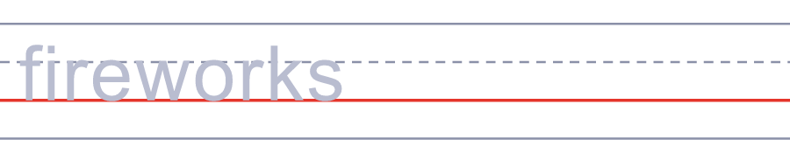

🍇 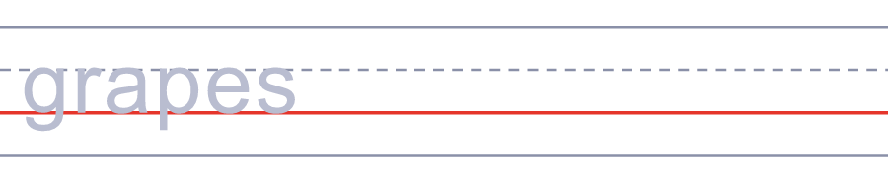
🕛 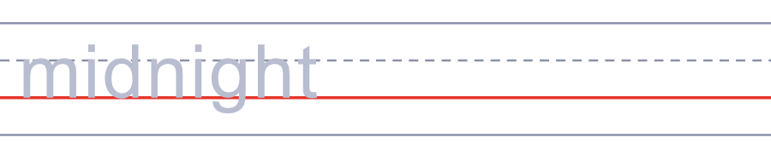
🔔 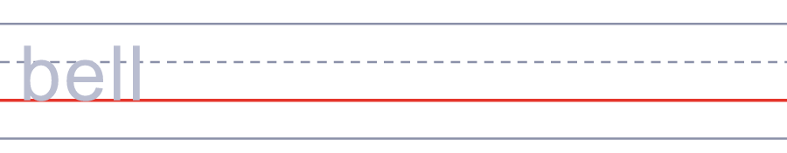
🌊 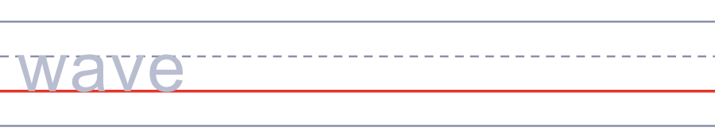
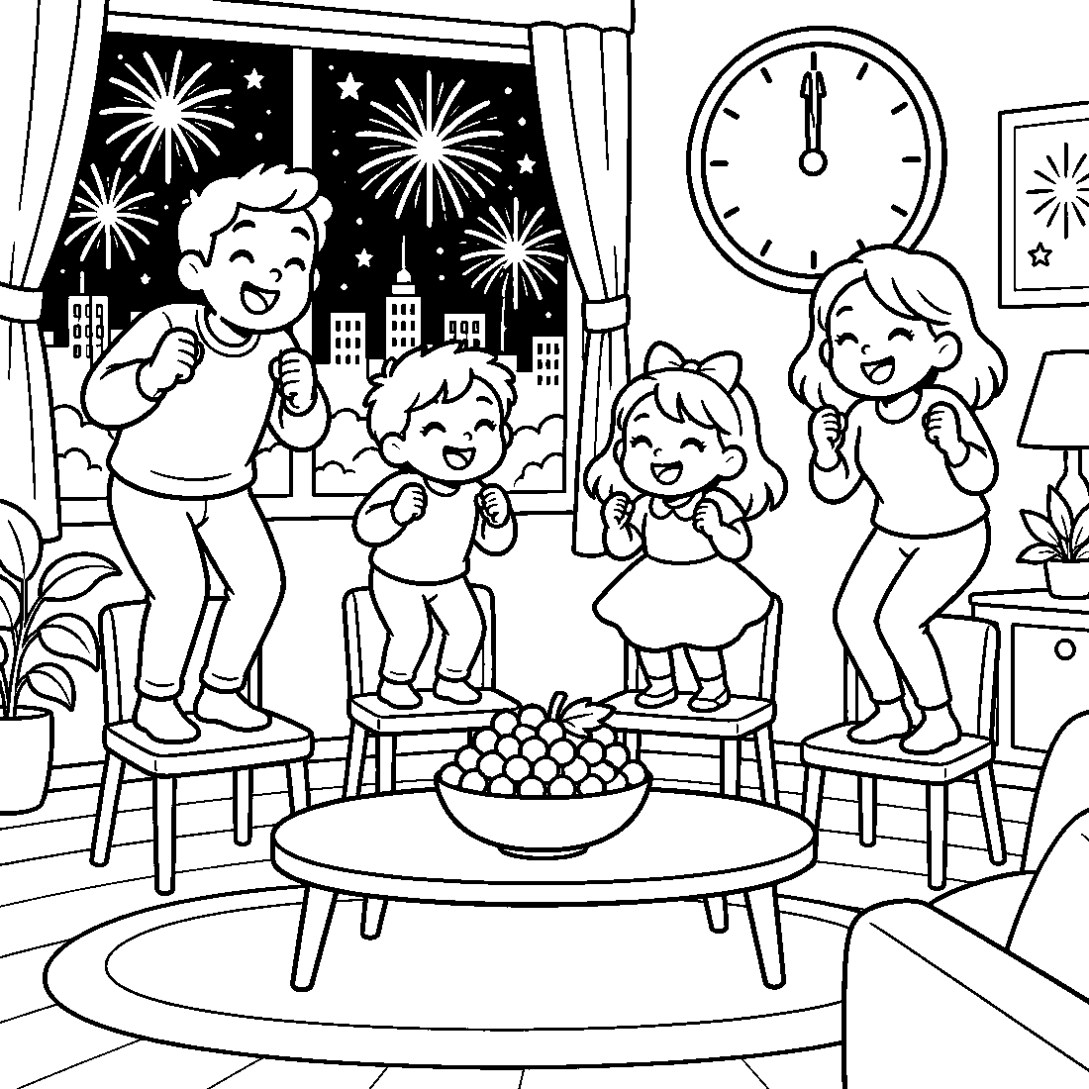

🎆 New Year's Eve Worksheet
Answer Key 解答
Reading Check: 1.B 2.C 3.B 4.A 5.A 6.C 7.D 8.B
True or False: 1.T 2.F 3.T 4.F 5.T 6.F
Match: 🎆=fireworks 🍇=grapes 🕛=midnight 🔔=bell 🌊=wave 🪑=chair 🧳=suitcase 🎊=confetti
Unscramble: 1.MIDNIGHT 2.GRAPES 3.ISLAND 4.CROWD 5.MELODY 6.GODDESS
Fill in the blanks: (1)dinner (2)show (3)clock (4)chairs (5)counts (6)midnight (7)year (8)fireworks (9)bottle (10)shout
Sentence order: 1. The new year moves around the world. 2. People in Spain eat twelve grapes. 3. Many people in Brazil wear white clothes. 4. A big ball comes down at midnight. 5. We sing an old song after midnight.
Secret Code: TEN NINE EIGHT
Maze: CHEERS
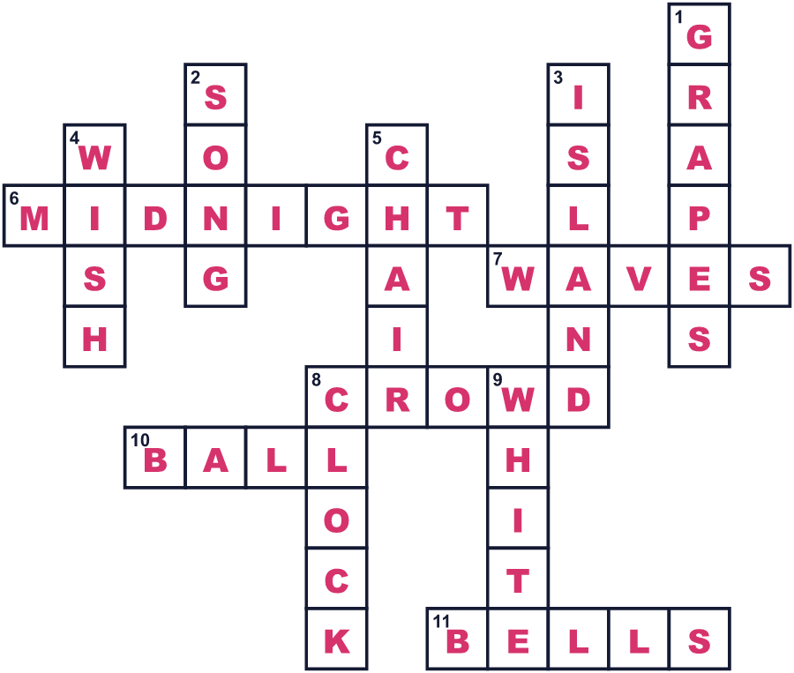
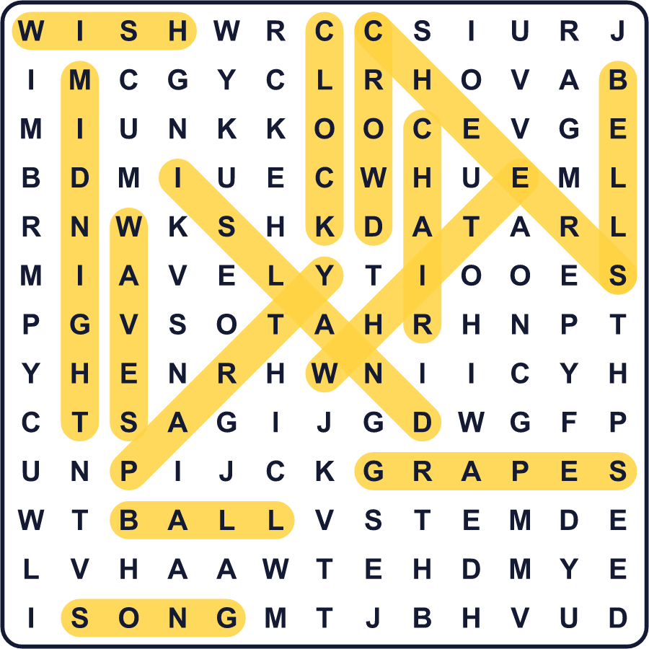
全訳
1 新しい年は、みんなに同時にやってくるわけではありません。リレーのように世界を回っていくのです。最初に新年を迎えるのは、太平洋の小さな島キリティマティに住む人たちです。その約25時間後、アメリカ領サモアの人たちがやっと古い年に別れを告げます。
2 シドニーでは、100万人以上がハーバーブリッジの上の花火を見ます。その後、マドリードでは、人々が12粒の緑のぶどうを手に持ちます。大きな時計が12回鳴ると、1回ごとにぶどうを1粒食べるのです。鐘が速いので、これは簡単ではありません！12粒全部食べきれたら、12か月の幸運がやってくるといわれます。
3 リオデジャネイロでは、人々が白い服を着て海岸へ行きます。その多くが波を7回飛びこえて、そのたびに願いごとをします。海の女神への贈り物として、白い花を海に流す人もいます。
4 それから新年はニューヨークに着きます。1907年から、真夜中にタイムズスクエアで大きなボールが柱を下りてきます。なぜボールなのでしょう。昔、船は落ちてくるボールを見て時刻を確かめていたのです。最初のボールは鉄と木でできていて、電球が100個ついていました。ボールが落ちていくと、群衆が「10、9、8…」とさけび、紙吹雪が空いっぱいに舞います。
5 真夜中を過ぎると、多くの人がスコットランドの古い歌「オールド・ラング・サイン」を歌います。昔の友だちと楽しかった日々の歌です。日本人は同じメロディーを「蛍の光」として知っています。だから今度、閉店の時間にお店でこの曲を聞いたら、ほほえんでください。世界のどこかで、人々はこの歌で真新しい1年を迎えているのですから。

