🎍 New Year's Day Worksheet
Why Does the Year Start in Winter?
Read the story. 英文を読もう。
Class ______ No. ____ Name ______________________________

🔊 音声を聞こう（スマホで読みとってね）
1 Why does the new year start on January 1, in the middle of winter? For a long time, it did not. In ancient Rome, the year started in March, when spring came. That is why September means "seventh month" in Latin, but today it is the ninth month.
2 In 153 BC, there was a war in Spain. Rome needed its new consuls, the top leaders, to start work early. So they started their year on January 1. Later, Julius Caesar made a new calendar, and January 1 became New Year's Day. The name January comes from Janus, a Roman god with two faces. One face looks back at the old year, and the other looks forward.
3 But the story did not end there. In the Middle Ages, many places in Europe started the year on other days, like Christmas or March 25. England moved its New Year to January 1 only in 1752. Because of this change, the year 1751 in England was very short. It had only 282 days.
4 Today, people spend January 1 in many different ways. In California, crowds watch the Rose Parade, and every float is covered with flowers and seeds. In Vienna, a famous orchestra plays happy waltzes, and the audience claps along to the last march. In the Netherlands, thousands of people run into the cold North Sea.
5 Food is important, too. In the southern United States, people eat black-eyed peas, because each pea looks like a coin. In Haiti, families eat soup joumou, a pumpkin soup. Long ago, enslaved people there were not allowed to eat it. On January 1, 1804, Haiti became free, and the soup became a symbol of freedom. So for many Haitians, the first meal of the year tastes like freedom.
Words 単語
calendar（暦、カレンダー） / ancient（古代の、大昔の） / consul（（古代ローマの）執政官） / god（神） / forward（前へ、前方に） / Middle Ages（中世） / float（（パレードの）山車） / orchestra（オーケストラ、管弦楽団） / audience（観客、聴衆） / clap along（（音楽に）合わせて手拍子する） / enslaved（奴隷にされた） / symbol（しるし、象徴）

🎍 New Year's Day Worksheet
Reading Check
Choose the best answer. 正しいものを選ぼう。
Class ______ No. ____ Name ______________________________
1. What is the main topic of the reading?
(A) How Japanese people spend New Year's Day (B) How January 1 became New Year's Day and how people spend it (C) Why the Rose Parade never happens on Sunday (D) How to cook soup joumou at home
2. In ancient Rome, when did the year start at first?
(A) In January (B) In September (C) In March (D) In December
3. Why did Rome start the consuls' year on January 1?
(A) Because of a war in Spain (B) Because January was warm (C) Because Janus was born that day (D) Because the king said so in 1752
4. How many days did the year 1751 have in England?
(A) 365 days (B) 445 days (C) 153 days (D) 282 days
5. In paragraph 4, what does "float" mean?
(A) A boat on the sea (B) A decorated car in a parade (C) A kind of soup (D) A cold drink
6. Which sentence is true about the reading?
(A) Janus had three faces. (B) England used January 1 as New Year's Day before Rome did. (C) In Vienna, the audience claps along to the last march. (D) People in the Netherlands swim in a warm lake on January 1.
7. Why do Haitians feel the soup "tastes like freedom"?
(A) Because the soup is free at restaurants (B) Because pumpkins grow only in free countries (C) Because Julius Caesar loved the soup (D) Because people once could not eat it, and they eat it on Independence Day
8. In the dialogue, why does the parade move to Monday when January 1 is a Sunday?
(A) Because people did not want to scare horses outside churches (B) Because everyone is too sleepy on Sunday (C) Because flowers do not bloom on Sunday (D) Because the TV station is closed on Sunday
True or False? T か F に○
1. In ancient Rome, the year once started in March. T / F
2. The name January comes from a Greek cake. T / F
3. England moved its New Year to January 1 in 1752. T / F
4. Every Rose Parade float is covered with plastic. T / F
5. In the southern United States, peas mean coins on New Year's Day. T / F
6. Haiti became free on December 25, 1804. T / F

🎍 New Year's Day Worksheet
Word Work
単語のれんしゅう
Class ______ No. ____ Name ______________________________
① Match the pictures and the words. 絵と単語を線でむすぼう。
📅 | ● | ● | cake
🌹 | ● | ● | coin
🐷 | ● | ● | violin
🪙 | ● | ● | calendar
🎃 | ● | ● | pumpkin
🎻 | ● | ● | sunrise
🌅 | ● | ● | rose
🎂 | ● | ● | pig
② Unscramble the words. 並べかえて単語にしよう。
1. C L D A A N E R (暦、カレンダー) → ____________________
2. R E A D P A (パレード) → ____________________
3. C K Y L U (幸運な) → ____________________
4. Z W L T A (ワルツ) → ____________________
5. M E D E R O F (自由) → ____________________
6. C T I N E N A (古代の) → ____________________
③ Fill in the blanks. 語群から選んで入れよう。
[ house / oldest / angry / coin / cake / shouts / pocket / spoon / start / carefully / cuts / lucky / summer ]
On December 31, Eleni's family in Greece makes a round (1) __________ . Her grandmother puts a small (2) __________ inside it before baking. At midnight, her father (3) __________ the cake into pieces. One piece is for the (4) __________ . Then everyone gets a piece, from the (5) __________ to the youngest. Eleni eats slowly and (6) __________ . Suddenly, she feels something hard. "I found it!" she (7) __________ . Everyone claps and laughs. Her grandmother says, "You will have a (8) __________ year." Eleni puts the coin in her (9) __________ and smiles. It is the best (10) __________ of the year.

🎍 New Year's Day Worksheet
Crossword Puzzle
ヒントを読んでクロスワードを完成させよう。
Class ______ No. ____ Name ______________________________
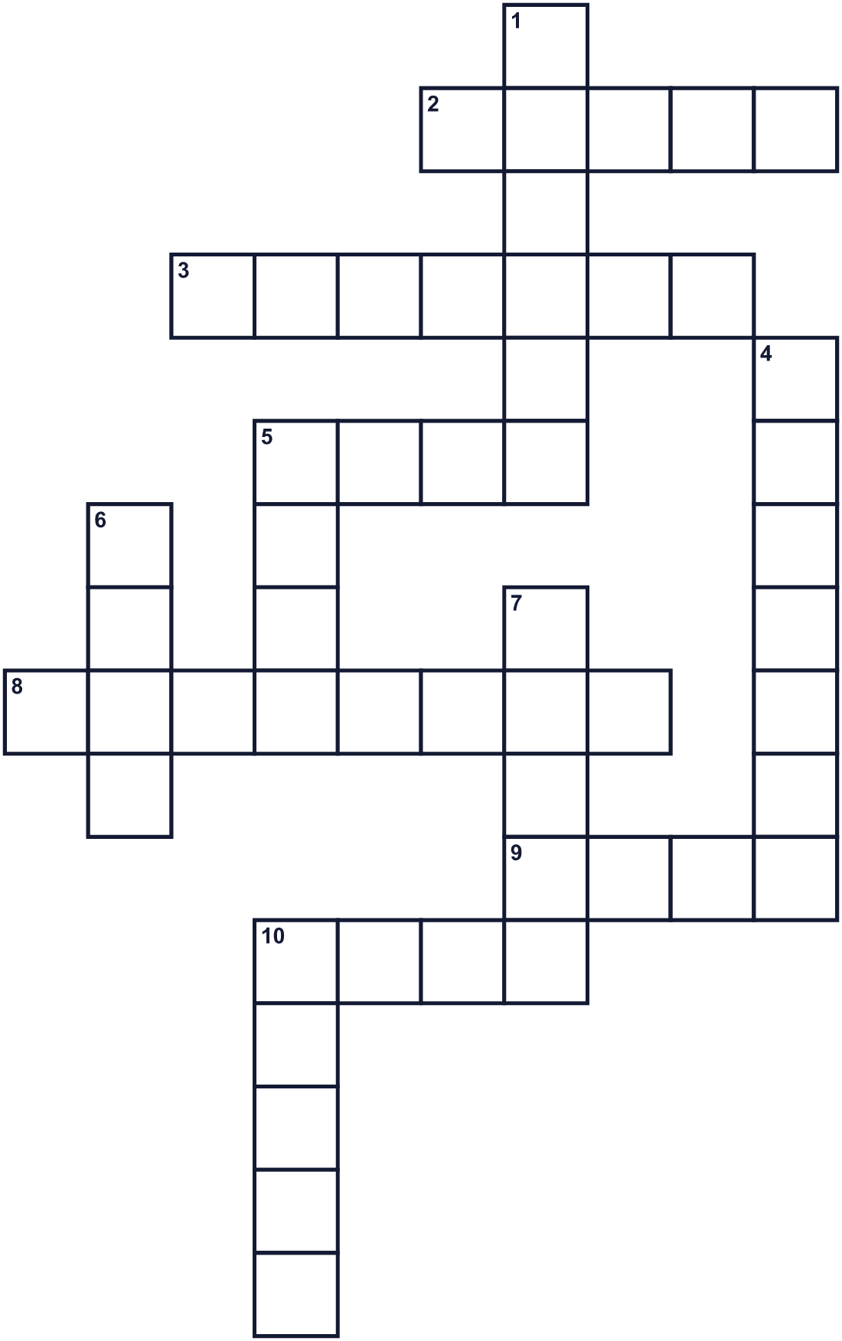
Across →
2. A Roman god with two faces. (5)
3. The first month of the year. (7)
5. A red flower with a sweet smell. A famous parade has its name. (4)
8. It shows the days, weeks, and months. (8)
9. Round money made of metal. (4)
10. You make one when you hope something good will happen. (4)
Down ↓
1. A long line of people and floats moving down a street. (6)
4. A big orange vegetable. Haitians make soup with it. (7)
5. The capital city of Italy. Julius Caesar lived there. (4)
6. Small round green or black-eyed beans. (4)
7. The old Roman year started in this spring month. (5)
10. A dance with three beats. Vienna is famous for it. (5)

🎍 New Year's Day Worksheet
Word Search
かくれた単語をさがそう（→ ↓ ↘ ↗）
Class ______ No. ____ Name ______________________________
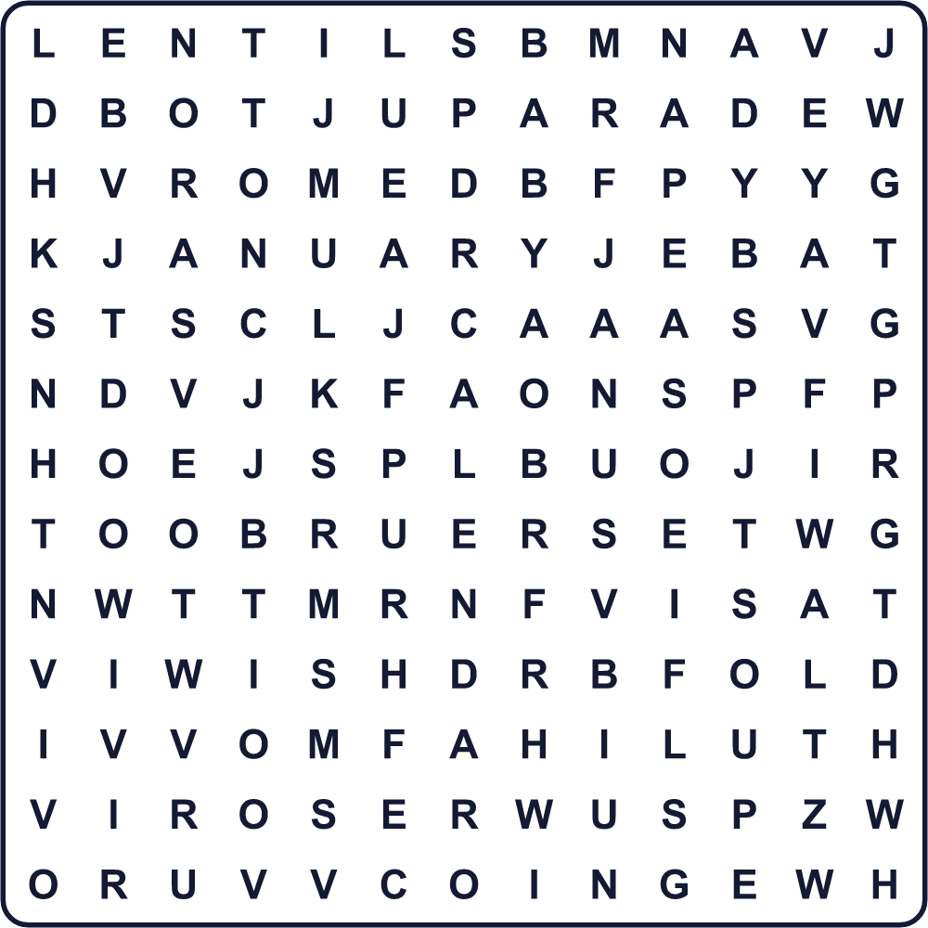
CALENDAR COIN JANUARY JANUS LENTILS PARADE PEAS PIG ROME ROSE SOUP SUNRISE WALTZ WISH
Secret Code 暗号を解こう
✿=A ☺=E ⚓=H ◎=N ☘=P ☾=R ◆=W ☎=Y
⚓ ✿ ☘ ☘ ☎ ◎ ☺ ◆ ☎ ☺ ✿ ☾
______________________________________________________________

🎍 New Year's Day Worksheet
Maze & Sentences
Class ______ No. ____ Name ______________________________
Help Eleni find the lucky coin! エレニを幸運のコインのところまで連れていこう！
正しい道の文字を集めると、ひみつの言葉になるよ。 START 👧 → GOAL 🪙
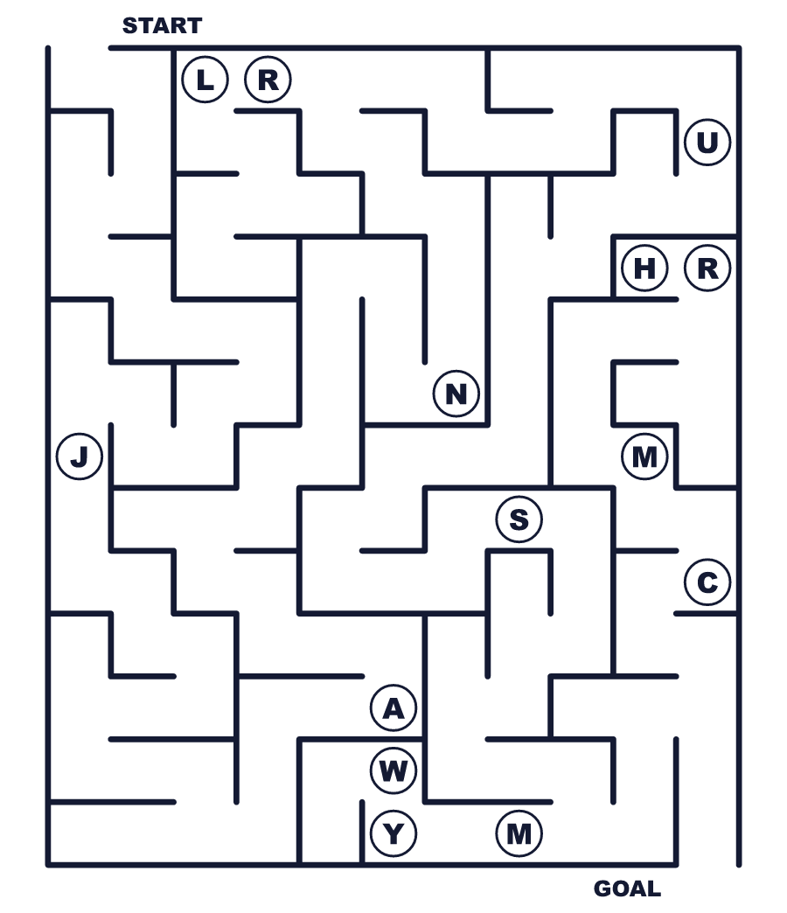
Secret word: ＿ ＿ ＿ ＿ ＿
Put the words in order. 並べかえよう。
1. comes / from / January / Janus / name / The . (January という名前はヤヌスから来ています。)
______________________________________________________________
2. Roman / March / in / started / year / The / old . (昔のローマの1年は3月に始まりました。)
______________________________________________________________
3. covered / flowers / with / Every / float / is . (山車はすべて花でおおわれています。)
______________________________________________________________
4. eat / People / peas / luck / for / good . (人々は幸運を願って豆を食べます。)
______________________________________________________________
5. of / soup / became / a / freedom / symbol / The . (そのスープは自由の象徴になりました。)
______________________________________________________________

🎍 New Year's Day Worksheet
Class Activity & Writing
Class ______ No. ____ Name ______________________________
Find Someone Who… クラスで聞いて回ろう！
Find someone who … | Name
… has seen the first sunrise of the year 初日の出を見たことがある
… has eaten zoni on New Year's Day 元日にお雑煮を食べたことがある
… knows what September means in Latin September のラテン語の意味を知っている
… likes waltz music ワルツの音楽が好き
… has swum in the sea in winter 冬に海で泳いだことがある
… can say Happy New Year in three languages 3つの言語で「あけましておめでとう」が言える
… has made a New Year's resolution this year 今年、新年の抱負を立てた
… likes beans or peas 豆が好き
Let's Write! 英語で書いてみよう。
Like Janus, I look back at last year. Last year, I ______.
ヤヌスのように去年をふり返ります。去年、私は＿＿＿。
______________________________________________________________
______________________________________________________________
This year, my New Year's resolution is to ______ because ______.
今年の抱負は＿＿＿です。なぜなら＿＿＿だからです。
______________________________________________________________
______________________________________________________________
If I could spend New Year's Day in another country, I would go to ______ and ______.
もしほかの国で元日を過ごせるなら、＿＿＿に行って＿＿＿したいです。
______________________________________________________________
______________________________________________________________

🎍 New Year's Day Worksheet
Trace & Color
なぞって書こう。絵に色をぬろう。
Class ______ No. ____ Name ______________________________
📅 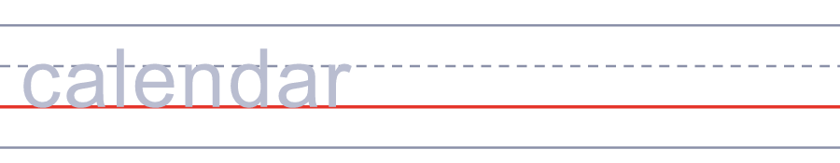

🌹 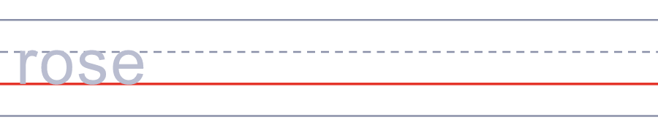
🐷 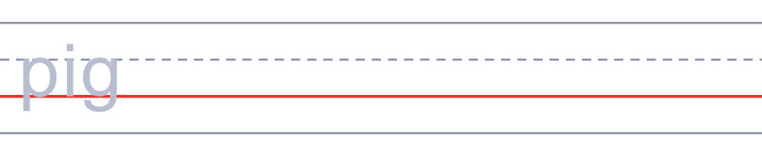
🪙 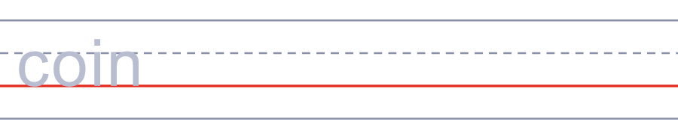
🎃 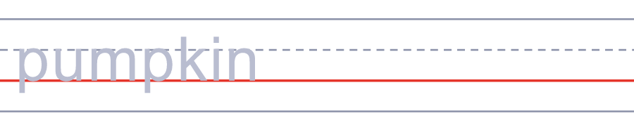
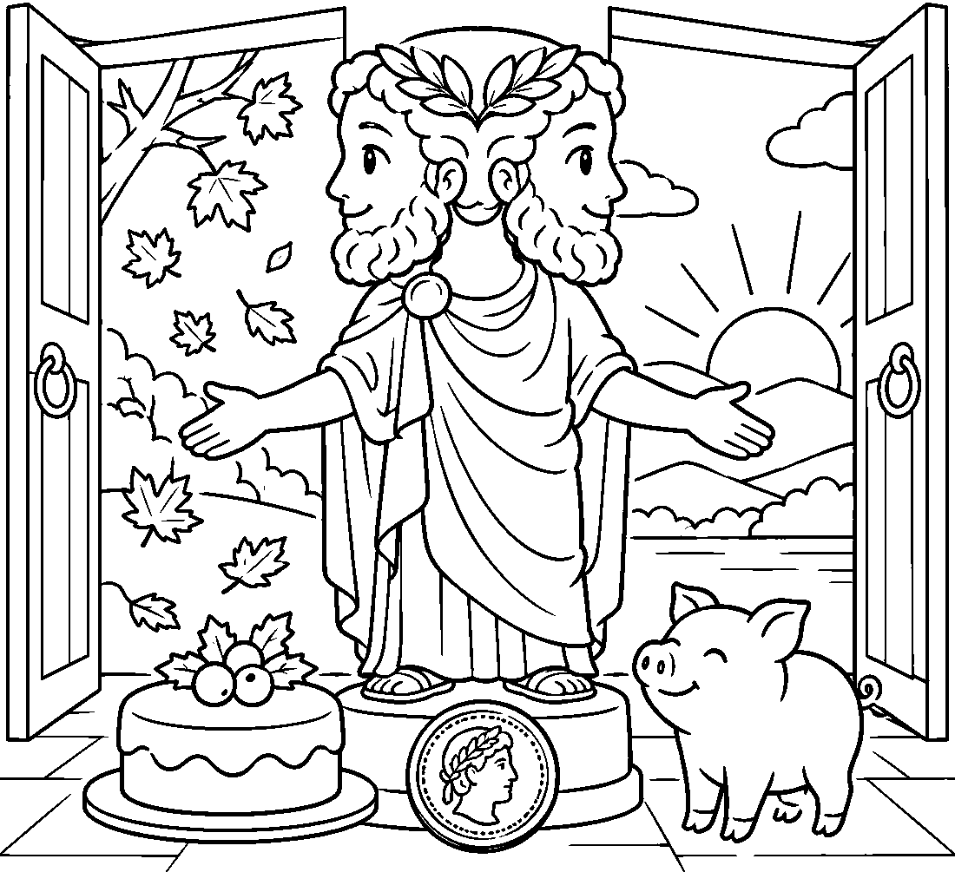

🎍 New Year's Day Worksheet
Answer Key 解答
Reading Check: 1.B 2.C 3.A 4.D 5.B 6.C 7.D 8.A
True or False: 1.T 2.F 3.T 4.F 5.T 6.F
Match: 📅=calendar 🌹=rose 🐷=pig 🪙=coin 🎃=pumpkin 🎻=violin 🌅=sunrise 🎂=cake
Unscramble: 1.CALENDAR 2.PARADE 3.LUCKY 4.WALTZ 5.FREEDOM 6.ANCIENT
Fill in the blanks: (1)cake (2)coin (3)cuts (4)house (5)oldest (6)carefully (7)shouts (8)lucky (9)pocket (10)start
Sentence order: 1. The name January comes from Janus. 2. The old Roman year started in March. 3. Every float is covered with flowers. 4. People eat peas for good luck. 5. The soup became a symbol of freedom.
Secret Code: HAPPY NEW YEAR
Maze: JANUS
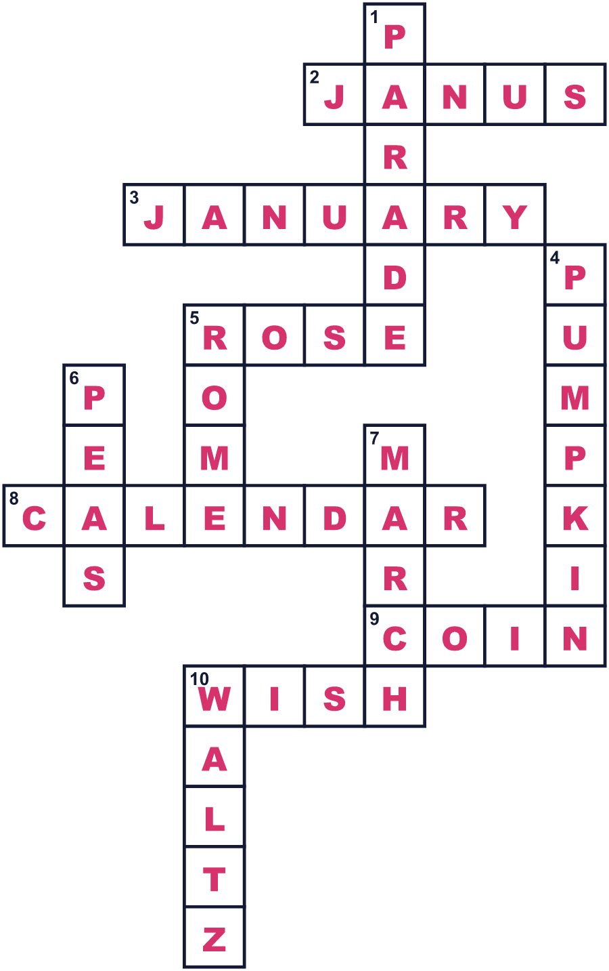
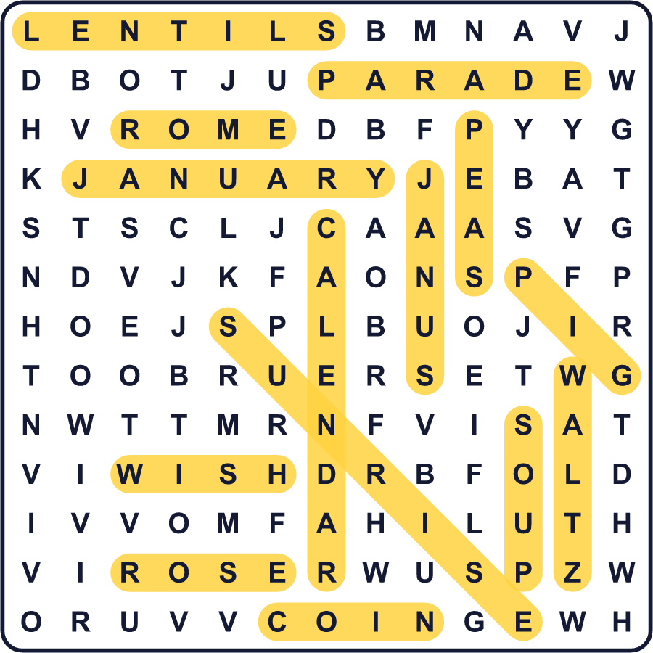
全訳
1 なぜ新しい年は、冬のまん中の1月1日に始まるのでしょうか。長いあいだ、そうではありませんでした。古代ローマでは、1年は春が来る3月に始まりました。だから September はラテン語で「7番目の月」という意味なのに、今は9番目の月なのです。
2 紀元前153年、スペインで戦争がありました。ローマは、新しい執政官、つまり国のトップに早く仕事を始めてもらう必要がありました。そこで、彼らの1年を1月1日に始めることにしたのです。その後、ユリウス・カエサルが新しい暦をつくり、1月1日が元日になりました。January という名前は、2つの顔をもつローマの神ヤヌスから来ています。1つの顔は古い年をふり返り、もう1つは前を見ています。
3 でも、話はそこで終わりませんでした。中世には、ヨーロッパの多くの場所で、クリスマスや3月25日など別の日に1年が始まりました。イングランドが新年を1月1日に移したのは、1752年になってからでした。この変更のため、イングランドの1751年はとても短い年になりました。282日しかなかったのです。
4 今、人々は1月1日をいろいろな方法で過ごします。カリフォルニアでは大勢の人がローズパレードを見ます。山車はすべて花や種でおおわれています。ウィーンでは有名なオーケストラが楽しいワルツを演奏し、観客は最後の行進曲に合わせて手拍子をします。オランダでは、何千人もの人が冷たい北海に走りこみます。
5 食べ物も大切です。アメリカ南部では、豆の一粒一粒がコインに見えるので、ササゲ豆を食べます。ハイチでは、家族でスープ・ジュムーというカボチャのスープを食べます。昔、そこで奴隷にされていた人々は、それを食べることを許されませんでした。1804年1月1日、ハイチは自由になり、スープは自由のしるしになりました。だから多くのハイチの人にとって、1年最初の食事は自由の味がするのです。

