🐱 Cat Day in Japan Worksheet
Nyan, Nyan, Nyan Day
Read the story. 英文を読もう。
Class ______ No. ____ Name ______________________________

🔊 音声を聞こう（スマホで読みとってね）
1 What sound does a cat make? In English, a cat says meow. In Japanese, a cat says nyan. And the Japanese word for the number two is ni. So the date February 22, or 2-2-2, sounds like nyan, nyan, nyan. That is why it is Cat Day in Japan.
2 Cat Day started in 1987. A group of cat lovers asked people to choose the best date. They got 8,953 answers. The most popular answer was February 22. The first Cat Day event was held in Tokyo. It is not a national holiday, but many shops and cafes sell cat goods and sweets on this day.
3 Japanese people have loved cats for a long time. More than 1,000 years ago, an emperor wrote about his black cat in his diary. Later, people made the maneki-neko, a lucky cat with one paw up. People believe it brings customers and money. One famous story says a temple cat once waved a lord inside, just before a big storm. You can still see it in many shops today.
4 Other countries have cat days, too, but the dates are different. International Cat Day is August 8. In Italy, it is February 17, and in Russia, it is March 1. In the United States, many people celebrate on October 29. In the UK, there is even a special day for black cats. So if you love cats, you can celebrate many times a year!
Words 単語
meow（ニャー（と鳴く）） / date（日付） / lover（～好きの人、愛好家） / popular（人気のある） / national holiday（国民の祝日） / emperor（天皇、皇帝） / paw（（動物の）足、手） / celebrate（祝う）

🐱 Cat Day in Japan Worksheet
Reading Check
Choose the best answer. 正しいものを選ぼう。
Class ______ No. ____ Name ______________________________
1. What is the main idea of the passage?
(A) Cats in Japan cannot say meow. (B) Japan's Cat Day comes from a sound joke, and other countries have cat days too. (C) February 22 is a national holiday in Japan. (D) The maneki-neko was made in Italy.
2. How many answers did the cat lovers get?
(A) 1,987 (B) 2,222 (C) 8,953 (D) 10,029
3. When is International Cat Day?
(A) August 8 (B) February 17 (C) March 1 (D) October 29
4. In paragraph 3, what is a paw?
(A) a cat's tail (B) a cat's ear (C) a cat's coin (D) a cat's foot or hand
5. Why does Rina say her cat can have two parties a year?
(A) Because her cat has two birthdays. (B) Because Japan and America have different cat days. (C) Because Cat Day is twice a year in Japan. (D) Because she has two cats.
True or False? T か F に○
1. Cat Day in Japan is February 22. T / F
2. Cat Day in Japan is a national holiday. T / F
3. In Japanese, the number two is ni. T / F
4. Every country celebrates cats on the same day. T / F

🐱 Cat Day in Japan Worksheet
Word Work
単語のれんしゅう
Class ______ No. ____ Name ______________________________
① Match the pictures and the words. 絵と単語を線でむすぼう。
🐱 | ● | ● | fish
🐶 | ● | ● | yarn
🐟 | ● | ● | dog
🧶 | ● | ● | cat
🥛 | ● | ● | milk
🪙 | ● | ● | coin
③ Fill in the blanks. 語群から選んで入れよう。
[ Japan / summer / photo / cookies / Nyan / black / dog / 22 / Day ]
Today is February (1) __________ . It is Cat Day in (2) __________ . Hana makes cat (3) __________ with her mother. Her cat, Kuro, is (4) __________ . Kuro sits by the window and says, " (5) __________ !" Hana takes a (6) __________ of Kuro and shows it to her friends. Then Kuro falls asleep in the warm sun. Hana says, "Happy Cat (7) __________ !"

🐱 Cat Day in Japan Worksheet
Crossword Puzzle
ヒントを読んでクロスワードを完成させよう。
Class ______ No. ____ Name ______________________________
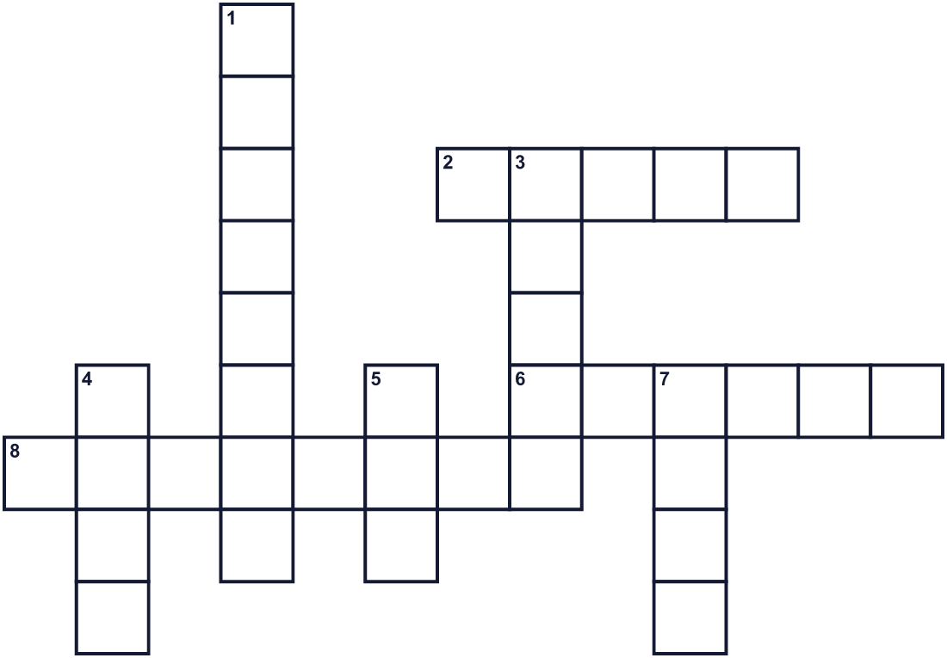
Across →
2. The color of the night sky. (5)
6. A baby cat. (6)
8. The second month of the year. (8)
Down ↓
1. Long thin hairs on a cat's face. (8)
3. Good things happen to you. You are ___. (5)
4. The sound a cat makes in English. (4)
5. An animal's foot. (3)
7. A long part at the back of an animal. (4)

🐱 Cat Day in Japan Worksheet
Word Search
かくれた単語をさがそう（→ ↓ ↘ ↗）
Class ______ No. ____ Name ______________________________
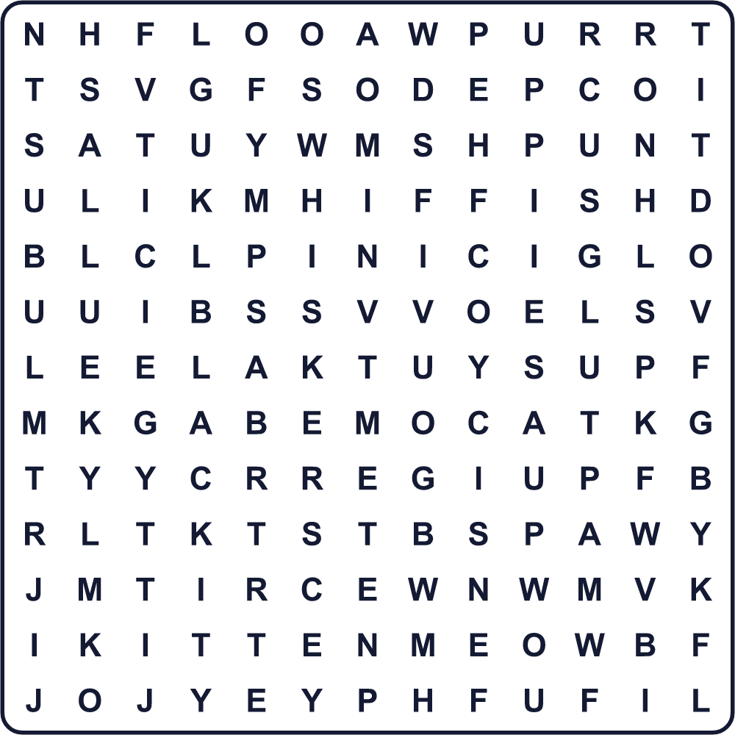
BLACK CAT FISH KITTEN LUCKY MEOW PAW PURR TAIL WHISKERS

🐱 Cat Day in Japan Worksheet
Maze & Sentences
Class ______ No. ____ Name ______________________________
Help the kitten find its mother! 子猫がお母さん猫のところへ行けるように助けよう！
正しい道の文字を集めると、ひみつの言葉になるよ。 START 🐱 → GOAL 🐈
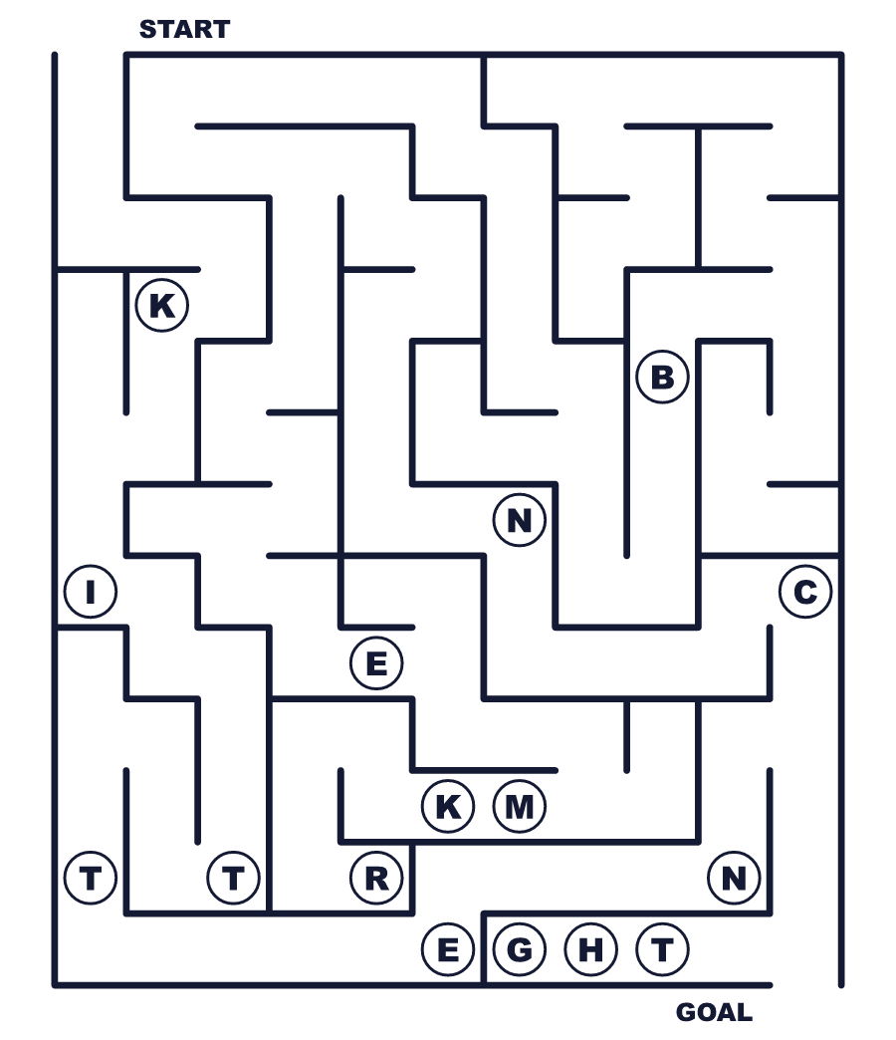
Secret word: ＿ ＿ ＿ ＿ ＿ ＿

🐱 Cat Day in Japan Worksheet
Class Activity & Writing
Class ______ No. ____ Name ______________________________
Let's Write! 英語で書いてみよう。
If I had a cat, I would name it ______ because ______.
もし猫を飼ったら、______と名づけます。なぜなら______だからです。
______________________________________________________________
______________________________________________________________
On Cat Day, I want to ______.
猫の日に、私は______したいです。
______________________________________________________________
______________________________________________________________

🐱 Cat Day in Japan Worksheet
Trace & Color
なぞって書こう。絵に色をぬろう。
Class ______ No. ____ Name ______________________________
🐱 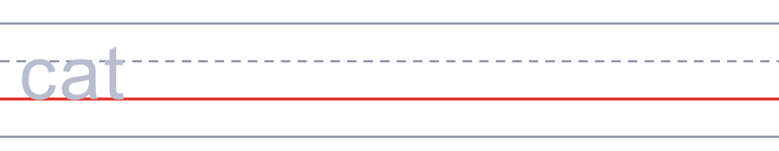

🐶 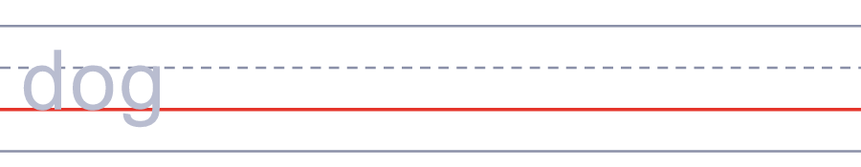
🐟 
🧶 
🥛 

🐱 Cat Day in Japan Worksheet
Answer Key 解答
Reading Check: 1.B 2.C 3.A 4.D 5.B
True or False: 1.T 2.F 3.T 4.F
Match: 🐱=cat 🐶=dog 🐟=fish 🧶=yarn 🥛=milk 🪙=coin
Fill in the blanks: (1)22 (2)Japan (3)cookies (4)black (5)Nyan (6)photo (7)Day
Maze: KITTEN
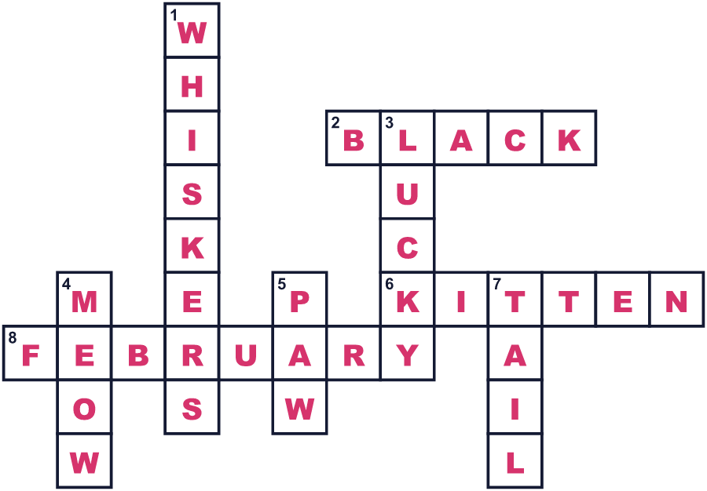
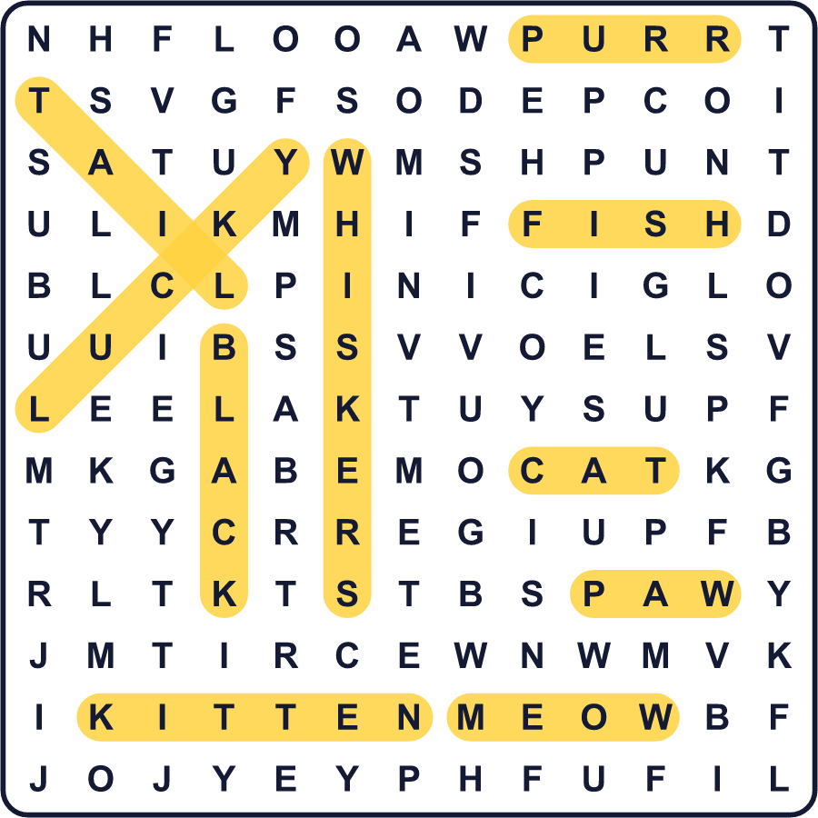
全訳
1 猫はどんな声で鳴くでしょう。英語では、猫は meow と鳴きます。日本語では「ニャン」と鳴きます。そして、数字の2は日本語で「に」です。だから2月22日、つまり2・2・2は、ニャン・ニャン・ニャンに聞こえるのです。それで、この日が日本の猫の日なのです。
2 猫の日は1987年に始まりました。猫好きのグループが、いちばんよい日付を選ぶよう人々に呼びかけました。8,953通の答えが集まりました。いちばん多かった答えが2月22日でした。最初の猫の日のイベントは東京で開かれました。国民の祝日ではありませんが、この日は多くの店やカフェが猫のグッズやお菓子を売ります。
3 日本人は長いあいだ猫を愛してきました。千年以上前、ある天皇が日記に自分の黒猫のことを書きました。のちに人々は招き猫を作りました。片方の手を挙げた縁起のよい猫です。お客さんやお金を招くと信じられています。ある有名な話では、お寺の猫が大きな嵐の直前に殿さまを手招きして中へ入れたと言われます。今でも多くのお店で見ることができます。
4 ほかの国にも猫の日がありますが、日付は違います。世界猫の日は8月8日です。イタリアでは2月17日、ロシアでは3月1日です。アメリカでは10月29日に祝う人が多いです。イギリスには黒猫のための特別な日まであります。だから猫好きなら、一年に何回もお祝いできますね！

