🍩 National Donut Day Worksheet
Donuts Near the Front Line
Read the story. 英文を読もう。
Class ______ No. ____ Name ______________________________
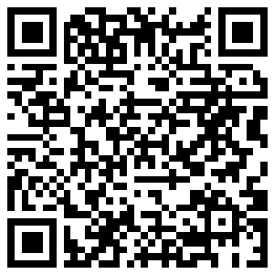
🔊 音声を聞こう（スマホで読みとってね）
1 In 1917, many young American soldiers went to France to fight in World War I. They were tired, cold, and far from home. A group called the Salvation Army wanted to help them. About 250 volunteers went to France.
2 Near the front line, it was hard to bake bread or cakes. So two women had a simple idea: donuts! You only need dough, oil, and a pan to make them. The women cut the dough into rings with old cans. The soldiers loved the hot, sweet donuts, and they called the women Donut Girls. One woman wrote that she made 300 donuts and 700 cups of coffee in one day.
3 About 20 years later, times were hard in America. Many people had no jobs and no food. In 1938, the Salvation Army in Chicago started National Donut Day. They used it to collect money for poor people. They also wanted to thank the Donut Girls.
4 Today, National Donut Day is on the first Friday in June. Many donut shops in America give away free donuts on this day. Some shops also give money to the Salvation Army. People post photos of their favorite donuts online. But the story began with a pan of hot oil and a kind idea. So when you eat a donut, remember the women who made them for tired soldiers long ago.
Words 単語
soldier（兵士） / volunteer（ボランティア、志願者） / front line（前線） / dough（（パンなどの）生地） / ring（輪） / collect（集める） / free（無料の） / thank（感謝する）

🍩 National Donut Day Worksheet
Reading Check
Choose the best answer. 正しいものを選ぼう。
Class ______ No. ____ Name ______________________________
1. What is the main idea of the reading?
(A) National Donut Day was started by a big donut company. (B) National Donut Day began with women who made donuts for soldiers. (C) Donuts were first made in France in 1938. (D) Soldiers in World War I did not like sweet food.
2. Why did the women choose to make donuts?
(A) Because soldiers asked for them (B) Because it was a French custom (C) Because it was hard to bake bread or cakes (D) Because donuts were very cheap in America
3. When did National Donut Day start?
(A) In 1917 (B) In 1938 (C) In 1971 (D) In 1847
4. In paragraph 4, "give away" is closest in meaning to:
(A) sell for a high price (B) throw in the trash (C) make at home (D) give for no money
5. In the dialogue, why is Jacob surprised at the end?
(A) He has never seen a Mister Donut shop. (B) He does not like donuts. (C) The line is very short. (D) Aoi made donuts for him.
True or False? T か F に○
1. National Donut Day is on the first Friday in June. T / F
2. A donut company started National Donut Day. T / F
3. Salvation Army women made donuts for soldiers in World War I. T / F
4. The word donut is older than doughnut. T / F

🍩 National Donut Day Worksheet
Word Work
単語のれんしゅう
Class ______ No. ____ Name ______________________________
① Match the pictures and the words. 絵と単語を線でむすぼう。
🍩 | ● | ● | milk
☕ | ● | ● | pan
🍳 | ● | ● | donut
🥛 | ● | ● | strawberry
🍓 | ● | ● | coffee
🍫 | ● | ● | chocolate
③ Fill in the blanks. 語群から選んで入れよう。
[ smile / coffee / free / Friday / bakery / sugar / snow / line / Monday ]
On the first (1) __________ in June, Lily goes to a (2) __________ with her dad. There is a long (3) __________ . Today, every child gets a (4) __________ donut. Lily chooses a pink one with (5) __________ on top. Her dad buys a cup of (6) __________ . "Thank you!" Lily says to the baker with a big (7) __________ .

🍩 National Donut Day Worksheet
Crossword Puzzle
ヒントを読んでクロスワードを完成させよう。
Class ______ No. ____ Name ______________________________
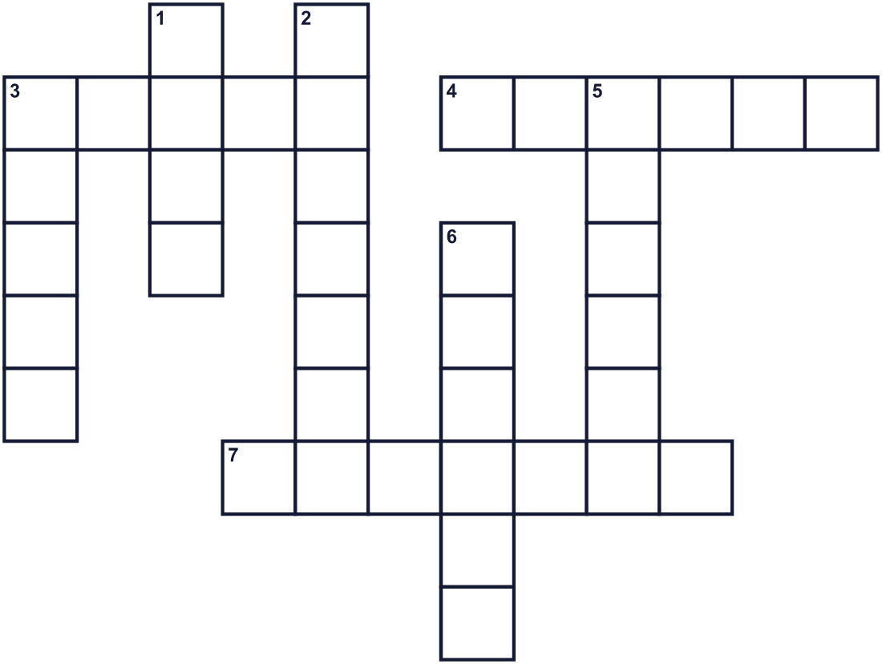
Across →
3. A soft mix of flour and water before cooking. (5)
4. A hot brown drink. People drink it with donuts. (6)
7. A person who fights in a war. (7)
Down ↓
1. The month after May. (4)
2. The American city where this day started. (7)
3. A sweet fried cake with a hole in the middle. (5)
5. The country where the Donut Girls worked. (6)
6. The day of the week for this special day. (6)

🍩 National Donut Day Worksheet
Word Search
かくれた単語をさがそう（→ ↓ ↘ ↗）
Class ______ No. ____ Name ______________________________
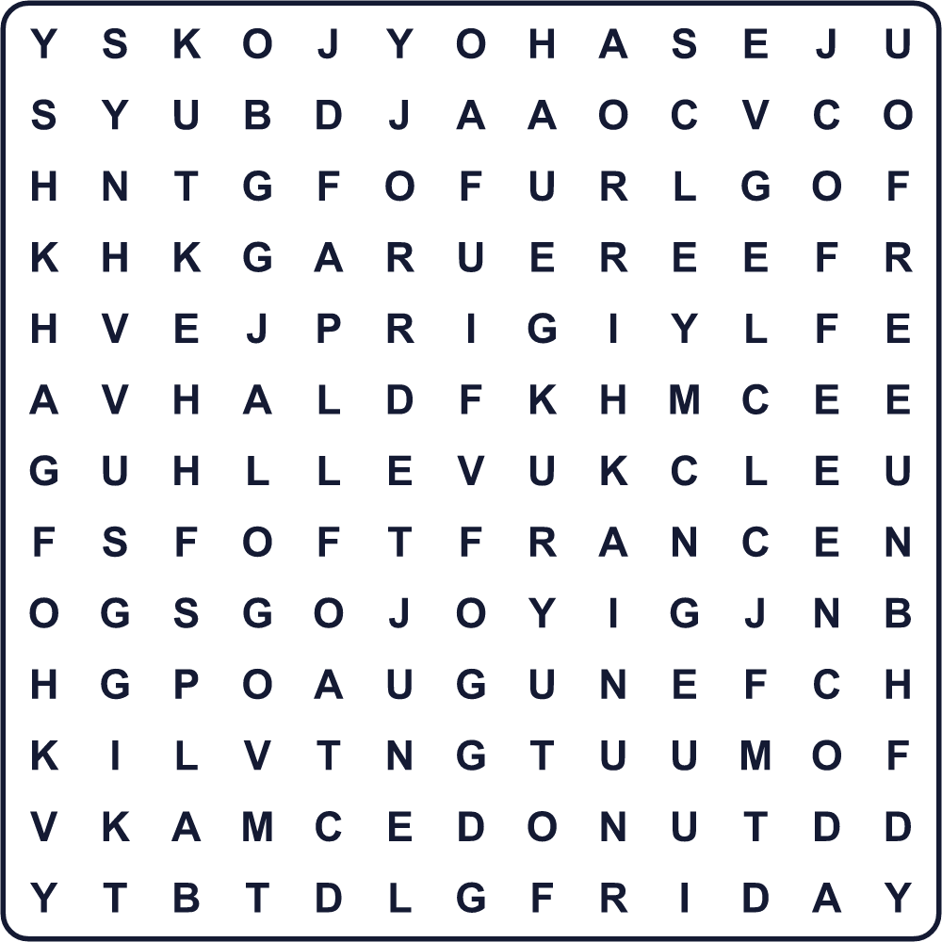
COFFEE DONUT DOUGH FRANCE FREE FRIDAY HOLE JUNE SOLDIER SUGAR

🍩 National Donut Day Worksheet
Maze & Sentences
Class ______ No. ____ Name ______________________________
Help Lily get to the donut shop! リリーをドーナツ屋さんまで連れていこう！
正しい道の文字を集めると、ひみつの言葉になるよ。 START 👧 → GOAL 🍩
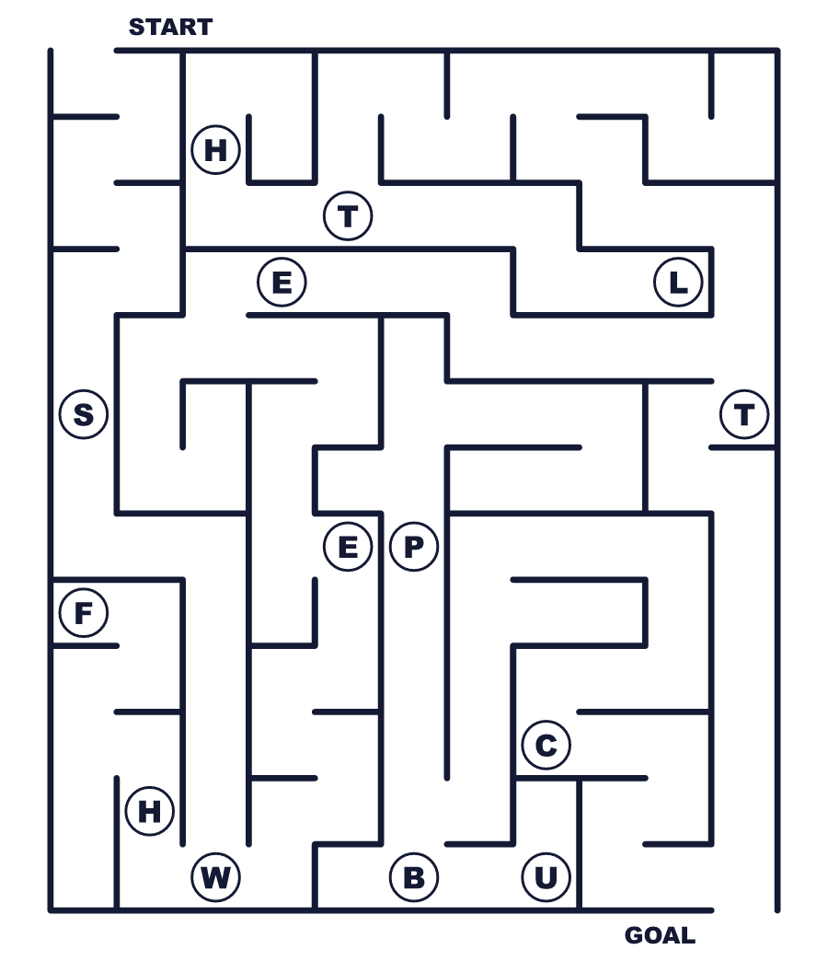
Secret word: ＿ ＿ ＿ ＿ ＿

🍩 National Donut Day Worksheet
Class Activity & Writing
Class ______ No. ____ Name ______________________________
Let's Write! 英語で書いてみよう。
If I made a new donut, it would have ______ and ______ on top.
新しいドーナツを作るなら、上に______と______をのせます。
______________________________________________________________
______________________________________________________________
I want to thank ______ because ______.
私は______に感謝したいです。なぜなら______だからです。
______________________________________________________________
______________________________________________________________

🍩 National Donut Day Worksheet
Trace & Color
なぞって書こう。絵に色をぬろう。
Class ______ No. ____ Name ______________________________
🍩 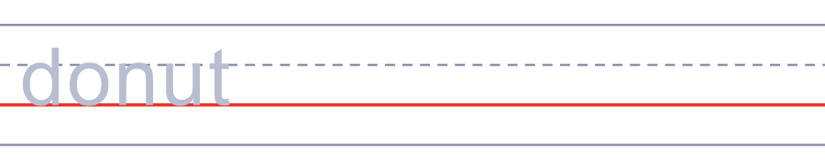

☕ 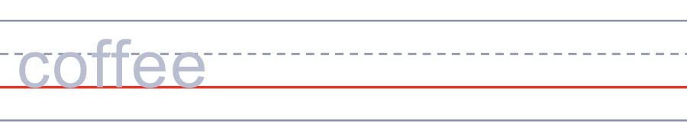
🍳 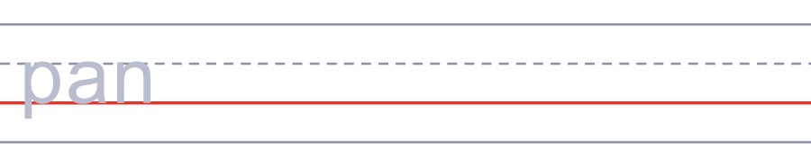
🥛 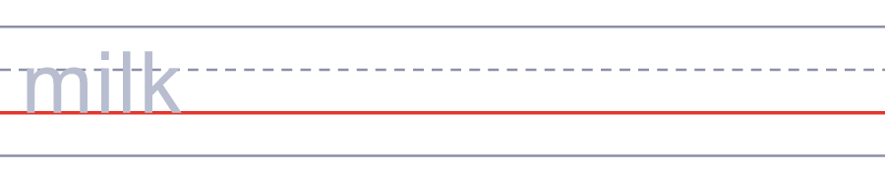
🍓 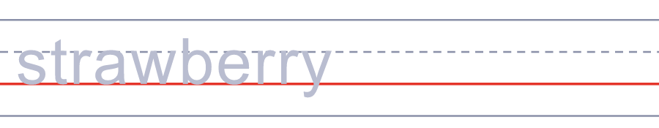

🍩 National Donut Day Worksheet
Answer Key 解答
Reading Check: 1.B 2.C 3.B 4.D 5.A
True or False: 1.T 2.F 3.T 4.F
Match: 🍩=donut ☕=coffee 🍳=pan 🥛=milk 🍓=strawberry 🍫=chocolate
Fill in the blanks: (1)Friday (2)bakery (3)line (4)free (5)sugar (6)coffee (7)smile
Maze: SWEET
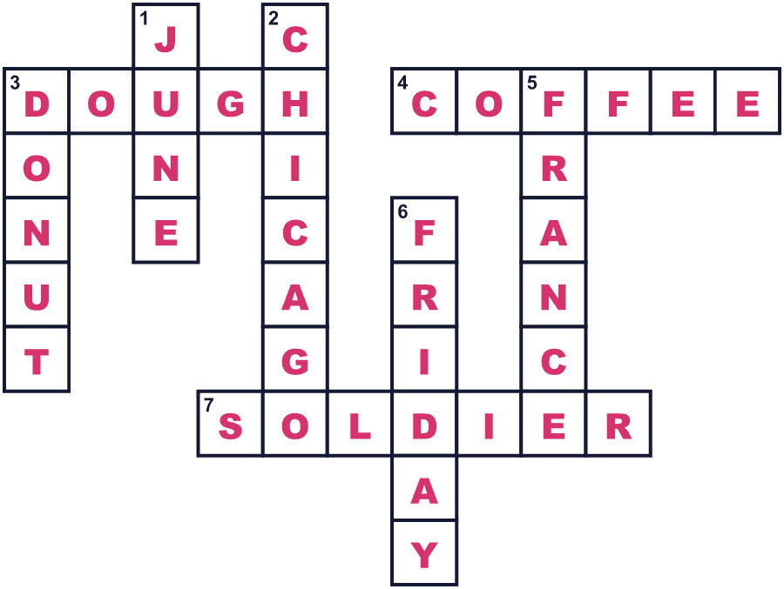
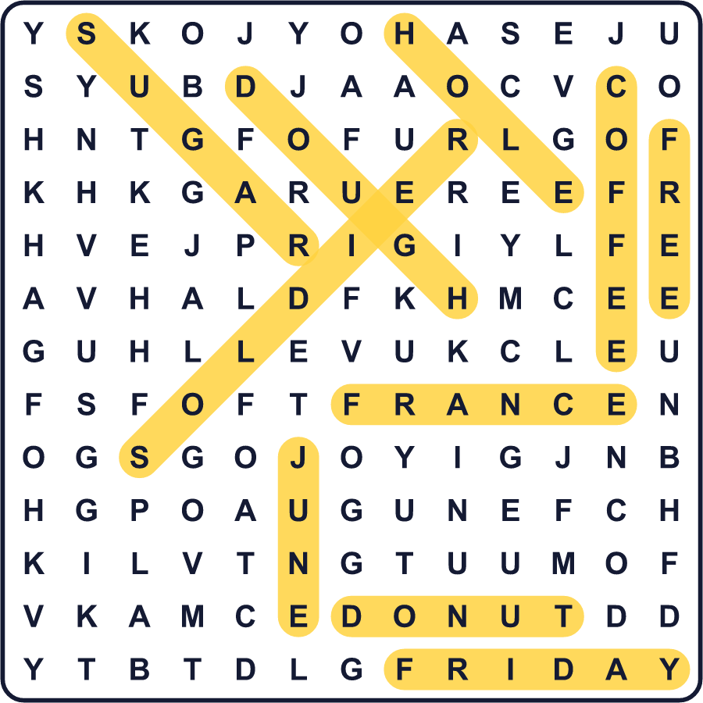
全訳
1 1917年、たくさんのアメリカの若い兵士が、第一次世界大戦を戦うためにフランスへ行きました。彼らは疲れていて、寒く、ふるさとから遠く離れていました。救世軍という団体が、彼らを助けたいと考えました。約250人のボランティアがフランスへ渡りました。
2 前線の近くでは、パンやケーキを焼くのは大変でした。そこで2人の女性が、簡単なアイデアを思いつきました。ドーナツです！生地と油と鍋さえあれば作れます。女性たちは古い缶で生地を輪の形にくりぬきました。兵士たちは温かくて甘いドーナツが大好きになり、彼女たちをドーナツ・ガールと呼びました。ある女性は、1日でドーナツを300個、コーヒーを700杯作ったと書き残しています。
3 約20年後、アメリカは苦しい時代を迎えていました。多くの人に仕事も食べ物もありませんでした。1938年、シカゴの救世軍がナショナル・ドーナツ・デーを始めました。貧しい人々のためのお金を集めるために、この日を使ったのです。ドーナツ・ガールたちに感謝したいという思いもありました。
4 今、ナショナル・ドーナツ・デーは6月の第1金曜日です。アメリカの多くのドーナツ店が、この日に無料のドーナツを配ります。救世軍にお金を寄付するお店もあります。人々はお気に入りのドーナツの写真をネットに投稿します。でもこの物語は、熱い油の入った鍋と、やさしいアイデアから始まったのです。だからドーナツを食べるときは、昔、疲れた兵士のためにそれを作った女性たちを思い出してください。

