🌿 Nanakusa (Seven Herbs Day) Worksheet
Seven Green Herbs in a Bowl
Read the story. 英文を読もう。
Class ______ No. ____ Name ______________________________

🔊 音声を聞こう（スマホで読みとってね）
1 On the morning of January 7, many families in Japan eat a simple bowl of rice porridge. It is soft, warm, and a little green. Inside, there are seven young spring plants. The dish is called nanakusa-gayu, and nanakusa means seven herbs. People eat it and wish for good health in the new year.
2 The custom started in old China. There, each of the first days of the year had an animal. Day one was for chickens, and day two was for dogs. Day seven was for people, so it was called Human Day. On that day, people made a hot soup with seven kinds of vegetables.
3 The idea came to Japan more than 1,000 years ago. Japanese people already liked to pick young plants in early spring. Fresh vegetables were hard to find in winter, so these plants were special. Later, the soup changed into rice porridge. In the Edo period, even the shogun ate it on January 7.
4 Today, supermarkets sell small packs of the seven herbs. Two of them are root vegetables, turnip and daikon radish. Some families chop the herbs while they sing an old song. Others soak their nails in herb water before the first nail cutting of the year. People say this keeps colds away. After all the rich New Year food, a light bowl of porridge feels just right.
Words 単語
porridge（おかゆ） / herb（ハーブ、香草、薬草） / custom（習慣、風習） / healthy（健康な） / chop（細かく刻む、たたき切る） / turnip（カブ） / radish（ダイコン、ラディッシュ） / soak（ひたす、つける）

🌿 Nanakusa (Seven Herbs Day) Worksheet
Reading Check
Choose the best answer. 正しいものを選ぼう。
Class ______ No. ____ Name ______________________________
1. What is the main idea of the passage?
(A) Japanese people eat a big meat dish on January 7. (B) A porridge with seven herbs is eaten for good health. (C) Supermarkets in Japan close on January 7. (D) Seven kinds of animals are eaten in early January.
2. In old China, what was day seven of the year for?
(A) chickens (B) dogs (C) horses (D) people
3. Why were young spring plants special in Japan long ago?
(A) Fresh vegetables were hard to find in winter. (B) The shogun gave them to everyone as a gift. (C) They grew only in China at that time. (D) People used them to make New Year cards.
4. In paragraph 4, what does soak mean in soak their nails in herb water?
(A) to cut (B) to paint (C) to put into liquid (D) to dry
5. In the dialogue, why does Sota say his stomach loves the porridge?
(A) He did not eat anything for a week. (B) He usually eats porridge every morning. (C) He ate New Year food for a week before. (D) He is sick and cannot eat other food.
True or False? T か F に○
1. People in Japan eat nanakusa-gayu on January 7. T / F
2. In old China, day one of the year was for people. T / F
3. Suzuna and suzushiro are turnip and daikon radish. T / F
4. People eat the seven autumn flowers, too. T / F

🌿 Nanakusa (Seven Herbs Day) Worksheet
Word Work
単語のれんしゅう
Class ______ No. ____ Name ______________________________
① Match the pictures and the words. 絵と単語を線でむすぼう。
🌿 | ● | ● | nails
🍚 | ● | ● | bowl
🔪 | ● | ● | knife
🥣 | ● | ● | herb
💅 | ● | ● | rice
🐔 | ● | ● | chicken
③ Fill in the blanks. 語群から選んで入れよう。
[ song / herbs / porridge / turnip / 7 / pizza / Canada / radish / health / summer ]
Leo is from (1) __________ . On January (2) __________ , his host mother makes rice (3) __________ . It has seven spring (4) __________ in it. Two of them are (5) __________ and daikon (6) __________ . Leo learns the names with a short (7) __________ . After the song, he eats the warm bowl slowly. He wishes for good (8) __________ .

🌿 Nanakusa (Seven Herbs Day) Worksheet
Crossword Puzzle
ヒントを読んでクロスワードを完成させよう。
Class ______ No. ____ Name ______________________________
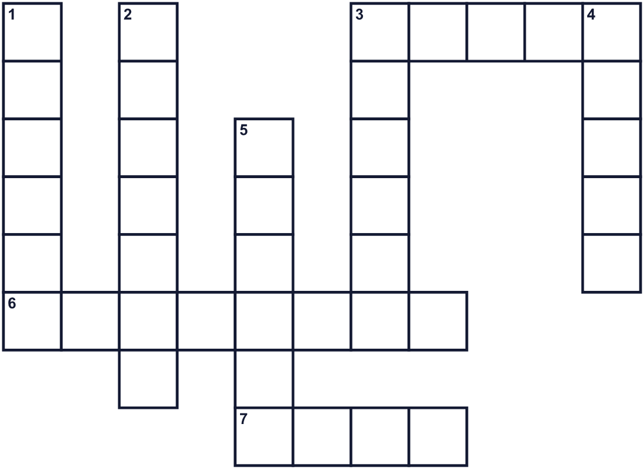
Across →
3. The number after six. (5)
6. Soft food. You cook rice in a lot of water. (8)
7. A small green plant. People use it in food or tea. (4)
Down ↓
1. A round white root vegetable. In Japan, it is kabu. (6)
2. The first month of the year. (7)
3. The season after winter. (6)
4. The hard parts at the ends of your fingers. (5)
5. A white root vegetable. In Japan, it is daikon. (6)

🌿 Nanakusa (Seven Herbs Day) Worksheet
Word Search
かくれた単語をさがそう（→ ↓ ↘ ↗）
Class ______ No. ____ Name ______________________________

GREEN HEALTH HERB NAILS PORRIDGE RADISH RICE SEVEN SPRING TURNIP

🌿 Nanakusa (Seven Herbs Day) Worksheet
Maze & Sentences
Class ______ No. ____ Name ______________________________
Help Kenta find the seven herbs! ケンタが七草を見つけられるように助けよう！
正しい道の文字を集めると、ひみつの言葉になるよ。 START 👦 → GOAL 🌿
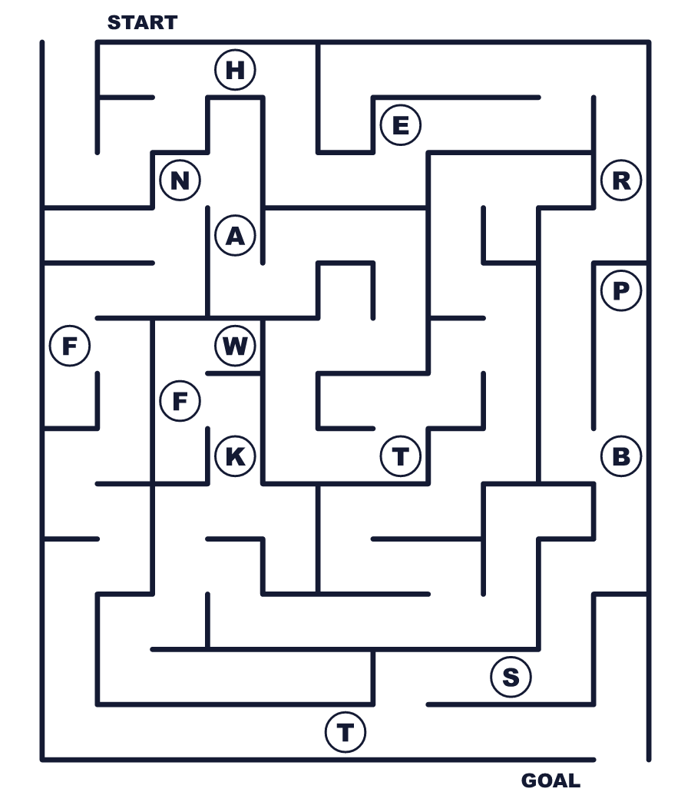
Secret word: ＿ ＿ ＿ ＿ ＿

🌿 Nanakusa (Seven Herbs Day) Worksheet
Class Activity & Writing
Class ______ No. ____ Name ______________________________
Let's Write! 英語で書いてみよう。
If I made my own seven-herb porridge, I would put in ______ because ______.
自分だけの七草がゆを作るなら、______を入れます。なぜなら______だからです。
______________________________________________________________
______________________________________________________________
This year, I wish for ______ for my family.
今年、私は家族のために______を願います。
______________________________________________________________
______________________________________________________________

🌿 Nanakusa (Seven Herbs Day) Worksheet
Trace & Color
なぞって書こう。絵に色をぬろう。
Class ______ No. ____ Name ______________________________
🌿 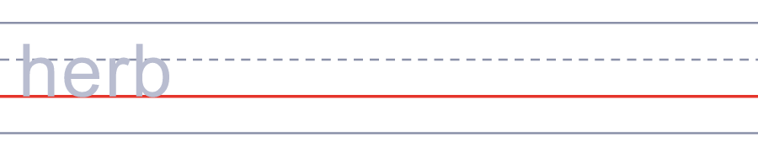

🍚 
🔪 
🥣 
💅 

🌿 Nanakusa (Seven Herbs Day) Worksheet
Answer Key 解答
Reading Check: 1.B 2.D 3.A 4.C 5.C
True or False: 1.T 2.F 3.T 4.F
Match: 🌿=herb 🍚=rice 🔪=knife 🥣=bowl 💅=nails 🐔=chicken
Fill in the blanks: (1)Canada (2)7 (3)porridge (4)herbs (5)turnip (6)radish (7)song (8)health
Maze: HERBS
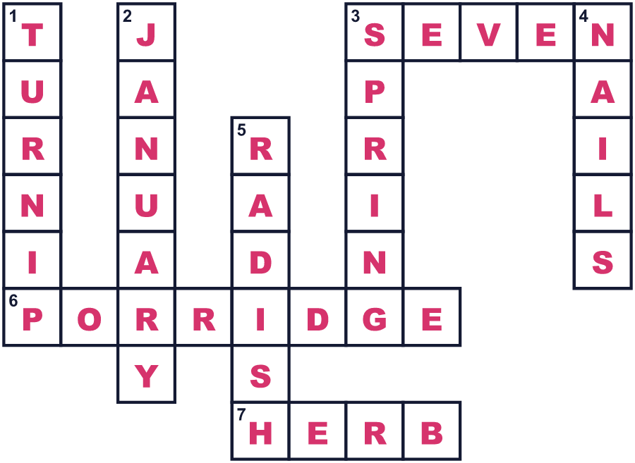

全訳
1 1月7日の朝、日本の多くの家族はシンプルなおかゆを食べます。やわらかくて温かく、少し緑色をしています。中には、7つの春の若い草が入っています。この料理は七草がゆと呼ばれ、七草は「7つの草」という意味です。人々はこれを食べて、新しい年の健康を願います。
2 この習慣は昔の中国で始まりました。そこでは、年のはじめの毎日に動物が割り当てられていました。1日目はニワトリ、2日目はイヌの日でした。7日目は人のための日だったので、「人の日」と呼ばれました。その日、人々は7種類の野菜で温かい汁物を作りました。
3 この考え方は千年以上前に日本へ伝わりました。日本の人々は、もともと早春に若い草を摘むのが好きでした。冬は新鮮な野菜が手に入りにくかったので、こうした草は特別でした。のちに、汁物はおかゆに変わりました。江戸時代には、将軍までもが1月7日にこれを食べました。
4 今では、スーパーで七草の小さなパックが売られています。そのうち2つは根の野菜、カブとダイコンです。古い歌を歌いながら七草を刻む家族もいます。その年はじめて爪を切る前に、七草をひたした水に爪をつける人もいます。こうするとかぜをひかないと言われています。お正月のごちそうのあとには、あっさりしたおかゆがちょうどいいのです。

