🥸 Movember Worksheet
Where Did the Mustache Go?
Read the story. 英文を読もう。
Class ______ No. ____ Name ______________________________

🔊 音声を聞こう（スマホで読みとってね）
1 In 2003, two friends sat in a bar in Melbourne, Australia. Their names were Travis Garone and Luke Slattery. They were talking about old fashions. Many were coming back, but the mustache was not. So they decided to bring it back for one month. In the end, 30 men took part, and each man paid 10 dollars.
2 They called the idea Movember. In Australia, people often call a mustache a mo, so mo plus November makes Movember. The next year, about 450 men took part. They raised money for men's health. The first cause was prostate cancer, a cancer that only men can get. In 2006, Movember became an official charity.
3 The rules are simple. On November 1, every Mo Bro shaves his face clean. Then he grows a mustache for the whole month, but no beard. His friends and family give money to support him. People who cannot grow a mustache can join too. Some walk or run 60 kilometers during the month. The number is for the 60 men around the world who take their own lives every hour.
4 Today, Movember is a big movement in many countries. Since 2003, it has raised more than 1.8 billion Australian dollars. The money has paid for more than 1,320 health projects for men. But money is only half of the plan. Many men do not like to say, "I feel sick" or "I feel sad." A funny mustache is easy to talk about. When a friend asks about your mo, a real conversation can begin.
Words 単語
mustache（口ひげ） / beard（あごひげ） / shave（（ひげを）そる） / charity（慈善団体、慈善） / raise（（お金を）集める） / cancer（がん） / movement（（社会的な）運動） / conversation（会話）

🥸 Movember Worksheet
Reading Check
Choose the best answer. 正しいものを選ぼう。
Class ______ No. ____ Name ______________________________
1. What is the reading mainly about?
(A) How to shave your face (B) How Movember started and what it does (C) The history of Melbourne (D) Why men like beards
2. How much did each man pay to join in 2003?
(A) 30 dollars (B) 450 dollars (C) 60 dollars (D) 10 dollars
3. Why is the Move challenge 60 kilometers?
(A) It is for the 60 men who take their own lives every hour. (B) It is the length of Melbourne. (C) Movember started 60 years ago. (D) Sixty friends joined the first year.
4. In paragraph 2, what does "raised money" mean?
(A) Spent money on clothes (B) Lost money in a bar (C) Collected money for a cause (D) Made money by selling beer
5. In the dialogue, what will Sota do for Movember?
(A) Grow a long beard (B) Walk 60 kilometers with Ruby (C) Shave his father's face (D) Enter a mustache contest
True or False? T か F に○
1. Movember started in Australia. T / F
2. In Movember, men grow a long beard. T / F
3. People without a mustache can join Movember. T / F
4. The first Movember had 450 men. T / F

🥸 Movember Worksheet
Word Work
単語のれんしゅう
Class ______ No. ____ Name ______________________________
① Match the pictures and the words. 絵と単語を線でむすぼう。
🪒 | ● | ● | mirror
🧔 | ● | ● | money
🏃 | ● | ● | walk
🪞 | ● | ● | run
🚶 | ● | ● | razor
💰 | ● | ● | beard
③ Fill in the blanks. 語群から選んで入れよう。
[ mustache / proud / shaved / health / money / November / walked / July / pizza ]
On (1) __________ 1, my dad stood in front of the mirror. He (2) __________ his face clean. "It's Movember!" he said. Every day, his (3) __________ got a little longer. Our neighbors gave (4) __________ for men's (5) __________ . I could not grow a mo, so I (6) __________ 60 kilometers. At the end of the month, Dad had a big, funny mo. We were very (7) __________ of him.

🥸 Movember Worksheet
Crossword Puzzle
ヒントを読んでクロスワードを完成させよう。
Class ______ No. ____ Name ______________________________
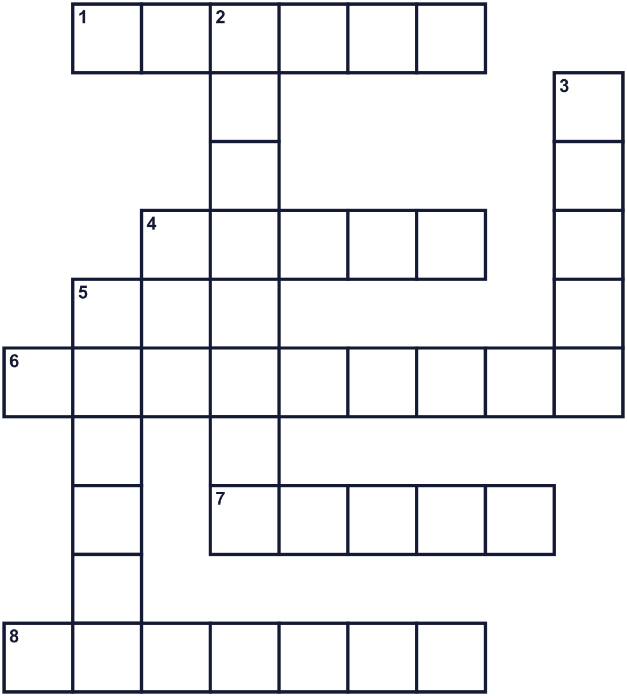
Across →
1. A serious illness. Prostate ____ is one kind. (6)
4. Hair on a man's chin and cheeks. Santa has a long white one. (5)
6. A big city in Australia. Movember started here. (9)
7. A tool with a sharp blade for cutting hair from your face. (5)
8. A group that collects money to help people. (7)
Down ↓
2. The eleventh month of the year. (8)
3. You do this with a razor to cut hair off your face. (5)
5. When your body and mind are well, you are in good ____. (6)

🥸 Movember Worksheet
Word Search
かくれた単語をさがそう（→ ↓ ↘ ↗）
Class ______ No. ____ Name ______________________________
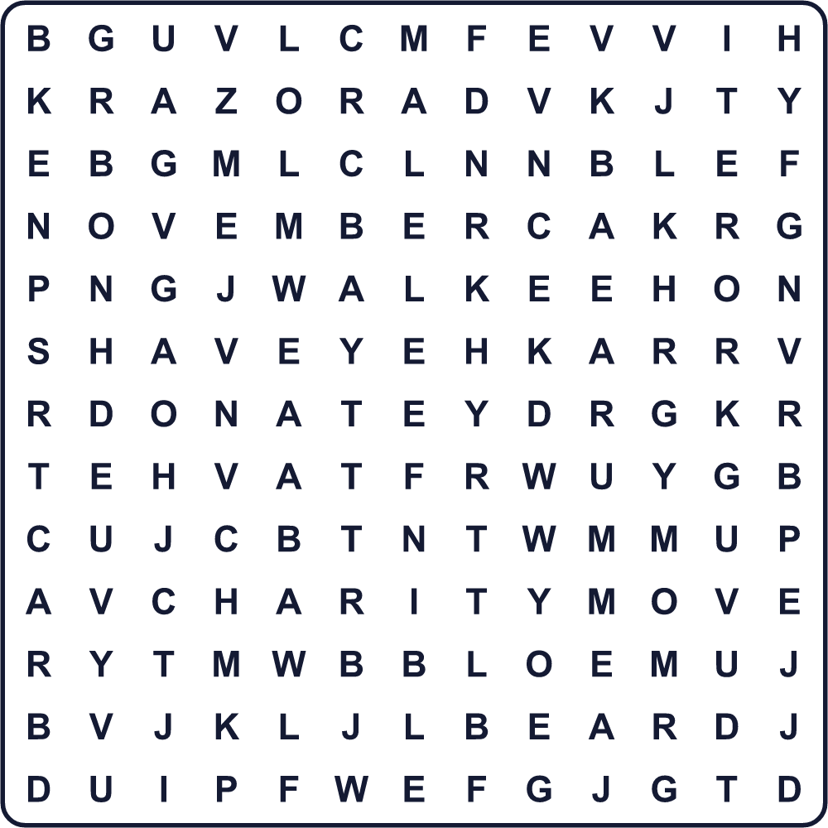
BEARD CANCER CHARITY DONATE HEALTH MOVE NOVEMBER RAZOR SHAVE WALK

🥸 Movember Worksheet
Maze & Sentences
Class ______ No. ____ Name ______________________________
Help Sota finish his 60 kilometers! ソウタの60キロ・ゴールまで連れていこう！
正しい道の文字を集めると、ひみつの言葉になるよ。 START 🏃 → GOAL 🏁
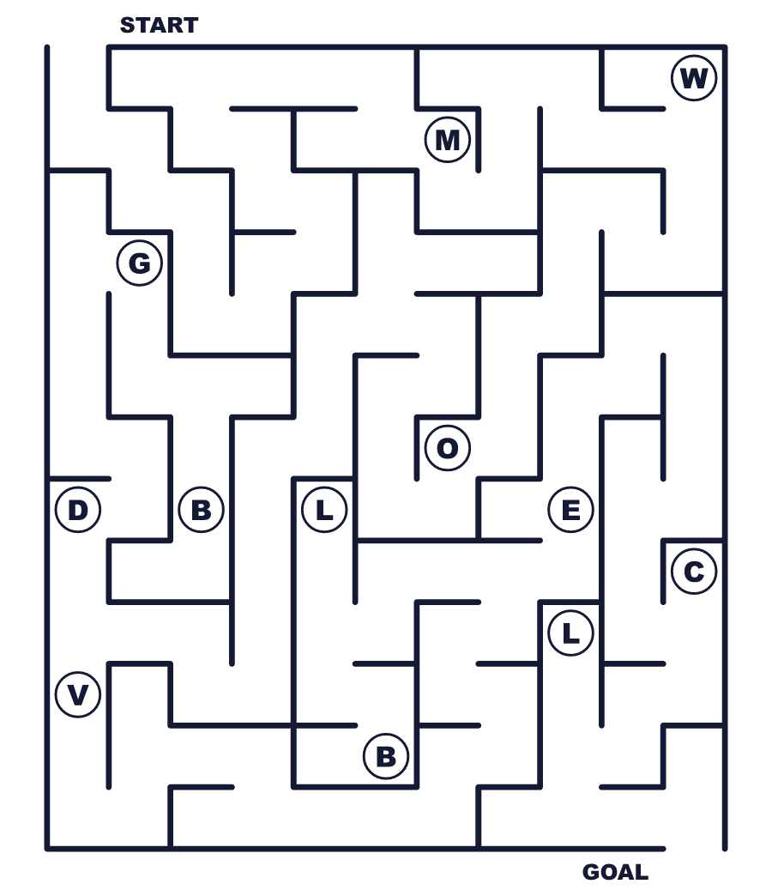
Secret word: ＿ ＿ ＿ ＿

🥸 Movember Worksheet
Class Activity & Writing
Class ______ No. ____ Name ______________________________
Let's Write! 英語で書いてみよう。
If I joined Movember, I would ______ because ______.
もし Movember に参加するなら、＿＿＿します。なぜなら＿＿＿だからです。
______________________________________________________________
______________________________________________________________
One way to help people stay healthy is ______.
人が健康でいるのを助ける方法の一つは＿＿＿です。
______________________________________________________________
______________________________________________________________

🥸 Movember Worksheet
Trace & Color
なぞって書こう。絵に色をぬろう。
Class ______ No. ____ Name ______________________________
🪒 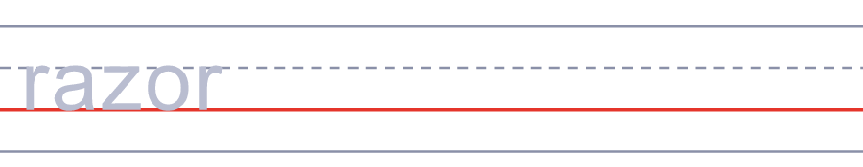

🧔 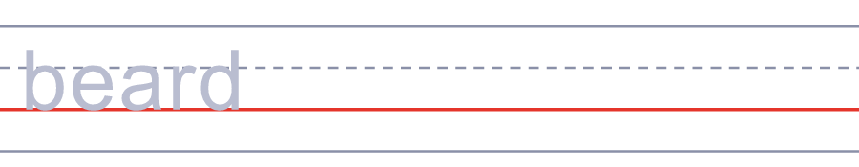
🏃 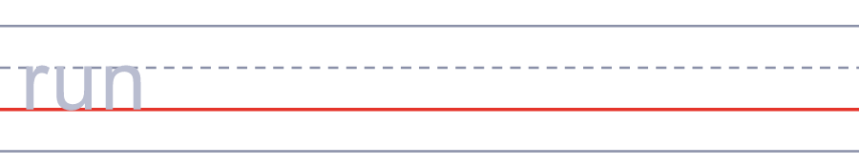
🪞 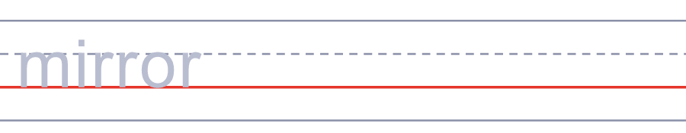
🚶 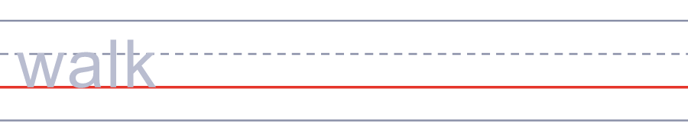

🥸 Movember Worksheet
Answer Key 解答
Reading Check: 1.B 2.D 3.A 4.C 5.B
True or False: 1.T 2.F 3.T 4.F
Match: 🪒=razor 🧔=beard 🏃=run 🪞=mirror 🚶=walk 💰=money
Fill in the blanks: (1)November (2)shaved (3)mustache (4)money (5)health (6)walked (7)proud
Maze: MOVE
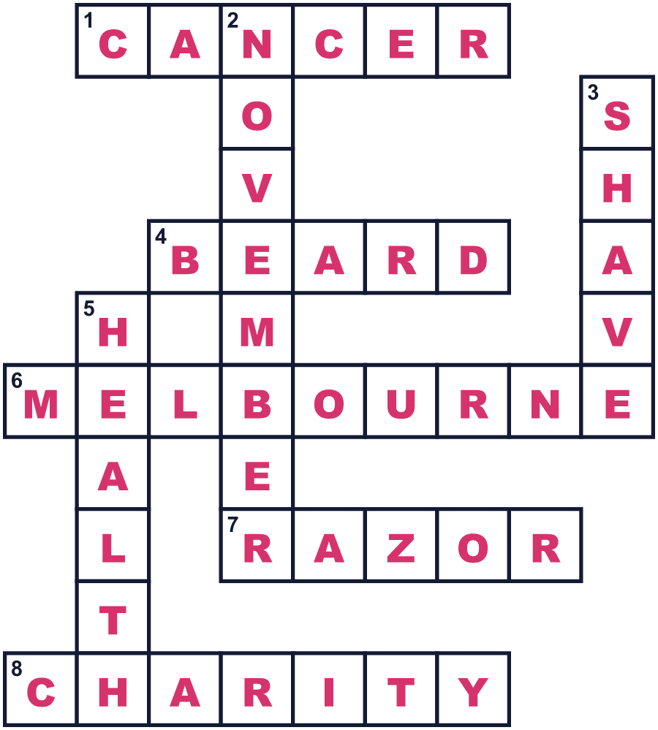
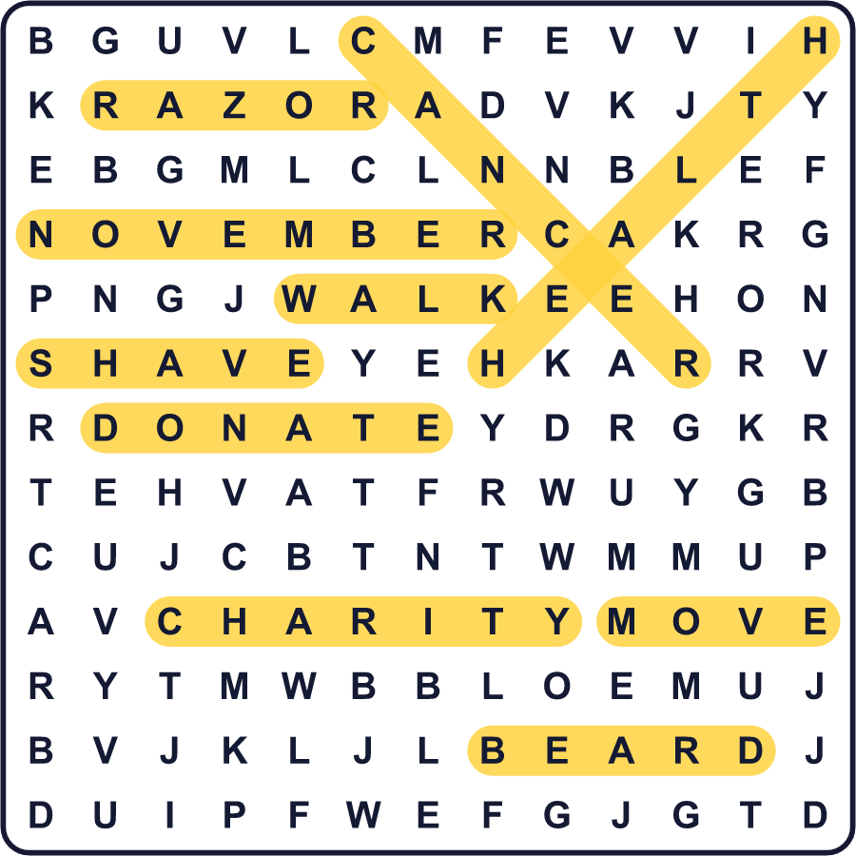
全訳
1 2003年、2人の友だちがオーストラリアのメルボルンのバーにすわっていました。名前はトラヴィス・ガローンとルーク・スラッテリーです。2人は昔の流行について話していました。いろいろな流行が戻ってきているのに、口ひげだけは戻ってきません。そこで2人は、1か月だけ口ひげを復活させることにしました。最終的に30人が参加し、1人10ドルずつ払いました。
2 2人はこのアイデアを Movember と名づけました。オーストラリアでは口ひげをよく mo と呼ぶので、mo と November を合わせて Movember です。次の年には、約450人が参加しました。男性の健康のためにお金を集めました。最初のテーマは前立腺がん。男性だけがかかるがんです。2006年、Movember は正式な慈善団体になりました。
3 ルールはかんたんです。11月1日、すべての Mo Bro が顔のひげをきれいにそります。それから1か月間、口ひげをのばします。でも、あごひげはだめです。友だちや家族が、応援のお金を寄付します。口ひげがのびない人も参加できます。1か月で60キロを歩いたり走ったりする人もいます。この数は、世界で1時間ごとに自ら命を絶つ60人の男性のためのものです。
4 今、Movember は多くの国に広がる大きな運動です。2003年から、18億豪ドル以上を集めてきました。そのお金は、1,320をこえる男性の健康のプロジェクトに使われています。でも、お金は作戦の半分にすぎません。多くの男性は「具合が悪い」「つらい」と言いたがりません。おもしろい口ひげなら、話題にしやすいのです。友だちがあなたの口ひげについてたずねたとき、本当の会話が始まるかもしれません。

