💐 Mother's Day Worksheet
The Woman Who Made Mother's Day
Read the story. 英文を読もう。
Class ______ No. ____ Name ______________________________

🔊 音声を聞こう（スマホで読みとってね）
1 On May 10, 1908, a small church in West Virginia got a big delivery. Inside were 500 white carnations. They came from a woman named Anna Jarvis. This was the first Mother's Day. But Anna herself was not there.
2 Anna wanted to remember her own mother, Ann. Ann had eleven children, and Anna was the ninth. Ann worked hard to help families stay clean and healthy. During a war, she also helped hurt soldiers from both sides. When Ann died in 1905, Anna had an idea. Why not have a special day for all mothers?
3 Her idea spread very fast. In 1910, West Virginia became the first state to have a Mother's Day. In 1914, President Woodrow Wilson made the second Sunday in May a national day for mothers. Anna was very happy. But soon, flower shops and card companies saw a chance to make money.
4 Anna became angry. She said a printed card was lazy, and a handwritten letter was much better. She did not want the day to be about shopping. She fought against the companies for the rest of her life. In 1925, the police even arrested her at a meeting. She never had children, and she died in 1948 with almost no money.
5 Today, Mother's Day is on different dates around the world. In Britain, it comes in March, and in Thailand, people give jasmine flowers in August. In Mexico, it is always May 10. In Japan and the United States, it is still the second Sunday in May. So this year, try what Anna wanted. Write a short letter to your mother by hand.
Words 単語
carnation（カーネーション） / delivery（配達、届いた荷物） / remember（覚えている、しのぶ） / healthy（健康な） / soldier（兵士） / national（国の、全国の） / company（会社） / printed（印刷された） / handwritten（手書きの） / lazy（なまけた、手抜きの） / arrest（逮捕する） / jasmine（ジャスミン）

💐 Mother's Day Worksheet
Reading Check
Choose the best answer. 正しいものを選ぼう。
Class ______ No. ____ Name ______________________________
1. What is the main idea of the reading?
(A) How to make a Mother's Day card (B) Why Mother's Day is in March in Britain (C) How Anna Jarvis started Mother's Day and then fought against its business side (D) Why flowers are expensive in May
2. How many carnations did Anna send to the church?
(A) 50 (B) 500 (C) 1,908 (D) 5,000
3. Why did Anna start Mother's Day?
(A) She wanted to remember her own mother. (B) She wanted to sell flowers. (C) The president asked her to do it. (D) She had many children.
4. What happened first?
(A) Anna was arrested. (B) President Wilson made a national day. (C) Anna's mother died. (D) Anna died.
5. In paragraph 4, what does lazy mean?
(A) expensive (B) too big (C) beautiful (D) not making much effort
6. Which sentence is true about the reading?
(A) Mother's Day is on the same date in every country. (B) Anna was very rich when she died. (C) Ann helped soldiers from both sides of a war. (D) Anna loved printed cards.
7. What would Anna Jarvis probably like best as a Mother's Day gift?
(A) an expensive ring from a shop (B) a letter written by hand (C) a box of cards from a store (D) a gift card for flowers
8. In the dialogue, why is Riku surprised?
(A) Emily does not like flowers. (B) Mother's Day in Britain is in March. (C) Emily's mother lives in Japan. (D) Carnations are very expensive.
True or False? T か F に○
1. Anna Jarvis started Mother's Day to remember her mother. T / F
2. Mother's Day is on the same day in every country. T / F
3. Anna Jarvis liked printed cards very much. T / F
4. In Britain, Mothering Sunday usually comes in March. T / F
5. In Thailand, people give jasmine flowers on Mother's Day. T / F
6. Anna Jarvis had ten children. T / F

💐 Mother's Day Worksheet
Word Work
単語のれんしゅう
Class ______ No. ____ Name ______________________________
① Match the pictures and the words. 絵と単語を線でむすぼう。
💐 | ● | ● | flowers
💌 | ● | ● | gift
🎁 | ● | ● | cake
🍰 | ● | ● | church
🤗 | ● | ● | hug
⛪ | ● | ● | tea
☕ | ● | ● | letter
❤ | ● | ● | love
② Unscramble the words. 並べかえて単語にしよう。
1. R M T H E O (母) → ____________________
2. W R E O F L (花) → ____________________
3. E R E T T L (手紙) → ____________________
4. S K T N A H (ありがとう) → ____________________
5. Y L I F A M (家族) → ____________________
6. A D U S Y N (日曜日) → ____________________
③ Fill in the blanks. 語群から選んで入れよう。
[ sweet / blue / August / smiles / mother / event / letter / December / snow / Bangkok / garland / angry / jasmine ]
Nok lives in (1) __________ , Thailand. In Thailand, Mother's Day is on (2) __________ 12. The night before, Nok makes a (3) __________ with small white (4) __________ flowers. They smell very (5) __________ . In the morning, there is a special (6) __________ at school. Nok kneels in front of her (7) __________ and gives her the flowers. Her mother (8) __________ and hugs her. Many people wear (9) __________ on this day. Nok writes a short (10) __________ , too.

💐 Mother's Day Worksheet
Crossword Puzzle
ヒントを読んでクロスワードを完成させよう。
Class ______ No. ____ Name ______________________________
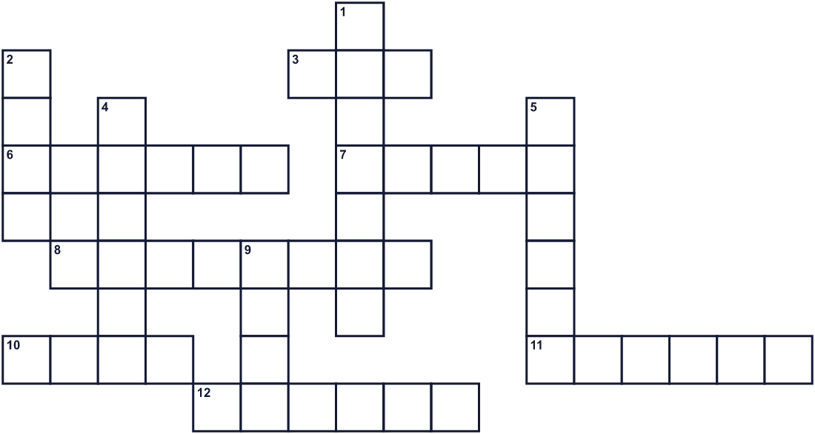
Across →
3. The fifth month of the year. (3)
6. A rose or a tulip is one. (6)
7. The month of Mothering Sunday in Britain. (5)
8. A country in Asia. Its Mother's Day is August 12. (8)
10. You write a message on this and give it to someone. (4)
11. Mother's Day in Japan is on this day of the week. (6)
12. You write this by hand and send it. (6)
Down ↓
1. A small white flower. Thai children give it to mothers. (7)
2. A present. (4)
4. Your mom. (6)
5. A word you say when someone helps you. (6)
9. A strong, warm feeling for family. (4)

💐 Mother's Day Worksheet
Word Search
かくれた単語をさがそう（→ ↓ ↘ ↗）
Class ______ No. ____ Name ______________________________
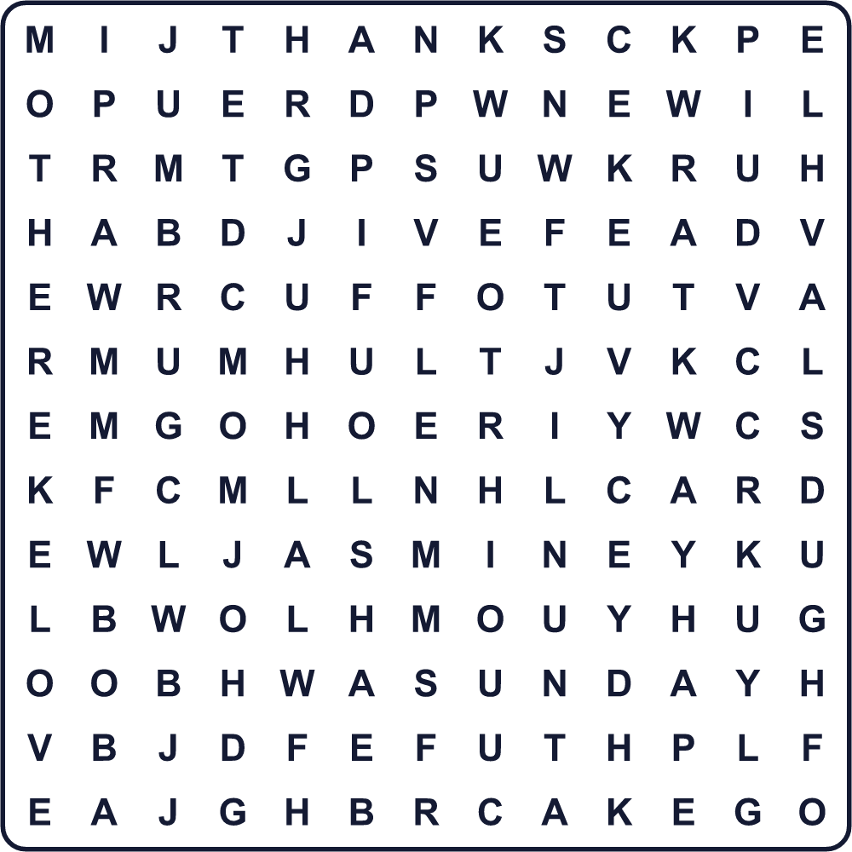
CAKE CARD FAMILY FLOWER GIFT HUG JASMINE LETTER LOVE MOM MOTHER SUNDAY THANKS
Secret Code 暗号を解こう
✂=A ♪=H ☎=K ▲=M ♥=N ✎=O ⚓=T ☀=U ✈=Y
⚓ ♪ ✂ ♥ ☎ ✈ ✎ ☀ ▲ ✎ ▲
______________________________________________________________

💐 Mother's Day Worksheet
Maze & Sentences
Class ______ No. ____ Name ______________________________
Help Ken bring the flowers to Mom! ケンがお母さんに花をとどけられるように手伝おう！
正しい道の文字を集めると、ひみつの言葉になるよ。 START 👦 → GOAL 💐
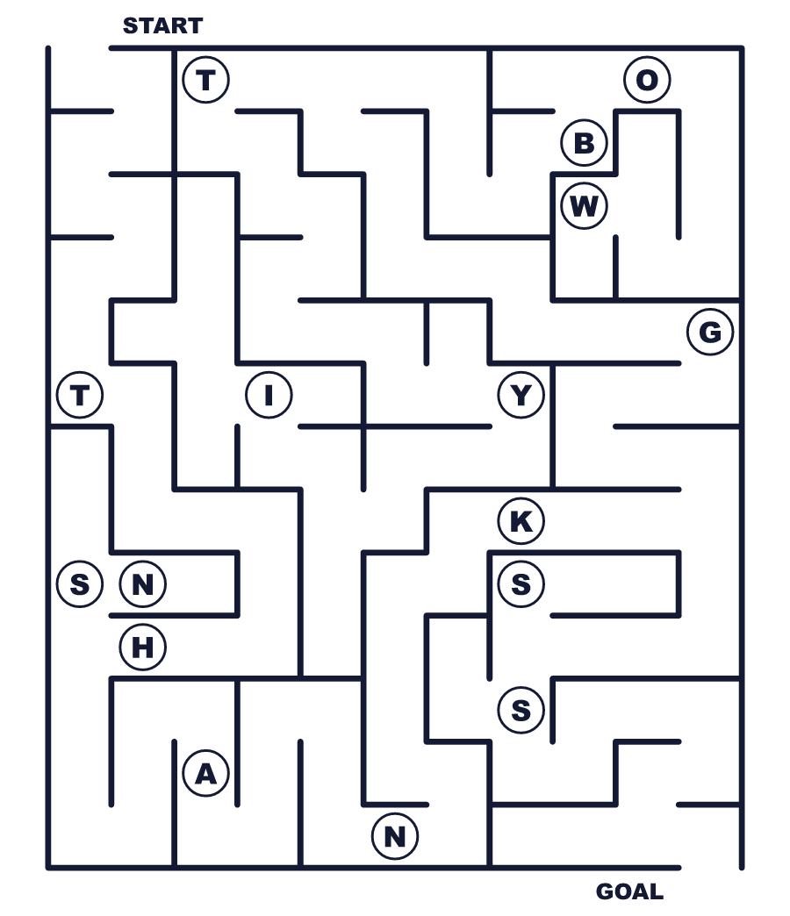
Secret word: ＿ ＿ ＿ ＿ ＿ ＿
Put the words in order. 並べかえよう。
1. Day / Sunday / in / May / is / Mother's / the / second . (母の日は5月の第2日曜日です。)
______________________________________________________________
2. gave / red / my / carnations / I / mother . (私は母に赤いカーネーションをあげました。)
______________________________________________________________
3. Day / in / started / Anna / Mother's / 1908 / Jarvis . (アンナ・ジャービスは1908年に母の日を始めました。)
______________________________________________________________
4. March / Day / Britain, / Mother's / in / comes / In . (イギリスでは母の日は3月に来ます。)
______________________________________________________________
5. mom / I / to / a / my / will / write / letter . (私はお母さんに手紙を書くつもりです。)
______________________________________________________________

💐 Mother's Day Worksheet
Class Activity & Writing
Class ______ No. ____ Name ______________________________
Find Someone Who… クラスで聞いて回ろう！
Find someone who … | Name
… has given flowers to their mother お母さんに花をあげたことがある
… has written a letter to their family 家族に手紙を書いたことがある
… can cook something for their family 家族のために何か料理を作れる
… knows the date of Mother's Day this year 今年の母の日の日付を知っている
… likes carnations カーネーションが好き
… knows a country with Mother's Day in March 母の日が3月の国を知っている
… has helped with housework this week 今週、家事を手伝った
… can say thank you in three languages 3つの言語で「ありがとう」が言える
Let's Write! 英語で書いてみよう。
Dear Mom, thank you for ______. I will ______ for you.
お母さんへ。＿＿をありがとう。お母さんのために＿＿します。
______________________________________________________________
______________________________________________________________
My mother is ______. She always ______.
私のお母さんは＿＿です。いつも＿＿しています。
______________________________________________________________
______________________________________________________________
If I could visit one country on Mother's Day, I would go to ______ because ______.
母の日に一つの国を訪れるなら、＿＿に行きたいです。なぜなら＿＿だからです。
______________________________________________________________
______________________________________________________________

💐 Mother's Day Worksheet
Trace & Color
なぞって書こう。絵に色をぬろう。
Class ______ No. ____ Name ______________________________
💐 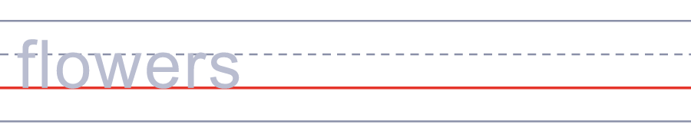

💌 
🎁 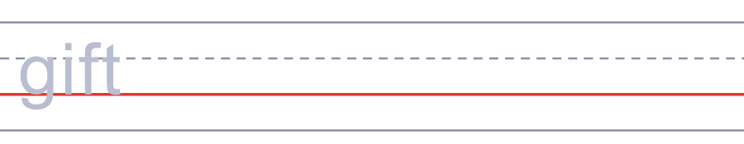
🍰 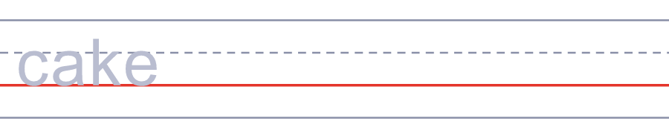
🤗 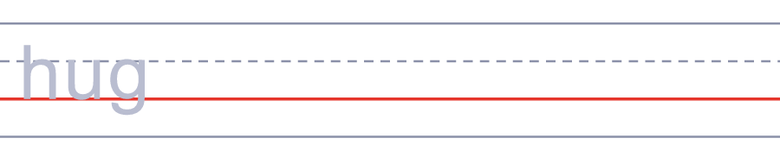
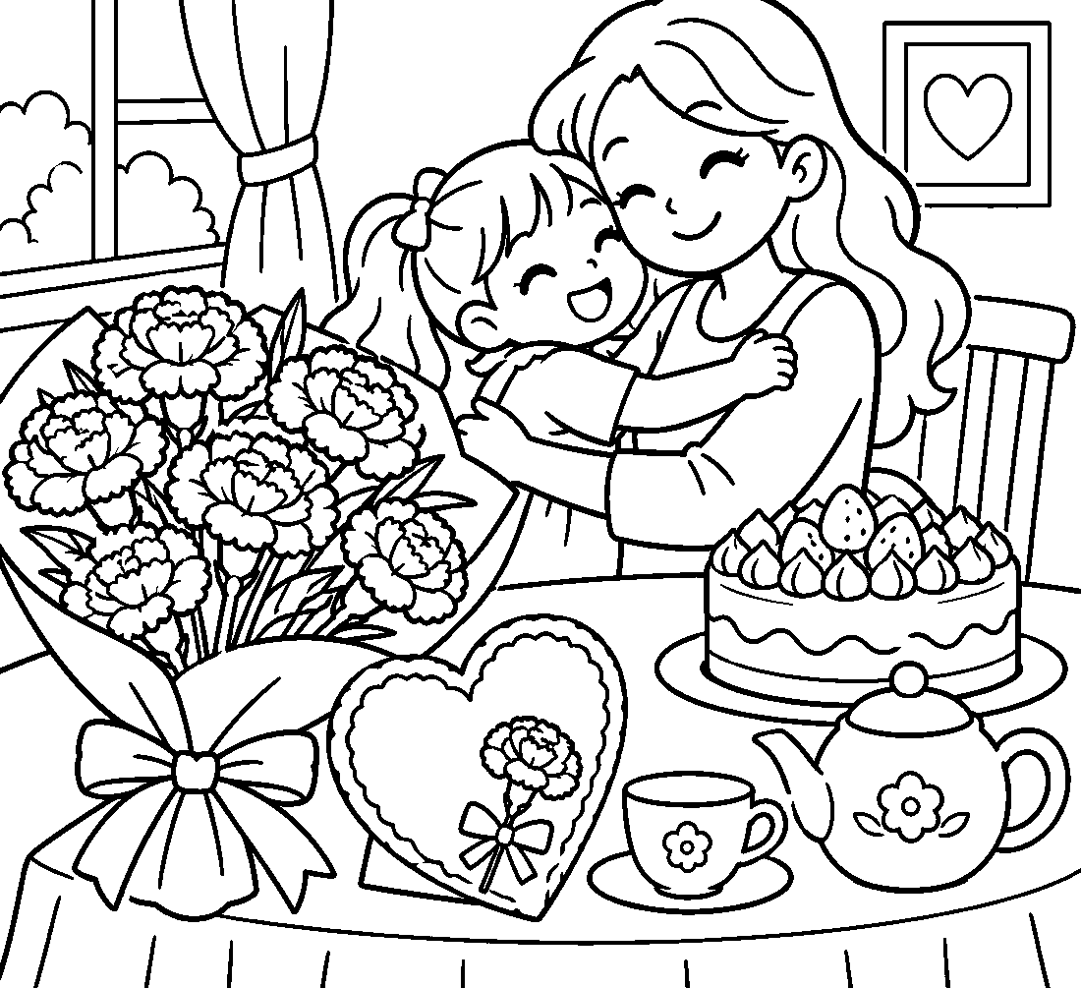

💐 Mother's Day Worksheet
Answer Key 解答
Reading Check: 1.C 2.B 3.A 4.C 5.D 6.C 7.B 8.B
True or False: 1.T 2.F 3.F 4.T 5.T 6.F
Match: 💐=flowers 💌=letter 🎁=gift 🍰=cake 🤗=hug ⛪=church ☕=tea ❤=love
Unscramble: 1.MOTHER 2.FLOWER 3.LETTER 4.THANKS 5.FAMILY 6.SUNDAY
Fill in the blanks: (1)Bangkok (2)August (3)garland (4)jasmine (5)sweet (6)event (7)mother (8)smiles (9)blue (10)letter
Sentence order: 1. Mother's Day is the second Sunday in May. 2. I gave my mother red carnations. 3. Anna Jarvis started Mother's Day in 1908. 4. In Britain, Mother's Day comes in March. 5. I will write a letter to my mom.
Secret Code: THANK YOU MOM
Maze: THANKS
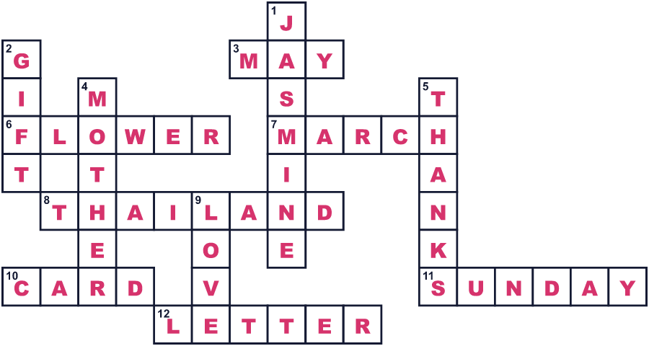
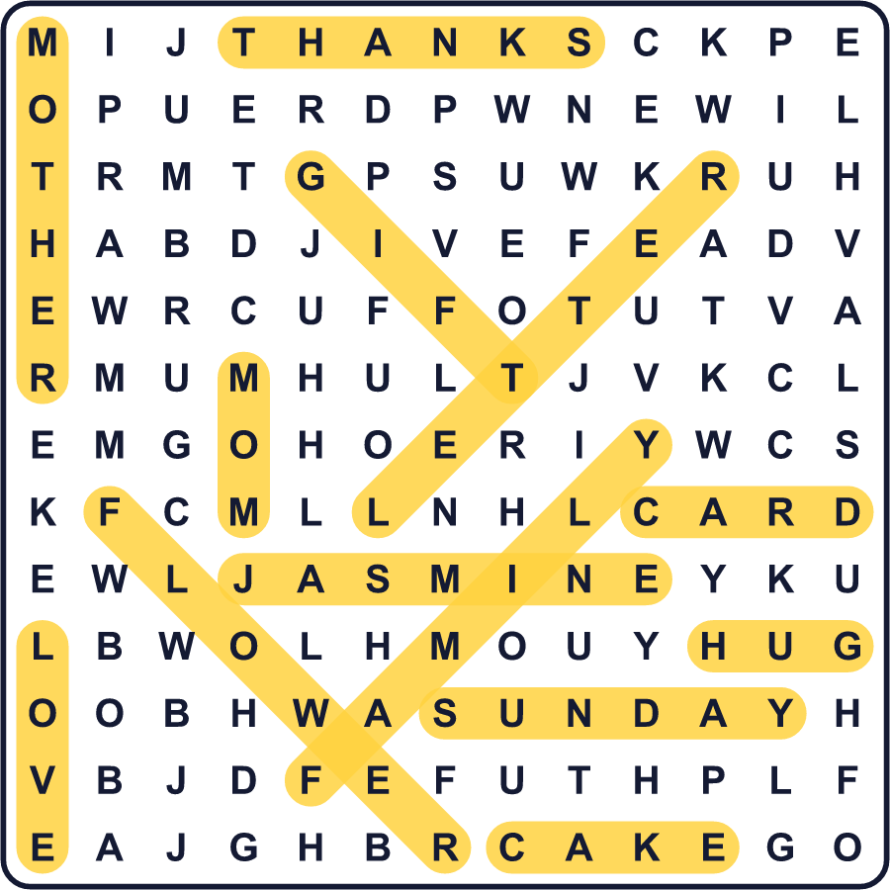
全訳
1 1908年5月10日、ウェストバージニア州の小さな教会に、大きな荷物が届きました。中には白いカーネーションが500本入っていました。送り主は、アンナ・ジャービスという女性でした。これが最初の母の日でした。でも、アンナ本人はその場にいませんでした。
2 アンナは、自分の母アンのことを忘れたくありませんでした。アンには11人の子どもがいて、アンナは9番目でした。アンは、家族が清潔で健康に暮らせるよう、熱心に活動していました。戦争の間は、敵と味方どちらの傷ついた兵士も助けました。1905年にアンが亡くなったとき、アンナはあることを思いつきました。すべてのお母さんのための特別な日を作ったらどうだろう、と。
3 彼女の考えは、あっという間に広まりました。1910年、ウェストバージニア州が母の日を作った最初の州になりました。1914年、ウッドロウ・ウィルソン大統領は、5月の第2日曜日を母親のための国の記念日にしました。アンナはとても喜びました。ところがまもなく、花屋やカード会社は、これはもうかるチャンスだと考えました。
4 アンナは怒りました。印刷されたカードは手抜きで、手書きの手紙の方がずっといい、と彼女は言いました。彼女は、この日を買い物の日にしたくなかったのです。彼女は残りの人生をかけて、企業と戦いました。1925年には、ある大会で警察に逮捕されたことさえありました。彼女は子どもを持たず、1948年にほとんどお金のないまま亡くなりました。
5 今では、母の日は世界中でちがう日にあります。イギリスでは3月に来て、タイでは8月に人々がジャスミンの花を贈ります。メキシコでは、いつも5月10日です。日本とアメリカでは、今も5月の第2日曜日です。だから今年は、アンナが望んだことをやってみませんか。お母さんに、手書きで短い手紙を書いてみましょう。

