🍁 Momijigari (Autumn Leaf Viewing) Worksheet
Hunting for Red Leaves
Read the story. 英文を読もう。
Class ______ No. ____ Name ______________________________

🔊 音声を聞こう（スマホで読みとってね）
1 In Japan, many people go hunting in autumn. But they do not hunt animals. They hunt for red and yellow leaves! This is called momijigari. Momiji means colored autumn leaves, and gari means hunting. Nobody takes anything home. People just walk, look, and take photos.
2 This custom is very old. About 1,000 years ago, people at the emperor's court went to the hills to enjoy the colors. Later, in the Edo period, people in the towns went too. There is even a famous old play about it. In the story, a brave man goes deer hunting and meets a group of women. They invite him to their leaf party, but the beautiful woman there is really a demon!
3 Why do leaves change color? In autumn, the green color in the leaves breaks down. Then the yellow color, hidden all summer, can be seen. The red color is new. The leaves make it in autumn. Trees start to change when the coldest part of the day goes below 8 degrees. Cold nights and sunny days make the colors even brighter.
4 The cherry blossom front moves north in spring. But the autumn leaf front moves south! It starts in Hokkaido in October and reaches the south of Kyushu in December. Trees on high mountains change first, so the tops turn red before the towns below. People in America enjoy autumn leaves too, and they call it leaf peeping. So where will you go hunting this fall?
Words 単語
hunt（狩る、探し回る） / custom（習慣、風習） / court（宮廷） / demon（鬼、悪魔） / hidden（かくれた） / break down（分解される、こわれる） / degree（（温度の）度） / peep（のぞく、ちらっと見る）

🍁 Momijigari (Autumn Leaf Viewing) Worksheet
Reading Check
Choose the best answer. 正しいものを選ぼう。
Class ______ No. ____ Name ______________________________
1. What is the main idea of this story?
(A) How to hunt animals in Japan (B) What momijigari is, its history, and why leaves change color (C) How to make tempura from leaves (D) Why Americans like Kyoto
2. Which color is new in autumn leaves?
(A) Green (B) Yellow (C) Red (D) Blue
3. Which way does the autumn leaf front move?
(A) South (B) North (C) East (D) It does not move.
4. In paragraph 3, "hidden" is closest in meaning to:
(A) very bright (B) broken (C) very cold (D) not easy to see
5. In the dialogue, what does Noah's family do every October?
(A) They go hunting for deer. (B) They go leaf peeping in Vermont. (C) They visit Kyoto. (D) They make maple syrup.
True or False? T か F に○
1. In momijigari, people hunt animals. T / F
2. The red color in leaves is made in autumn. T / F
3. The autumn leaf front moves from south to north. T / F
4. Americans call autumn leaf viewing leaf peeping. T / F

🍁 Momijigari (Autumn Leaf Viewing) Worksheet
Word Work
単語のれんしゅう
Class ______ No. ____ Name ______________________________
① Match the pictures and the words. 絵と単語を線でむすぼう。
🍁 | ● | ● | chestnut
🍂 | ● | ● | rice ball
🌰 | ● | ● | fallen leaves
⛰️ | ● | ● | maple leaf
📸 | ● | ● | mountain
🍙 | ● | ● | camera
③ Fill in the blanks. 語群から選んで入れよう。
[ yellow / beach / leaf / snowman / hand / photos / river / mountains / fresh ]
On Sunday, my family went to the (1) __________ . The trees were red, orange, and (2) __________ . The air was cool and (3) __________ . My brother picked up a red (4) __________ from the ground. It looked like a small (5) __________ . We took a lot of (6) __________ and ate rice balls by the (7) __________ .

🍁 Momijigari (Autumn Leaf Viewing) Worksheet
Crossword Puzzle
ヒントを読んでクロスワードを完成させよう。
Class ______ No. ____ Name ______________________________
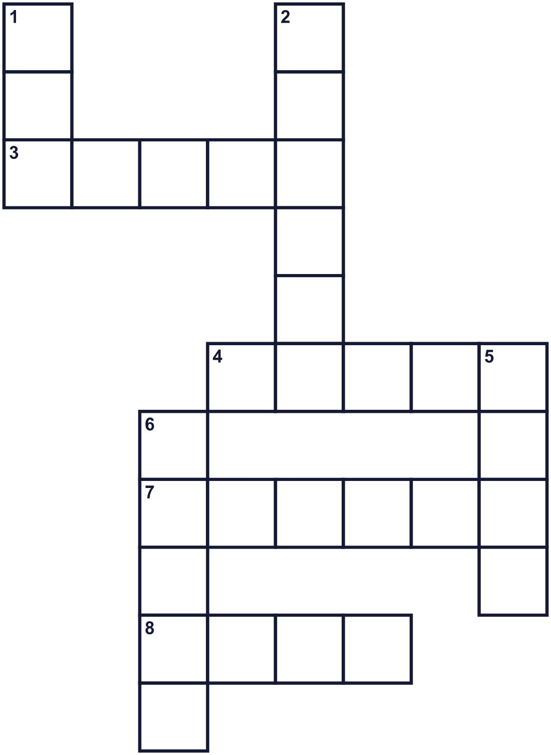
Across →
3. A scary monster in old stories. It may have horns. (5)
4. The opposite of north. (5)
7. The season after summer. (6)
8. A flat green part of a tree. It falls in autumn. (4)
Down ↓
1. The color of a tomato. (3)
2. A tree with fan-shaped leaves. They turn yellow. (6)
5. To look for animals and catch them. (4)
6. A tree. Its leaf is on the flag of Canada. (5)

🍁 Momijigari (Autumn Leaf Viewing) Worksheet
Word Search
かくれた単語をさがそう（→ ↓ ↘ ↗）
Class ______ No. ____ Name ______________________________
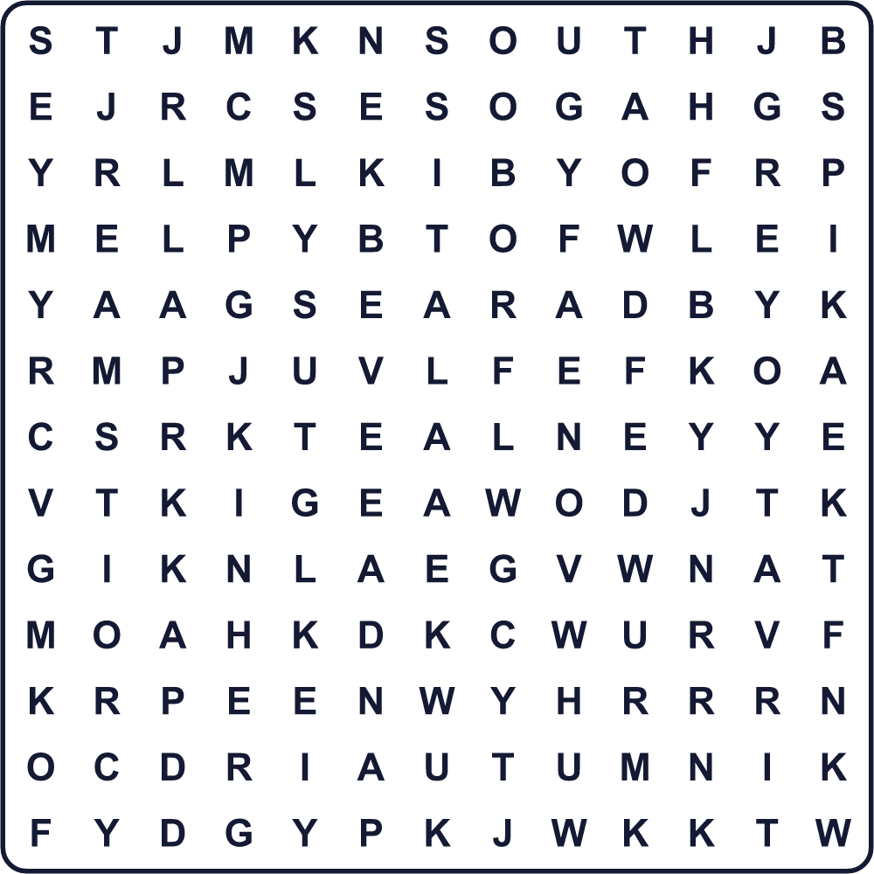
AUTUMN GINKGO HUNT LEAF MAPLE ORANGE RED SOUTH TREE YELLOW

🍁 Momijigari (Autumn Leaf Viewing) Worksheet
Maze & Sentences
Class ______ No. ____ Name ______________________________
Help the girl find the red maple tree! 女の子を赤いかえでの木まで連れていこう！
正しい道の文字を集めると、ひみつの言葉になるよ。 START 👧 → GOAL 🍁
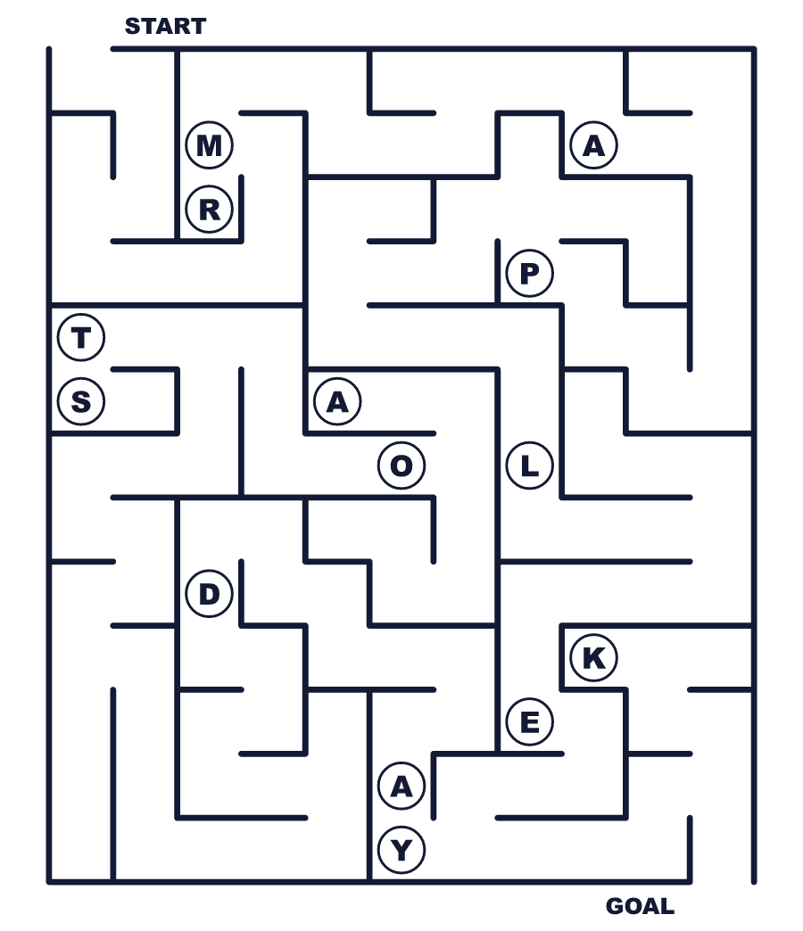
Secret word: ＿ ＿ ＿ ＿ ＿

🍁 Momijigari (Autumn Leaf Viewing) Worksheet
Class Activity & Writing
Class ______ No. ____ Name ______________________________
Let's Write! 英語で書いてみよう。
My favorite autumn color is ______ because ______.
私の好きな秋の色は______です。なぜなら______だからです。
______________________________________________________________
______________________________________________________________
If a friend from abroad visits in autumn, I will take them to ______.
外国の友だちが秋に来たら、______に連れていきます。
______________________________________________________________
______________________________________________________________

🍁 Momijigari (Autumn Leaf Viewing) Worksheet
Trace & Color
なぞって書こう。絵に色をぬろう。
Class ______ No. ____ Name ______________________________
🍁 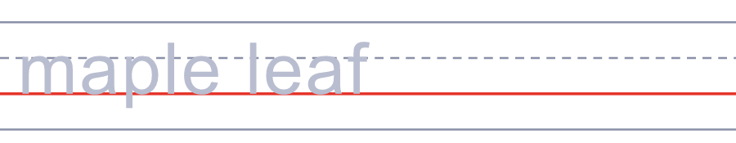

🍂 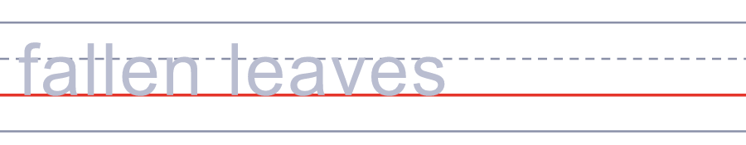
🌰 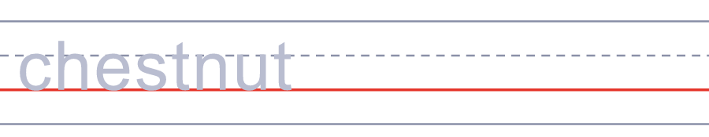
⛰️ 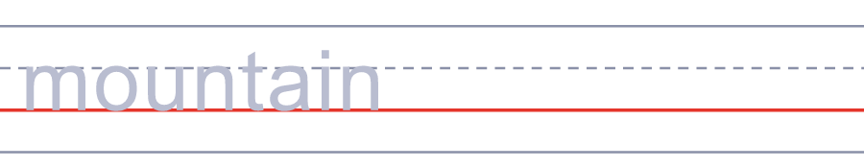
📸 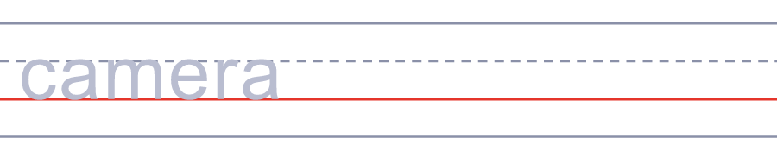

🍁 Momijigari (Autumn Leaf Viewing) Worksheet
Answer Key 解答
Reading Check: 1.B 2.C 3.A 4.D 5.B
True or False: 1.F 2.T 3.F 4.T
Match: 🍁=maple leaf 🍂=fallen leaves 🌰=chestnut ⛰️=mountain 📸=camera 🍙=rice ball
Fill in the blanks: (1)mountains (2)yellow (3)fresh (4)leaf (5)hand (6)photos (7)river
Maze: MAPLE
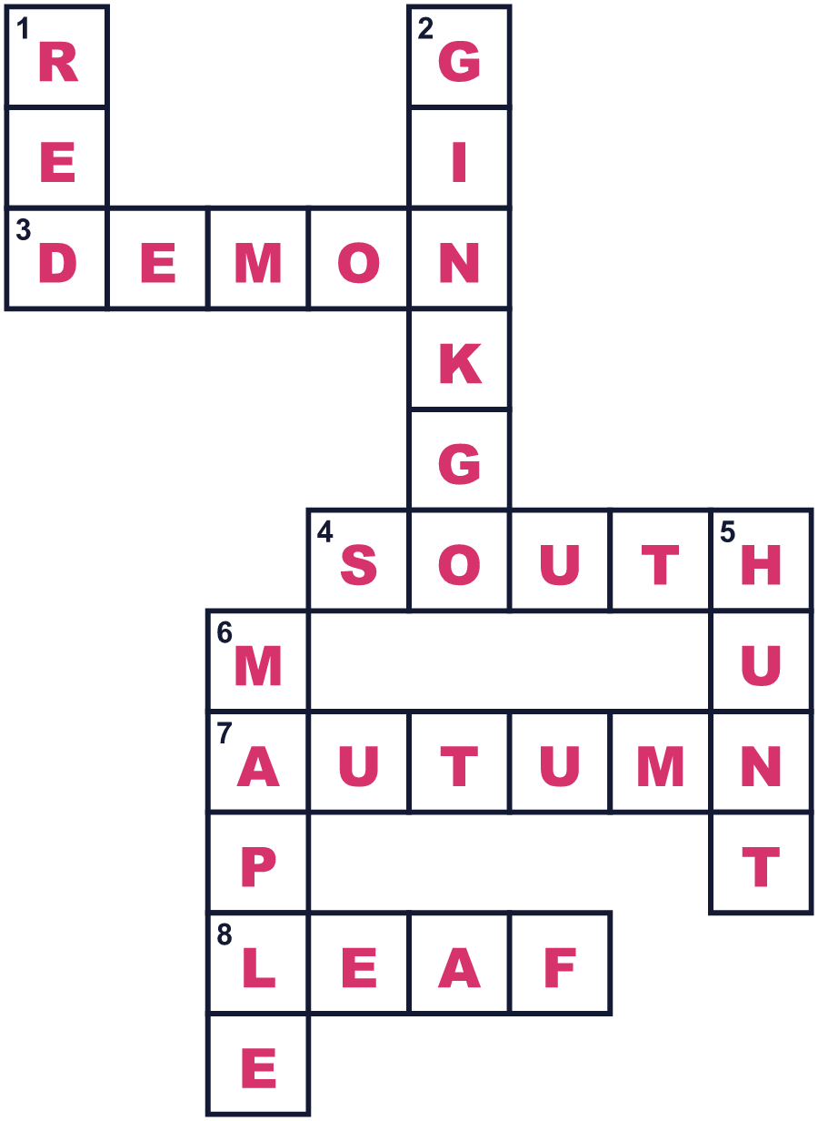
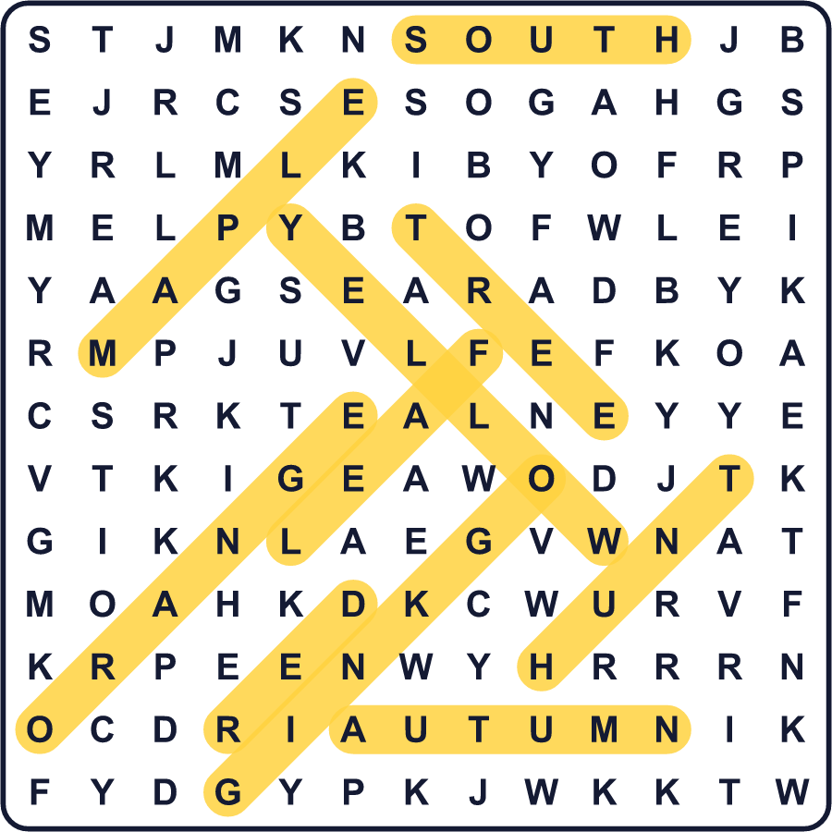
全訳
1 日本では、秋に多くの人が「狩り」に出かけます。でも、動物を狩るわけではありません。赤や黄色の葉を探しに行くのです！これを紅葉狩りといいます。「もみじ」は色づいた秋の葉、「がり」は狩りという意味です。だれも何も持ち帰りません。人々はただ歩き、ながめ、写真をとるのです。
2 この習慣はとても古いものです。約1000年前、天皇の宮廷の人々は、色を楽しむために山へ出かけました。のちの江戸時代には、町の人々も出かけるようになりました。それについての有名な古い劇まであります。物語では、勇ましい男が鹿狩りに出かけ、女性たちに出会います。女性たちは彼を紅葉の宴にさそいますが、そこにいた美しい女性は、じつは鬼なのです！
3 葉はなぜ色を変えるのでしょう。秋になると、葉の緑の色がこわれていきます。すると、夏の間かくれていた黄色が見えるようになります。赤い色は新しいものです。葉は秋にそれを作ります。1日でいちばん寒い時間の気温が8度を下回ると、木々は色を変え始めます。寒い夜と晴れた昼が、色をいっそうあざやかにします。
4 桜前線は春に北へ進みます。でも紅葉前線は南へ進むのです！10月に北海道で始まり、12月に九州の南に着きます。高い山の木が先に色づくので、ふもとの町より先に山頂が赤くなります。アメリカの人々も紅葉を楽しみ、それを leaf peeping と呼びます。さて、この秋はどこへ「狩り」に行きますか。

