🌼 Midsummer Worksheet
The Longest Day of the Year
Read the story. 英文を読もう。
Class ______ No. ____ Name ______________________________
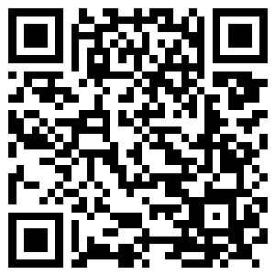
🔊 音声を聞こう（スマホで読みとってね）
1 In Sweden, winter is long and very dark. So when summer comes, people want to be outside. Around June 21, the days are the longest of the year. In the far north, the sun does not set at all. This is the time for Midsummer, one of the biggest parties in Sweden.
2 The main party is on Midsummer Eve. It is always on a Friday between June 19 and 25. Many offices and shops close early, and people go outside to celebrate. Friends meet in a green field and make crowns of wild flowers. Then they put up a tall pole covered with leaves and flowers.
3 Next comes the funniest part. Everyone holds hands and dances around the pole. In one song, they jump like little frogs and sing about having no ears and no tails. Grandparents, parents, and small children all jump together. Later, they eat fish, new potatoes, and fresh strawberries. Then the adults sing short songs together.
4 Before going to bed, some people pick seven different flowers. They put them under their pillow. People say you will see your future love in your dreams. Other countries in the north, like Finland and Latvia, celebrate too. They light big fires near lakes, and some people even jump over them. On the brightest night of the year, nobody wants to go to sleep early.
Words 単語
midsummer（夏至のころ、真夏） / pole（柱、さお） / crown（冠） / field（野原、畑） / frog（カエル） / tail（しっぽ） / pillow（枕） / bright（明るい）

🌼 Midsummer Worksheet
Reading Check
Choose the best answer. 正しいものを選ぼう。
Class ______ No. ____ Name ______________________________
1. What is the main idea of the reading?
(A) Midsummer is a fun festival in the north when the days are longest. (B) Midsummer is a winter festival with snow and ice. (C) Midsummer is a Japanese festival for frogs. (D) Midsummer is a day to stay at home and sleep early.
2. When is Midsummer Eve in Sweden?
(A) Always on June 21 (B) On a Monday in July (C) On a Friday between June 19 and 25 (D) On December 24
3. What do people do in the frog song?
(A) They swim in the lake. (B) They jump and sing about having no ears and no tails. (C) They eat strawberries very fast. (D) They put flowers under their pillow.
4. Why do people put seven flowers under their pillow?
(A) To sleep better on a hot night (B) To keep the flowers fresh (C) To give them to a friend the next day (D) To see their future love in a dream
5. In the dialogue, what surprises Takumi about the time?
(A) It is nine o'clock, but it is still bright. (B) It is very dark at six o'clock. (C) The party starts at midnight. (D) The dance is only one minute long.
True or False? T か F に○
1. Midsummer Eve in Sweden is always on a Friday. T / F
2. At Midsummer, the days are the shortest of the year. T / F
3. People dance around a pole with leaves and flowers. T / F
4. Midsummer is a national holiday in Japan. T / F

🌼 Midsummer Worksheet
Word Work
単語のれんしゅう
Class ______ No. ____ Name ______________________________
① Match the pictures and the words. 絵と単語を線でむすぼう。
🐸 | ● | ● | flower
🍓 | ● | ● | fish
🌞 | ● | ● | sun
🔥 | ● | ● | strawberry
🐟 | ● | ● | frog
🌼 | ● | ● | fire
③ Fill in the blanks. 語群から選んで入れよう。
[ bright / pumpkins / dance / frog / crowns / field / flowers / snow / pole / strawberries ]
It is Midsummer Eve. Freja and her friends walk to a green (1) __________ . They pick wild (2) __________ and make (3) __________ . Then everyone helps to put up a tall (4) __________ . They hold hands and (5) __________ around it. Freja's grandpa jumps like a (6) __________ ! For dessert, they eat sweet (7) __________ . At ten o'clock, the sky is still (8) __________ .

🌼 Midsummer Worksheet
Crossword Puzzle
ヒントを読んでクロスワードを完成させよう。
Class ______ No. ____ Name ______________________________
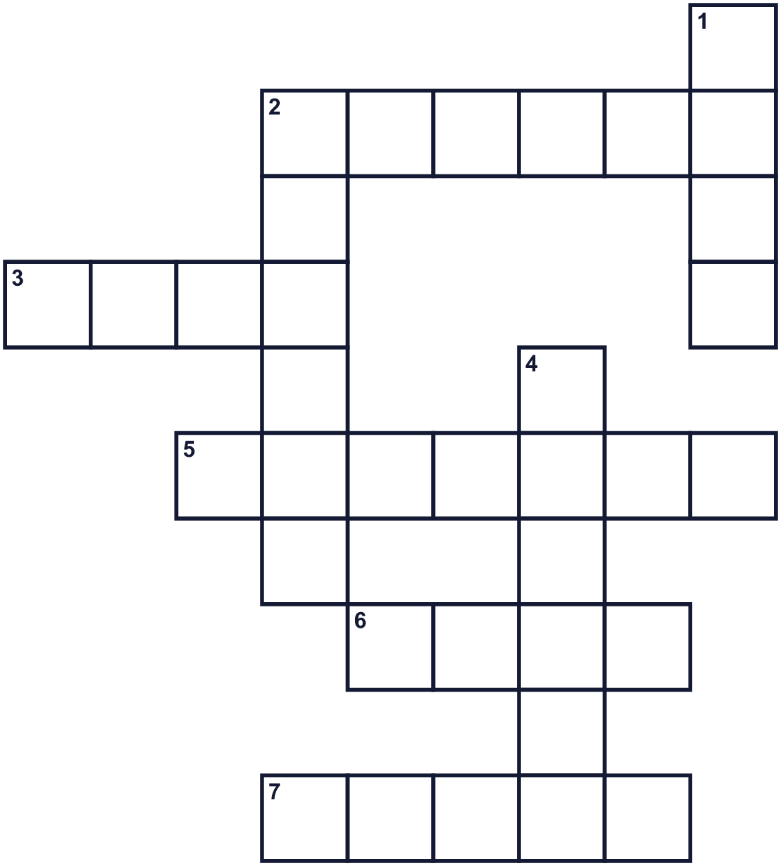
Across →
2. The hottest season of the year. (6)
3. In Finland, people make big ones by the lakes. (4)
5. A small fish. Swedes eat it at this festival. (7)
6. A tall stick. People dance around it. (4)
7. People wear it on their heads. It can be made of flowers. (5)
Down ↓
1. A small green animal that jumps and lives near water. (4)
2. A country in the north of Europe. Its capital is Stockholm. (6)
4. You put your head on it when you sleep. (6)

🌼 Midsummer Worksheet
Word Search
かくれた単語をさがそう（→ ↓ ↘ ↗）
Class ______ No. ____ Name ______________________________
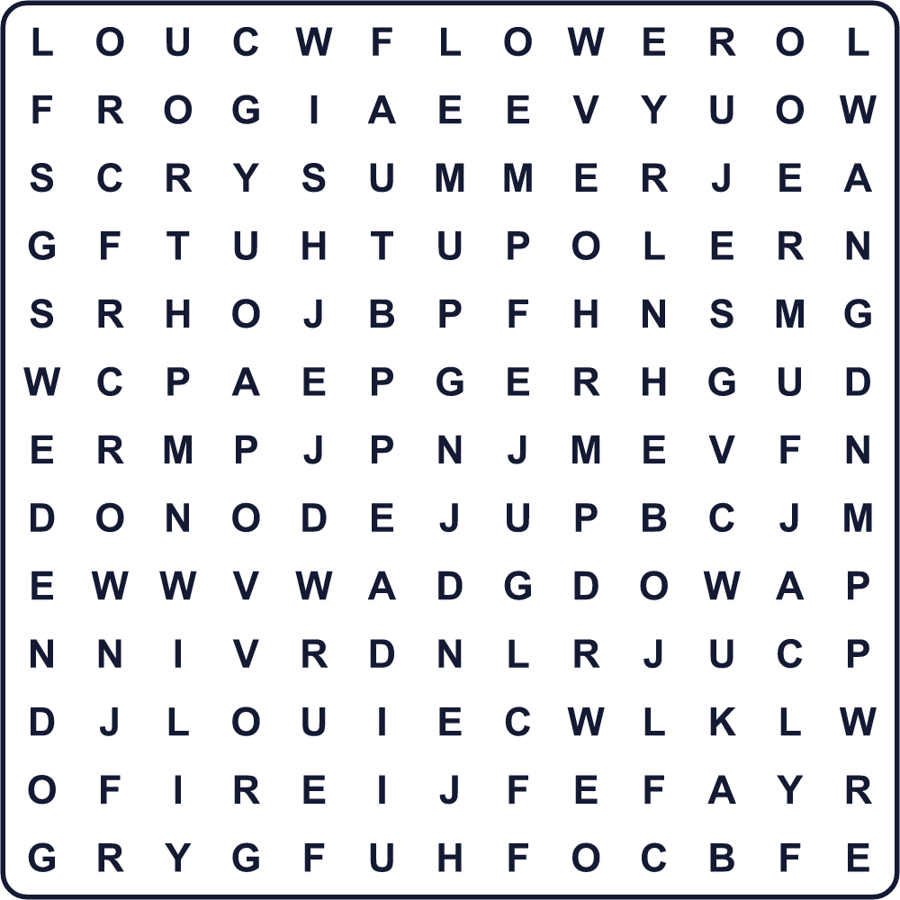
CROWN DANCE FIELD FIRE FLOWER FROG POLE SUMMER SUN SWEDEN

🌼 Midsummer Worksheet
Maze & Sentences
Class ______ No. ____ Name ______________________________
Help Freja get to the Midsummer pole! フレイヤを夏至柱まで連れていこう！
正しい道の文字を集めると、ひみつの言葉になるよ。 START 👧 → GOAL 🌿
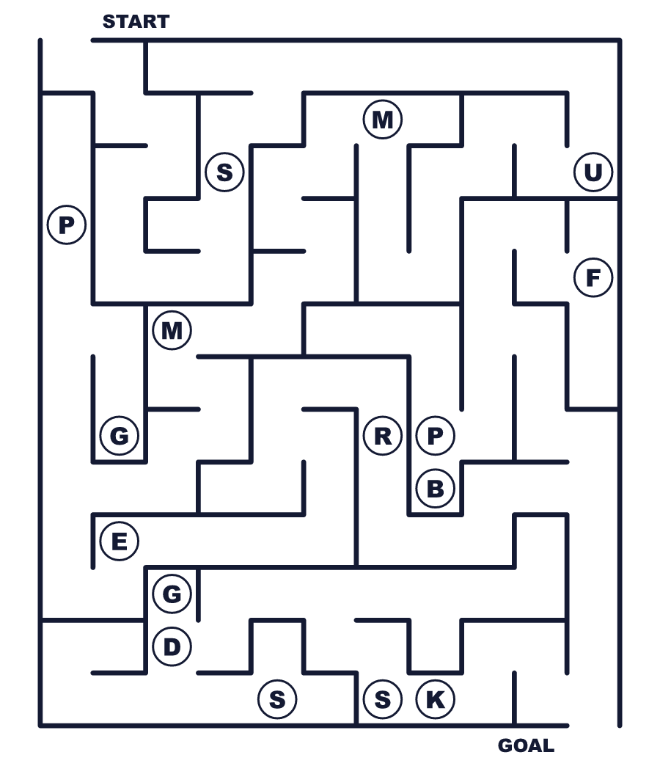
Secret word: ＿ ＿ ＿ ＿ ＿ ＿

🌼 Midsummer Worksheet
Class Activity & Writing
Class ______ No. ____ Name ______________________________
Let's Write! 英語で書いてみよう。
If the sun did not set all night, I would ______.
太陽が一晩じゅう沈まなかったら、私は______します。
______________________________________________________________
______________________________________________________________
My favorite season is ______ because ______.
私の好きな季節は______です。なぜなら______だからです。
______________________________________________________________
______________________________________________________________

🌼 Midsummer Worksheet
Trace & Color
なぞって書こう。絵に色をぬろう。
Class ______ No. ____ Name ______________________________
🐸 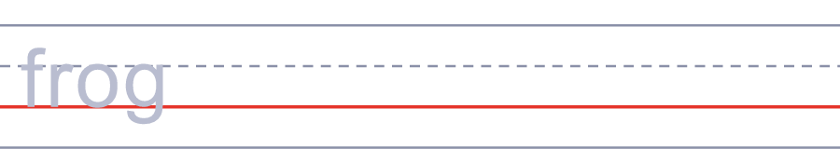

🍓 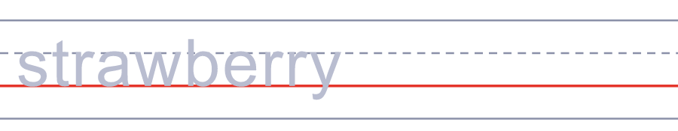
🌞 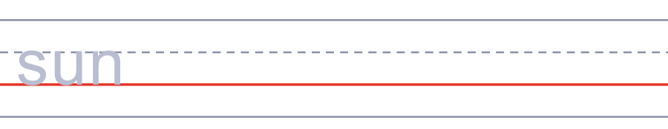
🔥 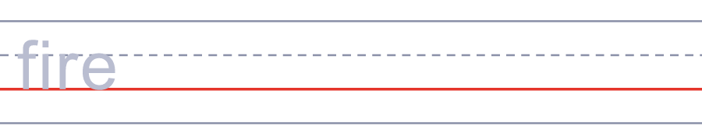
🐟 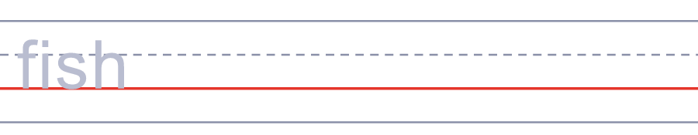

🌼 Midsummer Worksheet
Answer Key 解答
Reading Check: 1.A 2.C 3.B 4.D 5.A
True or False: 1.T 2.F 3.T 4.F
Match: 🐸=frog 🍓=strawberry 🌞=sun 🔥=fire 🐟=fish 🌼=flower
Fill in the blanks: (1)field (2)flowers (3)crowns (4)pole (5)dance (6)frog (7)strawberries (8)bright
Maze: SUMMER
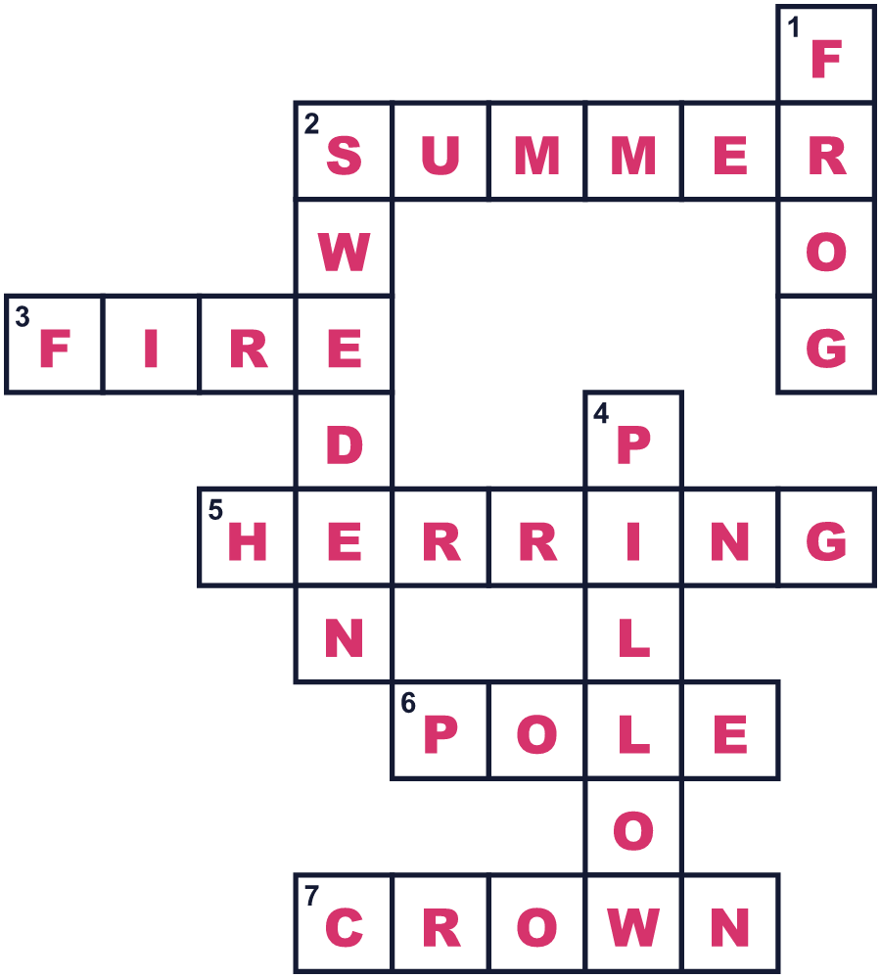
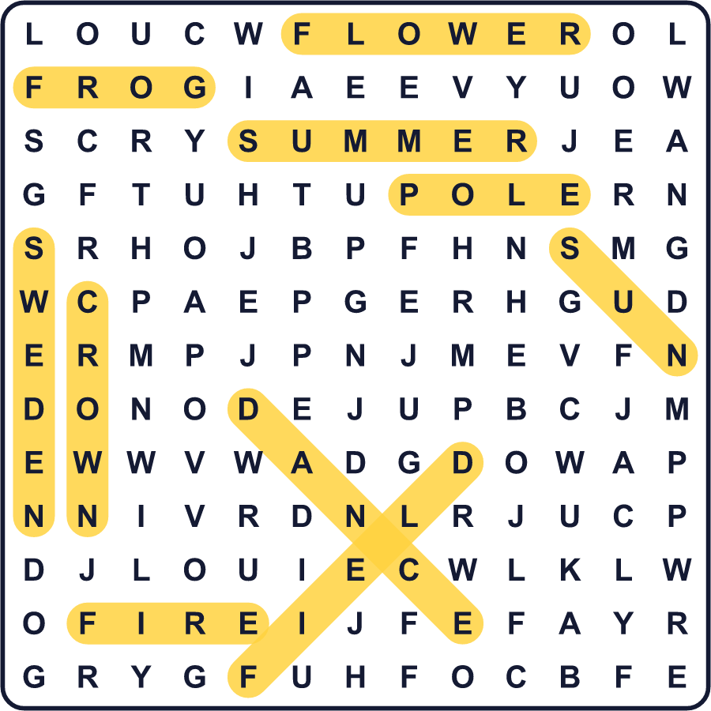
全訳
1 スウェーデンでは、冬は長く、とても暗いです。だから夏が来ると、人々は外で過ごしたくなります。6月21日ごろ、昼の長さは1年でいちばん長くなります。ずっと北のほうでは、太陽がまったく沈みません。これが、スウェーデンで最大級のお祭りの一つ、夏至祭の季節です。
2 お祭りの本番は夏至祭イブです。いつも6月19日から25日の間の金曜日です。多くの会社やお店は早じまいし、人々はお祝いのために外へ出かけます。友だちが緑の野原に集まり、野の花で冠を作ります。それから、葉と花でおおわれた高い柱を立てます。
3 次は、いちばんおもしろい場面です。みんなで手をつないで、柱のまわりを踊ります。ある歌では、小さなカエルのように跳ねながら、耳もしっぽもないと歌います。おじいさんもおばあさんも、親も、小さな子どもも、みんないっしょに跳ねます。そのあと、魚や新じゃがいも、とれたてのイチゴを食べます。それから大人たちは、短い歌をいっしょに歌います。
4 寝る前に、7種類のちがう花をつむ人もいます。それを枕の下に入れます。そうすると、将来の恋人が夢に出てくると言われています。フィンランドやラトビアなど、ほかの北の国々でも祝います。湖の近くで大きなたき火をし、それを跳びこえる人までいます。1年でいちばん明るい夜には、だれも早く寝たくないのです。

