🌿 Greenery Day Worksheet
A Holiday That Moved
Read the story. 英文を読もう。
Class ______ No. ____ Name ______________________________

🔊 音声を聞こう（スマホで読みとってね）
1 May 4 is Greenery Day in Japan. It is a day to enjoy nature and to say thank you for it. It sits between Constitution Memorial Day and Children's Day, right in the middle of Golden Week. Many people go to parks, gardens, and mountains on this day.
2 But Greenery Day was not always on May 4. From 1989 to 2006, it was on April 29. That day was the birthday of Emperor Showa, who died in January 1989. People did not want to lose a spring holiday. So the government kept the day and gave it a new name.
3 Why did they choose the word greenery? Late April is the season of fresh green leaves. Also, Emperor Showa was a scientist. He studied tiny sea animals and slime molds, and he loved plants. He once said that he did not like the word weeds, because it felt a little rude to plants.
4 In 2007, April 29 became Showa Day. Greenery Day moved to May 4. The move was only five days on the calendar. Before that, May 4 was a day off only because it was between two holidays. Now it has its own name.
5 On Greenery Day, many public parks let people in for free. Families have picnics under the new leaves, and some people plant trees. In April and May, the government also gives a prize to scientists who study plants and forests. It is a simple holiday with a big idea. Nature gives us so much, so let's take care of it.
Words 単語
greenery（（草木の）緑、青葉） / nature（自然） / emperor（天皇、皇帝） / scientist（科学者） / slime mold（粘菌、変形菌） / weed（雑草） / rude（失礼な） / used to（以前は〜だった） / free（無料の） / plant（植える／植物） / picnic（ピクニック、屋外での食事） / take care of（〜を大切にする、世話をする）

🌿 Greenery Day Worksheet
Reading Check
Choose the best answer. 正しいものを選ぼう。
Class ______ No. ____ Name ______________________________
1. What is the main idea of the passage?
(A) How to plant a tree (B) The story of Greenery Day and why it moved (C) The history of Golden Week trains (D) Why parks are closed in May
2. From 1989 to 2006, when was Greenery Day?
(A) May 4 (B) May 5 (C) April 29 (D) December 23
3. What did Emperor Showa study?
(A) Stars and planets (B) Old castles (C) Tiny sea animals and slime molds (D) Trains and cars
4. In which year did Greenery Day move to May 4?
(A) 2007 (B) 1989 (C) 1985 (D) 2006
5. In paragraph 3, what does "rude" mean?
(A) kind (B) not polite (C) very old (D) green
6. Which is true about May 4 before 2007?
(A) It was Children's Day. (B) It was a school day every year. (C) It was Showa Day. (D) It was a day off because it was between two holidays.
7. Why did the government keep the April 29 holiday in 1989?
(A) People did not want to lose a spring holiday. (B) It was the first day of school. (C) It was the new Emperor's birthday. (D) Parks were free on that day.
8. In the dialogue, what will Kenta bring to the park?
(A) Some fruit (B) A tree (C) A map (D) Rice balls
True or False? T か F に○
1. Greenery Day is on May 4. T / F
2. Greenery Day was on April 29 until 2006. T / F
3. Emperor Showa studied cars and trains. T / F
4. Many public parks are free on Greenery Day. T / F
5. Arbor Day started in Japan. T / F
6. Showa Day is on May 4. T / F

🌿 Greenery Day Worksheet
Word Work
単語のれんしゅう
Class ______ No. ____ Name ______________________________
① Match the pictures and the words. 絵と単語を線でむすぼう。
🌳 | ● | ● | leaf
🍃 | ● | ● | flower
🌱 | ● | ● | bird
🌸 | ● | ● | caterpillar
🐦 | ● | ● | microscope
🍙 | ● | ● | seedling
🔬 | ● | ● | tree
🐛 | ● | ● | rice ball
② Unscramble the words. 並べかえて単語にしよう。
1. A R N T E U (自然) → ____________________
2. O R E F T S (森) → ____________________
3. C C N I I P (ピクニック) → ____________________
4. G N P I S R (春) → ____________________
5. E R N E G (緑) → ____________________
6. A L T N P (植える・植物) → ____________________
③ Fill in the blanks. 語群から選んで入れよう。
[ balls / bird / nature / grass / free / leaves / snow / water / plant / Day / park / school / money ]
Today is May 4, Greenery (1) __________ . Sora and her dad go to a big (2) __________ . Today it is (3) __________ ! The trees have new green (4) __________ . They sit on the (5) __________ and eat rice (6) __________ . Sora sees a small (7) __________ in a tree. Dad says, "Let's say thank you to (8) __________ today." After lunch, they help (9) __________ a little tree. Sora gives it some (10) __________ . "Grow big!" she says. On the way home, she picks up a fallen leaf to keep.

🌿 Greenery Day Worksheet
Crossword Puzzle
ヒントを読んでクロスワードを完成させよう。
Class ______ No. ____ Name ______________________________
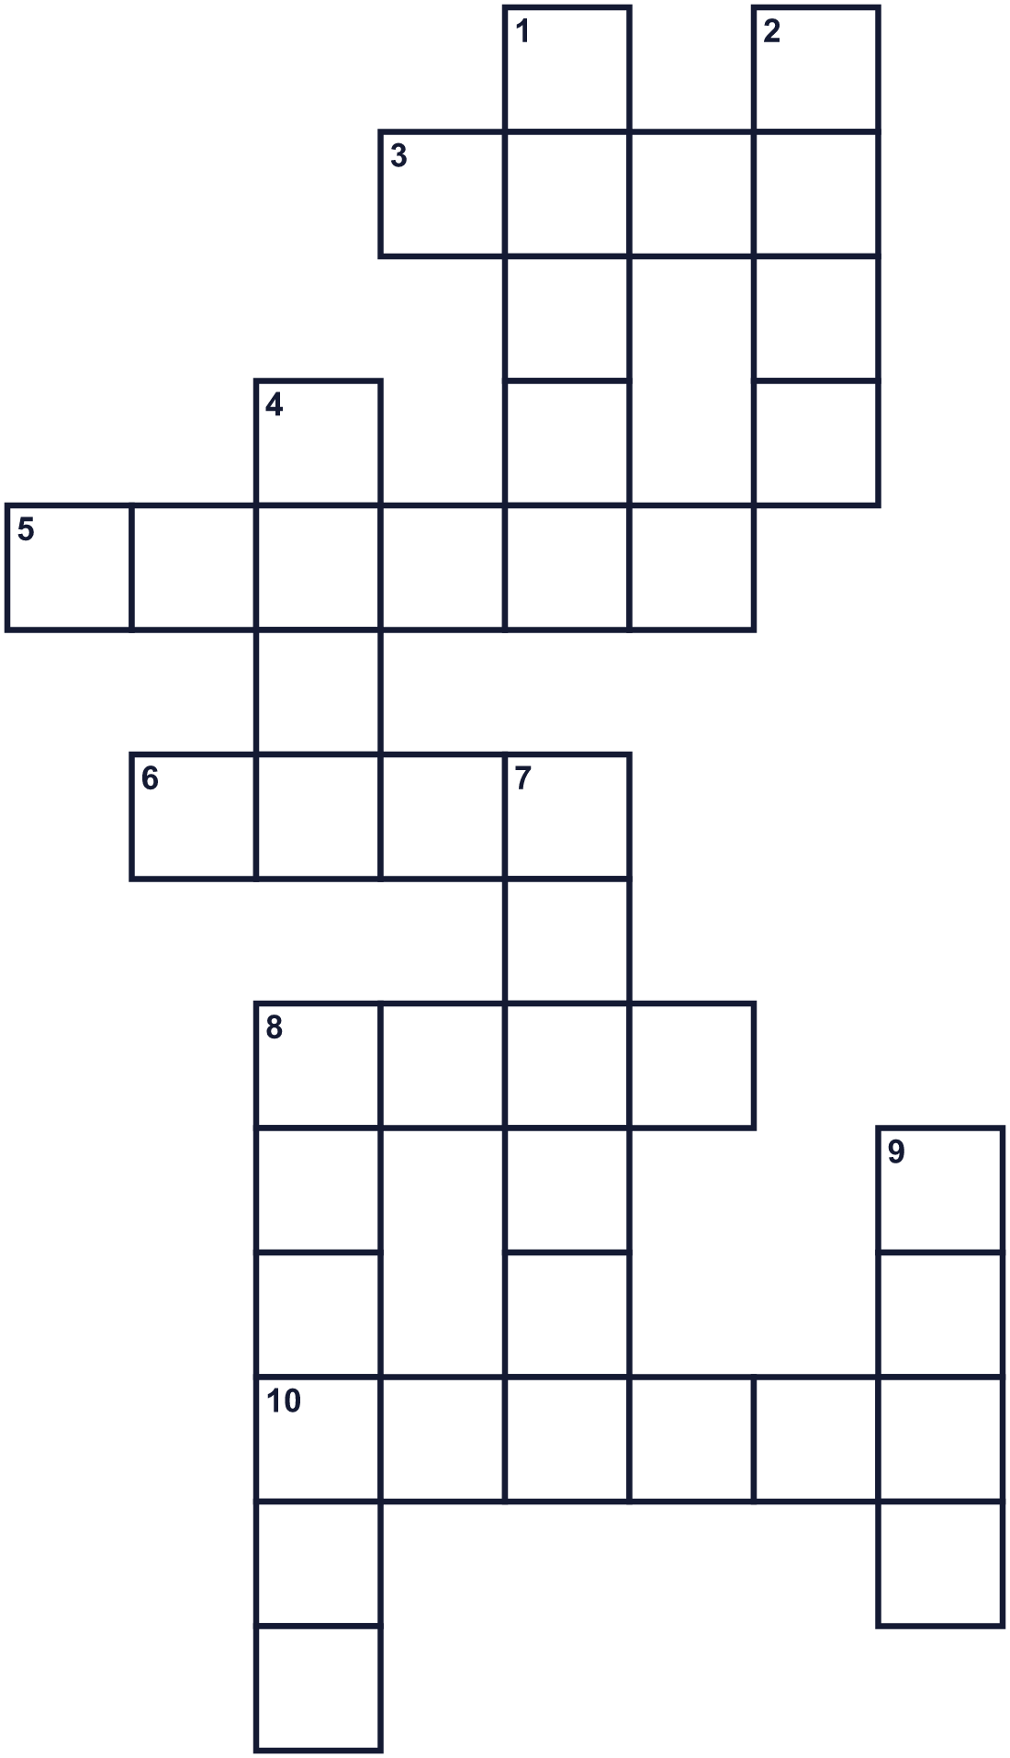
Across →
3. You do not have to pay. It costs nothing. (4)
5. The season after winter. (6)
6. A green part of a plant. In fall, it may turn red. (4)
8. A green place in a city with grass and trees. (4)
10. Mountains, rivers, trees, and animals. (6)
Down ↓
1. The color of new leaves. (5)
2. A plant that grows where people do not want it. (4)
4. A tall plant with a trunk and leaves. (4)
7. A big area with many, many trees. (6)
8. Eating lunch outside on the grass. (6)
9. A small thing that grows into a plant. (4)

🌿 Greenery Day Worksheet
Word Search
かくれた単語をさがそう（→ ↓ ↘ ↗）
Class ______ No. ____ Name ______________________________
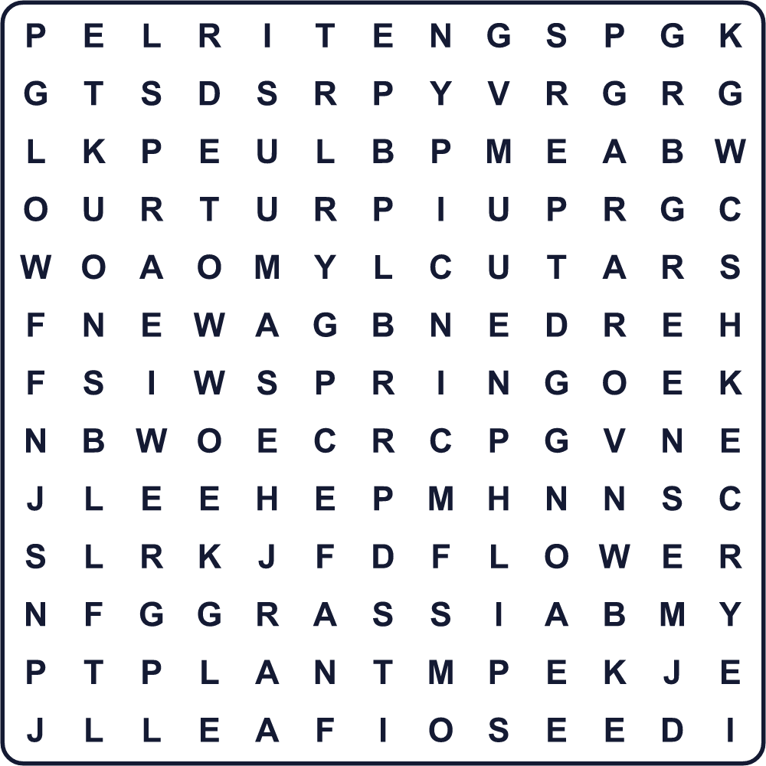
FLOWER FOREST FREE GRASS GREEN LEAF NATURE PARK PICNIC PLANT SEED SPRING TREE WEED
Secret Code 暗号を解こう
☺=A ⚓=E ✈=H ✿=K ♦=N ♥=O ▲=R ✎=T ☃=U ☎=Y
✎ ✈ ☺ ♦ ✿ ☎ ♥ ☃ ♦ ☺ ✎ ☃ ▲ ⚓
______________________________________________________________

🌿 Greenery Day Worksheet
Maze & Sentences
Class ______ No. ____ Name ______________________________
Help Sora get to the big tree! ソラを大きな木のところまで連れていこう！
正しい道の文字を集めると、ひみつの言葉になるよ。 START 👧 → GOAL 🌳
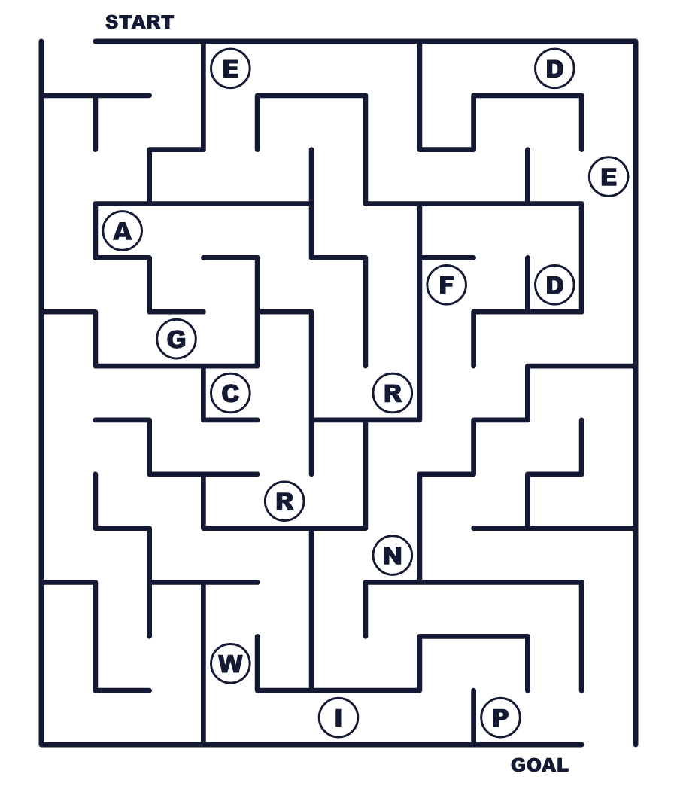
Secret word: ＿ ＿ ＿ ＿ ＿
Put the words in order. 並べかえよう。
1. is / Greenery / Day / May / on / 4 . (みどりの日は5月4日です。)
______________________________________________________________
2. be / to / April / It / 29 / on / used . (以前は4月29日でした。)
______________________________________________________________
3. public / are / free / parks / Many / today . (今日は多くの公立の公園が無料です。)
______________________________________________________________
4. a / picnic / trees / the / We / had / under . (私たちは木の下でピクニックをしました。)
______________________________________________________________
5. take / care / Let's / together / nature / of . (いっしょに自然を大切にしよう。)
______________________________________________________________

🌿 Greenery Day Worksheet
Class Activity & Writing
Class ______ No. ____ Name ______________________________
Find Someone Who… クラスで聞いて回ろう！
Find someone who … | Name
… has planted a tree 木を植えたことがある
… likes picnics ピクニックが好き
… knows the name of a wild flower 野の花の名前を1つ知っている
… has seen a slime mold 粘菌を見たことがある
… can name three kinds of trees in English 木の種類を英語で3つ言える
… has a plant at home 家で植物を育てている
… knows the date of Showa Day 昭和の日の日付を知っている
… has visited a botanical garden 植物園に行ったことがある
Let's Write! 英語で書いてみよう。
My favorite place in nature is ______ because ______.
自然の中で私のお気に入りの場所は＿＿です。なぜなら＿＿だからです。
______________________________________________________________
______________________________________________________________
On Greenery Day, I want to ______.
みどりの日に、私は＿＿したいです。
______________________________________________________________
______________________________________________________________
Thank you, nature, for ______.
自然よ、＿＿をありがとう。
______________________________________________________________
______________________________________________________________

🌿 Greenery Day Worksheet
Trace & Color
なぞって書こう。絵に色をぬろう。
Class ______ No. ____ Name ______________________________
🌳 

🍃 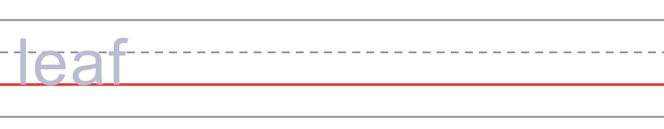
🌱 
🌸 
🐦 
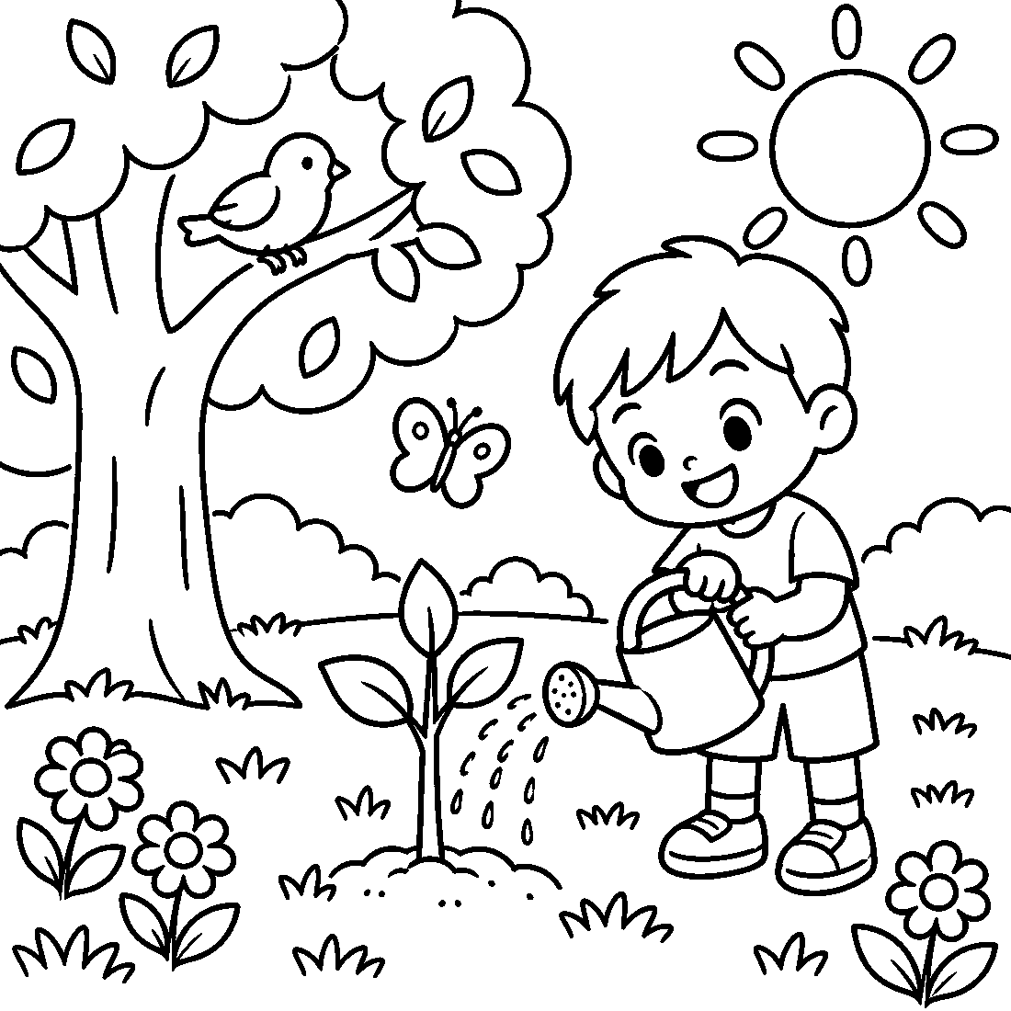

🌿 Greenery Day Worksheet
Answer Key 解答
Reading Check: 1.B 2.C 3.C 4.A 5.B 6.D 7.A 8.D
True or False: 1.T 2.T 3.F 4.T 5.F 6.F
Match: 🌳=tree 🍃=leaf 🌱=seedling 🌸=flower 🐦=bird 🍙=rice ball 🔬=microscope 🐛=caterpillar
Unscramble: 1.NATURE 2.FOREST 3.PICNIC 4.SPRING 5.GREEN 6.PLANT
Fill in the blanks: (1)Day (2)park (3)free (4)leaves (5)grass (6)balls (7)bird (8)nature (9)plant (10)water
Sentence order: 1. Greenery Day is on May 4. 2. It used to be on April 29. 3. Many public parks are free today. 4. We had a picnic under the trees. 5. Let's take care of nature together.
Secret Code: THANK YOU NATURE
Maze: GREEN
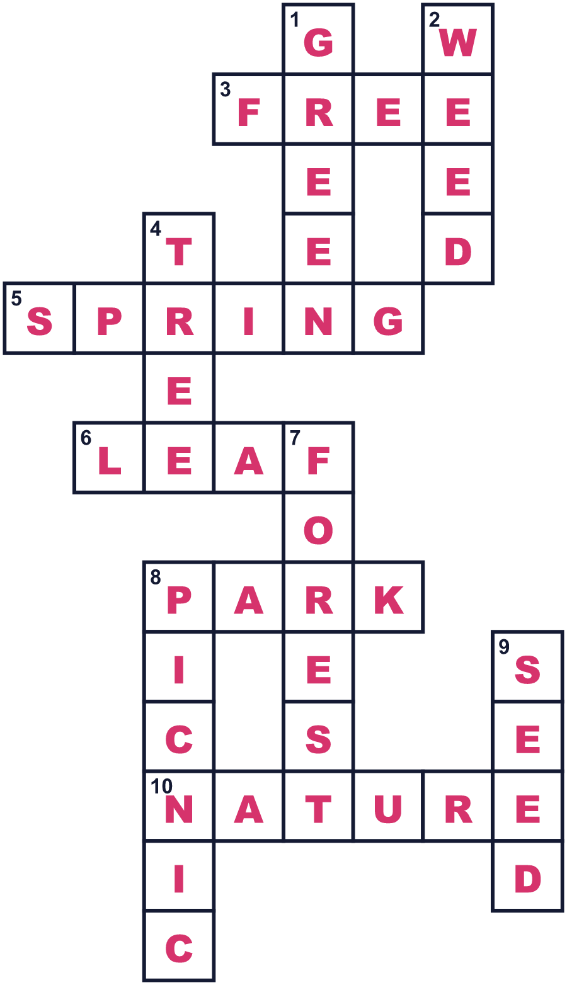
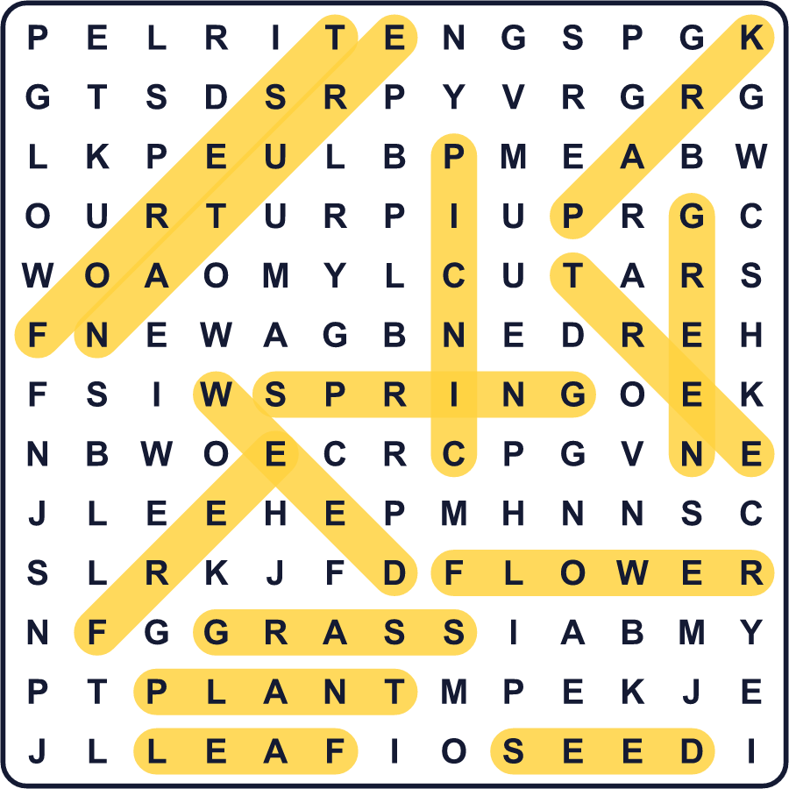
全訳
1 5月4日は日本の「みどりの日」です。自然を楽しみ、自然にありがとうを言う日です。憲法記念日とこどもの日の間にあり、ちょうどゴールデンウィークの真ん中です。この日、多くの人が公園や庭園、山に出かけます。
2 でも、みどりの日はずっと5月4日だったわけではありません。1989年から2006年までは4月29日でした。その日は、1989年1月に亡くなった昭和天皇の誕生日でした。人々は春の休日を失いたくありませんでした。そこで政府はその日を残し、新しい名前をつけました。
3 なぜ「みどり」という言葉が選ばれたのでしょう。4月の終わりは、新しい緑の葉の季節です。また、昭和天皇は科学者でもありました。小さな海の生き物や粘菌を研究し、植物を愛していました。「雑草」という言葉は植物に少し失礼な感じがするので好まない、と話したことがあります。
4 2007年、4月29日は昭和の日になりました。みどりの日は5月4日に移りました。カレンダーの上では、たった5日分の引っ越しでした。それまで5月4日は、2つの祝日にはさまれているという理由だけで休みでした。今は自分の名前を持っています。
5 みどりの日には、多くの公立の公園が無料で入れます。家族は若葉の下でピクニックをし、木を植える人もいます。4月と5月には、政府が植物や森を研究する科学者に賞も贈ります。シンプルだけれど、大きな考えのある祝日です。自然は私たちにたくさんのものをくれる。だから大切にしよう、という考えです。

