🥮 Mid-Autumn Festival Worksheet
One Moon, Many Families
Read the story. 英文を読もう。
Class ______ No. ____ Name ______________________________

🔊 音声を聞こう（スマホで読みとってね）
1 On one night in early autumn, people across East Asia look up at the same bright moon. This is the Mid-Autumn Festival. It comes on the 15th day of the 8th month of the old lunar calendar. So the date moves every year, from September to early October.
2 In China, people have celebrated the autumn moon for more than 2,000 years. Long ago, emperors gave gifts to the moon in autumn. Later, families started to eat mooncakes together on this night. A mooncake is round like the full moon. Inside, there is sweet bean paste, and sometimes an egg yolk that looks like a little moon.
3 Many people tell the story of Chang'e. She drank a magic medicine and flew all the way to the moon. Now she lives there with a white rabbit. In China, the rabbit makes medicine. But in Japan and Korea, people say the rabbit makes rice cakes.
4 Each country has its own way to celebrate. In Korea, the holiday is called Chuseok, and millions of people go back to their hometowns. They visit family graves and make half-moon rice cakes called songpyeon. In Vietnam, it is a festival for children, so kids carry star lanterns and watch lion dances. In Japan, people put out round dango and tall grass for the moon.
5 The most important word for this night is together. A round moon and a round cake are signs of a family circle with no one missing. Even when people live far apart, they can still share the same moon. In 1076, a Chinese poet missed his brother on this night. So he wrote a wish for people far apart to enjoy one moon together.
Words 単語
autumn（秋） / lunar（月の、太陰暦の） / calendar（暦、カレンダー） / celebrate（祝う） / emperor（皇帝） / paste（ペースト、あん） / yolk（卵の黄身） / medicine（薬） / hometown（故郷、地元） / grave（お墓） / lantern（ちょうちん、ランタン） / poet（詩人）

🥮 Mid-Autumn Festival Worksheet
Reading Check
Choose the best answer. 正しいものを選ぼう。
Class ______ No. ____ Name ______________________________
1. What is the story mainly about?
(A) How to make mooncakes at home (B) A moon festival in many East Asian countries (C) Why the moon changes its shape (D) A trip to the moon in 1969
2. When is the Mid-Autumn Festival?
(A) On the same day every year (B) On the first day of autumn (C) On the 15th day of the 8th lunar month (D) On the 8th day of the 15th month
3. What can be inside a mooncake?
(A) Sweet bean paste and an egg yolk (B) Fresh fish and rice (C) Chocolate and ice cream (D) Tall grass and flowers
4. In Korea, what do many people do for Chuseok?
(A) They carry star lanterns at night. (B) They go to their hometowns and visit graves. (C) They fly to the moon in a rocket. (D) They eat round dango with tall grass.
5. In paragraph 5, "a family circle with no one missing" means a family that is ...
(A) looking for a lost pet (B) playing a game in a circle (C) all together in one place (D) living in a round house
6. Which sentence is true about the story?
(A) The rabbit makes rice cakes in China. (B) Chuseok is a festival only for children. (C) Japanese people eat songpyeon on this night. (D) Vietnamese kids watch lion dances.
7. Why did the poet write his wish in 1076?
(A) He wanted to sell many mooncakes. (B) He was far from his brother and missed him. (C) He wanted to become an emperor. (D) He saw a rabbit on the moon.
8. In the dialogue, who does Linh say is on the moon?
(A) A woman with a white rabbit (B) A rabbit making rice cakes (C) A child with a star lantern (D) A man sitting under a tree
True or False? T か F に○
1. The Mid-Autumn Festival is on the same date every year. T / F
2. A mooncake is round like the full moon. T / F
3. In China, the moon rabbit makes medicine. T / F
4. In Vietnam, the festival is mainly for old people. T / F
5. In Korea, many people visit family graves for Chuseok. T / F
6. Japanese people make songpyeon for Jugoya. T / F

🥮 Mid-Autumn Festival Worksheet
Word Work
単語のれんしゅう
Class ______ No. ____ Name ______________________________
① Match the pictures and the words. 絵と単語を線でむすぼう。
🌕 | ● | ● | lantern
🐇 | ● | ● | fruit
🏮 | ● | ● | rabbit
🥮 | ● | ● | lion
🍡 | ● | ● | dango
⭐ | ● | ● | mooncake
🦁 | ● | ● | star
🍊 | ● | ● | full moon
② Unscramble the words. 並べかえて単語にしよう。
1. I B R A B T (うさぎ) → ____________________
2. E R A L N T N (ちょうちん) → ____________________
3. U N T M U A (秋) → ____________________
4. M A I L Y F (家族) → ____________________
5. U R A L N (月の・太陰暦の) → ____________________
6. O E P T (詩人) → ____________________
③ Fill in the blanks. 語群から選んで入れよう。
[ lion / festival / grandma / mooncakes / tree / snow / beach / high / star / pumpkin / parade / moon / drums ]
It is the night of the (1) __________ . Minh is 8 years old and lives in Hanoi. His (2) __________ helps him make a (3) __________ lantern with red paper. At night, the (4) __________ is big and round. Minh walks in a (5) __________ with his friends. They hear loud (6) __________ and watch a (7) __________ dance. Then the family shares (8) __________ and fruit. Grandma says, "Look at the moon. Can you see Cuoi under his (9) __________ ?" Minh smiles and holds his lantern up (10) __________ .

🥮 Mid-Autumn Festival Worksheet
Crossword Puzzle
ヒントを読んでクロスワードを完成させよう。
Class ______ No. ____ Name ______________________________
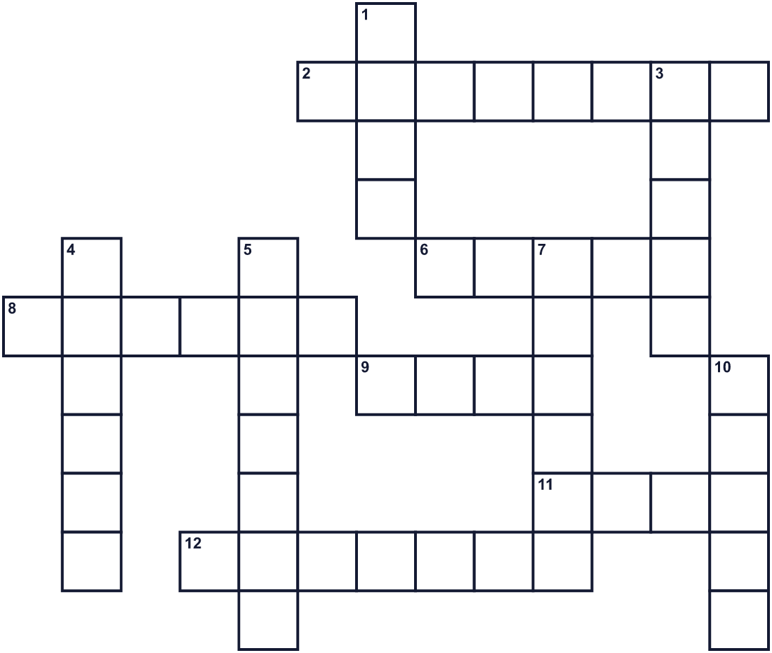
Across →
2. A round sweet food for this festival in China. (8)
6. A place where people visit family who died. (5)
8. An animal with long ears. People see it on the full moon. (6)
9. A person who writes poems. (4)
11. It is big and round in the night sky. (4)
12. Children carry this light at night. (7)
Down ↓
1. The yellow part of an egg. (4)
3. Chuseok is a big holiday in this country. (5)
4. Your parents, brothers, and sisters. (6)
5. In this country, kids carry star lights for the festival. (7)
7. The season after summer. (6)
10. Round rice balls for the moon in Japan. (5)

🥮 Mid-Autumn Festival Worksheet
Word Search
かくれた単語をさがそう（→ ↓ ↘ ↗）
Class ______ No. ____ Name ______________________________
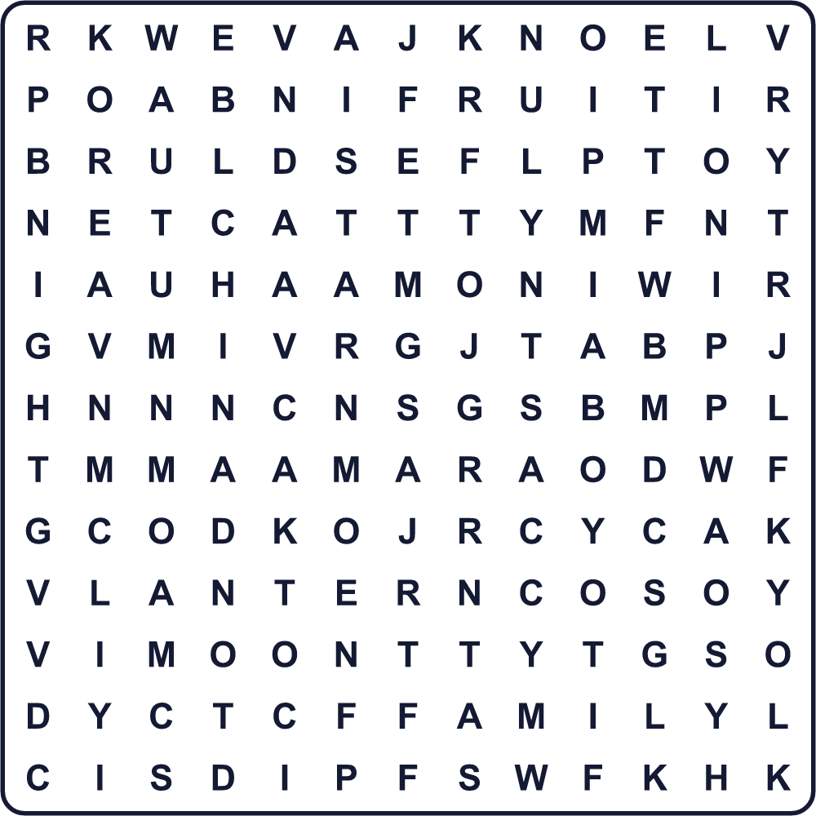
AUTUMN CHINA DANGO FAMILY FRUIT KOREA LANTERN LION MOON NIGHT RABBIT STAR VIETNAM YOLK
Secret Code 暗号を解こう
■=A ☎=E ☀=F ☘=I ✈=L ♥=M ●=N ✿=O ⚓=S ✎=Y
✿ ● ☎ ♥ ✿ ✿ ● ♥ ■ ● ✎ ☀ ■ ♥ ☘ ✈ ☘ ☎ ⚓
______________________________________________________________

🥮 Mid-Autumn Festival Worksheet
Maze & Sentences
Class ______ No. ____ Name ______________________________
Help the rabbit get to the moon! うさぎを月まで連れていこう！
正しい道の文字を集めると、ひみつの言葉になるよ。 START 🐇 → GOAL 🌕
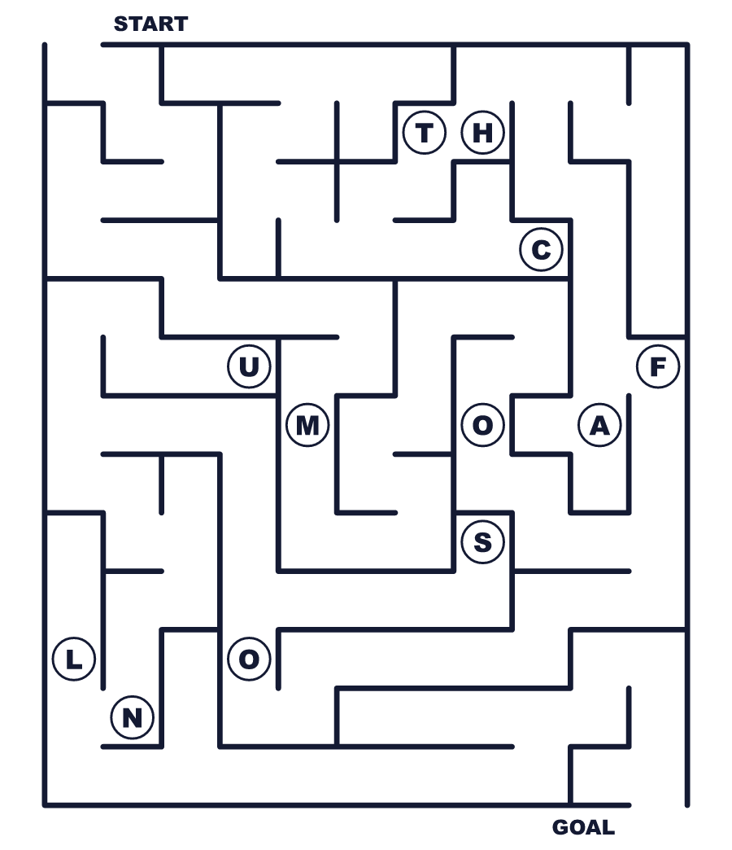
Secret word: ＿ ＿ ＿ ＿
Put the words in order. 並べかえよう。
1. bright / look / We / the / together / moon / at . (私たちはいっしょに明るい月を見ます。)
______________________________________________________________
2. the / is / A / round / like / moon / mooncake . (月餅は月のように丸い。)
______________________________________________________________
3. cakes / rabbit / Japan / in / rice / The / makes . (日本ではうさぎが餅をつきます。)
______________________________________________________________
4. lanterns / carry / Vietnam / Children / star / in . (ベトナムでは子どもたちが星のちょうちんを持ちます。)
______________________________________________________________
5. hometowns / Many / back / to / their / go / people . (多くの人が故郷へ帰ります。)
______________________________________________________________

🥮 Mid-Autumn Festival Worksheet
Class Activity & Writing
Class ______ No. ____ Name ______________________________
Find Someone Who… クラスで聞いて回ろう！
Find someone who … | Name
… has eaten a mooncake 月餅を食べたことがある
… can see a rabbit on the moon 月にうさぎが見える
… has made tsukimi dango 月見団子を作ったことがある
… knows the Korean word Chuseok チュソクという韓国語を知っている
… likes looking at the night sky 夜空を見るのが好き
… has carried a lantern ちょうちんを持って歩いたことがある
… has been to China, Korea, or Vietnam 中国・韓国・ベトナムのどこかに行ったことがある
… can name three round foods 丸い食べ物を3つ言える
Let's Write! 英語で書いてみよう。
When I look at the moon, I see ______. It looks like ______.
月を見ると＿＿が見えます。それは＿＿のように見えます。
______________________________________________________________
______________________________________________________________
If I could send a message to someone far away on this night, I would say ______.
この夜に遠くの誰かへメッセージを送れるなら、＿＿と言います。
______________________________________________________________
______________________________________________________________
I want to try the Mid-Autumn custom of ______ because ______.
＿＿の中秋節の習慣を試したい。なぜなら＿＿だから。
______________________________________________________________
______________________________________________________________

🥮 Mid-Autumn Festival Worksheet
Trace & Color
なぞって書こう。絵に色をぬろう。
Class ______ No. ____ Name ______________________________
🌕 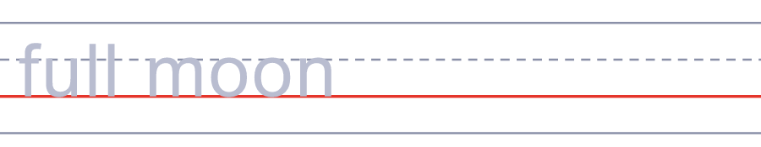

🐇 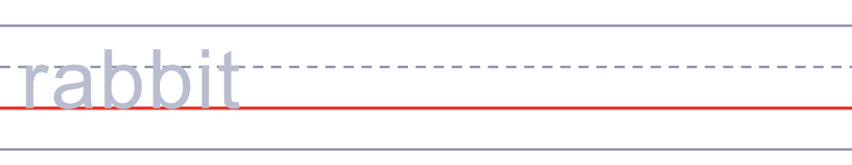
🏮 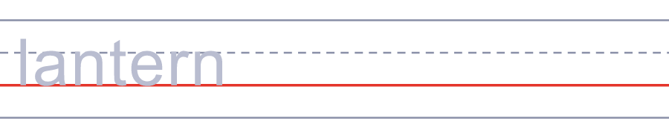
🥮 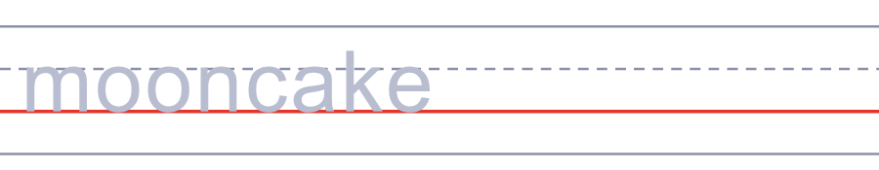
🍡 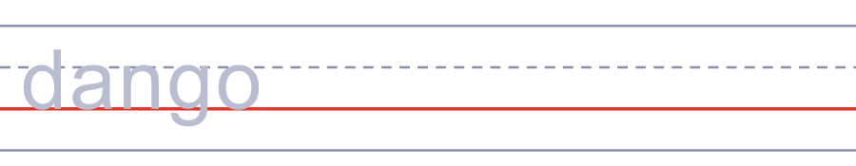
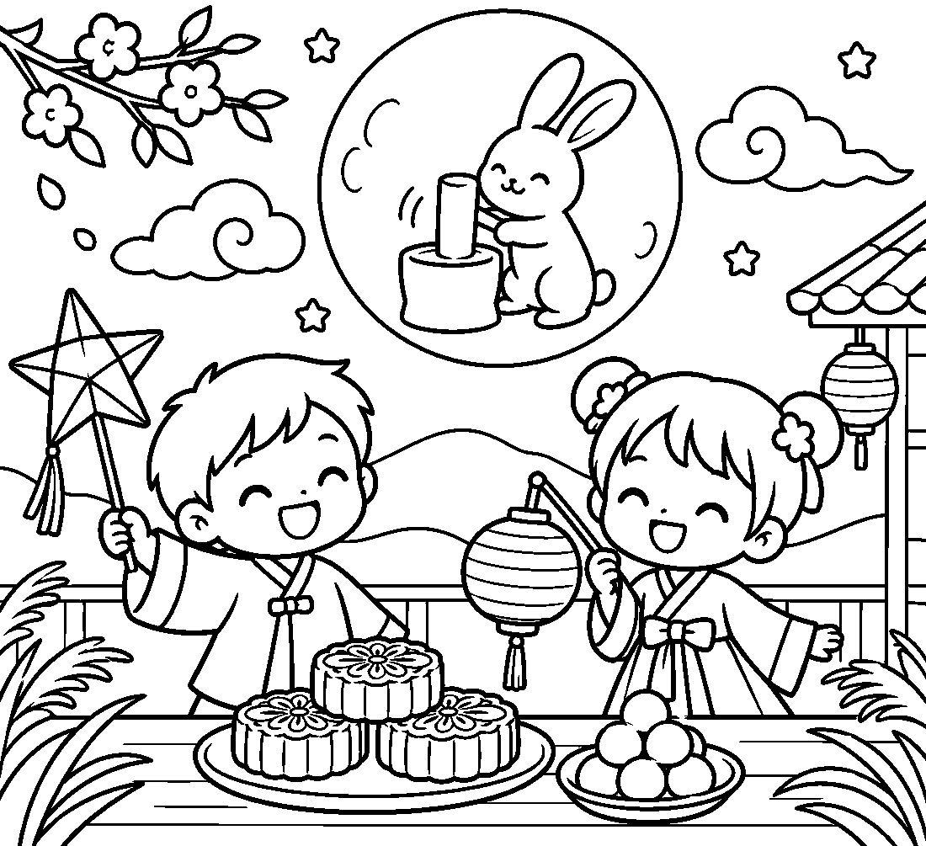

🥮 Mid-Autumn Festival Worksheet
Answer Key 解答
Reading Check: 1.B 2.C 3.A 4.B 5.C 6.D 7.B 8.D
True or False: 1.F 2.T 3.T 4.F 5.T 6.F
Match: 🌕=full moon 🐇=rabbit 🏮=lantern 🥮=mooncake 🍡=dango ⭐=star 🦁=lion 🍊=fruit
Unscramble: 1.RABBIT 2.LANTERN 3.AUTUMN 4.FAMILY 5.LUNAR 6.POET
Fill in the blanks: (1)festival (2)grandma (3)star (4)moon (5)parade (6)drums (7)lion (8)mooncakes (9)tree (10)high
Sentence order: 1. We look at the bright moon together. 2. A mooncake is round like the moon. 3. The rabbit makes rice cakes in Japan. 4. Children carry star lanterns in Vietnam. 5. Many people go back to their hometowns.
Secret Code: ONE MOON MANY FAMILIES
Maze: MOON
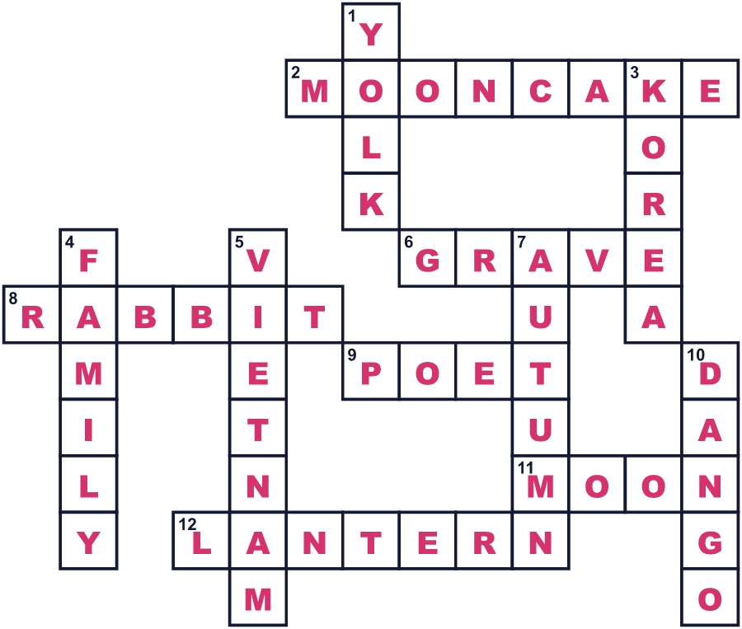
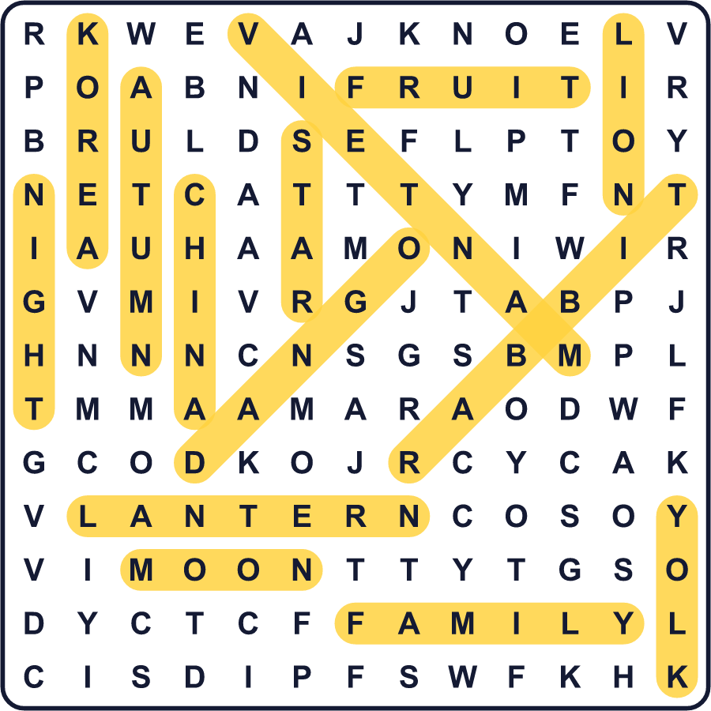
全訳
1 初秋のある夜、東アジアじゅうの人たちが同じ明るい月を見上げます。これが中秋節です。古い太陰暦の8月15日にやってきます。だから日付は毎年変わり、9月から10月の初めのどこかになります。
2 中国では、人々は2000年以上前から秋の月を祝ってきました。昔、皇帝たちは秋に月へ供え物をしました。のちに、家族がこの夜にいっしょに月餅を食べるようになりました。月餅は満月のように丸い形です。中には甘いあんが入っていて、小さな月のような卵の黄身が入っていることもあります。
3 多くの人が嫦娥の物語を語ります。彼女は魔法の薬を飲み、はるばる月まで飛んでいきました。今では白いうさぎといっしょにそこに住んでいます。中国では、うさぎは薬を作っています。でも日本と韓国では、うさぎは餅をついていると言われます。
4 国ごとに祝い方があります。韓国ではこの祝日をチュソクと呼び、何百万人もの人が故郷へ帰ります。家族のお墓を訪ね、ソンピョンという半月形の餅を作ります。ベトナムでは子どものための祭りなので、子どもたちは星のちょうちんを持ち、獅子舞を見ます。日本では、月のために丸い団子と背の高いススキを供えます。
5 この夜にいちばん大切な言葉は「いっしょに」です。丸い月と丸い月餅は、誰も欠けていない家族の輪のしるしです。遠く離れて暮らしていても、同じ月を分かち合うことはできます。1076年、中国のある詩人はこの夜に弟を恋しく思いました。そこで、遠く離れた人たちが1つの月をいっしょに楽しめるようにという願いを書きました。

