🇺🇸 Memorial Day Worksheet
Flowers for the Soldiers
Read the story. 英文を読もう。
Class ______ No. ____ Name ______________________________

🔊 音声を聞こう（スマホで読みとってね）
1 In the spring of 1865, a long war in America came to an end. It was the Civil War, and about 620,000 soldiers died. After the war, people put flowers on the soldiers' graves. That is why the day was first called Decoration Day.
2 In Charleston, a city in the South, newly free Black people held one of the first ceremonies. They buried 257 soldiers in proper graves and covered them with flowers. Then about 10,000 people marched together. They wanted to honor the soldiers of the war that ended slavery. Three years later, in 1868, the first national Decoration Day was held on May 30.
3 Later, the name changed to Memorial Day. Today, it remembers Americans who died in all wars. Since 1971, it has been on the last Monday in May. Flags fly halfway down the pole until noon. At 3 p.m., people stop what they are doing and stay quiet for a moment. A bugle plays a slow, sad song called Taps.
4 At Arlington National Cemetery, soldiers put a small flag on every grave. There are about 250,000 flags in all. Each flag is a way to say, We have not forgotten you. But Memorial Day is also the start of summer for many families. They enjoy a long weekend at the beach or in the park. Many of them still take a quiet minute to remember.
Words 単語
soldier（兵士） / grave（墓） / war（戦争） / ceremony（式典、儀式） / bury（埋葬する、埋める） / march（行進する） / noon（正午） / remember（しのぶ、思い出す）

🇺🇸 Memorial Day Worksheet
Reading Check
Choose the best answer. 正しいものを選ぼう。
Class ______ No. ____ Name ______________________________
1. What is the main idea of the reading?
(A) Memorial Day is a day to remember American soldiers who died. (B) Memorial Day is a day to thank teachers and doctors. (C) Memorial Day started in 1971 as a summer holiday. (D) Memorial Day is a day to buy new flags.
2. Why was the day first called Decoration Day?
(A) Because people decorated their houses (B) Because people put flowers on graves (C) Because it was the start of summer (D) Because soldiers decorated the city
3. How many soldiers were buried again in Charleston?
(A) 10,000 (B) 620,000 (C) 250,000 (D) 257
4. What do people do at 3 p.m. on Memorial Day?
(A) They raise the flag to the top. (B) They start a picnic at the beach. (C) They stop and stay quiet for a moment. (D) They march through the city.
5. In the dialogue, what is the difference between Veterans Day and Memorial Day?
(A) Veterans Day is in May, and Memorial Day is in August. (B) Veterans Day is for everyone who served. Memorial Day is for those who died. (C) Veterans Day is for children, and Memorial Day is for parents. (D) There is no difference between the two days.
True or False? T か F に○
1. Memorial Day is on the last Monday in May. T / F
2. The first name of Memorial Day was Decoration Day. T / F
3. Memorial Day is for all people who served, living or dead. T / F
4. On Memorial Day, flags stay at half-staff all day. T / F

🇺🇸 Memorial Day Worksheet
Word Work
単語のれんしゅう
Class ______ No. ____ Name ______________________________
① Match the pictures and the words. 絵と単語を線でむすぼう。
🇺🇸 | ● | ● | trumpet
🌺 | ● | ● | picnic basket
🎺 | ● | ● | American flag
🕒 | ● | ● | three o'clock
🕊 | ● | ● | dove
🧺 | ● | ● | flower
③ Fill in the blanks. 語群から選んで入れよう。
[ soldier / snow / cemetery / flowers / picnic / flag / grave / quiet / pumpkin ]
On Monday, Jake and his mom go to the (1) __________ . They bring red (2) __________ . Jake puts a small (3) __________ on his grandpa's (4) __________ . Grandpa was a (5) __________ long ago. At three o'clock, everyone stops and stays (6) __________ . Then Jake and his mom go home and have a (7) __________ in the yard.

🇺🇸 Memorial Day Worksheet
Crossword Puzzle
ヒントを読んでクロスワードを完成させよう。
Class ______ No. ____ Name ______________________________
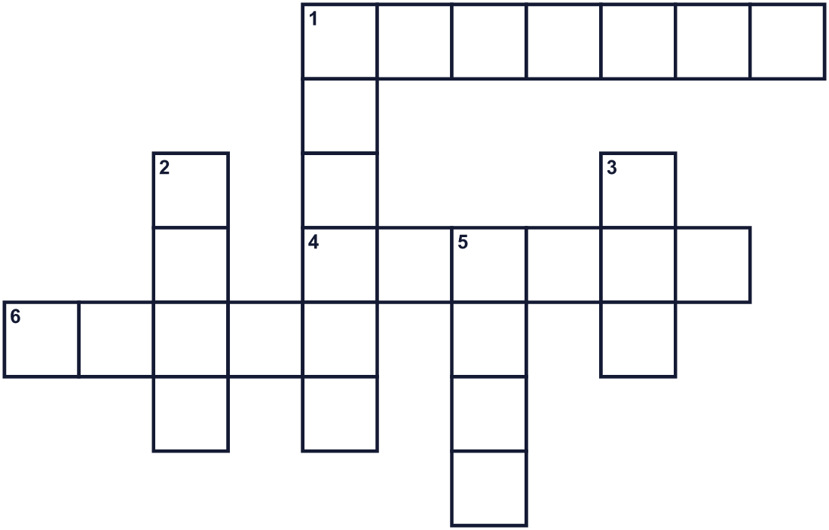
Across →
1. A person who works in the army. (7)
4. The day of the week for this holiday. (6)
6. The place where a person is buried. (5)
Down ↓
1. The hot season. This holiday is its unofficial start. (6)
2. Americans put a small one on each grave. (4)
3. The month after April. (3)
5. Twelve o'clock in the daytime. (4)

🇺🇸 Memorial Day Worksheet
Word Search
かくれた単語をさがそう（→ ↓ ↘ ↗）
Class ______ No. ____ Name ______________________________
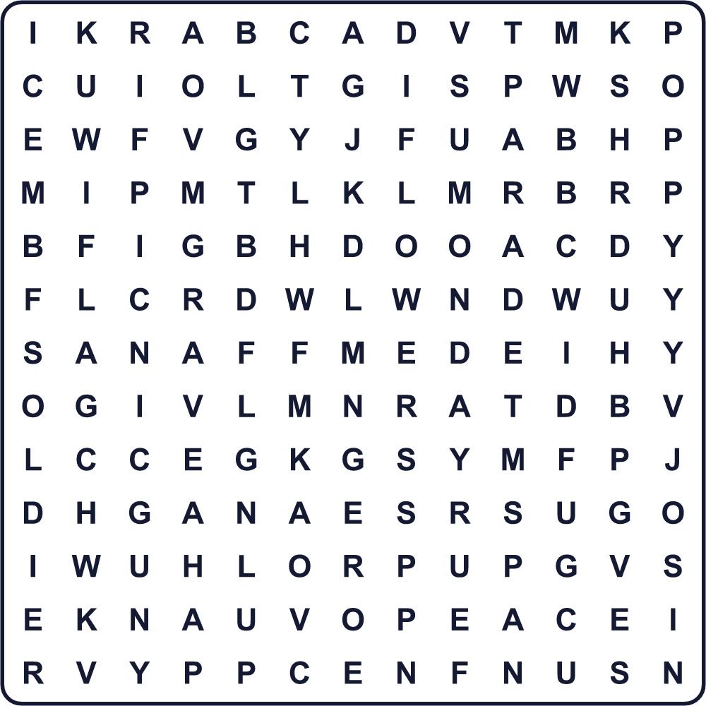
FLAG FLOWERS GRAVE MONDAY NOON PARADE PEACE PICNIC POPPY SOLDIER

🇺🇸 Memorial Day Worksheet
Maze & Sentences
Class ______ No. ____ Name ______________________________
Help Jake bring the flowers! ジェイクが花を届けるのを手伝おう！
正しい道の文字を集めると、ひみつの言葉になるよ。 START 🧒 → GOAL 💐
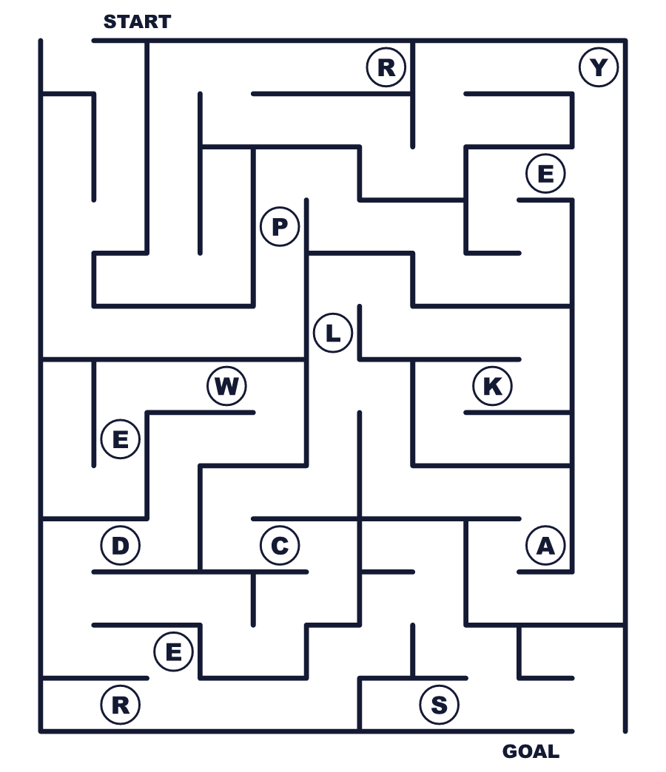
Secret word: ＿ ＿ ＿ ＿ ＿

🇺🇸 Memorial Day Worksheet
Class Activity & Writing
Class ______ No. ____ Name ______________________________
Let's Write! 英語で書いてみよう。
On a day to remember people, I would like to ______ because ______.
人をしのぶ日に、私は______したいです。なぜなら______だからです。
______________________________________________________________
______________________________________________________________
Memorial Day in America and August 15 in Japan are similar because ______.
アメリカのメモリアル・デーと日本の8月15日は______という点で似ています。
______________________________________________________________
______________________________________________________________

🇺🇸 Memorial Day Worksheet
Trace & Color
なぞって書こう。絵に色をぬろう。
Class ______ No. ____ Name ______________________________
🇺🇸 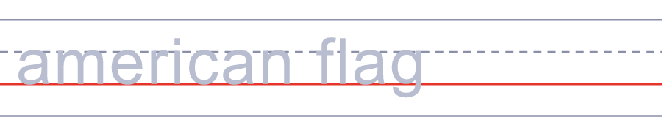

🌺 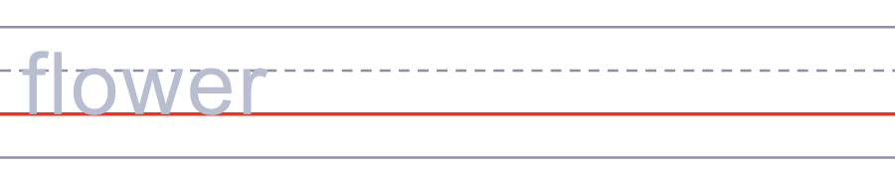
🎺 
🕒 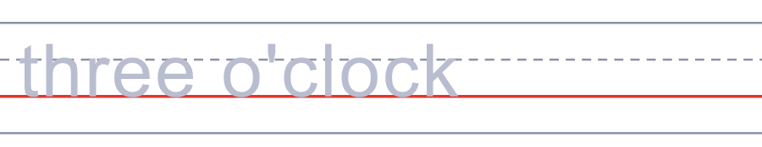
🕊 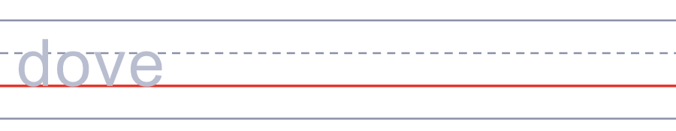

🇺🇸 Memorial Day Worksheet
Answer Key 解答
Reading Check: 1.A 2.B 3.D 4.C 5.B
True or False: 1.T 2.T 3.F 4.F
Match: 🇺🇸=American flag 🌺=flower 🎺=trumpet 🕒=three o'clock 🕊=dove 🧺=picnic basket
Fill in the blanks: (1)cemetery (2)flowers (3)flag (4)grave (5)soldier (6)quiet (7)picnic
Maze: PEACE
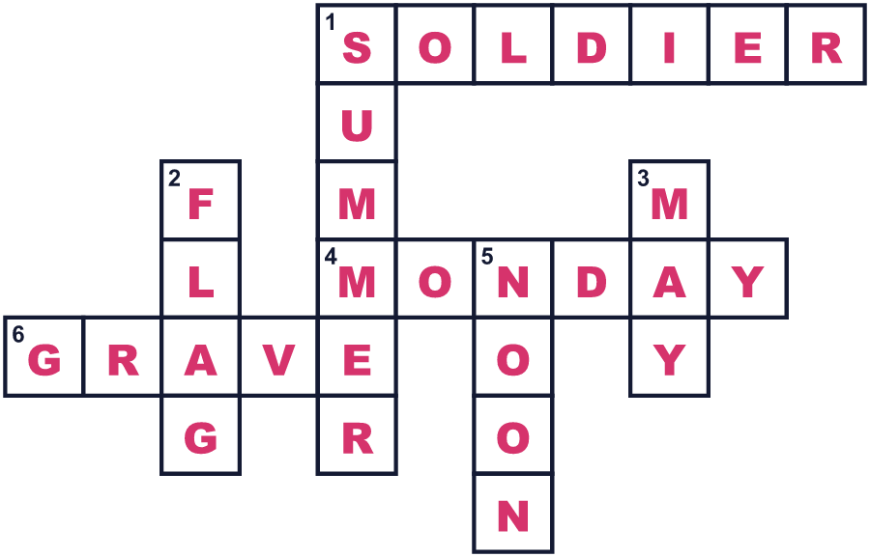
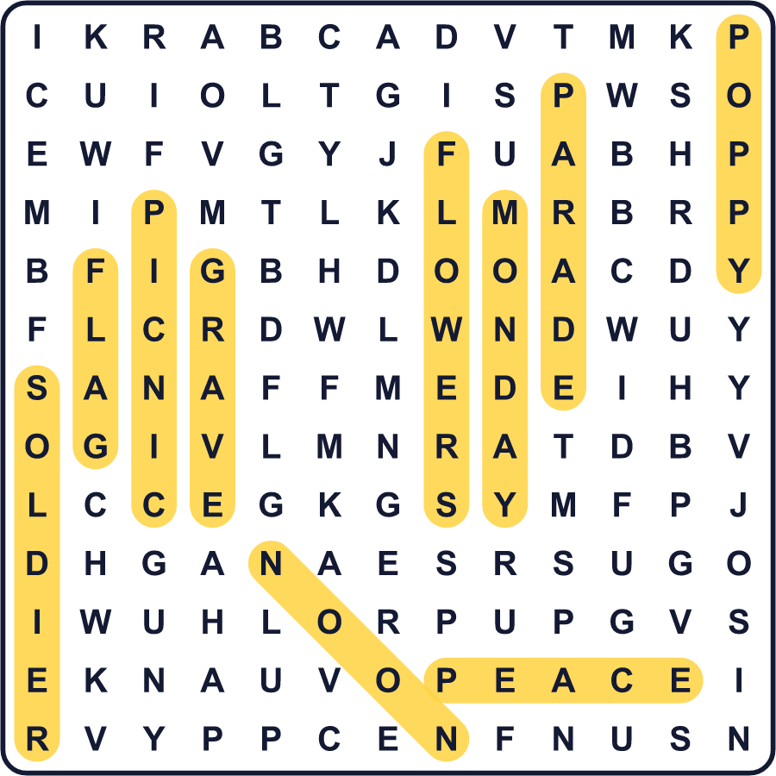
全訳
1 1865年の春、アメリカの長い戦争が終わりました。それは南北戦争で、約62万人の兵士が亡くなりました。戦争のあと、人々は兵士の墓に花を供えました。そのため、この日ははじめデコレーション・デーと呼ばれました。
2 南部の町チャールストンでは、自由になったばかりの黒人の人々が、最初の式典の一つを開きました。彼らは257人の兵士をきちんとした墓に埋葬し、花でおおいました。そして約1万人がいっしょに行進しました。彼らは、奴隷制を終わらせた戦争の兵士たちに敬意を表したかったのです。3年後の1868年、最初の全国的なデコレーション・デーが5月30日に行われました。
3 のちに、名前はメモリアル・デーに変わりました。今では、すべての戦争で亡くなったアメリカ人をしのぶ日です。1971年からは、5月の最終月曜日になっています。国旗は正午まで、旗ざおの半分の高さにかかげられます。午後3時、人々は手を止めて、しばらく静かにします。ラッパが、タップスというゆっくりとした悲しい曲を奏でます。
4 アーリントン国立墓地では、兵士たちがすべての墓に小さな旗を立てます。旗は全部で約25万本です。1本1本の旗が、「あなたを忘れていません」という気持ちを表しています。でもメモリアル・デーは、多くの家族にとって夏の始まりでもあります。人々はビーチや公園で3連休を楽しみます。それでも多くの人が、静かな1分間をとって亡くなった人を思います。

