💐 May Day Worksheet
Two Stories of May the First
Read the story. 英文を読もう。
Class ______ No. ____ Name ______________________________

🔊 音声を聞こう（スマホで読みとってね）
1 At six in the morning on May 1, a crowd stands quietly under a tall tower in Oxford, England. Then a choir begins to sing from the top of the tower. Summer is coming, and the city says hello to it with music.
2 In old Europe, May 1 was the first day of summer. People picked flowers and danced around a tall pole called a maypole. In the 1800s, dancers began to hold long ribbons. As they moved, the ribbons made a pretty pattern on the pole. In France, people still give small white flowers called lily of the valley for good luck.
3 May Day has a second story, too. In the 1800s, many factory workers in Britain worked 10 to 16 hours a day. On May 1, 1886, workers in America went on strike and asked for an eight-hour day. A few years later, workers in many countries chose May 1 as their special day. Today, it is a holiday called Labour Day or Workers' Day in many countries.
4 In Japan, the first May Day was in 1920 in Ueno Park in Tokyo. About 10,000 people came. Now May 1 is in the middle of Golden Week, but it is not a holiday. And here is one more surprise. When pilots shout "Mayday!" on the radio, they are not talking about May 1. The word comes from French and means "Help me!"
Words 単語
crowd（群衆、人ごみ） / choir（聖歌隊、合唱団） / pole（柱、さお） / ribbon（リボン） / pattern（模様、型） / strike（ストライキ） / worker（働く人、労働者） / shout（さけぶ）

💐 May Day Worksheet
Reading Check
Choose the best answer. 正しいものを選ぼう。
Class ______ No. ____ Name ______________________________
1. What is the main idea of the reading?
(A) May Day is only a holiday for pilots. (B) May Day started in Japan in 1920. (C) May Day is a summer holiday with no history. (D) May Day has two stories: a spring festival and a day for workers.
2. What did workers in America ask for in 1886?
(A) An eight-hour day (B) A new maypole (C) More flowers (D) A holiday in September
3. In paragraph 2, what is a "maypole"?
(A) A kind of white flower (B) A tall pole for dancing around (C) A song for summer (D) A long boat on a river
4. Which is true about "Mayday" on the radio?
(A) It means "Happy summer!" (B) It is only used on May 1. (C) It comes from French and means "Help me!" (D) It was first used in Ueno Park.
5. In the dialogue, what does Olivia tell Ren to do?
(A) Follow the person in front of him (B) Go to a workers' march (C) Buy some lily of the valley (D) Climb the maypole
True or False? T か F に○
1. May Day is on May 1. T / F
2. People dance around a maypole on May Day. T / F
3. May 1 is a national holiday in Japan. T / F
4. The radio call Mayday means "Happy May!" T / F

💐 May Day Worksheet
Word Work
単語のれんしゅう
Class ______ No. ____ Name ______________________________
① Match the pictures and the words. 絵と単語を線でむすぼう。
💐 | ● | ● | ribbon
🎀 | ● | ● | dance
👑 | ● | ● | sun
💃 | ● | ● | flowers
🌞 | ● | ● | radio
📻 | ● | ● | crown
③ Fill in the blanks. 語群から選んで入れよう。
[ village / winter / pole / flowers / dance / crown / pumpkin / snow / ribbon / pattern ]
It is May 1 in a small English (1) __________ . The sun is out, and the (2) __________ are pretty. In the middle of the green, there is a tall (3) __________ . Twelve children each hold a long (4) __________ . The music starts, and they (5) __________ around and around. Soon the ribbons make a beautiful (6) __________ . Everyone claps. A girl with a flower (7) __________ smiles.

💐 May Day Worksheet
Crossword Puzzle
ヒントを読んでクロスワードを完成させよう。
Class ______ No. ____ Name ______________________________
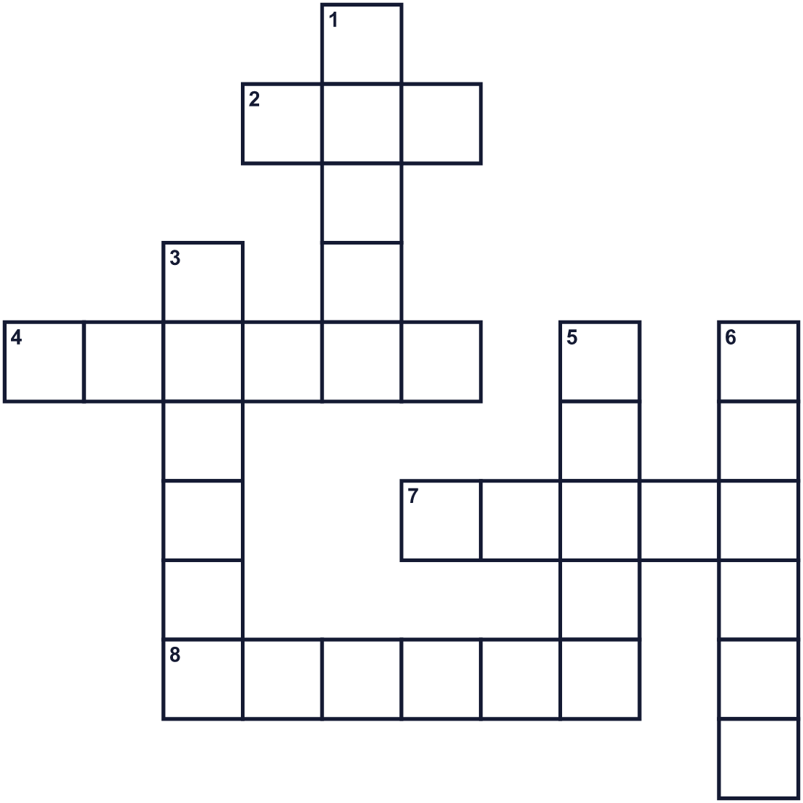
Across →
2. The fifth month of the year. (3)
4. A rose or a tulip, for example. (6)
7. A group of people who sing together. (5)
8. A long, thin piece of colored cloth. (6)
Down ↓
1. To move your body to music. (5)
3. A person who has a job. (6)
5. A queen wears this on her head. (5)
6. The season between winter and summer. (6)

💐 May Day Worksheet
Word Search
かくれた単語をさがそう（→ ↓ ↘ ↗）
Class ______ No. ____ Name ______________________________
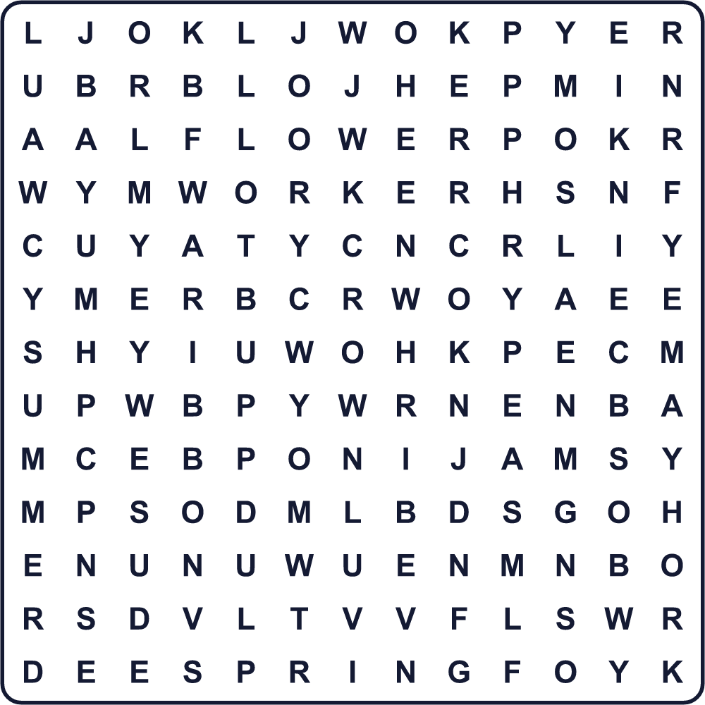
CHOIR CROWN DANCE FLOWER MAY POLE RIBBON SPRING SUMMER WORKER

💐 May Day Worksheet
Maze & Sentences
Class ______ No. ____ Name ______________________________
Help Ella get to the maypole! エラをメイポールまで連れていこう！
正しい道の文字を集めると、ひみつの言葉になるよ。 START 👧 → GOAL 🎀
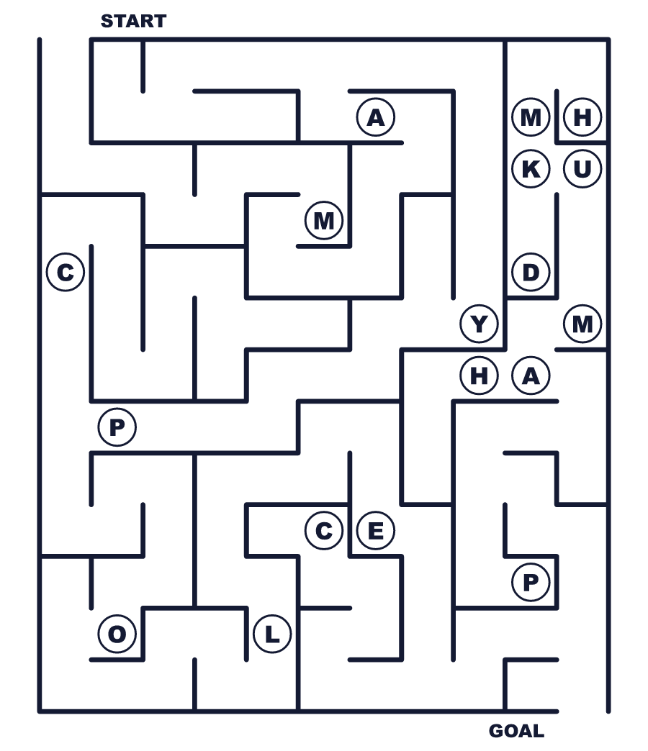
Secret word: ＿ ＿ ＿ ＿ ＿ ＿ ＿

💐 May Day Worksheet
Class Activity & Writing
Class ______ No. ____ Name ______________________________
Let's Write! 英語で書いてみよう。
If I had a spring festival in my town, we would ______.
もし私の町で春祭りをするなら、______をするだろう。
______________________________________________________________
______________________________________________________________
I think a good job is a job where you can ______.
よい仕事とは、______できる仕事だと思う。
______________________________________________________________
______________________________________________________________

💐 May Day Worksheet
Trace & Color
なぞって書こう。絵に色をぬろう。
Class ______ No. ____ Name ______________________________
💐 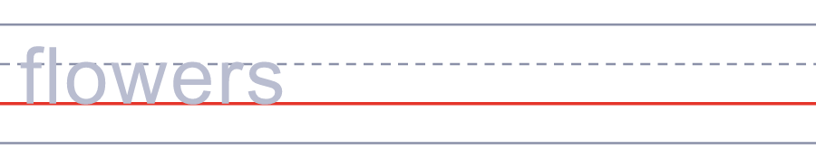

🎀 
👑 
💃 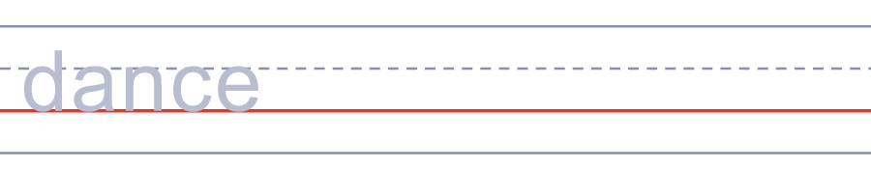
🌞 

💐 May Day Worksheet
Answer Key 解答
Reading Check: 1.D 2.A 3.B 4.C 5.A
True or False: 1.T 2.T 3.F 4.F
Match: 💐=flowers 🎀=ribbon 👑=crown 💃=dance 🌞=sun 📻=radio
Fill in the blanks: (1)village (2)flowers (3)pole (4)ribbon (5)dance (6)pattern (7)crown
Maze: MAYPOLE
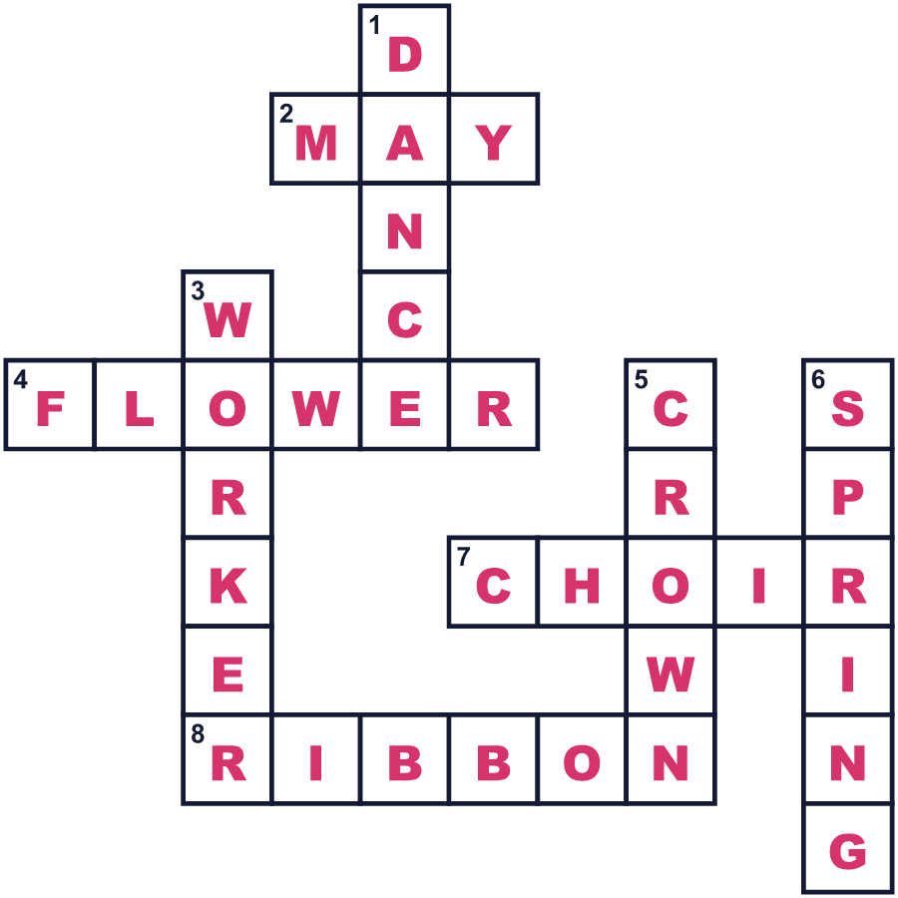
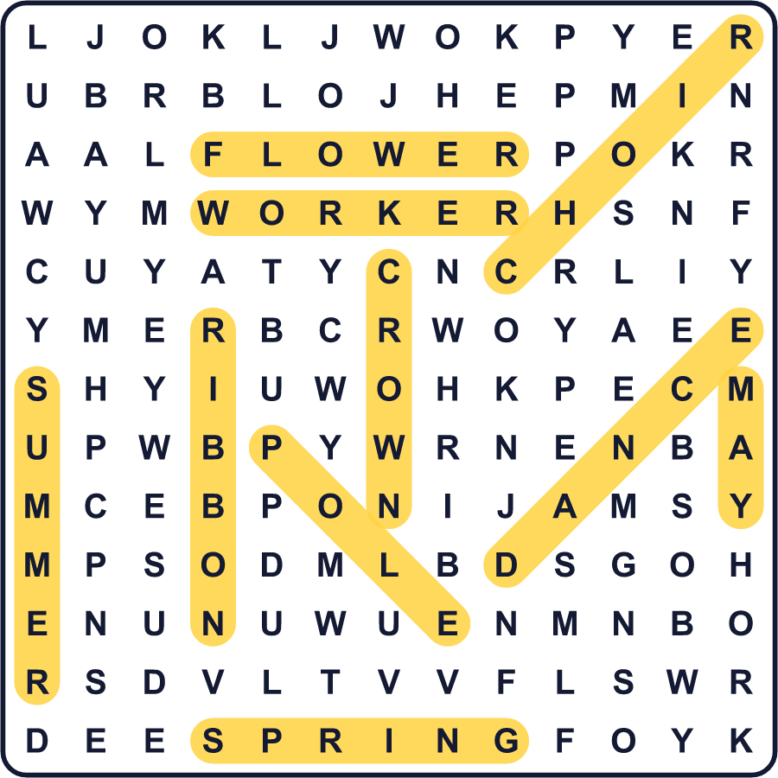
全訳
1 5月1日の朝6時、イギリスのオックスフォードで、高い塔の下に人々が静かに立っています。すると塔の上から、聖歌隊が歌い始めます。夏がやってきて、町は音楽でそれを迎えるのです。
2 昔のヨーロッパでは、5月1日は夏の最初の日でした。人々は花をつみ、メイポールという高い柱のまわりで踊りました。1800年代になると、踊る人たちが長いリボンを持つようになりました。動くにつれて、リボンが柱にきれいな模様を作りました。フランスでは今でも、幸運を願ってスズランという小さな白い花を贈ります。
3 メーデーには、もうひとつの物語もあります。1800年代、イギリスの多くの工場労働者は1日10〜16時間働いていました。1886年5月1日、アメリカの労働者たちはストライキをして、1日8時間労働を求めました。数年後、多くの国の労働者が5月1日を自分たちの特別な日に選びました。今では多くの国で、労働者の日と呼ばれる祝日になっています。
4 日本で最初のメーデーは、1920年に東京の上野公園で開かれました。約1万人が集まりました。今、5月1日はゴールデンウィークのまん中ですが、祝日ではありません。そして、もうひとつ驚きがあります。パイロットが無線で「メーデー！」とさけぶとき、5月1日の話をしているのではありません。この言葉はフランス語から来ていて、「助けて！」という意味なのです。

