🧧 Lunar New Year Worksheet
The Biggest Trip Home
Read the story. 英文を読もう。
Class ______ No. ____ Name ______________________________

🔊 音声を聞こう（スマホで読みとってね）
1 Every winter, the biggest trip on Earth begins. In China, people travel home for the Lunar New Year, also called the Spring Festival. In 2025, people made about nine billion trips in just 40 days. Trains and roads are full, but everyone wants to be home on New Year's Eve.
2 The date changes every year. It follows the moon and the sun, so the holiday comes between January 21 and February 20. In 2026, it was on February 17, and in 2027, it will be on February 6. Each year also has an animal, like the horse or the goat.
3 On New Year's Eve, families eat a big dinner together. In northern China, people make dumplings, because their shape looks like old Chinese money. Families also eat fish, but they do not finish it. The word for fish sounds like the word for extra. So leftover fish means extra money next year.
4 Red is everywhere. People hang red paper on their doors, and children get money in red envelopes. Some people hang the Chinese word for luck upside down. Why? In Chinese, upside down sounds like arrive. So the sign says, "Luck has arrived!"
5 Other countries have their own ways. In Korea, children bow deeply to their grandparents and get New Year money. In Vietnam, the zodiac has a cat, not a rabbit. In China, the festival lasts fifteen days. It ends with the Lantern Festival, when the first full moon of the year shines over thousands of red lanterns.
Words 単語
trip（旅行、移動） / billion（10億） / follow（～にしたがう、～についていく） / zodiac（十二支、星座） / dumpling（ギョーザ、だんご） / shape（形） / extra（よぶんな（もの）、あまり） / leftover（残り物（の）） / envelope（封筒） / upside down（逆さまに） / bow（おじぎをする） / lantern（ランタン、提灯）

🧧 Lunar New Year Worksheet
Reading Check
Choose the best answer. 正しいものを選ぼう。
Class ______ No. ____ Name ______________________________
1. What is the reading mainly about?
(A) How to make dumplings at home (B) How people get ready for and celebrate the Lunar New Year (C) Why trains in China are always late (D) The history of the Chinese zodiac
2. How many trips did people in China make in 40 days in 2025?
(A) About nine million (B) About fifteen thousand (C) About forty million (D) About nine billion
3. When will the Lunar New Year be in 2027?
(A) February 6 (B) February 17 (C) January 21 (D) February 20
4. Why do families leave some fish at dinner?
(A) Because fish is too expensive (B) Because the word for fish sounds like the word for extra (C) Because children do not like fish (D) Because the fish is for the Lantern Festival
5. In paragraph 4, what does "upside down" mean?
(A) Very big (B) In red color (C) With the top at the bottom (D) Next to the door
6. Which sentence is true about the reading?
(A) The festival in China lasts three days. (B) In Vietnam, the zodiac has a cat. (C) Korean children get money in green envelopes. (D) Dumplings are popular in southern China because they are long.
7. Why do you think people travel so far to be home on New Year's Eve?
(A) Because train tickets are free (B) Because they must work at home (C) Because the family dinner together is the most important part (D) Because they want to see fireworks in the city
8. In the dialogue, why does Wei Ling tell Ethan to toss the salad high?
(A) Because the salad tastes better cold (B) Because the boss wants to see it (C) Because it is everyone's birthday (D) Because a higher toss means higher luck
True or False? T か F に○
1. The Lunar New Year is on the same day every year. T / F
2. Many people in China travel home for the holiday. T / F
3. Families eat all of the fish on New Year's Eve. T / F
4. Red is a lucky color for the Lunar New Year. T / F
5. The Vietnamese zodiac has a cat. T / F
6. The festival in China ends after three days. T / F

🧧 Lunar New Year Worksheet
Word Work
単語のれんしゅう
Class ______ No. ____ Name ______________________________
① Match the pictures and the words. 絵と単語を線でむすぼう。
🏮 | ● | ● | red envelope
🥟 | ● | ● | train
🐟 | ● | ● | horse
🧧 | ● | ● | full moon
🐉 | ● | ● | lantern
🚄 | ● | ● | fish
🌕 | ● | ● | dumpling
🐴 | ● | ● | dragon
② Unscramble the words. 並べかえて単語にしよう。
1. L N R A N T E (ランタン、提灯) → ____________________
2. A N G D R O (龍) → ____________________
3. O A I Z C D (十二支) → ____________________
4. G I P N R S (春) → ____________________
5. Y M F I L A (家族) → ____________________
6. N I D E R N (夕食) → ____________________
③ Fill in the blanks. 語群から選んで入れよう。
[ smiles / bag / play / older / sleeps / fish / money / hanbok / pumpkin / soup / bows / grandparents / shouts ]
It is the morning of Seollal in Seoul. Minjun wears a colorful (1) __________ . His (2) __________ sit on the floor of the living room. Minjun puts his hands together and (3) __________ deeply. "Happy New Year, Grandma and Grandpa!" he says. His grandmother (4) __________ and gives him a small silk (5) __________ . There is New Year (6) __________ inside! Then the whole family eats rice cake (7) __________ for breakfast. "Now you are one year (8) __________ ," his grandfather jokes. In the afternoon, they (9) __________ a game with wooden sticks. Minjun wins and (10) __________ , "This year will be great!"

🧧 Lunar New Year Worksheet
Crossword Puzzle
ヒントを読んでクロスワードを完成させよう。
Class ______ No. ____ Name ______________________________
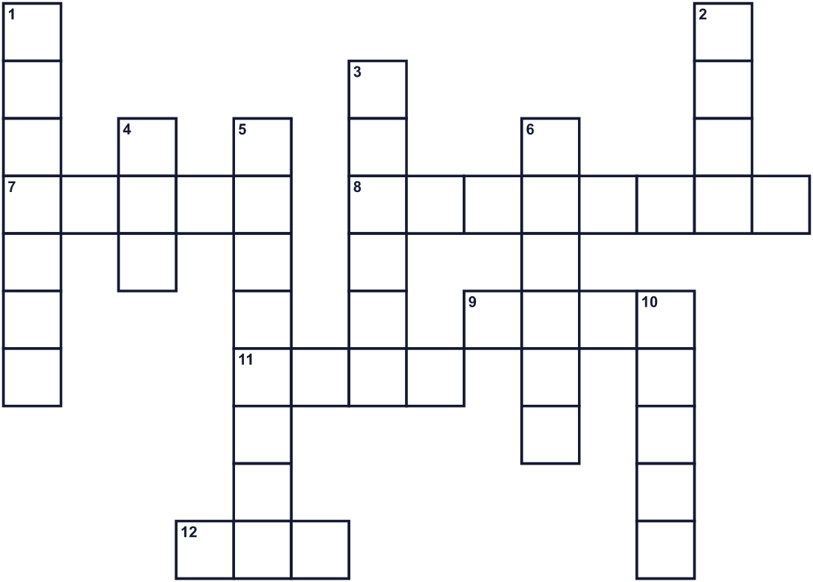
Across →
7. Many people ride it to go home. It runs on tracks. (5)
8. Food with a soft skin and meat inside. It looks like old money. (8)
9. Families eat it but do not finish it. (4)
11. Another word for good fortune. Everyone wants it at New Year. (4)
12. The lucky color of the holiday. Envelopes and paper have this color. (3)
Down ↓
1. A paper light. Thousands shine on the fifteenth day. (7)
2. The calendar follows it. It is full on the fifteenth night. (4)
3. The twelve animals for the years. (6)
4. In the Vietnamese zodiac, this pet takes the rabbit's place. (3)
5. Children get money in a paper one. (8)
6. The season in the name of the Chinese festival. (6)
10. The animal of 2026. It runs fast. (5)

🧧 Lunar New Year Worksheet
Word Search
かくれた単語をさがそう（→ ↓ ↘ ↗）
Class ______ No. ____ Name ______________________________
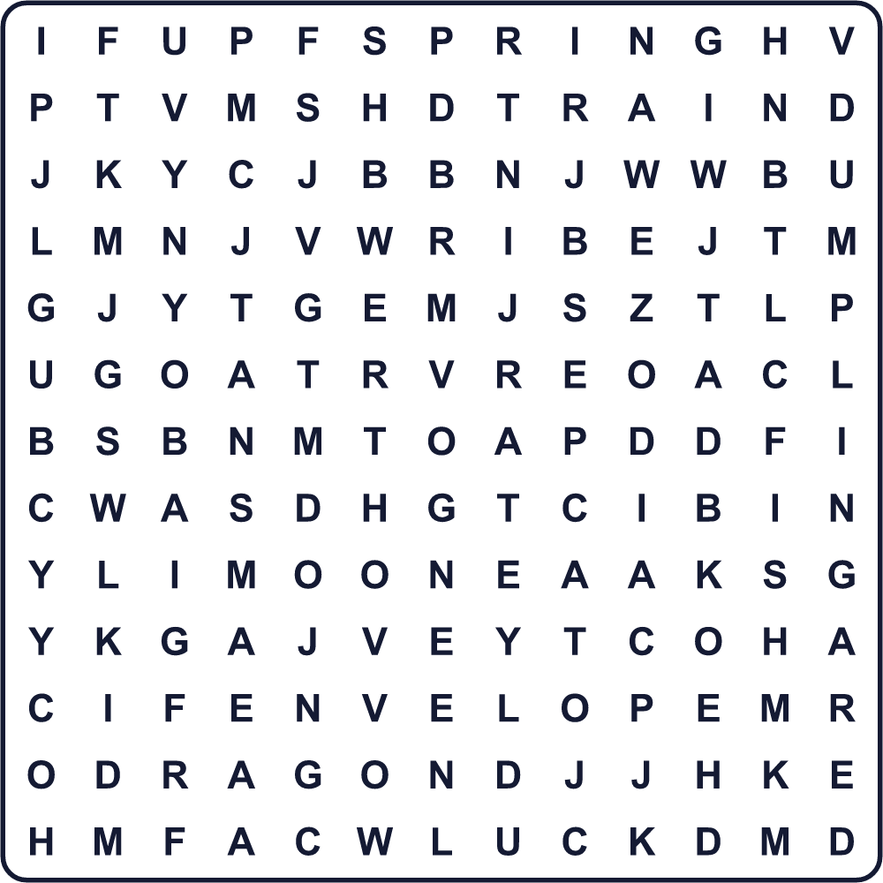
CAT DRAGON DUMPLING ENVELOPE FISH GOAT HORSE LANTERN LUCK MOON RED SPRING TRAIN ZODIAC
Secret Code 暗号を解こう
✉=A ■=E ●=H ◎=L ◆=N ☎=P ♪=R ✚=U ☺=W ☃=Y
● ✉ ☎ ☎ ☃ ◎ ✚ ◆ ✉ ♪ ◆ ■ ☺ ☃ ■ ✉ ♪
______________________________________________________________

🧧 Lunar New Year Worksheet
Maze & Sentences
Class ______ No. ____ Name ______________________________
Help Mei get home for New Year's Eve dinner! 大みそかの夕食に間に合うよう、メイを家まで連れていこう！
正しい道の文字を集めると、ひみつの言葉になるよ。 START 👧 → GOAL 🥟
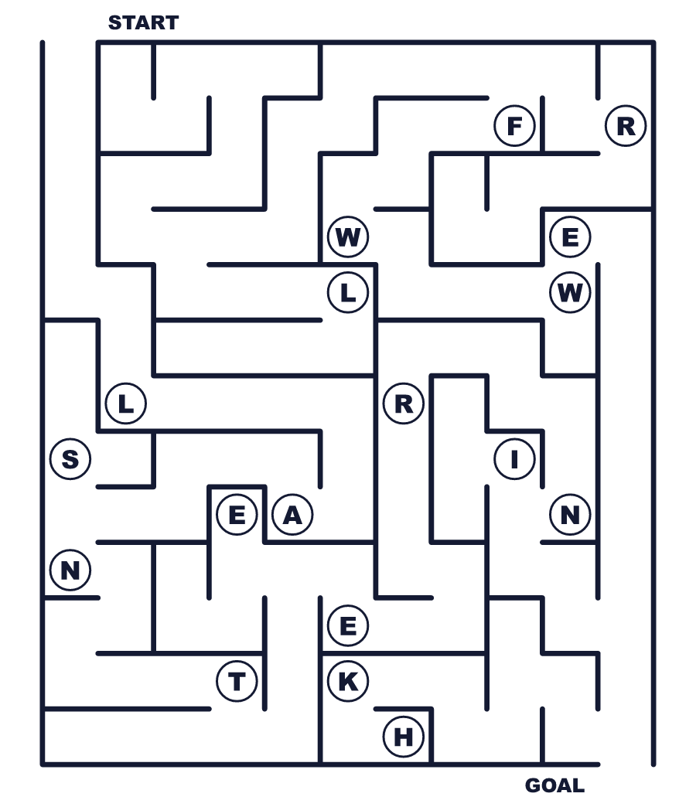
Secret word: ＿ ＿ ＿ ＿ ＿ ＿ ＿
Put the words in order. 並べかえよう。
1. travel / People / Year / New / for / the / home . (人々はお正月のためにふるさとへ帰ります。)
______________________________________________________________
2. dumplings / Year's / Families / on / eat / New / Eve . (家族は大みそかにギョーザを食べます。)
______________________________________________________________
3. get / red / Children / money / in / envelopes . (子どもたちは赤い封筒でお金をもらいます。)
______________________________________________________________
4. sign / Some / upside / the / down / people / hang . (その貼り紙を逆さまに貼る人もいます。)
______________________________________________________________
5. festival / ends / lanterns / The / with / red / many . (お祭りはたくさんの赤いランタンで終わります。)
______________________________________________________________

🧧 Lunar New Year Worksheet
Class Activity & Writing
Class ______ No. ____ Name ______________________________
Find Someone Who… クラスで聞いて回ろう！
Find someone who … | Name
… knows their zodiac animal in English 自分の干支を英語で言える
… has eaten dumplings this month 今月ギョーザを食べた
… has been to a Chinatown 中華街に行ったことがある
… has seen a lion dance 獅子舞を見たことがある
… can say Happy New Year in Chinese or Korean 中国語か韓国語で「あけましておめでとう」が言える
… likes the color red 赤い色が好き
… has traveled a long way to see family 家族に会うために遠くまで旅したことがある
… knows the date of the next Lunar New Year 次の旧正月の日付を知っている
Let's Write! 英語で書いてみよう。
My zodiac animal is the ______. People say this animal is ______.
私の干支は＿＿＿です。この動物は＿＿＿だと言われます。
______________________________________________________________
______________________________________________________________
If I visited ______ for the Lunar New Year, I would like to ______.
もし旧正月に＿＿＿を訪れたら、＿＿＿したいです。
______________________________________________________________
______________________________________________________________
In Japan, we eat ______ at New Year because it means ______.
日本ではお正月に＿＿＿を食べます。それは＿＿＿という意味があるからです。
______________________________________________________________
______________________________________________________________

🧧 Lunar New Year Worksheet
Trace & Color
なぞって書こう。絵に色をぬろう。
Class ______ No. ____ Name ______________________________
🏮 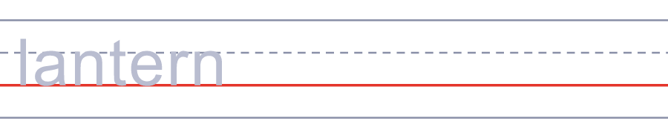

🥟 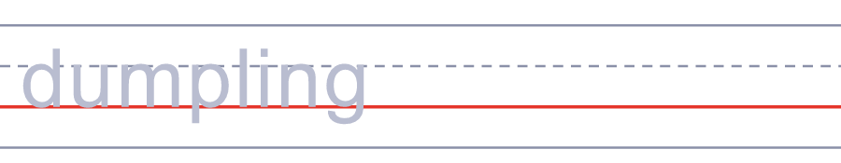
🐟 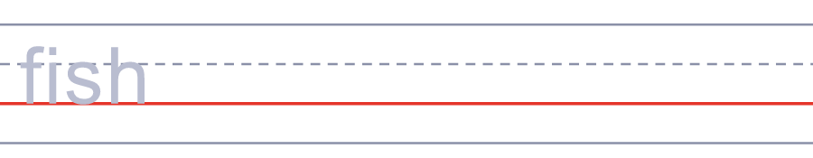
🧧 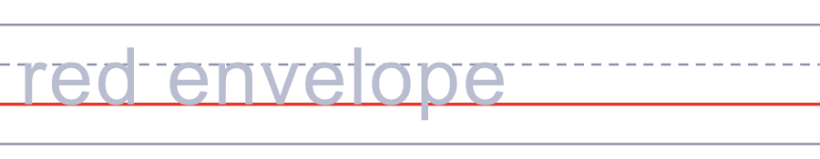
🐉 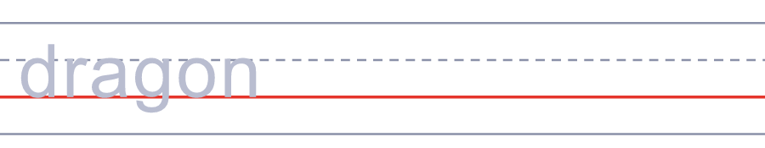
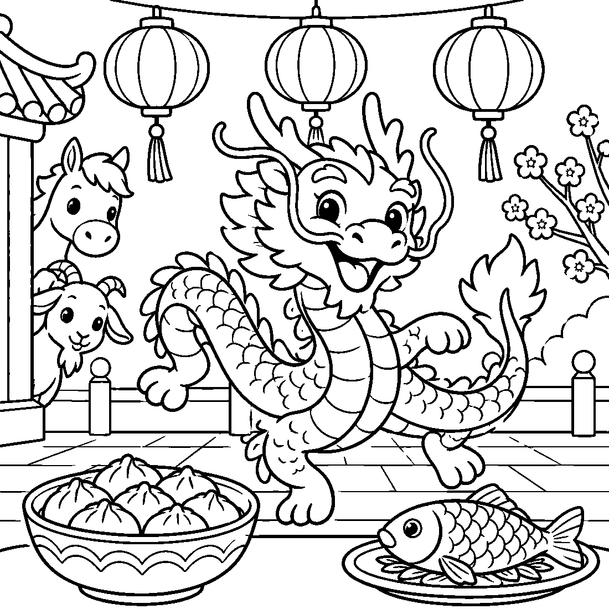

🧧 Lunar New Year Worksheet
Answer Key 解答
Reading Check: 1.B 2.D 3.A 4.B 5.C 6.B 7.C 8.D
True or False: 1.F 2.T 3.F 4.T 5.T 6.F
Match: 🏮=lantern 🥟=dumpling 🐟=fish 🧧=red envelope 🐉=dragon 🚄=train 🌕=full moon 🐴=horse
Unscramble: 1.LANTERN 2.DRAGON 3.ZODIAC 4.SPRING 5.FAMILY 6.DINNER
Fill in the blanks: (1)hanbok (2)grandparents (3)bows (4)smiles (5)bag (6)money (7)soup (8)older (9)play (10)shouts
Sentence order: 1. People travel home for the New Year. 2. Families eat dumplings on New Year's Eve. 3. Children get money in red envelopes. 4. Some people hang the sign upside down. 5. The festival ends with many red lanterns.
Secret Code: HAPPY LUNAR NEW YEAR
Maze: LANTERN
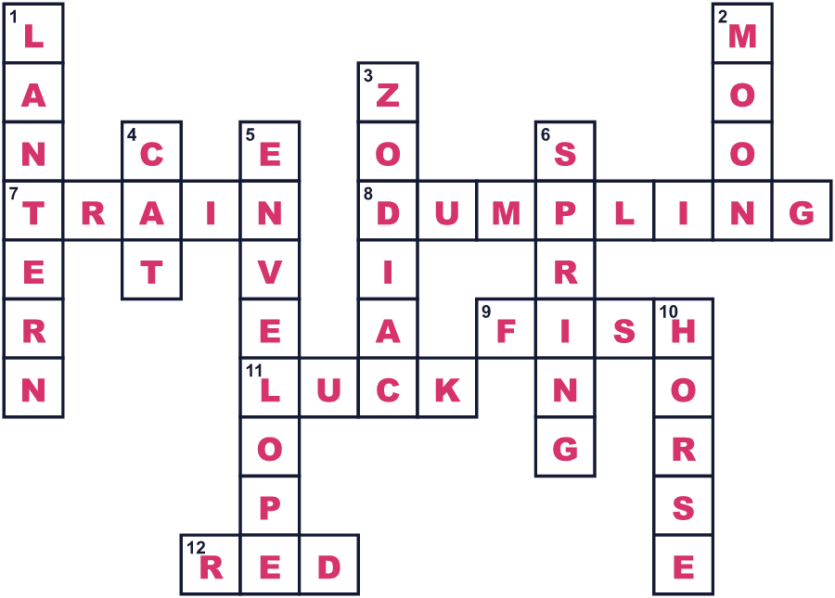
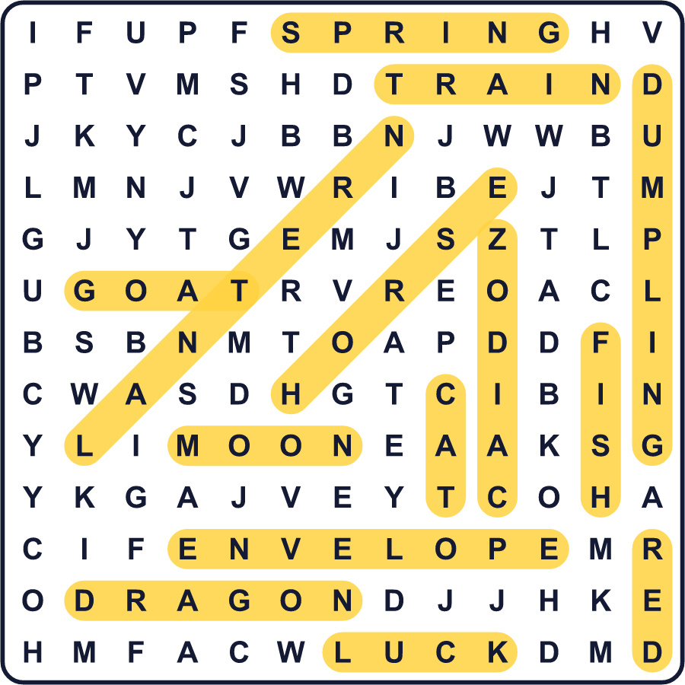
全訳
1 毎年冬になると、地球最大の旅が始まります。中国では、人々が春節とも呼ばれる旧正月のためにふるさとへ帰ります。2025年には、わずか40日間でのべ約90億回の移動がありました。電車も道路もいっぱいですが、だれもが大みそかには家にいたいのです。
2 日付は毎年変わります。月と太陽の動きにしたがうので、この祝日は1月21日から2月20日のあいだにやってきます。2026年は2月17日でした。2027年は2月6日になります。毎年、うまやひつじのような動物も決まっています。
3 大みそかには、家族がいっしょに大きな夕食を食べます。中国北部では、形が昔の中国のお金に似ているので、ギョーザを作ります。家族は魚も食べますが、全部は食べません。「魚」という言葉は「あまり」という言葉と同じように聞こえるのです。だから、残った魚は来年のよぶんなお金を意味します。
4 どこもかしこも赤です。人々はドアに赤い紙を貼り、子どもたちは赤い封筒に入ったお金をもらいます。「福」という漢字を逆さまに貼る人もいます。なぜでしょう。中国語では「逆さま」が「来る」と同じように聞こえるのです。だからその貼り紙は「福が来た！」と言っているのです。
5 ほかの国には、それぞれのやり方があります。韓国では、子どもたちが祖父母に深くおじぎをして、お年玉をもらいます。ベトナムでは、十二支にウサギではなくネコがいます。中国では、お祭りは15日間続きます。最後は元宵節です。その夜、1年で最初の満月が何千もの赤いランタンの上にかがやきます。

