✋ International Left-Handers Day Worksheet
A World Made for the Right Hand
Read the story. 英文を読もう。
Class ______ No. ____ Name ______________________________
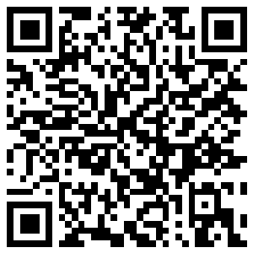
🔊 音声を聞こう（スマホで読みとってね）
1 Pick up a pair of scissors with your left hand and try to cut a straight line. It is not easy, right? Many left-handed people feel like this every day. About 7 to 10 percent of people in the world are left-handed. August 13 is International Left-Handers Day, a day to think about them.
2 An American man named Dean R. Campbell started the day in 1976. He wanted people to understand the problems of left-handers. Desks, scissors, and kitchen tools are often made for the right hand. In Japan, most sushi knives are made for the right hand, too. He also wanted schools to help left-handed children.
3 For a long time, many people thought the left hand was bad. The English word sinister means evil, but in Latin it simply meant left. Teachers often made left-handed children write with their right hand. Even King George VI of Britain had to write with his right hand as a boy. In 1932, only 2.1 percent of Americans wrote with their left hand. By 1972, the number was over 11 percent, because schools stopped changing left-handed children.
4 In some sports, being left-handed can help. About half of all fencers are left-handed. In baseball, a left-handed pitcher is called a southpaw. Many players are not used to playing against left-handers. So on August 13, look around you. Is there anything you can change to help a left-handed friend?
Words 単語
left-handed（左利きの） / scissors（はさみ） / straight（まっすぐな） / tool（道具） / sinister（不吉な、邪悪な） / evil（邪悪な、悪い） / southpaw（サウスポー、左利きの選手） / be used to（～に慣れている）

✋ International Left-Handers Day Worksheet
Reading Check
Choose the best answer. 正しいものを選ぼう。
Class ______ No. ____ Name ______________________________
1. What is the main idea of the reading?
(A) Left-handed people should use their right hand. (B) Left-handed people have problems and strengths, and we can help them. (C) Only Americans are left-handed. (D) Scissors were made in 1976.
2. Who started International Left-Handers Day?
(A) A Japanese teacher (B) A baseball pitcher (C) A Roman writer (D) Dean R. Campbell
3. Why did the number of left-handed writers in America grow by 1972?
(A) Because schools stopped changing left-handed children (B) Because more babies were born (C) Because new scissors were made (D) Because of baseball
4. In paragraph 3, "sinister" in Latin simply meant:
(A) evil (B) right (C) left (D) lucky
5. In the dialogue, why does Hana say batters must hate playing against Jack?
(A) Because Jack is very tall (B) Because Jack is a left-handed pitcher (C) Because Jack uses special scissors (D) Because Jack is new at school
True or False? T か F に○
1. About half of the people in the world are left-handed. T / F
2. International Left-Handers Day started in 1976. T / F
3. In Latin, sinister meant left. T / F
4. Left-handed players never do well in sports. T / F

✋ International Left-Handers Day Worksheet
Word Work
単語のれんしゅう
Class ______ No. ____ Name ______________________________
① Match the pictures and the words. 絵と単語を線でむすぼう。
✋ | ● | ● | hand
✂️ | ● | ● | pencil
✏️ | ● | ● | baseball
⚾ | ● | ● | fencing
🎾 | ● | ● | scissors
🤺 | ● | ● | tennis
③ Fill in the blanks. 語群から選んで入れよう。
[ pair / left-handed / straight / noisy / orange / scissors / line / class ]
Mika is (1) __________ . At school, she cannot cut paper well with the class (2) __________ . Her line is never (3) __________ . One day, her teacher gives her a new (4) __________ . "These are for lefties," he says. Mika tries them. "Wow, I can see the (5) __________ !" she says. Now she loves art (6) __________ .

✋ International Left-Handers Day Worksheet
Crossword Puzzle
ヒントを読んでクロスワードを完成させよう。
Class ______ No. ____ Name ______________________________
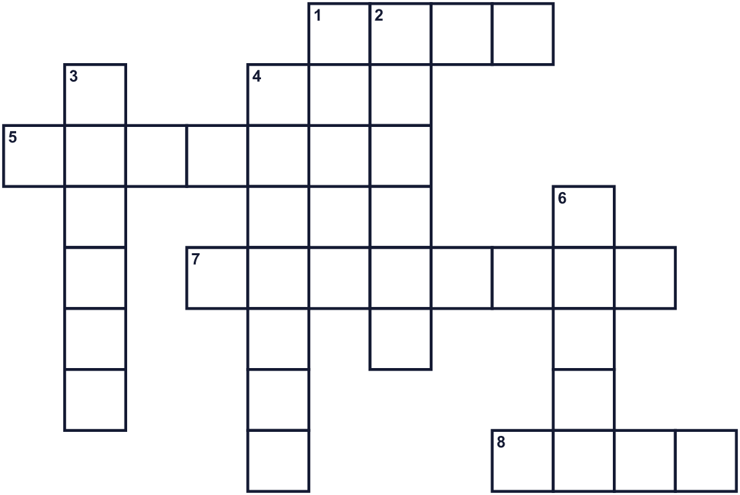
Across →
1. You have five fingers on each one. (4)
5. A sport with long thin swords. (7)
7. A tool for cutting paper. (8)
8. The opposite of right. (4)
Down ↓
2. The eighth month of the year. (6)
3. You use it to draw and write. It has an eraser. (6)
4. The baseball player who throws the ball to the batter. (7)
6. You do this with a pen. (5)

✋ International Left-Handers Day Worksheet
Word Search
かくれた単語をさがそう（→ ↓ ↘ ↗）
Class ______ No. ____ Name ______________________________
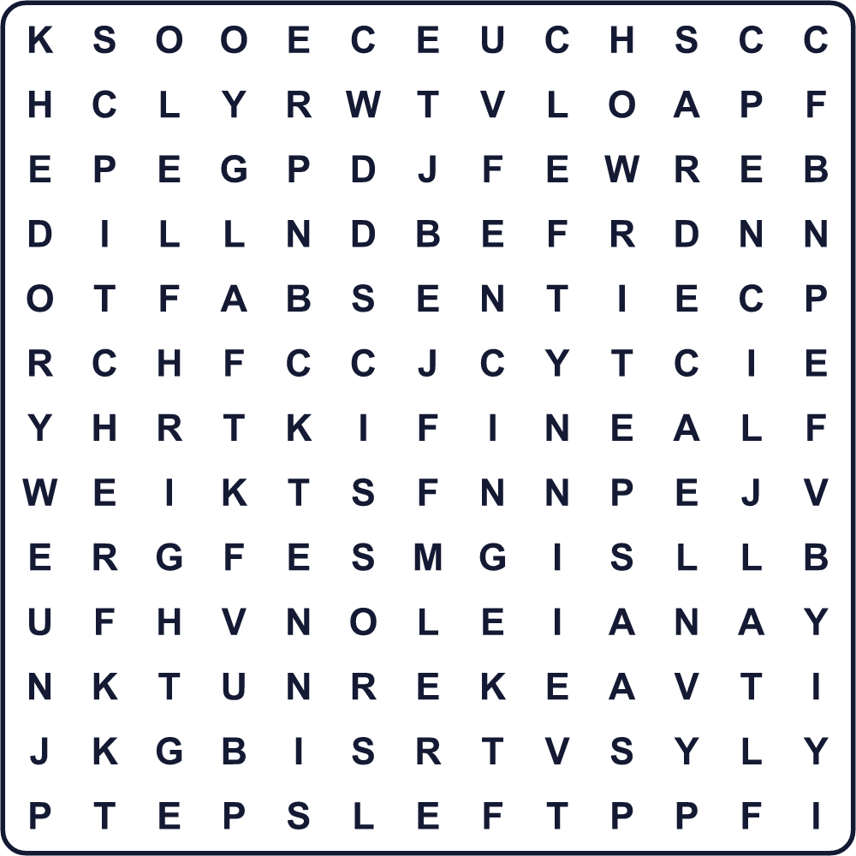
FENCING HAND LEFT LEFTY PENCIL PITCHER RIGHT SCISSORS TENNIS WRITE

✋ International Left-Handers Day Worksheet
Maze & Sentences
Class ______ No. ____ Name ______________________________
Help the boy find the left-handed scissors! 男の子を左利き用のはさみまで連れていこう！
正しい道の文字を集めると、ひみつの言葉になるよ。 START 👦 → GOAL ✂️
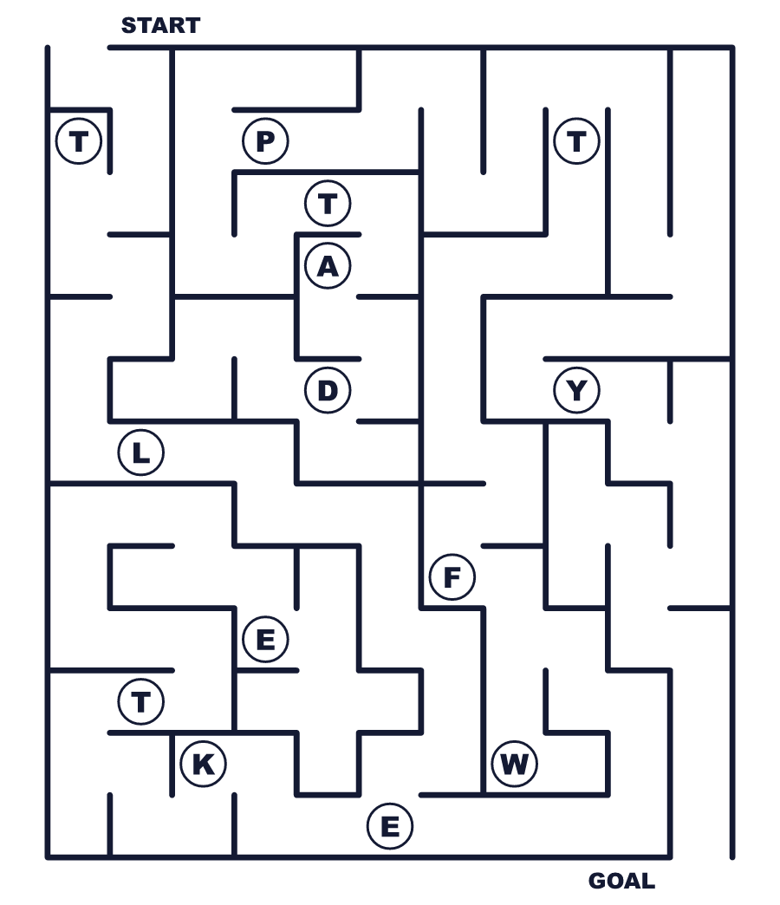
Secret word: ＿ ＿ ＿ ＿ ＿

✋ International Left-Handers Day Worksheet
Class Activity & Writing
Class ______ No. ____ Name ______________________________
Let's Write! 英語で書いてみよう。
I use my ______ hand to write. One thing that is hard for me is ______.
私は______手で字を書きます。私にとって難しいことは______です。
______________________________________________________________
______________________________________________________________
To help left-handed people, I think we should ______.
左利きの人を助けるために、私たちは______すべきだと思います。
______________________________________________________________
______________________________________________________________

✋ International Left-Handers Day Worksheet
Trace & Color
なぞって書こう。絵に色をぬろう。
Class ______ No. ____ Name ______________________________
✋ 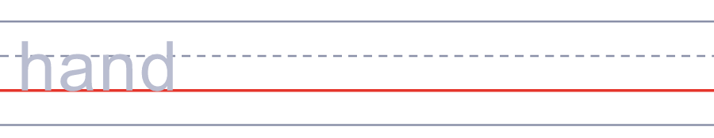

✂️ 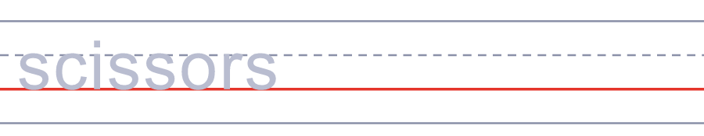
✏️ 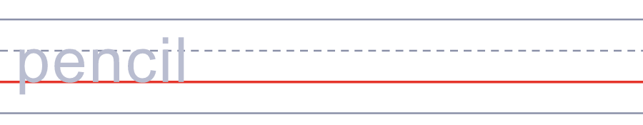
⚾ 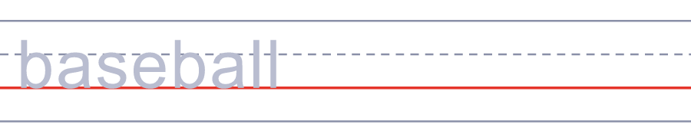
🎾 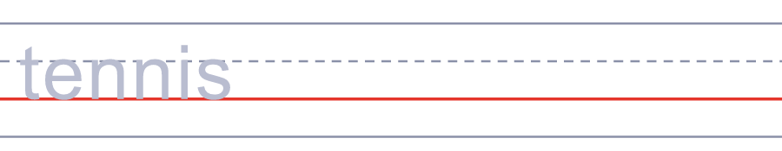

✋ International Left-Handers Day Worksheet
Answer Key 解答
Reading Check: 1.B 2.D 3.A 4.C 5.B
True or False: 1.F 2.T 3.T 4.F
Match: ✋=hand ✂️=scissors ✏️=pencil ⚾=baseball 🎾=tennis 🤺=fencing
Fill in the blanks: (1)left-handed (2)scissors (3)straight (4)pair (5)line (6)class
Maze: LEFTY
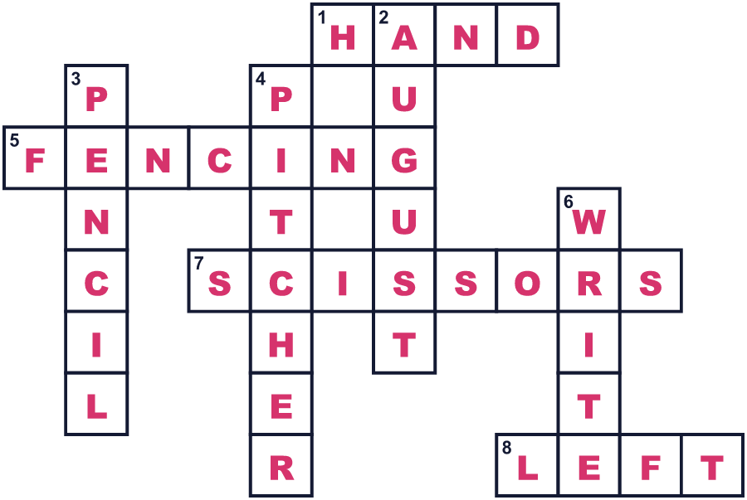
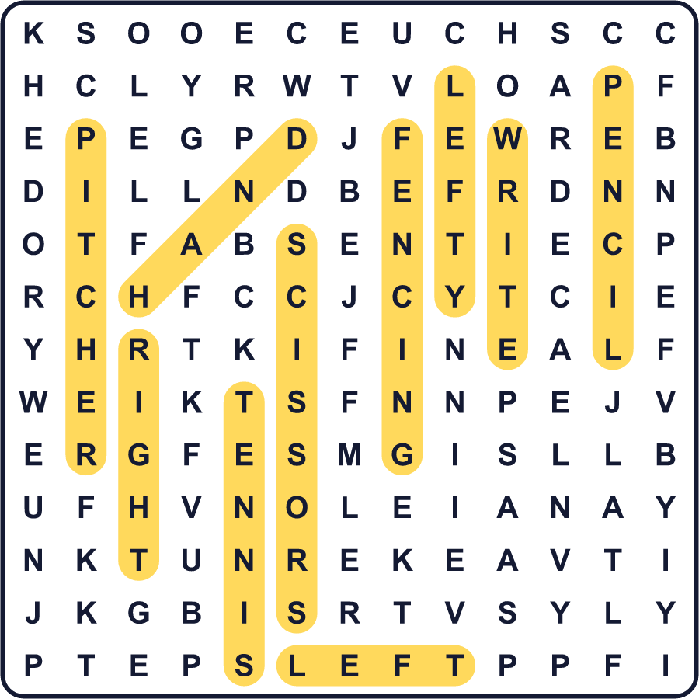
全訳
1 左手ではさみを持って、まっすぐな線を切ってみてください。簡単ではありませんよね。多くの左利きの人は、毎日こう感じています。世界の人の約7〜10％が左利きです。8月13日は国際左利きの日。その人たちのことを考える日です。
2 ディーン・R・キャンベルというアメリカ人が、1976年にこの日を始めました。彼は、左利きの人の困りごとをみんなに理解してほしいと考えました。机やはさみ、台所の道具は、右手用に作られていることが多いのです。日本のすし包丁も、たいてい右手用に作られています。また、学校が左利きの子どもを助けることも願っていました。
3 長い間、多くの人が左手は悪いものだと考えていました。英語の sinister は「邪悪な」という意味ですが、ラテン語ではただ「左」という意味でした。先生たちはよく、左利きの子どもに右手で字を書かせました。イギリス国王ジョージ6世でさえ、子どものころ右手で書かなければなりませんでした。1932年、左手で字を書くアメリカ人はわずか2.1％でした。1972年にはその数は11％をこえました。学校が無理に直さなくなったからです。
4 スポーツによっては、左利きが有利になることもあります。フェンシングの選手の約半分は左利きです。野球では、左利きの投手をサウスポーと呼びます。多くの選手は、左利きの相手との対戦に慣れていないのです。だから8月13日には、まわりを見回してみてください。左利きの友だちのために、変えられることはありませんか。

