🐸 Leap Day Worksheet
The Day That Comes Every Four Years
Read the story. 英文を読もう。
Class ______ No. ____ Name ______________________________

🔊 音声を聞こう（スマホで読みとってね）
1 February usually has 28 days. But every four years, it gets one extra day, February 29. We call this day Leap Day, and the year is a leap year. The next one is in 2028.
2 Why do we need it? The Earth takes about 365 and a quarter days to go around the sun. That extra quarter adds up. After four years, it is almost one full day. So we add February 29 to keep our calendar in time with the seasons. Without leap years, summer would slowly move into winter months over hundreds of years.
3 But a quarter is not exact. So the rule has a twist. Years like 1900, which end in 00, are not leap years. But if you can divide the year by 400, like 2000, it is a leap year. This rule comes from a calendar made for Pope Gregory XIII in the 1500s.
4 Leap Day has some fun traditions. In Ireland, an old story says women can ask men to marry them on this day. If the man says no, he should buy her gloves or a silk dress. People born on February 29 are called leaplings. They have a real birthday only once every four years. One family in Britain has three people born on this day, a grandfather, a father, and a daughter. In Japan, the law says leaplings become one year older at the end of February 28.
Words 単語
leap（跳ぶ、跳躍） / extra（余分の、追加の） / quarter（4分の1） / add up（たまる、積み重なる） / season（季節） / divide（割る、分ける） / tradition（伝統、言い伝え） / propose（結婚を申しこむ、提案する）

🐸 Leap Day Worksheet
Reading Check
Choose the best answer. 正しいものを選ぼう。
Class ______ No. ____ Name ______________________________
1. What is the main idea of the text?
(A) Leap Day is a holiday in Ireland. (B) February 29 keeps the calendar in time with the seasons and has fun traditions. (C) Leap Day happens every year in February. (D) February 29 was made by a Japanese law.
2. How long does the Earth take to go around the sun?
(A) Exactly 365 days (B) About 366 days (C) About 360 days (D) About 365 and a quarter days
3. Which year was NOT a leap year?
(A) 1900 (B) 2000 (C) 2024 (D) 2028
4. In paragraph 2, "adds up" is closest in meaning to:
(A) disappears (B) gets bigger little by little (C) stops (D) goes back
5. In the dialogue, when does Haruka usually celebrate her birthday?
(A) On March 1 (B) On February 29 every year (C) On February 28 (D) Only on New Year's Day
True or False? T か F に○
1. A leap year comes every four years. T / F
2. The year 1900 was a leap year. T / F
3. In an Irish tradition, women can propose on February 29. T / F
4. The Earth goes around the sun in exactly 365 days. T / F

🐸 Leap Day Worksheet
Word Work
単語のれんしゅう
Class ______ No. ____ Name ______________________________
① Match the pictures and the words. 絵と単語を線でむすぼう。
🐸 | ● | ● | sun
☀️ | ● | ● | gloves
🌍 | ● | ● | frog
🎂 | ● | ● | ring
💍 | ● | ● | birthday cake
🧤 | ● | ● | Earth
③ Fill in the blanks. 語群から選んで入れよう。
[ calendar / twelve / party / summer / rain / born / year / early / birthday ]
Ben was (1) __________ on February 29. Most years, his (2) __________ is not on the calendar. So his family has a (3) __________ on February 28. But this year is a leap (4) __________ ! Ben wakes up (5) __________ and looks at the (6) __________ . There it is, February 29! "I am finally (7) __________ ... or only three!" he laughs.

🐸 Leap Day Worksheet
Crossword Puzzle
ヒントを読んでクロスワードを完成させよう。
Class ______ No. ____ Name ______________________________
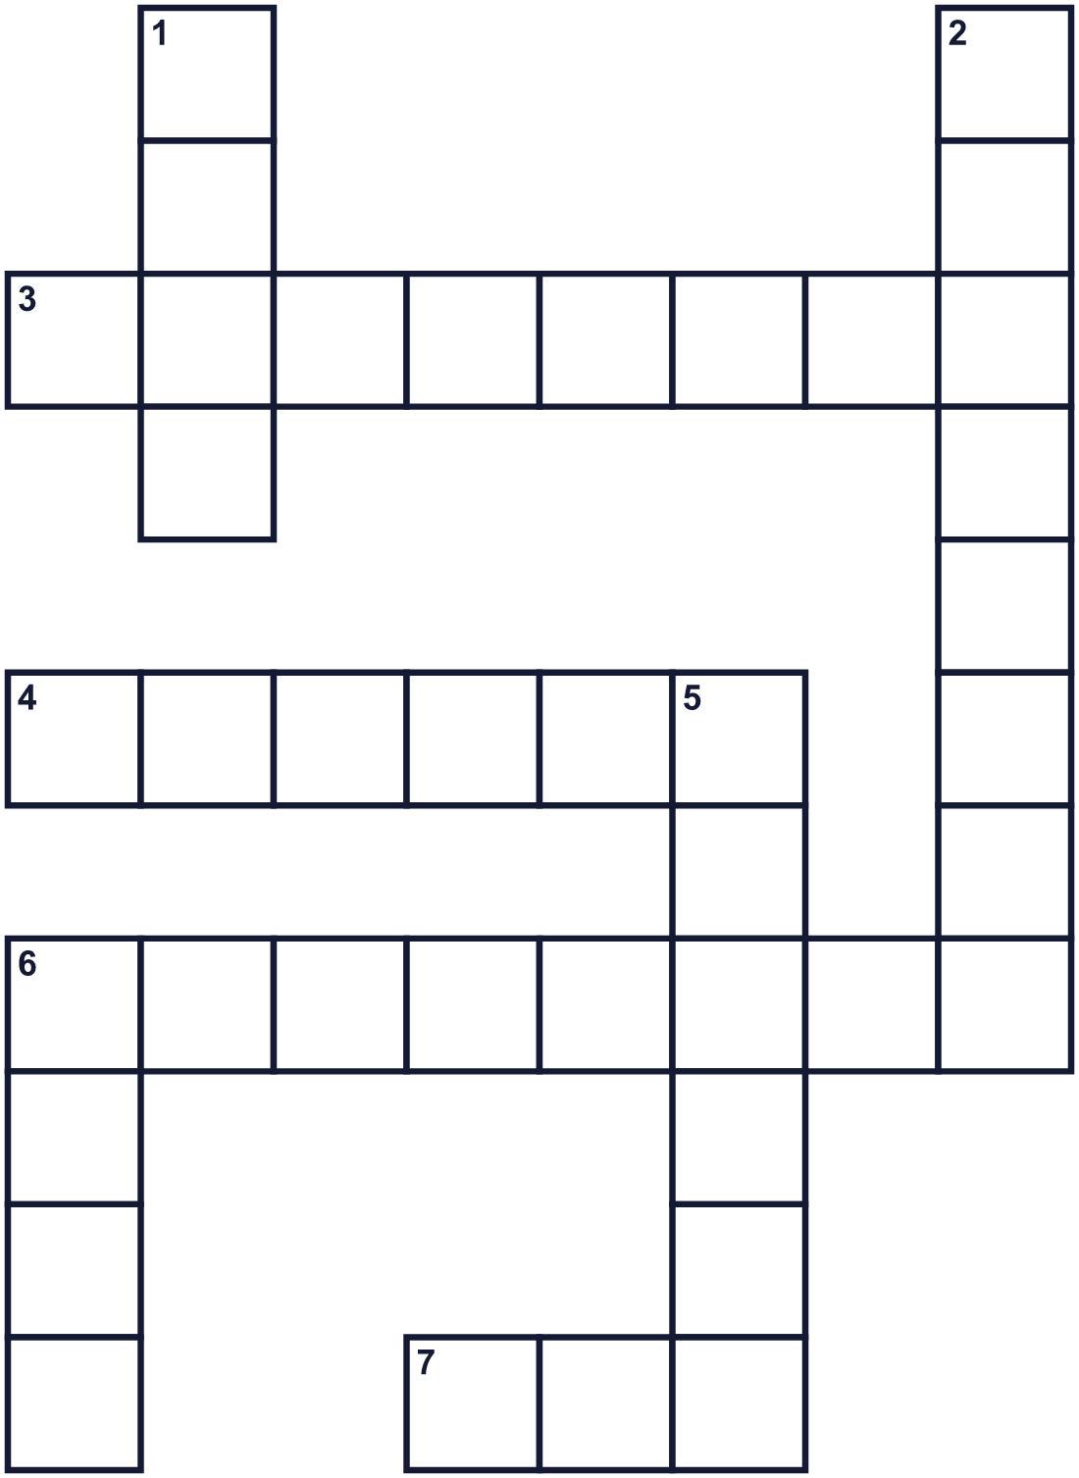
Across →
3. It shows all the days of the year. (8)
4. You wear them on your hands in winter. (6)
6. The second month of the year. (8)
7. The Earth goes around it. (3)
Down ↓
1. A big jump. A frog can do this. (4)
2. The day you were born. You get a cake. (8)
5. Spring, summer, fall, or winter. (6)
6. The number after three. (4)

🐸 Leap Day Worksheet
Word Search
かくれた単語をさがそう（→ ↓ ↘ ↗）
Class ______ No. ____ Name ______________________________
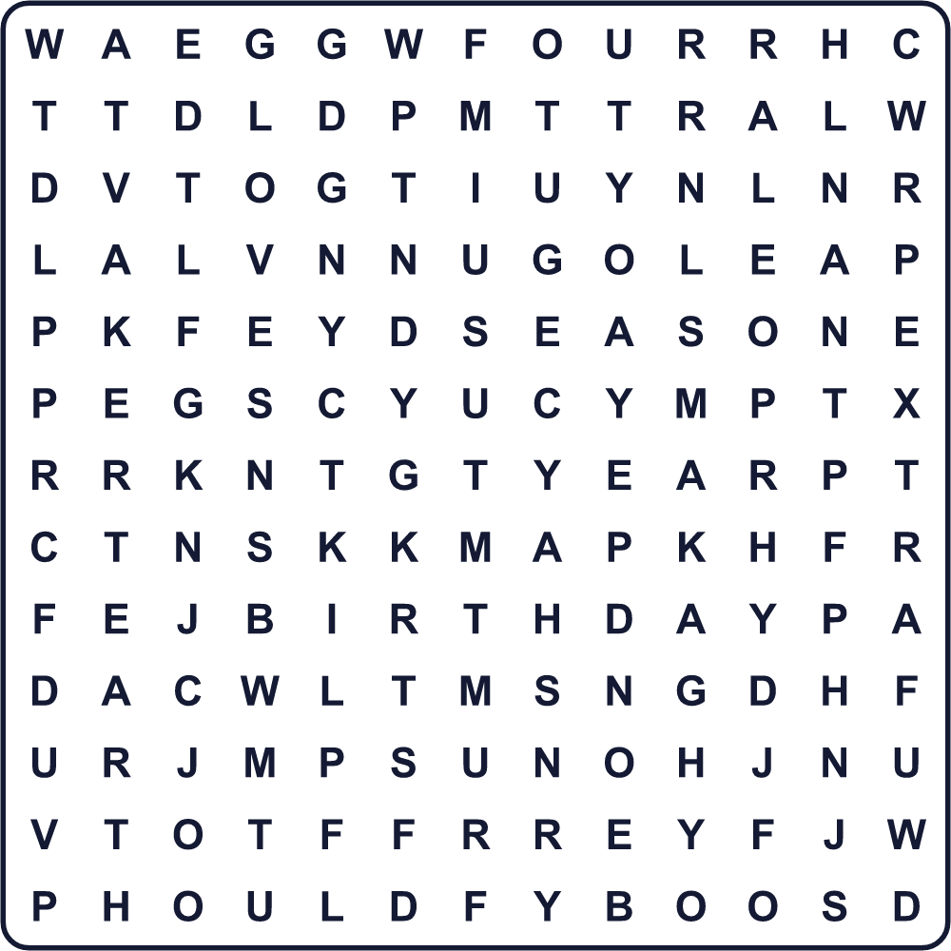
BIRTHDAY EARTH EXTRA FOUR FROG GLOVES LEAP SEASON SUN YEAR

🐸 Leap Day Worksheet
Maze & Sentences
Class ______ No. ____ Name ______________________________
Help the frog leap to February 29! カエルを2月29日まで跳ばせよう！
正しい道の文字を集めると、ひみつの言葉になるよ。 START 🐸 → GOAL 📅
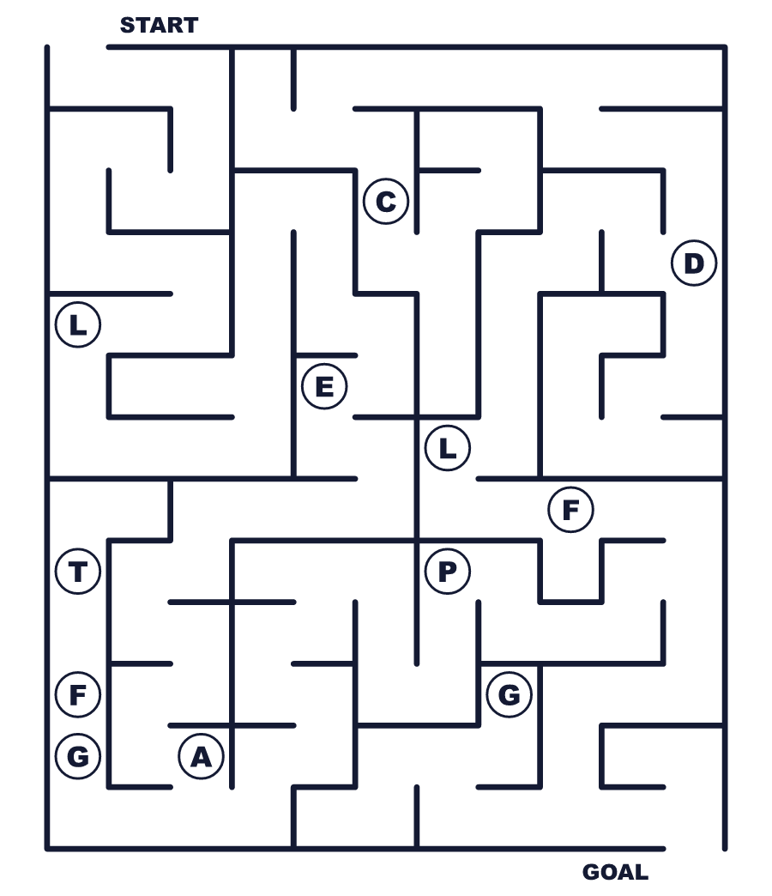
Secret word: ＿ ＿ ＿ ＿

🐸 Leap Day Worksheet
Class Activity & Writing
Class ______ No. ____ Name ______________________________
Let's Write! 英語で書いてみよう。
On my extra day, I want to ______.
おまけの1日に、私は______したいです。
______________________________________________________________
______________________________________________________________
If I were born on February 29, I would celebrate on ______ because ______.
もし2月29日生まれなら、______に祝います。なぜなら______だからです。
______________________________________________________________
______________________________________________________________

🐸 Leap Day Worksheet
Trace & Color
なぞって書こう。絵に色をぬろう。
Class ______ No. ____ Name ______________________________
🐸 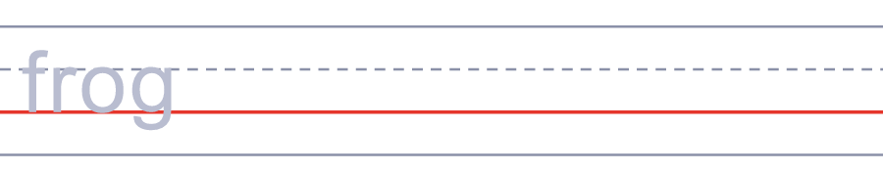

☀️ 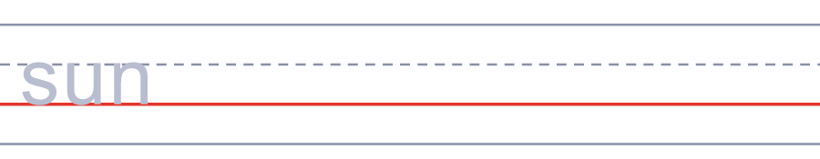
🌍 
🎂 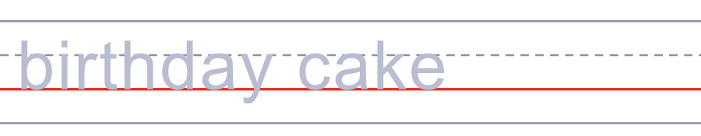
💍 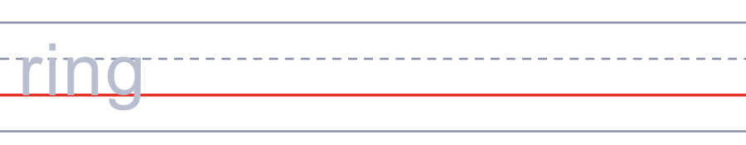

🐸 Leap Day Worksheet
Answer Key 解答
Reading Check: 1.B 2.D 3.A 4.B 5.C
True or False: 1.T 2.F 3.T 4.F
Match: 🐸=frog ☀️=sun 🌍=Earth 🎂=birthday cake 💍=ring 🧤=gloves
Fill in the blanks: (1)born (2)birthday (3)party (4)year (5)early (6)calendar (7)twelve
Maze: LEAP
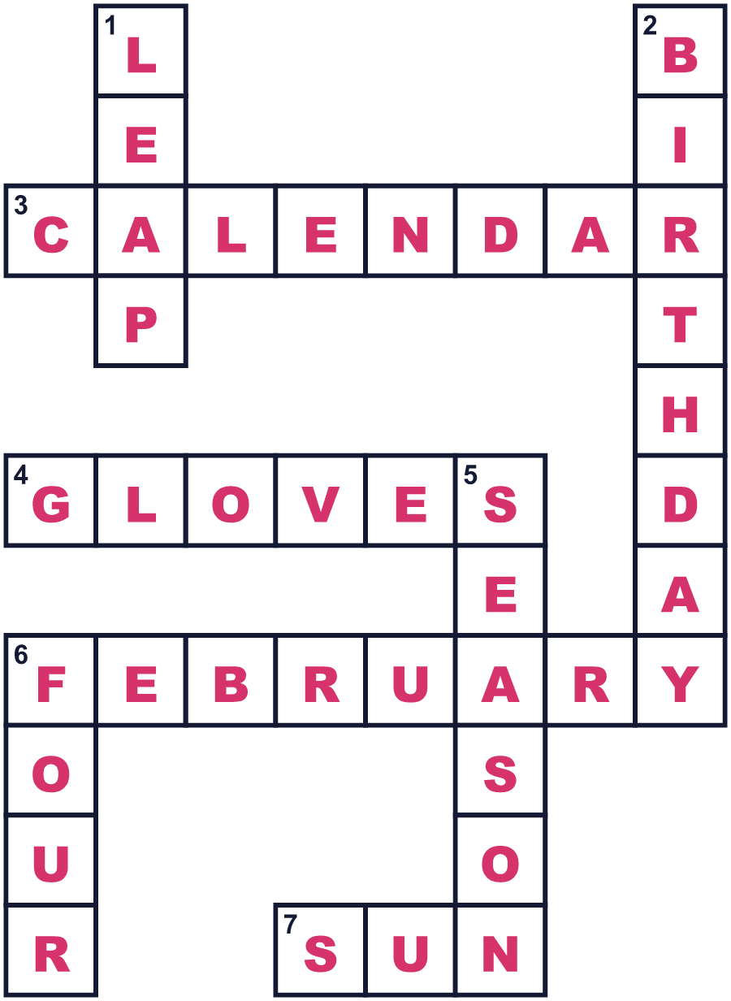
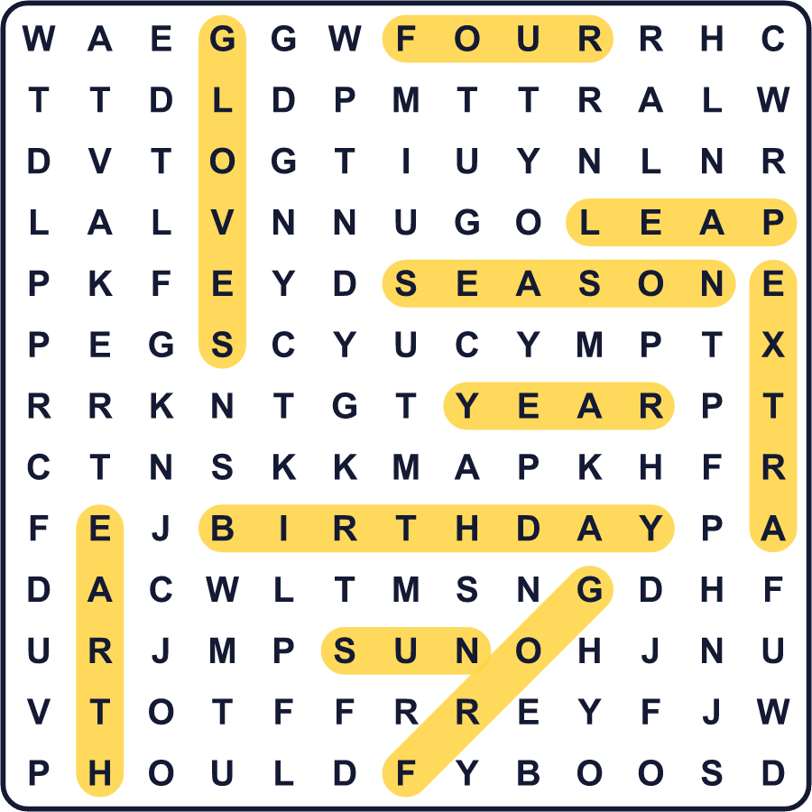
全訳
1 2月はふつう28日あります。でも4年に1度、もう1日増えます。2月29日です。この日をうるう日、その年をうるう年と呼びます。次は2028年です。
2 なぜこの日が必要なのでしょう。地球が太陽のまわりを回るのには、およそ365と4分の1日かかります。その4分の1日がたまっていきます。4年たつと、ほぼまる1日になります。そこで2月29日を足して、カレンダーを季節に合わせるのです。うるう年がなければ、何百年もかけて、夏が少しずつ冬の月へずれていってしまいます。
3 でも、4分の1はぴったりではありません。だからルールにはひとひねりあります。1900年のように00で終わる年は、うるう年ではありません。でも2000年のように400で割り切れる年は、うるう年です。このルールは、1500年代に教皇グレゴリウス13世のために作られた暦から来ています。
4 うるう日には楽しい言い伝えがあります。アイルランドの古い言い伝えでは、この日は女性から男性に結婚を申しこんでいいそうです。男性が断ったら、手袋か絹のドレスを買ってあげなければなりません。2月29日生まれの人は、リープリングと呼ばれます。本当の誕生日は4年に1度しか来ません。イギリスには、祖父、父、娘の3人がこの日に生まれた家族がいます。日本では、リープリングは2月28日の終わりに1つ年をとると法律で決まっています。

