🏮 Lantern Festival Worksheet
A Night of Red Lights
Read the story. 英文を読もう。
Class ______ No. ____ Name ______________________________

🔊 音声を聞こう（スマホで読みとってね）
1 On the first full moon of the Chinese new year, the streets glow red. Thousands of paper lanterns hang over the roads, and they come in many shapes and colors. Children walk with small lanterns in their hands. This is the Lantern Festival. It is on the 15th day of the new year, and it is the last day of the holidays.
2 The festival is more than 2,000 years old. Long ago, people lit lamps all night for this day. Later, the old capital city of Chang'an had a strict rule, and people could not go out at night. But during the Lantern Festival, everyone could go out and see the lights. Young women could go out too, and some of them met boyfriends there. So some people call it Chinese Valentine's Day.
3 Many lanterns have riddles on them. People read the riddles and try to guess the answers. They also eat sweet rice balls called tangyuan. Some have black sesame or sweet red beans inside. The balls are round like the full moon. Their name sounds like the Chinese word for a family coming together.
4 Today, people celebrate in many places. In Pingxi, Taiwan, people write wishes on big paper lanterns and send them up into the night sky. In Nagasaki, Japan, about 15,000 red lanterns light up the city every winter. In 2018, more than one million people came to see them.
Words 単語
lantern（ちょうちん、ランタン） / glow（（やわらかく）光る、輝く） / full moon（満月） / strict（きびしい） / riddle（なぞなぞ） / guess（（答えを）当てる、推測する） / wish（願いごと） / capital（首都、都）

🏮 Lantern Festival Worksheet
Reading Check
Choose the best answer. 正しいものを選ぼう。
Class ______ No. ____ Name ______________________________
1. What is the reading mainly about?
(A) How to make paper lanterns at home (B) The history of the city of Nagasaki (C) A Chinese festival with lanterns, riddles, and rice balls (D) Why the moon is round
2. When is the Lantern Festival?
(A) On the 15th day of the Chinese new year (B) On the last day of December (C) On the first day of the new year (D) In the middle of summer
3. Why do some people call it Chinese Valentine's Day?
(A) Because people give chocolate (B) Because the lanterns are shaped like hearts (C) Because it is in February every year (D) Because young women could go out and meet boyfriends
4. In paragraph 2, what does "strict" mean?
(A) Very bright (B) Not easy to break; you must follow it (C) Very old (D) Fun and exciting
5. What is inside Mei-ling's tangyuan?
(A) Black sesame (B) Red bean (C) Peanuts (D) Meat
True or False? T か F に○
1. The Lantern Festival is on the 15th day of the Chinese new year. T / F
2. People eat square cakes on the Lantern Festival. T / F
3. Many lanterns have riddles on them. T / F
4. The Lantern Festival is only 50 years old. T / F

🏮 Lantern Festival Worksheet
Word Work
単語のれんしゅう
Class ______ No. ____ Name ______________________________
① Match the pictures and the words. 絵と単語を線でむすぼう。
🏮 | ● | ● | lantern
🌕 | ● | ● | full moon
🦁 | ● | ● | soup
🐉 | ● | ● | dragon
❓ | ● | ● | riddle
🥣 | ● | ● | lion
③ Fill in the blanks. 語群から選んで入れよう。
[ balls / lantern / moon / snowman / sun / family / guesses / everywhere / riddle ]
Tonight is the Lantern Festival. Lily makes a red (1) __________ with her grandma. They walk to the park under the full (2) __________ . There are lights (3) __________ ! Lily reads a (4) __________ on a big lantern. She thinks hard and (5) __________ the answer. Then they go home and eat sweet rice (6) __________ with the whole (7) __________ .

🏮 Lantern Festival Worksheet
Crossword Puzzle
ヒントを読んでクロスワードを完成させよう。
Class ______ No. ____ Name ______________________________
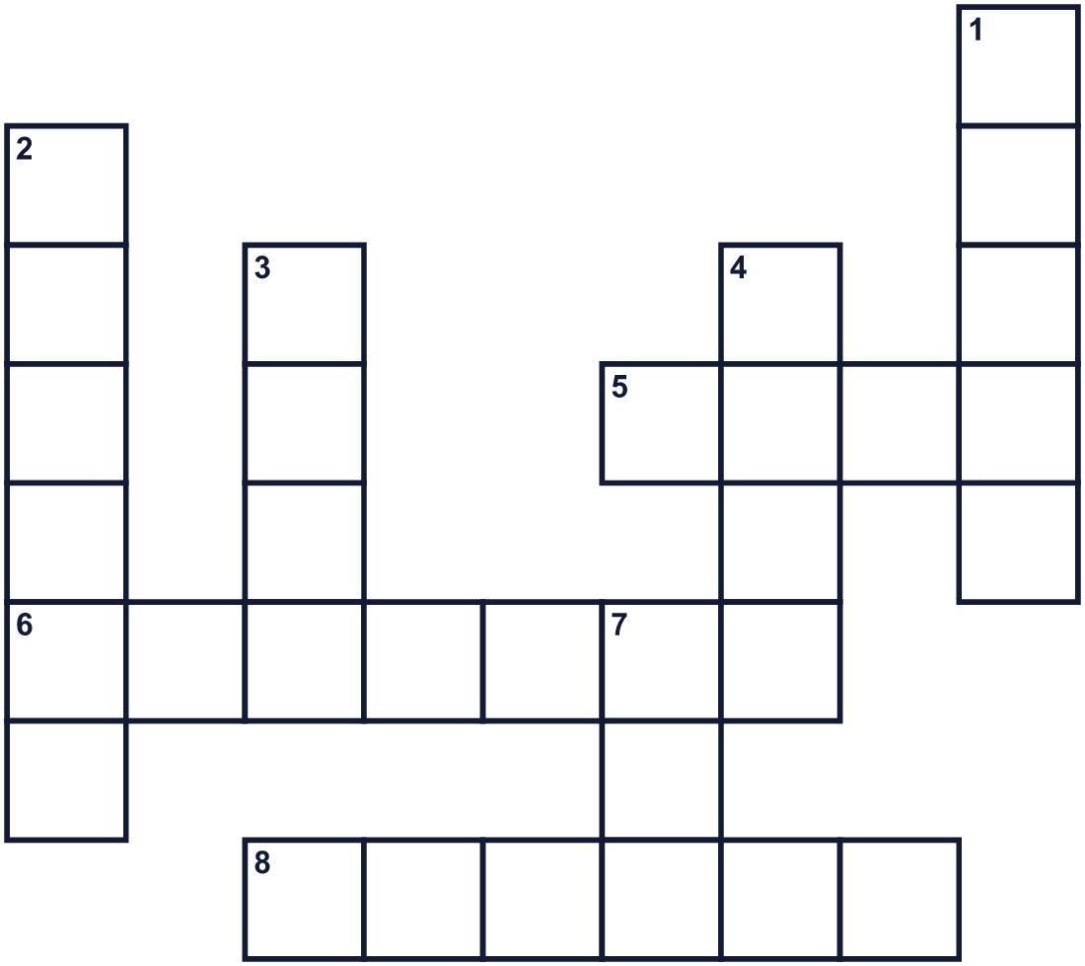
Across →
5. Something you hope for. People write it on sky lanterns. (4)
6. A light inside a paper or glass cover. (7)
8. A funny question. You must think hard to answer it. (6)
Down ↓
1. The dark time after the sun goes down. (5)
2. Parents, children, and grandparents together. (6)
3. It shines at night. It is full on this festival. (4)
4. A big cat. People dance in a costume of this animal. (4)
7. The color of most lanterns at this festival. (3)

🏮 Lantern Festival Worksheet
Word Search
かくれた単語をさがそう（→ ↓ ↘ ↗）
Class ______ No. ____ Name ______________________________
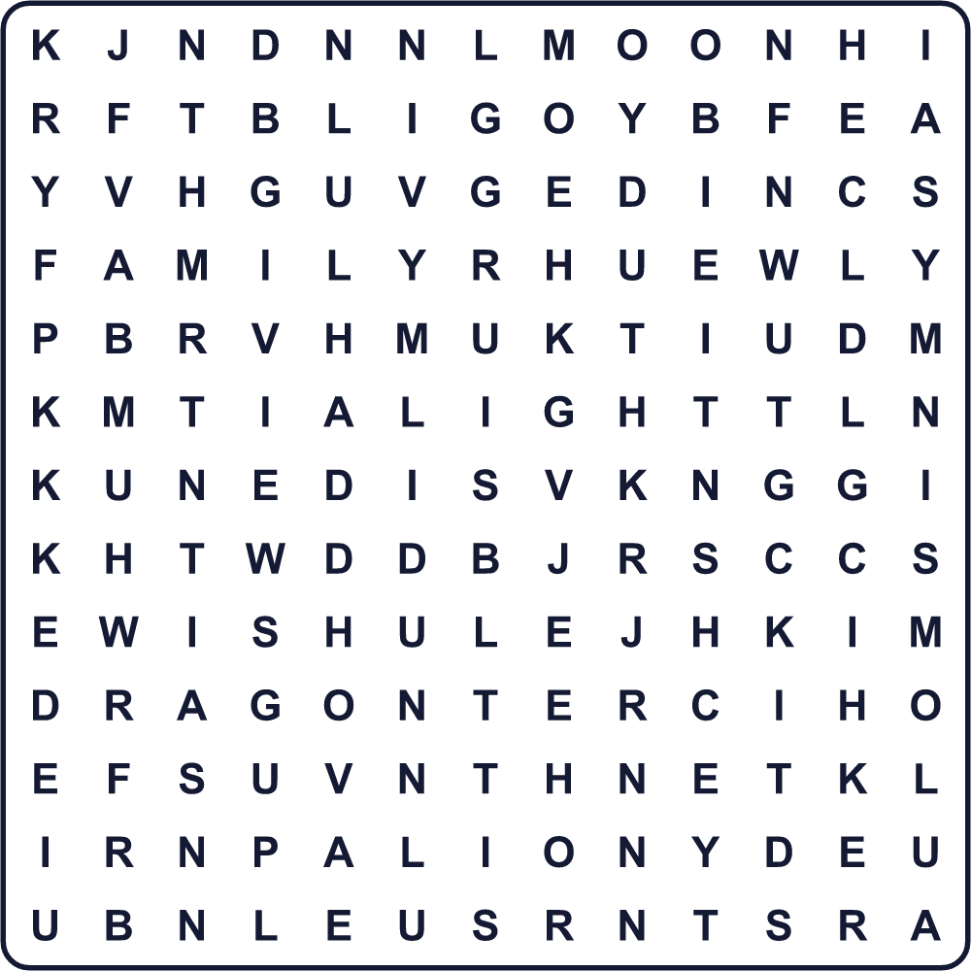
DRAGON FAMILY LANTERN LIGHT LION MOON NIGHT RED RIDDLE WISH

🏮 Lantern Festival Worksheet
Maze & Sentences
Class ______ No. ____ Name ______________________________
Help Lily carry her lantern to the park! リリーがちょうちんを持って公園まで行けるように手伝おう！
正しい道の文字を集めると、ひみつの言葉になるよ。 START 👧 → GOAL 🏮
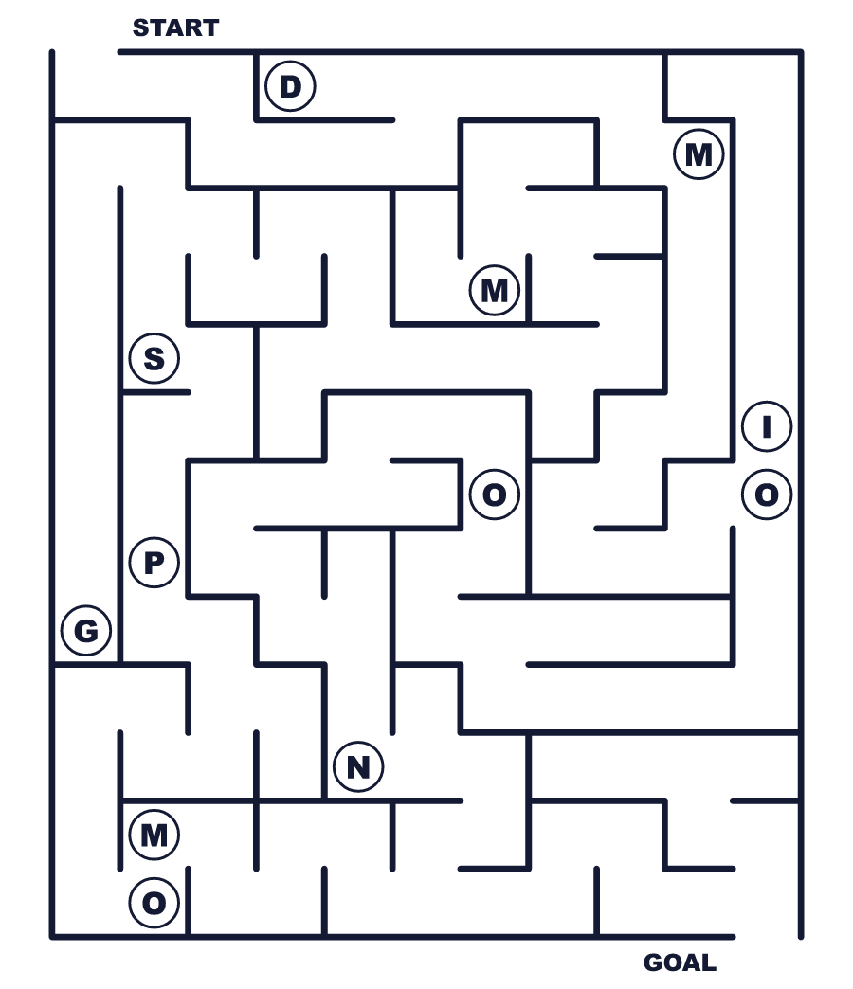
Secret word: ＿ ＿ ＿ ＿

🏮 Lantern Festival Worksheet
Class Activity & Writing
Class ______ No. ____ Name ______________________________
Let's Write! 英語で書いてみよう。
My wish for this year is ______ because ______.
今年の私の願いは＿＿＿です。なぜなら＿＿＿だからです。
______________________________________________________________
______________________________________________________________
Here is my riddle: I am ______ and ______. What am I?
私のなぞなぞ：私は＿＿＿で＿＿＿です。私はなんでしょう？
______________________________________________________________
______________________________________________________________

🏮 Lantern Festival Worksheet
Trace & Color
なぞって書こう。絵に色をぬろう。
Class ______ No. ____ Name ______________________________
🏮 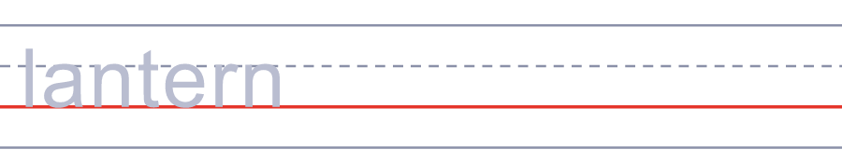

🌕 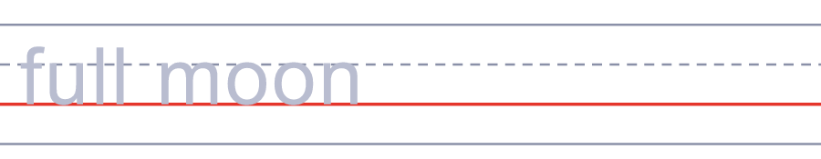
🦁 
🐉 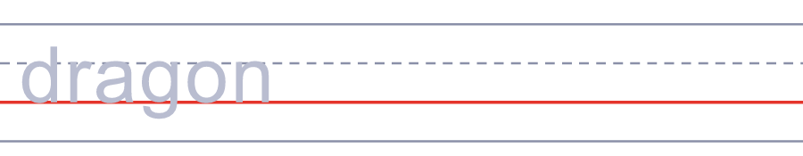
❓ 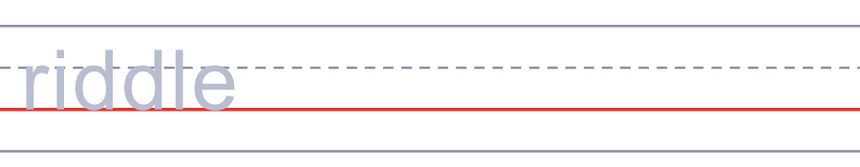

🏮 Lantern Festival Worksheet
Answer Key 解答
Reading Check: 1.C 2.A 3.D 4.B 5.A
True or False: 1.T 2.F 3.T 4.F
Match: 🏮=lantern 🌕=full moon 🦁=lion 🐉=dragon ❓=riddle 🥣=soup
Fill in the blanks: (1)lantern (2)moon (3)everywhere (4)riddle (5)guesses (6)balls (7)family
Maze: MOON
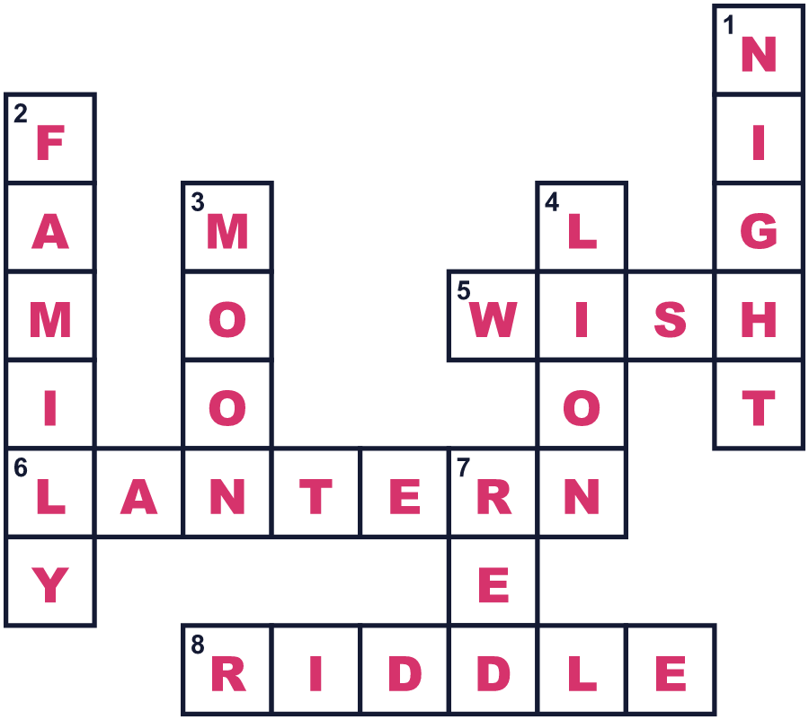
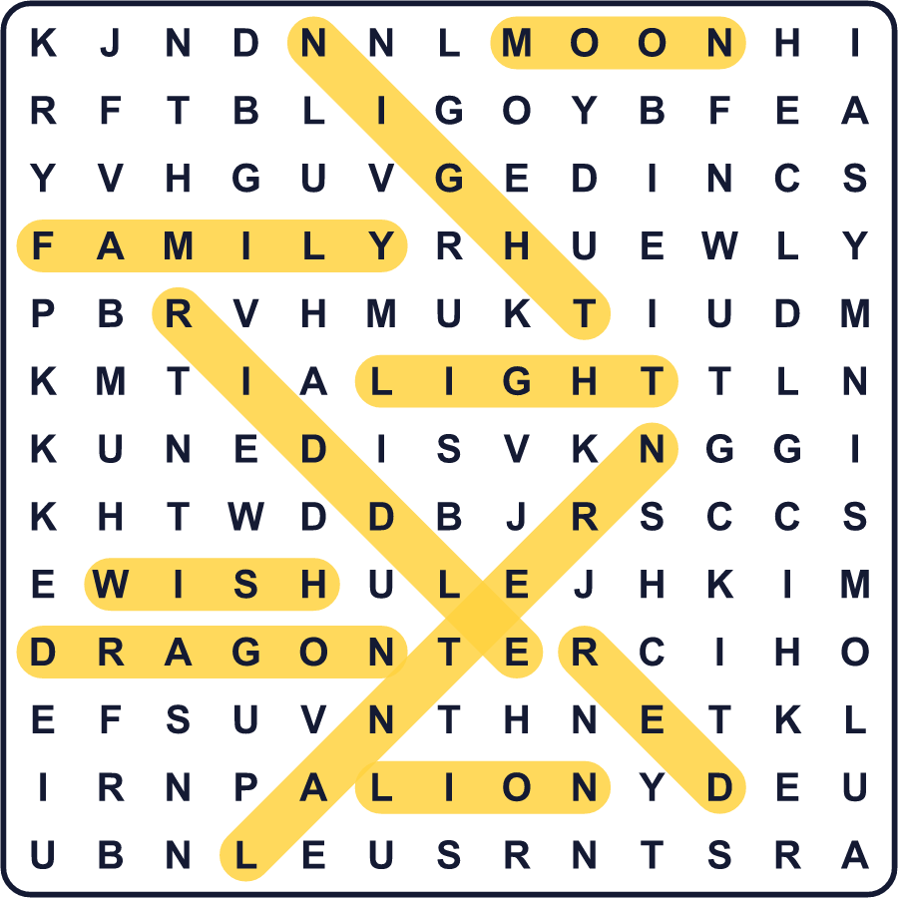
全訳
1 旧暦の新年最初の満月の夜、通りは赤く光ります。何千ものちょうちんが道の上につるされ、その形も色もさまざまです。子どもたちは小さなちょうちんを手に持って歩きます。これが元宵節です。新年から15日目にあたり、お祝いの最後の日です。
2 このお祭りは2000年以上の歴史があります。昔、人々はこの日のために一晩中灯りをともしました。のちに、昔の都・長安にはきびしい決まりがあり、人々は夜に外出できませんでした。でも元宵節のあいだは、だれでも外に出て灯りを見ることができました。若い女性も外出でき、そこで恋人と出会う人もいました。だから、この日を中国のバレンタインデーと呼ぶ人もいます。
3 多くのちょうちんには、なぞなぞが書かれています。人々はなぞなぞを読んで、答えを当てようとします。湯圓という甘いもち米の団子も食べます。中に黒ごまや甘いあずきが入っているものもあります。団子は満月のようにまるい形です。その名前は、中国語で家族がそろうことを表す言葉に似た音なのです。
4 今では、いろいろな場所でこの日が祝われています。台湾の平渓では、大きな紙のランタンに願いごとを書いて、夜空に飛ばします。日本の長崎では、毎年冬に約1万5000個の赤いちょうちんが町を照らします。2018年には、100万人以上がそれを見に来ました。

