🛠️ Labor Day Worksheet
The Day Ten Thousand Workers Stopped Working
Read the story. 英文を読もう。
Class ______ No. ____ Name ______________________________
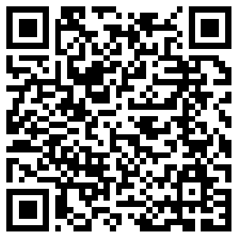
🔊 音声を聞こう（スマホで読みとってね）
1 On September 5, 1882, about 10,000 workers in New York did something brave. It was a Tuesday, but they did not go to work. They lost a day's pay and marched through the city instead. After the march, they had a big party with their families. Their message was simple: workers make the country strong.
2 At that time, many people worked 12 hours a day or more. Workers' groups, called unions, wanted shorter hours and a special day for workers. Other cities liked the idea, too. In 1887, Oregon became the first state to make Labor Day a holiday. Then in 1894, President Grover Cleveland signed a federal Labor Day law.
3 In many countries, the workers' day is on May 1. That day grew out of events in Chicago in 1886. But the United States chose a Monday in September. Some leaders worried that May 1 was connected to angry protests. Canada also has Labour Day in September, and it spells the name with the letter u.
4 Today, Labor Day feels like the last weekend of summer. Families have barbecues and take one more trip to the beach. Stores have big sales, and many children start school around this time. There is also an old fashion rule: no white clothes after Labor Day. Not many people follow it now, but they still joke about it every September.
Words 単語
brave（勇気のある） / march（行進する） / pay（給料） / union（労働組合） / federal（連邦の（国全体の）） / protest（抗議、抗議運動） / spell（（語を）つづる） / barbecue（バーベキュー）

🛠️ Labor Day Worksheet
Reading Check
Choose the best answer. 正しいものを選ぼう。
Class ______ No. ____ Name ______________________________
1. What is the reading mainly about?
(A) How to plan a barbecue in summer (B) How Labor Day started and how people spend it today (C) Why Chicago is a big city (D) Why workers in Canada spell words differently
2. What did the workers lose on September 5, 1882?
(A) Their jobs (B) Their homes (C) A day's pay (D) Their union
3. Which state made Labor Day a holiday first?
(A) Oregon (B) New York (C) Illinois (D) Virginia
4. Why did some leaders not want Labor Day on May 1?
(A) Because May was too cold for parades (B) Because schools started on May 1 (C) Because Canada used that day (D) Because May 1 was connected to angry protests
5. In the dialogue, why can Sota wear his white T-shirt on Monday?
(A) Because white is Emily's favorite color (B) Because the rule starts after Labor Day (C) Because there is a parade (D) Because it is cold by the lake
True or False? T か F に○
1. The first Labor Day parade was in New York. T / F
2. Labor Day in the United States is on May 1. T / F
3. Oregon was the first state to make Labor Day a holiday. T / F
4. In Canada, Labor Day is in December. T / F

🛠️ Labor Day Worksheet
Word Work
単語のれんしゅう
Class ______ No. ____ Name ______________________________
① Match the pictures and the words. 絵と単語を線でむすぼう。
🍔 | ● | ● | beach
🏖️ | ● | ● | worker
🎒 | ● | ● | flag
🏈 | ● | ● | football
🚩 | ● | ● | hamburger
👷 | ● | ● | backpack
③ Fill in the blanks. 語群から選んで入れよう。
[ snow / Monday / backpack / hard / lake / school / barbecue / summer / Friday ]
It is Labor Day, the first (1) __________ in September. Mia and her dad go to the (2) __________ . They cook hot dogs at a (3) __________ . Mia swims for the last time this (4) __________ . In the evening, she gets her (5) __________ ready. Tomorrow is the first day of (6) __________ . "Thank you for working so (7) __________ all year, Dad," she says. He smiles.

🛠️ Labor Day Worksheet
Crossword Puzzle
ヒントを読んでクロスワードを完成させよう。
Class ______ No. ____ Name ______________________________
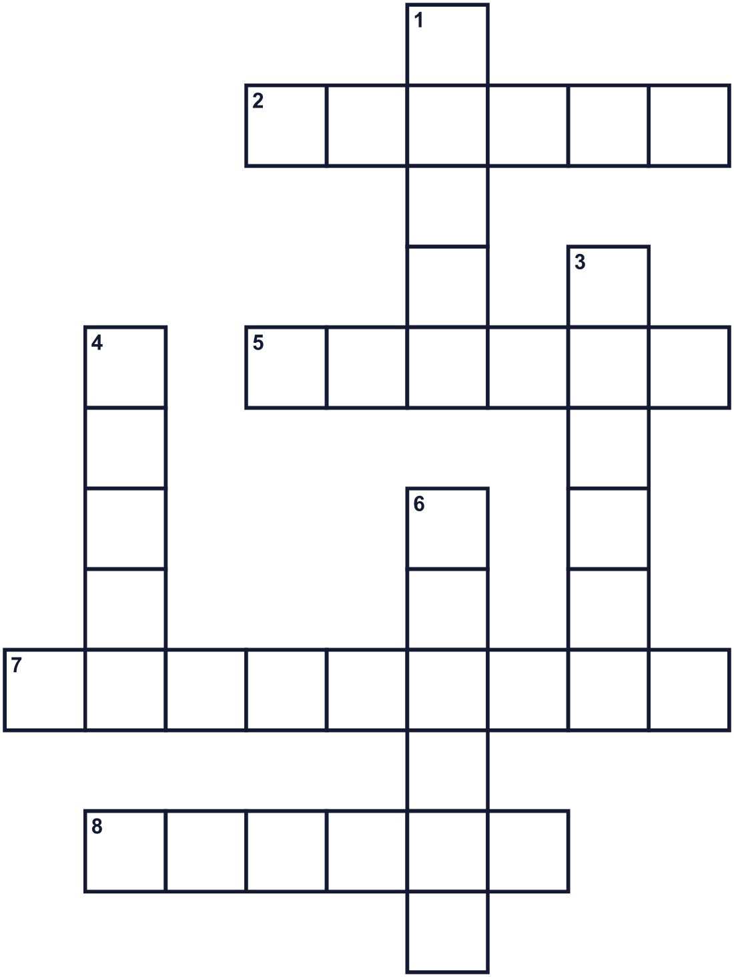
Across →
2. The country north of the United States. (6)
5. The first day of the work week. (6)
7. The ninth month of the year. (9)
8. A person who has a job. (6)
Down ↓
1. A group of workers who help each other. (5)
3. Many people walk in the street together with flags and music. (6)
4. The color of snow and milk. (5)
6. The hot season. It ends around this holiday. (6)

🛠️ Labor Day Worksheet
Word Search
かくれた単語をさがそう（→ ↓ ↘ ↗）
Class ______ No. ____ Name ______________________________
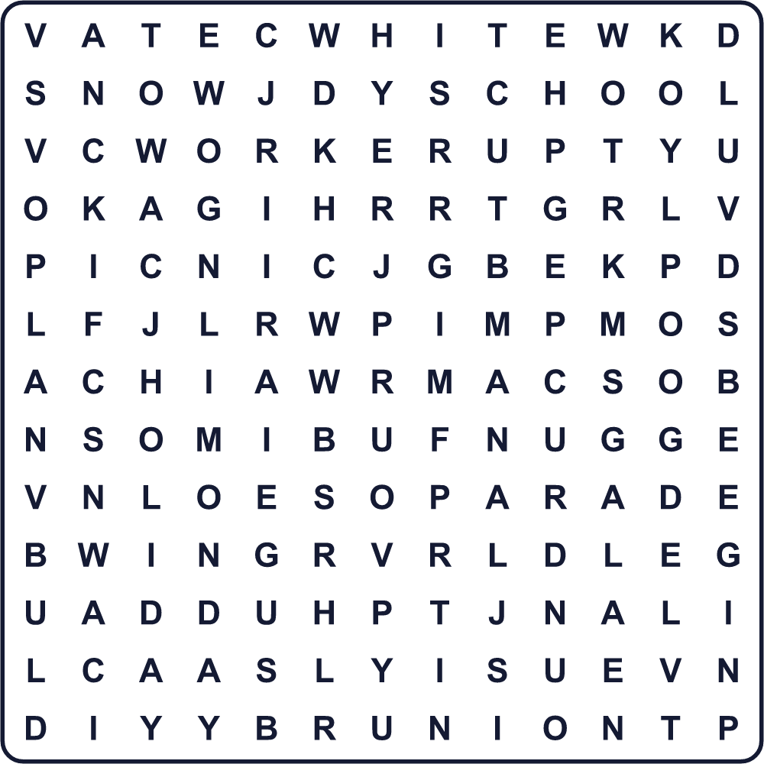
HOLIDAY LABOR MONDAY PARADE PICNIC SCHOOL SUMMER UNION WHITE WORKER

🛠️ Labor Day Worksheet
Maze & Sentences
Class ______ No. ____ Name ______________________________
Help the worker get to the picnic! 働く人をピクニックまで連れていこう！
正しい道の文字を集めると、ひみつの言葉になるよ。 START 👷 → GOAL 🍔
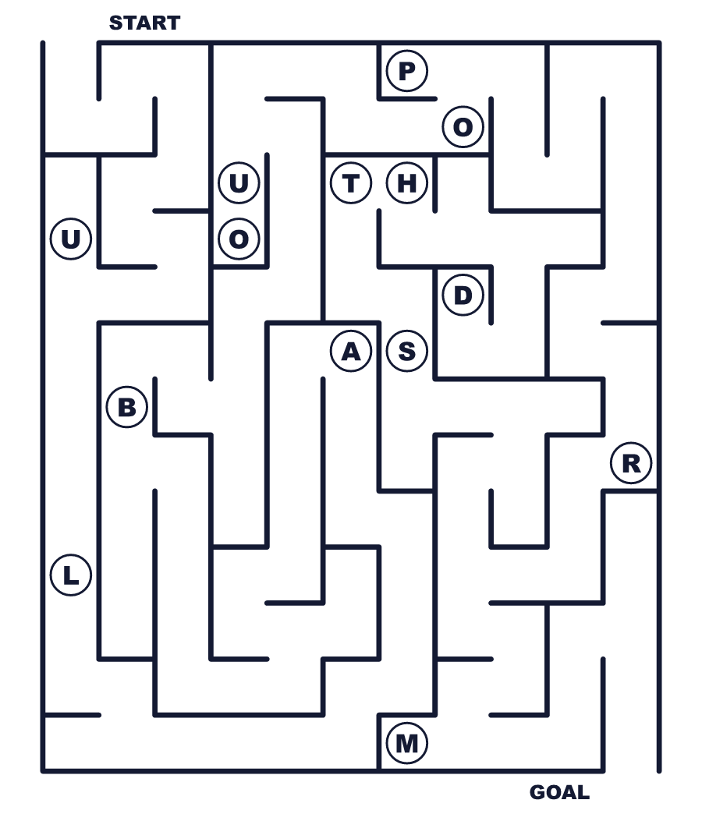
Secret word: ＿ ＿ ＿ ＿ ＿

🛠️ Labor Day Worksheet
Class Activity & Writing
Class ______ No. ____ Name ______________________________
Let's Write! 英語で書いてみよう。
I want to thank ______ for their work because ______.
私は______の仕事に感謝したい。なぜなら______だから。
______________________________________________________________
______________________________________________________________
On the last day of summer vacation, I like to ______.
夏休みの最後の日に、私は______するのが好きです。
______________________________________________________________
______________________________________________________________

🛠️ Labor Day Worksheet
Trace & Color
なぞって書こう。絵に色をぬろう。
Class ______ No. ____ Name ______________________________
🍔 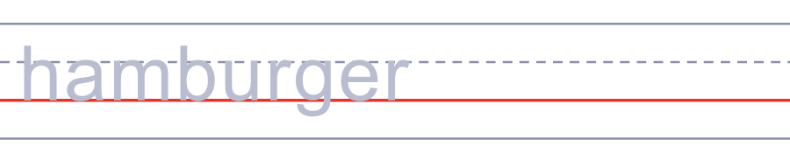

🏖️ 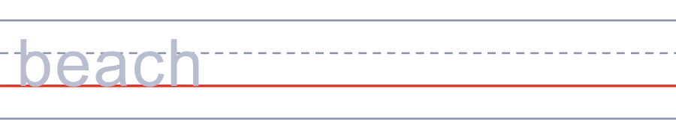
🎒 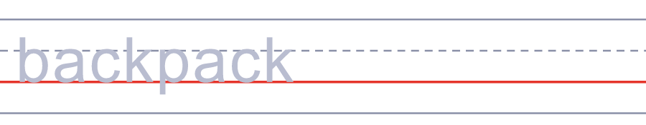
🏈 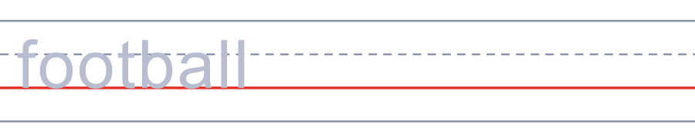
🚩 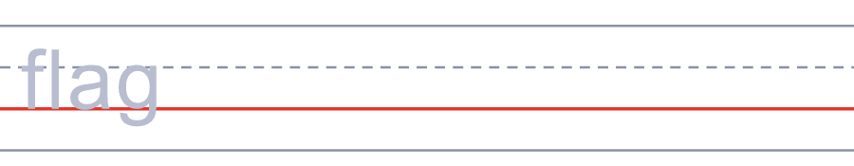

🛠️ Labor Day Worksheet
Answer Key 解答
Reading Check: 1.B 2.C 3.A 4.D 5.B
True or False: 1.T 2.F 3.T 4.F
Match: 🍔=hamburger 🏖️=beach 🎒=backpack 🏈=football 🚩=flag 👷=worker
Fill in the blanks: (1)Monday (2)lake (3)barbecue (4)summer (5)backpack (6)school (7)hard
Maze: LABOR
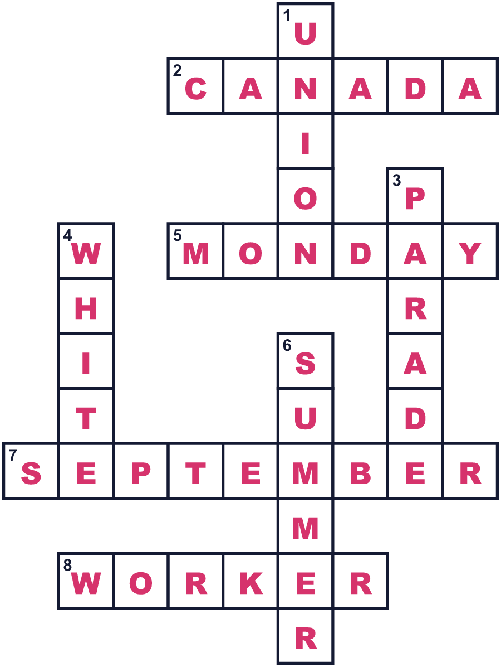
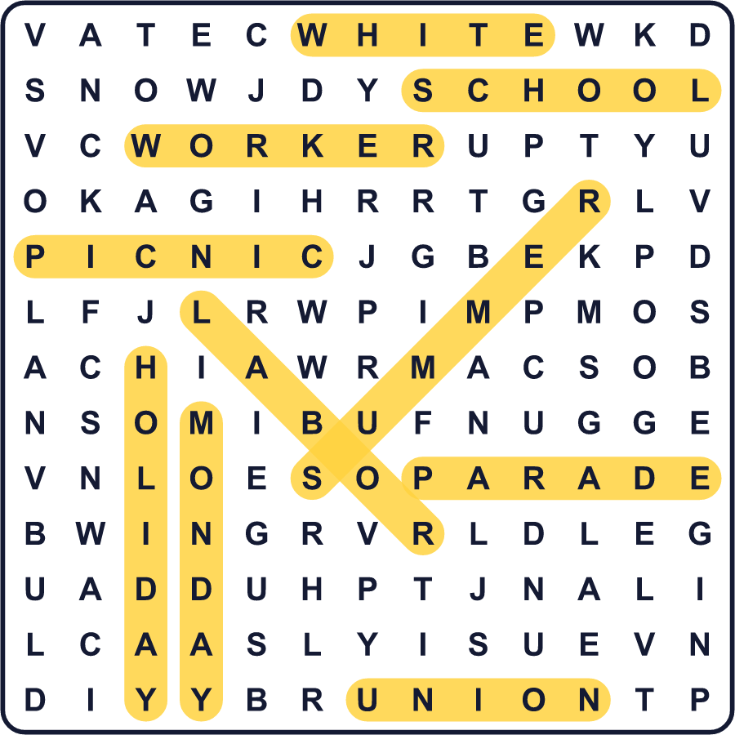
全訳
1 1882年9月5日、ニューヨークで約1万人の労働者が、勇気のいることをしました。その日は火曜日でしたが、彼らは仕事に行きませんでした。1日分の給料を失い、そのかわりに街を行進したのです。行進のあと、彼らは家族と一緒に大きなパーティーを開きました。彼らの伝えたいことは単純でした。働く人こそが国を強くする、ということです。
2 当時は、1日12時間以上働く人がたくさんいました。労働組合と呼ばれる働く人たちの団体は、もっと短い労働時間と、働く人のための特別な日を求めました。ほかの都市も、この考えを気に入りました。1887年、オレゴン州がレイバー・デーを祝日にした最初の州になりました。そして1894年、グロバー・クリーブランド大統領が連邦のレイバー・デーの法律に署名しました。
3 多くの国では、働く人の日は5月1日です。その日は、1886年のシカゴでの出来事から生まれました。でもアメリカは、9月の月曜日を選びました。5月1日は怒りに満ちた抗議運動と結びついている、と心配する指導者もいたのです。カナダも9月にレイバー・デーがあり、名前を u の字の入ったつづりで書きます。
4 今、レイバー・デーは夏の最後の週末のように感じられます。家族はバーベキューをしたり、もう一度海へ出かけたりします。お店は大きなセールをし、多くの子どもたちはこのころ新学期を迎えます。昔のファッションのルールもあります。レイバー・デーのあとは白い服を着ない、というものです。今はそれを守る人は多くありませんが、毎年9月になると今でも冗談のネタになります。

