🍅 La Tomatina Worksheet
One Red Hour in Buñol
Read the story. 英文を読もう。
Class ______ No. ____ Name ______________________________

🔊 音声を聞こう（スマホで読みとってね）
1 Every year, on the last Wednesday of August, a small town in Spain turns red. The town is Buñol, about 38 kilometers from Valencia. Only about 10,000 people live there. But on this day, around 20,000 visitors come to throw tomatoes at each other.
2 Local people say it all started in 1945. Young people pushed into a parade of giant puppets in the town square. Someone fell down, and a fight began. There was a vegetable stand nearby, so people grabbed tomatoes and threw them. The next year, the young people came back with their own tomatoes.
3 At first, the town did not like the tomato fight. It banned the fight several times in the 1950s. So in 1957, people held a funny protest. They carried a big tomato through the streets in a coffin, like a funeral, and a band played sad music. Two years later, the festival became official.
4 Today, the battle starts at noon. Big trucks bring more than 100 tons of very ripe tomatoes. These tomatoes are grown for the festival, not for eating. You must squash a tomato before you throw it, so it does not hurt. And you must not tear other people's shirts.
5 After one hour, a loud signal ends the fight. Then fire trucks wash the streets with water. Since 2013, people need a ticket to join, because the crowd got too big. Children aged 4 to 14 have their own smaller fight on the Saturday before. By the evening, the red streets are gray stone again, and the town is quiet until next August.
Words 単語
parade（パレード、行列） / puppet（人形、操り人形） / stand（屋台、売り場） / grab（ぱっとつかむ） / ban（禁止する） / protest（抗議） / coffin（棺おけ） / funeral（お葬式） / official（正式な、公式の） / ripe（熟した） / squash（ぐしゃっとつぶす） / tear（破る、引きさく）

🍅 La Tomatina Worksheet
Reading Check
Choose the best answer. 正しいものを選ぼう。
Class ______ No. ____ Name ______________________________
1. What is the main idea of the story?
(A) A town in Spain has a big tomato fight every summer. (B) Spain grows more tomatoes than any other country. (C) Children in Valencia learn how to cook tomatoes. (D) A fire truck festival happens every August in Spain.
2. When did the story of La Tomatina start?
(A) In 1945 (B) In 1957 (C) In 1959 (D) In 2013
3. Why did people throw tomatoes in the first fight?
(A) They wanted to win a prize. (B) A teacher told them to do it. (C) There was a vegetable stand nearby. (D) The tomatoes were too old to sell.
4. What did people carry through the streets in 1957?
(A) A giant puppet on a truck (B) A big tomato in a coffin (C) A ham on a long pole (D) A basket of fresh bread
5. In paragraph 4, what does "squash" mean?
(A) To wash something with water (B) To cut something into slices (C) To press something until it is soft (D) To throw something very high
6. Which sentence is true about the story?
(A) The tomatoes are grown for eating. (B) Anyone can join without a ticket. (C) The fight lasts for a whole day. (D) Children have their own smaller fight.
7. Why did the town start selling tickets?
(A) To make the crowd smaller and safer (B) To pay for a new train station (C) To stop people from eating tomatoes (D) To bring more people from Valencia
8. In the dialogue, what does Lucía tell Ren to wear?
(A) A white shirt and a hat (B) Old clothes, strong shoes, and goggles (C) A costume of a giant puppet (D) Sandals and a swimsuit
True or False? T か F に○
1. La Tomatina is on the last Wednesday of August. T / F
2. La Tomatina takes place in the center of Madrid. T / F
3. The tomato fight lasts for about one hour. T / F
4. In 1957, people held a funeral for a tomato. T / F
5. You can throw bottles if you want to. T / F
6. Anyone can join for free without a ticket. T / F

🍅 La Tomatina Worksheet
Word Work
単語のれんしゅう
Class ______ No. ____ Name ______________________________
① Match the pictures and the words. 絵と単語を線でむすぼう。
🍅 | ● | ● | tomato
🚚 | ● | ● | fire engine
🥽 | ● | ● | shower
🎫 | ● | ● | goggles
🚒 | ● | ● | ticket
👕 | ● | ● | T-shirt
🥘 | ● | ● | truck
🚿 | ● | ● | paella
② Unscramble the words. 並べかえて単語にしよう。
1. M T O A T O (トマト) → ____________________
2. S A H S Q U (つぶす) → ____________________
3. P A A D E R (パレード) → ____________________
4. T C R K U (トラック) → ____________________
5. G L G S E G O (ゴーグル) → ____________________
6. E C K T I T (入場券) → ____________________
③ Fill in the blanks. 語群から選んで入れよう。
[ winter / shower / goggles / squash / clothes / year / rice / brother / Saturday / truck / red / pencil / Spain ]
Mia is 9 years old. Her family is on vacation in (1) __________ . On (2) __________ , she joins the children's tomato fight in Buñol. She wears old (3) __________ and big (4) __________ . A man shouts, "Remember, (5) __________ the tomato first!" Then a (6) __________ drops a mountain of red tomatoes. Mia throws one at her (7) __________ . He laughs and throws one back. Soon, everyone is (8) __________ from head to toe. After the fight, Mia takes a cold (9) __________ . "Can we come back next (10) __________ ?" she asks.

🍅 La Tomatina Worksheet
Crossword Puzzle
ヒントを読んでクロスワードを完成させよう。
Class ______ No. ____ Name ______________________________
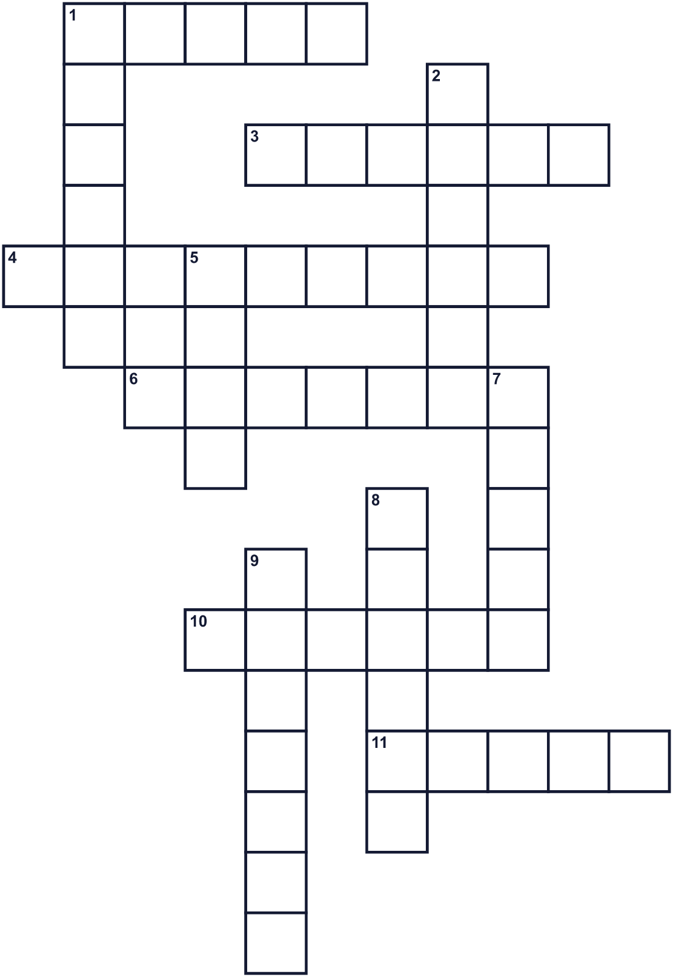
Across →
1. A big car that carries the fruit into the streets. (5)
3. A soft fruit. People throw it at this festival. (6)
4. The festival is on the last one of the month. (9)
6. You wear these to protect your eyes. (7)
10. The festival is in this month. (6)
11. The country where Buñol is. (5)
Down ↓
1. Since 2013, you need this to join. (6)
2. A line of people and giant puppets walking in the street. (6)
5. The fight starts at this time, 12 o'clock. (4)
7. Do not tear other people's clothes, like this white top. (5)
8. Press it until it is soft before you throw it. (6)
9. In 1957, people held one for a big tomato. (7)

🍅 La Tomatina Worksheet
Word Search
かくれた単語をさがそう（→ ↓ ↘ ↗）
Class ______ No. ____ Name ______________________________
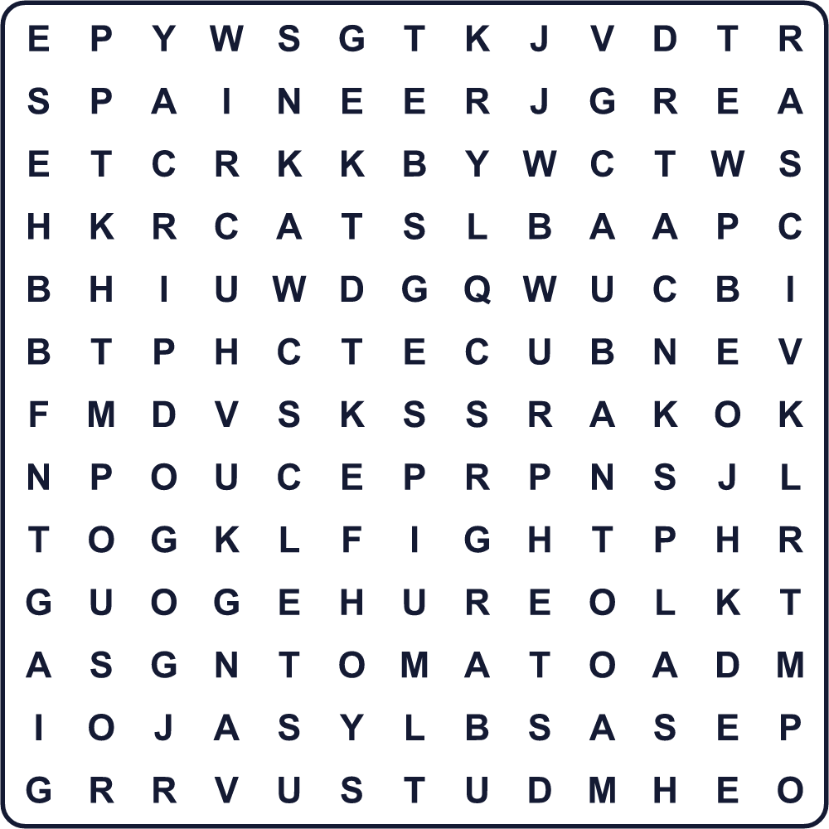
AUGUST BUNOL FIGHT GOGGLES NOON PARADE SPAIN SPLASH SQUASH TICKET TOMATO TRUCK WATER
Secret Code 暗号を解こう
♥=A ♦=F ♠=H ☂=I ☀=Q ⚑=R ☾=S ▲=T ◆=U
☾ ☀ ◆ ♥ ☾ ♠ ☂ ▲ ♦ ☂ ⚑ ☾ ▲
______________________________________________________________

🍅 La Tomatina Worksheet
Maze & Sentences
Class ______ No. ____ Name ______________________________
Help Lucía get to the tomato truck! ルシアをトマトのトラックまで連れていこう！
正しい道の文字を集めると、ひみつの言葉になるよ。 START 👧 → GOAL 🍅
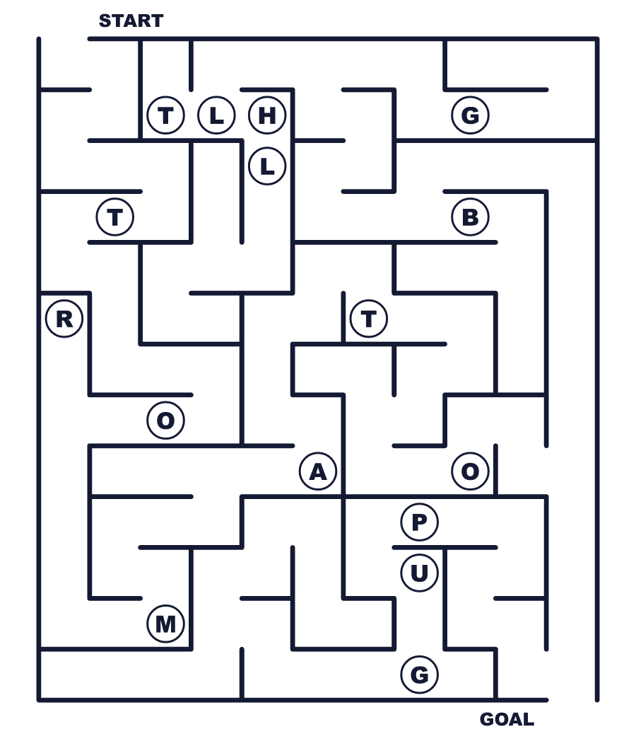
Secret word: ＿ ＿ ＿ ＿ ＿ ＿
Put the words in order. 並べかえよう。
1. town / is / The / Spanish / a / in / small / festival . (その祭りはスペインの小さな町で行われます。)
______________________________________________________________
2. You / tomato / must / the / first / squash . (まずトマトをつぶさなければなりません。)
______________________________________________________________
3. tons / bring / tomatoes / Big / trucks / of / ripe . (大きなトラックが熟したトマトを何トンも運んできます。)
______________________________________________________________
4. noon / and / starts / one / at / lasts / hour / The / fight . (戦いは正午に始まり、1時間続きます。)
______________________________________________________________
5. wash / after / Fire / streets / the / the / red / trucks / fight . (戦いのあと、消防車が赤い通りを洗います。)
______________________________________________________________

🍅 La Tomatina Worksheet
Class Activity & Writing
Class ______ No. ____ Name ______________________________
Find Someone Who… クラスで聞いて回ろう！
Find someone who … | Name
… likes tomatoes トマトが好き
… has been to Spain スペインに行ったことがある
… knows a word in Spanish スペイン語の単語を1つ知っている
… has thrown beans on Setsubun 節分に豆まきをしたことがある
… can name three red foods 赤い食べ物を3つ言える
… has ever worn goggles ゴーグルをつけたことがある
… likes ketchup on rice ごはんにケチャップ（オムライスなど）が好き
… has seen a parade パレードを見たことがある
Let's Write! 英語で書いてみよう。
If I went to La Tomatina, I would bring ______ because ______.
もしトマティーナに行くなら、＿＿を持っていく。なぜなら＿＿だから。
______________________________________________________________
______________________________________________________________
I think La Tomatina is ______ because ______.
トマティーナは＿＿だと思う。なぜなら＿＿だから。
______________________________________________________________
______________________________________________________________
One festival in Japan I want to show to the world is ______. People ______ there.
世界に紹介したい日本の祭りは＿＿です。そこでは人々は＿＿します。
______________________________________________________________
______________________________________________________________

🍅 La Tomatina Worksheet
Trace & Color
なぞって書こう。絵に色をぬろう。
Class ______ No. ____ Name ______________________________
🍅 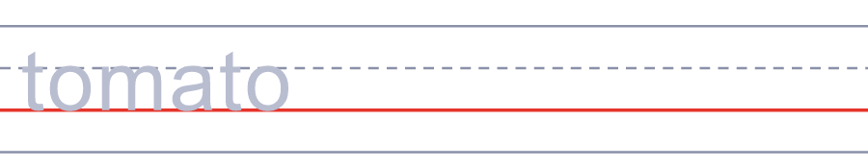

🚚 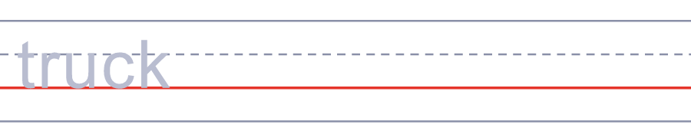
🥽 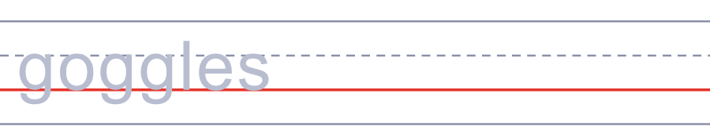
🎫 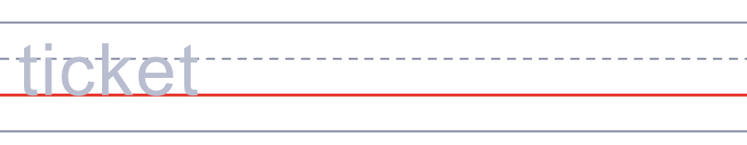
🚒 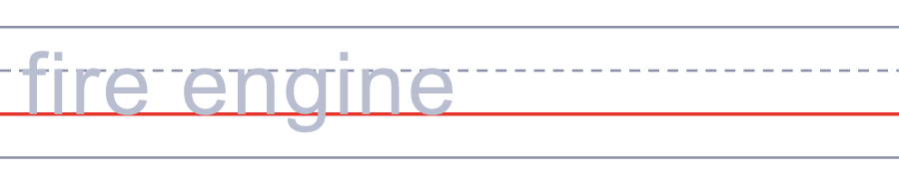
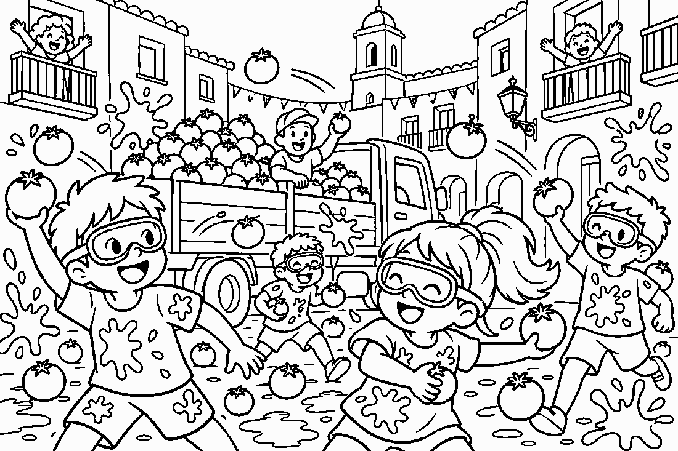

🍅 La Tomatina Worksheet
Answer Key 解答
Reading Check: 1.A 2.A 3.C 4.B 5.C 6.D 7.A 8.B
True or False: 1.T 2.F 3.T 4.T 5.F 6.F
Match: 🍅=tomato 🚚=truck 🥽=goggles 🎫=ticket 🚒=fire engine 👕=T-shirt 🥘=paella 🚿=shower
Unscramble: 1.TOMATO 2.SQUASH 3.PARADE 4.TRUCK 5.GOGGLES 6.TICKET
Fill in the blanks: (1)Spain (2)Saturday (3)clothes (4)goggles (5)squash (6)truck (7)brother (8)red (9)shower (10)year
Sentence order: 1. The festival is in a small Spanish town. 2. You must squash the tomato first. 3. Big trucks bring tons of ripe tomatoes. 4. The fight starts at noon and lasts one hour. 5. Fire trucks wash the red streets after the fight.
Secret Code: SQUASH IT FIRST
Maze: TOMATO
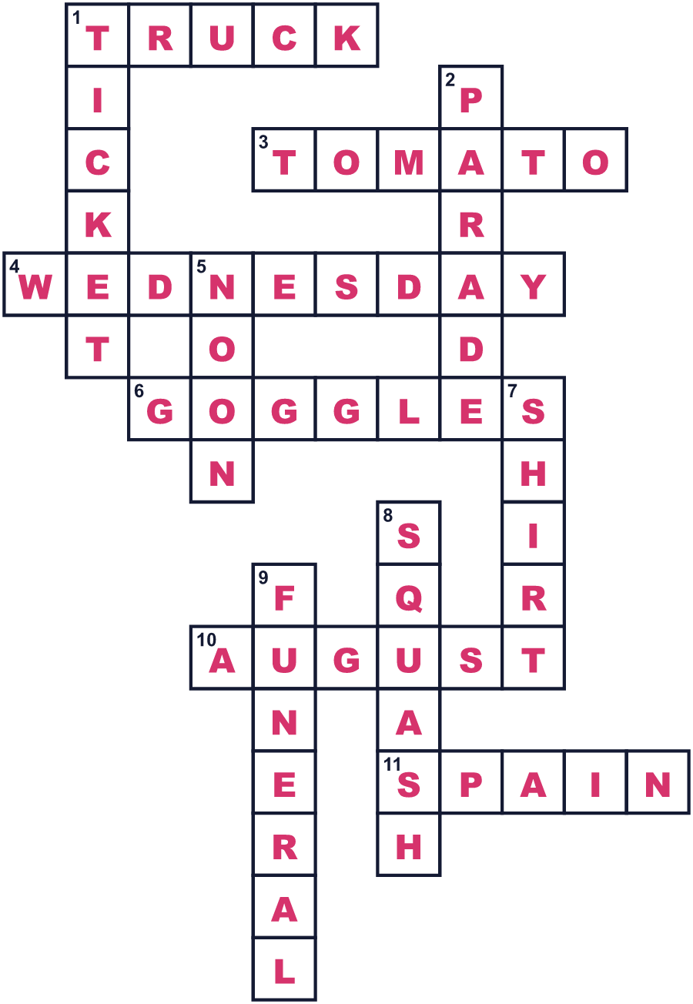
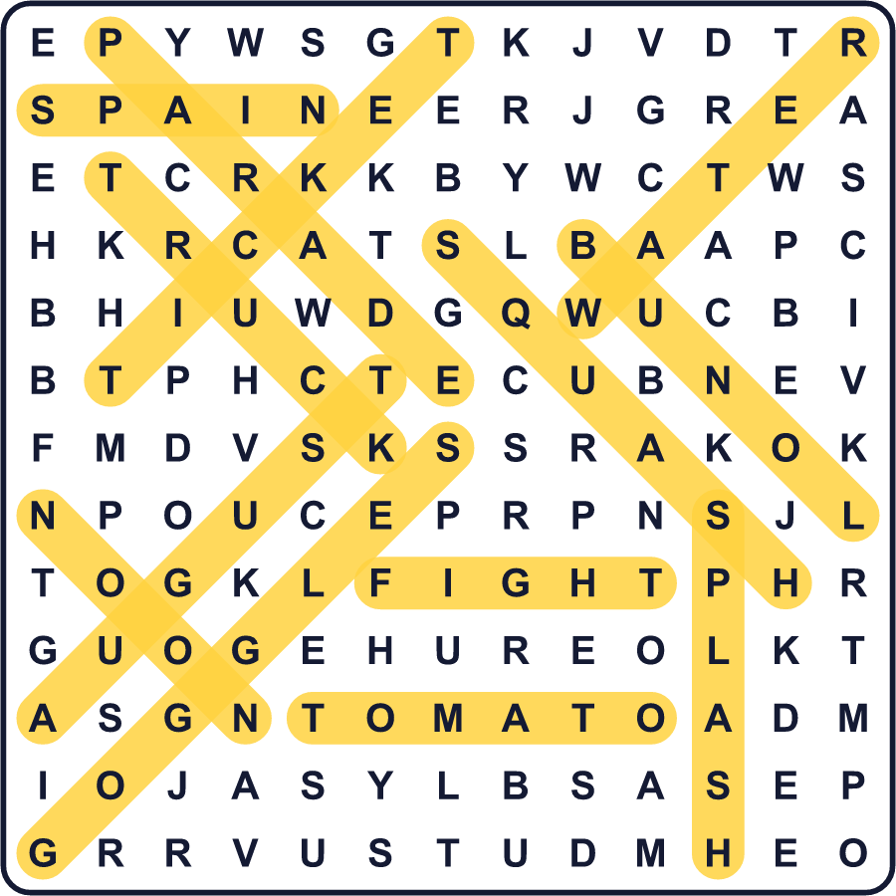
全訳
1 毎年8月の最終水曜日、スペインの小さな町が真っ赤に染まります。その町はブニョール。バレンシアから約38kmのところにあります。住んでいるのは約1万人だけです。でもこの日には、約2万人の人がトマトを投げ合うためにやってきます。
2 地元の人たちによると、すべては1945年に始まりました。若者たちが、町の広場で巨大な人形のパレードに割りこみました。誰かが転び、けんかが始まりました。すぐそばに野菜の屋台があったので、人々はトマトをつかんで投げました。次の年、若者たちは自分のトマトを持って戻ってきました。
3 最初、町はトマトの投げ合いを嫌がりました。1950年代には何度も禁止しました。そこで1957年、人々はおかしな抗議をしました。お葬式のように大きなトマトを棺おけに入れて通りを運び、楽隊が悲しい曲を演奏したのです。2年後、祭りは正式なものになりました。
4 今では、戦いは正午に始まります。大きなトラックが、よく熟したトマトを100トン以上運んできます。このトマトは食べるためではなく、祭りのために育てられたものです。痛くないように、投げる前にトマトをつぶさなければなりません。そして、人のシャツを破いてはいけません。
5 1時間たつと、大きな合図が戦いを終わらせます。それから消防車が水で通りを洗います。人が多くなりすぎたので、2013年からは参加に入場券が必要です。4〜14歳の子どもには、前の土曜日に小さな戦いがあります。夕方には赤い通りは灰色の石畳に戻り、町は次の8月まで静かになります。

