🎏 Children's Day Worksheet
Fish in the Sky
Read the story. 英文を読もう。
Class ______ No. ____ Name ______________________________

🔊 音声を聞こう（スマホで読みとってね）
1 In early May, you may see big fish flying in the sky over Japan. They are not real fish. They are koinobori, carp streamers made of cloth. They fly for May 5, Kodomo no Hi, or Children's Day. Some are small enough for a balcony, and some are longer than a swimming pool.
2 This day has two sides. It is an old festival called Tango no Sekku, and since 1948, it has also been a national holiday. In the old festival, families prayed for their sons to grow up healthy and strong. They put up carp streamers outside and set samurai helmets inside the house.
3 Why a carp? An old Chinese story says that a carp swam up a great waterfall and turned into a dragon. So the carp became a sign of a strong child with a bright future. At first, people flew only one black carp. Red and blue ones came much later.
4 The holiday law of 1948 says the day is for all children, not only boys. It also says something surprising. Children's Day is a day to thank mothers, too. Children also helped to make the holiday. In 1948, about 27,000 children in Kobe signed a letter that asked for it.
5 On this day, many families eat kashiwa mochi, a sweet rice cake wrapped in an oak leaf. At night, some people take a bath with long green shobu leaves. The leaves smell fresh, and people say they keep bad luck away. It is a day full of wishes for children to grow up happy.
Words 単語
carp（鯉） / streamer（吹き流し、長い旗） / cloth（布） / festival（祭り） / pray（祈る、願う） / helmet（かぶと、ヘルメット） / waterfall（滝） / dragon（竜） / sign（しるし、象徴） / oak（オーク、柏・ナラの仲間） / wrap（包む） / bad luck（不運、悪いこと）

🎏 Children's Day Worksheet
Reading Check
Choose the best answer. 正しいものを選ぼう。
Class ______ No. ____ Name ______________________________
1. What is the main idea of the passage?
(A) How to catch carp in a river (B) The customs and meaning of Children's Day (C) The history of Chinese dragons (D) Why baths are popular in Japan
2. What are koinobori made of?
(A) Real fish (B) Wood (C) Cloth (D) Glass
3. In the old story, what did the carp turn into?
(A) A dragon (B) A bird (C) A samurai (D) A waterfall
4. About how many children in Kobe signed the letter in 1948?
(A) 2,700 (B) 270 (C) 270,000 (D) 27,000
5. In paragraph 5, what does "keep bad luck away" mean?
(A) bring bad luck (B) stop bad things from coming (C) make the bath hot (D) grow more leaves
6. Which is true about carp streamers?
(A) They were always red and blue. (B) They are flown in winter. (C) At first, people flew only one black carp. (D) They come from America.
7. Why might a mother in Japan feel happy on May 5?
(A) The law says the day is also for thanking mothers. (B) Mothers get free kashiwa mochi. (C) Mothers do not need to cook. (D) It is the mothers' birthday.
8. In the dialogue, what will Emma do tonight?
(A) Eat an oak leaf (B) Fly a carp streamer (C) Take a shobu bath (D) Call her mother in England
True or False? T か F に○
1. Children's Day is on May 5. T / F
2. Carp streamers are made of real fish. T / F
3. In the story, a carp swam up a waterfall and became a dragon. T / F
4. The first carp streamers were red and blue. T / F
5. By law, Children's Day is also a day to thank mothers. T / F
6. People eat the oak leaf of kashiwa mochi. T / F

🎏 Children's Day Worksheet
Word Work
単語のれんしゅう
Class ______ No. ____ Name ______________________________
① Match the pictures and the words. 絵と単語を線でむすぼう。
🎏 | ● | ● | leaf
🐉 | ● | ● | helmet
🪖 | ● | ● | bath
🍃 | ● | ● | mother
🛁 | ● | ● | dragon
🌊 | ● | ● | wave
🐟 | ● | ● | carp streamer
👩 | ● | ● | fish
② Unscramble the words. 並べかえて単語にしよう。
1. O N R G A D (竜) → ____________________
2. E H E L M T (かぶと) → ____________________
3. O R M E H T (母) → ____________________
4. S N T O G R (強い) → ____________________
5. R V I E R (川) → ____________________
6. I N W D (風) → ____________________
③ Fill in the blanks. 語群から選んで入れよう。
[ cake / bath / snow / wind / children / mochi / pole / May / fresh / fish / streamer / moon / sky ]
It is (1) __________ 5. Ken's grandpa brings a big box. Inside, there is a carp (2) __________ . "Let's fly it!" says Grandpa. They put it on a tall (3) __________ . The (4) __________ blows, and the (5) __________ swims in the blue (6) __________ . Ken's little sister wants one, too. "This day is for all (7) __________ ," Mom says. So Grandpa adds a small pink carp. After that, they eat kashiwa (8) __________ together. At night, Ken takes a (9) __________ with green leaves. They smell so (10) __________ !

🎏 Children's Day Worksheet
Crossword Puzzle
ヒントを読んでクロスワードを完成させよう。
Class ______ No. ____ Name ______________________________
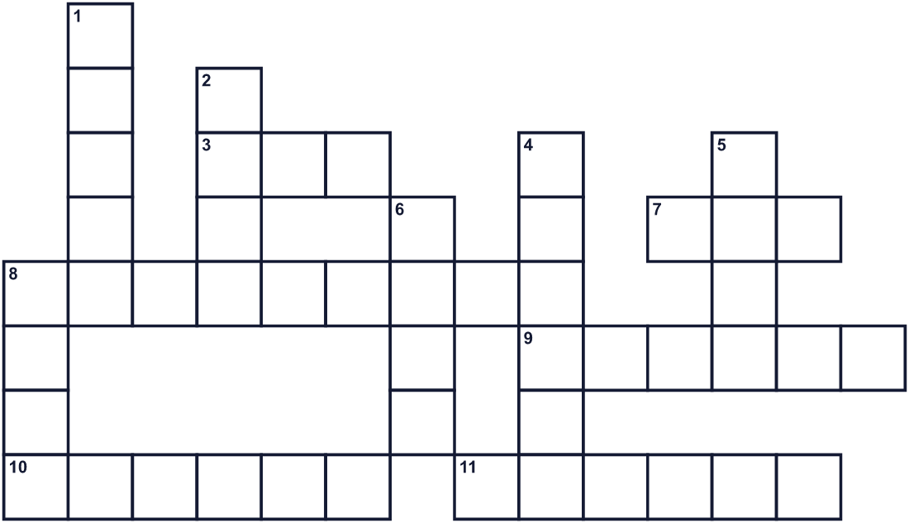
Across →
3. A tree. Its leaf wraps a sweet rice cake. (3)
7. Children's Day is in this month. (3)
8. Water falls down from a high place here. (9)
9. The law says we thank her on this day. (6)
10. A big animal in old stories. A brave fish turned into one. (6)
11. Families hope children grow up healthy and ___. (6)
Down ↓
1. A country next to Japan. Its Children's Day is also on May 5. (5)
2. A long stick. Streamers fly at the top of it. (4)
4. A samurai wore this on his head. (6)
5. You take this at night with shobu leaves. (4)
6. A fish. Its shape flies on a pole in May. (4)
8. It moves the streamers in the sky. (4)

🎏 Children's Day Worksheet
Word Search
かくれた単語をさがそう（→ ↓ ↘ ↗）
Class ______ No. ____ Name ______________________________
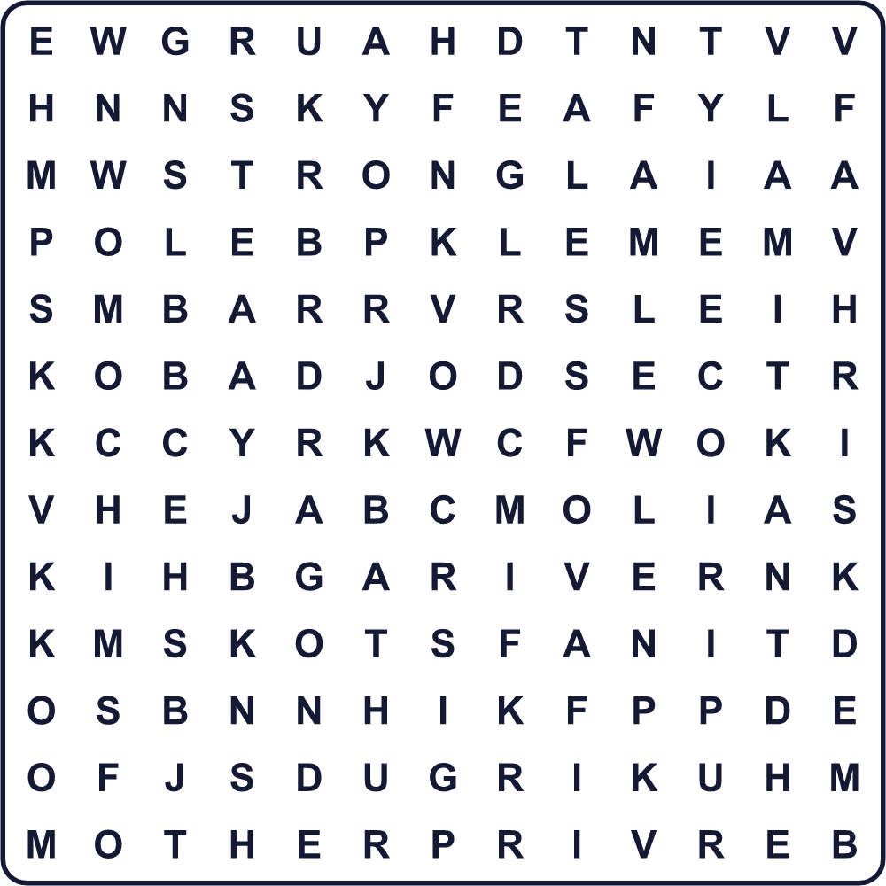
BATH CARP DRAGON HELMET KOREA LEAF MOCHI MOTHER OAK POLE RIVER SKY STRONG WIND
Secret Code 暗号を解こう
✚=A ✿=C ☃=D ☺=E ⚓=H ★=I ✉=L ☀=N ✈=P ♦=R ■=S ♠=Y
⚓ ✚ ✈ ✈ ♠ ✿ ⚓ ★ ✉ ☃ ♦ ☺ ☀ ■ ☃ ✚ ♠
______________________________________________________________

🎏 Children's Day Worksheet
Maze & Sentences
Class ______ No. ____ Name ______________________________
Help the carp swim up the waterfall! 鯉が滝を登れるように道を見つけよう！
正しい道の文字を集めると、ひみつの言葉になるよ。 START 🐟 → GOAL 🐉
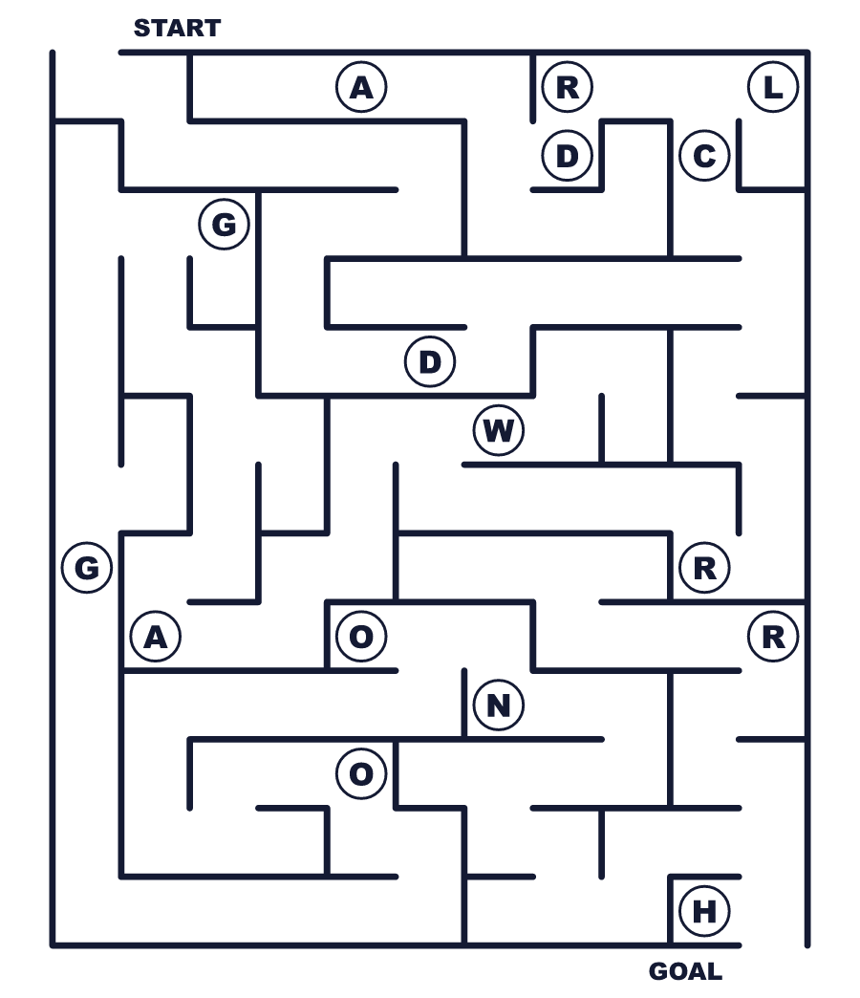
Secret word: ＿ ＿ ＿ ＿ ＿ ＿
Put the words in order. 並べかえよう。
1. 5 / Day / May / on / Children's / is . (こどもの日は5月5日です。)
______________________________________________________________
2. fly / carp / our / for / children / streamers / We . (私たちは子どものためにこいのぼりを揚げます。)
______________________________________________________________
3. The / swam / big / carp / waterfall / up / the . (鯉は大きな滝を泳いで登りました。)
______________________________________________________________
4. is / Kashiwa / wrapped / leaf / an / mochi / oak / in . (柏餅は柏の葉で包まれています。)
______________________________________________________________
5. to / It / a / mothers / also / day / is / thank . (お母さんに感謝する日でもあります。)
______________________________________________________________

🎏 Children's Day Worksheet
Class Activity & Writing
Class ______ No. ____ Name ______________________________
Find Someone Who… クラスで聞いて回ろう！
Find someone who … | Name
… has flown a carp streamer こいのぼりを揚げたことがある
… likes kashiwa mochi 柏餅が好き
… has eaten chimaki ちまきを食べたことがある
… has taken a shobu bath 菖蒲湯に入ったことがある
… has a helmet or May doll at home 家にかぶとか五月人形がある
… knows the story of the carp and the dragon 鯉と竜の話を知っている
… can say thank you to their mother in English お母さんへのお礼を英語で言える
… knows another country's Children's Day ほかの国のこどもの日を知っている
Let's Write! 英語で書いてみよう。
On Children's Day, I want to ______.
こどもの日に、私は＿＿したいです。
______________________________________________________________
______________________________________________________________
Thank you, Mom, for ______.
お母さん、＿＿をありがとう。
______________________________________________________________
______________________________________________________________
If I were a carp, I would swim up to ______ because ______.
もし私が鯉なら、＿＿まで泳いで登ります。なぜなら＿＿だからです。
______________________________________________________________
______________________________________________________________

🎏 Children's Day Worksheet
Trace & Color
なぞって書こう。絵に色をぬろう。
Class ______ No. ____ Name ______________________________
🎏 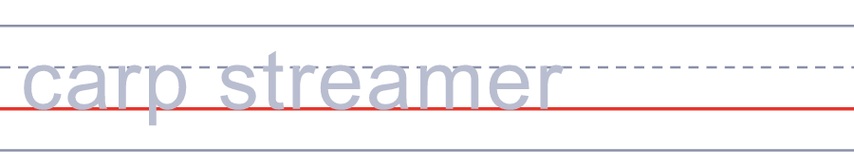

🐉 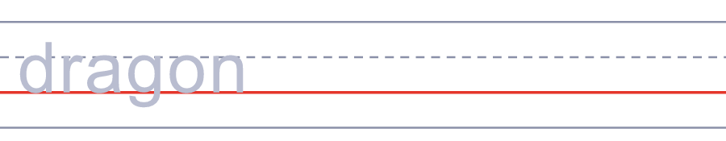
🪖 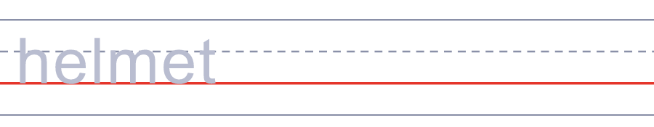
🍃 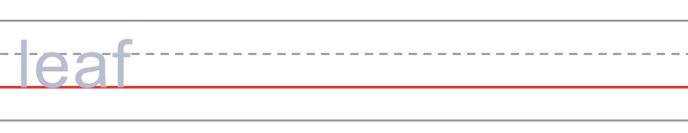
🛁 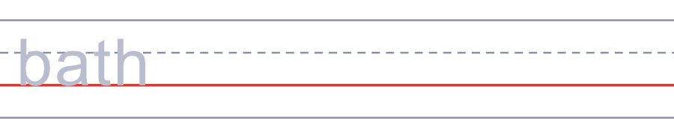
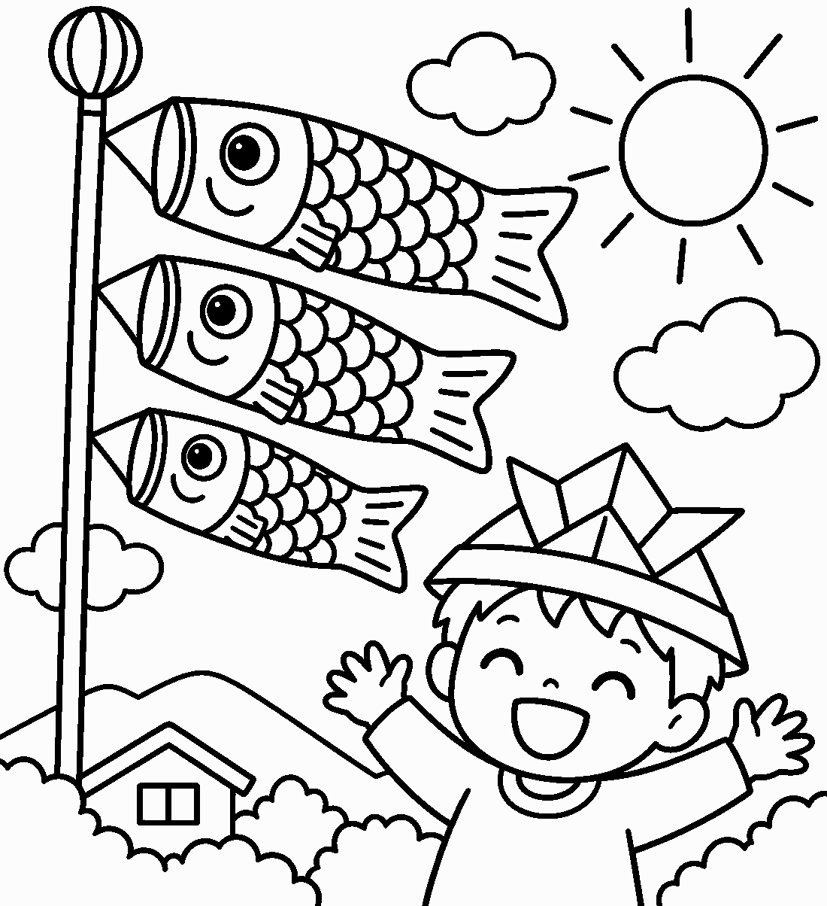

🎏 Children's Day Worksheet
Answer Key 解答
Reading Check: 1.B 2.C 3.A 4.D 5.B 6.C 7.A 8.D
True or False: 1.T 2.F 3.T 4.F 5.T 6.F
Match: 🎏=carp streamer 🐉=dragon 🪖=helmet 🍃=leaf 🛁=bath 🌊=wave 🐟=fish 👩=mother
Unscramble: 1.DRAGON 2.HELMET 3.MOTHER 4.STRONG 5.RIVER 6.WIND
Fill in the blanks: (1)May (2)streamer (3)pole (4)wind (5)fish (6)sky (7)children (8)mochi (9)bath (10)fresh
Sentence order: 1. Children's Day is on May 5. 2. We fly carp streamers for our children. 3. The carp swam up the big waterfall. 4. Kashiwa mochi is wrapped in an oak leaf. 5. It is also a day to thank mothers.
Secret Code: HAPPY CHILDRENS DAY
Maze: DRAGON
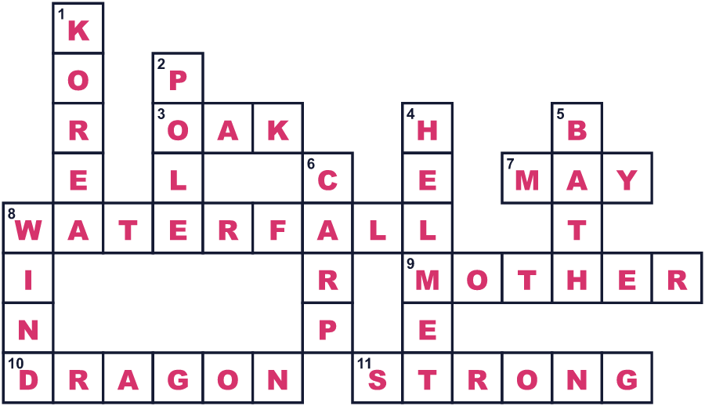
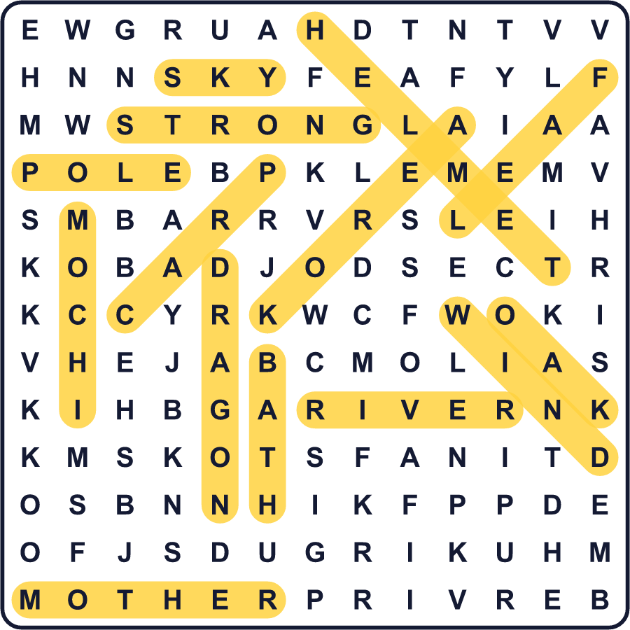
全訳
1 5月の初め、日本の空に大きな魚が泳いでいるのを見るかもしれません。本物の魚ではありません。布でできた鯉の形ののぼり、こいのぼりです。5月5日のこどもの日のために揚げられています。ベランダに飾れる小さなものもあれば、プールより長いものもあります。
2 この日には2つの顔があります。端午の節句という古いお祭りであり、1948年からの国民の祝日でもあります。古いお祭りでは、家族は息子が健康でたくましく育つよう願いました。外にこいのぼりを立て、家の中にはかぶとを飾りました。
3 なぜ鯉なのでしょう。中国の古い話では、ある鯉が大きな滝を登りきって竜になったと言われています。そこで鯉は、明るい未来を持つたくましい子どものしるしになりました。はじめは、黒い鯉を1匹だけ揚げていました。赤や青の鯉が加わったのは、ずっと後のことです。
4 1948年の祝日法は、この日は男の子だけでなく、すべての子どものための日だとしています。さらに、驚くことも書いてあります。こどもの日は、お母さんに感謝する日でもあるのです。子どもたちも、この祝日づくりに力を貸しました。1948年、神戸の子ども約2万7千人が、祝日を求める手紙に署名したのです。
5 この日、多くの家庭は、柏の葉で包んだ甘いお餅、柏餅を食べます。夜には、長い緑の菖蒲の葉を入れたお風呂に入る人もいます。葉はさわやかな香りがして、悪いものを遠ざけると言われています。子どもが幸せに育つようにという願いがいっぱいつまった日です。

