🌾 Labor Thanksgiving Day Worksheet
From New Rice to Thank You
Read the story. 英文を読もう。
Class ______ No. ____ Name ______________________________
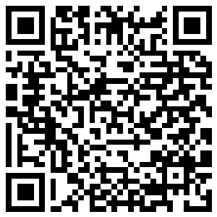
🔊 音声を聞こう（スマホで読みとってね）
1 On the night of November 23, a very old ceremony takes place inside the Imperial Palace in Tokyo. By the light of torches, the emperor offers the year's new rice to the gods. Then he eats some of it himself. This ceremony is called Niinamesai, and it is more than 1,000 years old.
2 Long ago, the date changed every year. It was held on the second Day of the Rabbit in the eleventh month of the old calendar. In 1873, Japan started using a new calendar. That year, the second Day of the Rabbit in November was the 23rd, and the date never moved again.
3 After World War II, Japan made new national holidays. Lawmakers talked a lot about a new name for November 23. Ideas included New Grain Festival and simply Thanks Day. But some said, thanks for what? In 1948, they chose Kinro Kansha no Hi, or Labor Thanksgiving Day. The law says it is a day to respect work, celebrate production, and thank each other.
4 Today, many children write thank-you cards for police officers, firefighters, and their own parents. In Nagano, people enjoy a big fireworks show on this night. In Japan, people often say otsukaresama to each other after work. It is hard to translate, but it means something like thank you for your hard work.
5 Some people compare this day to Thanksgiving in the United States. Both started with thanks for the harvest. In 2028, they will even fall on the same day, November 23. So this year, why not say thank you to someone who works for you?
Words 単語
ceremony（儀式） / offer（供える、差し出す） / harvest（収穫） / grain（穀物） / calendar（暦、カレンダー） / labor（労働、勤労） / thanksgiving（感謝、感謝祭） / respect（大切にする、尊重する） / production（生産） / firefighter（消防士） / translate（翻訳する、訳す） / fireworks（花火）

🌾 Labor Thanksgiving Day Worksheet
Reading Check
Choose the best answer. 正しいものを選ぼう。
Class ______ No. ____ Name ______________________________
1. What is the passage mainly about?
(A) How to cook new rice (B) The history of American Thanksgiving (C) The story of Labor Thanksgiving Day in Japan (D) Fireworks shows in Nagano
2. What does the emperor do in the Niinamesai ceremony?
(A) He offers new rice to the gods and eats some. (B) He writes thank-you cards. (C) He watches fireworks. (D) He plants rice in the field.
3. Why did the date become November 23?
(A) Because it was the emperor's birthday (B) Because American Thanksgiving was on that day (C) Because it was a Monday (D) Because it was the second Day of the Rabbit in November 1873
4. When did lawmakers choose the name Labor Thanksgiving Day?
(A) In 1873 (B) In 1948 (C) In 2028 (D) More than 1,000 years ago
5. In paragraph 4, the word translate is closest in meaning to ____.
(A) forget (B) change into another language (C) say loudly (D) write by hand
6. Which is true about the passage?
(A) The ceremony is held in the morning. (B) Japan started a new calendar in 1948. (C) Some lawmakers asked, thanks for what? (D) Americans and Japanese eat turkey on November 23 every year.
7. Why might people compare this day to American Thanksgiving?
(A) Both began with thanks for the harvest. (B) Both have turkey dinners. (C) Both are always on Thursday. (D) Both were made by the emperor.
8. In the dialogue, what idea does Grace have for her students?
(A) Cooking turkey at school (B) Visiting the Imperial Palace (C) Watching fireworks in Nagano (D) Making thank-you cards in English class
True or False? T か F に○
1. Labor Thanksgiving Day is on November 23. T / F
2. People in Japan eat turkey on this day. T / F
3. The holiday started from an old rice festival. T / F
4. The date of Niinamesai changed every year long ago. T / F
5. The name of the holiday was chosen in 1873. T / F
6. The emperor no longer holds Niinamesai. T / F

🌾 Labor Thanksgiving Day Worksheet
Word Work
単語のれんしゅう
Class ______ No. ____ Name ______________________________
① Match the pictures and the words. 絵と単語を線でむすぼう。
🌾 | ● | ● | farmer
🚒 | ● | ● | hospital
👮 | ● | ● | fire truck
🧑‍🌾 | ● | ● | police officer
💌 | ● | ● | rice plant
🎆 | ● | ● | letter
🏥 | ● | ● | bus
🚌 | ● | ● | fireworks
② Unscramble the words. 並べかえて単語にしよう。
1. T H R A E V S (収穫) → ____________________
2. A N K T H S (感謝) → ____________________
3. R R M F E A (農家の人) → ____________________
4. A I R G N (穀物) → ____________________
5. B A L O R (勤労、労働) → ____________________
6. E C R I (米) → ____________________
③ Fill in the blanks. 語群から選んで入れよう。
[ early / turkey / smiled / driver / card / rice / snow / hospital / angry / happy / work / bus / mother ]
On Labor Thanksgiving Day, Ren made a (1) __________ for his father. His father is a bus (2) __________ . He gets up very (3) __________ every morning. Ren drew a big green (4) __________ and wrote, Thank you for your hard (5) __________ . Then he made a card for his (6) __________ , too. She works at a (7) __________ . In the evening, the family ate new (8) __________ together. His father read the card and (9) __________ . Ren felt warm and (10) __________ .

🌾 Labor Thanksgiving Day Worksheet
Crossword Puzzle
ヒントを読んでクロスワードを完成させよう。
Class ______ No. ____ Name ______________________________
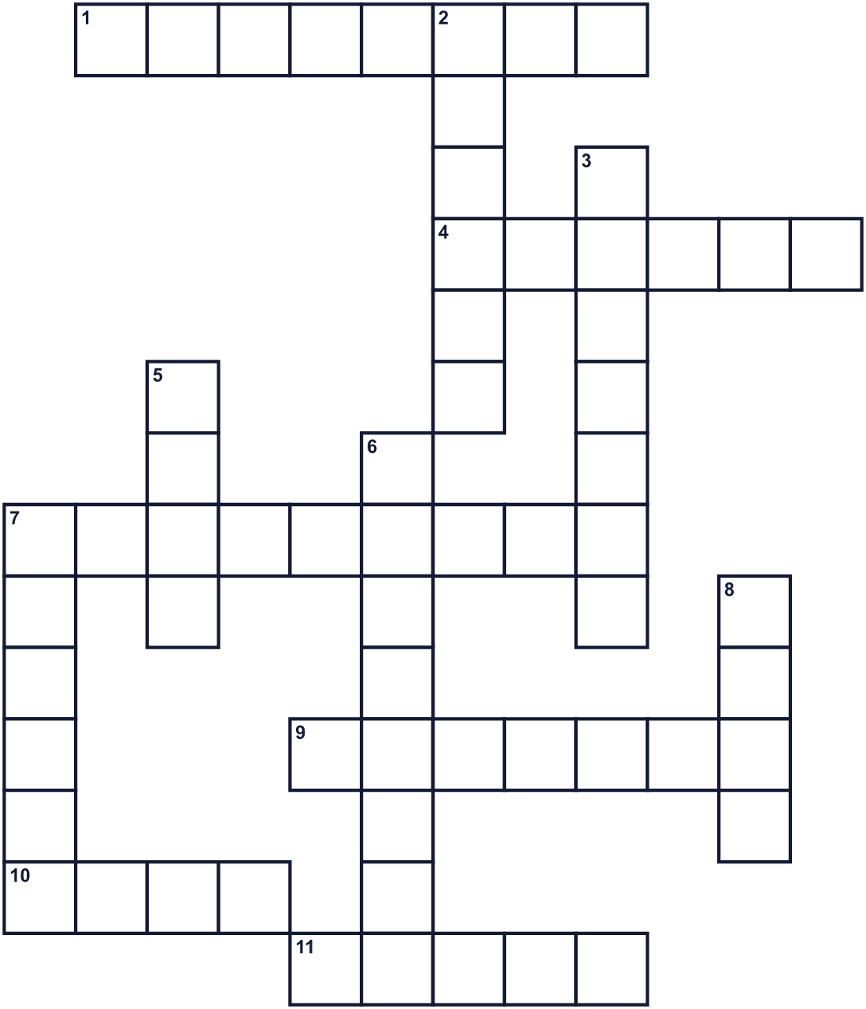
Across →
1. It shows the days and months of a year. (8)
4. Words you say when someone helps you. (6)
7. Colorful lights that explode in the night sky. (9)
9. He offers new rice to the gods at night. (7)
10. Japanese people eat this white grain every day. (4)
11. Rice, wheat, and corn are all this. (5)
Down ↓
2. A person who helps sick people at a hospital. (6)
3. The time when farmers gather their crops. (7)
5. What people do at their jobs. (4)
6. The eleventh month of the year. (8)
7. A person who grows food in fields. (6)
8. A small paper with a message on it. (4)

🌾 Labor Thanksgiving Day Worksheet
Word Search
かくれた単語をさがそう（→ ↓ ↘ ↗）
Class ______ No. ____ Name ______________________________
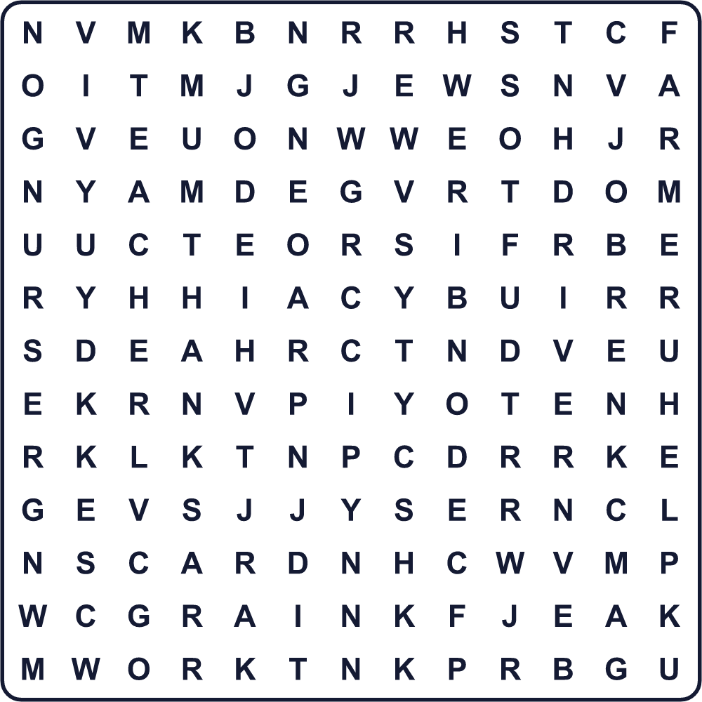
CARD DOCTOR DRIVER FARMER GRAIN HARVEST HELP JOB NURSE RICE TEACHER THANKS WORK
Secret Code 暗号を解こう
♥=A ✉=F ✂=H ☂=K ♣=N ✎=O ◆=R ♦=T ☃=U ▲=W ●=Y
♦ ✂ ♥ ♣ ☂ ● ✎ ☃ ✉ ✎ ◆ ● ✎ ☃ ◆ ▲ ✎ ◆ ☂
______________________________________________________________

🌾 Labor Thanksgiving Day Worksheet
Maze & Sentences
Class ______ No. ____ Name ______________________________
Help Ren bring his card to the fire station! レンが消防署にカードを届けられるように道を見つけよう！
正しい道の文字を集めると、ひみつの言葉になるよ。 START 👦 → GOAL 🚒
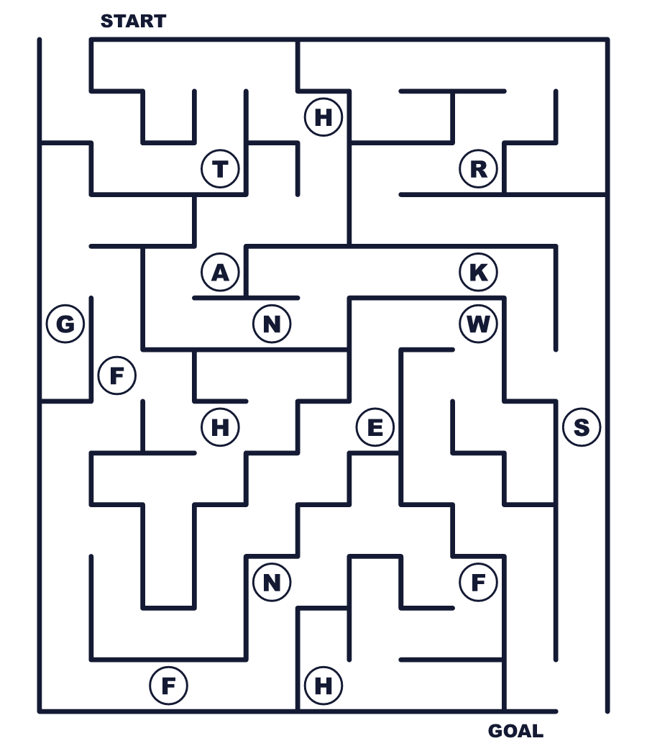
Secret word: ＿ ＿ ＿ ＿ ＿ ＿
Put the words in order. 並べかえよう。
1. Day / is / 23 / Labor / November / on / Thanksgiving . (勤労感謝の日は11月23日です。)
______________________________________________________________
2. a / to / day / It / thank / is / workers . (働く人に感謝する日です。)
______________________________________________________________
3. a / as / rice / festival / It / harvest / started . (それはお米の収穫祭として始まりました。)
______________________________________________________________
4. for / a / made / my / father / I / card . (私は父にカードを作りました。)
______________________________________________________________
5. every / for / your / work / Thank / hard / day / you . (毎日がんばってくれてありがとう。)
______________________________________________________________

🌾 Labor Thanksgiving Day Worksheet
Class Activity & Writing
Class ______ No. ____ Name ______________________________
Find Someone Who… クラスで聞いて回ろう！
Find someone who … | Name
… has written a thank-you card 感謝のカードを書いたことがある
… has helped with housework this week 今週、家の手伝いをした
… knows a farmer 農家の人を知っている
… likes new rice 新米が好き
… can name five jobs in English 英語で仕事の名前を5つ言える
… wants to be a doctor or nurse 医者か看護師になりたい
… has visited a fire station 消防署に行ったことがある
… knows the meaning of otsukaresama 「お疲れさま」の意味を知っている
Let's Write! 英語で書いてみよう。
On Labor Thanksgiving Day, I want to thank ______ because ______.
勤労感謝の日に、私は＿＿に感謝したいです。なぜなら＿＿だからです。
______________________________________________________________
______________________________________________________________
In the future, I want to work as a ______ because ______.
将来、私は＿＿として働きたいです。なぜなら＿＿だからです。
______________________________________________________________
______________________________________________________________
One job that helps my town is ______. They ______.
私の町を助けている仕事は＿＿です。その人たちは＿＿します。
______________________________________________________________
______________________________________________________________

🌾 Labor Thanksgiving Day Worksheet
Trace & Color
なぞって書こう。絵に色をぬろう。
Class ______ No. ____ Name ______________________________
🌾 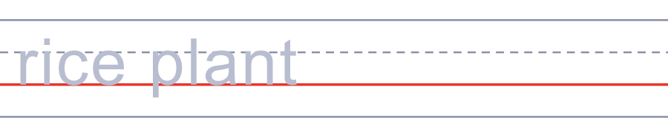

🚒 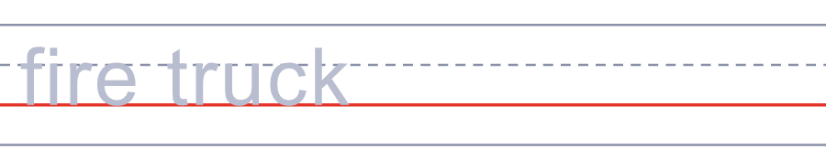
👮 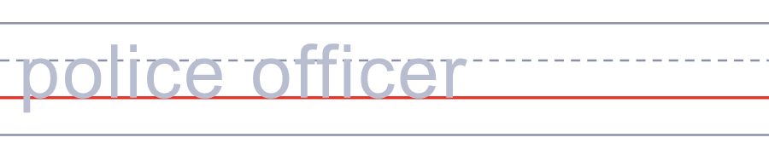
🧑‍🌾 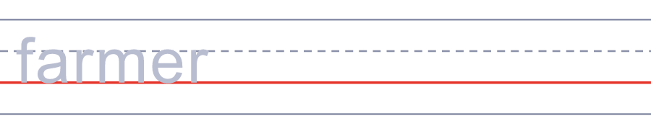
💌 
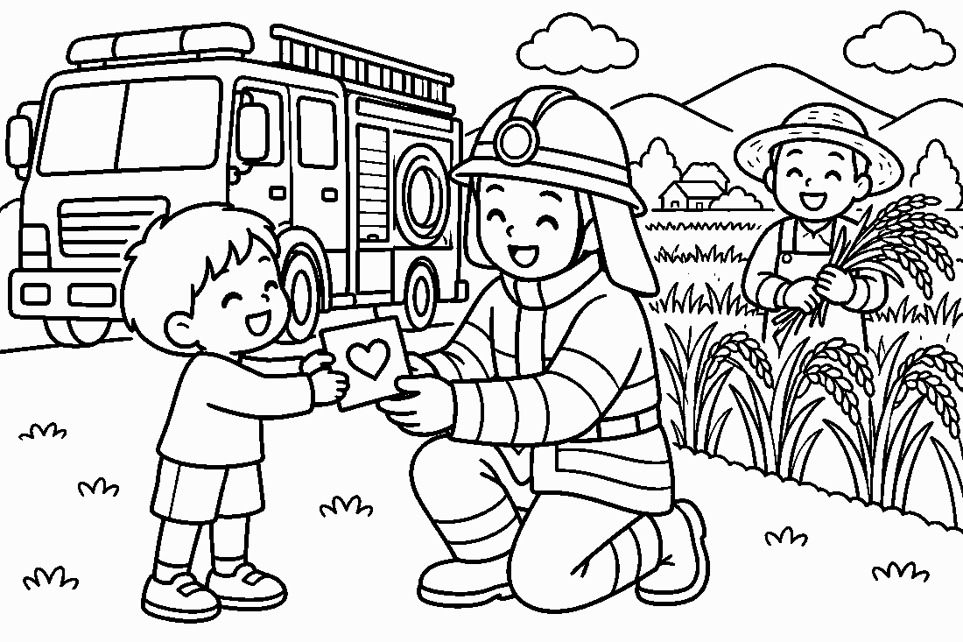

🌾 Labor Thanksgiving Day Worksheet
Answer Key 解答
Reading Check: 1.C 2.A 3.D 4.B 5.B 6.C 7.A 8.D
True or False: 1.T 2.F 3.T 4.T 5.F 6.F
Match: 🌾=rice plant 🚒=fire truck 👮=police officer 🧑‍🌾=farmer 💌=letter 🎆=fireworks 🏥=hospital 🚌=bus
Unscramble: 1.HARVEST 2.THANKS 3.FARMER 4.GRAIN 5.LABOR 6.RICE
Fill in the blanks: (1)card (2)driver (3)early (4)bus (5)work (6)mother (7)hospital (8)rice (9)smiled (10)happy
Sentence order: 1. Labor Thanksgiving Day is on November 23. 2. It is a day to thank workers. 3. It started as a rice harvest festival. 4. I made a card for my father. 5. Thank you for your hard work every day.
Secret Code: THANK YOU FOR YOUR WORK
Maze: THANKS
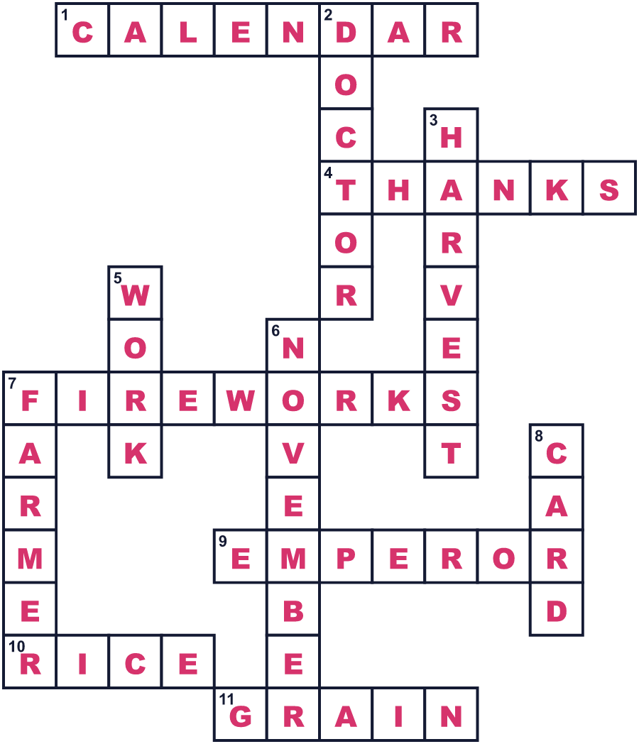
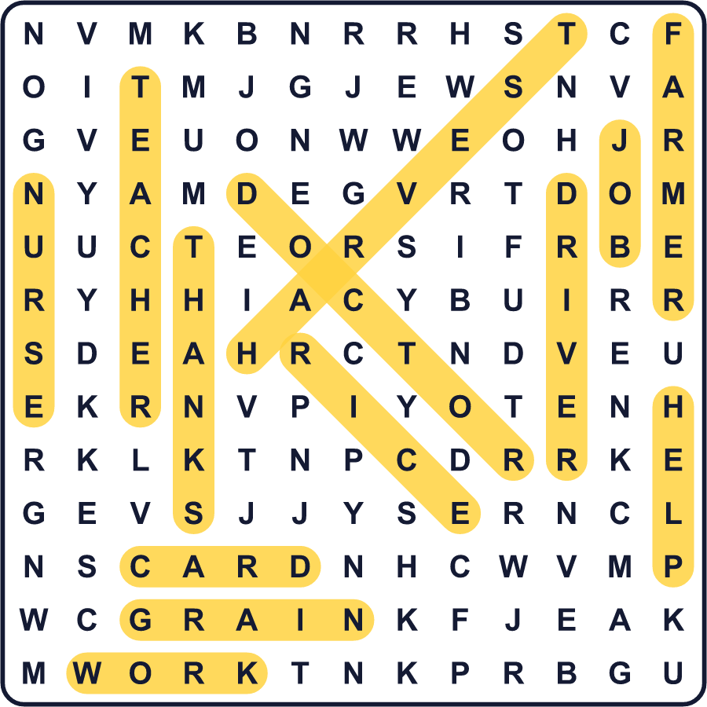
全訳
1 11月23日の夜、東京の皇居の中で、とても古い儀式が行われます。たいまつの明かりの中で、天皇がその年の新しいお米を神々に供えるのです。そして、それを自分も少し食べます。この儀式は新嘗祭と呼ばれ、1000年以上の歴史があります。
2 昔は、日付が毎年変わりました。旧暦の11月の、2回目の卯の日に行われていたのです。1873年、日本は新しい暦を使い始めました。その年の11月の2回目の卯の日が23日で、それ以来、日付は二度と動きませんでした。
3 第二次世界大戦の後、日本は新しい国民の祝日を作りました。国会議員たちは、11月23日の新しい名前について何度も話し合いました。案の中には「新穀祭」や、シンプルな「感謝の日」もありました。でも、「何への感謝なの？」と言う人もいました。1948年、彼らは「勤労感謝の日」を選びました。法律は、この日を勤労を大切にし、生産を祝い、おたがいに感謝しあう日だとしています。
4 今では、多くの子どもたちが、警察官や消防士、自分の親に感謝のカードを書きます。長野では、この夜に大きな花火大会を楽しみます。日本では、仕事のあとに「お疲れさま」と言い合うことがよくあります。訳すのは難しいですが、「がんばってくれてありがとう」のような意味です。
5 この日をアメリカの感謝祭とくらべる人もいます。どちらも収穫への感謝から始まりました。2028年には、両方が同じ11月23日になります。だから今年は、あなたのために働いてくれている人に「ありがとう」を言ってみませんか。

