👑 King's Day (Netherlands) Worksheet
The Day the Netherlands Turns Orange
Read the story. 英文を読もう。
Class ______ No. ____ Name ______________________________

🔊 音声を聞こう（スマホで読みとってね）
1 On one spring day, a whole country dresses in orange. People wear orange shirts, orange hats, and even orange wigs. Some even make their hair orange for the day. In Amsterdam, people party in the streets and even on the canals. This is King's Day in the Netherlands.
2 King's Day is on April 27, the birthday of King Willem-Alexander. But the story began in 1885 with a little princess. Her name was Wilhelmina, and she was turning five. Later, she became queen, and the day became Queen's Day. Many years later, people brought flowers and gifts to the palace on Queen's Day. When a new king or queen comes, the date often changes. In 2014, it became King's Day.
3 Why orange? The Dutch royal family is called the House of Orange. The name does not come from the fruit. It comes from Orange, a small place in the south of France. In 1544, an 11-year-old boy named William got this land, and his family kept the name.
4 King's Day is also the biggest flea market in the country. On this one day, anyone can sell things on the street without asking the city first. People sell old clothes, books, and kitchen things. In a big park in Amsterdam, children sell their old toys. In the city of Utrecht, the market even goes on all night. At the end of the day, many kids go home with a little money and a big smile.
Words 単語
royal（王の、王室の） / princess（王女、お姫さま） / queen（女王） / canal（運河） / flea market（フリーマーケット、のみの市） / sell（売る） / wig（かつら） / without（～なしで）

👑 King's Day (Netherlands) Worksheet
Reading Check
Choose the best answer. 正しいものを選ぼう。
Class ______ No. ____ Name ______________________________
1. What is the main idea of the reading?
(A) King's Day is a quiet day when people stay at home. (B) King's Day started in France and later moved to the Netherlands. (C) Only children can join King's Day in the Netherlands. (D) King's Day is a birthday holiday full of orange clothes and street markets.
2. Whose birthday started the holiday in 1885?
(A) King Willem-Alexander (B) Princess Wilhelmina (C) A prince from France (D) Queen Beatrix
3. Where does the name "Orange" come from?
(A) A small place in the south of France (B) The color of Dutch tulips (C) An orange tree in Amsterdam (D) The fruit that the king likes
4. In paragraph 4, what is a "flea market"?
(A) A shop that sells only new clothes (B) A place to buy tickets for boats (C) A market where people sell used things (D) A market for animals and insects
5. In the dialogue, what is Emma selling?
(A) Orange hats (B) Her old comics (C) Cakes she made (D) Boat tickets
True or False? T か F に○
1. King's Day is the king's birthday. T / F
2. The name Orange comes from the fruit. T / F
3. On King's Day, people can sell things on the street. T / F
4. King's Day started in 2014. T / F

👑 King's Day (Netherlands) Worksheet
Word Work
単語のれんしゅう
Class ______ No. ____ Name ______________________________
① Match the pictures and the words. 絵と単語を線でむすぼう。
👑 | ● | ● | tulip
🍊 | ● | ● | boat
🚤 | ● | ● | birthday cake
🧸 | ● | ● | orange
🎂 | ● | ● | crown
🌷 | ● | ● | toy
③ Fill in the blanks. 語群から選んで入れよう。
[ house / toys / shouted / green / orange / boat / canal / school / snow / shirt ]
On King's Day, Daan put on an orange (1) __________ . He took his old (2) __________ outside and sold them in front of his (3) __________ . A woman bought his toy (4) __________ for two euros. In the afternoon, Daan and his sister went to the (5) __________ . The water was full of (6) __________ boats. "Happy King's Day!" they (7) __________ .

👑 King's Day (Netherlands) Worksheet
Crossword Puzzle
ヒントを読んでクロスワードを完成させよう。
Class ______ No. ____ Name ______________________________
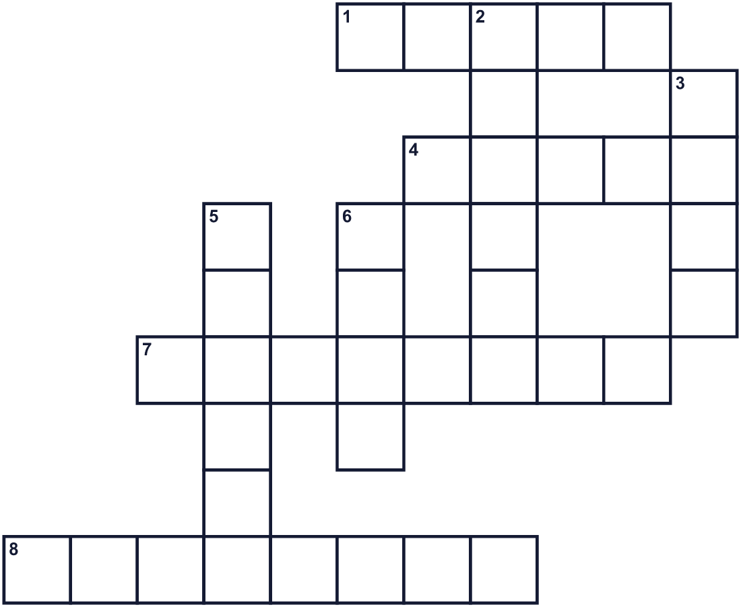
Across →
1. A gold hat for a king or queen. (5)
4. A long waterway in a city. Boats go on it. (5)
7. The daughter of a king or queen. (8)
8. The day you were born. You may get a cake. (8)
Down ↓
2. The color people wear on this day in the Netherlands. (6)
3. A country's colors on a piece of cloth. (4)
5. A place where people buy and sell things. (6)
6. A man who rules a country. His wife may be a queen. (4)

👑 King's Day (Netherlands) Worksheet
Word Search
かくれた単語をさがそう（→ ↓ ↘ ↗）
Class ______ No. ____ Name ______________________________
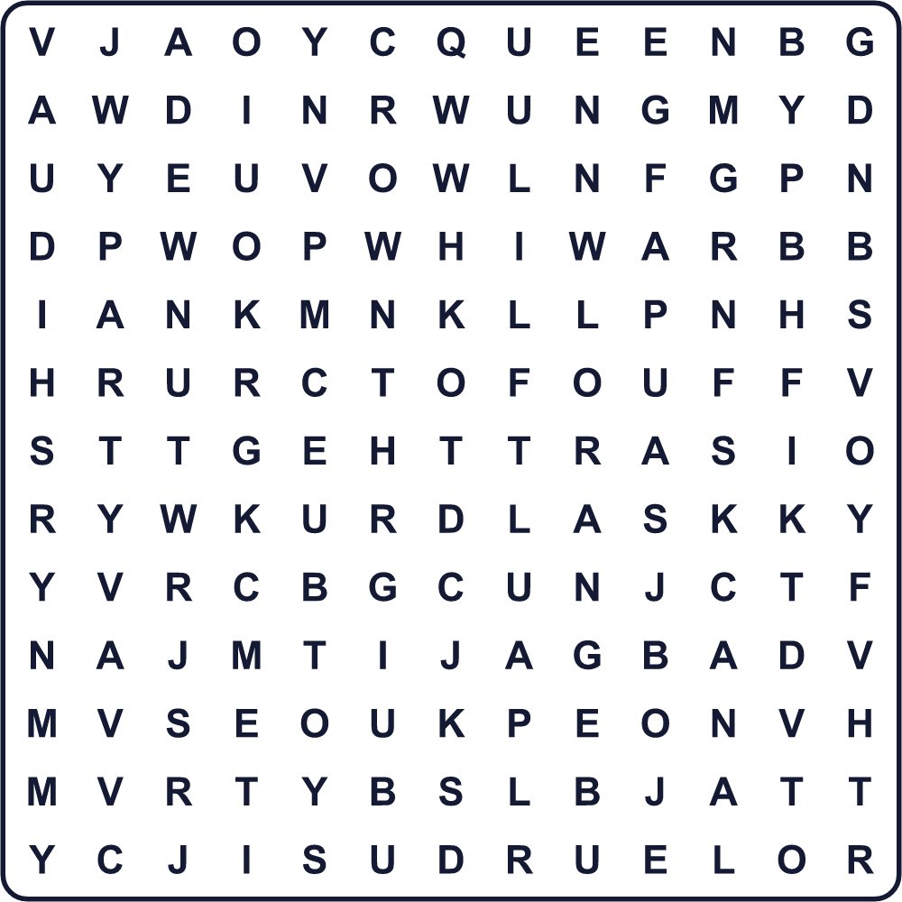
BOAT CANAL CROWN FLAG KING MARKET ORANGE PARTY QUEEN TOYS

👑 King's Day (Netherlands) Worksheet
Maze & Sentences
Class ______ No. ____ Name ______________________________
Help Daan get to the market! ダーンをフリーマーケットまで連れていこう！
正しい道の文字を集めると、ひみつの言葉になるよ。 START 👦 → GOAL 🧸
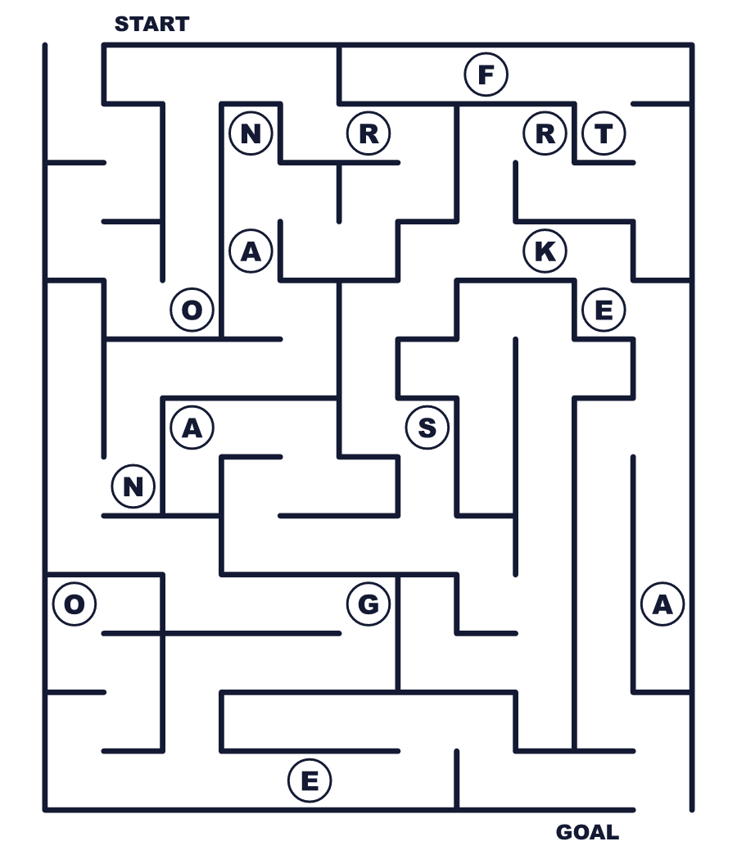
Secret word: ＿ ＿ ＿ ＿ ＿ ＿

👑 King's Day (Netherlands) Worksheet
Class Activity & Writing
Class ______ No. ____ Name ______________________________
Let's Write! 英語で書いてみよう。
If I lived in the Netherlands, on King's Day I would ______.
もしオランダに住んでいたら、国王の日に私は______するだろう。
______________________________________________________________
______________________________________________________________
I want to sell my ______ at a flea market because ______.
フリーマーケットで______を売りたい。なぜなら______だから。
______________________________________________________________
______________________________________________________________

👑 King's Day (Netherlands) Worksheet
Trace & Color
なぞって書こう。絵に色をぬろう。
Class ______ No. ____ Name ______________________________
👑 

🍊 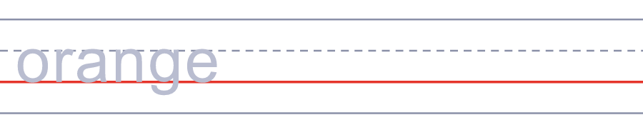
🚤 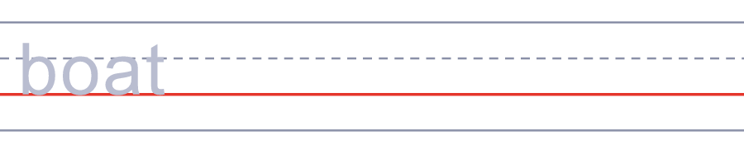
🧸 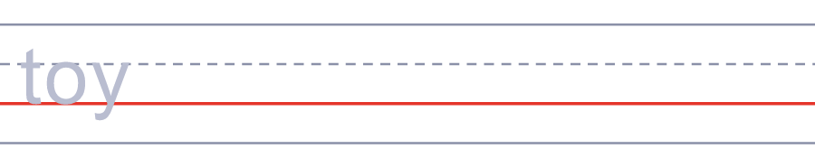
🎂 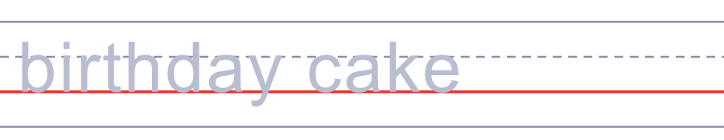

👑 King's Day (Netherlands) Worksheet
Answer Key 解答
Reading Check: 1.D 2.B 3.A 4.C 5.B
True or False: 1.T 2.F 3.T 4.F
Match: 👑=crown 🍊=orange 🚤=boat 🧸=toy 🎂=birthday cake 🌷=tulip
Fill in the blanks: (1)shirt (2)toys (3)house (4)boat (5)canal (6)orange (7)shouted
Maze: ORANGE
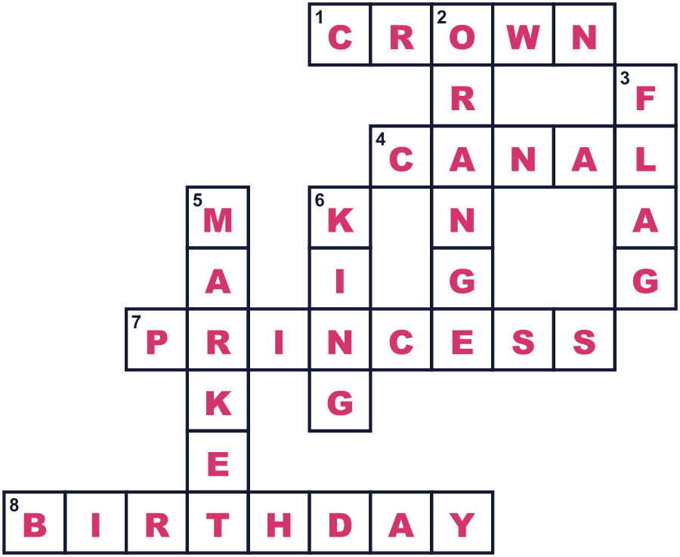
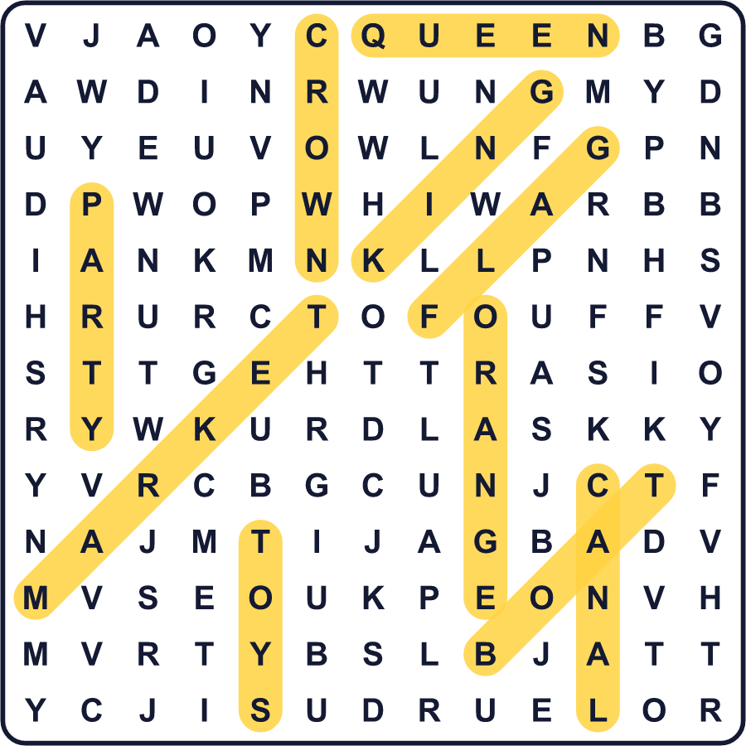
全訳
1 春のある日、国じゅうがオレンジ色の服を着ます。オレンジのシャツ、オレンジの帽子、オレンジのかつらまで。この日のために髪をオレンジに染める人さえいます。アムステルダムでは、通りでも運河の上でもお祭りです。これがオランダの国王の日です。
2 国王の日は4月27日、国王ウィレム＝アレクサンダーの誕生日です。でも物語は1885年、小さなお姫さまから始まりました。名前はウィルヘルミナ、5歳の誕生日でした。のちに彼女は女王になり、この日は「女王の日」になりました。のちの時代には、女王の日に人々が宮殿へ花や贈り物を届けました。新しい王や女王になると、日付が変わることがよくあります。2014年に「国王の日」になりました。
3 なぜオレンジなのでしょう。オランダの王家は「オラニエ家」と呼ばれています。この名前は果物から来たのではありません。南フランスの小さな土地「オランジュ」から来ています。1544年、11歳の少年ウィレムがこの土地を受けつぎ、一族はその名前を使い続けました。
4 国王の日は、国でいちばん大きなフリーマーケットの日でもあります。この日だけは、だれでも市に許可をとらずに道ばたで物を売ることができます。古い服や本、台所の道具などが売られます。アムステルダムの大きな公園では、子どもたちが古いおもちゃを売ります。ユトレヒトの市では、なんと夜通し市が開かれます。1日の終わりには、多くの子どもが少しのお金と大きな笑顔で家に帰ります。

