📜 Constitution Memorial Day Worksheet
The Day the Rules Began
Read the story. 英文を読もう。
Class ______ No. ____ Name ______________________________
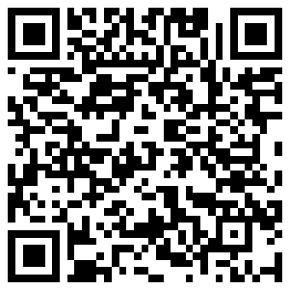
🔊 音声を聞こう（スマホで読みとってね）
1 In Japan, May 3 is a national holiday called Kenpo Kinenbi. In English, we call it Constitution Memorial Day. A constitution is the most important set of rules for a country. It says how the country works and what rights people have.
2 Japan's constitution was announced on November 3, 1946. But it did not start on that day. It came into use six months later, on May 3, 1947. Here is a little secret. The government chose May 3 first, and then it counted back six months to pick November 3.
3 The new constitution was big news. On May 3, 1947, people held a ceremony in front of the Imperial Palace in Tokyo. The same day, a famous theater had a party with violin music and a kabuki dance. A group also made a small book about the constitution. About 20 million copies went to homes all over Japan.
4 May 3 became a national holiday in 1948. At first, some lawmakers wanted Children's Day on May 3. They liked the idea of mixing March 3, the girls' festival, and May 5, the boys' festival. But Constitution Memorial Day took May 3, so Children's Day moved to May 5.
5 Today, May 3 is in the middle of Golden Week, a group of spring holidays. Many families travel or relax in the park. Newspapers and TV programs talk about the constitution, and some people go to talks about it. It is a good day to think about the rules we all share.
Words 単語
constitution（憲法） / memorial（記念の、記念碑） / announce（発表する、公表する） / come into use（使われ始める） / national holiday（国民の祝日） / rights（権利） / ceremony（式典、儀式） / palace（宮殿） / copy（（本などの）部、冊） / lawmaker（国会議員、立法者） / count back（さかのぼって数える） / share（共有する、分かち合う）

📜 Constitution Memorial Day Worksheet
Reading Check
Choose the best answer. 正しいものを選ぼう。
Class ______ No. ____ Name ______________________________
1. What is the main idea of the passage?
(A) How to travel during Golden Week (B) Why Japan has a holiday on May 3 (C) How children celebrate May 5 (D) Why banks close on Sundays
2. When was Japan's constitution announced?
(A) May 3, 1946 (B) May 3, 1947 (C) November 3, 1947 (D) November 3, 1946
3. How long after the announcement did the constitution start?
(A) Six months (B) Three months (C) One year (D) Two years
4. Which date did the government choose first?
(A) November 3 (B) March 3 (C) May 3 (D) May 5
5. In paragraph 2, what does "came into use" mean?
(A) was written (B) started to be used (C) was sold (D) was changed
6. Which is true about the year 1947?
(A) Children's Day started on May 3. (B) The constitution was changed. (C) There were no events on May 3. (D) About 20 million copies of a small book went to homes.
7. Why is Children's Day on May 5, not May 3?
(A) Because May 3 was given to Constitution Memorial Day. (B) Because May 3 is always rainy. (C) Because children go to school on May 3. (D) Because the boys' festival was banned.
8. In the dialogue, what does Ben say about Constitution Day in America?
(A) It is on May 3. (B) Everyone gets a day off. (C) It is in September, but it is not a day off. (D) It is called Culture Day.
True or False? T か F に○
1. Constitution Memorial Day is on May 3. T / F
2. Japan's constitution was announced on May 3, 1947. T / F
3. The constitution started six months after it was announced. T / F
4. Some lawmakers wanted Children's Day on May 3. T / F
5. November 3 is called Constitution Memorial Day now. T / F
6. In the United States, Constitution Day is a day off for everyone. T / F

📜 Constitution Memorial Day Worksheet
Word Work
単語のれんしゅう
Class ______ No. ____ Name ______________________________
① Match the pictures and the words. 絵と単語を線でむすぼう。
📅 | ● | ● | carp streamer
📖 | ● | ● | book
🎉 | ● | ● | tree
🎻 | ● | ● | train
🚄 | ● | ● | party
🍙 | ● | ● | violin
🌳 | ● | ● | calendar
🎏 | ● | ● | rice ball
② Unscramble the words. 並べかえて単語にしよう。
1. H D I L O Y A (祝日) → ____________________
2. L S R E U (ルール) → ____________________
3. L C E A P A (宮殿) → ____________________
4. S I G H R T (権利) → ____________________
5. D E R A A P (パレード) → ____________________
6. L C T U U E R (文化) → ____________________
③ Fill in the blanks. 語群から選んで入れよう。
[ Day / snow / park / May / Golden / rules / picnic / school / free / winter / holiday / calendar / started ]
It is (1) __________ 3. Mika and her brother visit their grandma. Mika asks, "Why is today a (2) __________ ?" Grandma smiles. "It is Constitution Memorial (3) __________ . Our constitution (4) __________ on this day in 1947. It is the basic set of (5) __________ for Japan." Mika's brother looks at the (6) __________ . "Tomorrow is a holiday too!" "Yes," says Grandma. "This week is (7) __________ Week. Let's go to the (8) __________ and have a (9) __________ ." The children cheer. They have three (10) __________ days in a row.

📜 Constitution Memorial Day Worksheet
Crossword Puzzle
ヒントを読んでクロスワードを完成させよう。
Class ______ No. ____ Name ______________________________
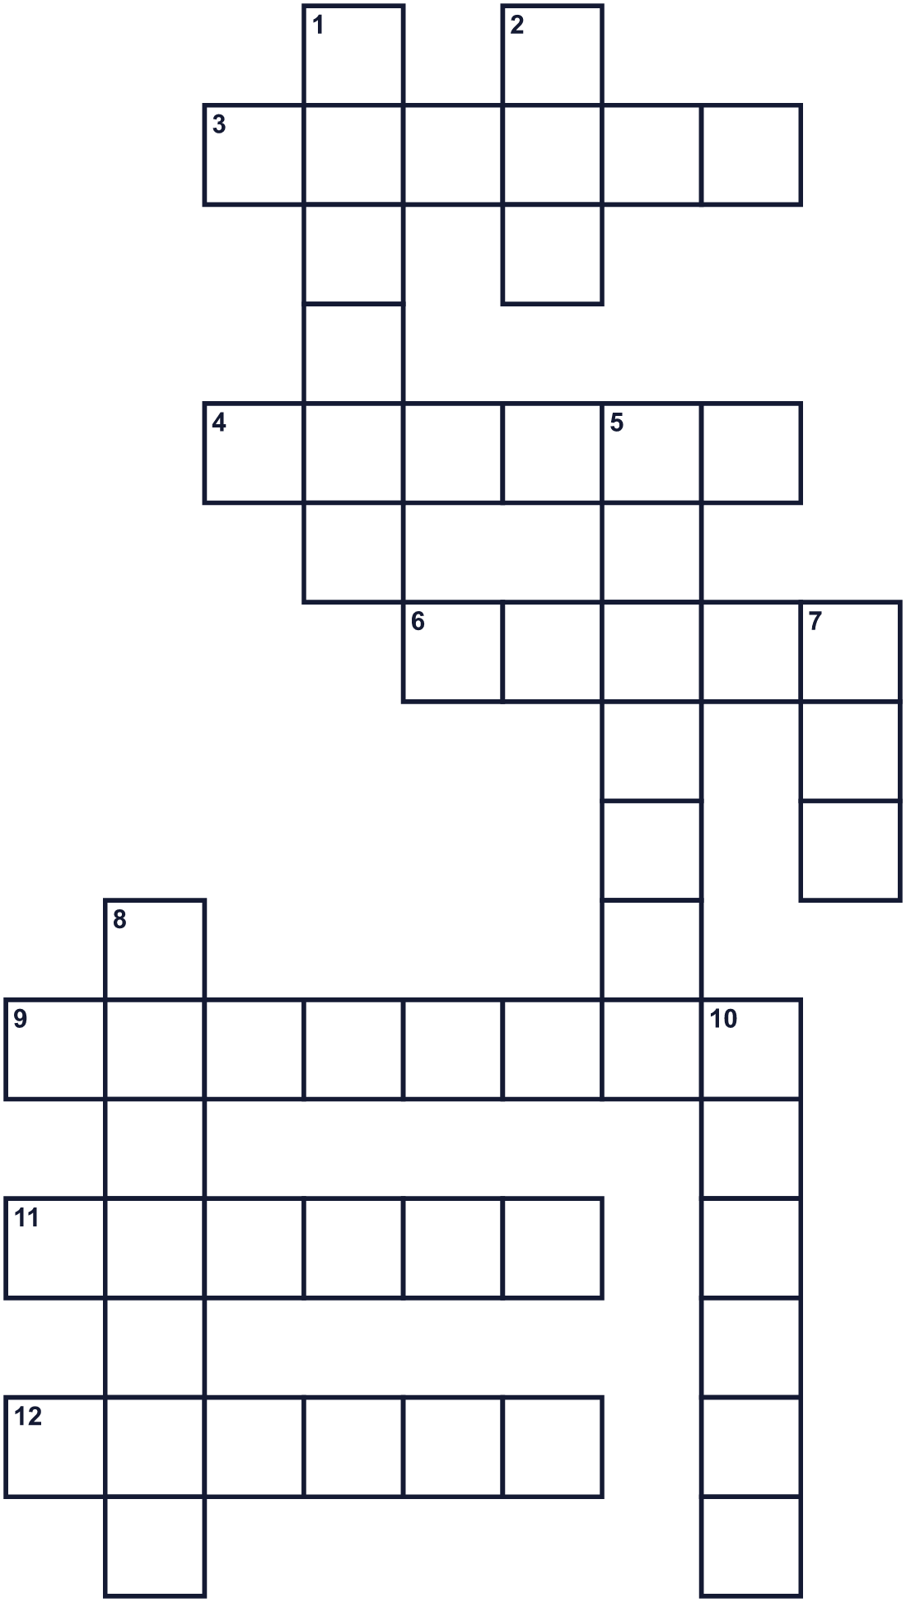
Across →
3. This country also has a constitution holiday on May 3. (6)
4. The Imperial ___ is a big home in Tokyo. (6)
6. A constitution is a set of these for a country. (5)
9. The constitution was announced in this month in 1946. (8)
11. Eating lunch outside in the park. (6)
12. Children in Norway march in this on May 17. (6)
Down ↓
1. A country in Europe that celebrates on May 17. (6)
2. Constitution Memorial Day is in this month. (3)
5. November 3 is ___ Day in Japan. (7)
7. The number of months between November 3 and May 3. (3)
8. A day with no school or work. (7)
10. Things the constitution protects, like freedom. (6)

📜 Constitution Memorial Day Worksheet
Word Search
かくれた単語をさがそう（→ ↓ ↘ ↗）
Class ______ No. ____ Name ______________________________
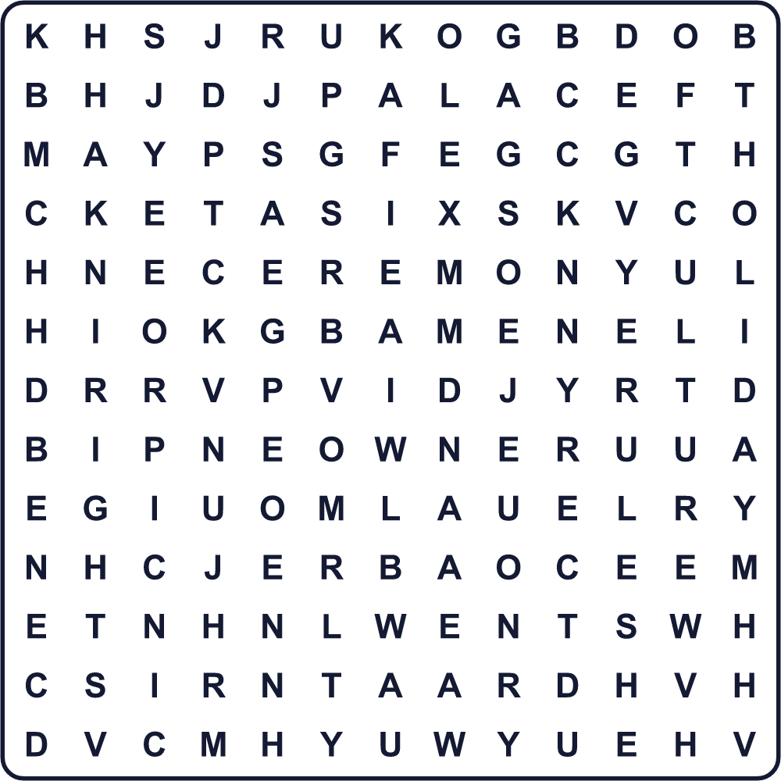
CEREMONY CULTURE DIET HOLIDAY MAY NORWAY NOVEMBER PALACE PARADE PICNIC POLAND RIGHTS RULES SIX
Secret Code 暗号を解こう
♥=A ✂=E ◆=F ♣=L ☃=O ☺=R ⚑=S ●=U
☺ ● ♣ ✂ ⚑ ◆ ☃ ☺ ♥ ♣ ♣
______________________________________________________________

📜 Constitution Memorial Day Worksheet
Maze & Sentences
Class ______ No. ____ Name ______________________________
Help Ken get to the Golden Week picnic! ケンをゴールデンウィークのピクニックまで連れていこう！
正しい道の文字を集めると、ひみつの言葉になるよ。 START 🧒 → GOAL 🧺
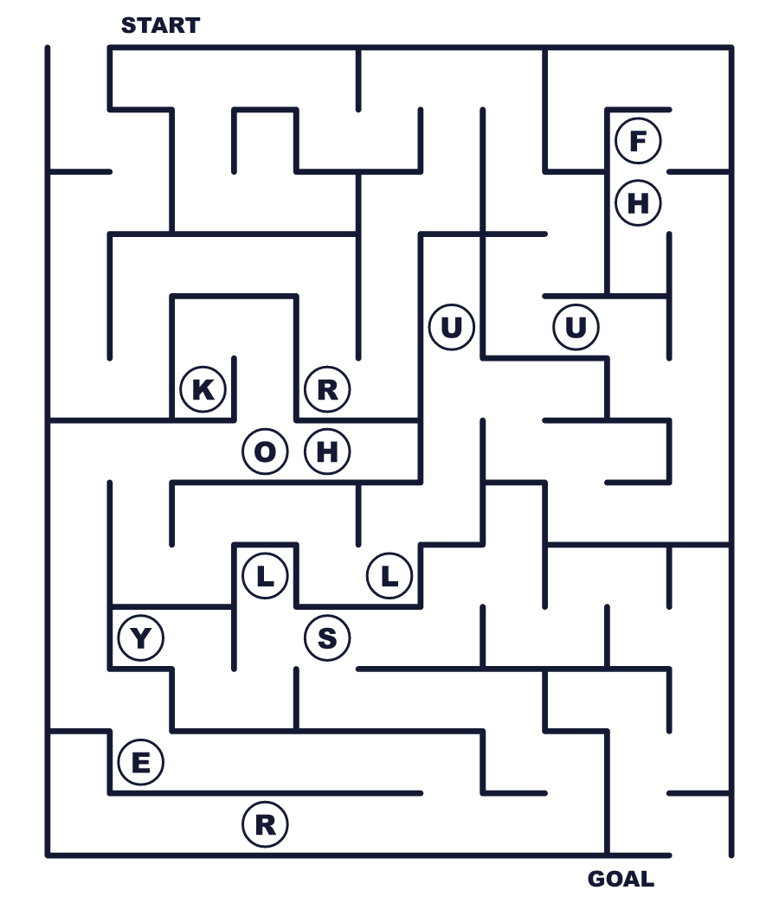
Secret word: ＿ ＿ ＿ ＿ ＿
Put the words in order. 並べかえよう。
1. is / national / May / a / in / Japan / holiday / 3 . (5月3日は日本の国民の祝日です。)
______________________________________________________________
2. started / 3, / 1947 / on / May / constitution / The . (憲法は1947年5月3日に施行されました。)
______________________________________________________________
3. Week / travel / during / Golden / families / Many . (多くの家族がゴールデンウィークに旅行します。)
______________________________________________________________
4. Children / a / Norway / big / in / parade / march / in . (ノルウェーの子どもたちは大きなパレードで行進します。)
______________________________________________________________
5. 3 / November / Day / is / now / Culture / called . (11月3日は今、文化の日と呼ばれています。)
______________________________________________________________

📜 Constitution Memorial Day Worksheet
Class Activity & Writing
Class ______ No. ____ Name ______________________________
Find Someone Who… クラスで聞いて回ろう！
Find someone who … | Name
… has visited the National Diet Building 国会議事堂に行ったことがある
… knows the date of Culture Day 文化の日の日付を知っている
… has traveled during Golden Week ゴールデンウィークに旅行したことがある
… can name three holidays in May 5月の祝日を3つ言える
… likes picnics ピクニックが好き
… knows what a constitution is 憲法とは何か知っている
… has seen a parade パレードを見たことがある
… can say May 3 in English 5月3日を英語で言える
Let's Write! 英語で書いてみよう。
One important rule in my class is ______ because ______.
私のクラスの大切なルールの1つは＿＿です。なぜなら＿＿だからです。
______________________________________________________________
______________________________________________________________
During Golden Week, I want to ______.
ゴールデンウィークに、私は＿＿したいです。
______________________________________________________________
______________________________________________________________
If I could make a new holiday, it would be on ______ because ______.
もし新しい祝日を作れるなら、＿＿にします。なぜなら＿＿だからです。
______________________________________________________________
______________________________________________________________

📜 Constitution Memorial Day Worksheet
Trace & Color
なぞって書こう。絵に色をぬろう。
Class ______ No. ____ Name ______________________________
📅 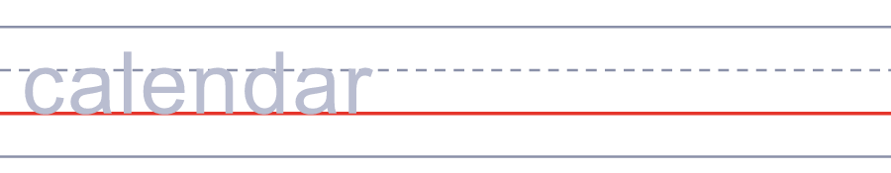

📖 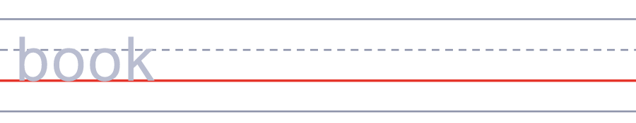
🎉 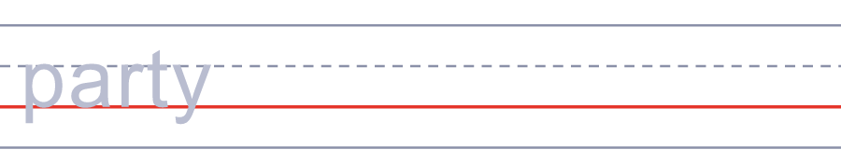
🎻 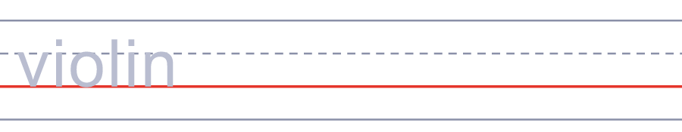
🚄 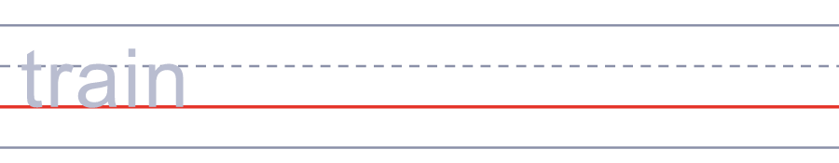
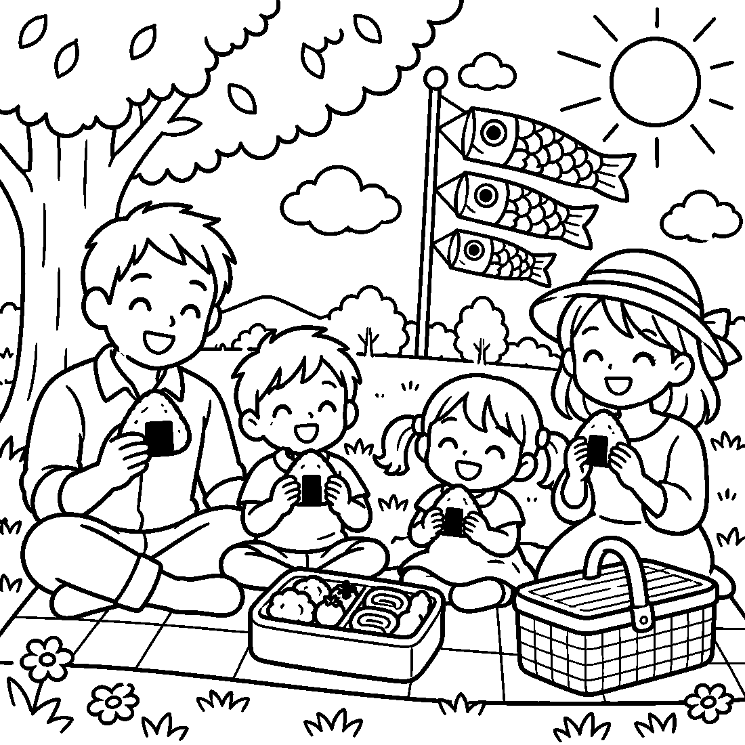

📜 Constitution Memorial Day Worksheet
Answer Key 解答
Reading Check: 1.B 2.D 3.A 4.C 5.B 6.D 7.A 8.C
True or False: 1.T 2.F 3.T 4.T 5.F 6.F
Match: 📅=calendar 📖=book 🎉=party 🎻=violin 🚄=train 🍙=rice ball 🌳=tree 🎏=carp streamer
Unscramble: 1.HOLIDAY 2.RULES 3.PALACE 4.RIGHTS 5.PARADE 6.CULTURE
Fill in the blanks: (1)May (2)holiday (3)Day (4)started (5)rules (6)calendar (7)Golden (8)park (9)picnic (10)free
Sentence order: 1. May 3 is a national holiday in Japan. 2. The constitution started on May 3, 1947. 3. Many families travel during Golden Week. 4. Children in Norway march in a big parade. 5. November 3 is called Culture Day now.
Secret Code: RULES FOR ALL
Maze: RULES
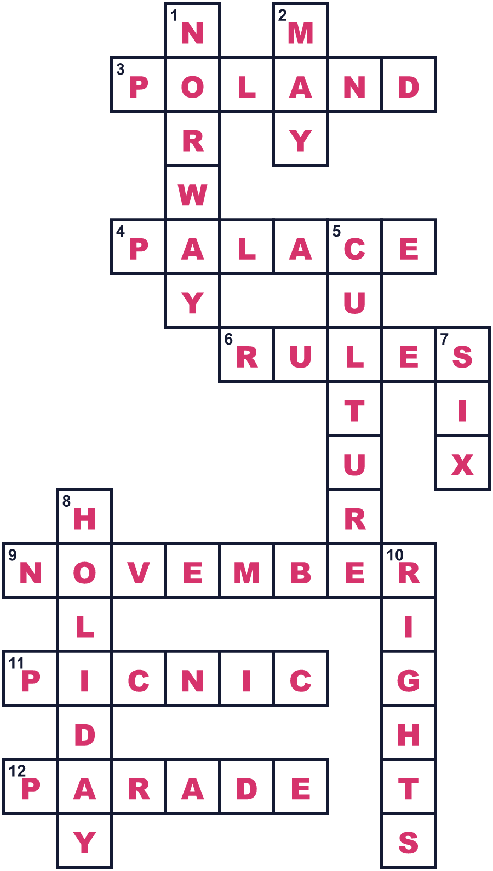
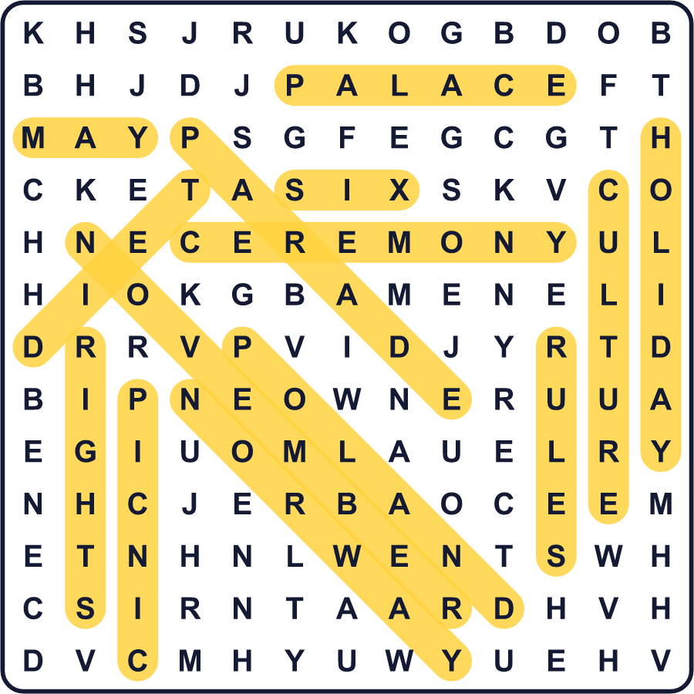
全訳
1 日本では、5月3日は「憲法記念日」という国民の祝日です。英語では Constitution Memorial Day と呼びます。憲法とは、国にとっていちばん大事なルールの集まりです。国がどう動くか、人々がどんな権利を持つかを決めています。
2 日本の憲法は1946年11月3日に公布されました。でも、その日に使われ始めたわけではありません。使われ始めたのは半年後、1947年5月3日です。ちょっとした秘密があります。政府はまず5月3日を選び、そこから半年さかのぼって11月3日を選んだのです。
3 新しい憲法は大きなニュースでした。1947年5月3日、東京の皇居の前で式典が開かれました。同じ日、有名な劇場でバイオリンの演奏と歌舞伎の踊りのある祝賀会が開かれました。また、ある団体が憲法についての小さな本を作りました。約2,000万部が日本中の家庭に届けられました。
4 5月3日は1948年に国民の祝日になりました。最初、一部の国会議員はこどもの日を5月3日にしたいと考えていました。3月3日の女の子のお祭りと、5月5日の男の子のお祭りを組み合わせる考えが気に入っていたのです。でも憲法記念日が5月3日になったので、こどもの日は5月5日になりました。
5 今、5月3日は春の休日が集まったゴールデンウィークの真ん中にあります。多くの家族が旅行したり、公園でのんびりしたりします。新聞やテレビは憲法を取り上げ、憲法についての講演を聞きに行く人もいます。みんなで分かち合っているルールについて考えるのに、ちょうどいい日です。

