🗾 National Foundation Day Worksheet
A Birthday Nobody Can Prove
Read the story. 英文を読もう。
Class ______ No. ____ Name ______________________________
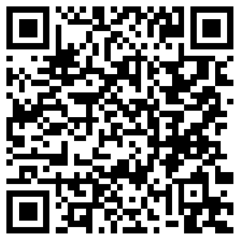
🔊 音声を聞こう（スマホで読みとってね）
1 February 11 is National Foundation Day in Japan. But here is a puzzle. Nobody knows the real birthday of Japan. So why do people celebrate on this day?
2 The date comes from an old history book called the Nihon Shoki, finished in 720. The book says the first emperor, Jimmu, became emperor on New Year's Day long ago. People later said that this year was 660 BC. In 1873, the Meiji government changed this date to the new calendar and got February 11. The holiday was called Kigensetsu.
3 After World War II, Japan stopped this holiday in 1948. Some people wanted it back because they felt every country needs a day to celebrate its beginning. But others were against the idea. They said the story of Jimmu was a myth, not history. They also said the holiday had been used to support the war. The debate went on for about 18 years.
4 In 1967, the day became a holiday again with a careful new name. The Japanese name has a small word, no, in the middle. Because of this word, the name does not say that Japan began on February 11. It is a day to remember that Japan began at some time.
5 Today, it is a quiet day off for most people. Some groups hold parades to celebrate, and other groups hold meetings to question the holiday. The government does not hold an official ceremony. So the day gives everyone a chance to ask one big question: how did my country begin?
Words 単語
foundation（建国、創設） / emperor（天皇、皇帝） / myth（神話） / history（歴史） / calendar（暦） / celebrate（祝う） / debate（議論、論争） / against（～に反対して） / official（公式の） / remember（思い起こす、記念する） / opinion（意見） / puzzle（なぞ、パズル）

🗾 National Foundation Day Worksheet
Reading Check
Choose the best answer. 正しいものを選ぼう。
Class ______ No. ____ Name ______________________________
1. What is the main idea of the reading?
(A) Japan was founded on February 11 for sure. (B) National Foundation Day is a holiday for skiing. (C) National Foundation Day has a long and debated history. (D) The holiday started after the year 2000.
2. Where does the date February 11 come from?
(A) From an old history book (B) From a law made in 2000 (C) From the Fourth of July (D) From a weather report
3. When did Japan stop the holiday?
(A) In 720 (B) In 1873 (C) In 1967 (D) In 1948
4. Why were some people against bringing the holiday back?
(A) Because February is too cold (B) Because the story was a myth and the holiday had supported the war (C) Because they wanted more holidays in summer (D) Because the book was lost
5. In paragraph 5, 'question the holiday' means:
(A) ask a quiz about the holiday (B) cancel the holiday (C) answer a test (D) think about whether the holiday is right
6. Which is true according to the reading?
(A) The government holds a big ceremony every year. (B) The holiday was called Kigensetsu before the war. (C) The Japanese name says Japan began on February 11. (D) Everybody agrees about the holiday.
7. Why did the new name need a careful word like 'no'?
(A) Because the true date of the founding cannot be proved (B) Because the name was too short (C) Because foreign people asked for it (D) Because the old book used that word
8. In the dialogue, what is Daiki going to do tomorrow?
(A) Watch fireworks (B) Go to a ceremony (C) Go skiing (D) Teach English
True or False? T か F に○
1. National Foundation Day is on February 11. T / F
2. Everyone knows the exact day when Japan was founded. T / F
3. The holiday was called Kigensetsu before the war. T / F
4. The government holds a big ceremony on this day. T / F
5. The holiday came back in 1967. T / F
6. February 11 has been a holiday every year since 1873. T / F

🗾 National Foundation Day Worksheet
Word Work
単語のれんしゅう
Class ______ No. ____ Name ______________________________
① Match the pictures and the words. 絵と単語を線でむすぼう。
🇯🇵 | ● | ● | flag
📜 | ● | ● | drum
⛩️ | ● | ● | skiing
🥁 | ● | ● | crown
📅 | ● | ● | map of Japan
👑 | ● | ● | shrine
⛷️ | ● | ● | scroll
🗾 | ● | ● | calendar
② Unscramble the words. 並べかえて単語にしよう。
1. Y T M H (神話) → ____________________
2. E R P E M O R (天皇) → ____________________
3. E E A D T B (議論) → ____________________
4. N O N I P O I (意見) → ____________________
5. N I N T A O (国) → ____________________
6. Z U Z E P L (なぞ) → ____________________
③ Fill in the blanks. 語群から選んで入れよう。
[ sure / red / beach / pizza / founded / summer / grandfather / calendar / holiday / notebook / school / homework / book ]
On February 11, Sota had no (1) __________ . His teacher gave him (2) __________ about the holiday, so he visited his (3) __________ . "Grandpa, when was Japan (4) __________ ?" Grandpa laughed. "Nobody knows for (5) __________ . The date comes from a very old (6) __________ ." Then he showed Sota an old (7) __________ from 1960. On that page, February 11 was not (8) __________ ! "It was not a (9) __________ back then," Grandpa said. Sota was surprised. He wrote everything in his (10) __________ and smiled.

🗾 National Foundation Day Worksheet
Crossword Puzzle
ヒントを読んでクロスワードを完成させよう。
Class ______ No. ____ Name ______________________________
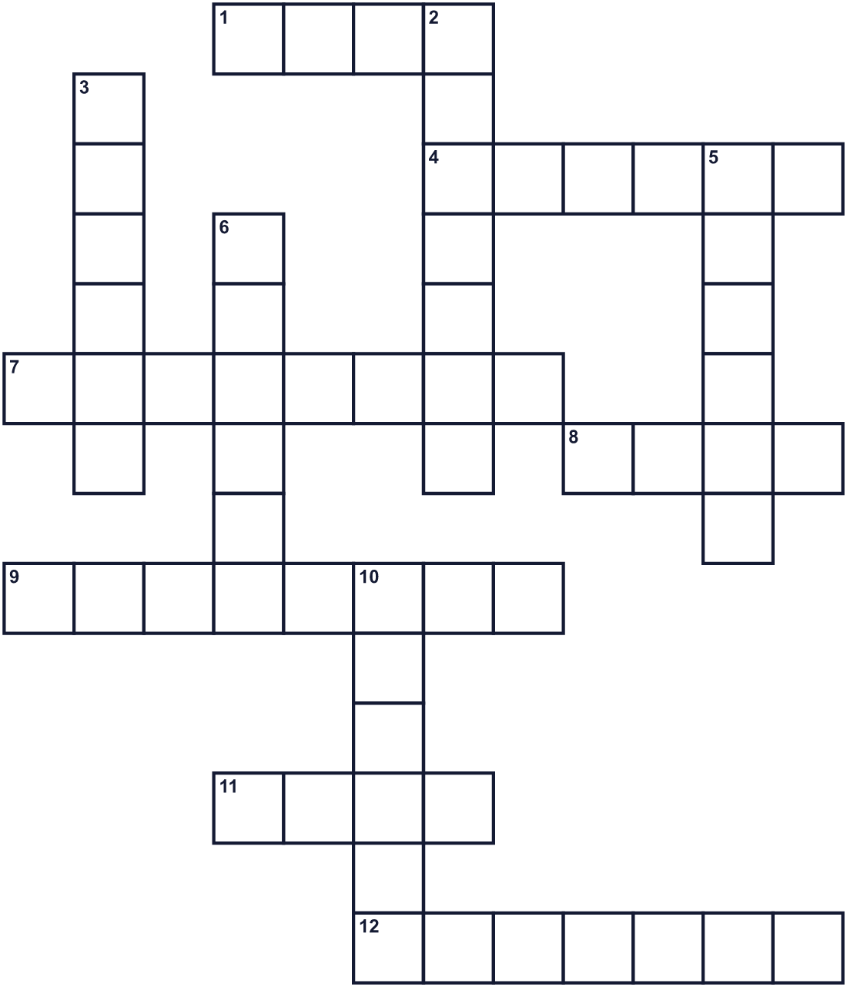
Across →
1. An old story about gods or heroes. It may not be true. (4)
4. A Shinto place where people pray. It often has a gate. (6)
7. The second month of the year. (8)
8. The Nihon Shoki is an old one of these. (4)
9. It shows the days, weeks, and months of a year. (8)
11. A piece of cloth with colors. Each country has one. (4)
12. The title of Jimmu in the old story. (7)
Down ↓
2. The study of things that really happened in the past. (7)
3. The coldest season of the year. (6)
5. Another word for a country. (6)
6. People march down the street with music and flags. (6)
10. A long talk where people share different opinions. (6)

🗾 National Foundation Day Worksheet
Word Search
かくれた単語をさがそう（→ ↓ ↘ ↗）
Class ______ No. ____ Name ______________________________
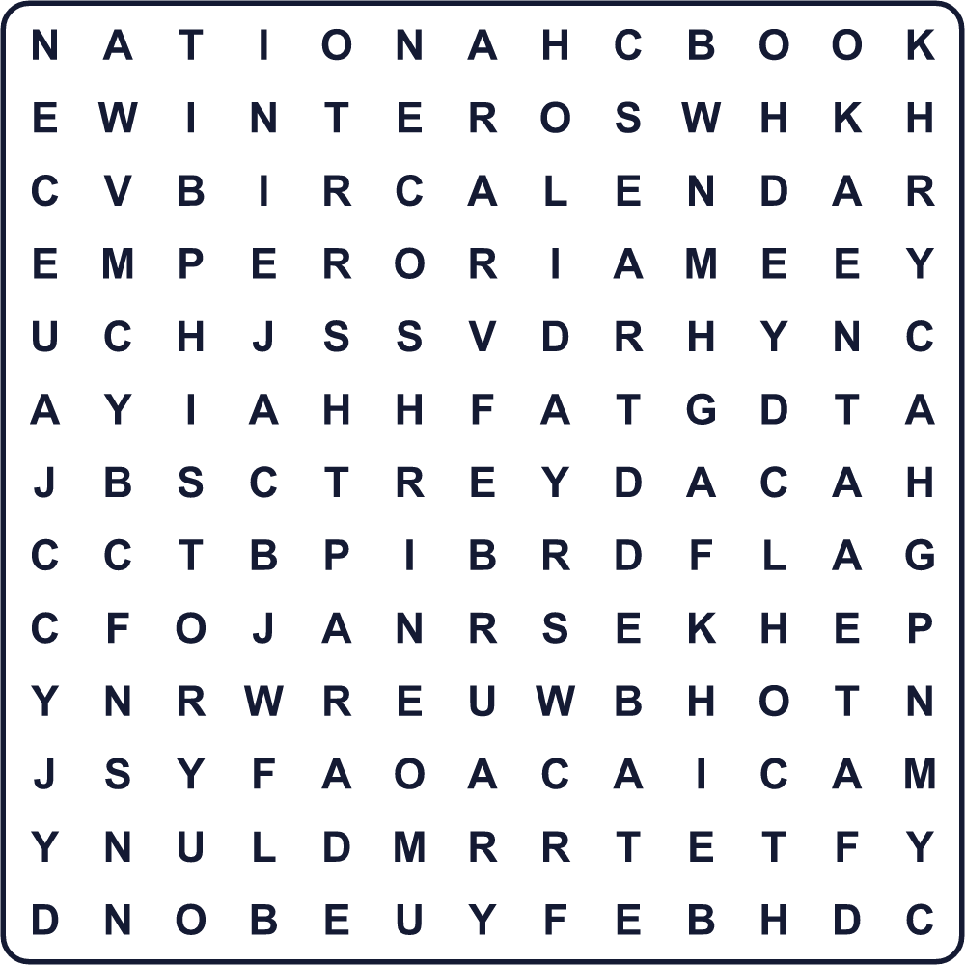
BOOK CALENDAR DEBATE EMPEROR FEBRUARY FLAG HISTORY HOLIDAY MYTH NATION PARADE SHRINE WINTER
Secret Code 暗号を解こう
☂=A ☘=B ★=D ✈=E ⚑=G ✎=H ☺=I ♪=J ♦=N ⚓=O ■=P ▲=W
✎ ⚓ ▲ ★ ☺ ★ ♪ ☂ ■ ☂ ♦ ☘ ✈ ⚑ ☺ ♦
______________________________________________________________

🗾 National Foundation Day Worksheet
Maze & Sentences
Class ______ No. ____ Name ______________________________
Help Sota find the old history book! ソウタを古い歴史書のところまで連れていこう！
正しい道の文字を集めると、ひみつの言葉になるよ。 START 🧒 → GOAL 📜
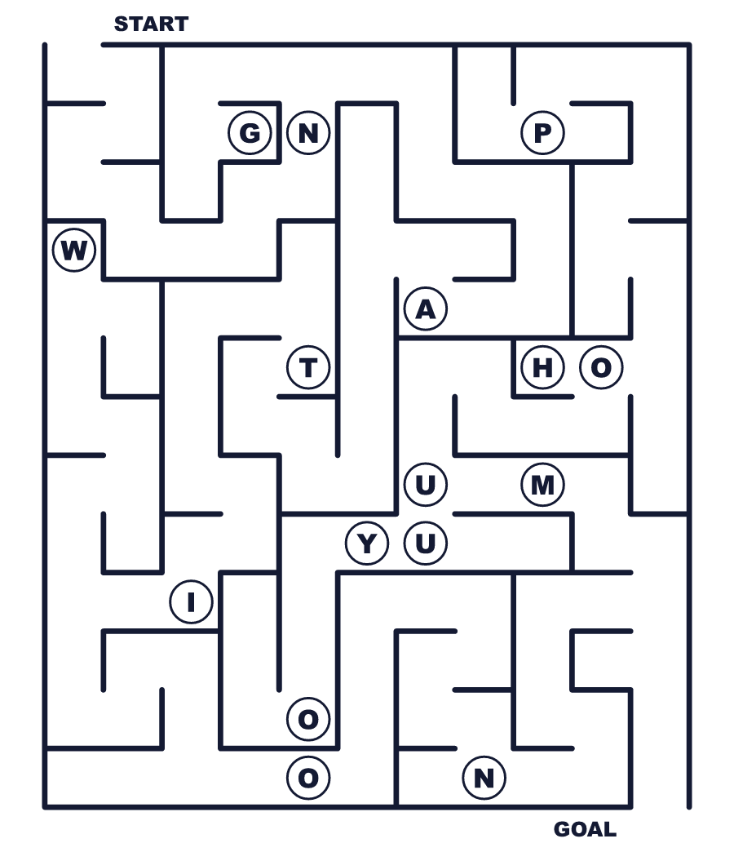
Secret word: ＿ ＿ ＿ ＿ ＿ ＿
Put the words in order. 並べかえよう。
1. a / February / is / 11 / national / holiday . (2月11日は国民の祝日です。)
______________________________________________________________
2. book / from / an / date / old / The / comes . (その日付は古い本から来ています。)
______________________________________________________________
3. birthday / knows / of / the / Nobody / Japan / real . (日本の本当の誕生日はだれにもわかりません。)
______________________________________________________________
4. day / this / opinions / People / different / have / about . (人々はこの日についてさまざまな意見を持っています。)
______________________________________________________________
5. came / holiday / The / back / in / 1967 . (その祝日は1967年に戻ってきました。)
______________________________________________________________

🗾 National Foundation Day Worksheet
Class Activity & Writing
Class ______ No. ____ Name ______________________________
Find Someone Who… クラスで聞いて回ろう！
Find someone who … | Name
… knows the date of National Foundation Day 建国記念の日の日付を知っている
… knows the national day of another country ほかの国の建国記念日を知っている
… has been to a big shrine in Nara 奈良の大きな神社に行ったことがある
… likes reading old stories 昔話を読むのが好き
… can name one myth from another country ほかの国の神話を一つ言える
… has seen a parade パレードを見たことがある
… likes history class 歴史の授業が好き
… went skiing in February 2月にスキーに行ったことがある
Let's Write! 英語で書いてみよう。
If I explain National Foundation Day to a friend, I will say ______.
建国記念の日を友だちに説明するなら、＿＿と言います。
______________________________________________________________
______________________________________________________________
I think a national day is important because ______.
建国記念日は大切だと思います。なぜなら＿＿だからです。
______________________________________________________________
______________________________________________________________
On February 11, I want to ______.
2月11日には＿＿したいです。
______________________________________________________________
______________________________________________________________

🗾 National Foundation Day Worksheet
Trace & Color
なぞって書こう。絵に色をぬろう。
Class ______ No. ____ Name ______________________________
🇯🇵 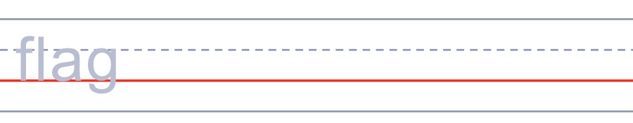

📜 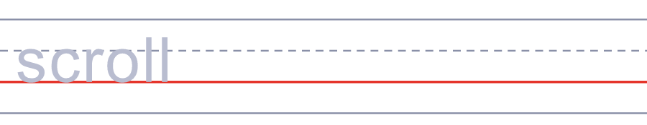
⛩️ 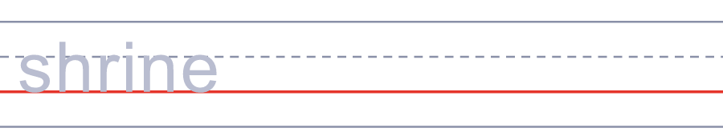
🥁 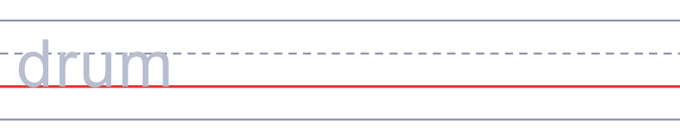
📅 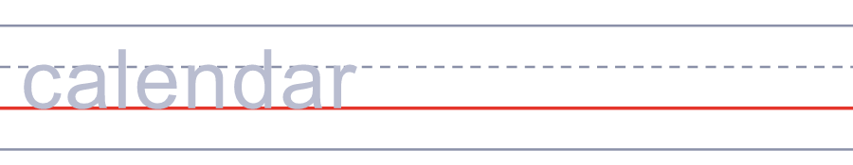
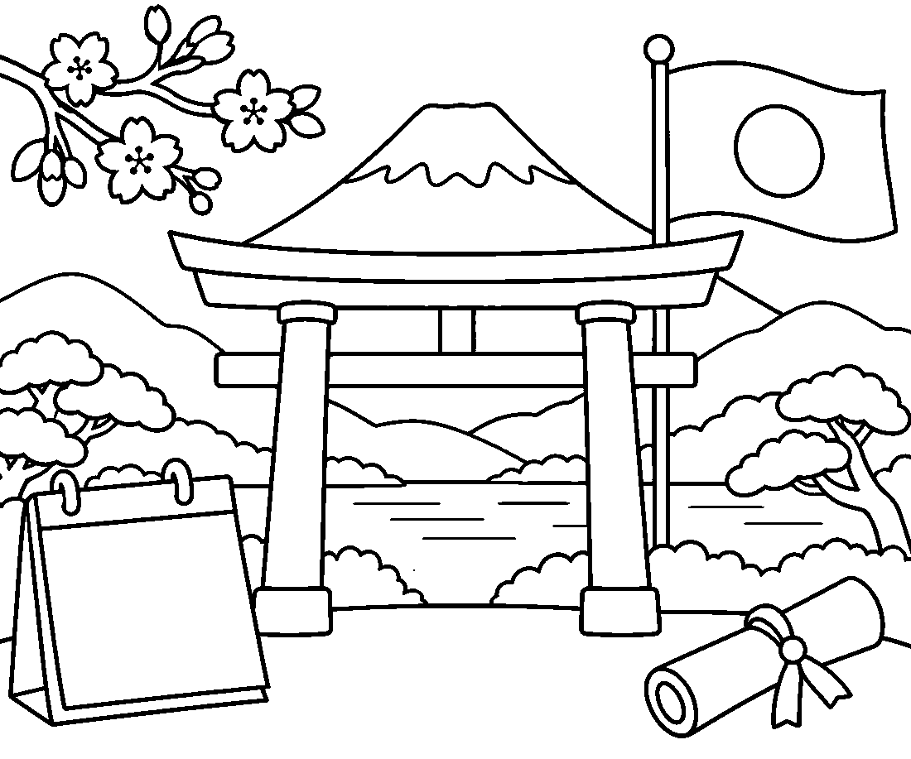

🗾 National Foundation Day Worksheet
Answer Key 解答
Reading Check: 1.C 2.A 3.D 4.B 5.D 6.B 7.A 8.C
True or False: 1.T 2.F 3.T 4.F 5.T 6.F
Match: 🇯🇵=flag 📜=scroll ⛩️=shrine 🥁=drum 📅=calendar 👑=crown ⛷️=skiing 🗾=map of Japan
Unscramble: 1.MYTH 2.EMPEROR 3.DEBATE 4.OPINION 5.NATION 6.PUZZLE
Fill in the blanks: (1)school (2)homework (3)grandfather (4)founded (5)sure (6)book (7)calendar (8)red (9)holiday (10)notebook
Sentence order: 1. February 11 is a national holiday. 2. The date comes from an old book. 3. Nobody knows the real birthday of Japan. 4. People have different opinions about this day. 5. The holiday came back in 1967.
Secret Code: HOW DID JAPAN BEGIN
Maze: NATION
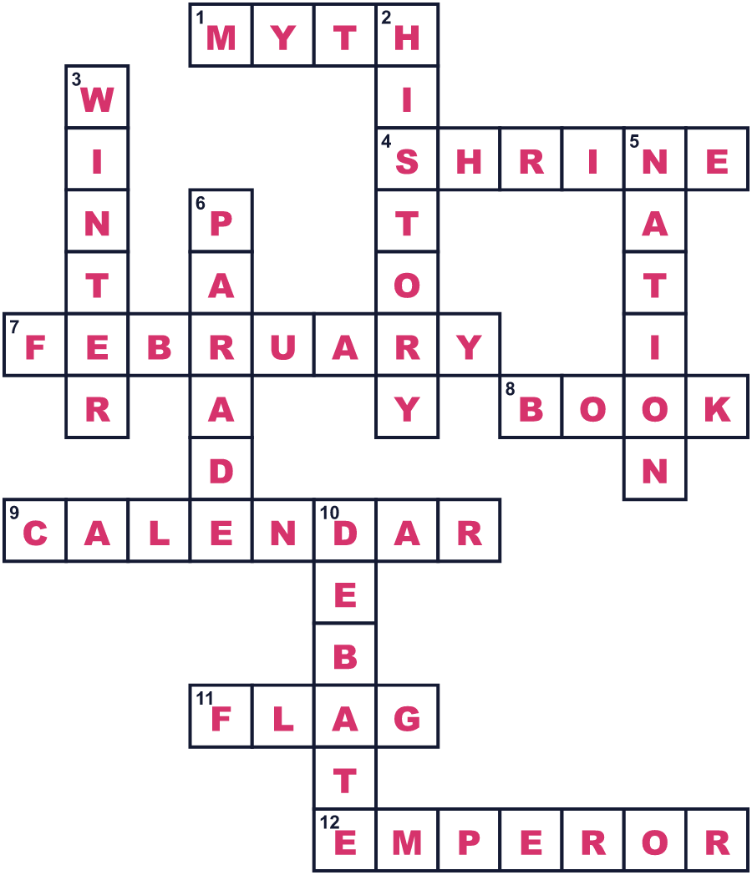
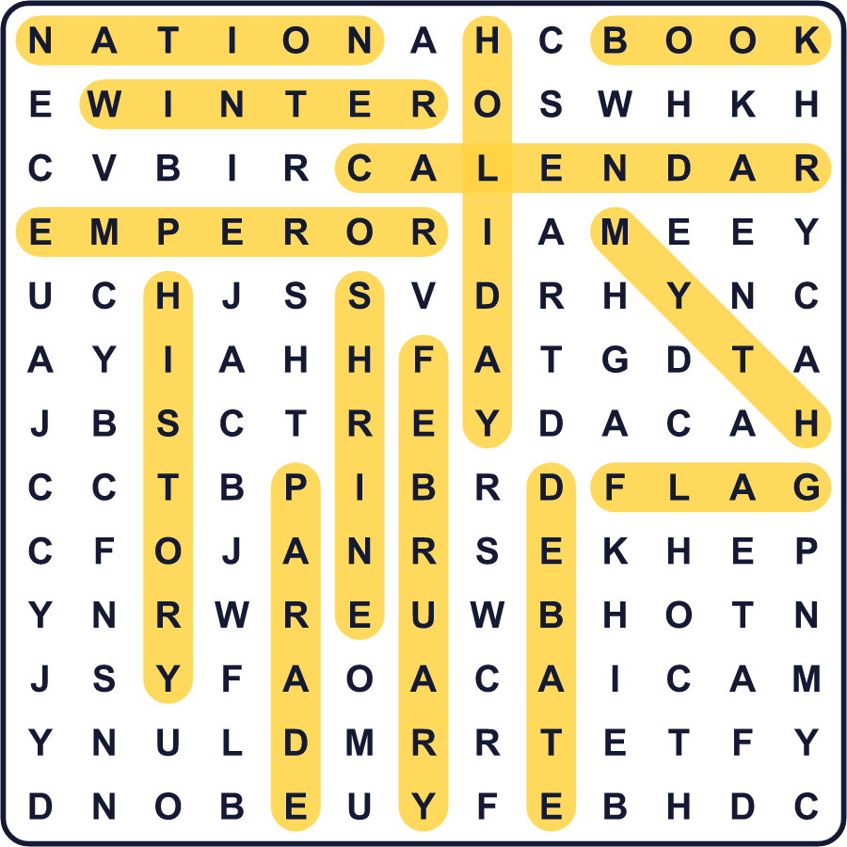
全訳
1 2月11日は日本の建国記念の日です。でも、ここに一つのなぞがあります。日本の本当の誕生日は、だれにもわからないのです。では、なぜ人々はこの日に祝うのでしょうか。
2 この日付は、720年に完成した『日本書紀』という古い歴史書から来ています。その本には、初代の天皇の神武天皇が、遠い昔の元日に天皇になったと書かれています。後の人々は、その年を紀元前660年だとしました。1873年、明治政府はこの日付を新しい暦に直し、2月11日を出しました。その祝日は紀元節と呼ばれました。
3 第二次世界大戦のあと、日本は1948年にこの祝日をやめました。それを取り戻したいと思う人もいました。どの国にも始まりを祝う日が必要だと考えたからです。しかし、その考えに反対する人もいました。反対した人は、神武天皇の物語は歴史ではなく神話だと言いました。また、この祝日が戦争を後押しするのに使われたとも言いました。その議論は約18年続きました。
4 1967年、この日は慎重に考えられた新しい名前で、ふたたび祝日になりました。日本語の名前には、まん中に「の」という小さな言葉があります。この言葉があるので、名前は日本が2月11日に始まったとは言っていません。それは、日本がいつか始まったことを思い起こす日なのです。
5 今日、多くの人にとって、この日は静かな休日です。お祝いのパレードを開くグループもあれば、この祝日を問い直す集会を開くグループもあります。政府は公式の式典を開きません。だからこの日は、すべての人に一つの大きな問いを考えるきっかけをくれます。自分の国はどうやって始まったのだろう？

