👵 Respect for the Aged Day Worksheet
A Village Party That Became a National Holiday
Read the story. 英文を読もう。
Class ______ No. ____ Name ______________________________

🔊 音声を聞こう（スマホで読みとってね）
1 On September 15, 1947, small three-wheeled trucks drove around a mountain village in Hyogo. They picked up older people and took them to the village hall. There, a big party with food and shows was waiting. Everyone aged 55 and over was invited.
2 The party was the idea of the village head, Kadowaki Masao. World War II had just ended, and many parents were very tired and sad. He wanted to thank them for their long, hard work. He also wanted older people to share their wisdom with young people. He chose September because farm work was not busy and the weather was nice.
3 The idea spread across Hyogo and then across Japan. In 1966, it became a national holiday called Keiro no Hi, or Respect for the Aged Day. Keiro means showing respect to older people. Since 2003, it has been on the third Monday of September, so many people get a three-day weekend. Today, a tall stone in the town tells visitors that the holiday was born there.
4 On this day, children call their grandparents, send flowers, or draw pictures for them. Some schools ask students to write letters to their grandparents. Many towns hold parties for older people with songs and dances. People who turn 100 get a letter and a silver cup from the Prime Minister.
5 Today, Japan has more older people than ever. In 1963, only 153 people in the country were 100 or older. In 2026, the number passed 100,000 for the first time. And those 55-year-old guests from 1947 would look very young now.
Words 単語
respect（尊敬（する）、敬う） / aged（年をとった／〜歳の） / village（村） / invite（招待する） / grandparents（祖父母） / spread（広がる、広める） / national holiday（国民の祝日） / three-day weekend（3連休） / turn（（年齢に）なる） / Prime Minister（内閣総理大臣、首相） / silver（銀（の）） / for the first time（初めて）

👵 Respect for the Aged Day Worksheet
Reading Check
Choose the best answer. 正しいものを選ぼう。
Class ______ No. ____ Name ______________________________
1. What is the main idea of the reading?
(A) A village party in 1947 grew into a national holiday for older people. (B) Three-wheeled trucks were popular in Japan after the war. (C) The Prime Minister started a holiday for grandparents in 2003. (D) Japan has fewer older people than before.
2. Who was invited to the party in 1947?
(A) Only people over 100. (B) Children and their teachers. (C) Everyone aged 55 and over. (D) Only the village head's family.
3. Why did Kadowaki choose September?
(A) Because it was his birthday month. (B) Because farm work was not busy and the weather was nice. (C) Because the war ended in September. (D) Because the government told him to.
4. When did the day become a national holiday?
(A) In 1947. (B) In 1963. (C) In 2003. (D) In 1966.
5. In paragraph 3, what does "spread" mean?
(A) Stopped. (B) Went to more and more places. (C) Became smaller. (D) Was kept secret.
6. Which sentence matches the reading?
(A) The holiday is always on September 15 now. (B) Only 153 people were 100 or older in 1963. (C) People who turn 100 get a gold cup. (D) The first party was held in Tokyo.
7. What does the last sentence of the reading suggest?
(A) People aged 55 are not seen as very old today. (B) The guests in 1947 were all children. (C) People in 1947 lived longer than people today. (D) Nobody aged 55 likes parties.
8. In the dialogue, why is Tuesday a holiday?
(A) Because it is Aoi's grandma's birthday. (B) Because the school decided it. (C) Because it is between two holidays. (D) Because it is Grandparents Day.
True or False? T か F に○
1. Respect for the Aged Day is on the third Monday of September. T / F
2. The holiday started in Tokyo in 2003. T / F
3. At the first party, people aged 55 and over were invited. T / F
4. People who turn 100 get a silver cup. T / F
5. In 1963, there were more than 10,000 people aged 100 or older in Japan. T / F
6. In 2026, Tuesday, September 22, was a school day. T / F

👵 Respect for the Aged Day Worksheet
Word Work
単語のれんしゅう
Class ______ No. ____ Name ______________________________
① Match the pictures and the words. 絵と単語を線でむすぼう。
👵 | ● | ● | telephone
👴 | ● | ● | flowers
💐 | ● | ● | tea
✉️ | ● | ● | grandmother
☎️ | ● | ● | cup
🎂 | ● | ● | letter
🏆 | ● | ● | birthday cake
🍵 | ● | ● | grandfather
② Unscramble the words. 並べかえて単語にしよう。
1. R T E P E C S (敬意) → ____________________
2. G V L L A I E (村) → ____________________
3. V I L E R S (銀) → ____________________
4. A L H Y T E H (健康な) → ____________________
5. N V I T I E (招待する) → ____________________
6. T A R P Y (パーティー、会) → ____________________
③ Fill in the blanks. 語群から選んで入れよう。
[ called / card / grandfather / healthy / laughed / wall / village / winter / angry / teaching / picture / turn / school ]
Ren's (1) __________ lives in a small (2) __________ by the sea. He lives there with his old dog, Kuro. On Respect for the Aged Day, Ren made a (3) __________ for him. He drew a (4) __________ of Grandpa fishing. He wrote, "Thank you for (5) __________ me how to fish. Please stay (6) __________ !" Then he (7) __________ Grandpa on the phone. Grandpa (8) __________ and said, "I will put your card on the (9) __________ ." Next year, Grandpa will (10) __________ 80.

👵 Respect for the Aged Day Worksheet
Crossword Puzzle
ヒントを読んでクロスワードを完成させよう。
Class ______ No. ____ Name ______________________________
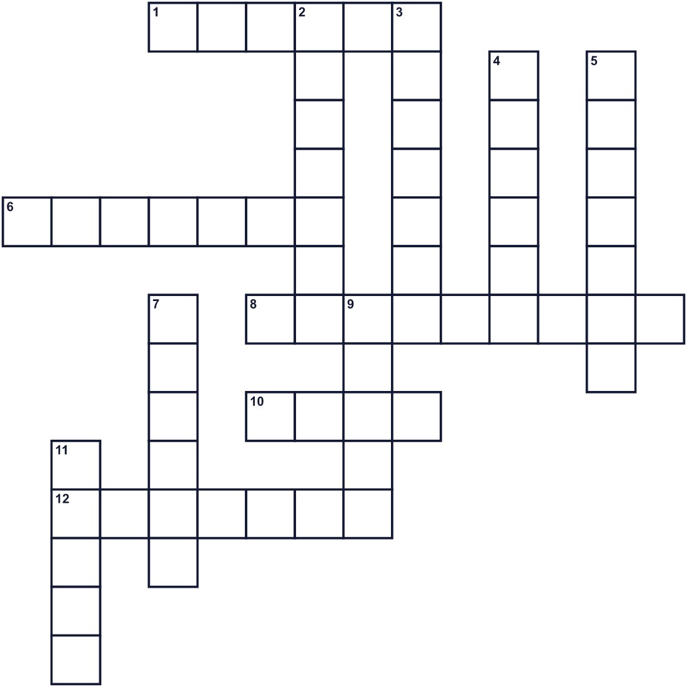
Across →
1. A shiny gray metal. Gold is first, this is second. (6)
6. Your mother's mother or your father's mother. (7)
8. The ninth month of the year. (9)
10. A small piece of paper with a message for someone. (4)
12. Not sick. Strong and well. (7)
Down ↓
2. A very small town in the countryside. (7)
3. A feeling that someone is important and good. (7)
4. Knowledge you get from a long life. (6)
5. The number 100 in words. (7)
7. The day after Sunday. (6)
9. People get together to eat and have fun. (5)
11. You say this word with "you" when someone helps you. (5)

👵 Respect for the Aged Day Worksheet
Word Search
かくれた単語をさがそう（→ ↓ ↘ ↗）
Class ______ No. ____ Name ______________________________
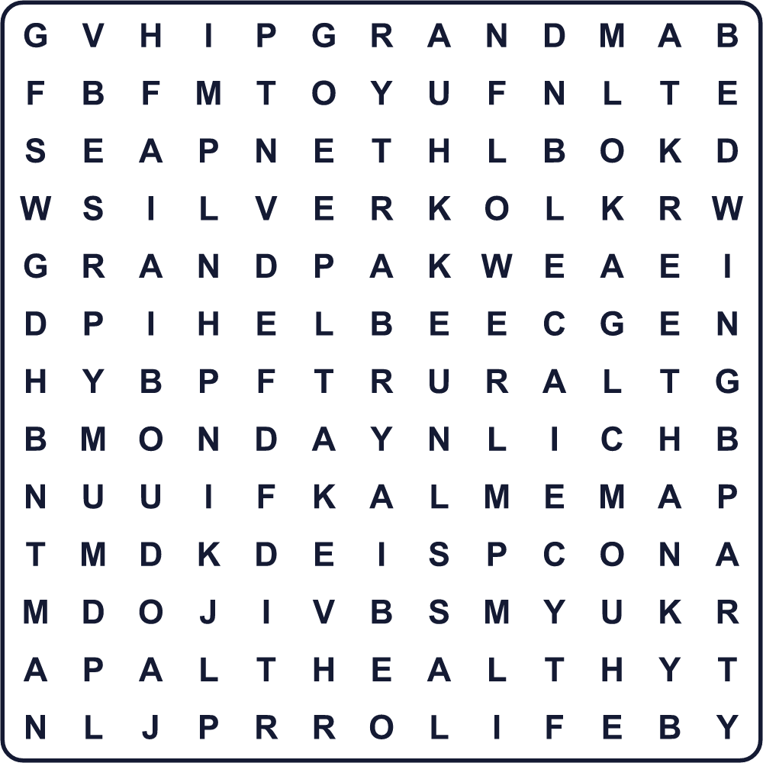
CARD FLOWER GRANDMA GRANDPA HEALTHY LIFE MONDAY PARTY RESPECT SILVER SMILE THANK VILLAGE
Secret Code 暗号を解こう
⚑=A ☀=D ☂=G ♥=H ✚=K ☾=M ✈=N ✂=O ♦=R ✎=T ■=U ◆=Y
✎ ♥ ⚑ ✈ ✚ ◆ ✂ ■ ☂ ♦ ⚑ ✈ ☀ ☾ ⚑
______________________________________________________________

👵 Respect for the Aged Day Worksheet
Maze & Sentences
Class ______ No. ____ Name ______________________________
Take the flowers to Grandma! 花をおばあちゃんに届けよう！
正しい道の文字を集めると、ひみつの言葉になるよ。 START 🧒 → GOAL 👵
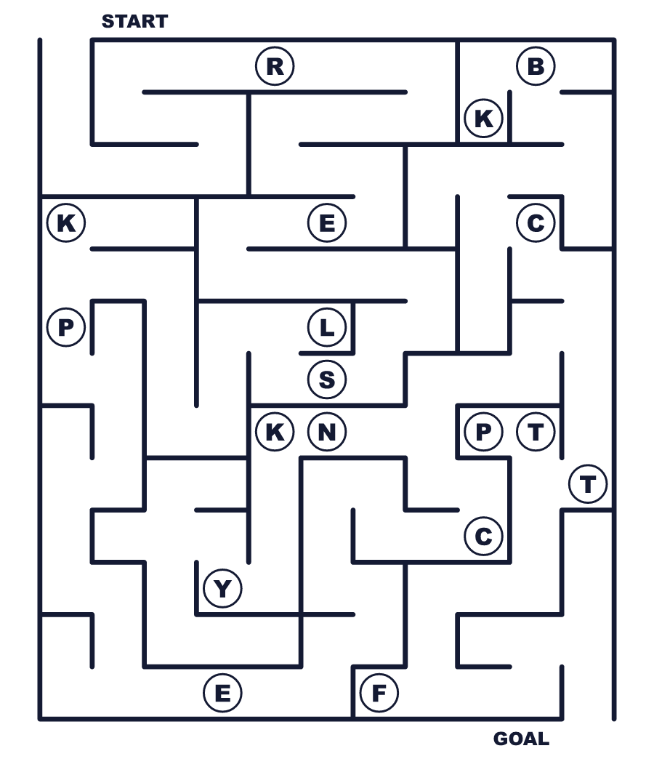
Secret word: ＿ ＿ ＿ ＿ ＿ ＿ ＿
Put the words in order. 並べかえよう。
1. a / The / holiday / started / small / in / village . (その祝日は小さな村で始まりました。)
______________________________________________________________
2. will / I / my / send / flowers / grandma / to . (私は祖母に花を送るつもりです。)
______________________________________________________________
3. long / and / live / healthy / Please / stay . (どうか元気で長生きしてください。)
______________________________________________________________
4. next / year / eighty / will / grandpa / turn / My . (祖父は来年80歳になります。)
______________________________________________________________
5. respect / worked / who / for / us / people / hard / We . (私たちは自分たちのために懸命に働いてくれた人を敬います。)
______________________________________________________________

👵 Respect for the Aged Day Worksheet
Class Activity & Writing
Class ______ No. ____ Name ______________________________
Find Someone Who… クラスで聞いて回ろう！
Find someone who … | Name
… has a grandparent over 80 80歳をこえる祖父母がいる
… has written a letter to a grandparent 祖父母に手紙を書いたことがある
… likes cooking with a grandparent 祖父母と料理をするのが好き
… knows where Respect for the Aged Day started 敬老の日が始まった場所を知っている
… can say "grandmother" in another language 「おばあちゃん」を別の言語で言える
… has learned a game from an older person お年寄りから遊びを教わったことがある
… knows someone who is over 90 90歳をこえる知り合いがいる
… has visited a grandparent's hometown 祖父母のふるさとを訪れたことがある
Let's Write! 英語で書いてみよう。
Dear ______, thank you for ______. I want to ______ with you next time.
＿＿へ。＿＿してくれてありがとう。今度は一緒に＿＿したいです。
______________________________________________________________
______________________________________________________________
An older person I respect is ______ because ______.
私が尊敬するお年寄りは＿＿です。なぜなら＿＿だからです。
______________________________________________________________
______________________________________________________________
When I am 100 years old, I want to ______.
100歳になったら、私は＿＿したいです。
______________________________________________________________
______________________________________________________________

👵 Respect for the Aged Day Worksheet
Trace & Color
なぞって書こう。絵に色をぬろう。
Class ______ No. ____ Name ______________________________
👵 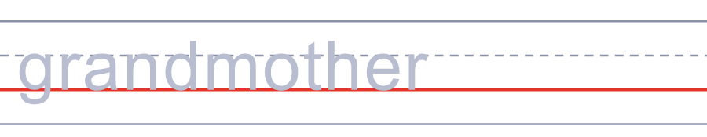

👴 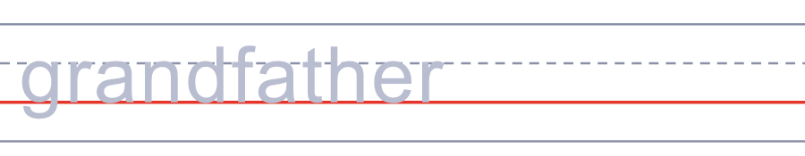
💐 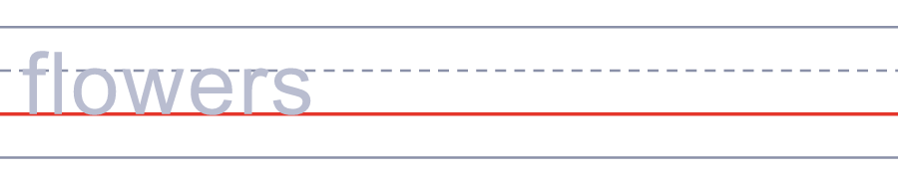
✉️ 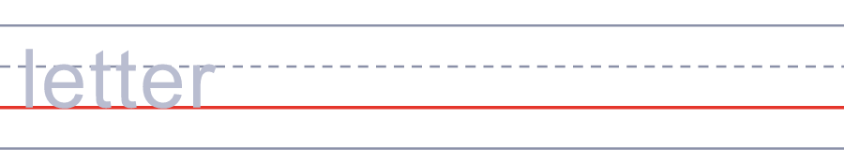
☎️ 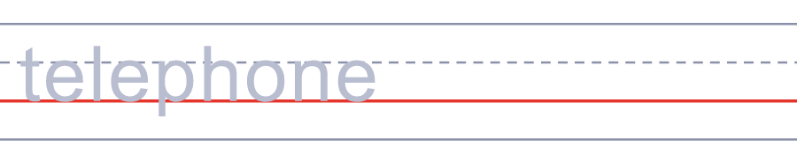
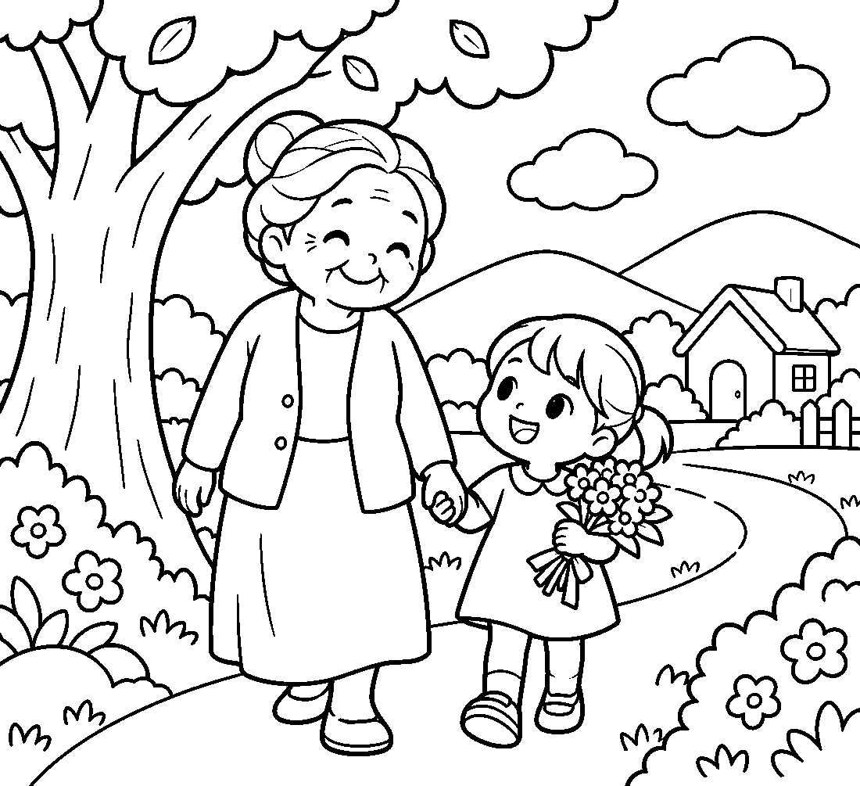

👵 Respect for the Aged Day Worksheet
Answer Key 解答
Reading Check: 1.A 2.C 3.B 4.D 5.B 6.B 7.A 8.C
True or False: 1.T 2.F 3.T 4.T 5.F 6.F
Match: 👵=grandmother 👴=grandfather 💐=flowers ✉️=letter ☎️=telephone 🎂=birthday cake 🏆=cup 🍵=tea
Unscramble: 1.RESPECT 2.VILLAGE 3.SILVER 4.HEALTHY 5.INVITE 6.PARTY
Fill in the blanks: (1)grandfather (2)village (3)card (4)picture (5)teaching (6)healthy (7)called (8)laughed (9)wall (10)turn
Sentence order: 1. The holiday started in a small village. 2. I will send flowers to my grandma. 3. Please stay healthy and live long. 4. My grandpa will turn eighty next year. 5. We respect people who worked hard for us.
Secret Code: THANK YOU GRANDMA
Maze: RESPECT
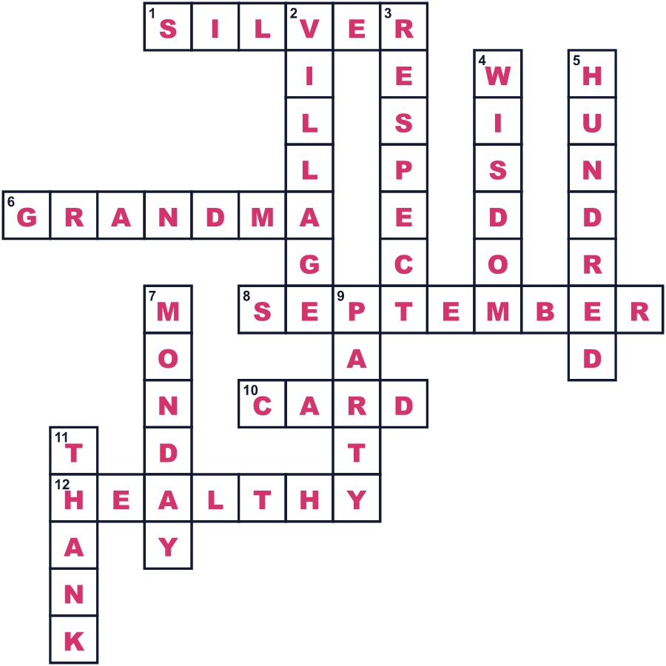
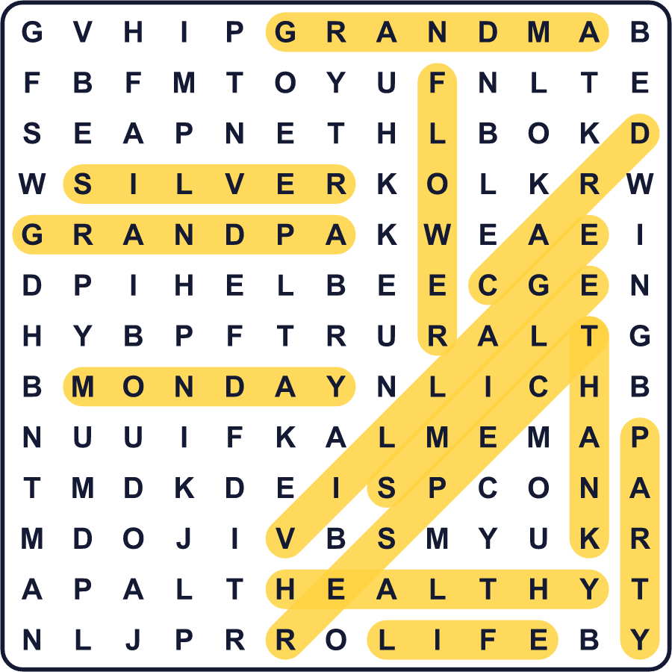
全訳
1 1947年9月15日、兵庫県の山あいの村を、小さな三輪トラックが走り回っていました。トラックはお年寄りを乗せて、村の公会堂へ連れていきました。そこでは、ごちそうと出し物のある大きなパーティーが待っていました。55歳以上の人がみんな招かれていました。
2 このパーティーは、村長の門脇政夫さんの思いつきでした。第二次世界大戦が終わったばかりで、多くの親たちはとても疲れ、悲しんでいました。彼は、長いあいだ懸命に働いてきた人たちに感謝したいと思ったのです。また、お年寄りに若い人たちへ知恵を伝えてもらいたいとも考えました。農作業が忙しくなく、天気もよいので、彼は9月を選びました。
3 この考えは兵庫県中に、そして日本中に広がりました。1966年、それは「敬老の日」という国民の祝日になりました。「敬老」とは、お年寄りを敬うという意味です。2003年からは9月の第3月曜日になったので、多くの人が3連休を楽しめます。今、その町では高い石碑が、ここでこの祝日が生まれたことを訪れる人に伝えています。
4 この日、子どもたちは祖父母に電話をしたり、花を贈ったり、絵を描いたりします。祖父母への手紙を書かせる学校もあります。多くの町では、お年寄りのために歌や踊りのある会を開きます。100歳になる人は、総理大臣から手紙と銀の杯を受け取ります。
5 今、日本にはかつてないほど多くのお年寄りがいます。1963年、100歳以上の人は全国でたった153人でした。2026年、その数は初めて10万人をこえました。そして1947年の55歳のお客さんたちは、今ならとても若く見えることでしょう。

