🪞 Kagami Biraki Worksheet
Opening the Mirror
Read the story. 英文を読もう。
Class ______ No. ____ Name ______________________________

🔊 音声を聞こう（スマホで読みとってね）
1 In early January, many homes in Japan have a strange decoration. Two round rice cakes sit on top of each other, with a small orange on top. This is kagami mochi. Kagami means mirror, and the cakes have this name because old mirrors in Japan were round like them. People offer the cakes to the god of the new year.
2 Around January 11, families take down the rice cakes and eat them. This custom is called kagami biraki, or opening the mirror. By then, the cakes are very hard. But people do not cut them with a knife. Long ago, samurai thought cutting with a blade brought bad luck. So people break the cakes with a wooden hammer or with their hands.
3 At first, samurai did this on January 20. Then in 1651, the shogun Tokugawa Iemitsu died on the 20th day of a month. Many people say this is why the day moved to the 11th. But the date is still different in some areas, like January 15 or 20.
4 Today, people often put the pieces in sweet red bean soup. This warm dessert is called oshiruko. Judo and kendo schools also hold kagami biraki to start the year. And at weddings, guests sometimes open a big barrel of sake with wooden hammers. That is called kagami biraki, too, because the round lid was once called a mirror.
Words 単語
decoration（飾り） / mirror（鏡） / offer（（神仏に）供える、ささげる） / blade（刃） / luck（運） / hammer（金づち、ハンマー） / barrel（樽） / lid（ふた）

🪞 Kagami Biraki Worksheet
Reading Check
Choose the best answer. 正しいものを選ぼう。
Class ______ No. ____ Name ______________________________
1. What is the passage mainly about?
(A) How to make a new mirror for New Year (B) Why Japanese people buy new knives in January (C) A custom of breaking and eating New Year rice cakes (D) The history of judo in the United States
2. Why is the rice cake called kagami mochi?
(A) Because old mirrors were round like the cakes. (B) Because people can see their faces in it. (C) Because it is kept next to a mirror. (D) Because it was first made by a mirror maker.
3. What happened in 1651?
(A) The first kagami mochi was made. (B) Judo schools started kagami biraki. (C) People started eating oshiruko. (D) The shogun Tokugawa Iemitsu died.
4. In paragraph 4, what does lid mean?
(A) the bottom of a box (B) the top cover of a container (C) a kind of drink (D) a large hammer
5. Why does Mai say they open the rice cake?
(A) Because a knife is too heavy. (B) Because cutting sounds unlucky. (C) Because the cake is soft. (D) Because her teacher told her to.
True or False? T か F に○
1. Many people in Japan do kagami biraki around January 11. T / F
2. People usually cut the rice cake with a knife. T / F
3. Kagami means mirror. T / F
4. The date is the same in every part of Japan. T / F

🪞 Kagami Biraki Worksheet
Word Work
単語のれんしゅう
Class ______ No. ____ Name ______________________________
① Match the pictures and the words. 絵と単語を線でむすぼう。
🪞 | ● | ● | judo
🔨 | ● | ● | mirror
🔪 | ● | ● | hammer
🍊 | ● | ● | knife
🍶 | ● | ● | sake
🥋 | ● | ● | orange
③ Fill in the blanks. 語群から選んで入れよう。
[ hammer / hard / soup / rice / knife / pizza / snow / open / lucky ]
In January, Mika's family takes down the (1) __________ cake. It is very (2) __________ now. Her father does not use a (3) __________ . He uses a wooden (4) __________ . Mika puts the pieces in sweet bean (5) __________ . Her mother says, "We do not say cut. We say (6) __________ ." Mika thinks it is a (7) __________ day.

🪞 Kagami Biraki Worksheet
Crossword Puzzle
ヒントを読んでクロスワードを完成させよう。
Class ______ No. ____ Name ______________________________
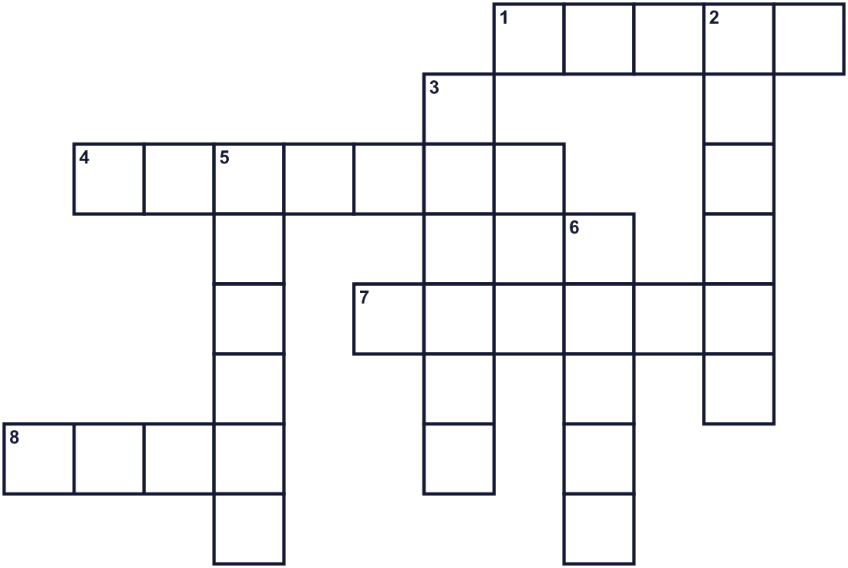
Across →
1. A sticky Japanese rice cake. (5)
4. A Japanese warrior with a sword. (7)
7. A round fruit. A small one sits on top of the cakes. (6)
8. A Japanese sport. You throw your partner. (4)
Down ↓
2. A tool for hitting things. (6)
3. A big round wooden box for sake. (6)
5. You look into it to see your face. (6)
6. A tool for cutting food. People do not use it on this day. (5)

🪞 Kagami Biraki Worksheet
Word Search
かくれた単語をさがそう（→ ↓ ↘ ↗）
Class ______ No. ____ Name ______________________________
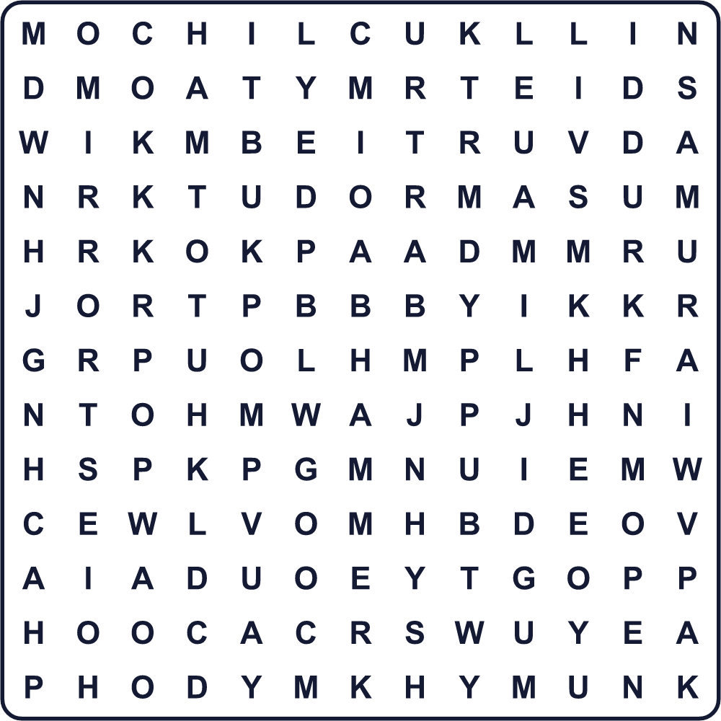
BARREL HAMMER JUDO LID LUCK MIRROR MOCHI OPEN SAMURAI SOUP

🪞 Kagami Biraki Worksheet
Maze & Sentences
Class ______ No. ____ Name ______________________________
Help Yuto carry the rice cake to the table! ユウトがお餅をテーブルまで運べるように助けよう！
正しい道の文字を集めると、ひみつの言葉になるよ。 START 👦 → GOAL 🍡
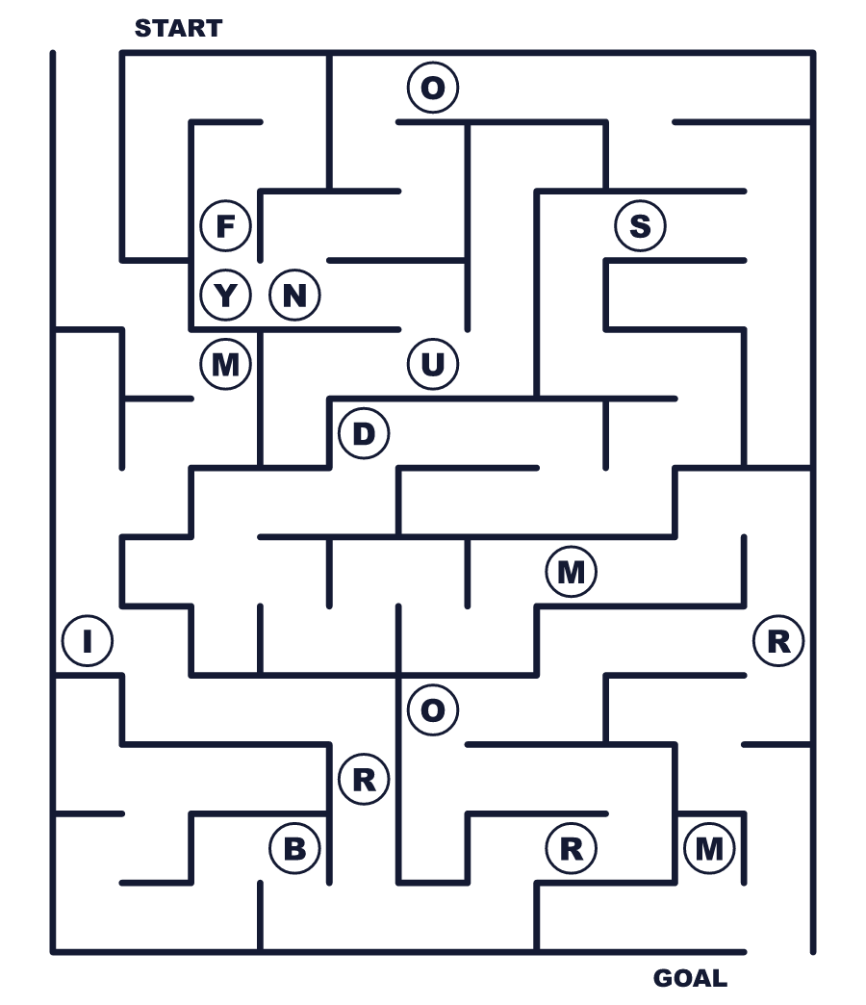
Secret word: ＿ ＿ ＿ ＿ ＿ ＿

🪞 Kagami Biraki Worksheet
Class Activity & Writing
Class ______ No. ____ Name ______________________________
Let's Write! 英語で書いてみよう。
On kagami biraki, I want to eat the rice cake in ______ because ______.
鏡開きには、お餅を______にして食べたいです。なぜなら______だからです。
______________________________________________________________
______________________________________________________________
One lucky word I know is ______. It is lucky because ______.
私が知っている縁起のよい言葉は______です。縁起がよい理由は______です。
______________________________________________________________
______________________________________________________________

🪞 Kagami Biraki Worksheet
Trace & Color
なぞって書こう。絵に色をぬろう。
Class ______ No. ____ Name ______________________________
🪞 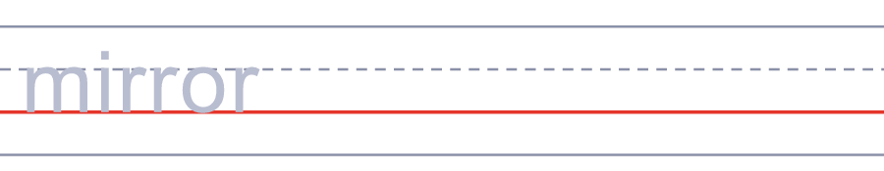

🔨 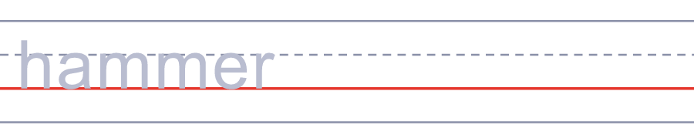
🔪 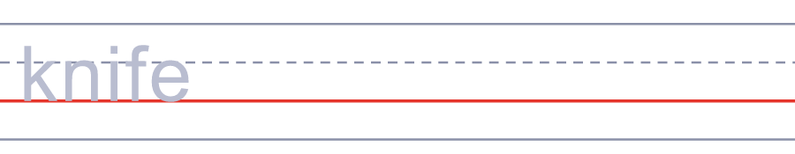
🍊 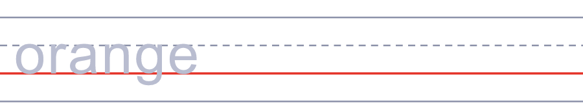
🍶 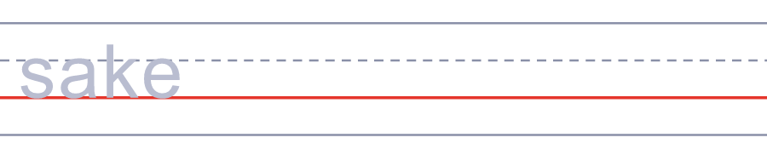

🪞 Kagami Biraki Worksheet
Answer Key 解答
Reading Check: 1.C 2.A 3.D 4.B 5.B
True or False: 1.T 2.F 3.T 4.F
Match: 🪞=mirror 🔨=hammer 🔪=knife 🍊=orange 🍶=sake 🥋=judo
Fill in the blanks: (1)rice (2)hard (3)knife (4)hammer (5)soup (6)open (7)lucky
Maze: MIRROR
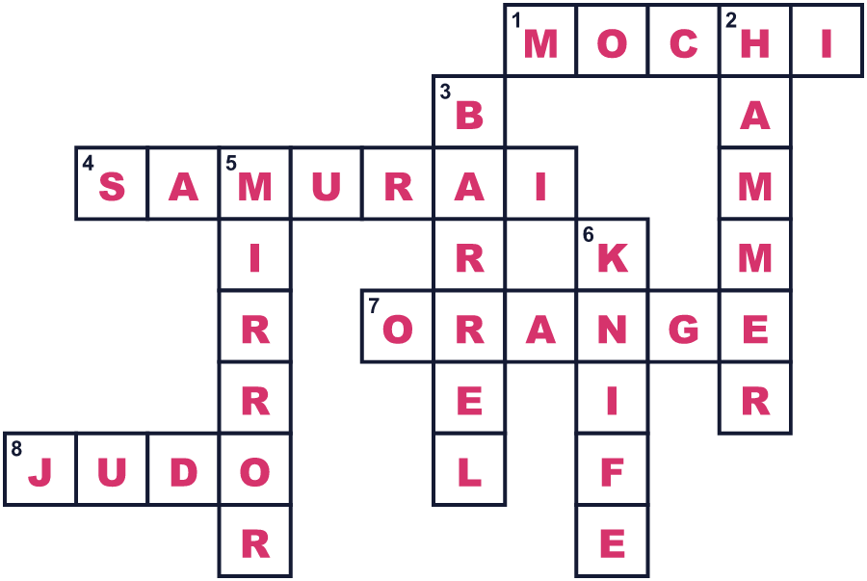
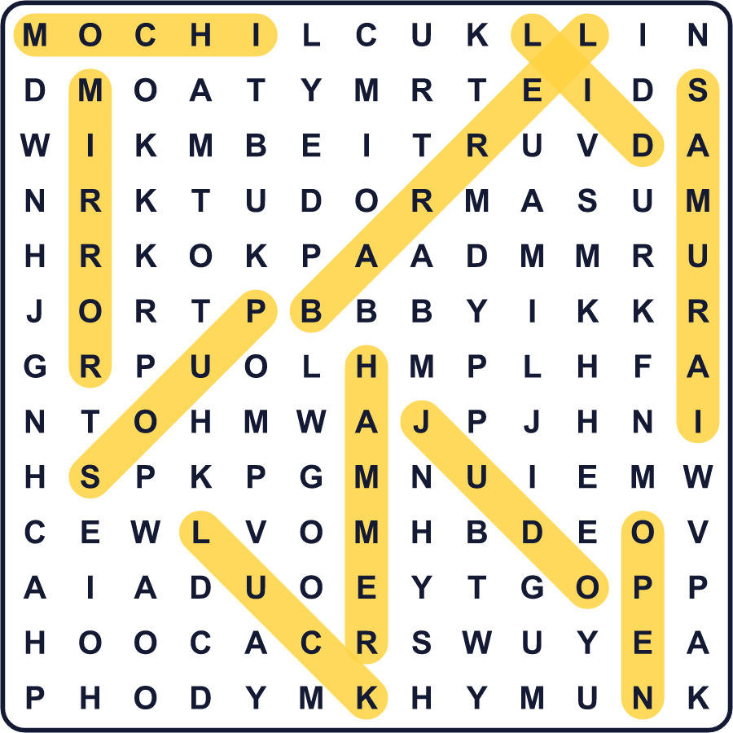
全訳
1 1月のはじめ、日本の多くの家には不思議な飾りがあります。丸いお餅が2つ重なり、そのいちばん上に小さなみかん色の果物がのっています。これが鏡餅です。鏡は英語で mirror。昔の日本の鏡がこのお餅のように丸かったので、この名前がついています。人々は新年の神さまにこのお餅をささげます。
2 1月11日ごろ、家族はお餅を下げて食べます。この習慣を鏡開き、つまり「鏡を開く」と言います。そのころには、お餅はとても固くなっています。でも人々は包丁で切りません。昔、武士は刃物で切ることは不運を招くと考えました。そこで、木づちや手でお餅を割るのです。
3 はじめは、武士たちは1月20日にこれを行っていました。ところが1651年、将軍の徳川家光がある月の20日に亡くなりました。これが、日付が11日に移った理由だと多くの人が言います。でも今でも、1月15日や20日など、地域によって日付は違います。
4 今では、割ったお餅を甘い小豆の汁に入れることがよくあります。この温かいデザートはお汁粉と呼ばれます。柔道や剣道の道場も、一年の始まりに鏡開きをします。また結婚式では、招待客が大きな酒樽を木づちで開けることもあります。樽の丸いふたが昔「鏡」と呼ばれていたので、これも鏡開きと言います。

