🌰 Jusanya (The 13th Night Moon) Worksheet
The Second Moon of Autumn
Read the story. 英文を読もう。
Class ______ No. ____ Name ______________________________

🔊 音声を聞こう（スマホで読みとってね）
1 In autumn, many Japanese people look up at the moon not once, but twice. The first time is Jugoya, the famous harvest moon night. About one month later comes Jusanya, the night of the thirteenth moon. In 2026, Jusanya is on October 23. Its date moves every year, because it follows the old moon calendar.
2 Jugoya came from China, but Jusanya started in Japan. Old records say that a retired emperor held a moon party on this night in the year 919. People at the party enjoyed poems, and he praised the moon as the best of all. Later, the custom spread to ordinary people.
3 Here is a strange fact. The moon on Jusanya is never full. One side is still a little thin. So why do people celebrate the thirteenth night and not the fifteenth? Many stories try to explain it, but nobody knows for sure. One old book gave a reason about the stars. But scientists say it does not match the real sky. It has been a small mystery for more than 1,000 years.
4 On Jusanya, families put chestnuts and beans next to rice dumplings by the window. That is why it is also called the Chestnut Moon or the Bean Moon. Long ago, people said it was bad luck to see only one of the two moons. So if you saw the first moon, don't forget to look up again about a month later!
Words 単語
look up at（〜を見上げる） / harvest（収穫） / retired（引退した） / praise（ほめる、たたえる） / full（（月が）満ちた、いっぱいの） / mystery（謎、なぞ） / chestnut（栗） / bad luck（不運、縁起が悪いこと）

🌰 Jusanya (The 13th Night Moon) Worksheet
Reading Check
Choose the best answer. 正しいものを選ぼう。
Class ______ No. ____ Name ______________________________
1. What is the main idea of the reading?
(A) Jusanya is a second moon-viewing night that started in Japan. (B) Jusanya is a Chinese festival with mooncakes. (C) Japanese people look at the moon only once a year. (D) Jusanya is always on the 13th of October.
2. When did the first Jusanya party happen, according to old records?
(A) In 2026 (B) In 1,000 BC (C) In 919 (D) In 1895
3. What is strange about the moon on Jusanya?
(A) It is red. (B) It is never full. (C) It is very small. (D) It rises in the west.
4. Why is Jusanya called the Chestnut Moon?
(A) Because the moon looks brown (B) Because people eat chestnuts in China (C) Because a chestnut tree grows on the moon (D) Because families put chestnuts out as offerings
5. In the dialogue, what does Lucy teach Daiki?
(A) How to cook chestnuts (B) The English name of the full moon after the Harvest Moon (C) The date of Jugoya (D) Why 13 is bad luck in England
True or False? T か F に○
1. Jusanya started in China. T / F
2. The moon on Jusanya is never full. T / F
3. Jusanya comes about one month after Jugoya. T / F
4. People thought it was lucky to see only one of the two moons. T / F

🌰 Jusanya (The 13th Night Moon) Worksheet
Word Work
単語のれんしゅう
Class ______ No. ____ Name ______________________________
① Match the pictures and the words. 絵と単語を線でむすぼう。
🌕 | ● | ● | leaf
🌰 | ● | ● | beans
🫘 | ● | ● | rabbit
🍡 | ● | ● | chestnut
🍂 | ● | ● | dumplings
🐇 | ● | ● | moon
③ Fill in the blanks. 語群から選んで入れよう。
[ pizza / thin / summer / window / moon / beans / rain / October / dumplings / chestnuts ]
On a cool night in (1) __________ , Grandma and I sat by the (2) __________ . We put rice (3) __________ on a plate. Next to them, we put roasted (4) __________ and green (5) __________ . "Look!" said Grandma. The (6) __________ was bright, but one side was a little (7) __________ . "It is not full yet, but it is still beautiful," she said.

🌰 Jusanya (The 13th Night Moon) Worksheet
Crossword Puzzle
ヒントを読んでクロスワードを完成させよう。
Class ______ No. ____ Name ______________________________
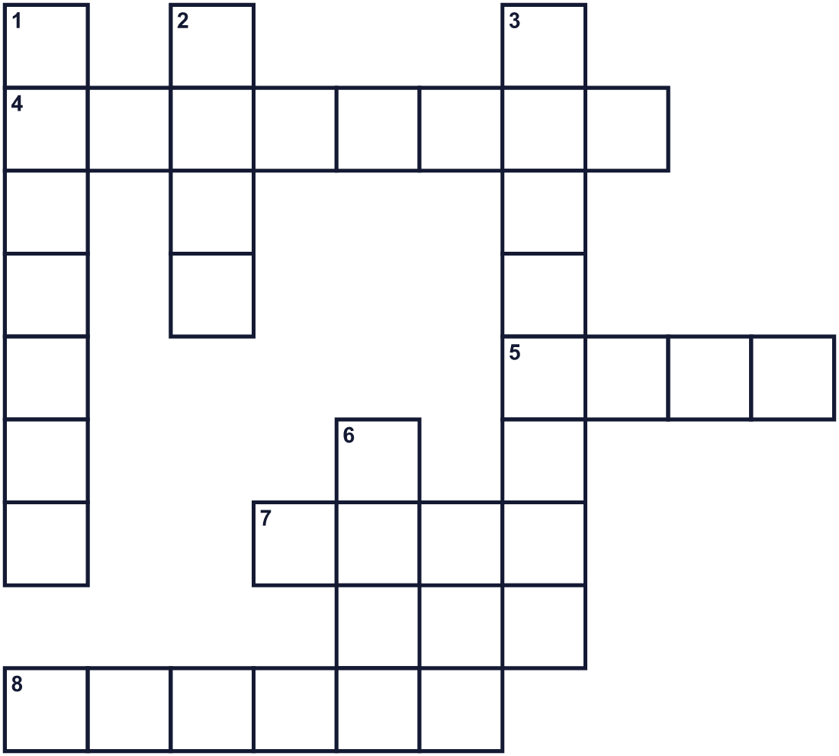
Across →
4. A brown nut in a spiky shell. (8)
5. Something good that happens by chance. (4)
7. It shines in the night sky and changes its shape. (4)
8. The season when leaves turn red and yellow. (6)
Down ↓
1. The tenth month of the year. (7)
2. A small seed you can eat. Edamame is one kind. (4)
3. A small round ball made from rice flour. (8)
6. Words written in short lines, often about beauty. (4)

🌰 Jusanya (The 13th Night Moon) Worksheet
Word Search
かくれた単語をさがそう（→ ↓ ↘ ↗）
Class ______ No. ____ Name ______________________________
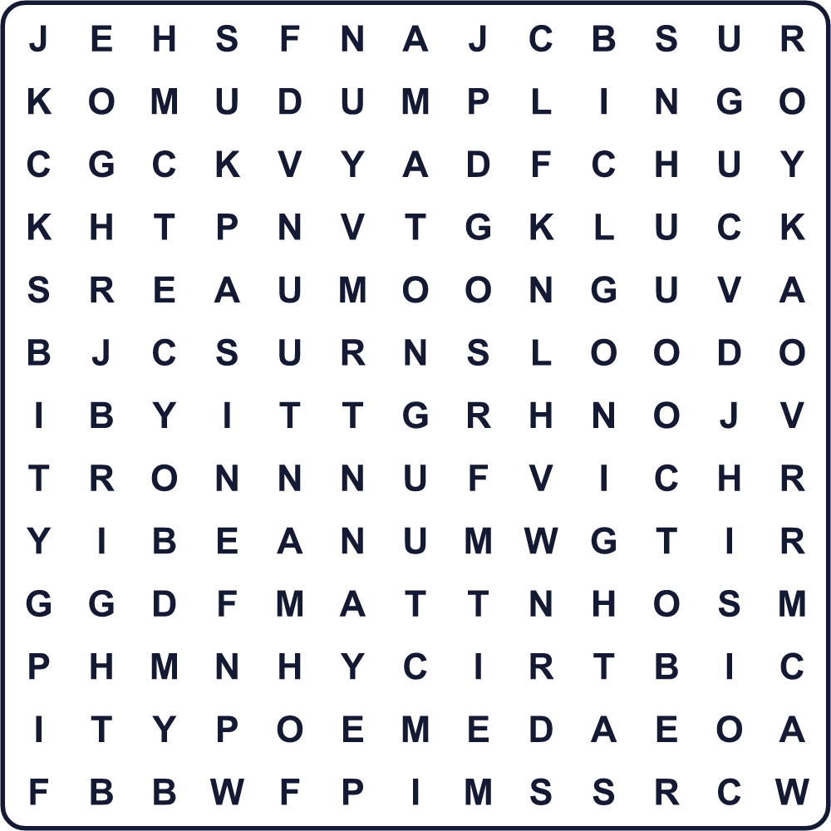
AUTUMN BEAN BRIGHT CHESTNUT DUMPLING LUCK MOON NIGHT OCTOBER POEM

🌰 Jusanya (The 13th Night Moon) Worksheet
Maze & Sentences
Class ______ No. ____ Name ______________________________
Help the rabbit get to the moon! うさぎを月まで連れていこう！
正しい道の文字を集めると、ひみつの言葉になるよ。 START 🐇 → GOAL 🌔
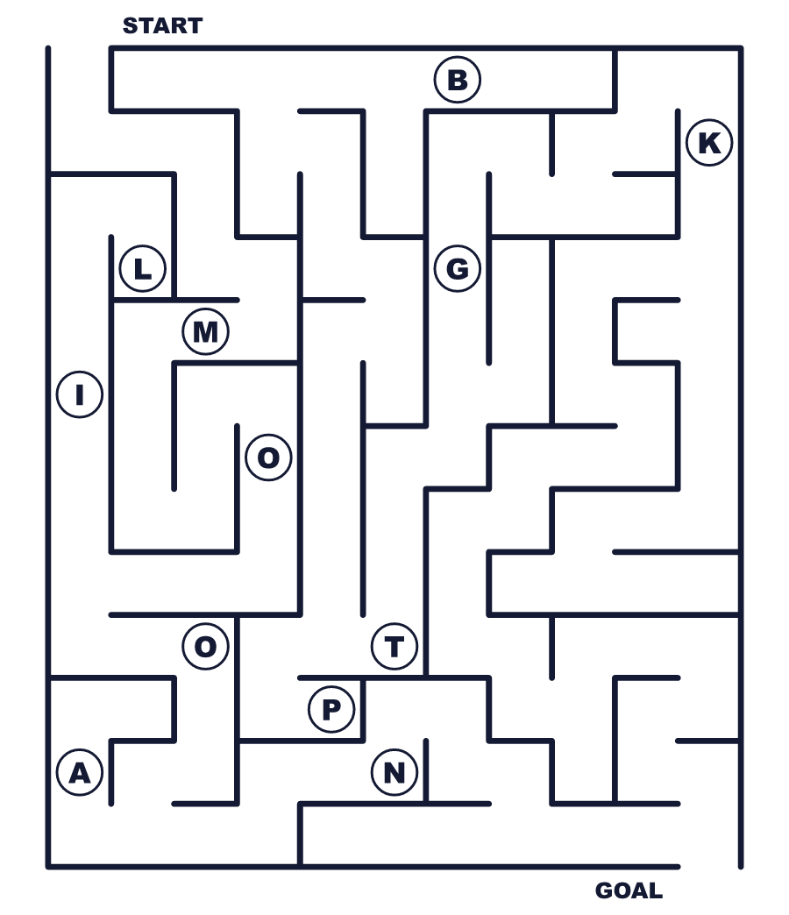
Secret word: ＿ ＿ ＿ ＿

🌰 Jusanya (The 13th Night Moon) Worksheet
Class Activity & Writing
Class ______ No. ____ Name ______________________________
Let's Write! 英語で書いてみよう。
On a moon-viewing night, I want to eat ______ because ______.
お月見の夜に、私は＿＿を食べたいです。なぜなら＿＿だからです。
______________________________________________________________
______________________________________________________________
If I gave the moon on Jusanya a new English name, it would be the ______ Moon because ______.
十三夜の月に新しい英語の名前をつけるなら「＿＿ Moon」にします。なぜなら＿＿だからです。
______________________________________________________________
______________________________________________________________

🌰 Jusanya (The 13th Night Moon) Worksheet
Trace & Color
なぞって書こう。絵に色をぬろう。
Class ______ No. ____ Name ______________________________
🌕 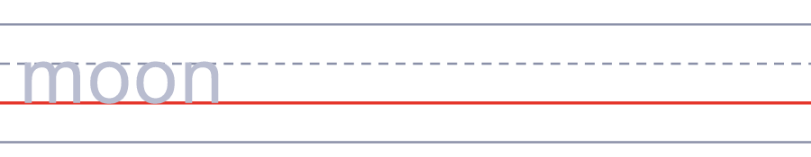

🌰 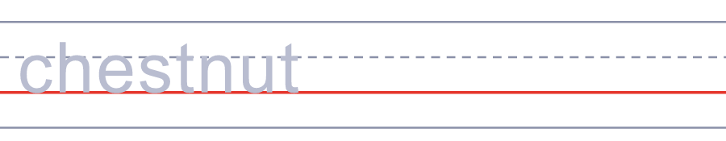
🫘 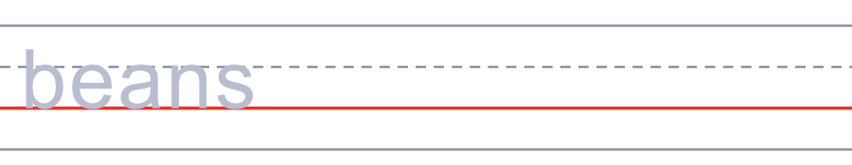
🍡 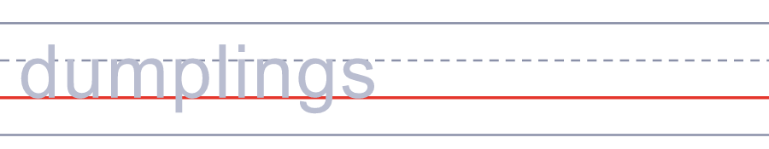
🍂 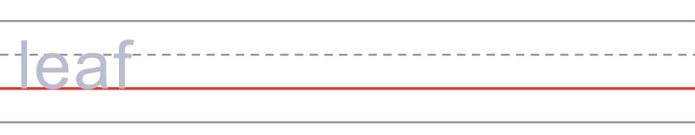

🌰 Jusanya (The 13th Night Moon) Worksheet
Answer Key 解答
Reading Check: 1.A 2.C 3.B 4.D 5.B
True or False: 1.F 2.T 3.T 4.F
Match: 🌕=moon 🌰=chestnut 🫘=beans 🍡=dumplings 🍂=leaf 🐇=rabbit
Fill in the blanks: (1)October (2)window (3)dumplings (4)chestnuts (5)beans (6)moon (7)thin
Maze: MOON
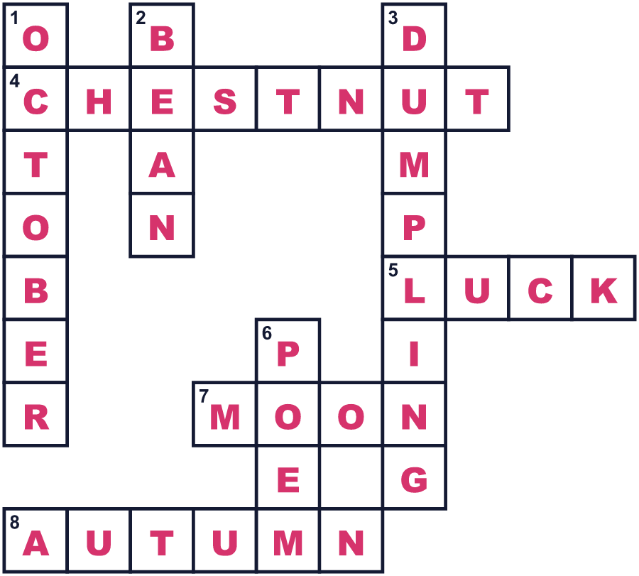
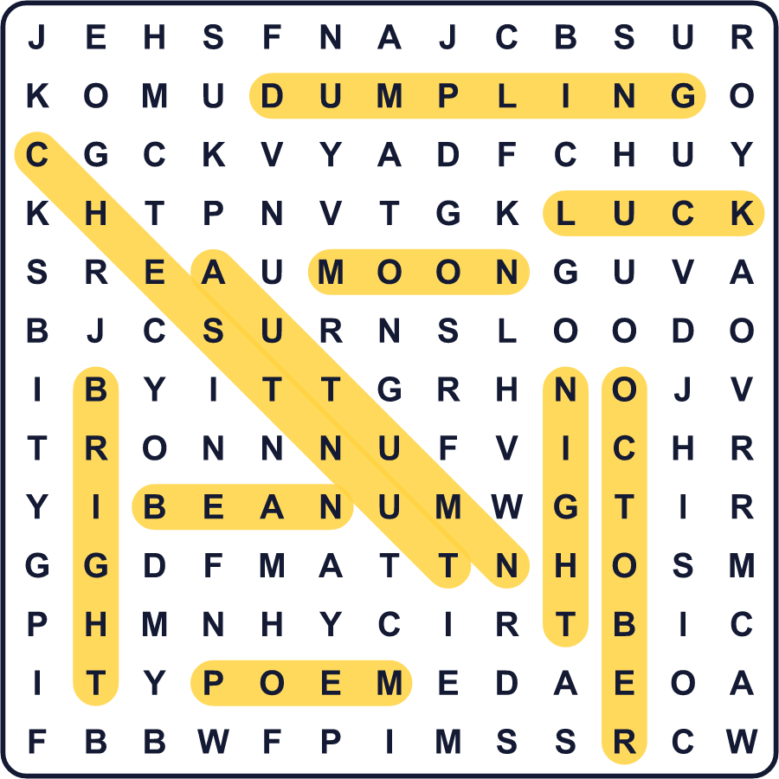
全訳
1 秋、多くの日本人は月を1回ではなく2回見上げます。1回目は有名な中秋の名月の夜、十五夜です。その約1か月後に、十三番目の夜の月、十三夜がやってきます。2026年の十三夜は10月23日です。昔の月の暦にしたがうので、日付は毎年変わります。
2 十五夜は中国から来ましたが、十三夜は日本で始まりました。古い記録によると、919年のこの夜に、ある法皇が月見の宴を開きました。宴では詩が楽しまれ、法皇はその月を並ぶものがないほどすばらしいとほめました。のちに、この習慣はふつうの人々にも広がりました。
3 ここで不思議な事実があります。十三夜の月は決して満月になりません。片側がまだ少し欠けています。では、なぜ人々は十五番目ではなく十三番目の夜を祝うのでしょう。多くの説が説明しようとしてきましたが、本当のところは誰にもわかりません。ある古い本は、星にまつわる理由を挙げました。でも科学者は、それは実際の空と合わないと言います。それは1000年以上も小さな謎のままです。
4 十三夜には、家族が窓辺の月見団子の横に栗や豆を供えます。だから十三夜は栗名月とか豆名月とも呼ばれます。昔の人は、2つの月の片方だけを見るのは縁起が悪いと言いました。だから1回目の月を見たなら、約1か月後にもう一度見上げるのを忘れないでね！

