✊🏿 Juneteenth Worksheet
Freedom Comes Late to Texas
Read the story. 英文を読もう。
Class ______ No. ____ Name ______________________________

🔊 音声を聞こう（スマホで読みとってね）
1 On June 19, 1865, Union soldiers were in the port city of Galveston, Texas. That day, General Gordon Granger gave an order with big news. It said that all slaves are free. About 250,000 enslaved people lived in Texas at that time.
2 But there is a surprising part of this story. President Abraham Lincoln's Emancipation Proclamation started on January 1, 1863. That was 900 days earlier! So why was Texas so late? Texas was far away, and very few Union soldiers were there. Without soldiers, nobody could make enslavers follow the law.
3 The news did not reach everyone on the same day. Some enslavers kept it a secret until the cotton harvest was over. When people finally heard it, some were shocked, and others were full of joy. Many left right away to look for family members.
4 One year later, freed people in Texas held the first celebration. They called it Jubilee Day. Later, people put the words June and nineteenth together and made a new name, Juneteenth. In 1872, a group in Houston raised 1,000 dollars and bought land for a park. They named it Emancipation Park.
5 For a long time, Juneteenth was mostly a Texas holiday. Then, at age 89, a woman named Opal Lee started a long trip from Texas to Washington, D.C. She wanted a national holiday. In 2021, her dream came true, and she stood next to the president. Today, families enjoy parades, barbecues, and red drinks like strawberry soda.
Words 単語
enslaved（奴隷にされた） / free（自由な） / freedom（自由） / order（命令） / general（将軍） / soldier（兵士） / harvest（収穫） / secret（秘密） / celebration（お祝い、祝典） / emancipation（（束縛からの）解放） / national holiday（国の祝日） / parade（パレード、行進）

✊🏿 Juneteenth Worksheet
Reading Check
Choose the best answer. 正しいものを選ぼう。
Class ______ No. ____ Name ______________________________
1. What is the story mainly about?
(A) How Galveston became a big port city (B) How the news of freedom came to Texas and became a holiday (C) Why strawberry soda is popular in Texas (D) How Abraham Lincoln won the war
2. How many enslaved people lived in Texas in 1865?
(A) About 2,000 (B) About 25,000 (C) About 250,000 (D) About 2,500,000
3. How many days after the Emancipation Proclamation did the order come?
(A) 19 days (B) 71 days (C) 250 days (D) 900 days
4. Why was Texas so late, according to the story?
(A) There were very few Union soldiers there. (B) Lincoln did not like Texas. (C) The letter was lost in the sea. (D) People in Texas could not read.
5. In paragraph 4, "raised 1,000 dollars" means they ...
(A) lost 1,000 dollars (B) collected 1,000 dollars (C) lifted 1,000 dollars up (D) paid a 1,000-dollar fine
6. Which is true according to the story?
(A) The first celebration was called Freedom Week. (B) Everyone in Texas heard the news on June 19. (C) Opal Lee was 89 when she started her trip. (D) Juneteenth became a national holiday in 1872.
7. Why did some enslavers keep the news a secret?
(A) They wanted to give a surprise party. (B) They wanted workers for the cotton harvest. (C) They did not understand English. (D) The soldiers asked them to do it.
8. In the dialogue, why is the park special?
(A) Lincoln visited it in 1865. (B) It is the biggest park in Texas. (C) Freed people bought the land in 1872. (D) It sells strawberry soda.
True or False? T か F に○
1. Juneteenth is on June 19. T / F
2. The order was given in Galveston, Texas. T / F
3. The Emancipation Proclamation came after Juneteenth. T / F
4. Juneteenth became a national holiday in 2021. T / F
5. Red foods are a Juneteenth tradition. T / F
6. Slavery ended in every state on June 19, 1865. T / F

✊🏿 Juneteenth Worksheet
Word Work
単語のれんしゅう
Class ______ No. ____ Name ______________________________
① Match the pictures and the words. 絵と単語を線でむすぼう。
📜 | ● | ● | soda
⭐ | ● | ● | ship
🥤 | ● | ● | harvest
🍰 | ● | ● | star
🚢 | ● | ● | cake
🎺 | ● | ● | trumpet
🌾 | ● | ● | walk
🚶 | ● | ● | order
② Unscramble the words. 並べかえて単語にしよう。
1. E E M F O R D (自由) → ____________________
2. L E D I O S R (兵士) → ____________________
3. A A E P D R (パレード) → ____________________
4. I H Y L D A O (祝日) → ____________________
5. A H S T R V E (収穫) → ____________________
6. U I J B L E E (歓喜の祝い（最初の呼び名）) → ____________________
③ Fill in the blanks. 語群から選んで入れよう。
[ celebrate / angry / park / proud / soda / parade / free / snow / dress / story / barbecue / Christmas / June ]
Every year on (1) __________ 19, Maya's family goes to a (2) __________ in Houston. Her grandmother wears her best (3) __________ . Her father cooks (4) __________ , and Maya drinks red (5) __________ . In the afternoon, they watch a (6) __________ and listen to music with their cousins and friends. Then her grandmother tells a (7) __________ about the past. "Our family was not always (8) __________ ," she says. "That is why we (9) __________ today." Maya feels (10) __________ of her family.

✊🏿 Juneteenth Worksheet
Crossword Puzzle
ヒントを読んでクロスワードを完成させよう。
Class ______ No. ____ Name ______________________________
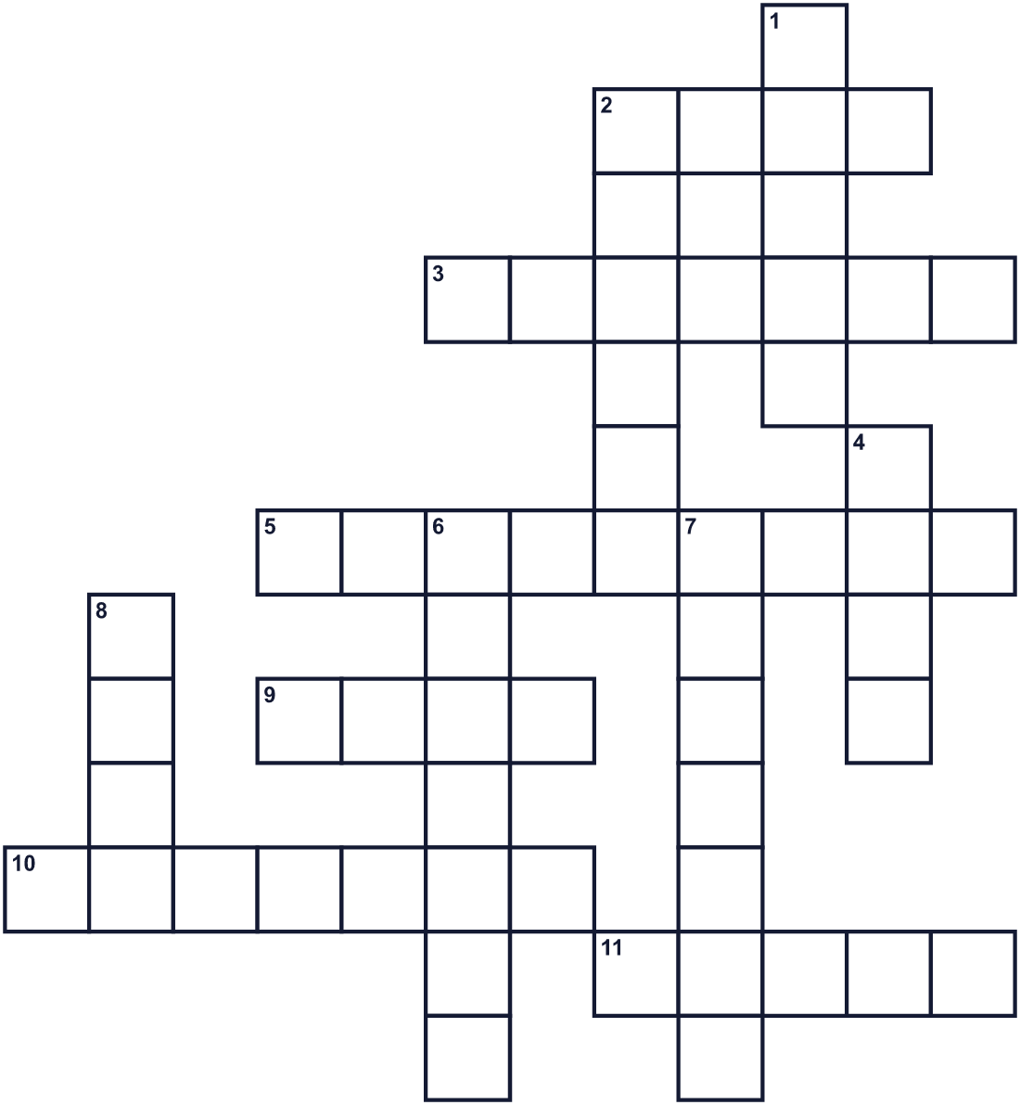
Across →
2. Freed people in Houston bought land for this in 1872. (4)
3. The time when farmers pick their crops. (7)
5. The port city where the order was given in 1865. (9)
9. The sixth month of the year. (4)
10. The state of being free. (7)
11. The big southern state where Galveston is. (5)
Down ↓
1. Words from a leader that tell people what to do. (5)
2. People walk and play music down the street for this. (6)
4. A sweet drink with bubbles. Strawberry is popular on June 19. (4)
6. The president who signed the Emancipation Proclamation. (7)
7. A person in an army. (7)
8. The shape in the middle of the Juneteenth flag. (4)

✊🏿 Juneteenth Worksheet
Word Search
かくれた単語をさがそう（→ ↓ ↘ ↗）
Class ______ No. ____ Name ______________________________
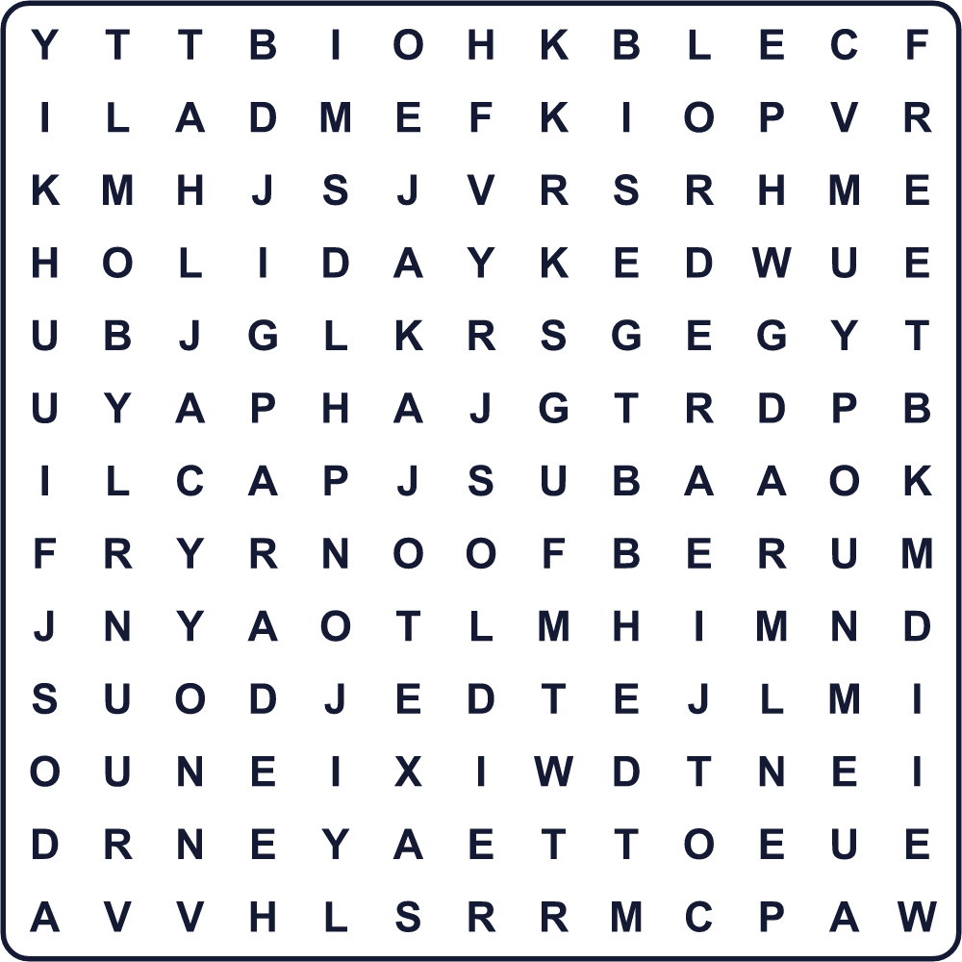
FLAG FREE FREEDOM HOLIDAY JUBILEE JUNE ORDER PARADE PARK SODA SOLDIER STAR TEXAS
Secret Code 暗号を解こう
◎=A ✉=B ✿=D ◆=E ☘=I ♪=J ☾=L ✈=U ▲=Y
♪ ✈ ✉ ☘ ☾ ◆ ◆ ✿ ◎ ▲
______________________________________________________________

✊🏿 Juneteenth Worksheet
Maze & Sentences
Class ______ No. ____ Name ______________________________
Help the news reach Texas! 自由の知らせをテキサスに届けよう！
正しい道の文字を集めると、ひみつの言葉になるよ。 START 📜 → GOAL 🎉
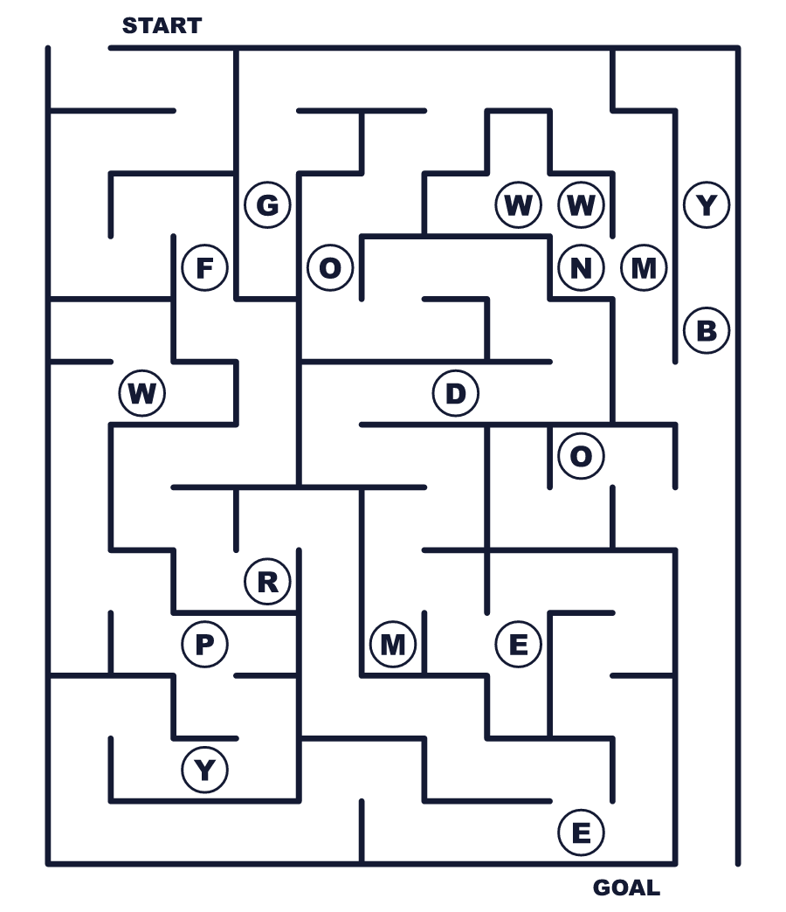
Secret word: ＿ ＿ ＿ ＿ ＿ ＿ ＿
Put the words in order. 並べかえよう。
1. free / said / slaves / order / The / all / are . (命令は、すべての奴隷は自由だと告げました。)
______________________________________________________________
2. Texas / in / were / soldiers / few / Very . (テキサスには兵士がほとんどいませんでした。)
______________________________________________________________
3. first / was / 1866 / celebration / in / The . (最初のお祝いは1866年でした。)
______________________________________________________________
4. park / for / land / They / a / bought . (彼らは公園のための土地を買いました。)
______________________________________________________________
5. national / became / 2021 / a / holiday / Juneteenth / in . (ジューンティーンスは2021年に国の祝日になりました。)
______________________________________________________________

✊🏿 Juneteenth Worksheet
Class Activity & Writing
Class ______ No. ____ Name ______________________________
Find Someone Who… クラスで聞いて回ろう！
Find someone who … | Name
… knows the meaning of the word Juneteenth Juneteenth という言葉の意味を知っている
… has been to a parade パレードを見に行ったことがある
… likes strawberry soda ストロベリーソーダが好き
… has eaten red velvet cake レッドベルベットケーキを食べたことがある
… can name an American president アメリカの大統領の名前を言える
… knows a song about freedom 自由についての歌を知っている
… has walked more than 4 kilometers in one day 1日に4キロ以上歩いたことがある
… likes barbecue バーベキューが好き
Let's Write! 英語で書いてみよう。
If I were in Galveston on June 19, 1865, I would feel ______ because ______.
もし1865年6月19日にガルヴェストンにいたら、＿＿と感じるでしょう。なぜなら＿＿だからです。
______________________________________________________________
______________________________________________________________
Freedom is important to me because ______.
自由は私にとって大切です。なぜなら＿＿だからです。
______________________________________________________________
______________________________________________________________
Opal Lee walked for her dream. My dream is ______, and I will ______.
オパール・リーは夢のために歩きました。私の夢は＿＿で、私は＿＿します。
______________________________________________________________
______________________________________________________________

✊🏿 Juneteenth Worksheet
Trace & Color
なぞって書こう。絵に色をぬろう。
Class ______ No. ____ Name ______________________________
📜 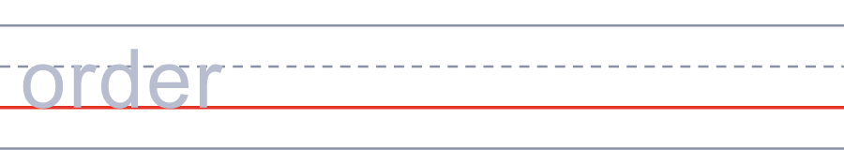

⭐ 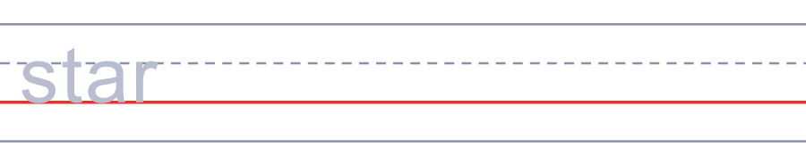
🥤 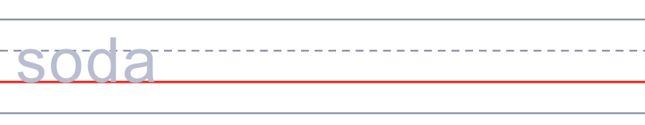
🍰 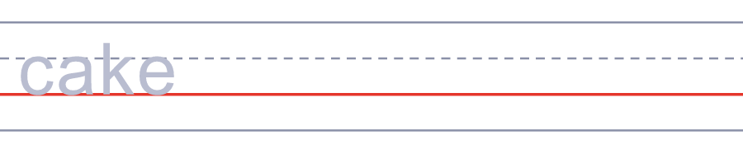
🚢 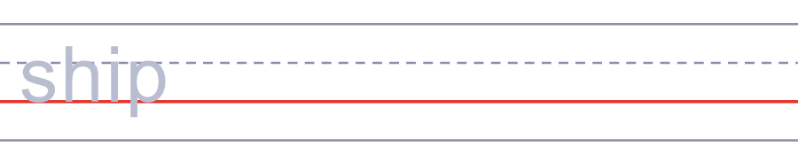
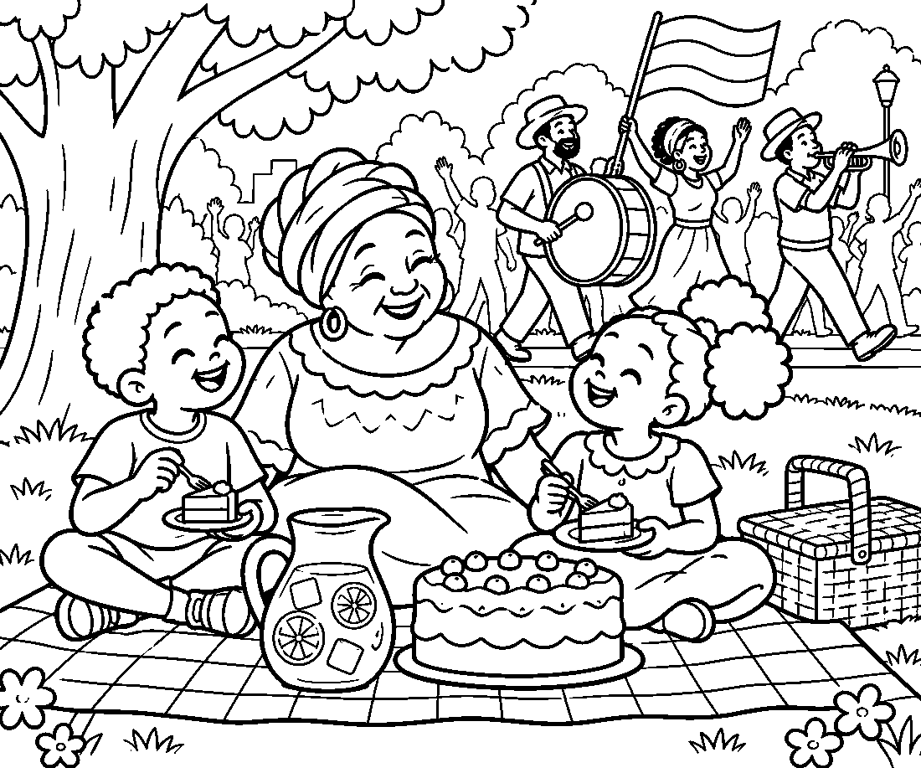

✊🏿 Juneteenth Worksheet
Answer Key 解答
Reading Check: 1.B 2.C 3.D 4.A 5.B 6.C 7.B 8.C
True or False: 1.T 2.T 3.F 4.T 5.T 6.F
Match: 📜=order ⭐=star 🥤=soda 🍰=cake 🚢=ship 🎺=trumpet 🌾=harvest 🚶=walk
Unscramble: 1.FREEDOM 2.SOLDIER 3.PARADE 4.HOLIDAY 5.HARVEST 6.JUBILEE
Fill in the blanks: (1)June (2)park (3)dress (4)barbecue (5)soda (6)parade (7)story (8)free (9)celebrate (10)proud
Sentence order: 1. The order said all slaves are free. 2. Very few soldiers were in Texas. 3. The first celebration was in 1866. 4. They bought land for a park. 5. Juneteenth became a national holiday in 2021.
Secret Code: JUBILEE DAY
Maze: FREEDOM
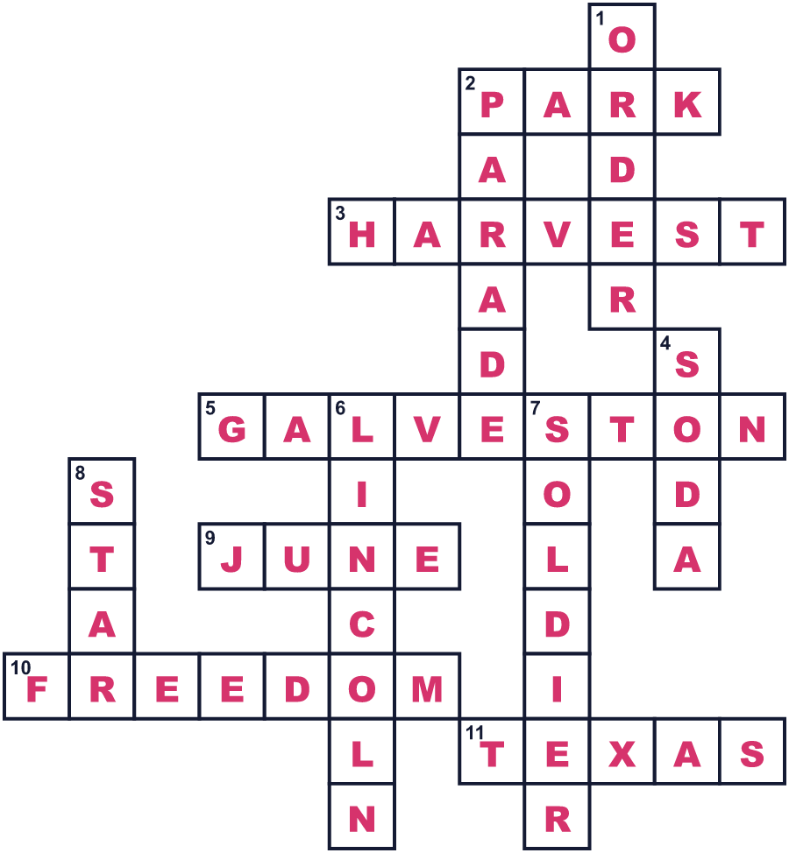
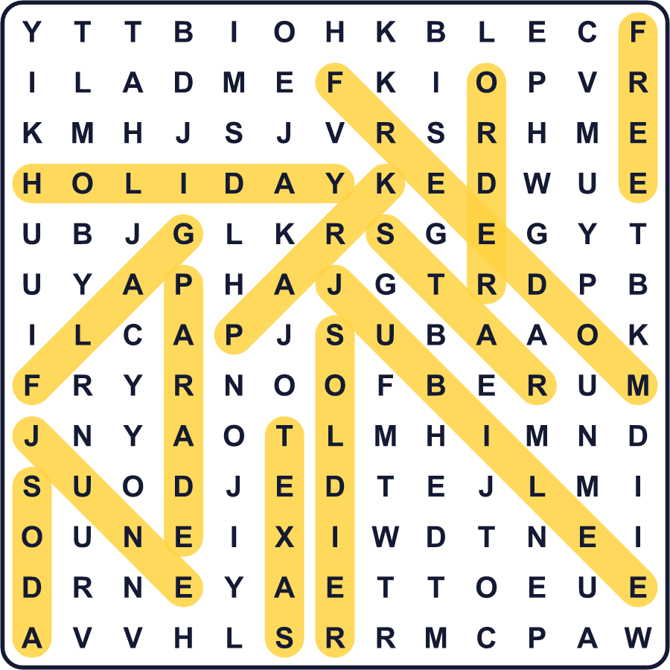
全訳
1 1865年6月19日、北軍の兵士たちがテキサス州の港町ガルヴェストンにいました。その日、ゴードン・グレンジャー将軍が大きな知らせを伝える命令を出しました。それは、すべての奴隷は自由であると告げていました。当時テキサスには、およそ25万人の奴隷にされた人々が暮らしていました。
2 でも、この話には意外な部分があります。エイブラハム・リンカーン大統領の奴隷解放宣言は、1863年1月1日に始まっていました。それは900日も前のことでした！では、なぜテキサスはそんなに遅れたのでしょう。テキサスは遠く、北軍の兵士はほとんどいませんでした。兵士がいなければ、だれも奴隷主に法律を守らせることができなかったのです。
3 知らせは、全員に同じ日に届いたわけではありませんでした。綿花の収穫が終わるまで、それを秘密にした奴隷主もいました。人々がやっとそれを聞いたとき、ぼうぜんとする人もいれば、喜びでいっぱいになる人もいました。多くの人がすぐに出発し、家族を探しに行きました。
4 1年後、テキサスの解放された人々が最初のお祝いを開きました。彼らはそれをジュビリー・デーと呼びました。のちに人々は June と nineteenth という言葉を合わせて、ジューンティーンスという新しい名前を作りました。1872年、ヒューストンのあるグループが1,000ドルを集め、公園のための土地を買いました。彼らはそれをエマンシペーション・パークと名づけました。
5 長いあいだ、ジューンティーンスはおもにテキサスの記念日でした。そして89歳のとき、オパール・リーという女性が、テキサスからワシントンD.C.への長い旅を始めました。彼女は国の祝日を求めていたのです。2021年、その夢はかない、彼女は大統領のとなりに立ちました。今では家族でパレードやバーベキュー、ストロベリーソーダのような赤い飲み物を楽しみます。

