💐 International Women's Day Worksheet
Bread, Flowers, and a Big Idea
Read the story. 英文を読もう。
Class ______ No. ____ Name ______________________________
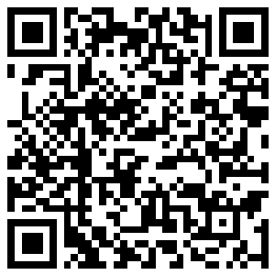
🔊 音声を聞こう（スマホで読みとってね）
1 On March 8, 1917, women in Petrograd, Russia, left their factories and walked into the cold streets. They were tired and hungry. They shouted for "bread and peace." Many more workers joined them. About one week later, the ruler of Russia lost his power. Later that year, Russian women won the right to vote.
2 But the idea of a women's day is a little older. In 1909, women in New York held a Woman's Day on February 28. Then in 1910, a German woman named Clara Zetkin had a big idea. At a meeting in Denmark, she said, "Let's have one women's day in every country." More than 100 women from 17 countries said yes.
3 The first International Women's Day was on March 19, 1911. More than one million people joined events in four countries in Europe. They asked for the right to vote, to work, and to be treated fairly. Later, people chose March 8 to remember the brave women of Petrograd. In 1975, the United Nations started to celebrate the day, too.
4 Today, the day looks different around the world. In Russia, it is a holiday, and men buy flowers for the women in their lives. In Italy, people give small yellow flowers called mimosa. In China, many women get half a day off work. In Spain, millions of people have marched in the streets for equal pay.
5 So International Women's Day is two things at once. It is a day to say thank you to women. It is also a day to ask a hard question. Are women and men really equal yet? Many people answer, "Not yet." That is why people still march every March 8.
Words 単語
factory（工場） / shout（叫ぶ、大声で言う） / ruler（支配者、国を治める人） / power（権力、力） / right（権利） / vote（投票する／投票） / meeting（会議、集まり） / fairly（公平に） / brave（勇気のある） / celebrate（祝う） / equal（平等な、等しい） / march（行進する／デモ行進）

💐 International Women's Day Worksheet
Reading Check
Choose the best answer. 正しいものを選ぼう。
Class ______ No. ____ Name ______________________________
1. What is the main idea of the story?
(A) Women's Day started in Italy with yellow flowers. (B) Women's Day is a day to thank women and to ask for equality. (C) Women's Day is a holiday in every country in the world. (D) Women's Day is only about the history of Russia.
2. What did the women in Petrograd shout for?
(A) Flowers and chocolate (B) Money and new houses (C) Bread and peace (D) Schools and books
3. Who had the idea of one women's day in every country?
(A) Clara Zetkin (B) A Russian ruler (C) The United Nations (D) Women in New York
4. When was the first International Women's Day?
(A) February 28, 1909 (B) March 8, 1917 (C) March 8, 1975 (D) March 19, 1911
5. In the story, what does "treated fairly" mean?
(A) Given a lot of money (B) Given the same chances as others (C) Given a day off work (D) Given beautiful flowers
6. Which sentence is true?
(A) Men in Italy buy tulips for women. (B) The UN started the day in 1910. (C) Many women in China get half a day off. (D) Russian women could vote before 1917.
7. Why do people still march on March 8?
(A) Because many people think women and men are not equal yet. (B) Because it is a holiday in every country. (C) Because they want to buy cheap flowers. (D) Because the ruler of Russia asked them to.
8. In the dialogue, why did Italian women choose mimosa?
(A) Because violets were not pretty (B) Because Giulia's friends liked it (C) Because it came from Russia (D) Because it was cheap and bloomed in March
True or False? T か F に○
1. International Women's Day is on March 8. T / F
2. Clara Zetkin was from Italy. T / F
3. The first International Women's Day was in 1911. T / F
4. In Italy, people give red roses on this day. T / F
5. Women in Petrograd asked for bread and peace. T / F
6. International Women's Day is a national holiday in Japan. T / F

💐 International Women's Day Worksheet
Word Work
単語のれんしゅう
Class ______ No. ____ Name ______________________________
① Match the pictures and the words. 絵と単語を線でむすぼう。
💐 | ● | ● | vote
🍞 | ● | ● | chocolate
🗳️ | ● | ● | bread
🏭 | ● | ● | factory
🌷 | ● | ● | flowers
🕊️ | ● | ● | purple
💜 | ● | ● | tulip
🍫 | ● | ● | peace
② Unscramble the words. 並べかえて単語にしよう。
1. E L Q A U (平等な) → ____________________
2. I S H G R T (権利) → ____________________
3. M M O A S I (ミモザ) → ____________________
4. Y O F C A R T (工場) → ____________________
5. E R A B V (勇気のある) → ____________________
6. B E A E C R T E L (祝う) → ____________________
③ Fill in the blanks. 語群から選んで入れよう。
[ shop / tomorrow / story / March / factory / slowly / Grandma / smiles / mimosa / marches / angry / yellow / pay ]
It is (1) __________ 8 in Rome. Sofia walks to the flower (2) __________ with her dad. They buy small (3) __________ flowers called (4) __________ . "These are for (5) __________ ," says Sofia. Grandma worked in a (6) __________ when she was young. She also went to many (7) __________ for equal (8) __________ . When Grandma sees the flowers, she (9) __________ . "Thank you, my dear," she says. "Sit down next to me. Now let me tell you a (10) __________ about this special day."

💐 International Women's Day Worksheet
Crossword Puzzle
ヒントを読んでクロスワードを完成させよう。
Class ______ No. ____ Name ______________________________
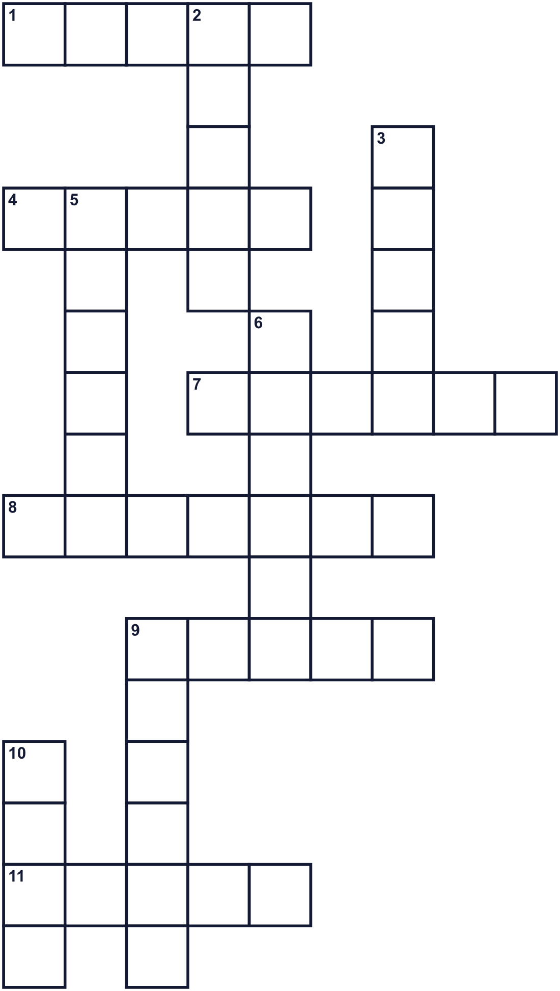
Across →
1. More than one woman. (5)
4. Women in Petrograd asked for this food in 1917. (5)
7. Things every person should be free to have or do. (6)
8. A building where workers make things. (7)
9. The opposite of war. (5)
11. A spring flower. The Netherlands is famous for it. People in Moscow buy it on this day. (5)
Down ↓
2. The same in value or size. (5)
3. The third month of the year. (5)
5. A big country. Petrograd was its capital in 1917. (6)
6. A small yellow flower. Italians give it to women. (6)
9. The main color of the day. Mix red and blue. (6)
10. You do this in an election to choose a leader. (4)

💐 International Women's Day Worksheet
Word Search
かくれた単語をさがそう（→ ↓ ↘ ↗）
Class ______ No. ____ Name ______________________________
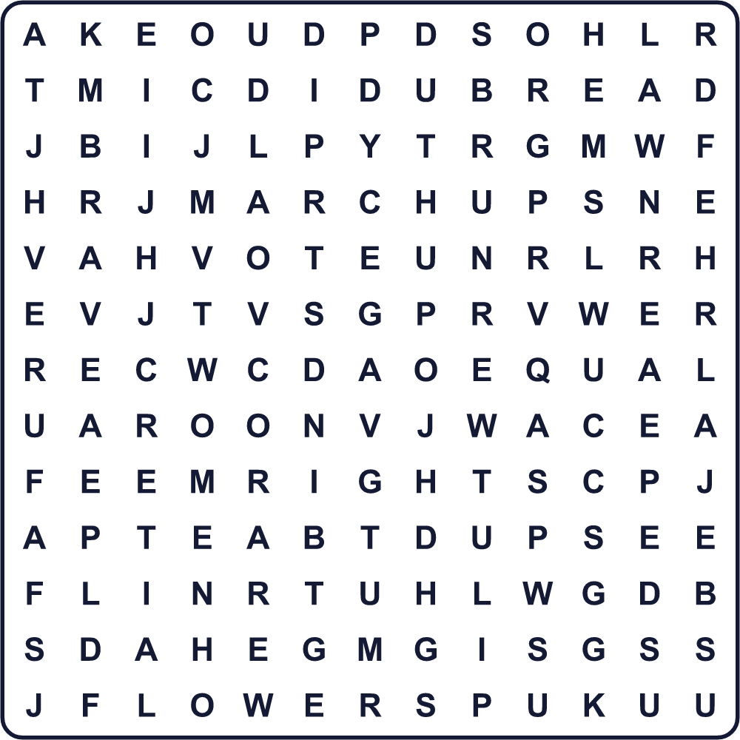
BRAVE BREAD EQUAL FACTORY FLOWERS MARCH MIMOSA PEACE PURPLE RIGHTS TULIP VOTE WOMEN
Secret Code 暗号を解こう
■=A ✿=B ✂=C ★=D ◆=E ♥=N ☃=P ☺=R
✿ ☺ ◆ ■ ★ ■ ♥ ★ ☃ ◆ ■ ✂ ◆
______________________________________________________________

💐 International Women's Day Worksheet
Maze & Sentences
Class ______ No. ____ Name ______________________________
Help Giulia bring mimosa to her mom! ジュリアがお母さんにミモザを届けるのを手伝おう！
正しい道の文字を集めると、ひみつの言葉になるよ。 START 👧 → GOAL 💐
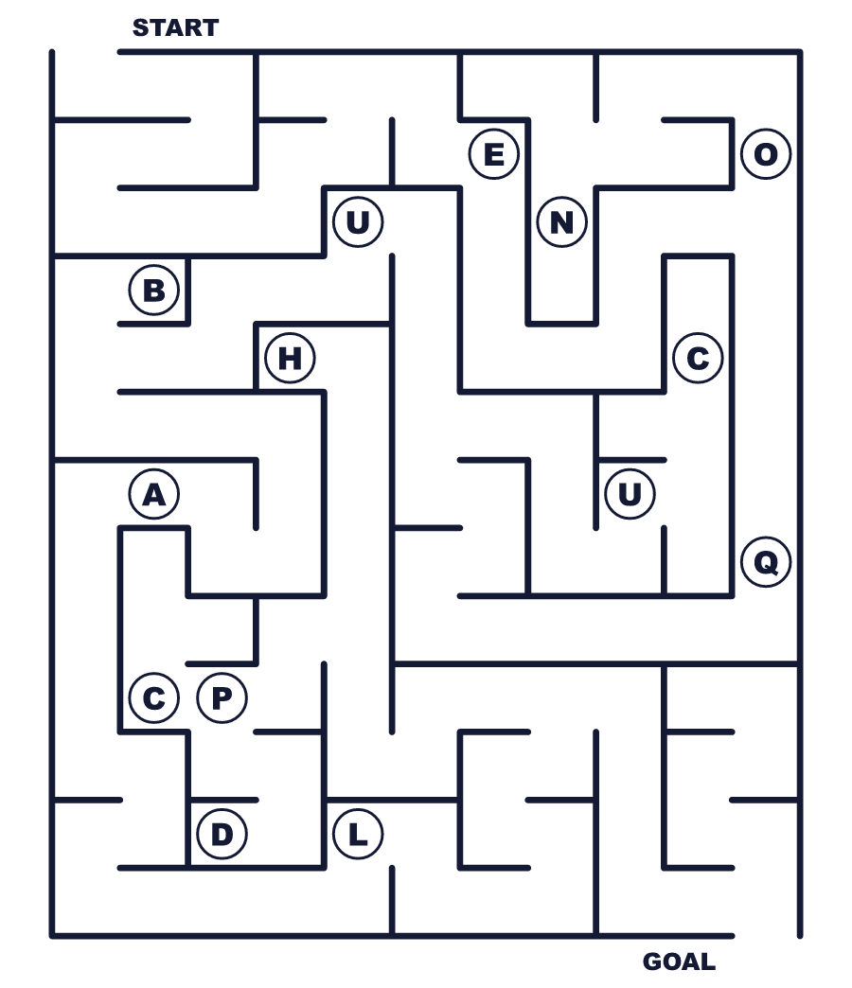
Secret word: ＿ ＿ ＿ ＿ ＿
Put the words in order. 並べかえよう。
1. peace / in / Women / for / Petrograd / asked / and / bread . (ペトログラードの女性たちはパンと平和を求めました。)
______________________________________________________________
2. idea / had / big / 1910 / in / Clara / Zetkin / a . (クララ・ツェトキンは1910年に大きなアイデアを思いつきました。)
______________________________________________________________
3. flowers / People / give / yellow / in / mimosa / Italy . (イタリアの人々は黄色いミモザの花を贈ります。)
______________________________________________________________
4. in / get / half / off / women / day / Many / China / a . (中国では多くの女性が半日休めます。)
______________________________________________________________
5. at / Everyone / be / should / fairly / work / treated . (誰もが職場で公平に扱われるべきです。)
______________________________________________________________

💐 International Women's Day Worksheet
Class Activity & Writing
Class ______ No. ____ Name ______________________________
Find Someone Who… クラスで聞いて回ろう！
Find someone who … | Name
… has given flowers to a woman 女性に花を贈ったことがある
… knows the name of a woman scientist 女性の科学者の名前を知っている
… likes yellow flowers 黄色い花が好き
… has been to Italy or Russia イタリアかロシアに行ったことがある
… knows what year Japanese women first voted 日本の女性が初めて投票した年を知っている
… can say thank you in three languages 3つの言語で「ありがとう」と言える
… has a mother or grandmother who worked outside the home 母か祖母が家の外で働いていた
… likes chocolate cake チョコレートケーキが好き
Let's Write! 英語で書いてみよう。
A woman I respect is ______ because ______.
私が尊敬する女性は＿＿です。なぜなら＿＿だからです。
______________________________________________________________
______________________________________________________________
If I could give flowers to one woman, I would give them to ______.
1人の女性に花を贈れるなら、私は＿＿に贈ります。
______________________________________________________________
______________________________________________________________
One thing I want to change for a more equal world is ______.
もっと平等な世界のために変えたいことの1つは＿＿です。
______________________________________________________________
______________________________________________________________

💐 International Women's Day Worksheet
Trace & Color
なぞって書こう。絵に色をぬろう。
Class ______ No. ____ Name ______________________________
💐 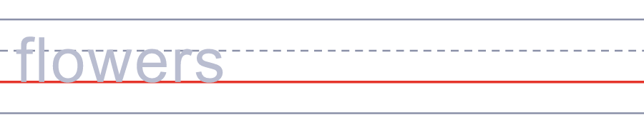

🍞 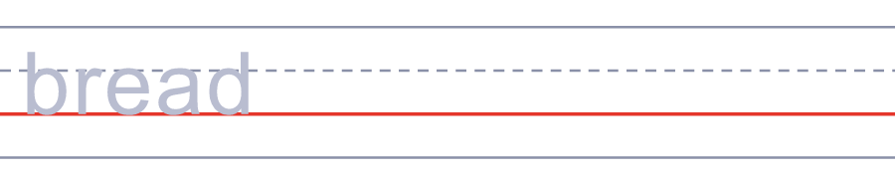
🗳️ 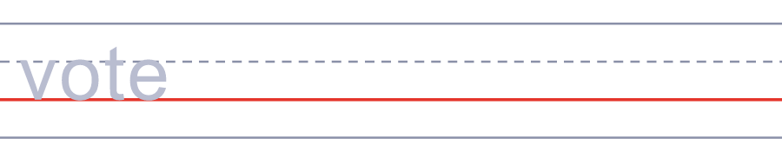
🏭 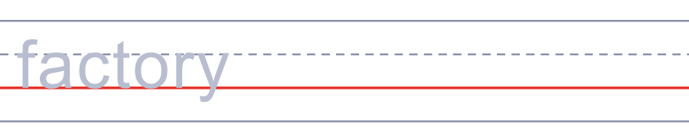
🌷 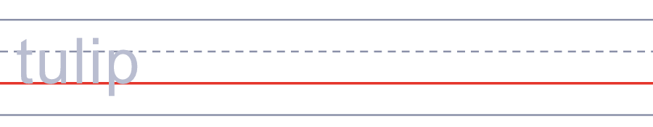
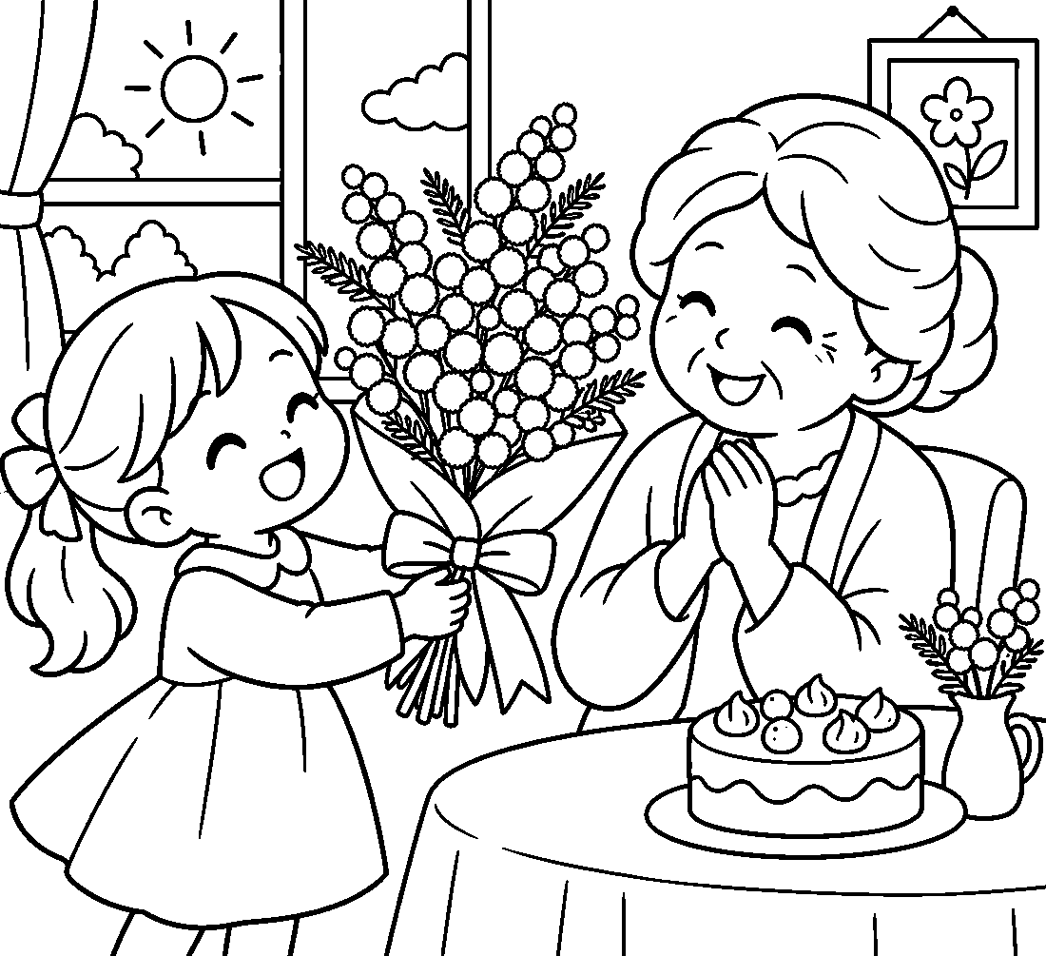

💐 International Women's Day Worksheet
Answer Key 解答
Reading Check: 1.B 2.C 3.A 4.D 5.B 6.C 7.A 8.D
True or False: 1.T 2.F 3.T 4.F 5.T 6.F
Match: 💐=flowers 🍞=bread 🗳️=vote 🏭=factory 🌷=tulip 🕊️=peace 💜=purple 🍫=chocolate
Unscramble: 1.EQUAL 2.RIGHTS 3.MIMOSA 4.FACTORY 5.BRAVE 6.CELEBRATE
Fill in the blanks: (1)March (2)shop (3)yellow (4)mimosa (5)Grandma (6)factory (7)marches (8)pay (9)smiles (10)story
Sentence order: 1. Women in Petrograd asked for bread and peace. 2. Clara Zetkin had a big idea in 1910. 3. People in Italy give yellow mimosa flowers. 4. Many women in China get half a day off. 5. Everyone should be treated fairly at work.
Secret Code: BREAD AND PEACE
Maze: EQUAL
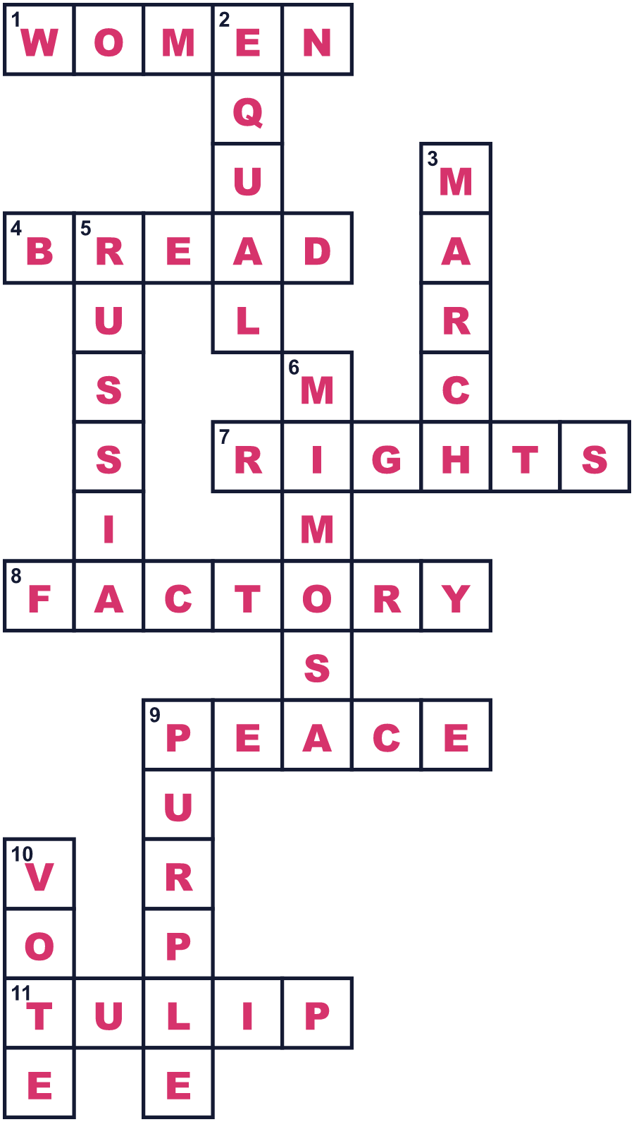
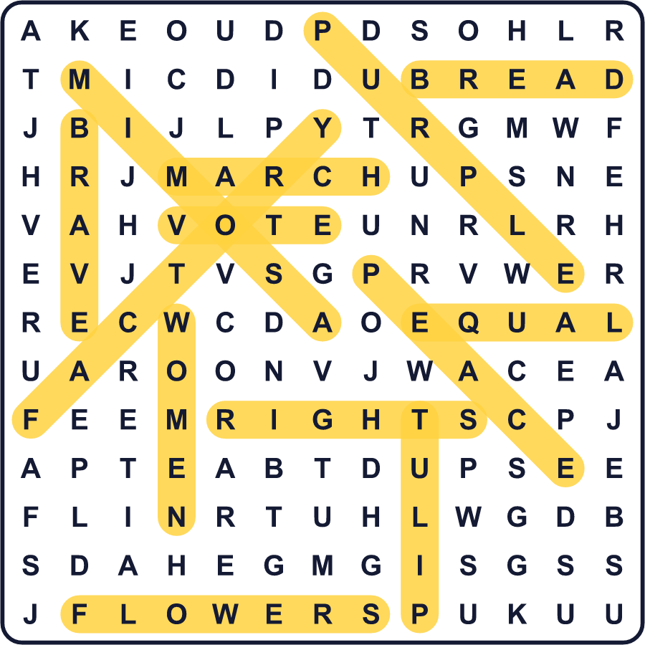
全訳
1 1917年3月8日、ロシアのペトログラードで、女性たちが工場を出て、寒い通りへと歩き出しました。彼女たちは疲れていて、おなかをすかせていました。彼女たちは「パンと平和を」と叫びました。さらに多くの労働者が加わりました。およそ1週間後、ロシアの皇帝は権力を失いました。その年のうちに、ロシアの女性は選挙で投票する権利を勝ち取りました。
2 でも、「女性の日」という考えは、それより少し前からありました。1909年2月28日、ニューヨークの女性たちが「女性の日」を開きました。そして1910年、クララ・ツェトキンというドイツの女性が、大きなアイデアを思いつきました。デンマークでの会議で、彼女は「すべての国で、同じ女性の日を開こう」と言いました。17か国から来た100人以上の女性が賛成しました。
3 最初の国際女性デーは、1911年3月19日でした。ヨーロッパの4か国で、100万人を超える人が集会に参加しました。人々は、投票する権利、働く権利、そして公平に扱われることを求めました。のちに、ペトログラードの勇気ある女性たちを記念して、3月8日が選ばれました。1975年には、国連もこの日を祝うようになりました。
4 今日、この日の様子は世界中でさまざまです。ロシアでは休日で、男性が身近な女性たちのために花を買います。イタリアでは、ミモザという小さな黄色い花を贈ります。中国では、多くの女性が半日、仕事を休めます。スペインでは、何百万もの人が、同じ給料を求めて通りを行進してきました。
5 つまり、国際女性デーには2つの顔があります。女性に「ありがとう」と言う日。そして、むずかしい問いを投げかける日でもあります。女性と男性は、もう本当に平等になったでしょうか？多くの人が「まだだ」と答えます。だから人々は今も、毎年3月8日に行進するのです。

