🤝 International Day of Friendship Worksheet
A Dinner That Started a World Day
Read the story. 英文を読もう。
Class ______ No. ____ Name ______________________________

🔊 音声を聞こう（スマホで読みとってね）
1 On July 20, 1958, a doctor in Paraguay had dinner with some friends. His name was Ramón Artemio Bracho. That night, he had a big idea: a day for friendship around the world. His group started to celebrate on July 30. They wanted people to be friends across all borders.
2 In 2011, the United Nations made July 30 the International Day of Friendship. The UN believes that friendship between people and countries can help bring peace. It especially wants young people to make friends with people from other cultures. Back in 1998, the UN even named Winnie the Pooh its Ambassador of Friendship.
3 But not every country uses July 30. In Argentina, Friend's Day is on July 20. On that day in 1969, a man named Enrique Febbraro watched the first people walk on the Moon. He felt it was a moment for all people to be friends. He sent 1,000 letters to 100 countries and got 700 answers. In India and the United States, many people celebrate on the first Sunday of August.
4 Today, people send messages, give small gifts, and eat together with their friends. In 2005, so many people in Argentina sent messages that phone networks stopped in four cities. You do not need a big party, though. A short message to an old friend is a great way to celebrate.
Words 単語
friendship（友情） / border（国境、境目） / peace（平和） / culture（文化） / ambassador（大使） / celebrate（祝う） / moment（瞬間、時） / network（回線、ネットワーク）

🤝 International Day of Friendship Worksheet
Reading Check
Choose the best answer. 正しいものを選ぼう。
Class ______ No. ____ Name ______________________________
1. Where did the idea for a world friendship day start?
(A) At a school in Japan (B) At a dinner in Paraguay (C) On the Moon (D) At a card shop in America
2. When did the UN make July 30 the International Day of Friendship?
(A) 1958 (B) 1969 (C) 1998 (D) 2011
3. Why did Enrique Febbraro choose July 20?
(A) Because people first walked on the Moon that day (B) Because it was his birthday (C) Because the UN asked him (D) Because it was a holiday in Paraguay
4. In paragraph 1, "across all borders" is closest in meaning to:
(A) only in one town (B) in many different countries (C) in the same family (D) at the same school
5. In the dialogue, how does Daiki celebrate with Sofia?
(A) He sends her 1,000 letters. (B) He gives her a cookie. (C) He invites her to watch the Moon. (D) He buys her lunch.
True or False? T か F に○
1. The idea for a world friendship day started in Paraguay. T / F
2. Every country celebrates Friendship Day on July 30. T / F
3. Winnie the Pooh became an Ambassador of Friendship. T / F
4. Friendship Day is a national holiday in Japan. T / F

🤝 International Day of Friendship Worksheet
Word Work
単語のれんしゅう
Class ______ No. ____ Name ______________________________
① Match the pictures and the words. 絵と単語を線でむすぼう。
🤝 | ● | ● | handshake
🎁 | ● | ● | cookie
✉️ | ● | ● | moon
🌕 | ● | ● | letter
🧸 | ● | ● | gift
🍪 | ● | ● | teddy bear
③ Fill in the blanks. 語群から選んで入れよう。
[ winter / Day / happy / gift / pal / letter / angry / photo / English ]
On July 30, Aya gets a (1) __________ from Brazil. It is from her pen (2) __________ , Lucas. "Happy Friendship (3) __________ !" he writes. He puts a (4) __________ of his dog in the letter. Aya is very (5) __________ . She writes back in (6) __________ that night. She sends him a small (7) __________ from Japan.

🤝 International Day of Friendship Worksheet
Crossword Puzzle
ヒントを読んでクロスワードを完成させよう。
Class ______ No. ____ Name ______________________________
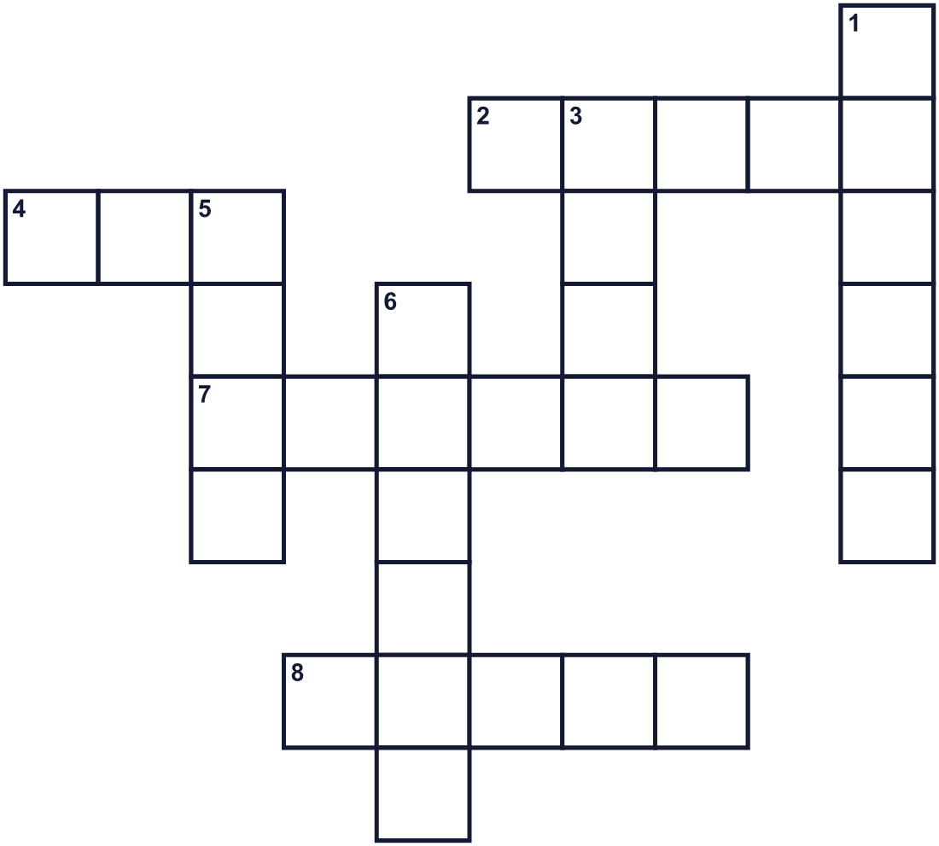
Across →
2. You do this with your mouth when you are happy. (5)
4. You put your arms around someone. (3)
7. A person you like and trust. (6)
8. A time with no war. (5)
Down ↓
1. You write it on paper and send it. (6)
3. People first walked on it in 1969. (4)
5. Something you give to someone. A present. (4)
6. The meal you eat in the evening. (6)

🤝 International Day of Friendship Worksheet
Word Search
かくれた単語をさがそう（→ ↓ ↘ ↗）
Class ______ No. ____ Name ______________________________
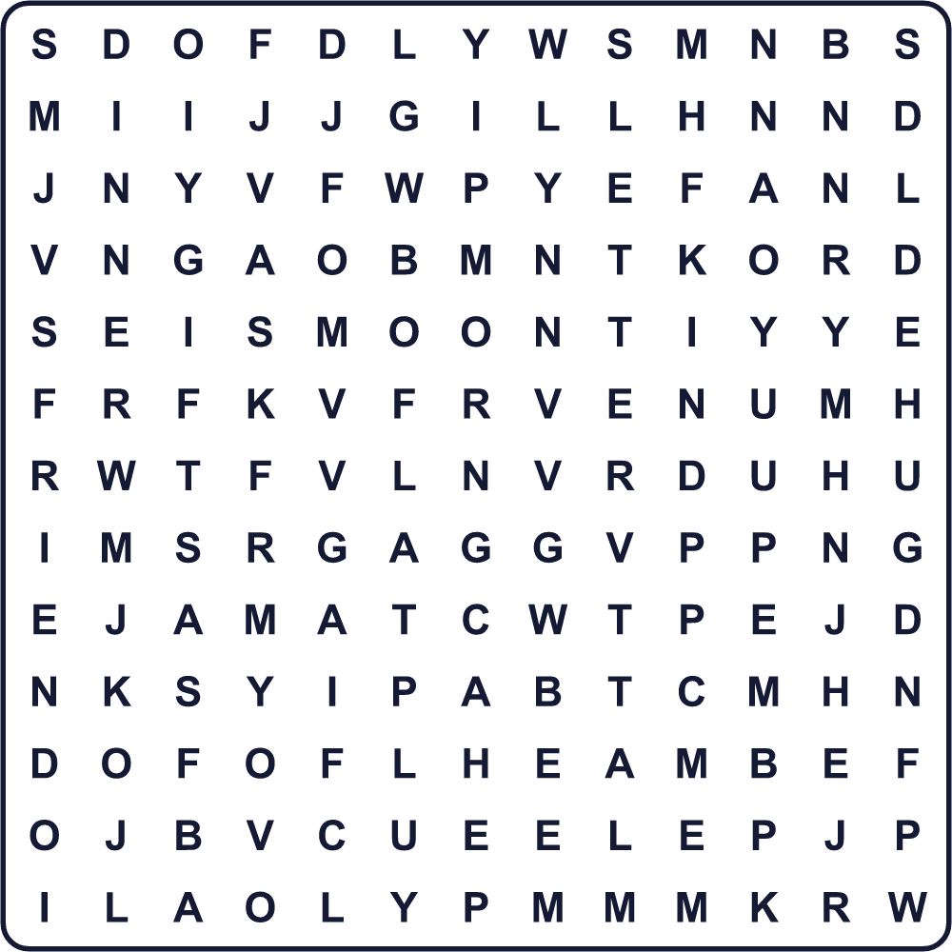
DINNER FRIEND GIFT HUG KIND LETTER MOON PEACE SHARE SMILE

🤝 International Day of Friendship Worksheet
Maze & Sentences
Class ______ No. ____ Name ______________________________
Help the boy meet his friend! 男の子を友だちのところまで連れていこう！
正しい道の文字を集めると、ひみつの言葉になるよ。 START 👦 → GOAL 👧
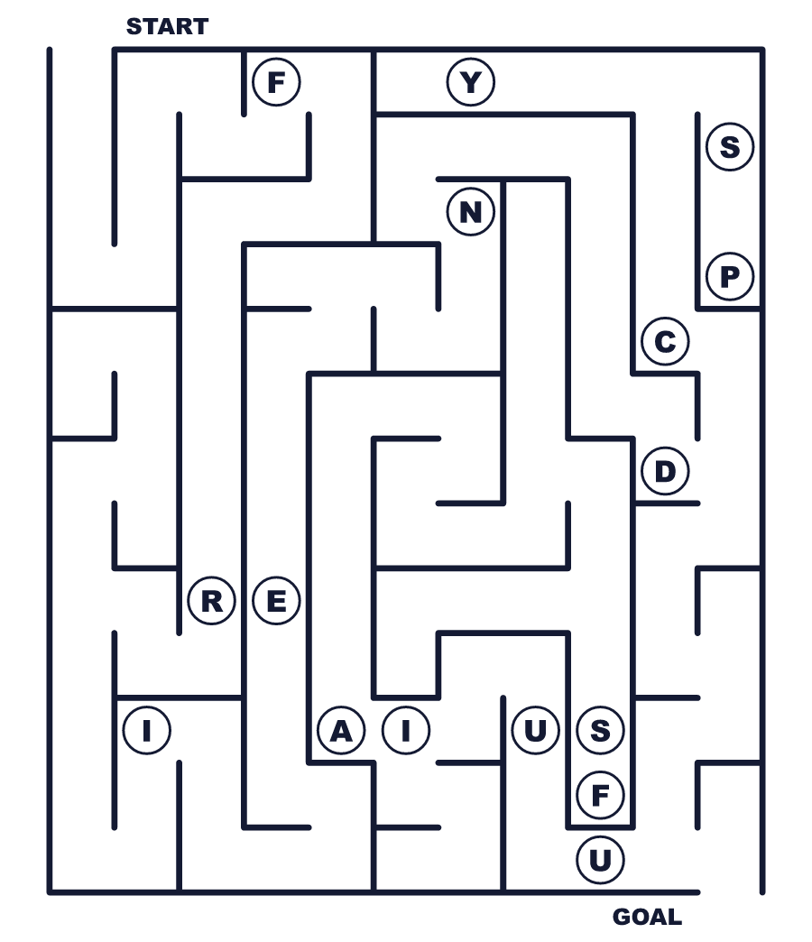
Secret word: ＿ ＿ ＿ ＿ ＿ ＿

🤝 International Day of Friendship Worksheet
Class Activity & Writing
Class ______ No. ____ Name ______________________________
Let's Write! 英語で書いてみよう。
My best friend is ______. I like him or her because ______.
私の親友は______です。好きな理由は______だからです。
______________________________________________________________
______________________________________________________________
On Friendship Day, I want to tell my friend, "______."
フレンドシップ・デーに、友だちに「______」と伝えたいです。
______________________________________________________________
______________________________________________________________

🤝 International Day of Friendship Worksheet
Trace & Color
なぞって書こう。絵に色をぬろう。
Class ______ No. ____ Name ______________________________
🤝 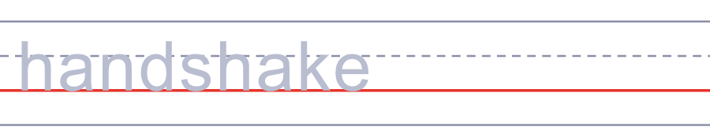

🎁 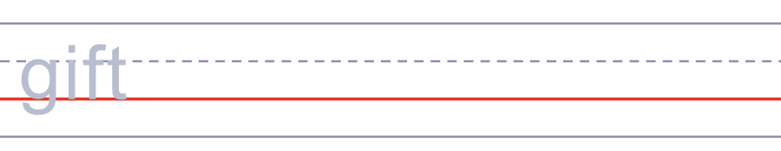
✉️ 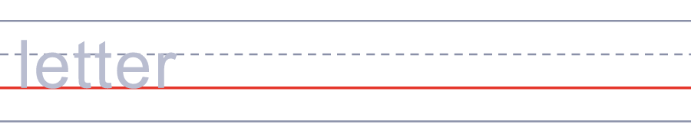
🌕 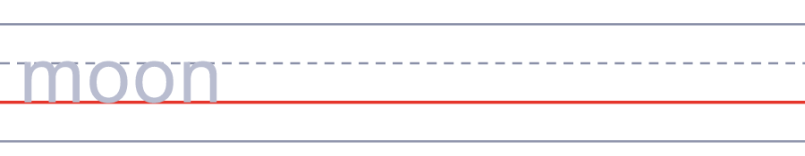
🧸 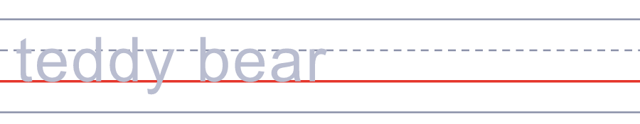

🤝 International Day of Friendship Worksheet
Answer Key 解答
Reading Check: 1.B 2.D 3.A 4.B 5.D
True or False: 1.T 2.F 3.T 4.F
Match: 🤝=handshake 🎁=gift ✉️=letter 🌕=moon 🧸=teddy bear 🍪=cookie
Fill in the blanks: (1)letter (2)pal (3)Day (4)photo (5)happy (6)English (7)gift
Maze: FRIEND
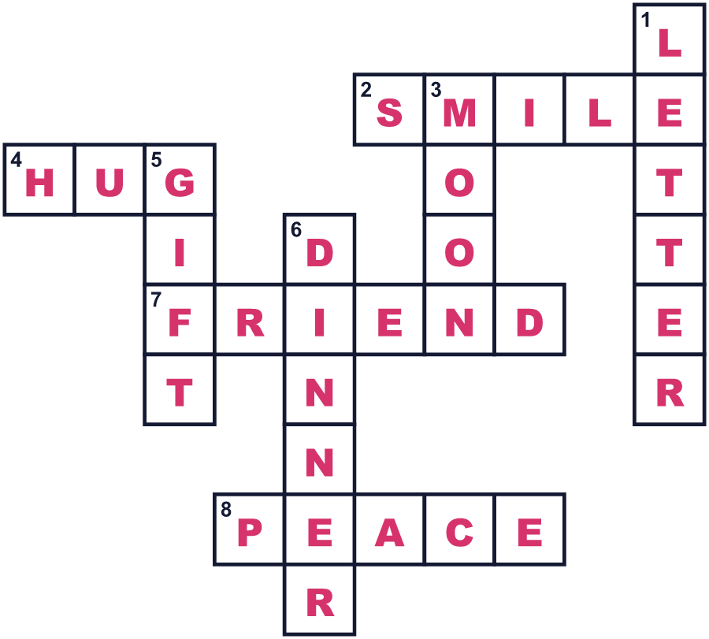
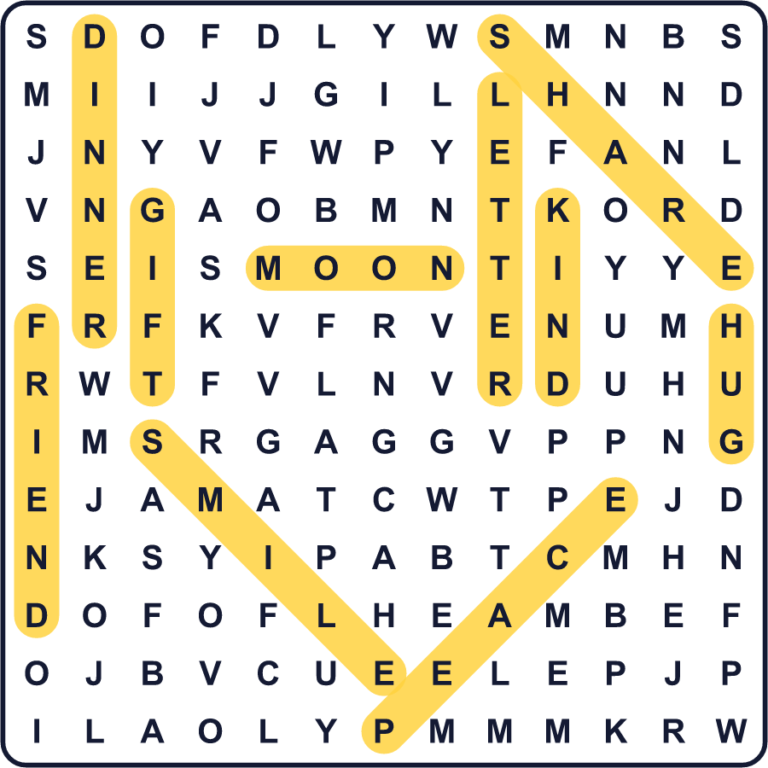
全訳
1 1958年7月20日、パラグアイの医師が友人たちと夕食をとっていました。彼の名前はラモン・アルテミオ・ブラチョ。その夜、彼は大きなアイデアを思いつきました。世界中で友情を祝う日です。彼の仲間たちは7月30日に祝い始めました。彼らは、人々があらゆる国境をこえて友だちになることを願っていました。
2 2011年、国連は7月30日を国際フレンドシップ・デーにしました。国連は、人と人、国と国の友情が平和をもたらす助けになると考えています。とくに若い人たちに、ほかの文化の人と友だちになってほしいと願っています。さかのぼって1998年には、国連はくまのプーさんを友情大使に任命したこともあります。
3 でも、すべての国が7月30日を使っているわけではありません。アルゼンチンでは、友だちの日は7月20日です。1969年のその日、エンリケ・フェブラロという男性は、人類が初めて月を歩くのを見ました。彼は、すべての人が友だちになれる瞬間だと感じました。彼は100か国に1000通の手紙を送り、700通の返事を受け取りました。インドやアメリカでは、8月の第1日曜日に祝う人が多いです。
4 今では人々は、友だちにメッセージを送ったり、小さな贈り物をしたり、いっしょに食事をしたりします。2005年、アルゼンチンではあまりに多くの人がメッセージを送ったので、4つの都市で電話の回線が止まりました。でも、大きなパーティーは必要ありません。昔の友だちへの短いメッセージは、すてきな祝い方です。

