🐕 National Dog Day Worksheet
A Girl, a Shelter, and a Dog
Read the story. 英文を読もう。
Class ______ No. ____ Name ______________________________

🔊 音声を聞こう（スマホで読みとってね）
1 When Colleen Paige was 10 years old, her family went to an animal shelter. They came home with a dog named Sheltie. That day was August 26. Many years later, in 2004, Paige made August 26 National Dog Day. Today, many people outside America call it International Dog Day.
2 The day has two goals. First, many dogs in shelters are waiting for a new family. Paige wants people to think about adopting one of them. Second, the day thanks working dogs. Police dogs, guide dogs, and dogs that find bombs all help people every day.
3 Dogs have lived with people for at least 14,000 years. In Germany, people found a dog buried with a man and a woman from about 14,000 years ago. Today, there are about 450 dog breeds, from tiny Chihuahuas to huge Great Danes. Dogs have an amazing nose. They have about 40 times more smell receptors than humans. They can also hear sounds from about 400 meters away.
4 In Japan, the most famous dog is Hachiko. After his owner died in 1925, Hachiko waited at Shibuya Station for almost 10 years. Japan also has its own Dog Day on November 1, because 1-1-1 sounds like wan, wan, wan. So on August 26, give your dog a walk and a hug. If you do not have a dog, you can say thank you to a working dog.
Words 単語
shelter（保護施設、避難所） / adopt（（ペットを）引き取る、養子にする） / goal（目的、目標） / guide dog（盲導犬） / bury（埋める、埋葬する） / receptor（受容体（においなどを受け取る部分）） / breed（（犬などの）品種、犬種） / owner（飼い主、持ち主） / pet（なでる）

🐕 National Dog Day Worksheet
Reading Check
Choose the best answer. 正しいものを選ぼう。
Class ______ No. ____ Name ______________________________
1. Why is National Dog Day on August 26?
(A) It is the birthday of Hachiko. (B) The founder's family adopted their first dog on that day. (C) The UN chose that day. (D) It sounds like wan, wan, wan.
2. What are the two goals of the day?
(A) Buying dogs and selling dog food (B) Helping shelter dogs and thanking working dogs (C) Visiting Germany and Japan (D) Teaching dogs new words
3. How long did Hachiko wait at Shibuya Station?
(A) Almost 10 years (B) About 14 years (C) About 4 years (D) Only one day
4. In paragraph 2, "adopting" a dog means:
(A) training a dog for the police (B) taking a dog for a walk (C) giving a dog a new home and family (D) drawing a picture of a dog
5. In the dialogue, why is today special for Max?
(A) It is his birthday. (B) He is going to Japan. (C) He is starting police work. (D) It is International Dog Day.
True or False? T か F に○
1. National Dog Day is on August 26. T / F
2. The United Nations started National Dog Day. T / F
3. Dogs have a better sense of smell than humans. T / F
4. Japan's Dog Day is also on August 26. T / F

🐕 National Dog Day Worksheet
Word Work
単語のれんしゅう
Class ______ No. ____ Name ______________________________
① Match the pictures and the words. 絵と単語を線でむすぼう。
🐕 | ● | ● | nose
🐶 | ● | ● | bone
🦴 | ● | ● | puppy
🐾 | ● | ● | dog
🦮 | ● | ● | paw
👃 | ● | ● | guide dog
③ Fill in the blanks. 語群から選んで入れよう。
[ tail / adopt / waiting / cloud / barks / shelter / hug / swim ]
On Saturday, Yuki and her mom go to an animal (1) __________ . Many dogs are (2) __________ for a family. A small brown dog wags its (3) __________ at Yuki. "I like this one," she says. They (4) __________ the dog and name him Kuri. At home, Kuri runs and (5) __________ . Yuki gives him a big (6) __________ .

🐕 National Dog Day Worksheet
Crossword Puzzle
ヒントを読んでクロスワードを完成させよう。
Class ______ No. ____ Name ______________________________
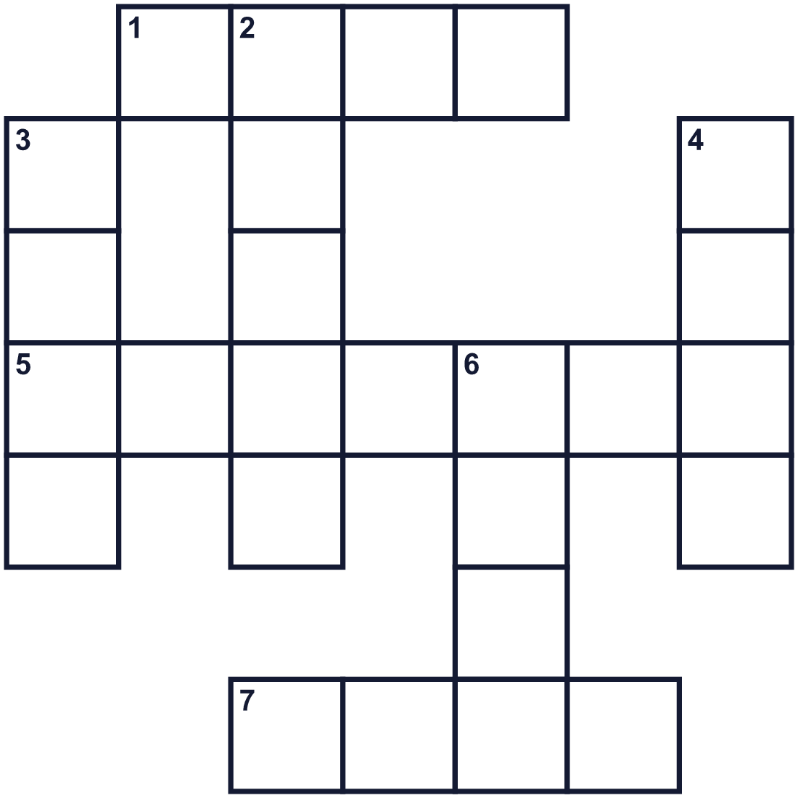
Across →
1. A hard white thing. Dogs like to chew it. (4)
5. A place where dogs wait for a new family. (7)
7. Dogs go for one every day. (4)
Down ↓
2. The person who takes care of a pet. (5)
3. Dogs smell very well with this. (4)
4. The loud sound a dog makes. (4)
6. A happy dog wags this. (4)

🐕 National Dog Day Worksheet
Word Search
かくれた単語をさがそう（→ ↓ ↘ ↗）
Class ______ No. ____ Name ______________________________
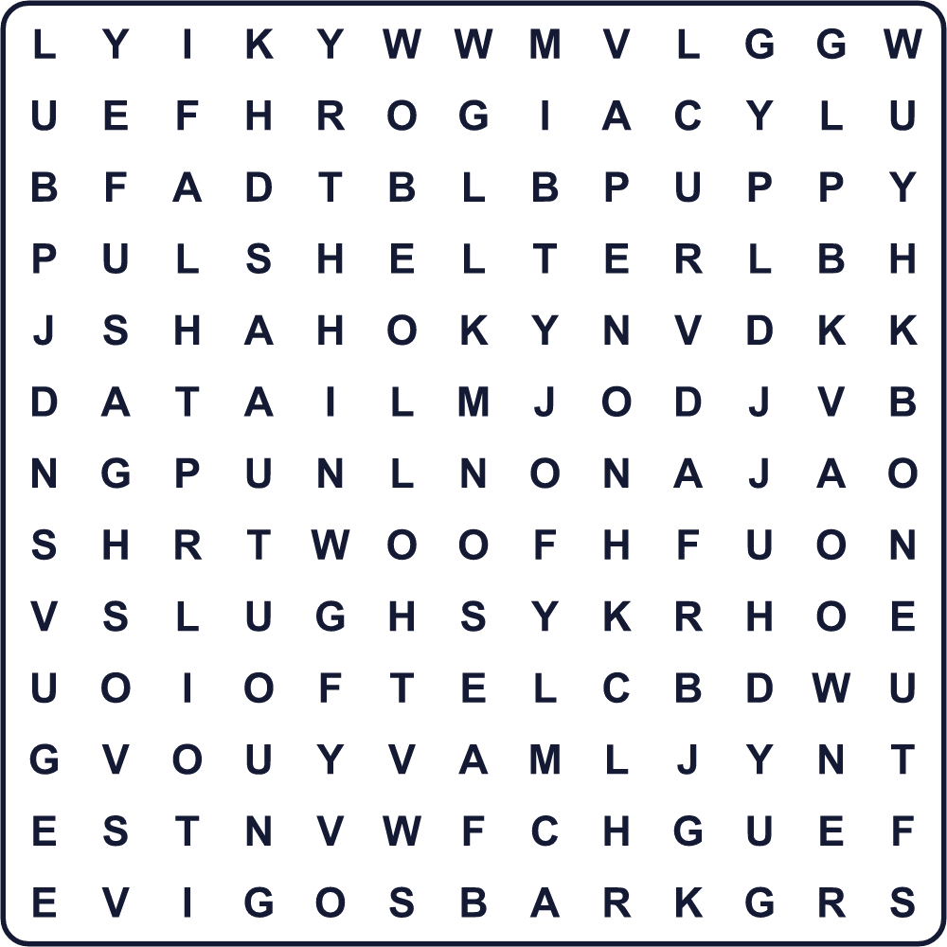
BARK BONE LEASH NOSE OWNER PUPPY SHELTER TAIL WALK WOOF

🐕 National Dog Day Worksheet
Maze & Sentences
Class ______ No. ____ Name ______________________________
Help the dog find its bone! 犬をほねのところまで連れていこう！
正しい道の文字を集めると、ひみつの言葉になるよ。 START 🐕 → GOAL 🦴
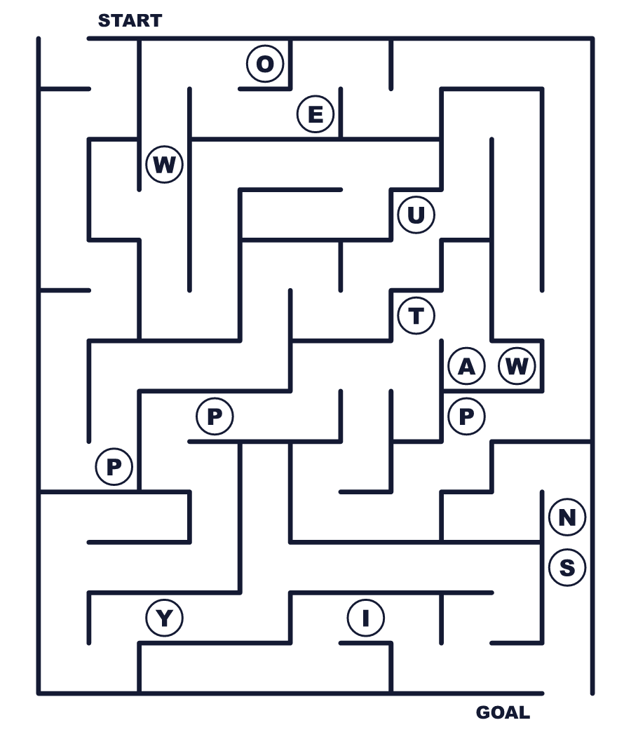
Secret word: ＿ ＿ ＿ ＿ ＿

🐕 National Dog Day Worksheet
Class Activity & Writing
Class ______ No. ____ Name ______________________________
Let's Write! 英語で書いてみよう。
If I had a dog, I would name it ______ and ______ with it every day.
犬を飼ったら、______と名づけて、毎日いっしょに______します。
______________________________________________________________
______________________________________________________________
I want to thank working dogs because ______.
働く犬にありがとうを言いたいです。なぜなら______だからです。
______________________________________________________________
______________________________________________________________

🐕 National Dog Day Worksheet
Trace & Color
なぞって書こう。絵に色をぬろう。
Class ______ No. ____ Name ______________________________
🐕 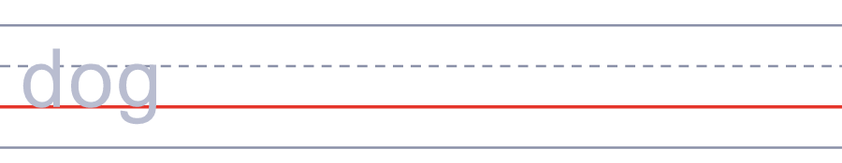

🐶 
🦴 
🐾 
🦮 

🐕 National Dog Day Worksheet
Answer Key 解答
Reading Check: 1.B 2.B 3.A 4.C 5.D
True or False: 1.T 2.F 3.T 4.F
Match: 🐕=dog 🐶=puppy 🦴=bone 🐾=paw 🦮=guide dog 👃=nose
Fill in the blanks: (1)shelter (2)waiting (3)tail (4)adopt (5)barks (6)hug
Maze: PUPPY
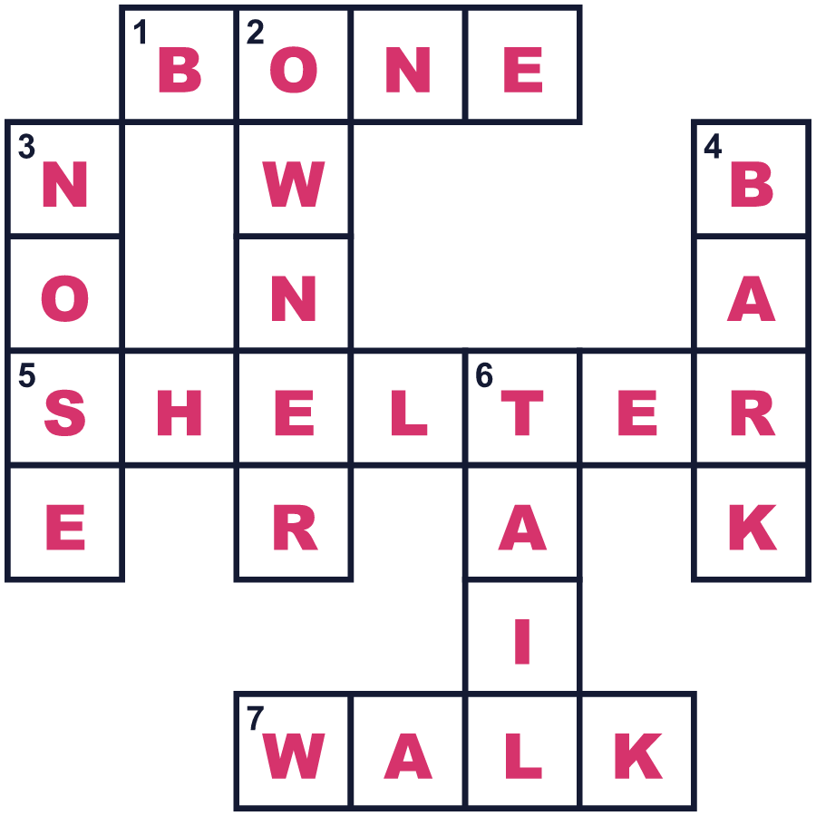
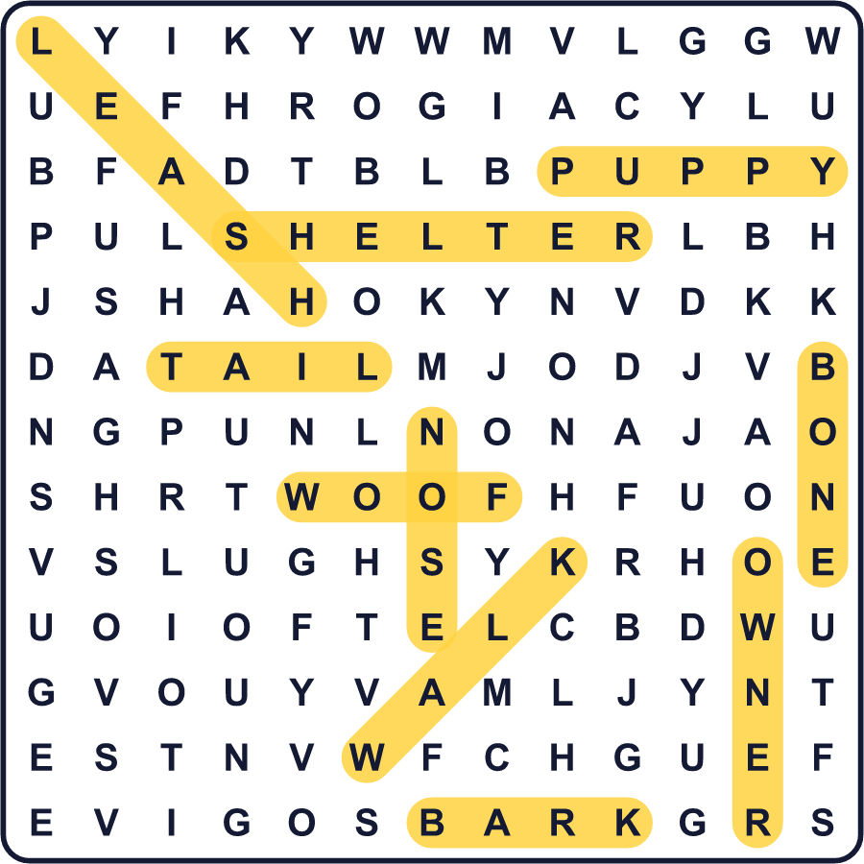
全訳
1 コリーン・ペイジが10歳のとき、家族は動物保護施設に行きました。彼らはシェルティという名前の犬を連れて帰りました。その日が8月26日でした。何年もたった2004年、ペイジは8月26日をナショナル・ドッグ・デーにしました。今ではアメリカの外でも、この日を国際犬の日と呼ぶ人がたくさんいます。
2 この日には2つの目的があります。1つ目。保護施設では、たくさんの犬が新しい家族を待っています。ペイジは、人々にそうした犬を迎えることを考えてほしいと願っています。2つ目。この日は働く犬に感謝します。警察犬、盲導犬、爆発物を見つける犬は、みな毎日人を助けています。
3 犬は少なくとも1万4000年、人とともに暮らしてきました。ドイツでは、約1万4000年前に男性と女性といっしょに埋葬された犬が見つかりました。今では、小さなチワワから巨大なグレート・デーンまで、約450の犬種がいます。犬にはすばらしい鼻があります。においを感じる受容体は、人間の約40倍あります。また、約400メートル先の音を聞くこともできます。
4 日本でいちばん有名な犬はハチ公です。1925年に飼い主が亡くなったあと、ハチ公は10年近く渋谷駅で待ち続けました。日本には11月1日に独自の犬の日もあります。1-1-1が「ワン、ワン、ワン」に聞こえるからです。だから8月26日には、犬を散歩に連れていって、ぎゅっと抱きしめてあげましょう。犬を飼っていないなら、働く犬にありがとうを伝えることもできます。

