😊 International Day of Happiness Worksheet
Which Step Are You On?
Read the story. 英文を読もう。
Class ______ No. ____ Name ______________________________

🔊 音声を聞こう（スマホで読みとってね）
1 How happy are you today? Think of a ladder with 11 steps. The bottom step is 0, and it means the worst life for you. The top step is 10, and it means the best life. Which step are you on now?
2 This is a real question from a big survey. Every year, people in more than 140 countries answer it. The results go into the World Happiness Report. It comes out every year on March 20, the International Day of Happiness. In 2026, Finland was number one for the ninth year in a row. Japan was number 61.
3 The day started with a small country in the Himalayas. In 1972, the king of Bhutan said that happiness was more important than the size of the economy. He wanted to measure the country's success by its Gross National Happiness. Later, Bhutan asked the United Nations to think about this idea. In 2012, the UN made March 20 a day for happiness, and the first one was in 2013.
4 Of course, happiness is not only about money. Friends who help you, good health, and the freedom to make choices are also important. On March 20, the UN asks everyone to think about these things. So ask a friend what makes them happy. Then do something kind for that person. You may move two people up the ladder at the same time!
Words 単語
happiness（幸せ、幸福） / ladder（はしご） / survey（調査、アンケート） / result（結果） / in a row（連続で） / economy（経済） / measure（測る） / freedom（自由）

😊 International Day of Happiness Worksheet
Reading Check
Choose the best answer. 正しいものを選ぼう。
Class ______ No. ____ Name ______________________________
1. What is the reading mainly about?
(A) How to climb a ladder safely (B) The history of Finland (C) A day for happiness and how happiness is measured (D) How to make a lot of money
2. Which country started the idea of Gross National Happiness?
(A) Finland (B) Bhutan (C) Japan (D) The United States
3. When was the first International Day of Happiness?
(A) 1972 (B) 2012 (C) 2026 (D) 2013
4. In paragraph 2, what does "in a row" mean?
(A) One after another, without a break (B) In a straight line of chairs (C) For the first time (D) By a small number
5. Why does Kaito say his number became an eight?
(A) Because Finland won (B) Because it is a holiday (C) Because he got a good test score (D) Because he is enjoying lunch with Aino
True or False? T か F に○
1. The International Day of Happiness is on March 20. T / F
2. Japan was number one in the 2026 happiness ranking. T / F
3. The idea of Gross National Happiness came from Bhutan. T / F
4. The happiness ranking counts how many times people smile. T / F

😊 International Day of Happiness Worksheet
Word Work
単語のれんしゅう
Class ______ No. ____ Name ______________________________
① Match the pictures and the words. 絵と単語を線でむすぼう。
😊 | ● | ● | ladder
🪜 | ● | ● | handshake
🏔️ | ● | ● | smile
❤️ | ● | ● | heart
🤝 | ● | ● | mountain
☀️ | ● | ● | sun
③ Fill in the blanks. 語群から選んで入れよう。
[ question / angry / happy / list / soccer / smile / homework / family / grandma ]
On March 20, Nana's teacher asks the class a (1) __________ . "What makes you (2) __________ ?" Nana thinks for a minute. Then she writes a (3) __________ . Number one is her (4) __________ . Number two is playing (5) __________ with friends. Number three is her dog, Momo. After school, Nana helps her (6) __________ carry heavy bags. Grandma gives her a big (7) __________ .

😊 International Day of Happiness Worksheet
Crossword Puzzle
ヒントを読んでクロスワードを完成させよう。
Class ______ No. ____ Name ______________________________
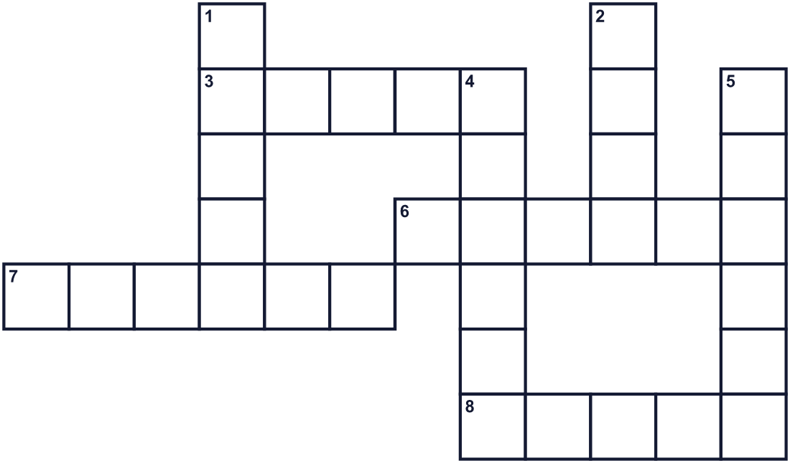
Across →
3. The third month of the year. (5)
6. You climb its steps to reach a high place. (6)
7. A person you like and trust. (6)
8. How you feel when something good happens. (5)
Down ↓
1. Your mouth does this when you are glad. (5)
2. Nice and helpful to other people. (4)
4. The condition of your body. Sleep and good food help it. (6)
5. Many people answer the same questions in it. (6)

😊 International Day of Happiness Worksheet
Word Search
かくれた単語をさがそう（→ ↓ ↘ ↗）
Class ______ No. ____ Name ______________________________
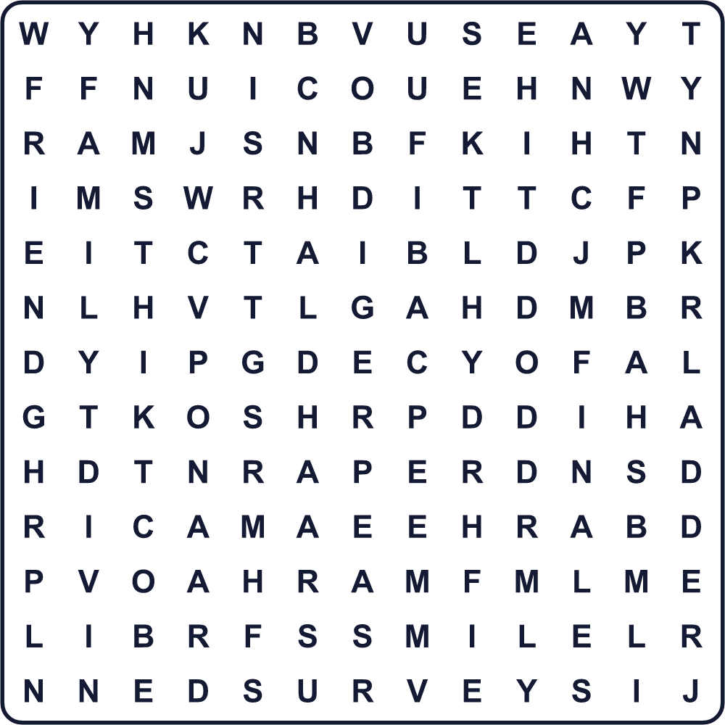
FAMILY FREEDOM FRIEND HAPPY HEALTH KIND LADDER MARCH SMILE SURVEY

😊 International Day of Happiness Worksheet
Maze & Sentences
Class ______ No. ____ Name ______________________________
Help Nana climb to the top of the happiness ladder! ナナが幸せのはしごのてっぺんまでたどり着けるように手伝おう！
正しい道の文字を集めると、ひみつの言葉になるよ。 START 👧 → GOAL 😊
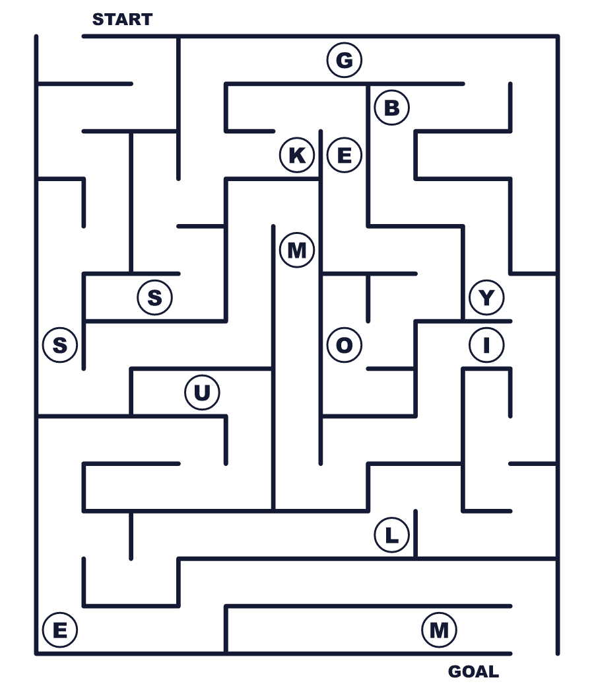
Secret word: ＿ ＿ ＿ ＿ ＿

😊 International Day of Happiness Worksheet
Class Activity & Writing
Class ______ No. ____ Name ______________________________
Let's Write! 英語で書いてみよう。
Today I am on step ______ of the happiness ladder because ______.
今日の私は、幸せのはしごの＿＿＿段目です。なぜなら＿＿＿だからです。
______________________________________________________________
______________________________________________________________
To make someone happy, I will ______.
だれかを幸せにするために、私は＿＿＿をします。
______________________________________________________________
______________________________________________________________

😊 International Day of Happiness Worksheet
Trace & Color
なぞって書こう。絵に色をぬろう。
Class ______ No. ____ Name ______________________________
😊 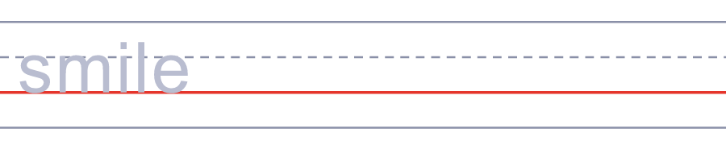

🪜 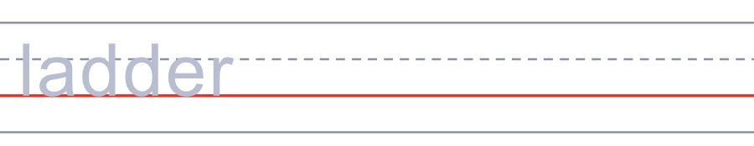
🏔️ 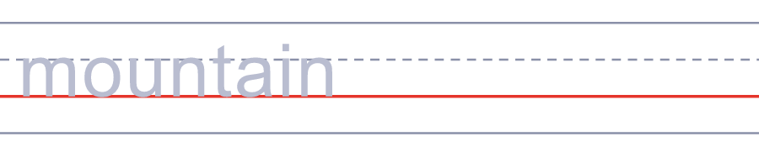
❤️ 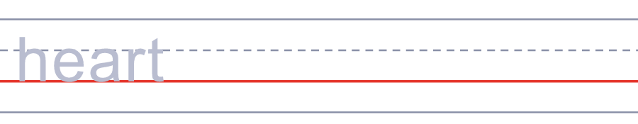
🤝 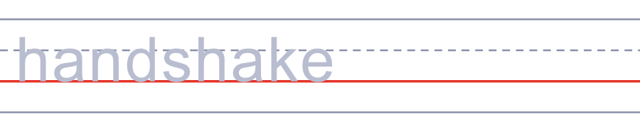

😊 International Day of Happiness Worksheet
Answer Key 解答
Reading Check: 1.C 2.B 3.D 4.A 5.D
True or False: 1.T 2.F 3.T 4.F
Match: 😊=smile 🪜=ladder 🏔️=mountain ❤️=heart 🤝=handshake ☀️=sun
Fill in the blanks: (1)question (2)happy (3)list (4)family (5)soccer (6)grandma (7)smile
Maze: SMILE
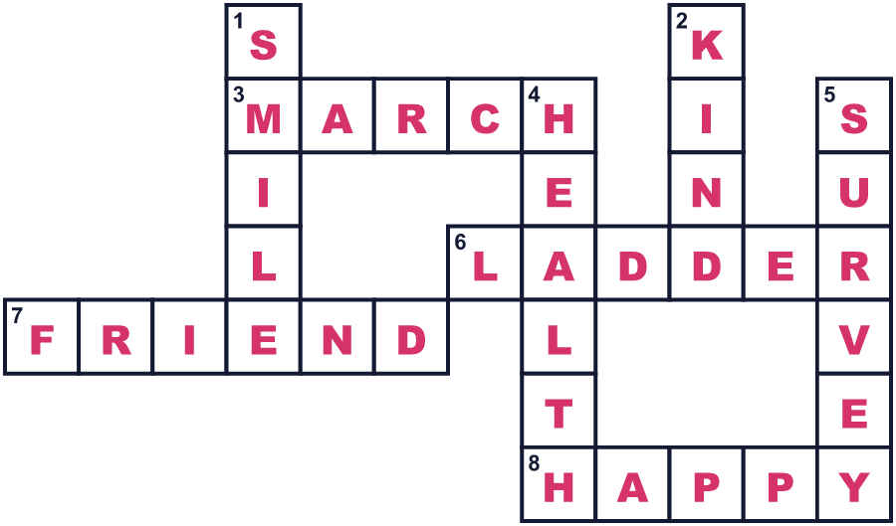
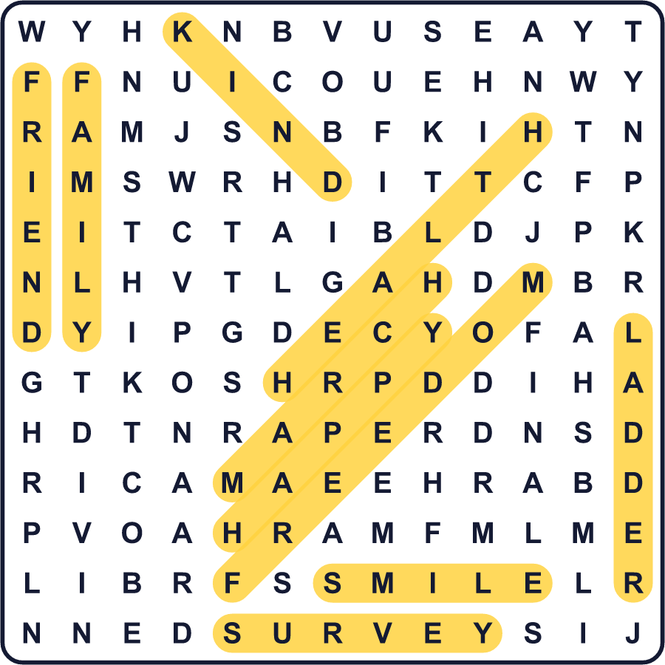
全訳
1 あなたは今日、どのくらい幸せですか。11段のはしごを思いうかべてください。いちばん下の段は0で、あなたにとって最悪の生活を意味します。いちばん上の段は10で、最高の生活を意味します。あなたは今、何段目にいますか。
2 これは大きな調査で使われている本物の質問です。毎年、140をこえる国の人々がこの質問に答えています。結果は世界幸福度報告にまとめられます。報告は毎年3月20日、国際幸福デーに発表されます。2026年、フィンランドは9年連続で1位でした。日本は61位でした。
3 この日の始まりは、ヒマラヤの小さな国でした。1972年、ブータンの国王は、経済の大きさよりも幸せのほうが大切だと言いました。彼は、国の成功を国民総幸福量で測りたいと考えたのです。のちにブータンは、この考えについて考えてほしいと国連に呼びかけました。2012年、国連は3月20日を幸福の日にし、最初の幸福デーは2013年でした。
4 もちろん、幸せはお金だけで決まるものではありません。助けてくれる友だち、健康、そして自分で選べる自由も大切です。3月20日、国連はみんなにこうしたことを考えてほしいと呼びかけています。だから、友だちに何が幸せかを聞いてみましょう。そして、その人のために何かやさしいことをしてみてください。2人いっしょに、はしごを上がれるかもしれません！

