🐈 International Cat Day Worksheet
Our Quiet Roommates
Read the story. 英文を読もう。
Class ______ No. ____ Name ______________________________

🔊 音声を聞こう（スマホで読みとってね）
1 About 9,500 years ago, on the island of Cyprus, a person was buried with a cat. It is one of the oldest signs that people and cats lived together. Cats probably caught mice near farms, and people were happy to have them around. Later, people in ancient Egypt loved and honored cats. Today, there are about 600 million house cats in the world.
2 International Cat Day is on August 8. An animal group called IFAW started it in 2002. In 2020, a British group called International Cat Care took over the day. The goal is not only to share cute photos. It is also a day to learn how to help and protect cats.
3 Cats are full of surprises. They cannot taste sweet food, so cake means nothing to them. They usually sleep 12 to 16 hours a day. When they are happy, their purr shakes about 25 to 33 times every second. But their ears are always working. Cats can hear very high sounds that people and dogs cannot hear.
4 In Japan, people have another cat day on February 22. In Japanese, two is ni, so 2-2-2 sounds like nyan, nyan, nyan. In 2017, Japan had more pet cats than pet dogs for the first time. So on August 8, take a photo of a cat, or learn one new fact about cats. Your cat may not say thank you, but it might purr.
Words 単語
bury（埋める、埋葬する） / mouse（ネズミ） / pet（ペット） / protect（守る） / take over（引き継ぐ） / taste（味がわかる、味わう） / purr（（ネコが）のどをゴロゴロ鳴らす） / vet（獣医、動物病院）

🐈 International Cat Day Worksheet
Reading Check
Choose the best answer. 正しいものを選ぼう。
Class ______ No. ____ Name ______________________________
1. What is the main idea of the reading?
(A) Cats are dangerous animals. (B) International Cat Day is a day to learn about and care for cats. (C) Cats came from Japan. (D) Only Japan has a cat day.
2. Who started International Cat Day?
(A) International Cat Care (B) The Japanese government (C) IFAW (D) A cat magazine in Italy
3. Why does cake mean nothing to cats?
(A) Because they are always sleeping (B) Because they cannot taste sweet food (C) Because they only eat mice (D) Because cake is too big
4. In paragraph 2, "took over" is closest in meaning to:
(A) started to take care of (B) stopped (C) forgot (D) sold
5. In the dialogue, what did Mei do for Mochi on Cat Day?
(A) She gave her a cake. (B) She took her to London. (C) She bought her a new box. (D) She took her for a check-up.
True or False? T か F に○
1. International Cat Day is on August 8. T / F
2. Cats love the sweet taste of cake. T / F
3. People and cats have lived together for thousands of years. T / F
4. Japan's Cat Day is also on August 8. T / F

🐈 International Cat Day Worksheet
Word Work
単語のれんしゅう
Class ______ No. ____ Name ______________________________
① Match the pictures and the words. 絵と単語を線でむすぼう。
🐈 | ● | ● | mouse
🐭 | ● | ● | box
🐾 | ● | ● | sleep
📦 | ● | ● | paw
🐟 | ● | ● | cat
😴 | ● | ● | fish
③ Fill in the blanks. 語群から選んで入れよう。
[ kitchen / bark / cat / sleeping / rabbit / eye / bed / sound / purr ]
Ken cannot find his (1) __________ , Tama. He looks under the (2) __________ . She is not there. He looks in the (3) __________ . She is not there. Then he hears a soft (4) __________ from a box. Tama is (5) __________ in the box! Ken smiles. "Happy Cat Day, Tama," he says. Tama opens one (6) __________ and starts to (7) __________ .

🐈 International Cat Day Worksheet
Crossword Puzzle
ヒントを読んでクロスワードを完成させよう。
Class ______ No. ____ Name ______________________________
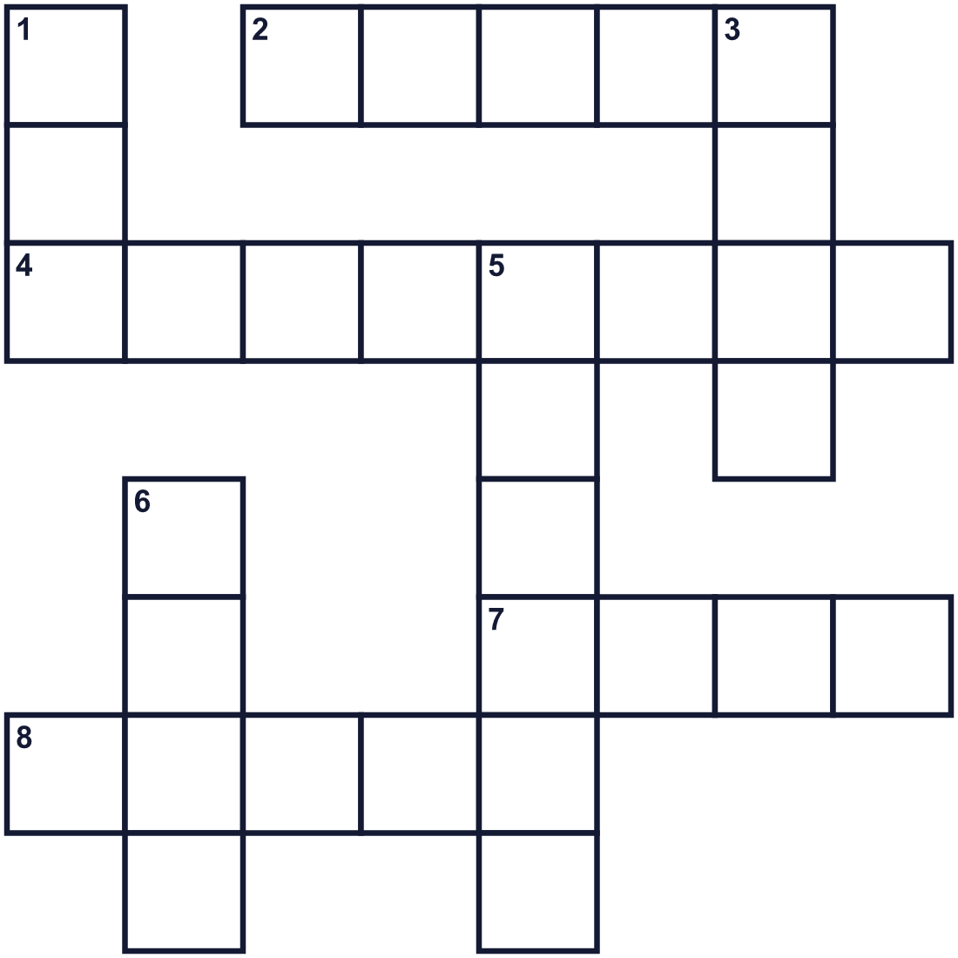
Across →
2. Cats do this 12 to 16 hours a day. (5)
4. Long hairs near a cat's nose. (8)
7. The long part at the back of a cat. (4)
8. A small animal. Cats like to chase it. (5)
Down ↓
1. A cat's foot. (3)
3. The soft sound a happy cat makes. (4)
5. A baby cat. (6)
6. The sound a cat makes when it wants food. (4)

🐈 International Cat Day Worksheet
Word Search
かくれた単語をさがそう（→ ↓ ↘ ↗）
Class ______ No. ____ Name ______________________________
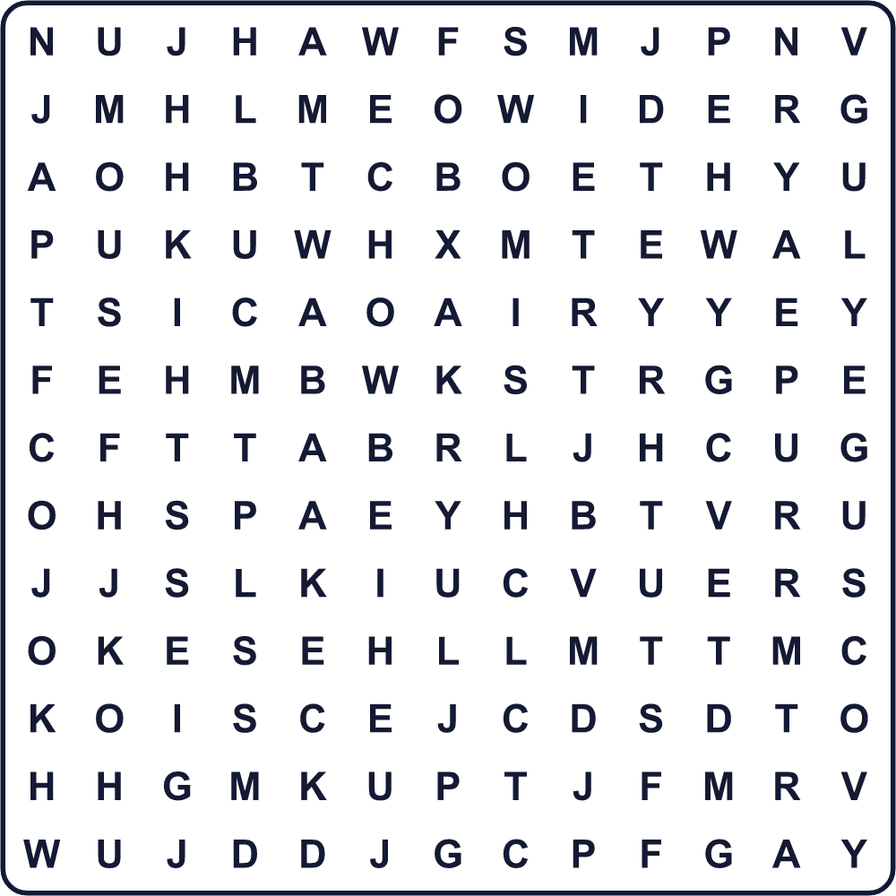
BOX KITTEN MEOW MOUSE PAW PURR SLEEP TAIL VET WHISKERS

🐈 International Cat Day Worksheet
Maze & Sentences
Class ______ No. ____ Name ______________________________
Help the cat find its cozy box! ネコをお気に入りの箱まで連れていこう！
正しい道の文字を集めると、ひみつの言葉になるよ。 START 🐈 → GOAL 📦
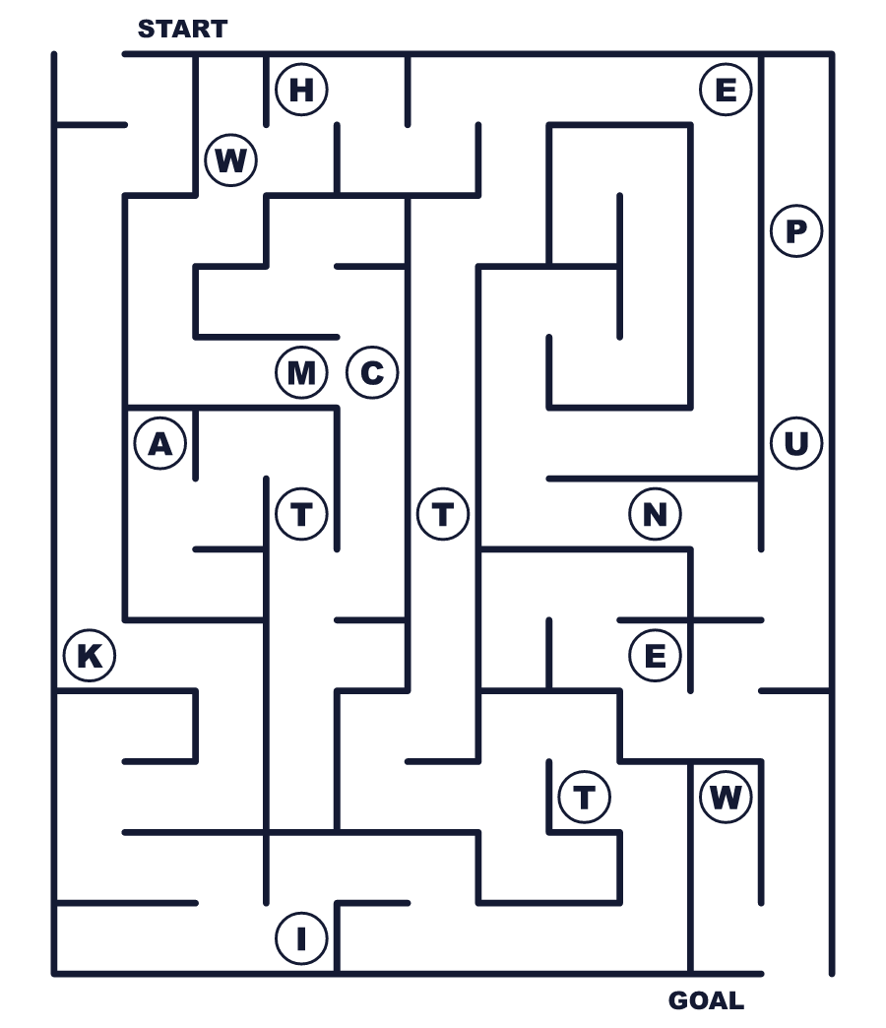
Secret word: ＿ ＿ ＿ ＿ ＿ ＿

🐈 International Cat Day Worksheet
Class Activity & Writing
Class ______ No. ____ Name ______________________________
Let's Write! 英語で書いてみよう。
If I had a cat, I would name it ______ because ______.
もしネコを飼うなら、______と名づけます。なぜなら______だからです。
______________________________________________________________
______________________________________________________________
One surprising fact about cats is ______.
ネコについての意外な事実は______です。
______________________________________________________________
______________________________________________________________

🐈 International Cat Day Worksheet
Trace & Color
なぞって書こう。絵に色をぬろう。
Class ______ No. ____ Name ______________________________
🐈 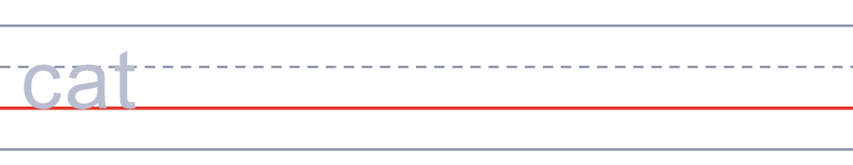

🐭 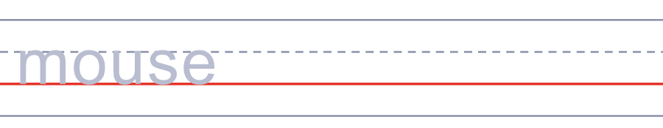
🐾 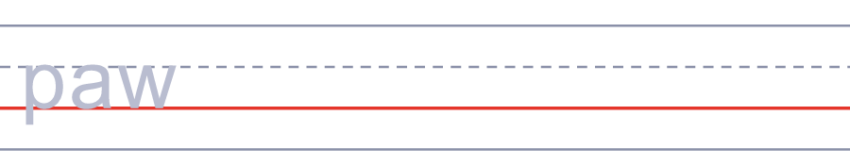
📦 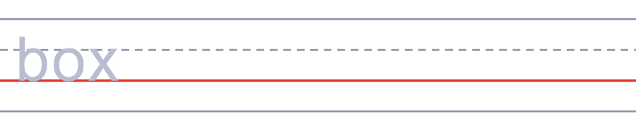
🐟 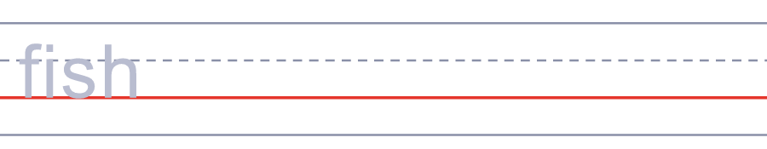

🐈 International Cat Day Worksheet
Answer Key 解答
Reading Check: 1.B 2.C 3.B 4.A 5.D
True or False: 1.T 2.F 3.T 4.F
Match: 🐈=cat 🐭=mouse 🐾=paw 📦=box 🐟=fish 😴=sleep
Fill in the blanks: (1)cat (2)bed (3)kitchen (4)sound (5)sleeping (6)eye (7)purr
Maze: KITTEN
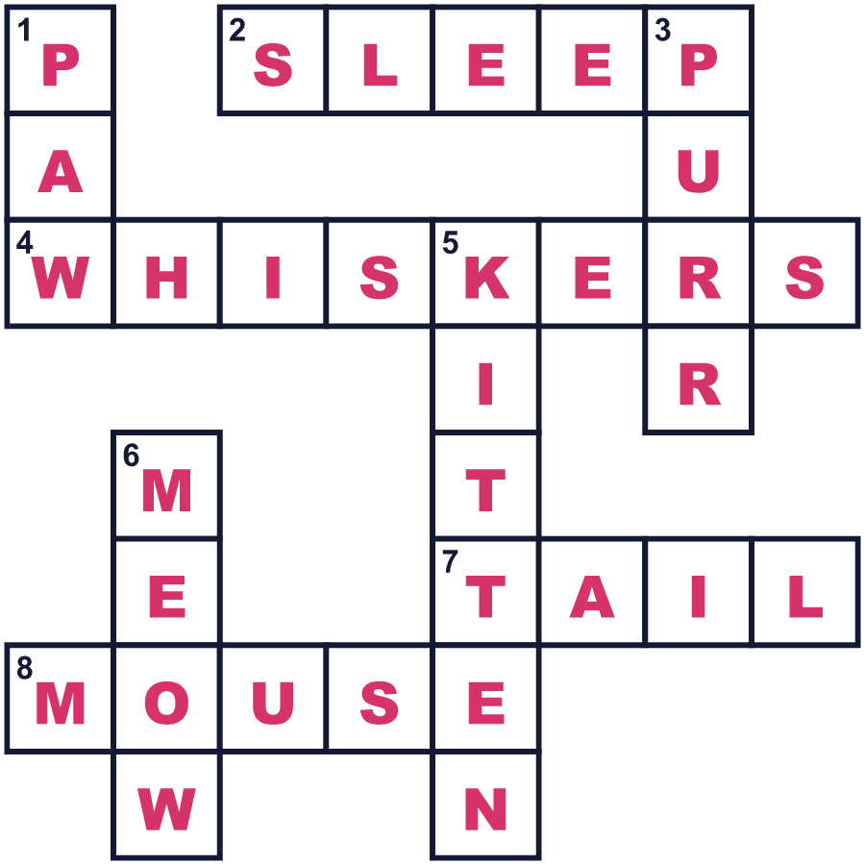

全訳
1 約9500年前、キプロス島で、ある人がネコといっしょに埋葬されました。それは、人とネコがいっしょに暮らしていた最も古い証拠のひとつです。ネコはおそらく農地の近くでネズミをとり、人々はネコがそばにいるのを喜んだのでしょう。のちに古代エジプトの人々は、ネコを愛し、あがめました。今、世界には約6億匹のイエネコがいます。
2 国際ネコの日は8月8日です。IFAWという動物の団体が2002年に始めました。2020年、インターナショナル・キャット・ケアというイギリスの団体がこの日を引き継ぎました。目的は、かわいい写真を見せ合うことだけではありません。ネコを助け、守る方法を学ぶ日でもあるのです。
3 ネコは驚きでいっぱいです。ネコは甘い物の味がわからないので、ケーキは何の意味もありません。ふつう1日に12〜16時間眠ります。うれしいときのゴロゴロは、1秒に約25〜33回ふるえています。でも、耳はいつも働いています。ネコは、人や犬には聞こえないとても高い音も聞くことができます。
4 日本では、2月22日にもうひとつのネコの日があります。日本語で2は「に」なので、2-2-2は「にゃん、にゃん、にゃん」に聞こえます。2017年、日本で初めて飼いネコの数が飼い犬を上回りました。だから8月8日には、ネコの写真を撮るか、ネコについて新しいことを1つ学んでみましょう。ネコはありがとうとは言わないかもしれませんが、ゴロゴロのどを鳴らすかもしれません。

