🪶 Indigenous Peoples' Day / Columbus Day Worksheet
One Day, Two Names
Read the story. 英文を読もう。
Class ______ No. ____ Name ______________________________

🔊 音声を聞こう（スマホで読みとってね）
1 On the second Monday in October, some Americans celebrate Columbus Day. Others celebrate Indigenous Peoples' Day. Some towns even celebrate both. Why does one day have two names? The answer starts with a trip across the ocean more than 500 years ago.
2 In 1492, Christopher Columbus sailed west from Spain with three ships. He wanted to reach Asia, and he hoped to find Japan. On October 12, he landed on a small island in the Caribbean Sea. He thought he was near India, so he called the people there Indians. He did not know that two large continents were in his way.
3 For many Italian Americans, Columbus is a hero. He was born in Genoa, Italy. In the 1890s, many Italian immigrants faced hate in the United States. Columbus Day became a way to show pride in their history. In 1971, it became a national holiday on the second Monday in October. Big parades still march through New York on this day.
4 But Columbus did not find an empty land. Millions of people already lived in the Americas. Under Columbus, many of them were made slaves, and new diseases killed many more. In 1992, exactly 500 years after his trip, the city of Berkeley chose a new name. It called the day Indigenous Peoples' Day. Today, the two names show two ways of looking at the same history. Which name would you choose?
Words 単語
indigenous（先住の、その土地に昔からいる） / sail（航海する） / land（上陸する、着陸する） / hero（英雄） / immigrant（（外国から来た）移民） / pride（誇り） / slave（奴隷） / disease（病気）

🪶 Indigenous Peoples' Day / Columbus Day Worksheet
Reading Check
Choose the best answer. 正しいものを選ぼう。
Class ______ No. ____ Name ______________________________
1. What is the reading mainly about?
(A) How to sail a ship across the ocean (B) Why one American holiday has two names (C) The life of people in Genoa (D) How to make a parade
2. Why did Columbus call the people "Indians"?
(A) Because they came from India (B) Because they spoke an Indian language (C) Because he thought he was near India (D) Because the king told him to
3. When did Berkeley start Indigenous Peoples' Day?
(A) In 1992 (B) In 1492 (C) In 1971 (D) In 1890
4. Why is Columbus Day important to many Italian Americans?
(A) Because it is the first day of school (B) Because Columbus was born in Spain (C) Because Columbus found Japan (D) Because it showed pride when they faced hate
5. In the dialogue, what does Aoi learn?
(A) The day means different things to different people. (B) Everyone in the US hates Columbus. (C) Her host family is from Spain. (D) There is no holiday on Monday.
True or False? T か F に○
1. Columbus landed on an island in 1492. T / F
2. Columbus knew he was in the Americas. T / F
3. Berkeley started Indigenous Peoples' Day in 1992. T / F
4. Columbus was born in Japan. T / F

🪶 Indigenous Peoples' Day / Columbus Day Worksheet
Word Work
単語のれんしゅう
Class ______ No. ____ Name ______________________________
① Match the pictures and the words. 絵と単語を線でむすぼう。
⛵ | ● | ● | island
🏝️ | ● | ● | ship
🌊 | ● | ● | compass
🗺️ | ● | ● | ocean
🧭 | ● | ● | map
🥁 | ● | ● | drum
③ Fill in the blanks. 語群から選んで入れよう。
[ pizza / proud / holiday / Native / summer / before / Italy / stories / school ]
On Monday, there is no (1) __________ . Lily asks her grandfather about the (2) __________ . "Our family came from (3) __________ ," he says. "This day makes me (4) __________ ." Then Lily asks her friend Sam. Sam's family is (5) __________ American. "My people lived here long (6) __________ Columbus," Sam says. Lily thinks about it. "One day can have two (7) __________ ," she says.

🪶 Indigenous Peoples' Day / Columbus Day Worksheet
Crossword Puzzle
ヒントを読んでクロスワードを完成させよう。
Class ______ No. ____ Name ______________________________
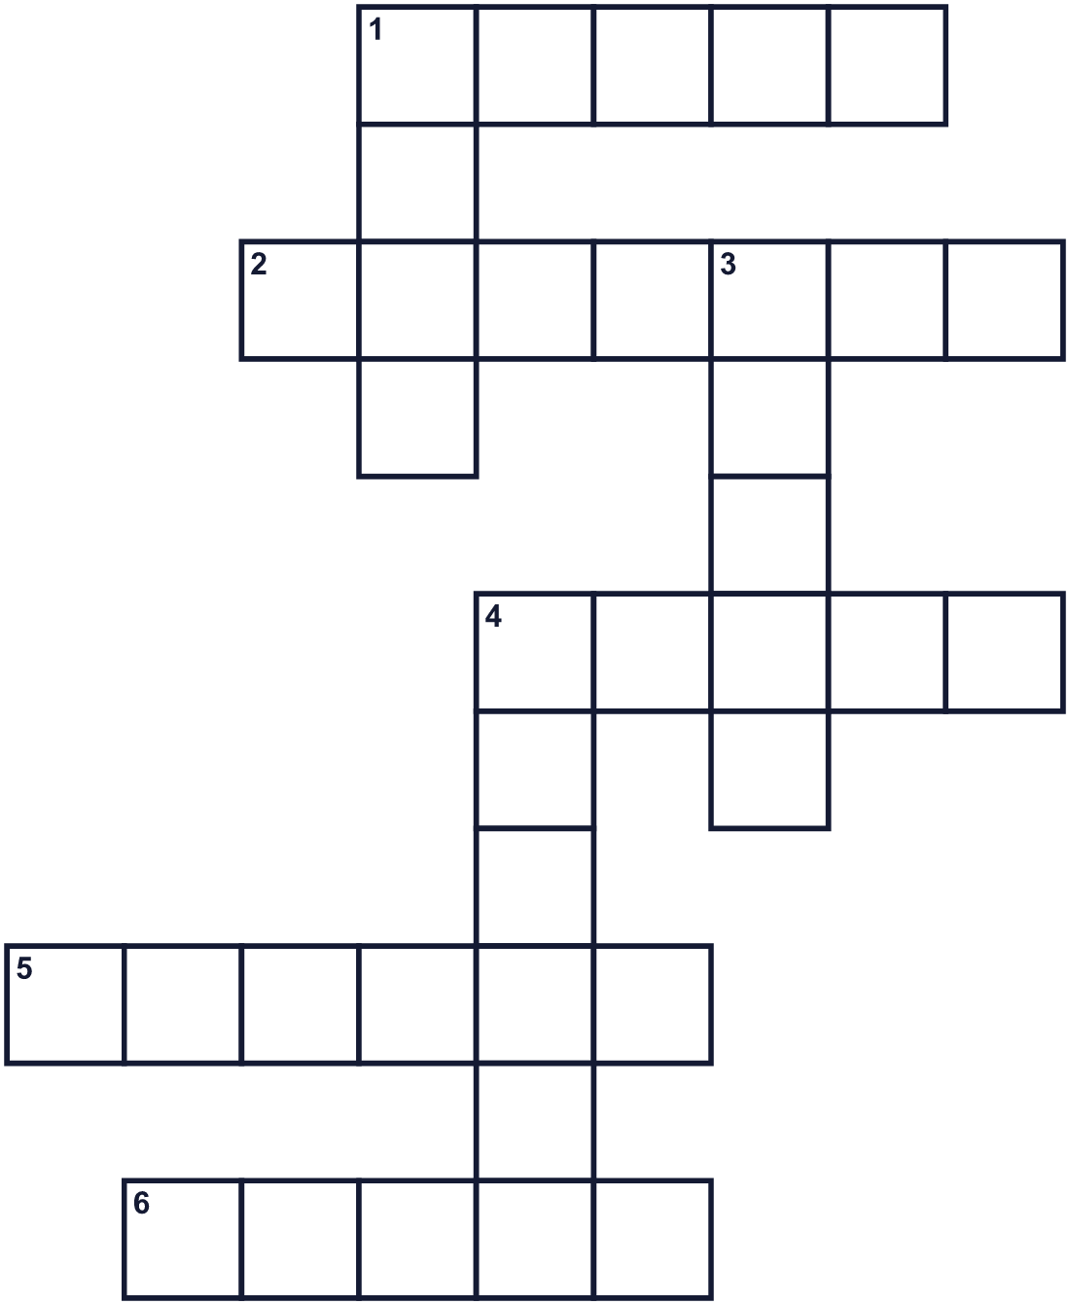
Across →
1. Columbus sailed from this country in 1492. (5)
2. The story of the past. (7)
4. The country where Genoa is. (5)
5. The day after Sunday. (6)
6. A good feeling about who you are. (5)
Down ↓
1. A big boat. Columbus had three of them. (4)
3. A very big sea, like the Atlantic. (5)
4. Land with water all around it. (6)

🪶 Indigenous Peoples' Day / Columbus Day Worksheet
Word Search
かくれた単語をさがそう（→ ↓ ↘ ↗）
Class ______ No. ____ Name ______________________________
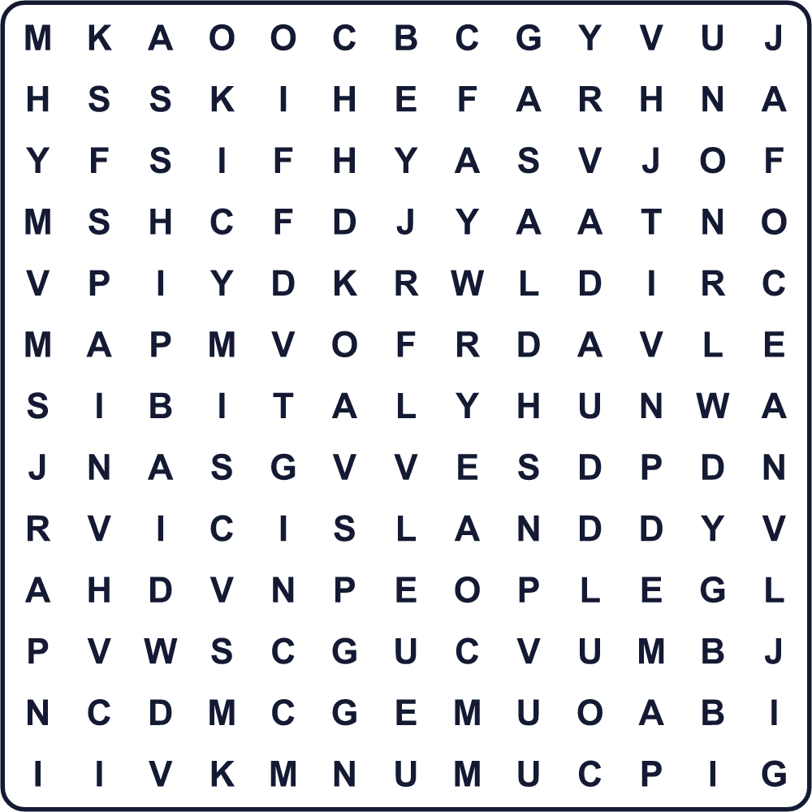
HISTORY ISLAND ITALY LAND MAP OCEAN PEOPLE SAIL SHIP SPAIN

🪶 Indigenous Peoples' Day / Columbus Day Worksheet
Maze & Sentences
Class ______ No. ____ Name ______________________________
Help the ship cross the ocean! 船が海を渡れるようにしよう！
正しい道の文字を集めると、ひみつの言葉になるよ。 START ⛵ → GOAL 🏝️
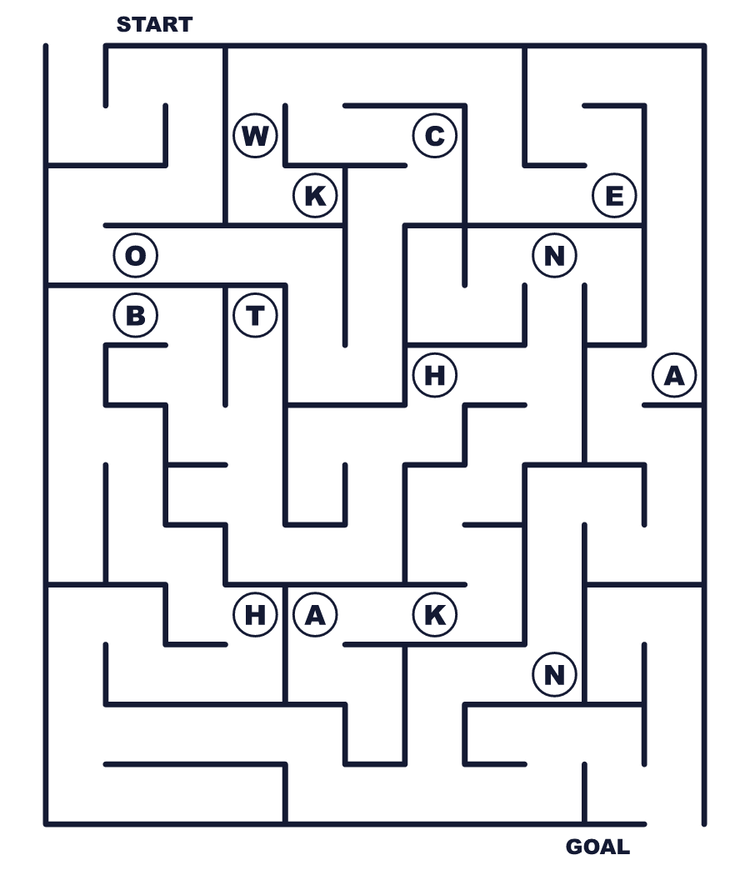
Secret word: ＿ ＿ ＿ ＿ ＿

🪶 Indigenous Peoples' Day / Columbus Day Worksheet
Class Activity & Writing
Class ______ No. ____ Name ______________________________
Let's Write! 英語で書いてみよう。
I think the second Monday in October should be called ______ because ______.
10月の第2月曜日は______と呼ぶべきだと思います。なぜなら______だからです。
______________________________________________________________
______________________________________________________________
One thing I want to learn about the first people of my area is ______.
自分の地域に昔から住んでいた人々について知りたいことは______です。
______________________________________________________________
______________________________________________________________

🪶 Indigenous Peoples' Day / Columbus Day Worksheet
Trace & Color
なぞって書こう。絵に色をぬろう。
Class ______ No. ____ Name ______________________________
⛵ 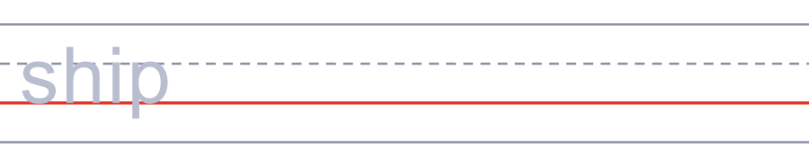

🏝️ 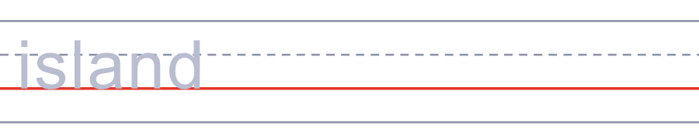
🌊 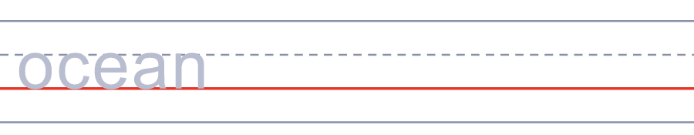
🗺️ 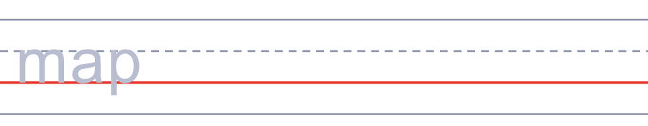
🧭 

🪶 Indigenous Peoples' Day / Columbus Day Worksheet
Answer Key 解答
Reading Check: 1.B 2.C 3.A 4.D 5.A
True or False: 1.T 2.F 3.T 4.F
Match: ⛵=ship 🏝️=island 🌊=ocean 🗺️=map 🧭=compass 🥁=drum
Fill in the blanks: (1)school (2)holiday (3)Italy (4)proud (5)Native (6)before (7)stories
Maze: OCEAN
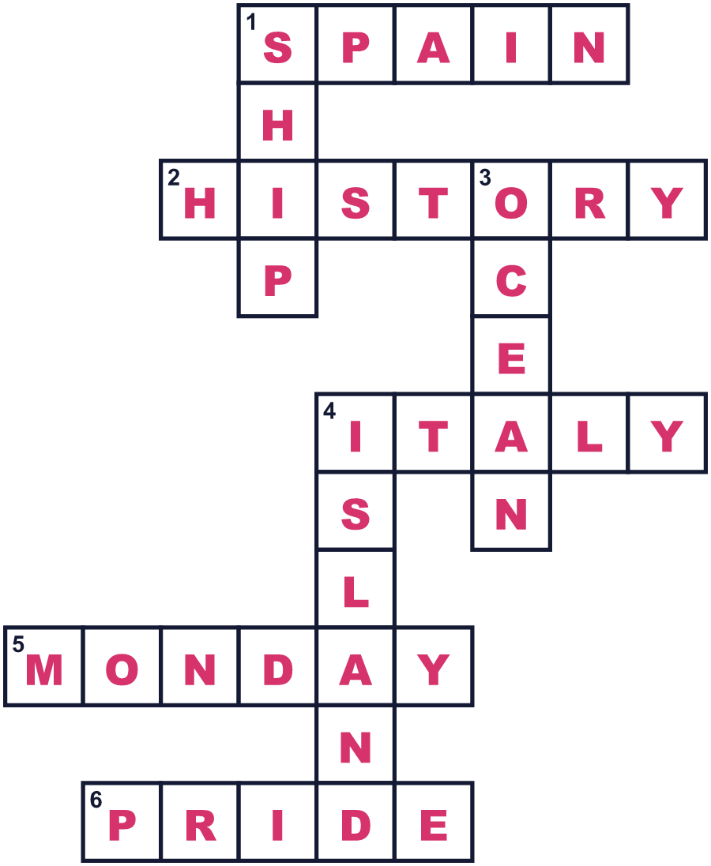
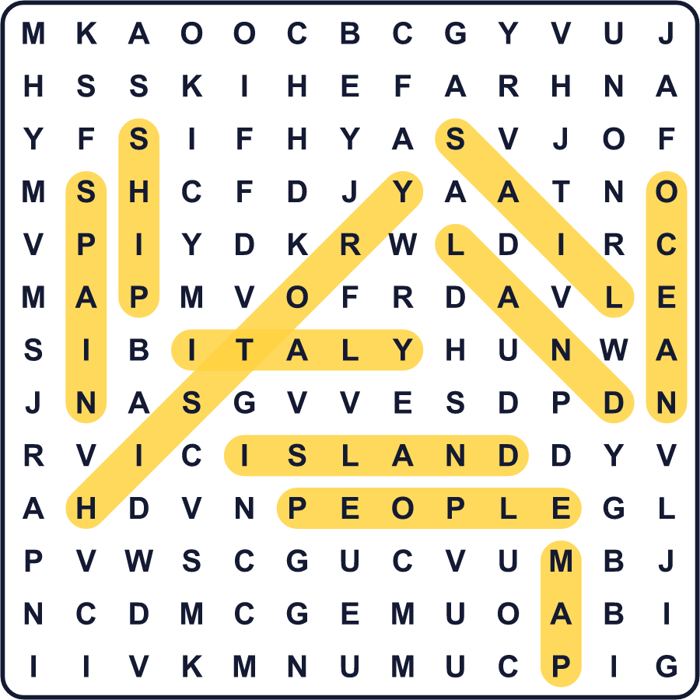
全訳
1 10月の第2月曜日、コロンブス・デーを祝うアメリカ人がいます。先住民の日を祝う人もいます。両方を祝う町さえあります。なぜ1つの日に2つの名前があるのでしょうか。答えは、500年以上前の海を渡る旅から始まります。
2 1492年、クリストファー・コロンブスは3隻の船でスペインから西へ向かいました。彼はアジアに行きたいと思い、日本を見つけたいと願っていました。10月12日、彼はカリブ海の小さな島に着きました。彼はインドの近くにいると思ったので、そこの人々をインディアンと呼びました。行く手に2つの大きな大陸があることを、彼は知らなかったのです。
3 多くのイタリア系アメリカ人にとって、コロンブスは英雄です。彼はイタリアのジェノバで生まれました。1890年代、多くのイタリア系移民がアメリカで憎しみにさらされました。コロンブス・デーは、自分たちの歴史への誇りを示す方法になりました。1971年、この日は10月の第2月曜日の国の祝日になりました。今でもこの日には、ニューヨークを大きなパレードが行進します。
4 でも、コロンブスが見つけたのは、だれもいない土地ではありませんでした。アメリカ大陸には、すでに何百万人もの人が暮らしていました。コロンブスのもとで多くの人が奴隷にされ、新しい病気がさらに多くの命を奪いました。航海からちょうど500年後の1992年、バークレー市は新しい名前を選びました。その日を先住民の日と呼んだのです。今、2つの名前は、同じ歴史の2つの見方を表しています。あなたなら、どちらの名前を選びますか。

