🎆 Independence Day (USA) Worksheet
Two Days Off, but Right in the End
Read the story. 英文を読もう。
Class ______ No. ____ Name ______________________________
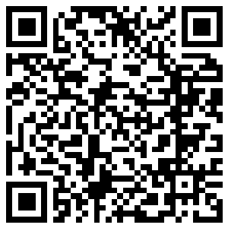
🔊 音声を聞こう（スマホで読みとってね）
1 On July 3, 1776, John Adams wrote a letter to his wife, Abigail. He said that one day would be remembered forever. People would celebrate it with games, guns, bells, and bright lights. But the day he wrote about was July 2, not July 4.
2 On July 2, leaders from 13 American colonies voted to break away from Britain. Two days later, on July 4, they accepted a paper that explained why. It was the Declaration of Independence, and Thomas Jefferson wrote most of it. He was only 33 years old. Printed copies carried the date July 4, 1776, so people remembered that day.
3 Here is another surprise. Most of the leaders did not sign the Declaration on July 4. They signed a clean copy on August 2, almost a month later. In the end, 56 men signed it. John Hancock wrote his name so big that his name now means signature. It is about 13 centimeters long!
4 Adams and Jefferson later became the second and third presidents. Then something strange happened. Both men died on July 4, 1826, exactly 50 years after the Declaration. Jefferson died first, and Adams died a few hours later.
5 Today, Americans call the holiday Independence Day or the Fourth of July. Towns have parades in the morning. Some towns also read the Declaration out loud. Families eat hot dogs and hamburgers in their backyards. At night, fireworks fill the sky in red, white, and blue. Adams got the date wrong, but he was right about the party.
Words 単語
independence（独立） / colony（植民地） / vote（投票する） / declaration（宣言） / accept（受け入れる、採択する） / sign（署名する） / signature（署名） / president（大統領） / exactly（ちょうど、正確に） / fireworks（花火） / backyard（裏庭） / parade（パレード）

🎆 Independence Day (USA) Worksheet
Reading Check
Choose the best answer. 正しいものを選ぼう。
Class ______ No. ____ Name ______________________________
1. What is the main point of the story?
(A) Fireworks were invented in 1776. (B) The story of July 4 has surprising facts about dates. (C) John Adams did not like parties. (D) America became independent in 1826.
2. When did the leaders vote to break away from Britain?
(A) July 2, 1776 (B) July 3, 1776 (C) July 4, 1776 (D) August 2, 1776
3. How many men signed the Declaration in the end?
(A) 13 (B) 26 (C) 50 (D) 56
4. Why did people remember July 4 and not July 2?
(A) Because Adams told them to. (B) Because printed copies had the date July 4. (C) Because the fireworks were on July 4. (D) Because Jefferson was born on July 4.
5. In paragraph 3, a "clean copy" is a copy that is ...
(A) washed with water (B) neatly written again (C) kept in a clean room (D) printed in color
6. Which is true according to the story?
(A) Adams died before Jefferson. (B) Jefferson became the second president. (C) Adams and Jefferson died on the same day. (D) Most leaders signed on July 4.
7. What does the last sentence mean?
(A) Adams chose the wrong food for the party. (B) Adams was wrong about the date, but people do celebrate as he said. (C) Adams never went to a party. (D) Adams wanted fireworks on July 2 only.
8. In the dialogue, what does Olivia ask Kenta to do?
(A) Bring hamburgers (B) Sign a paper (C) Wear red, white, or blue (D) Watch the fireworks on TV
True or False? T か F に○
1. Independence Day is on July 4. T / F
2. The leaders voted for independence on July 2. T / F
3. Most leaders signed the Declaration on July 4. T / F
4. Thomas Jefferson wrote most of the Declaration. T / F
5. Adams and Jefferson died in different years. T / F
6. There is a treasure map on the back of the Declaration. T / F

🎆 Independence Day (USA) Worksheet
Word Work
単語のれんしゅう
Class ______ No. ____ Name ______________________________
① Match the pictures and the words. 絵と単語を線でむすぼう。
🎆 | ● | ● | paper
🌭 | ● | ● | hot dog
🔔 | ● | ● | watermelon
🦅 | ● | ● | fireworks
📜 | ● | ● | trumpet
🥧 | ● | ● | eagle
🍉 | ● | ● | bell
🎺 | ● | ● | pie
② Unscramble the words. 並べかえて単語にしよう。
1. D R E M E F O (自由) → ____________________
2. A R A D E P (パレード) → ____________________
3. C O L Y N O (植民地) → ____________________
4. S G N R E U A I T (署名) → ____________________
5. I P C I C N (ピクニック) → ____________________
6. I T R O S H Y (歴史) → ____________________
③ Fill in the blanks. 語群から選んで入れよう。
[ 4 / quiet / fireworks / barbecue / pie / birthday / flag / parade / blue / snow / music / breakfast / dark ]
It is the morning of July (1) __________ . Lucas puts a small (2) __________ on his bike. Then he rides to Main Street to watch the (3) __________ . A band plays loud (4) __________ , and people wear red, white, and (5) __________ . In the afternoon, his family has a (6) __________ in the backyard. His mom makes an apple (7) __________ . When it gets (8) __________ , everyone goes to the lake. Boom! The (9) __________ light up the sky. "Happy (10) __________ , America!" Lucas shouts.

🎆 Independence Day (USA) Worksheet
Crossword Puzzle
ヒントを読んでクロスワードを完成させよう。
Class ______ No. ____ Name ______________________________
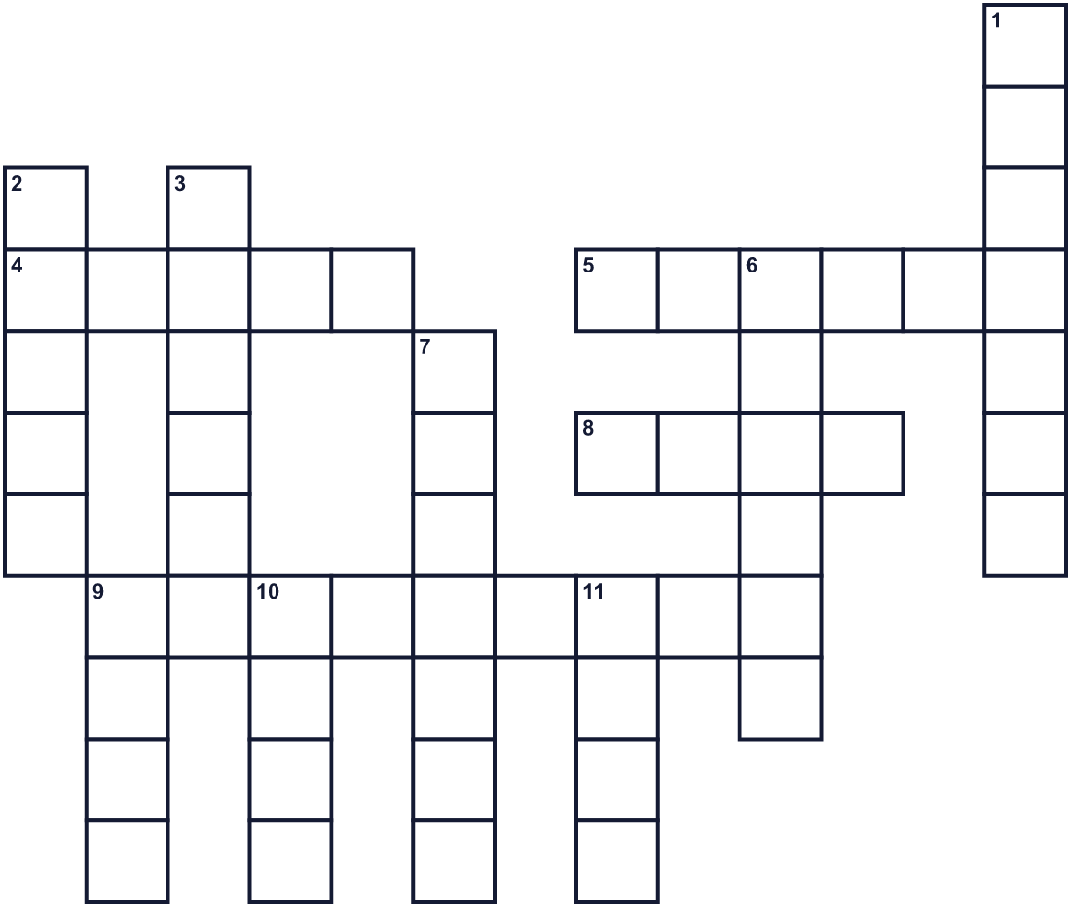
Across →
4. The second president. He wrote to his wife on July 3, 1776. (5)
5. A meal you eat outside in a park. (6)
8. The famous one in Philadelphia has a crack. (4)
9. He wrote most of the Declaration. (9)
Down ↓
1. His big signature is famous. (7)
2. A big bird. The bald one is a symbol of America. (5)
3. Bands and people walk down the street in this. (6)
6. A place ruled by another country far away. (6)
7. Being able to do what you want. Liberty. (7)
9. The seventh month of the year. (4)
10. The Stars and Stripes is one. (4)
11. To write your name on a paper. (4)

🎆 Independence Day (USA) Worksheet
Word Search
かくれた単語をさがそう（→ ↓ ↘ ↗）
Class ______ No. ____ Name ______________________________
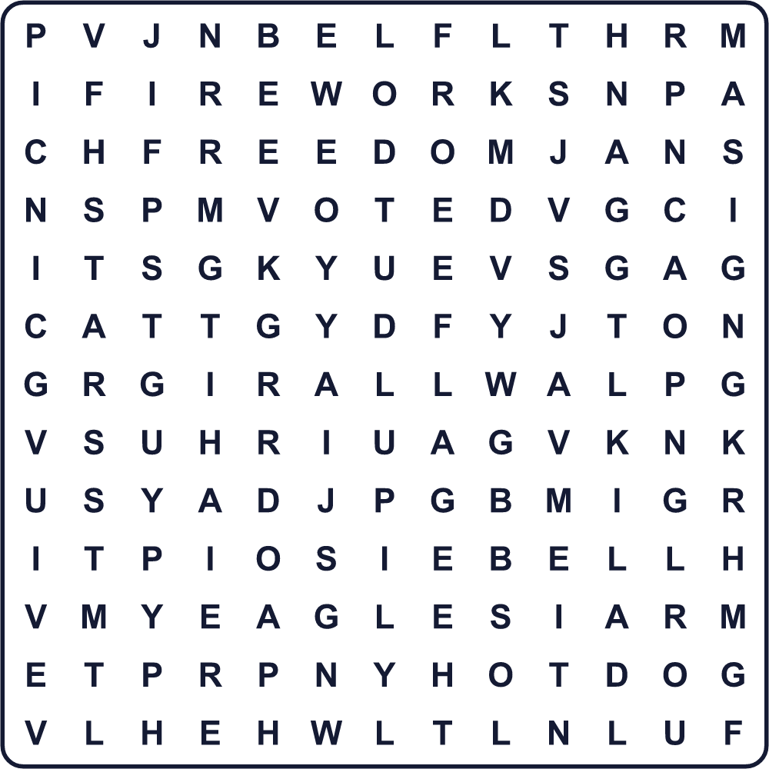
BELL EAGLE FIREWORKS FLAG FREEDOM HOTDOG JULY PARADE PICNIC SIGN STARS STRIPES VOTE
Secret Code 暗号を解こう
☘=A ♠=F ✈=H ✚=O ♥=P ⚓=R ◆=T ☺=U ✿=Y
✈ ☘ ♥ ♥ ✿ ♠ ✚ ☺ ⚓ ◆ ✈
______________________________________________________________

🎆 Independence Day (USA) Worksheet
Maze & Sentences
Class ______ No. ____ Name ______________________________
Help Kenta find the fireworks! ケンタを花火のところまで連れていこう！
正しい道の文字を集めると、ひみつの言葉になるよ。 START 🧑 → GOAL 🎆
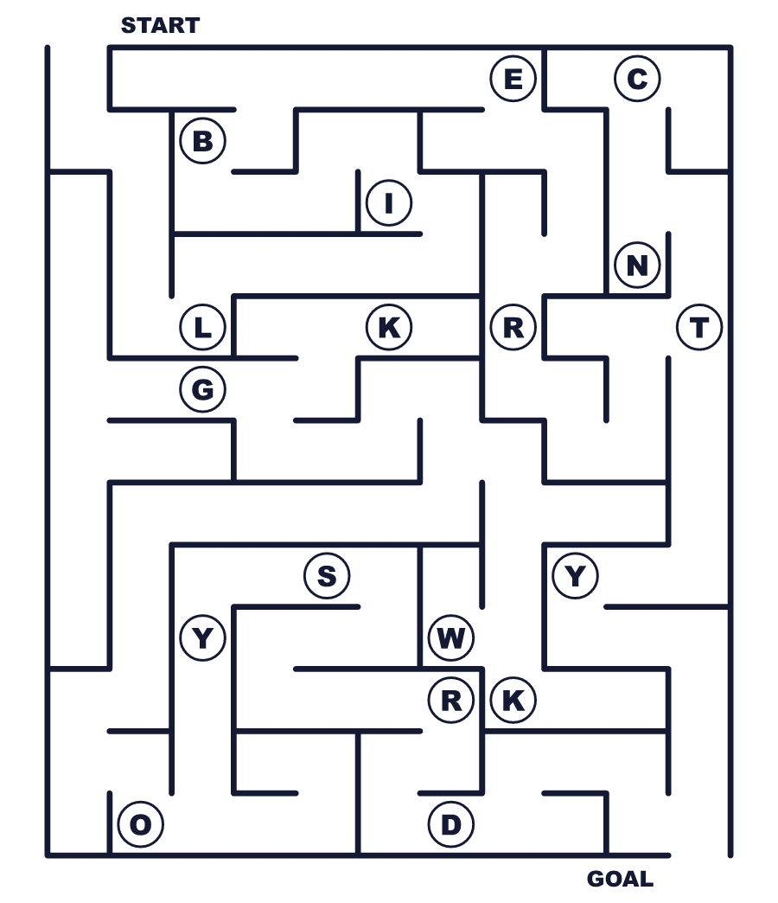
Secret word: ＿ ＿ ＿ ＿ ＿ ＿ ＿
Put the words in order. 並べかえよう。
1. for / on / 2 / July / voted / independence / They . (彼らは7月2日に独立に賛成する投票をしました。)
______________________________________________________________
2. wrote / the / of / most / Declaration / Jefferson . (ジェファーソンが宣言の大部分を書きました。)
______________________________________________________________
3. in / Most / leaders / August / signed / it . (ほとんどの代表は8月にそれに署名しました。)
______________________________________________________________
4. died / on / July / 1826 / men / 4, / Both . (2人とも1826年7月4日に亡くなりました。)
______________________________________________________________
5. fireworks / watch / the / Fourth / on / We . (私たちは7月4日に花火を見ます。)
______________________________________________________________

🎆 Independence Day (USA) Worksheet
Class Activity & Writing
Class ______ No. ____ Name ______________________________
Find Someone Who… クラスで聞いて回ろう！
Find someone who … | Name
… has seen big fireworks 大きな花火を見たことがある
… likes hot dogs ホットドッグが好き
… knows the name of an American president アメリカの大統領の名前を知っている
… has written a letter by hand this year 今年、手書きの手紙を書いた
… can sign his or her name in English 英語で自分の名前をサインできる
… has been to a parade パレードを見に行ったことがある
… likes apple pie アップルパイが好き
… knows what color the stripes on the American flag are 星条旗のしまの色を知っている
Let's Write! 英語で書いてみよう。
If I could write a letter to John Adams, I would say ______.
もしジョン・アダムズに手紙を書けるなら、＿＿と書きます。
______________________________________________________________
______________________________________________________________
On the Fourth of July, I would like to ______ because ______.
7月4日には、＿＿したいです。なぜなら＿＿だからです。
______________________________________________________________
______________________________________________________________
I think all people should have the right to ______.
すべての人に＿＿の権利があるべきだと思います。
______________________________________________________________
______________________________________________________________

🎆 Independence Day (USA) Worksheet
Trace & Color
なぞって書こう。絵に色をぬろう。
Class ______ No. ____ Name ______________________________
🎆 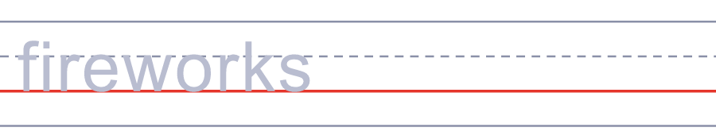

🌭 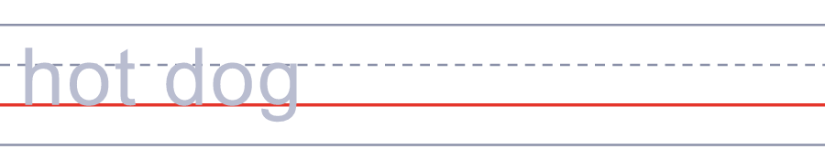
🔔 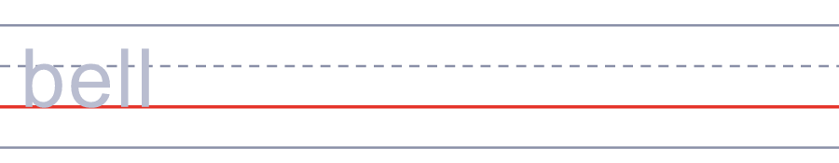
🦅 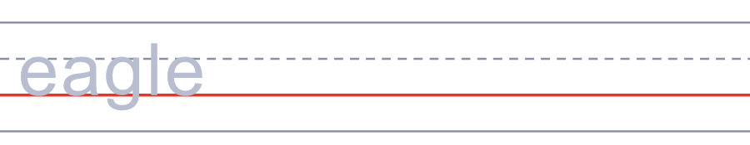
📜 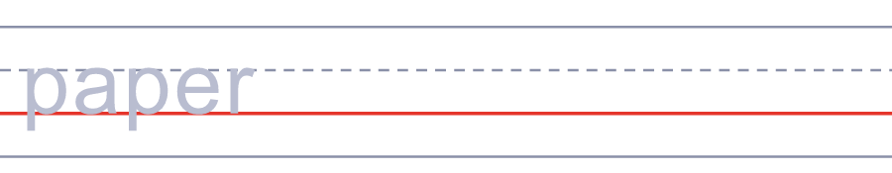
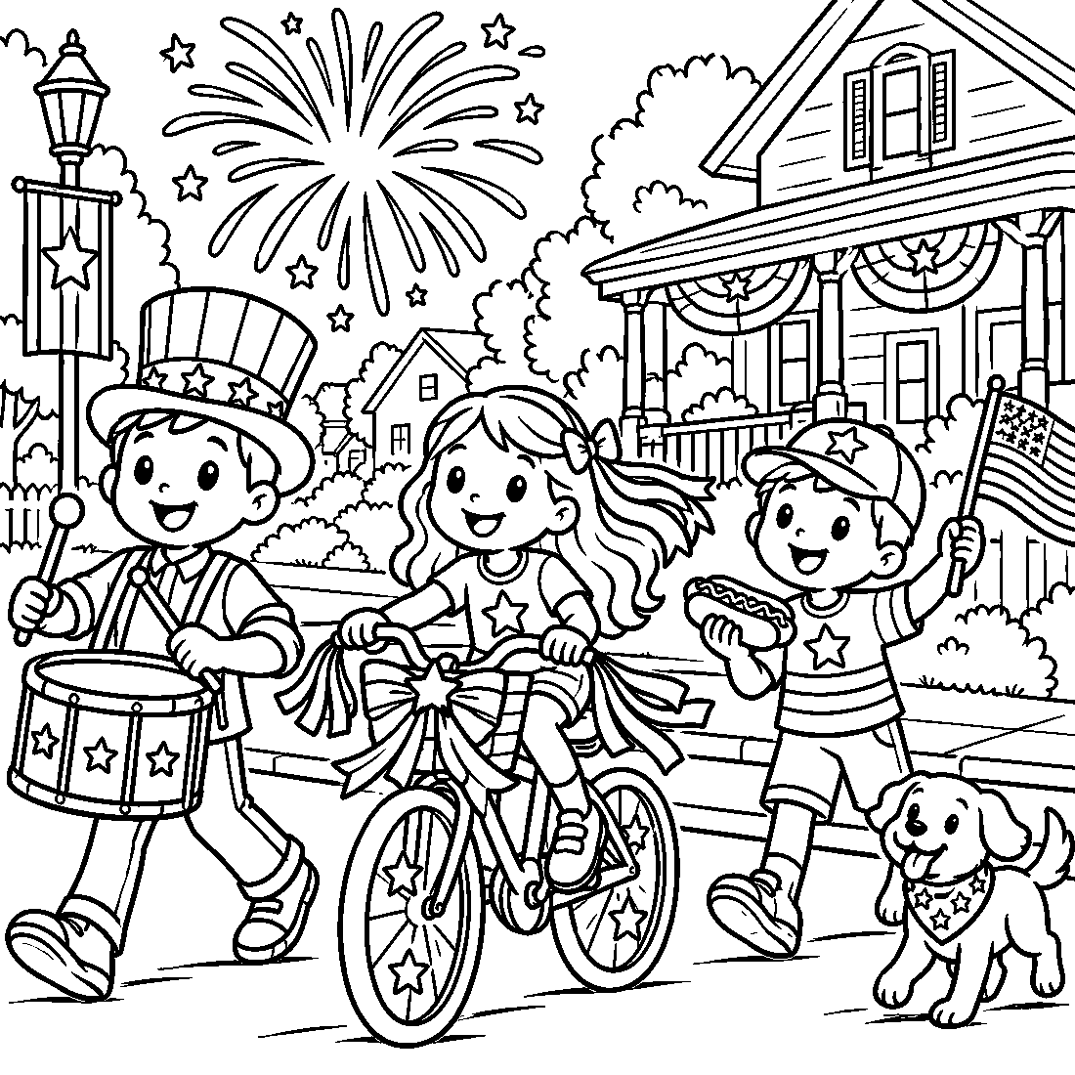

🎆 Independence Day (USA) Worksheet
Answer Key 解答
Reading Check: 1.B 2.A 3.D 4.B 5.B 6.C 7.B 8.C
True or False: 1.T 2.T 3.F 4.T 5.F 6.F
Match: 🎆=fireworks 🌭=hot dog 🔔=bell 🦅=eagle 📜=paper 🥧=pie 🍉=watermelon 🎺=trumpet
Unscramble: 1.FREEDOM 2.PARADE 3.COLONY 4.SIGNATURE 5.PICNIC 6.HISTORY
Fill in the blanks: (1)4 (2)flag (3)parade (4)music (5)blue (6)barbecue (7)pie (8)dark (9)fireworks (10)birthday
Sentence order: 1. They voted for independence on July 2. 2. Jefferson wrote most of the Declaration. 3. Most leaders signed it in August. 4. Both men died on July 4, 1826. 5. We watch fireworks on the Fourth.
Secret Code: HAPPY FOURTH
Maze: LIBERTY
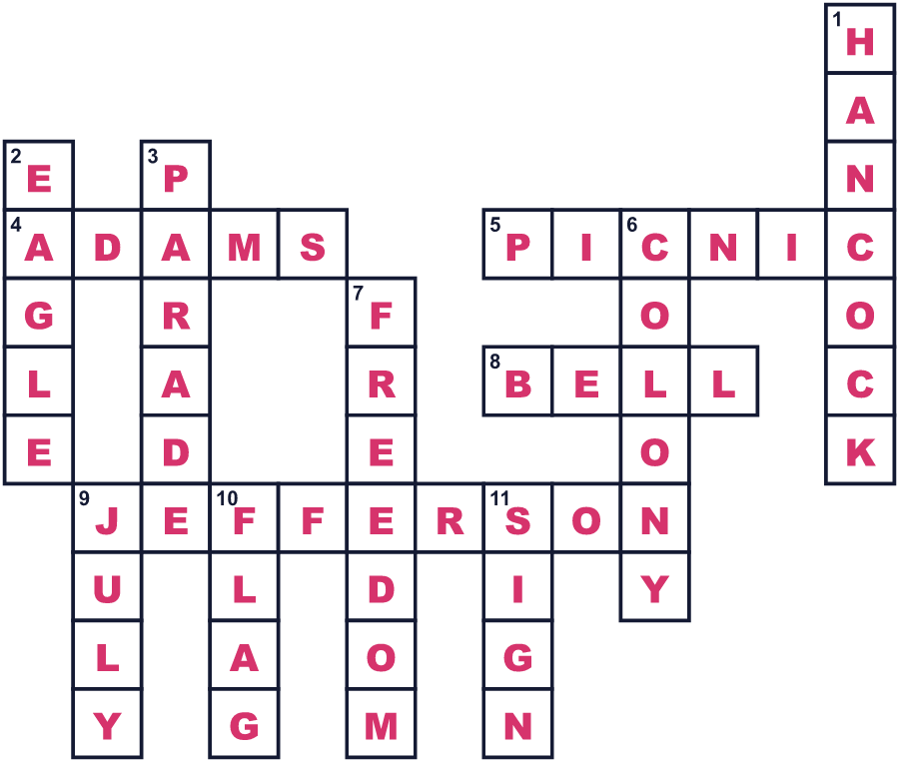
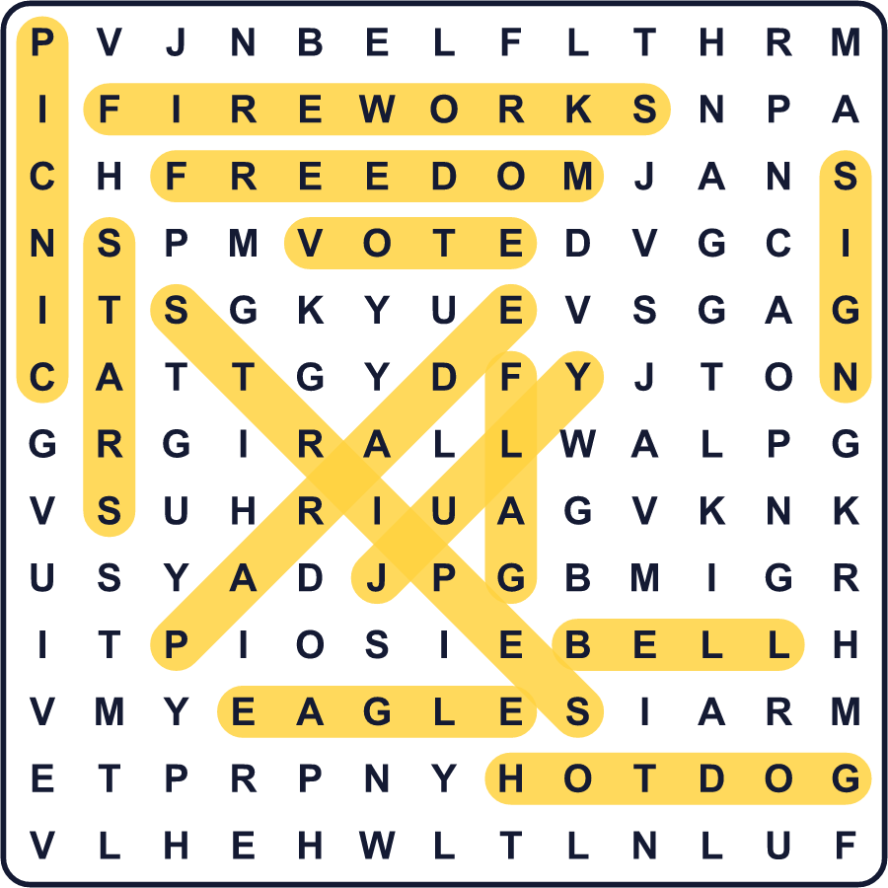
全訳
1 1776年7月3日、ジョン・アダムズは妻のアビゲイルに手紙を書きました。ある日が永遠に記憶されるだろう、と彼は書きました。人々はそれを、競技や祝砲、鐘、明るい光で祝うだろう、と。でも、彼が書いたのは7月4日ではなく、7月2日のことでした。
2 7月2日、アメリカの13の植民地の代表たちが、イギリスから離れることを投票で決めました。2日後の7月4日、彼らはその理由を説明する文書を採択しました。それが独立宣言で、その大部分を書いたのはトマス・ジェファーソンでした。彼はまだ33歳でした。印刷された紙には1776年7月4日という日付があったので、人々はその日を覚えました。
3 もう1つ、驚きがあります。代表たちのほとんどは、7月4日に独立宣言に署名しませんでした。彼らはほぼ1か月後の8月2日に、清書された宣言に署名したのです。最終的に56人が署名しました。ジョン・ハンコックはとても大きく名前を書いたので、今では彼の名前が「署名」という意味になっています。その長さは約13センチもあります！
4 アダムズとジェファーソンは、のちに第2代と第3代の大統領になりました。そして不思議なことが起こりました。2人とも、独立宣言からちょうど50年後の1826年7月4日に亡くなったのです。ジェファーソンが先に亡くなり、アダムズはその数時間後に亡くなりました。
5 今、アメリカ人はこの祝日を Independence Day や the Fourth of July と呼びます。町では朝にパレードがあります。独立宣言を声に出して読み上げる町もあります。家族は裏庭でホットドッグやハンバーガーを食べます。夜には、赤・白・青の花火が空いっぱいに広がります。アダムズは日付をまちがえましたが、お祝いのしかたについては正しかったのです。

