💑 Good Couples Day Worksheet
When Numbers Say Good Couple
Read the story. 英文を読もう。
Class ______ No. ____ Name ______________________________

🔊 音声を聞こう（スマホで読みとってね）
1 In Japanese, numbers can be read in many ways. The number 1 can be read as i, so 11 can be ii, which means good. The number 2 can sound like fu. So November 22, or 11/22, can be read as ii fufu. In Japanese, that means a good married couple.
2 This day did not start with love songs or flowers. In the 1980s, many people said Japanese workers worked too much. So in 1985, the government called November a month for a more relaxed life. Then, in 1988, a group that studied free time chose November 22 as Good Couples Day. They hoped husbands and wives would enjoy their free time together.
3 Later, the day got a special prize called Partner of the Year. Every year, a famous couple is chosen as the best pair of the year. Some couples also choose this day to get married, because the date is easy to remember. And the next day, November 23, is a national holiday in Japan.
4 Other countries play with numbers, too. In South Korea, May 21 is Couples' Day. The idea is that two people become one, so the date uses the numbers 2 and 1. On Good Couples Day in Japan, people give flowers, eat dinner together, or simply say thank you. Thank you is a small phrase, but on November 22 it can mean a lot.
Words 単語
couple（夫婦、カップル、ふたり組） / married（結婚している） / relaxed（ゆったりした、くつろいだ） / free time（自由な時間、余暇） / prize（賞） / remember（覚えている、思い出す） / simply（ただ、単に） / phrase（言い回し、短い言葉）

💑 Good Couples Day Worksheet
Reading Check
Choose the best answer. 正しいものを選ぼう。
Class ______ No. ____ Name ______________________________
1. What is the main idea of the passage?
(A) Good Couples Day is an old national holiday. (B) Good Couples Day is only for famous people. (C) A number pun made November 22 a day for couples in Japan. (D) Japanese couples must give flowers on November 22.
2. Why did the government call November a month for a more relaxed life?
(A) Because people said Japanese workers worked too much. (B) Because November has many holidays. (C) Because couples asked for it. (D) Because of a famous love song.
3. When was November 22 chosen as Good Couples Day?
(A) In 1985. (B) In 1988. (C) In 1999. (D) In 2007.
4. Why does Couples' Day in South Korea use the numbers 2 and 1?
(A) Because it is the second day of the first month. (B) Because couples have two children. (C) Because it started in 2001. (D) Because two people become one.
5. In the dialogue, what will Grace probably do tonight?
(A) Buy flowers for Yuta. (B) Go to a restaurant with Yuta. (C) Cook dinner for her husband. (D) Get married.
True or False? T か F に○
1. Good Couples Day is on November 22. T / F
2. Good Couples Day is a national holiday in Japan. T / F
3. The day was first chosen in 1988. T / F
4. In South Korea, Couples' Day is on November 11. T / F

💑 Good Couples Day Worksheet
Word Work
単語のれんしゅう
Class ______ No. ____ Name ______________________________
① Match the pictures and the words. 絵と単語を線でむすぼう。
💐 | ● | ● | ring
💍 | ● | ● | prize
🍽️ | ● | ● | flowers
🏆 | ● | ● | dinner
💌 | ● | ● | letter
📅 | ● | ● | date
③ Fill in the blanks. 語群から選んで入れよう。
[ card / cook / you / parents / Couples / plan / ticket / school / flowers / snow / dinner ]
Mika's (1) __________ have been married for 15 years. On November 22, Mika and her brother make a (2) __________ . They buy (3) __________ and write a (4) __________ . In the evening, they (5) __________ curry and rice. When their parents come home, the children say, "Happy Good (6) __________ Day!" Their mother smiles and says, "Thank (7) __________ . This is the best (8) __________ !"

💑 Good Couples Day Worksheet
Crossword Puzzle
ヒントを読んでクロスワードを完成させよう。
Class ______ No. ____ Name ______________________________
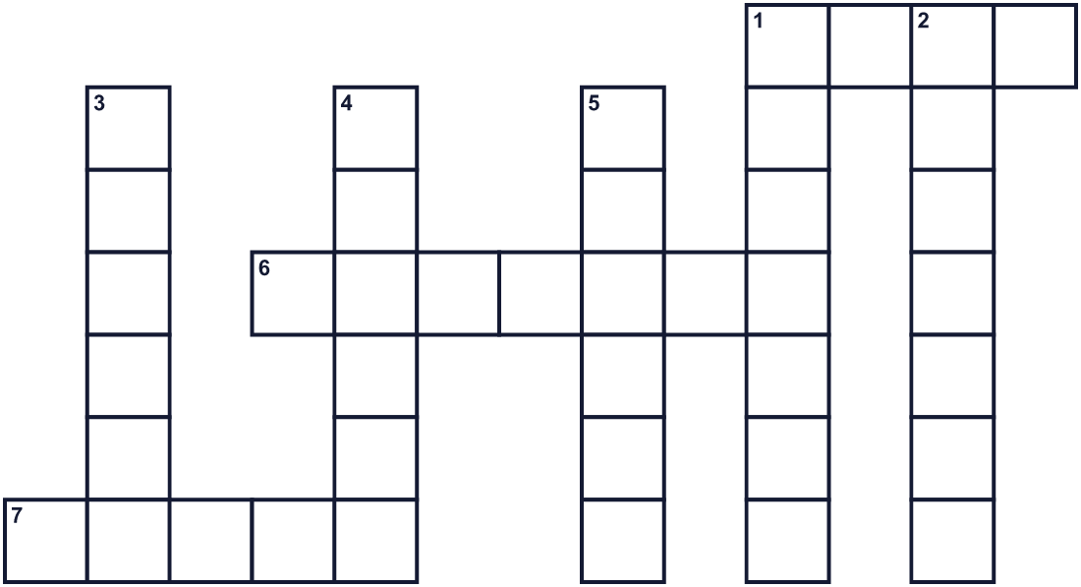
Across →
1. A married woman. (4)
6. A married man. (7)
7. Something you win in a contest. (5)
Down ↓
1. The party when two people get married. (7)
2. Roses and tulips are these. (7)
3. The meal in the evening. (6)
4. Two people who are together, like a husband and wife. (6)
5. You say this word when someone helps you. (6)

💑 Good Couples Day Worksheet
Word Search
かくれた単語をさがそう（→ ↓ ↘ ↗）
Class ______ No. ____ Name ______________________________
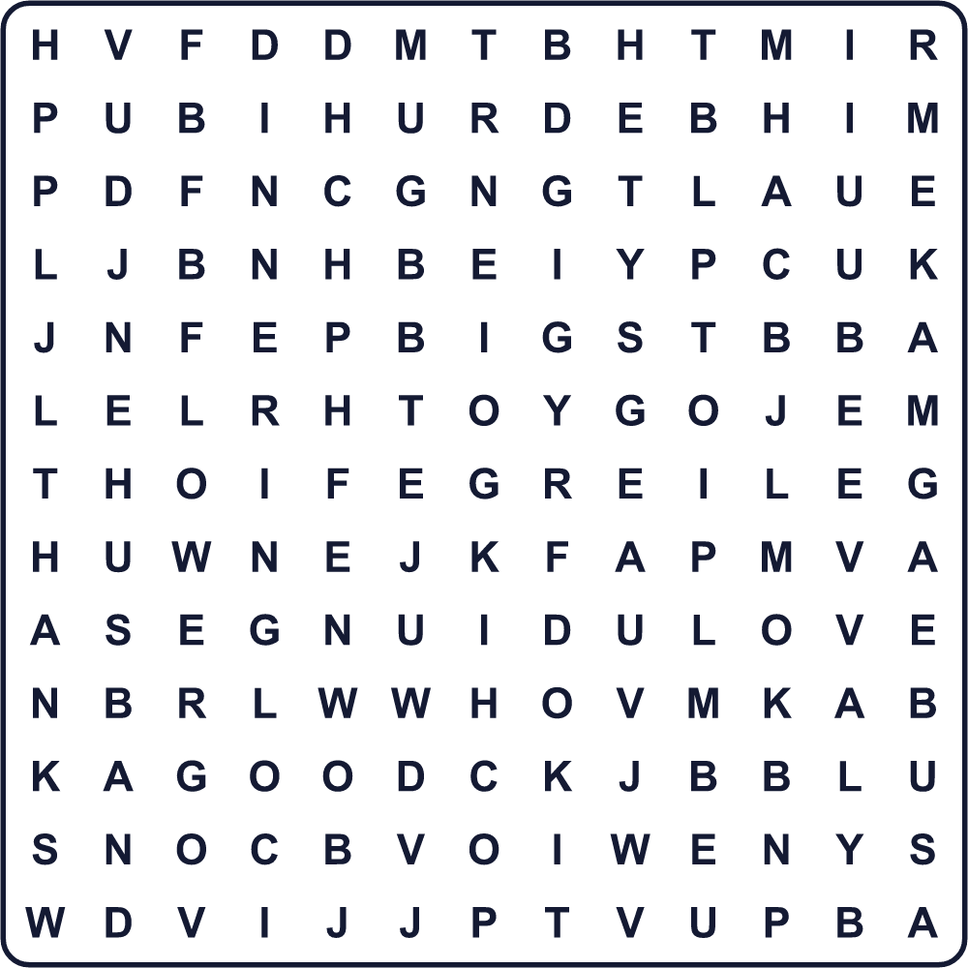
COUPLE DINNER FLOWER GOOD HUSBAND LOVE PAIR RING THANKS WIFE

💑 Good Couples Day Worksheet
Maze & Sentences
Class ______ No. ____ Name ______________________________
Help Mika bring the flowers to her parents! ミカが両親に花を届けられるように助けよう！
正しい道の文字を集めると、ひみつの言葉になるよ。 START 👧 → GOAL 💐
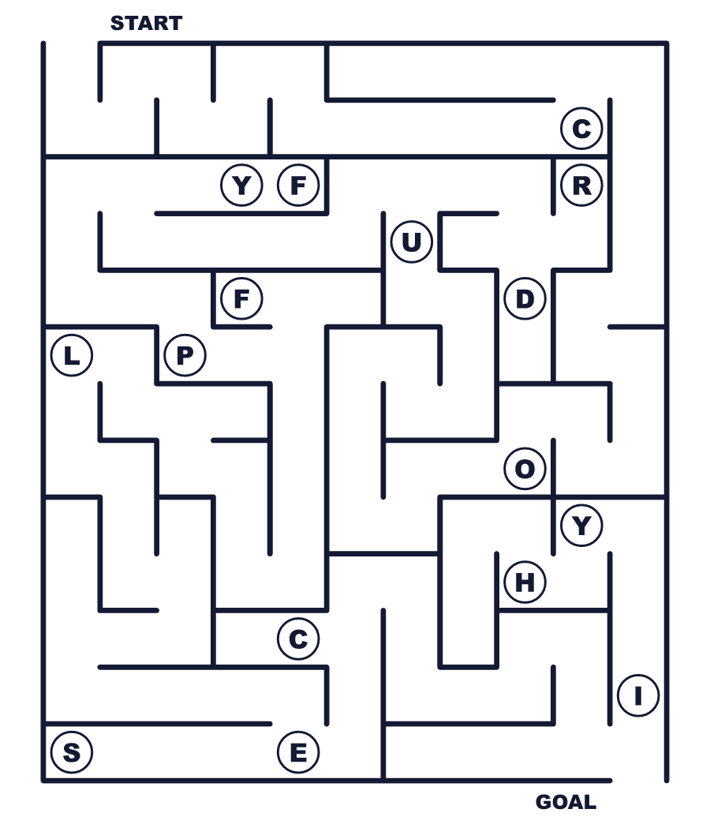
Secret word: ＿ ＿ ＿ ＿ ＿ ＿

💑 Good Couples Day Worksheet
Class Activity & Writing
Class ______ No. ____ Name ______________________________
Let's Write! 英語で書いてみよう。
On Good Couples Day, I want to say "thank you" to ______ because ______.
いい夫婦の日に、______に「ありがとう」と言いたいです。なぜなら______だからです。
______________________________________________________________
______________________________________________________________
A good couple always ______.
いい夫婦はいつも______。
______________________________________________________________
______________________________________________________________

💑 Good Couples Day Worksheet
Trace & Color
なぞって書こう。絵に色をぬろう。
Class ______ No. ____ Name ______________________________
💐 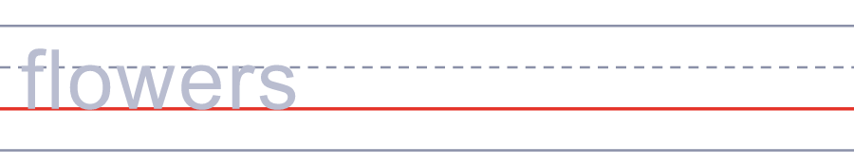

💍 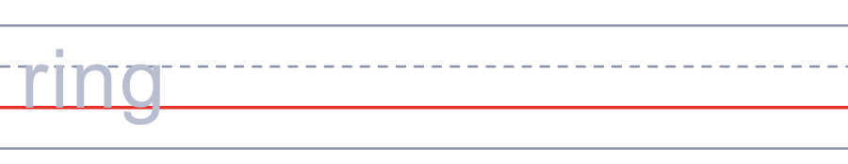
🍽️ 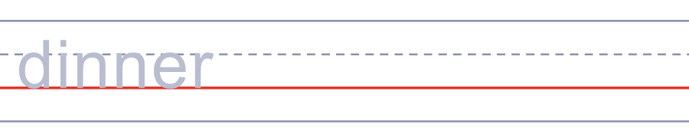
🏆 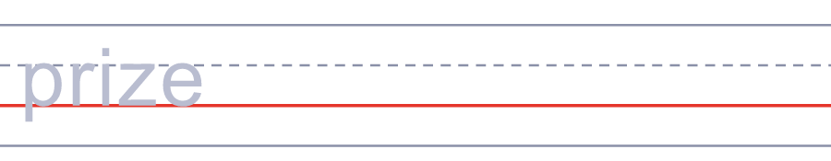
💌 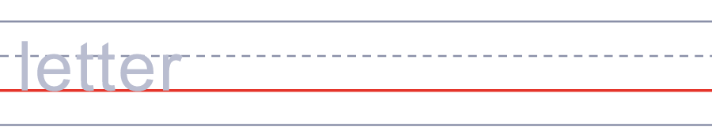

💑 Good Couples Day Worksheet
Answer Key 解答
Reading Check: 1.C 2.A 3.B 4.D 5.C
True or False: 1.T 2.F 3.T 4.F
Match: 💐=flowers 💍=ring 🍽️=dinner 🏆=prize 💌=letter 📅=date
Fill in the blanks: (1)parents (2)plan (3)flowers (4)card (5)cook (6)Couples (7)you (8)dinner
Maze: COUPLE
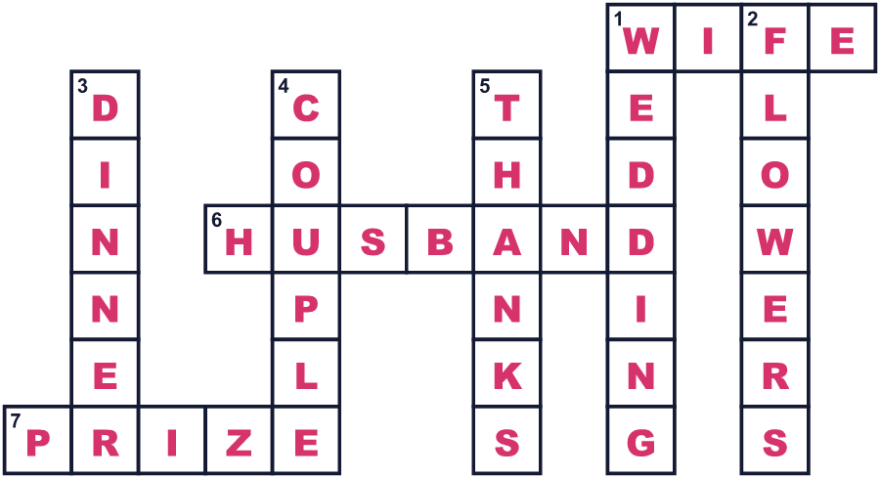
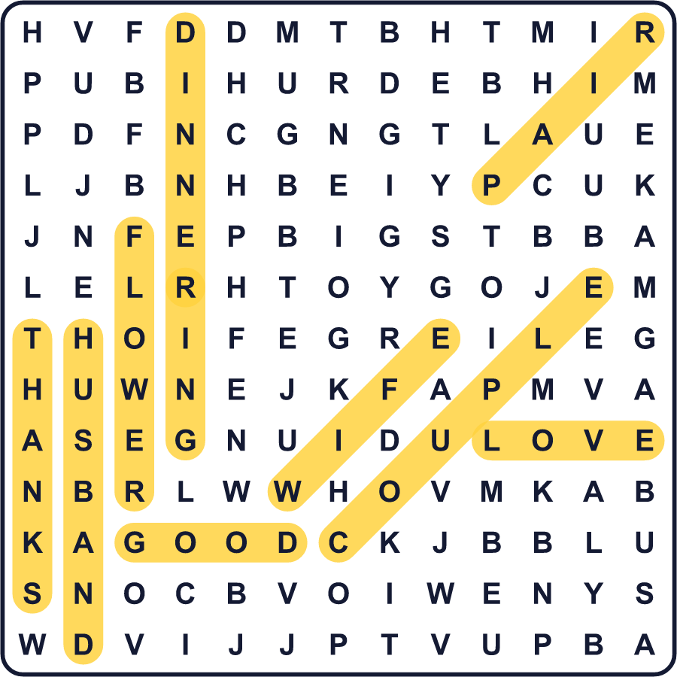
全訳
1 日本語では、数字をいろいろな読み方で読むことができます。1は「い」と読めるので、11は「いい」になります。「良い」という意味です。2は「ふ」に聞こえることがあります。だから11月22日、つまり11/22は「いいふうふ」と読めるのです。日本語で「良い夫婦」という意味です。
2 この日は、ラブソングや花から始まったわけではありません。1980年代、多くの人が日本の会社員は働きすぎだと言っていました。そこで1985年、政府は11月を、もっとゆとりのある暮らしのための月にしました。そして1988年、余暇を研究していた団体が11月22日を「いい夫婦の日」に選びました。夫と妻が一緒に自由な時間を楽しんでほしいと願ったのです。
3 その後、この日には「パートナー・オブ・ザ・イヤー」という特別な賞ができました。毎年、有名な夫婦がその年のベストなふたりに選ばれます。日付が覚えやすいので、この日を選んで結婚するカップルもいます。しかも翌日の11月23日は、日本の祝日です。
4 ほかの国でも数字で遊んでいます。韓国では、5月21日が「夫婦の日」です。2人が1つになるという考えから、日付に2と1の数字を使っています。日本のいい夫婦の日には、花を贈ったり、一緒に夕食を食べたり、ただ「ありがとう」と言ったりします。「ありがとう」は小さな言葉ですが、11月22日には大きな意味を持つかもしれません。

