🎨 Holi Worksheet
A Fire at Night, Colors in the Morning
Read the story. 英文を読もう。
Class ______ No. ____ Name ______________________________

🔊 音声を聞こう（スマホで読みとってね）
1 On the night before Holi, people in many Indian towns light big fires. They sing, pray, and walk around the flames. The fire tells an old story about a brave boy named Prahlad.
2 Prahlad's father was a proud king, and he wanted everyone to pray to him. But Prahlad prayed only to the god Vishnu. The angry king asked his sister Holika for help, because fire could not hurt her. She sat in a fire with the boy on her lap. But in the story, Holika burned, and Prahlad was safe. So the fire means that good wins over evil.
3 The next morning, the colors come out. People throw bright powder called gulal at each other. Red, yellow, green, and pink fly through the air. Children use water guns and water balloons. Friends, neighbors, and even strangers become the colors of a rainbow. Many people say Holi is also a festival of love. In old stories, the god Krishna and his friend Radha played with colors.
4 In the past, all the colors came from plants. Red and orange came from the flowers of the palash tree, and yellow came from turmeric. Today, many colors are made in factories. Some of them can hurt your eyes or skin, so many families now choose natural powders.
5 Later in the day, people visit family and friends. They eat sweets like gujiya and drink a cold milk drink called thandai. Holi is also a day to forgive. People who had a fight may laugh together and start again. Holi comes at the end of winter, and it welcomes spring with every color in the world.
Words 単語
bonfire（たき火（屋外の大きな火）） / flame（炎） / brave（勇敢な） / proud（思い上がった、誇りに思う） / evil（悪） / powder（粉） / stranger（知らない人） / turmeric（ターメリック、ウコン） / factory（工場） / natural（天然の、自然の） / forgive（許す） / welcome（迎える、歓迎する）

🎨 Holi Worksheet
Reading Check
Choose the best answer. 正しいものを選ぼう。
Class ______ No. ____ Name ______________________________
1. What is the passage mainly about?
(A) How to make turmeric (B) The story, customs, and meaning of Holi (C) Why fire is dangerous (D) The life of a king in India
2. Why did the king ask his sister Holika for help?
(A) Fire could not hurt her. (B) She was a god. (C) She lived near the fire. (D) She was Prahlad's teacher.
3. What happens on the morning of Holi?
(A) People light big fires. (B) People go to bed early. (C) People throw colored powder at each other. (D) People eat only plants.
4. Where did yellow color come from in the past?
(A) Palash flowers (B) Factories (C) Water balloons (D) Turmeric
5. In paragraph 3, what does "strangers" mean?
(A) Strange animals (B) People you do not know (C) People from Japan (D) Very old friends
6. Which sentence matches the passage?
(A) Holi comes at the end of summer. (B) All Holi colors are made in factories today. (C) Prahlad prayed to his father. (D) People visit family and friends later in the day.
7. Why might two people who had a fight laugh together at Holi?
(A) Because Holi is a day to forgive (B) Because they must buy gujiya (C) Because the king tells them to (D) Because they cannot see each other
8. In the dialogue, why does Arjun tell Saki to wear white clothes?
(A) Because white is the color of Holika (B) Because the colors look beautiful on white (C) Because it is cold (D) Because white clothes are cheap
True or False? T か F に○
1. Holi is a festival of colors in India and Nepal. T / F
2. People light big fires on the night before Holi. T / F
3. Holi is always on March 1. T / F
4. In the old story, Prahlad burned in the fire. T / F
5. In the past, colors came from plants like turmeric. T / F
6. The word Holi comes from the English word holy. T / F

🎨 Holi Worksheet
Word Work
単語のれんしゅう
Class ______ No. ____ Name ______________________________
① Match the pictures and the words. 絵と単語を線でむすぼう。
🔥 | ● | ● | milk
🌕 | ● | ● | water
🎈 | ● | ● | moon
🌸 | ● | ● | balloon
💧 | ● | ● | flower
🥛 | ● | ● | rainbow
🥁 | ● | ● | fire
🌈 | ● | ● | drum
② Unscramble the words. 並べかえて単語にしよう。
1. O O L R C (色) → ____________________
2. S N G I R P (春) → ____________________
3. D O P E W R (粉) → ____________________
4. N M O O (月) → ____________________
5. B V A R E (勇敢な) → ____________________
6. I D I A N (インド) → ____________________
③ Fill in the blanks. 語群から選んで入れよう。
[ colorful / snow / laughing / story / village / shields / angry / gujiya / sticks / face / pink / winter / Holi ]
Meera lives in Barsana, a small (1) __________ in India. Every year, men from the next village come to visit at (2) __________ . The men hold big (3) __________ . Meera and the other women hold long (4) __________ . When the men arrive, the women hit them, but everyone is (5) __________ . It is an old (6) __________ about the god Krishna. Then people throw (7) __________ and green powder. Meera's (8) __________ turns orange. In the evening, she eats sweet (9) __________ with her family. "This is the most (10) __________ day of the year!" she says.

🎨 Holi Worksheet
Crossword Puzzle
ヒントを読んでクロスワードを完成させよう。
Class ______ No. ____ Name ______________________________
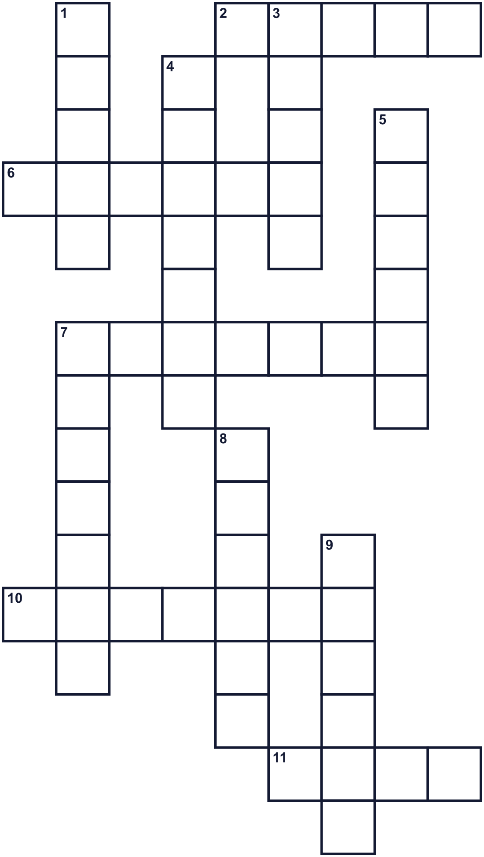
Across →
2. A big country in South Asia. Its capital is New Delhi. (5)
6. The king's sister in the old story. She burned in the fire. (6)
7. People burn a big pile of wood outside and sing around it. (7)
10. To stop being angry with someone. (7)
11. It is full and round on the night of the festival. (4)
Down ↓
1. Red, blue, and yellow are each one of these. (5)
3. A country with high mountains, north of India. (5)
4. A Hindu god with a flute. He loved Radha. (7)
5. Very small, dry pieces. People throw it at Holi. (6)
7. Children fill it with water and throw it. (7)
8. The season after winter. (6)
9. The color of a banana. Turmeric makes this color. (6)

🎨 Holi Worksheet
Word Search
かくれた単語をさがそう（→ ↓ ↘ ↗）
Class ______ No. ____ Name ______________________________
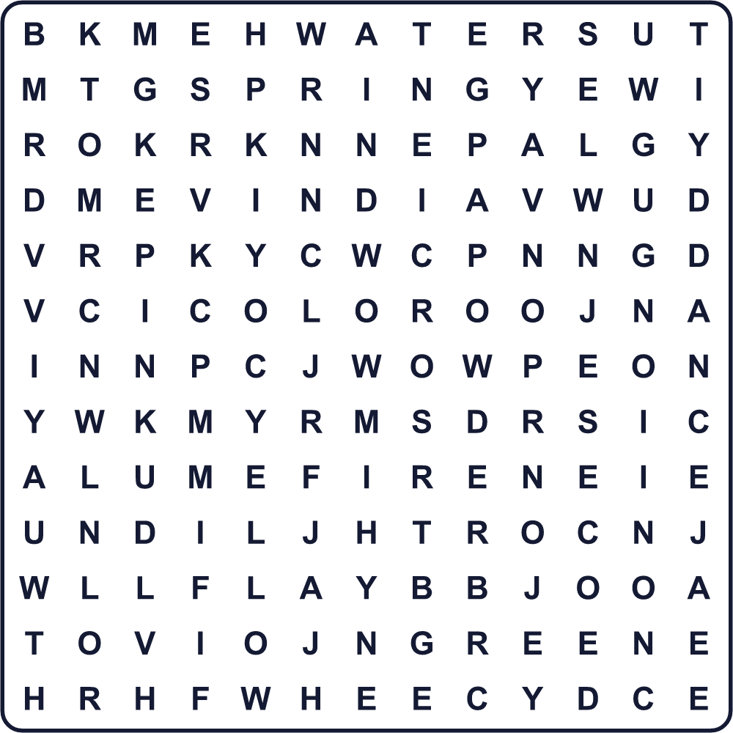
COLOR DANCE FIRE GREEN HOLI INDIA MOON NEPAL PINK POWDER SPRING WATER YELLOW
Secret Code 暗号を解こう
☺=A ▲=H ⚑=I ☎=L ■=O ◎=P ♣=Y
▲ ☺ ◎ ◎ ♣ ▲ ■ ☎ ⚑
______________________________________________________________

🎨 Holi Worksheet
Maze & Sentences
Class ______ No. ____ Name ______________________________
Help Saki find the colors! サキを色の粉のところまで連れていこう！
正しい道の文字を集めると、ひみつの言葉になるよ。 START 👧 → GOAL 🎨
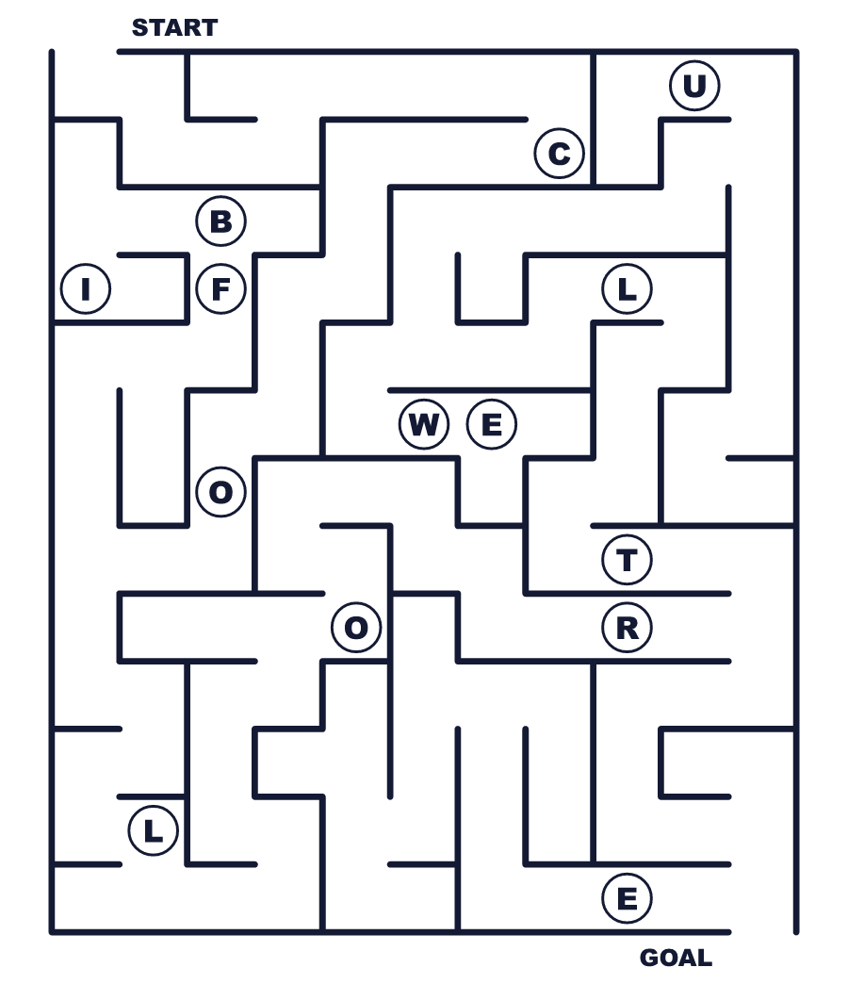
Secret word: ＿ ＿ ＿ ＿ ＿
Put the words in order. 並べかえよう。
1. big / night / fires / light / at / People . (人々は夜に大きな火をたきます。)
______________________________________________________________
2. at / throw / People / other / powder / each / bright . (人々はあざやかな粉をかけ合います。)
______________________________________________________________
3. and / water / balloons / Children / guns / use . (子どもたちは水鉄砲や風船を使います。)
______________________________________________________________
4. forgive / to / Holi / a / is / also / day . (ホーリーは許しの日でもあります。)
______________________________________________________________
5. many / colors / with / Holi / welcomes / spring . (ホーリーはたくさんの色で春を迎えます。)
______________________________________________________________

🎨 Holi Worksheet
Class Activity & Writing
Class ______ No. ____ Name ______________________________
Find Someone Who… クラスで聞いて回ろう！
Find someone who … | Name
… likes pink ピンクが好き
… has eaten Indian curry インドカレーを食べたことがある
… has played with water balloons 水風船で遊んだことがある
… knows the capital of India インドの首都を知っている
… has seen a big bonfire 大きなたき火を見たことがある
… can name five colors in English 英語で色を5つ言える
… has made up with a friend after a fight けんかのあと友だちと仲直りしたことがある
… likes spring the best 春がいちばん好き
Let's Write! 英語で書いてみよう。
If I joined Holi, I would throw ______ powder at ______ because ______.
ホーリーに参加するなら、私は______色の粉を______にかけます。なぜなら______だからです。
______________________________________________________________
______________________________________________________________
I want to say sorry to ______ for ______.
私は______に、______のことを謝りたい。
______________________________________________________________
______________________________________________________________
My favorite thing about spring is ______ because ______.
春でいちばん好きなものは______です。なぜなら______だからです。
______________________________________________________________
______________________________________________________________

🎨 Holi Worksheet
Trace & Color
なぞって書こう。絵に色をぬろう。
Class ______ No. ____ Name ______________________________
🔥 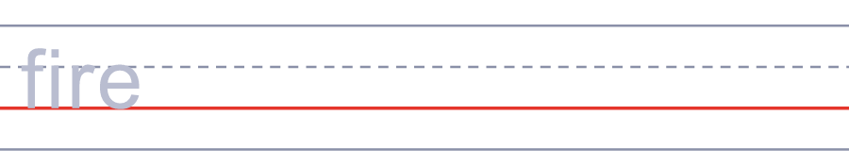

🌕 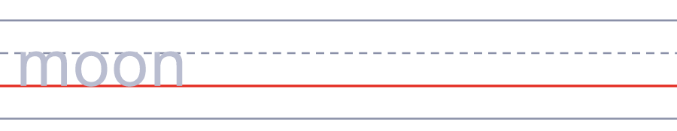
🎈 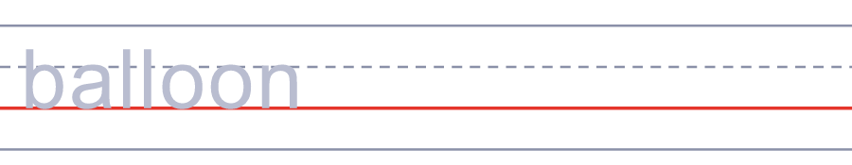
🌸 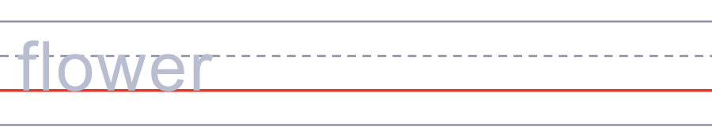
💧 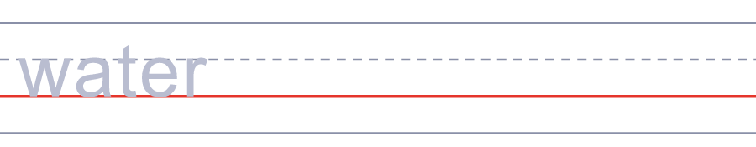
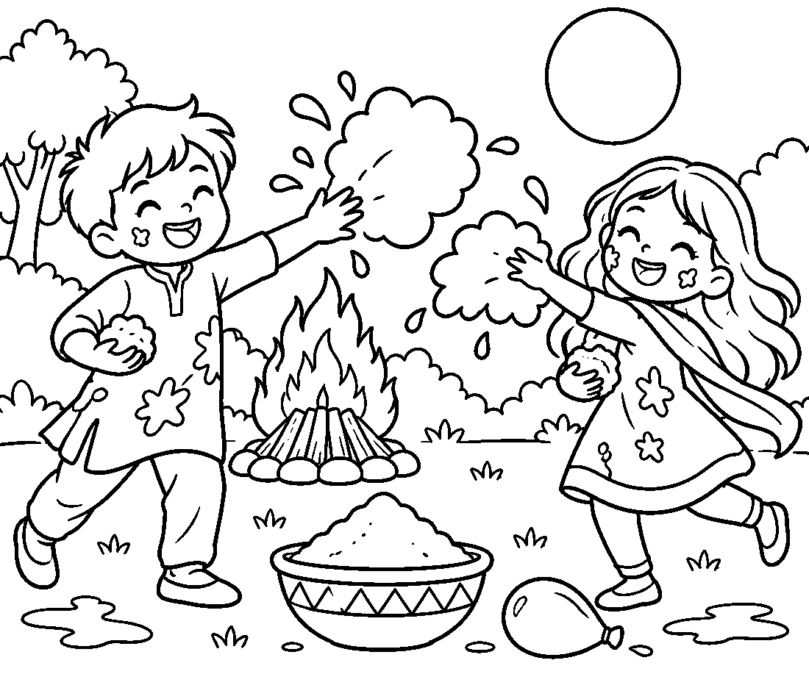

🎨 Holi Worksheet
Answer Key 解答
Reading Check: 1.B 2.A 3.C 4.D 5.B 6.D 7.A 8.B
True or False: 1.T 2.T 3.F 4.F 5.T 6.F
Match: 🔥=fire 🌕=moon 🎈=balloon 🌸=flower 💧=water 🥛=milk 🥁=drum 🌈=rainbow
Unscramble: 1.COLOR 2.SPRING 3.POWDER 4.MOON 5.BRAVE 6.INDIA
Fill in the blanks: (1)village (2)Holi (3)shields (4)sticks (5)laughing (6)story (7)pink (8)face (9)gujiya (10)colorful
Sentence order: 1. People light big fires at night. 2. People throw bright powder at each other. 3. Children use water guns and balloons. 4. Holi is also a day to forgive. 5. Holi welcomes spring with many colors.
Secret Code: HAPPY HOLI
Maze: COLOR
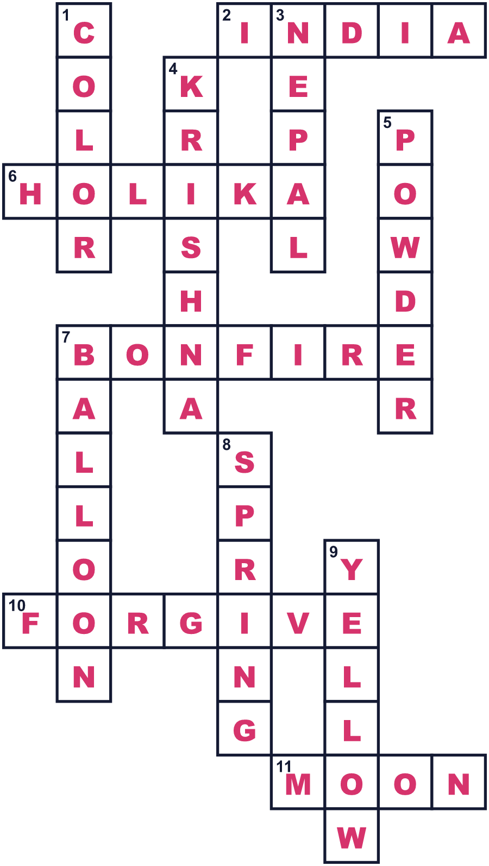
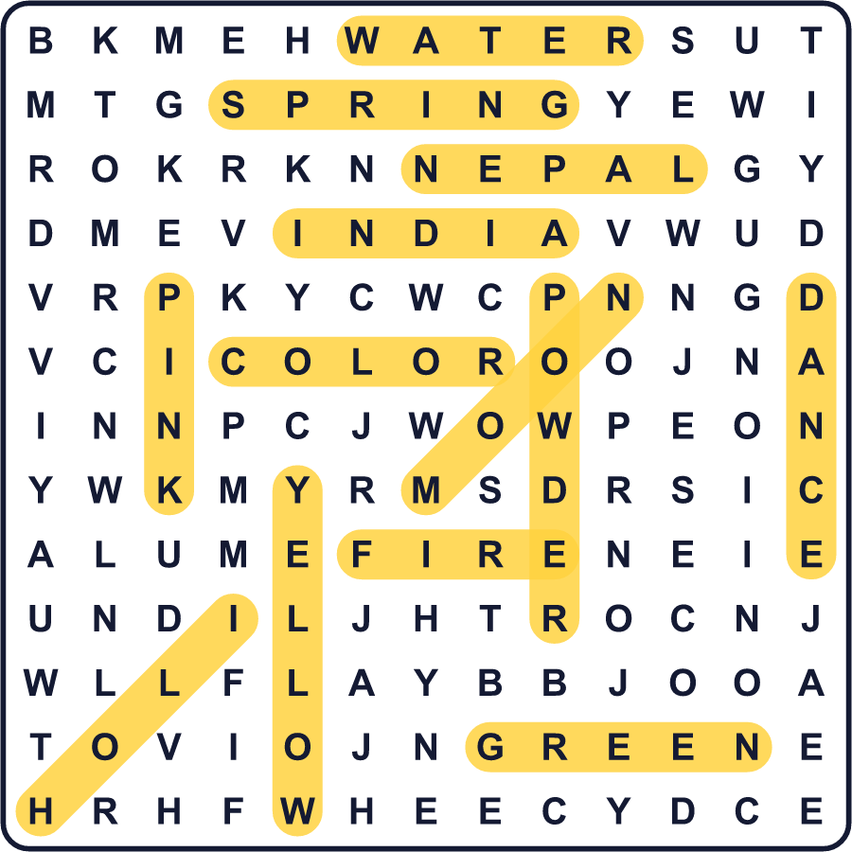
全訳
1 ホーリーの前の晩、インドの多くの町で人々は大きな火をたきます。人々は歌い、祈り、炎のまわりを歩きます。その火は、プラフラーダという勇敢な少年の昔話を伝えています。
2 プラフラーダの父は思い上がった王で、みんなに自分を拝ませたがっていました。でもプラフラーダは、ヴィシュヌ神にだけ祈りました。怒った王は、妹のホリカに助けを求めました。ホリカは火で傷つかなかったからです。ホリカは少年をひざにのせて、火の中に座りました。ところが物語では、焼けたのはホリカで、プラフラーダは無事でした。だからこの火は、善が悪に勝つことを意味するのです。
3 次の朝、色が登場します。人々はグラールと呼ばれるあざやかな粉をかけ合います。赤、黄、緑、ピンクが宙を舞います。子どもたちは水鉄砲や水風船を使います。友だちも近所の人も、知らない人までもが虹色になります。ホーリーは愛の祭りでもある、と多くの人が言います。昔話では、クリシュナ神と友だちのラーダーが色遊びをしたのです。
4 昔は、色はすべて植物から作られていました。赤とオレンジはパラーシャの木の花から、黄色はターメリックから作られました。今では、多くの色が工場で作られています。目や肌を傷めるものもあるので、今は天然の粉を選ぶ家族も多くなっています。
5 その日の後半には、人々は家族や友だちを訪ねます。グジヤのようなお菓子を食べ、タンダイという冷たいミルクの飲み物を飲みます。ホーリーは許しの日でもあります。けんかしていた人たちも、いっしょに笑ってやり直すことがあります。ホーリーは冬の終わりにやってきて、世界中のあらゆる色で春を迎えるのです。

