🎺 Hispanic Heritage Month Worksheet
A Month That Starts in the Middle
Read the story. 英文を読もう。
Class ______ No. ____ Name ______________________________

🔊 音声を聞こう（スマホで読みとってね）
1 Most special months in the United States start on the first day. But one month starts in the middle of September. National Hispanic Heritage Month runs from September 15 to October 15. Why does it start on such a strange day?
2 The answer is in Latin America. On September 15, 1821, Central America became free from Spain. Today, five countries there celebrate on that day: Costa Rica, El Salvador, Guatemala, Honduras, and Nicaragua. Mexico celebrates its independence on September 16, and Chile has a big national party on September 18. So the month begins with a week full of birthdays for countries.
3 The idea started small. In 1968, President Lyndon Johnson signed a law for one special week. Twenty years later, many people wanted more time. In 1988, President Ronald Reagan signed a new law, and the week became a month. Today, about 70 million Hispanic people live in the United States. That is about one in five Americans.
4 During the month, students learn about famous Hispanic Americans. One of them is Ellen Ochoa, and in 1993 she became the first Hispanic woman in space. Towns hold street festivals with music and dancing. People eat tamales from Mexico and pupusas from El Salvador. Some families share stories about their grandparents and their home countries. For many people, it is a month to remember where they come from.
Words 単語
heritage（（受けつがれた）文化、伝統、遺産） / Hispanic（ヒスパニックの（人）、スペイン語圏につながる（人）） / independence（独立） / celebrate（祝う） / strange（変わった、ふしぎな） / law（法律） / festival（祭り、フェスティバル） / grandparent（祖父母（の1人））

🎺 Hispanic Heritage Month Worksheet
Reading Check
Choose the best answer. 正しいものを選ぼう。
Class ______ No. ____ Name ______________________________
1. What is the reading mainly about?
(A) How to make tamales at home (B) Why and how people celebrate Hispanic Heritage Month (C) The history of the Super Bowl (D) Life in Spain in 1821
2. Why does the month start on September 15?
(A) It is the birthday of President Johnson. (B) School starts on that day. (C) Spain chose the day. (D) Central America became free from Spain on that day.
3. What happened in 1988?
(A) The week became a month. (B) Ellen Ochoa went to space. (C) Mexico became free from Spain. (D) The first special week started.
4. In paragraph 2, what does "a week full of birthdays for countries" mean?
(A) A week with many birthday parties at school (B) A week when many people are born (C) A week with many independence days (D) A week with no holidays
5. In the dialogue, why does Lucia invite Sota to her house?
(A) To watch a soccer game (B) So he can try her grandma's tamales (C) To make Guatemalan flags (D) To help with homework
True or False? T か F に○
1. Hispanic Heritage Month starts on September 1. T / F
2. Mexico celebrates its independence on September 16. T / F
3. The month started as one special week in 1968. T / F
4. Hispanic Heritage Month is a day off from school. T / F

🎺 Hispanic Heritage Month Worksheet
Word Work
単語のれんしゅう
Class ______ No. ____ Name ______________________________
① Match the pictures and the words. 絵と単語を線でむすぼう。
🔔 | ● | ● | rocket
🎺 | ● | ● | bell
💃 | ● | ● | trumpet
🌮 | ● | ● | guitar
🚀 | ● | ● | taco
🎸 | ● | ● | dancer
③ Fill in the blanks. 語群から選んで入れよう。
[ music / festival / dance / tamales / flags / slowly / proud / winter / September ]
It is (1) __________ 16. Lucia goes to a street (2) __________ with her family. A band plays loud (3) __________ , and people (4) __________ in the street. Lucia's grandma sells (5) __________ at a small table. Many people wave (6) __________ from different countries. "Your grandma's food is the best," says Lucia's friend. Lucia is very (7) __________ .

🎺 Hispanic Heritage Month Worksheet
Crossword Puzzle
ヒントを読んでクロスワードを完成させよう。
Class ______ No. ____ Name ______________________________
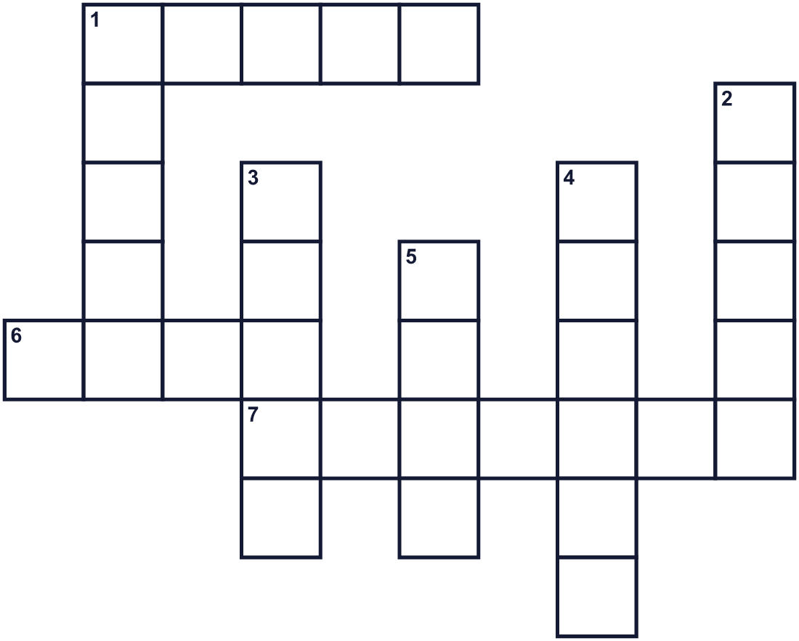
Across →
1. Many countries in Latin America became free from this country. (5)
6. A priest rang this in a church in 1810. (4)
7. The main language of Mexico, Peru, and Chile. (7)
Down ↓
1. Ellen Ochoa went here in 1993 on a shuttle. (5)
2. September and October are each one of these. (5)
3. A dance and music. It became popular in New York in the 1970s. (5)
4. This country celebrates its independence on September 16. (6)
5. Each country has one. It has colors and is made of cloth. (4)

🎺 Hispanic Heritage Month Worksheet
Word Search
かくれた単語をさがそう（→ ↓ ↘ ↗）
Class ______ No. ____ Name ______________________________
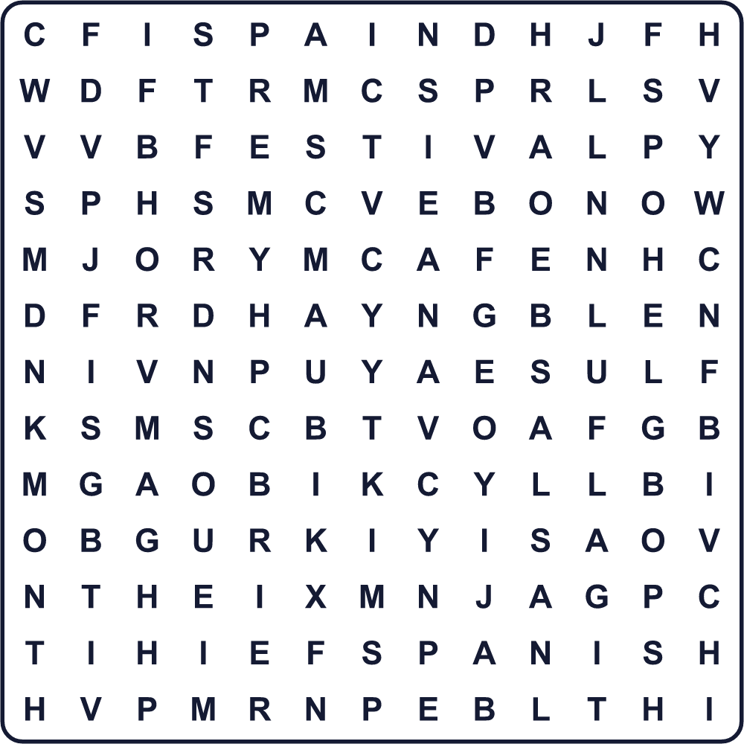
BELL FESTIVAL FLAG HERITAGE MEXICO MONTH SALSA SPACE SPAIN SPANISH

🎺 Hispanic Heritage Month Worksheet
Maze & Sentences
Class ______ No. ____ Name ______________________________
Help Lucia get to the festival! ルシアをフェスティバルまで連れていこう！
正しい道の文字を集めると、ひみつの言葉になるよ。 START 👧 → GOAL 🎺
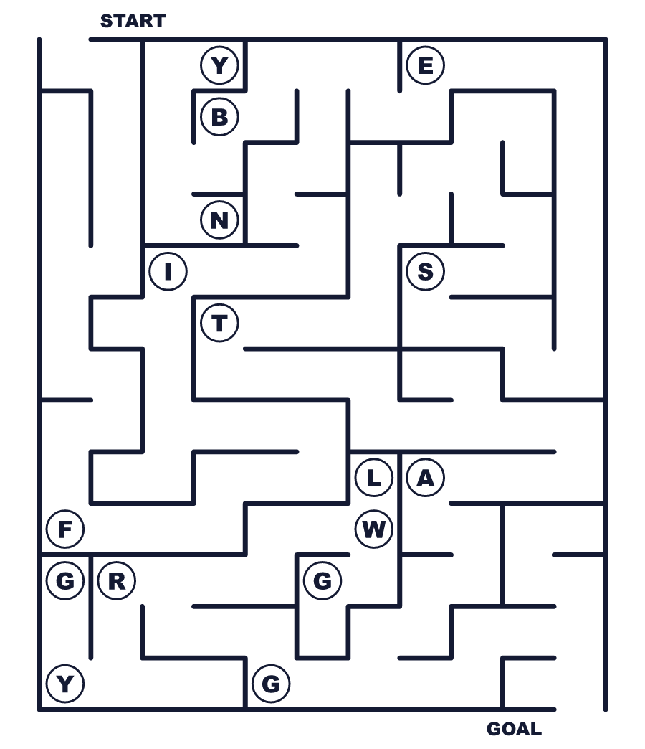
Secret word: ＿ ＿ ＿ ＿ ＿ ＿

🎺 Hispanic Heritage Month Worksheet
Class Activity & Writing
Class ______ No. ____ Name ______________________________
Let's Write! 英語で書いてみよう。
My family's special food is ______. We eat it when ______.
私の家の特別な料理は＿＿＿です。＿＿＿のときに食べます。
______________________________________________________________
______________________________________________________________
If I could visit a country in Latin America, I would go to ______ because ______.
ラテンアメリカの国を訪れるなら、＿＿＿へ行きたいです。なぜなら＿＿＿だからです。
______________________________________________________________
______________________________________________________________

🎺 Hispanic Heritage Month Worksheet
Trace & Color
なぞって書こう。絵に色をぬろう。
Class ______ No. ____ Name ______________________________
🔔 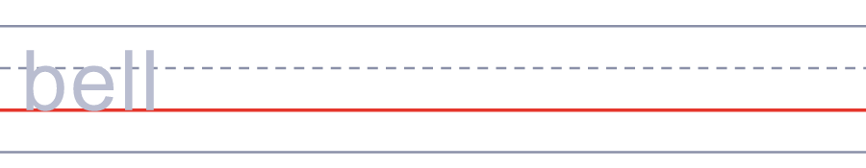

🎺 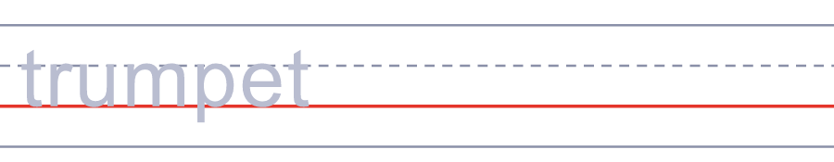
💃 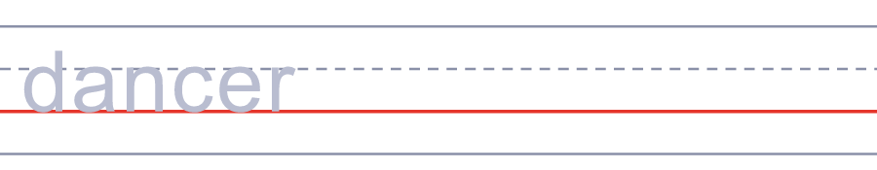
🌮 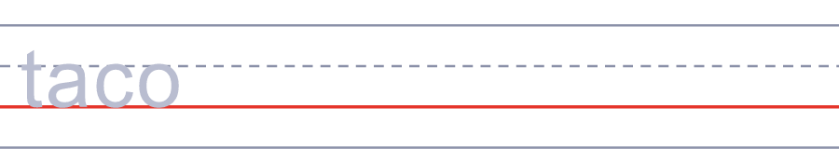
🚀 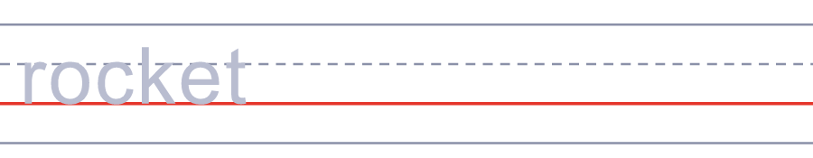

🎺 Hispanic Heritage Month Worksheet
Answer Key 解答
Reading Check: 1.B 2.D 3.A 4.C 5.B
True or False: 1.F 2.T 3.T 4.F
Match: 🔔=bell 🎺=trumpet 💃=dancer 🌮=taco 🚀=rocket 🎸=guitar
Fill in the blanks: (1)September (2)festival (3)music (4)dance (5)tamales (6)flags (7)proud
Maze: FIESTA
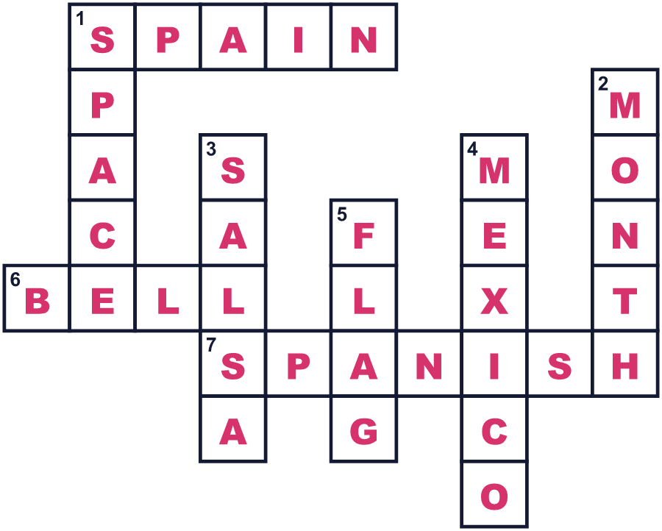
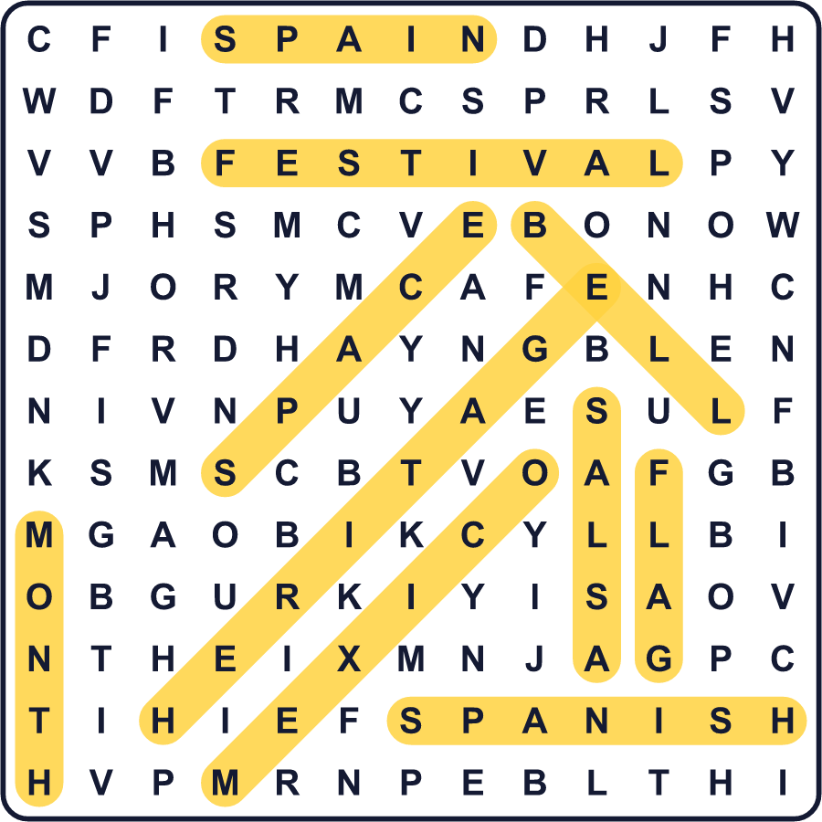
全訳
1 アメリカの記念月間のほとんどは、1日に始まります。でも、9月の真ん中に始まる月間が1つあります。ヒスパニック文化継承月間は、9月15日から10月15日まで続きます。なぜ、こんな変わった日に始まるのでしょうか。
2 答えはラテンアメリカにあります。1821年9月15日、中央アメリカがスペインから独立しました。今、そこにある5か国が、そろってこの日を祝います。コスタリカ、エルサルバドル、グアテマラ、ホンジュラス、ニカラグアです。メキシコは9月16日に独立を祝い、チリは9月18日に国をあげたお祭りをします。だからこの月間は、国々の誕生日がつまった1週間で始まるのです。
3 この考えは、小さく始まりました。1968年、リンドン・ジョンソン大統領が、記念の1週間をつくる法律に署名しました。20年後、多くの人がもっと長い期間を望みました。1988年、ロナルド・レーガン大統領が新しい法律に署名し、週間は月間になりました。今、アメリカには約7,000万人のヒスパニックが住んでいます。アメリカ人のおよそ5人に1人です。
4 月間のあいだ、生徒たちは有名なヒスパニック系アメリカ人について学びます。その1人がエレン・オチョアで、1993年に宇宙へ行った初めてのヒスパニック女性になりました。町では、音楽とダンスのあるストリートフェスティバルが開かれます。人々はメキシコのタマーレスや、エルサルバドルのププサを食べます。祖父母や、その故郷の国の話をする家族もいます。多くの人にとって、自分のルーツを思い出す1か月なのです。

