🎎 Hinamatsuri (Girls' Day) Worksheet
Dolls That Carry Away Bad Luck
Read the story. 英文を読もう。
Class ______ No. ____ Name ______________________________

🔊 音声を聞こう（スマホで読みとってね）
1 Every year on March 3, many homes in Japan bring out a set of special dolls. This day is called Hinamatsuri. In English, people call it the Doll Festival or Girls' Day. Families wish that their daughters will grow up healthy and happy.
2 The dolls sit on steps covered with red cloth. At the top, there are an emperor doll and an empress doll. Below them are court ladies, five musicians, and many tiny things like boxes and carts. A big set can have seven steps and fifteen dolls.
3 But long ago, these dolls were not for display. More than 1,000 years ago, people made simple dolls from paper or grass. They touched their bodies with the dolls to give them their bad luck. Then they put the dolls on a river and let them float away. Some towns still do this today, and it is called nagashi-bina, or floating dolls.
4 Hinamatsuri is also a day for special food. Many families eat chirashi-zushi, a colorful rice dish, and clam soup. A clam shell fits only its own partner, so clams are a sign of a happy marriage. Children also enjoy hina-arare, small sweet rice snacks, and pink, white, and green rice cakes.
5 After the festival, families put the dolls away quickly. An old saying warns that a girl will marry late if the dolls stay out too long. Nobody really believes it now, but it is still good advice. Dolls kept in a dry box stay beautiful for many years, and some families use their grandmother's dolls.
Words 単語
display（飾ること、展示（する）） / emperor（天皇、皇帝） / court lady（（宮廷の）官女） / musician（音楽家、演奏者） / float（浮かぶ、浮かんで流れる） / bad luck（不運、災い） / clam（はまぐりなどの二枚貝） / shell（貝がら、殻） / partner（相手、相方、パートナー） / marriage（結婚） / put away（片付ける、しまう） / saying（言い伝え、ことわざ）

🎎 Hinamatsuri (Girls' Day) Worksheet
Reading Check
Choose the best answer. 正しいものを選ぼう。
Class ______ No. ____ Name ______________________________
1. What is the main idea of the passage?
(A) Hinamatsuri is a day of dolls, food, and wishes for girls. (B) Hinamatsuri is a national holiday with a big parade. (C) Hinamatsuri started in America in the 1900s. (D) Hinamatsuri is a day to buy new dolls every year.
2. How many dolls can a big set have?
(A) Three (B) Five (C) Seven (D) Fifteen
3. What did people make simple dolls from long ago?
(A) Wood or stone (B) Paper or grass (C) Rice or beans (D) Cloth or gold
4. Why are clams a sign of a happy marriage?
(A) Because they are expensive. (B) Because they live for 100 years. (C) Because a shell fits only its own partner. (D) Because they are pink and white.
5. In paragraph 3, what does "float away" mean?
(A) To sink to the bottom (B) To move away on the water (C) To fly into the sky (D) To burn in a fire
6. Which is true according to the passage?
(A) The dolls sit on blue steps. (B) Nagashi-bina is not done anywhere today. (C) Some families use their grandmother's dolls. (D) Children drink white sake.
7. Why do families probably put the dolls in a dry box?
(A) To keep the dolls in good shape for a long time (B) To sell the dolls next year (C) To give the dolls to the river (D) To make the girls marry early
8. In the dialogue, what does Lucas learn about odairi-sama?
(A) It means only the emperor doll. (B) It means the five musicians. (C) It is the name of a song. (D) It means the emperor and empress dolls together.
True or False? T か F に○
1. Hinamatsuri is on March 3. T / F
2. Hinamatsuri is a national holiday in Japan. T / F
3. Long ago, people put paper dolls on rivers. T / F
4. The two dolls at the top are a prince and a dragon. T / F
5. People often eat clam soup on Hinamatsuri. T / F
6. Families usually keep the dolls out until summer. T / F

🎎 Hinamatsuri (Girls' Day) Worksheet
Word Work
単語のれんしゅう
Class ______ No. ____ Name ______________________________
① Match the pictures and the words. 絵と単語を線でむすぼう。
🎎 | ● | ● | lantern
🌸 | ● | ● | shell
🐚 | ● | ● | girl
🍣 | ● | ● | river
🏮 | ● | ● | box
👧 | ● | ● | flower
🌊 | ● | ● | dolls
📦 | ● | ● | sushi
② Unscramble the words. 並べかえて単語にしよう。
1. L O S D L (人形（複数）) → ____________________
2. P H A E C (桃) → ____________________
3. L C A M (はまぐり) → ____________________
4. T L A F O (浮かんで流れる) → ____________________
5. R S E P M E S (皇后) → ____________________
6. A M H R C (3月) → ____________________
③ Fill in the blanks. 語群から選んで入れよう。
[ snow / away / Canada / steps / top / Halloween / pizza / dolls / box / celebrate / rice / soup / shells ]
Mia is from (1) __________ . She lives with a Japanese family this year. In early March, her host mother takes out a big (2) __________ . Inside, there are many (3) __________ in beautiful clothes. They put the dolls on red (4) __________ . The emperor and empress sit at the (5) __________ . On March 3, they eat colorful (6) __________ and clam (7) __________ . Mia learns that the clam (8) __________ fit only their partners. After the festival, Mia helps put the dolls (9) __________ . She says, "I want to (10) __________ this festival again next year!"

🎎 Hinamatsuri (Girls' Day) Worksheet
Crossword Puzzle
ヒントを読んでクロスワードを完成させよう。
Class ______ No. ____ Name ______________________________
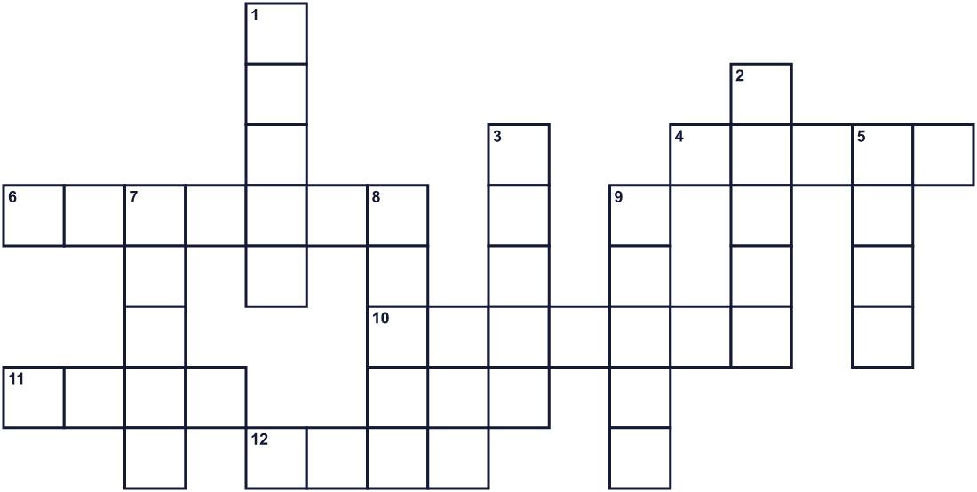
Across →
4. The third month of the year. (5)
6. The woman next to him at the top. (7)
10. The man at the very top of the red steps. (7)
11. The dolls take away the bad kind of this. (4)
12. A small toy that looks like a person. (4)
Down ↓
1. Long ago, people put paper dolls on this water. (5)
2. Old floating dolls were made of this or grass. (5)
3. The dolls sit on these. They are covered with red cloth. (5)
5. A sea animal in two shells. People make soup with it. (4)
7. A pink flower. The March 3 festival is named after it. (5)
8. The hard outside part of a clam. (5)
9. This festival is a day for them. Families wish them good health. (5)

🎎 Hinamatsuri (Girls' Day) Worksheet
Word Search
かくれた単語をさがそう（→ ↓ ↘ ↗）
Class ______ No. ____ Name ______________________________
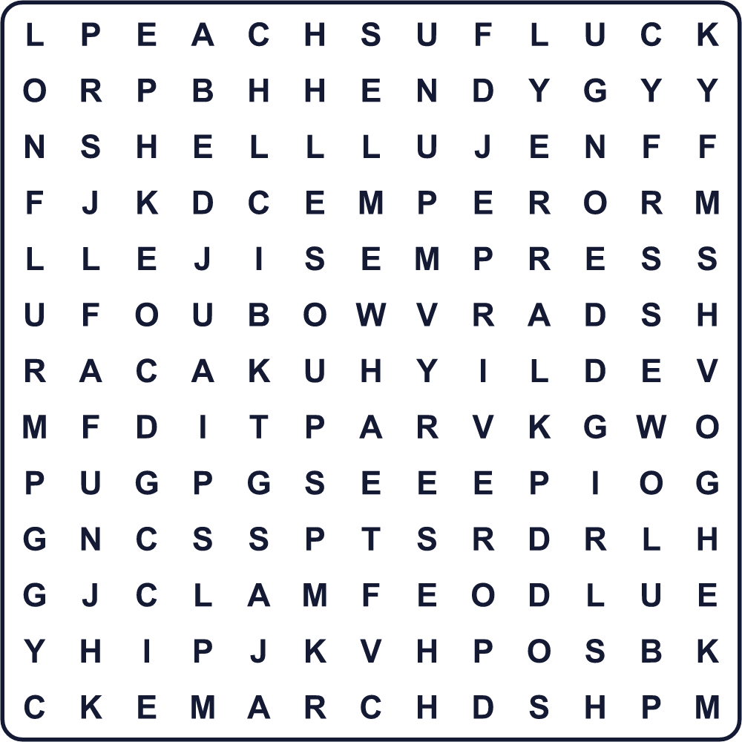
CLAM DOLL EMPEROR EMPRESS FLOAT GIRLS LUCK MARCH PAPER PEACH RIVER SHELL SOUP STEPS
Secret Code 暗号を解こう
✎=A ♣=D ♪=E ■=F ✚=H ⚑=I ▲=L ♦=O ◎=P ♥=S ♠=T ☃=V ☎=Y
✚ ✎ ◎ ◎ ☎ ♣ ♦ ▲ ▲ ■ ♪ ♥ ♠ ⚑ ☃ ✎ ▲
______________________________________________________________

🎎 Hinamatsuri (Girls' Day) Worksheet
Maze & Sentences
Class ______ No. ____ Name ______________________________
Help Hana bring the doll to the red steps! ハナが人形をひな壇まで運べるように助けよう！
正しい道の文字を集めると、ひみつの言葉になるよ。 START 👧 → GOAL 🎎
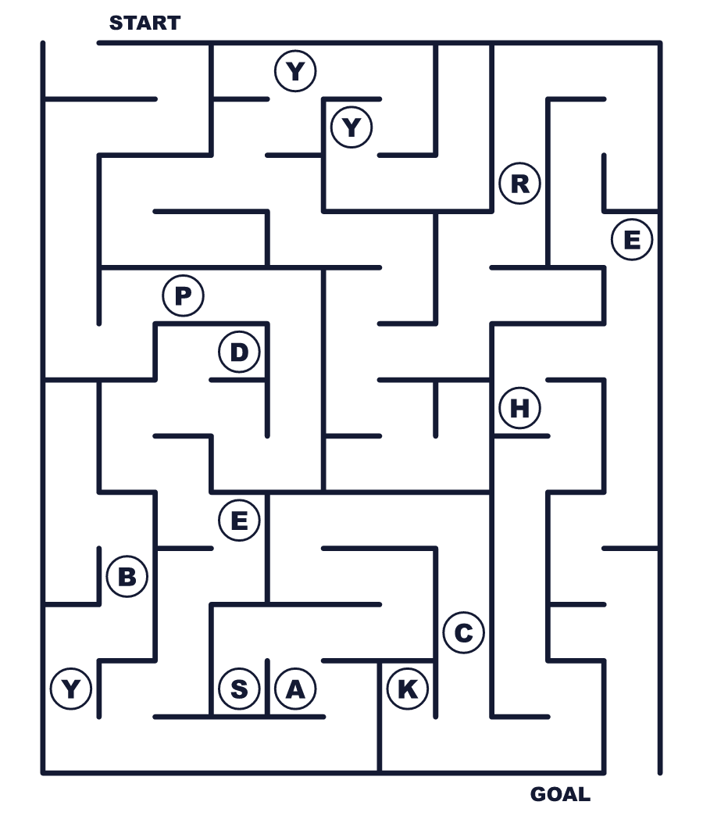
Secret word: ＿ ＿ ＿ ＿ ＿
Put the words in order. 並べかえよう。
1. festival / a / girls / is / Hinamatsuri / for . (ひな祭りは女の子のためのお祭りです。)
______________________________________________________________
2. on / sit / dolls / The / red / steps . (人形は赤い段の上に座ります。)
______________________________________________________________
3. on / put / dolls / river / paper / People / the . (人々は紙の人形を川に流します。)
______________________________________________________________
4. We / March / soup / on / 3 / clam / eat . (3月3日にはまぐりのお吸い物を食べます。)
______________________________________________________________
5. dolls / away / quickly / My / family / the / puts . (私の家族はすぐに人形を片付けます。)
______________________________________________________________

🎎 Hinamatsuri (Girls' Day) Worksheet
Class Activity & Writing
Class ______ No. ____ Name ______________________________
Find Someone Who… クラスで聞いて回ろう！
Find someone who … | Name
… has hina dolls at home 家に雛人形がある
… likes chirashi-zushi ちらし寿司が好き
… has eaten hina-arare this year 今年ひなあられを食べた
… knows the name of the doll festival in English ひな祭りの英語名を知っている
… can name three foods for Hinamatsuri ひな祭りの食べ物を3つ言える
… has seen peach flowers 桃の花を見たことがある
… likes clam soup はまぐりのお吸い物が好き
… knows what odairi-sama means お内裏様の意味を知っている
Let's Write! 英語で書いてみよう。
If I could make my own hina doll, it would look like ______ because ______.
自分だけの雛人形を作れるなら、______のような姿にします。なぜなら______だからです。
______________________________________________________________
______________________________________________________________
On Hinamatsuri, I want to wish for ______ for my family and friends.
ひな祭りに、家族や友だちのために______を願いたいです。
______________________________________________________________
______________________________________________________________
To explain Hinamatsuri to a friend from another country, I would say, "______."
外国の友だちにひな祭りを説明するなら「______」と言います。
______________________________________________________________
______________________________________________________________

🎎 Hinamatsuri (Girls' Day) Worksheet
Trace & Color
なぞって書こう。絵に色をぬろう。
Class ______ No. ____ Name ______________________________
🎎 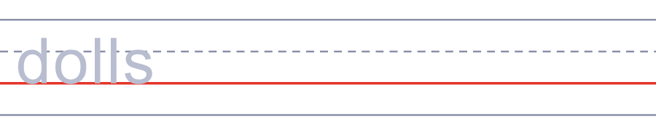

🌸 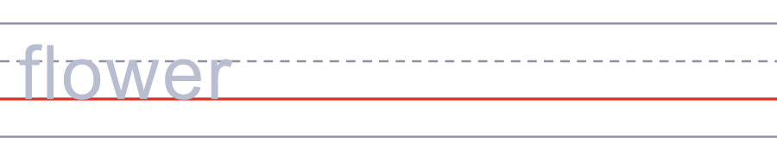
🐚 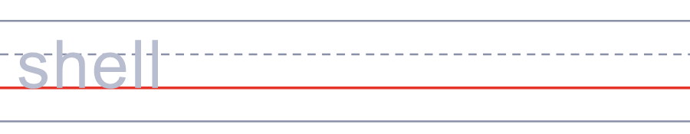
🍣 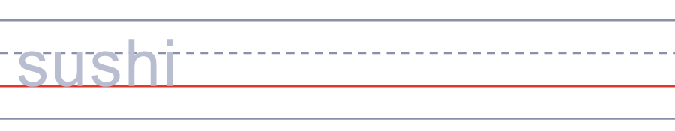
🏮 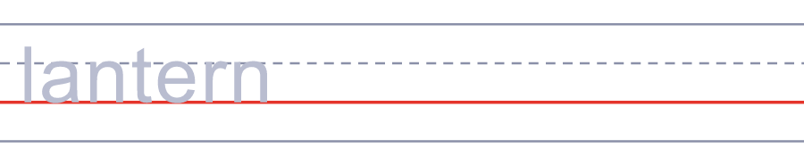
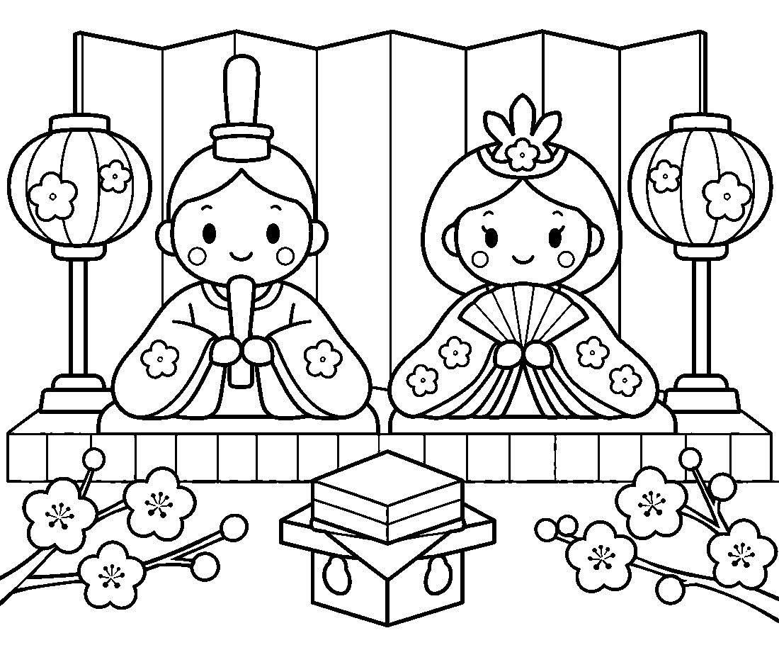

🎎 Hinamatsuri (Girls' Day) Worksheet
Answer Key 解答
Reading Check: 1.A 2.D 3.B 4.C 5.B 6.C 7.A 8.D
True or False: 1.T 2.F 3.T 4.F 5.T 6.F
Match: 🎎=dolls 🌸=flower 🐚=shell 🍣=sushi 🏮=lantern 👧=girl 🌊=river 📦=box
Unscramble: 1.DOLLS 2.PEACH 3.CLAM 4.FLOAT 5.EMPRESS 6.MARCH
Fill in the blanks: (1)Canada (2)box (3)dolls (4)steps (5)top (6)rice (7)soup (8)shells (9)away (10)celebrate
Sentence order: 1. Hinamatsuri is a festival for girls. 2. The dolls sit on red steps. 3. People put paper dolls on the river. 4. We eat clam soup on March 3. 5. My family puts the dolls away quickly.
Secret Code: HAPPY DOLL FESTIVAL
Maze: PEACH
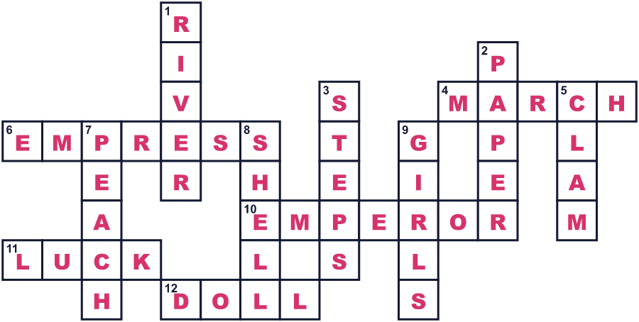
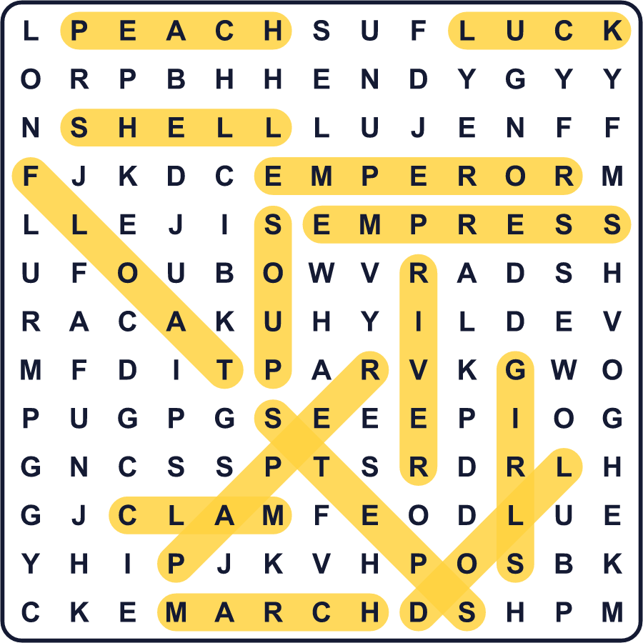
全訳
1 毎年3月3日になると、日本の多くの家で特別な人形が飾られます。この日を「ひな祭り」と言います。英語では Doll Festival（人形の祭り）や Girls' Day（女の子の日）と呼ばれます。家族は、娘が健康で幸せに育つように願います。
2 人形は赤い布をかけた段の上に座ります。いちばん上には、天皇と皇后の姿をした人形がいます。その下には官女や5人の音楽隊、そして箱や車などのたくさんの小さな道具が並びます。大きなセットは7段で、人形は15体にもなります。
3 でも昔、こうした人形は飾るためのものではありませんでした。1000年以上前、人々は紙や草で簡単な人形を作りました。人形で体をなでて、自分の悪いものを人形に移したのです。それから人形を川に置き、流していきました。今もこれを続けている町があり、「流し雛」と呼ばれています。
4 ひな祭りは、特別な料理の日でもあります。多くの家庭で、色あざやかなご飯料理のちらし寿司と、はまぐりのお吸い物を食べます。はまぐりの貝は自分の相方としか合わないので、幸せな結婚のしるしなのです。子どもたちは、小さくて甘い米菓子のひなあられや、ピンク・白・緑の餅も楽しみます。
5 祭りが終わると、家族はすぐに人形を片付けます。人形を長く出しておくと女の子の結婚が遅れる、という古い言い伝えがあります。今では本気で信じる人はほとんどいませんが、それでも良いアドバイスです。乾いた箱にしまった人形は何年も美しいままで、おばあちゃんの人形を使っている家族もいます。

