⛩️ Hatsumode & New Year Customs Worksheet
Trains, Brushes, and Little Envelopes
Read the story. 英文を読もう。
Class ______ No. ____ Name ______________________________

🔊 音声を聞こう（スマホで読みとってね）
1 In the first days of January, millions of people in Japan visit shrines and temples. This first visit of the year is called hatsumode. People throw coins into a box, bow, and make a wish for the new year. Many also buy a paper fortune called omikuji.
2 Hatsumode feels like a very old tradition, but its modern form is not so old. Long ago, people visited their local shrine or a shrine in the lucky direction of the year. Then trains came. In the late 1800s, railway companies told people to ride their trains to famous shrines and temples at New Year. The word hatsumode spread with these ads.
3 On January 2, many children do kakizome, the first writing of the year. They use a brush and black ink to write words like hope or dream on long paper. In mid-January, people burn these papers at a winter fire festival. If the fire goes up high, they say your writing will get better.
4 And of course, children wait for otoshidama, New Year money from adults. The money goes in small, cute envelopes called pochi-bukuro. Pochi is an old word from western Japan for a small tip. So the name means something like just a little something for you. Adults also try not to give amounts with 4 or 9, because these numbers can sound like death and pain in Japanese.
Words 単語
shrine（神社） / wish（願い、願う） / fortune（運勢、運） / tradition（伝統） / direction（方角、方向） / brush（筆、ブラシ） / ink（インク、墨） / envelope（封筒）

⛩️ Hatsumode & New Year Customs Worksheet
Reading Check
Choose the best answer. 正しいものを選ぼう。
Class ______ No. ____ Name ______________________________
1. What is the main idea of the passage?
(A) Japanese people do not go out at New Year. (B) Hatsumode started in Germany. (C) Japan has several New Year customs, like hatsumode, kakizome, and otoshidama. (D) Children write letters to Santa in January.
2. What helped the word hatsumode spread?
(A) Ads by railway companies. (B) A law made by the government. (C) A popular song. (D) Television news.
3. When do many children do kakizome?
(A) On December 31. (B) On January 2. (C) On January 1. (D) On February 3.
4. Why do adults avoid giving amounts with 4 or 9?
(A) Because the envelopes are too small. (B) Because children do not like odd numbers. (C) Because banks do not have those bills. (D) Because the numbers can sound like death and pain.
5. In the dialogue, what does Takumi suggest for tomorrow?
(A) Visit another shrine. (B) Buy more omikuji. (C) Try kakizome together. (D) Give Mia otoshidama.
True or False? T か F に○
1. Hatsumode is the first visit to a shrine or temple in the new year. T / F
2. People must go to a shrine, not a temple, for hatsumode. T / F
3. People burn kakizome papers in a fire festival. T / F
4. Adults like to give 4,000 yen as otoshidama. T / F

⛩️ Hatsumode & New Year Customs Worksheet
Word Work
単語のれんしゅう
Class ______ No. ____ Name ______________________________
① Match the pictures and the words. 絵と単語を線でむすぼう。
⛩️ | ● | ● | envelope
🖌️ | ● | ● | train
🪙 | ● | ● | shrine
🚃 | ● | ● | coin
🔥 | ● | ● | brush
✉️ | ● | ● | fire
③ Fill in the blanks. 語群から選んで入れよう。
[ beach / wish / line / coin / shrine / brush / pizza / money / envelope / summer / omikuji ]
On January 1, Yuna goes to a (1) __________ with her family. They wait in a long (2) __________ . Yuna throws a (3) __________ into the box and makes a (4) __________ . Then she buys an (5) __________ . It says great luck! On January 2, she writes the word dream with a (6) __________ . Her grandfather gives her a small (7) __________ . There is New Year (8) __________ inside!

⛩️ Hatsumode & New Year Customs Worksheet
Crossword Puzzle
ヒントを読んでクロスワードを完成させよう。
Class ______ No. ____ Name ______________________________
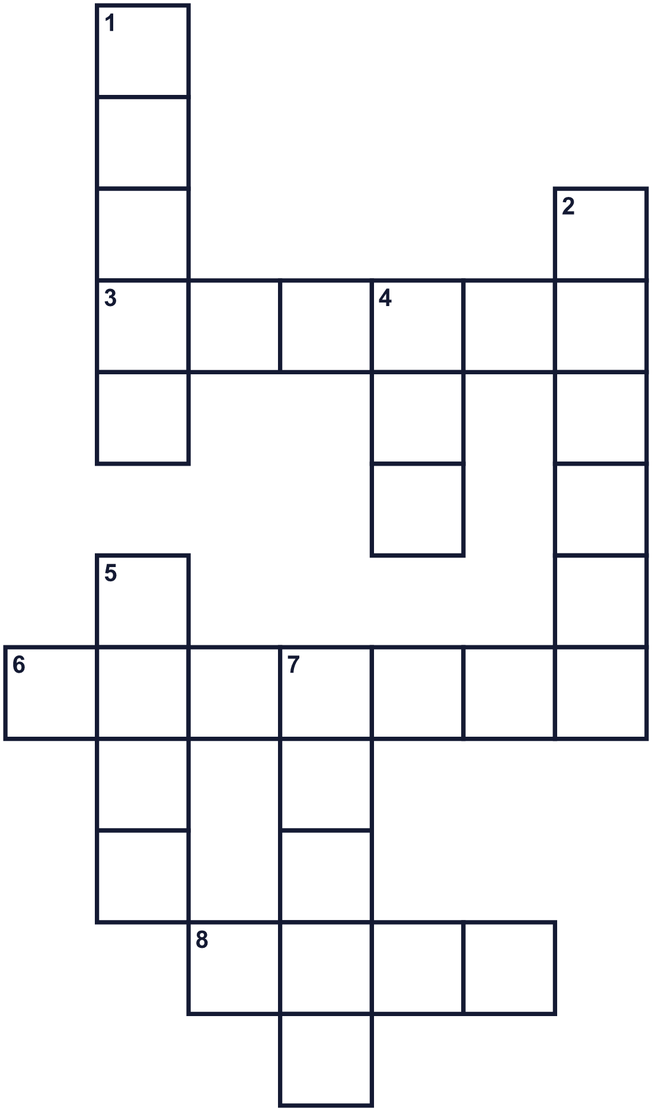
Across →
3. A holy place in Japan with a torii gate. (6)
6. A paper at a shrine tells you this about your year. (7)
8. Something you hope will happen. (4)
Down ↓
1. You use this to write kanji with ink. (5)
2. A Buddhist building where people pray. (6)
4. Black liquid for writing. (3)
5. Money made of metal. (4)
7. Many people ride this to famous shrines. (5)

⛩️ Hatsumode & New Year Customs Worksheet
Word Search
かくれた単語をさがそう（→ ↓ ↘ ↗）
Class ______ No. ____ Name ______________________________
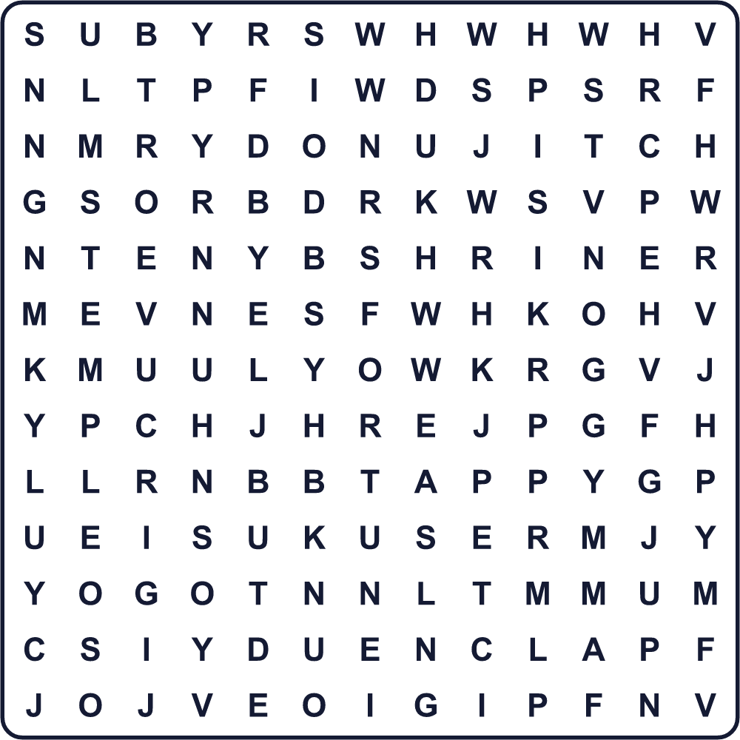
BOW BRUSH CLAP COIN FORTUNE INK MONEY SHRINE TEMPLE WISH

⛩️ Hatsumode & New Year Customs Worksheet
Maze & Sentences
Class ______ No. ____ Name ______________________________
Help Yuna get to the shrine! ユナが神社にたどり着けるように助けよう！
正しい道の文字を集めると、ひみつの言葉になるよ。 START 👧 → GOAL ⛩️
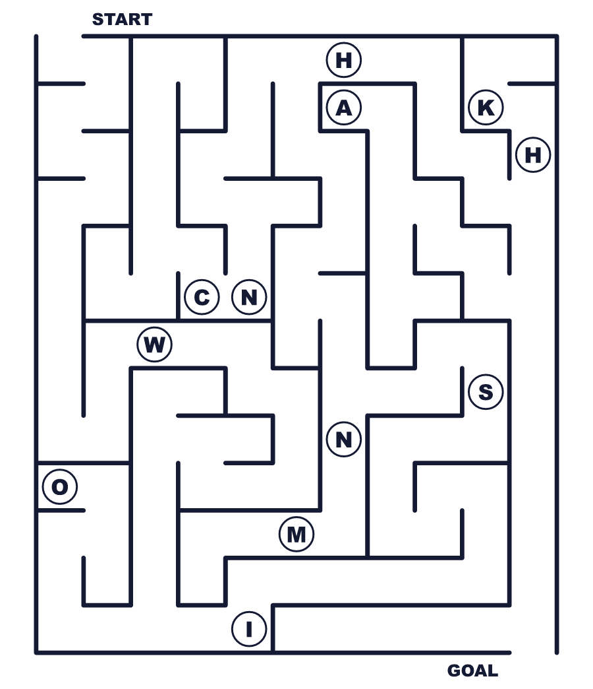
Secret word: ＿ ＿ ＿ ＿

⛩️ Hatsumode & New Year Customs Worksheet
Class Activity & Writing
Class ______ No. ____ Name ______________________________
Let's Write! 英語で書いてみよう。
At hatsumode this year, I will wish for ______ because ______.
今年の初詣では______を願います。なぜなら______だからです。
______________________________________________________________
______________________________________________________________
For my kakizome, I want to write the word ______ because ______.
書き初めでは______という言葉を書きたいです。なぜなら______だからです。
______________________________________________________________
______________________________________________________________

⛩️ Hatsumode & New Year Customs Worksheet
Trace & Color
なぞって書こう。絵に色をぬろう。
Class ______ No. ____ Name ______________________________
⛩️ 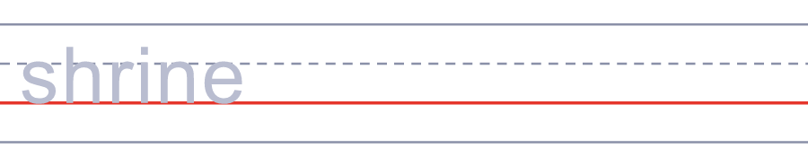

🖌️ 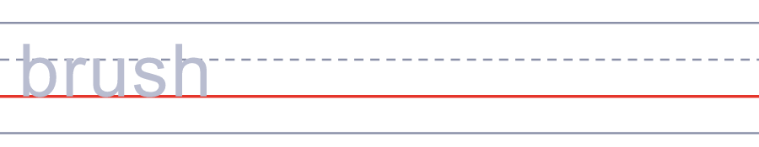
🪙 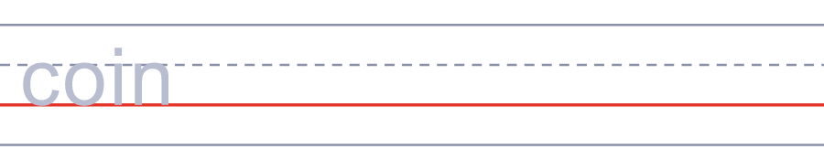
🚃 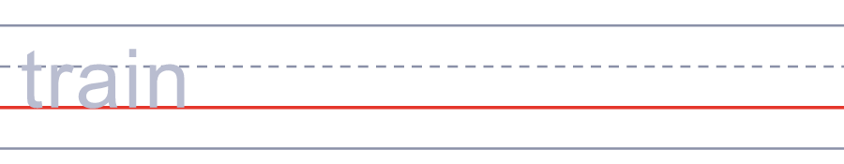
🔥 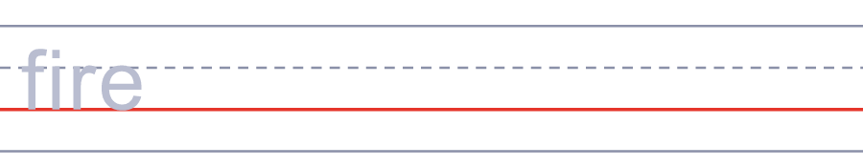

⛩️ Hatsumode & New Year Customs Worksheet
Answer Key 解答
Reading Check: 1.C 2.A 3.B 4.D 5.C
True or False: 1.T 2.F 3.T 4.F
Match: ⛩️=shrine 🖌️=brush 🪙=coin 🚃=train 🔥=fire ✉️=envelope
Fill in the blanks: (1)shrine (2)line (3)coin (4)wish (5)omikuji (6)brush (7)envelope (8)money
Maze: WISH
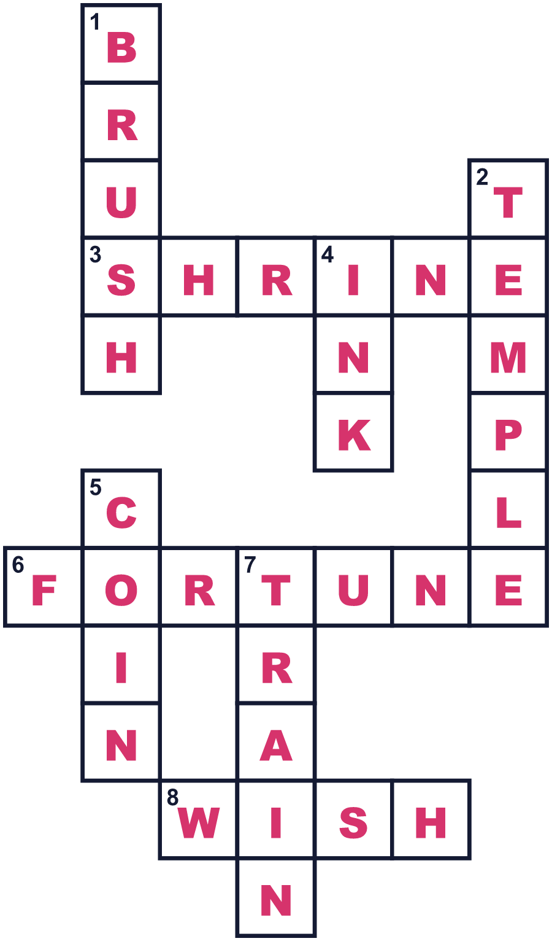
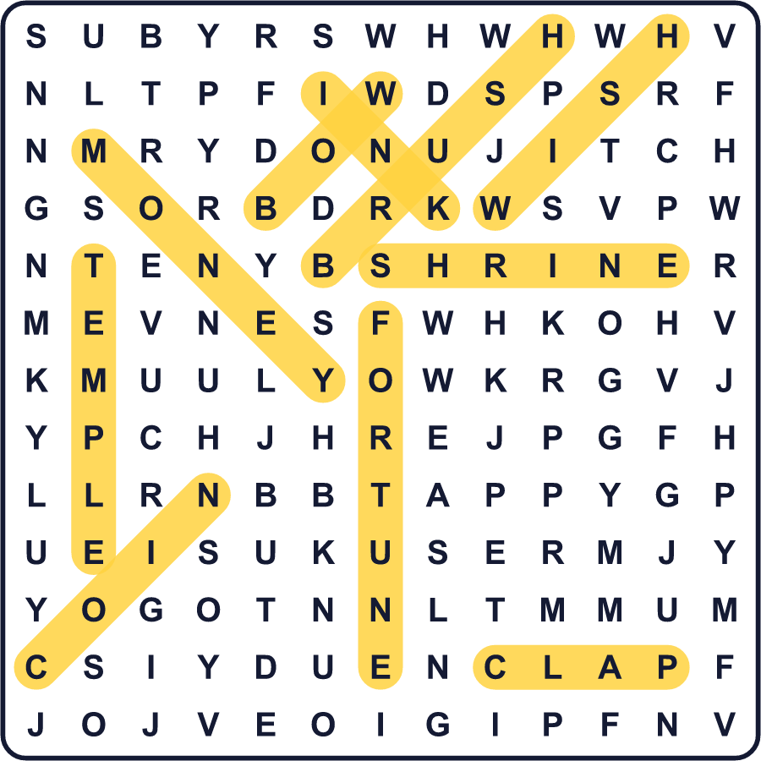
全訳
1 1月のはじめ、日本では何百万人もの人が神社やお寺を訪れます。この年最初のお参りを「初詣」と言います。人々はさい銭箱に硬貨を投げ入れ、おじぎをして、新年の願いごとをします。多くの人は「おみくじ」という紙の運勢も買います。
2 初詣はとても古い伝統のように感じられますが、今の形はそれほど古くありません。昔の人は、地元の神社か、その年の縁起のよい方角にある神社にお参りしました。そこへ鉄道がやって来ました。1800年代の終わり、鉄道会社は、お正月には自分たちの電車で有名な神社やお寺へ行こうと宣伝しました。「初詣」という言葉は、こうした広告とともに広まったのです。
3 1月2日、多くの子どもが書き初め、つまりその年最初の書道をします。筆と墨を使って、長い紙に「希望」や「夢」のような言葉を書きます。1月の中ごろ、人々は冬の火祭りでこの紙を燃やします。炎が高く上がると、字が上手になると言われています。
4 そしてもちろん、子どもたちは大人からのお年玉を待っています。お金は「ぽち袋」という小さくてかわいい袋に入れます。「ぽち」は西日本の古い言葉で、ちょっとした心づけのことです。だからこの名前は「ほんの気持ちです」というような意味になります。大人は4や9のつく金額も避けようとします。日本語では、これらの数字が「死」や「苦」に聞こえることがあるからです。

