🕎 Hanukkah Worksheet
Eight Nights of Light
Read the story. 英文を読もう。
Class ______ No. ____ Name ______________________________
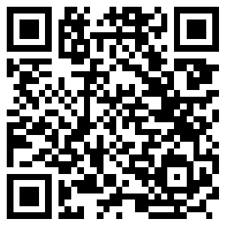
🔊 音声を聞こう（スマホで読みとってね）
1 More than 2,100 years ago, a king took over the Temple in Jerusalem. He put an altar for a Greek god inside, and he told Jewish people to stop their religion. A small family army called the Maccabees said no. They fought for about three years, and in the end they won the Temple back.
2 The Maccabees cleaned the Temple and gave it to God again. In Hebrew, this is called hanukkah, and it means dedication. There is also a famous story about oil. The Temple lamp needed pure olive oil, but people found only one small jar. It was enough for one day, but the lamp burned for eight days.
3 So today Hanukkah lasts for eight nights. Families use a special lamp with nine branches. Each night, they light one more candle than the night before. The ninth candle is called the shamash, and it is the helper. It gives its fire to the other candles. Many people put the lamp in a window, so people outside can see the light.
4 Hanukkah is also a time for games and food. Children spin a top called a dreidel and play for chocolate coins. Families eat food fried in oil, like potato pancakes called latkes. In Israel, jelly doughnuts are the big favorite, and people eat millions of them.
5 Some people call Hanukkah the Jewish Christmas, but that is not right. It has its own story, and it started long before Christmas. Its message is simple and strong. In the darkest weeks of winter, a small light can grow a little brighter every night.
Words 単語
temple（神殿、寺院） / altar（祭壇） / dedication（奉献、ささげること） / pure（清い、まじりけのない） / jar（つぼ、びん） / last（続く） / branch（枝） / shamash（シャマシュ（点火係のろうそく）） / spin（回す、回る） / fried（揚げた、油で焼いた） / miracle（奇跡） / message（メッセージ、伝えたいこと）

🕎 Hanukkah Worksheet
Reading Check
Choose the best answer. 正しいものを選ぼう。
Class ______ No. ____ Name ______________________________
1. What is the main idea of the reading?
(A) Hanukkah is a Jewish festival about winning back the Temple and lighting candles. (B) Hanukkah is the day Jewish people celebrate the birth of a king in Jerusalem. (C) Hanukkah is a summer holiday when families cook food outside in parks. (D) Hanukkah is the Jewish name for Christmas, with the same story and songs.
2. How long did the Maccabees fight?
(A) About eight days (B) About one year (C) About three years (D) About 2,100 years
3. How much oil did people find in the Temple?
(A) Enough for eight days (B) One small jar, enough for one day (C) Nine big jars (D) No oil at all
4. On the third night of Hanukkah, how many candles do people light, not counting the shamash?
(A) One (B) Two (C) Eight (D) Three
5. In paragraph 3, the word "helper" is closest in meaning to:
(A) a person or thing that does work for others (B) a thing that is very old (C) a kind of food (D) a person who sells candles
6. Which sentence is true about the reading?
(A) Children play with a top called a dreidel. (B) Families put the lamp under a table to hide it. (C) People in Israel do not eat doughnuts. (D) The lamp has seven branches.
7. Why do people put the lamp in a window?
(A) Because the room is too small for it (B) Because they want to share the light with others (C) Because fire is not allowed in houses (D) Because the shamash must be cold
8. In the dialogue, which night of Hanukkah is it?
(A) The first night (B) The second night (C) The eighth night (D) The fourth night
True or False? T か F に○
1. Hanukkah lasts for eight nights. T / F
2. The Hanukkah lamp has seven branches. T / F
3. The shamash is used to light the other candles. T / F
4. Hanukkah celebrates the birthday of a king. T / F
5. People often eat fried food on Hanukkah. T / F
6. On the first night, people light all eight candles. T / F

🕎 Hanukkah Worksheet
Word Work
単語のれんしゅう
Class ______ No. ____ Name ______________________________
① Match the pictures and the words. 絵と単語を線でむすぼう。
🕯 | ● | ● | window
🍩 | ● | ● | present
🥔 | ● | ● | doughnut
🪙 | ● | ● | coin
🫒 | ● | ● | olive
🪟 | ● | ● | fire
🔥 | ● | ● | candle
🎁 | ● | ● | potato
② Unscramble the words. 並べかえて単語にしよう。
1. L C D E N A (ろうそく) → ____________________
2. G L I T H (光) → ____________________
3. T E M L E P (神殿) → ____________________
4. I L A C E M R (奇跡) → ____________________
5. N I E R W T (冬) → ____________________
6. D L I E D E R (ハヌカのコマ) → ____________________
③ Fill in the blanks. 語群から選んで入れよう。
[ summer / coins / nights / fried / shamash / oil / snowman / window / dark / dreidel / candle / night / pumpkin ]
On the first (1) __________ of Hanukkah, Noah went to his grandma's house. It was cold and (2) __________ outside. Grandma lit the (3) __________ , and then Noah lit one (4) __________ . They put the menorah in the (5) __________ . Then Grandma made latkes. She (6) __________ the potato pancakes in hot (7) __________ . The kitchen smelled great. After dinner, Noah and his sister played with a (8) __________ . Noah won ten chocolate (9) __________ . "Hanukkah is the best," he said. "And there are seven more (10) __________ !"

🕎 Hanukkah Worksheet
Crossword Puzzle
ヒントを読んでクロスワードを完成させよう。
Class ______ No. ____ Name ______________________________
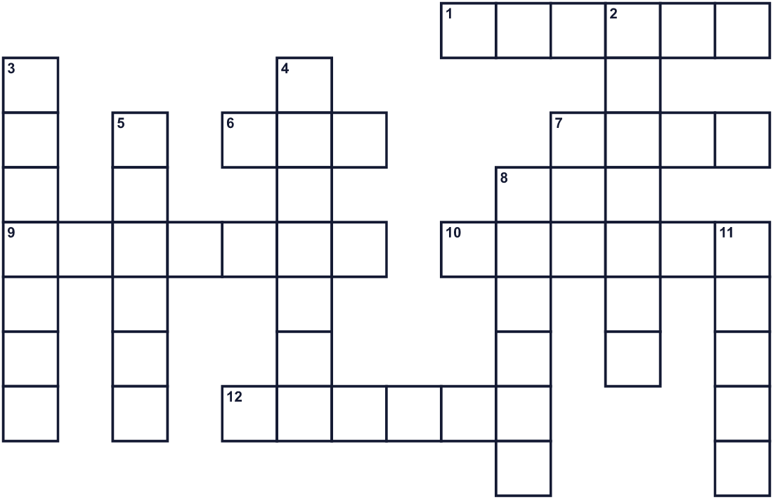
Across →
1. People put the lamp here so others can see the light. (6)
6. Olive ___. A small jar of it burned for eight days. (3)
7. Money or chocolate coins for children. (4)
9. A lamp with nine branches for this holiday. (7)
10. It gives light when you burn it. You light one more each night. (6)
12. A holy building in Jerusalem. The Maccabees won it back. (6)
Down ↓
2. A top with four sides. Children spin it. (7)
3. The helper candle. It lights the others. (7)
4. A wonderful thing that people cannot explain. (7)
5. The cold season when this festival comes. (6)
8. Fried potato pancakes. (6)
11. The number of nights in this festival. (5)

🕎 Hanukkah Worksheet
Word Search
かくれた単語をさがそう（→ ↓ ↘ ↗）
Class ______ No. ____ Name ______________________________
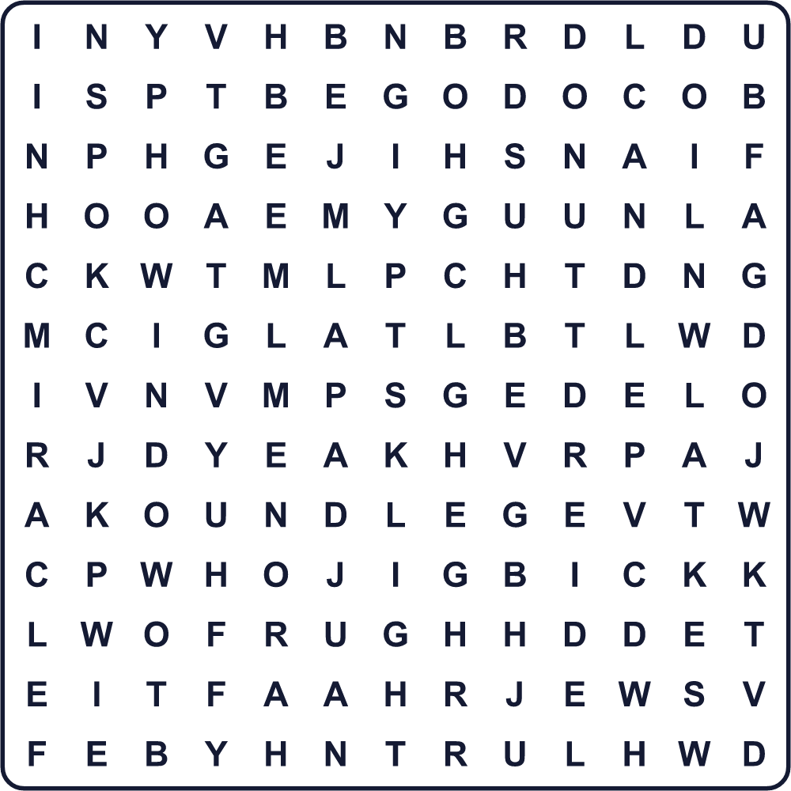
CANDLE DONUT DREIDEL EIGHT GELT LATKES LIGHT MENORAH MIRACLE OIL SHAMASH TEMPLE WINDOW
Secret Code 暗号を解こう
☘=A ☺=C ☎=E ◎=G ⚑=I ☂=L ✚=M ✈=R ☃=T
☘ ◎ ✈ ☎ ☘ ☃ ✚ ⚑ ✈ ☘ ☺ ☂ ☎
______________________________________________________________

🕎 Hanukkah Worksheet
Maze & Sentences
Class ______ No. ____ Name ______________________________
Help Noah bring the shamash to the menorah! ノアがシャマシュを燭台まで運べるように手伝おう！
正しい道の文字を集めると、ひみつの言葉になるよ。 START 🧒 → GOAL 🕎
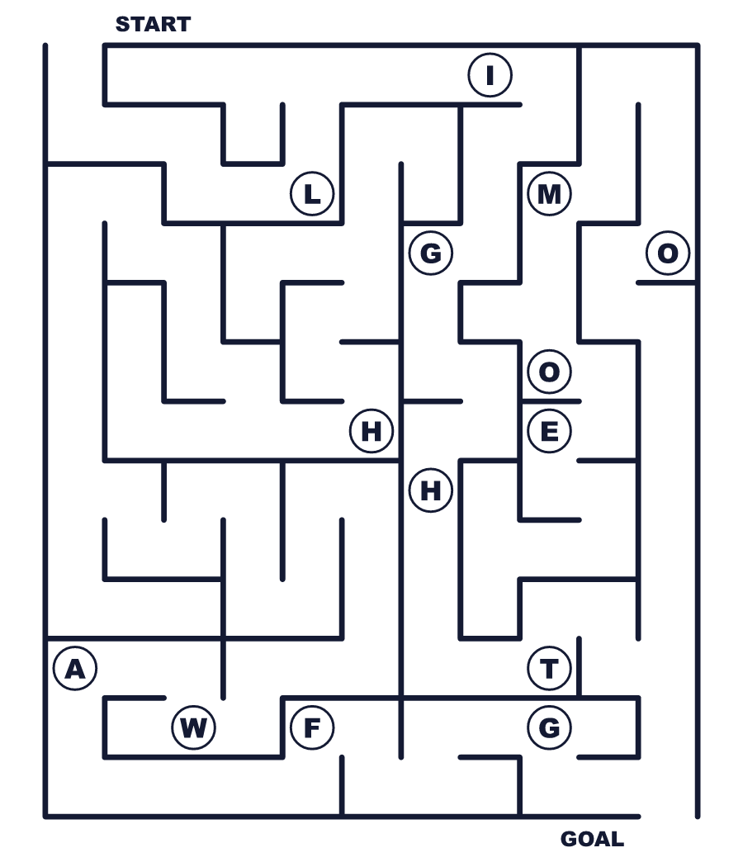
Secret word: ＿ ＿ ＿ ＿ ＿
Put the words in order. 並べかえよう。
1. called / the / is / Hanukkah / of / Festival / Lights . (ハヌカは光の祭りと呼ばれます。)
______________________________________________________________
2. light / more / We / one / candle / night / every . (毎晩ろうそくを1本ずつ増やします。)
______________________________________________________________
3. candles / the / The / shamash / other / lights . (シャマシュがほかのろうそくに火をつけます。)
______________________________________________________________
4. makes / potato / father / My / oil / in / pancakes . (父が油でジャガイモのパンケーキを作ります。)
______________________________________________________________
5. dinner / dreidel / spin / a / after / Children . (子どもたちは夕食のあとにドレイドルを回します。)
______________________________________________________________

🕎 Hanukkah Worksheet
Class Activity & Writing
Class ______ No. ____ Name ______________________________
Find Someone Who… クラスで聞いて回ろう！
Find someone who … | Name
… has lit a candle ろうそくに火をつけたことがある
… has played with a spinning top コマで遊んだことがある
… likes potato pancakes ジャガイモのパンケーキが好き
… likes jelly doughnuts ジャム入りドーナツが好き
… knows the meaning of the word miracle miracle という単語の意味を知っている
… can count to eight in another language 英語以外の外国語で8まで数えられる
… has received money as a present プレゼントにお金をもらったことがある
… knows a holiday about light 光に関係する行事を知っている
Let's Write! 英語で書いてみよう。
If I could add one light to my town every night, I would put it ______ because ______.
毎晩、町に灯りを1つ足せるなら、______に置きたい。なぜなら______だから。
______________________________________________________________
______________________________________________________________
My favorite winter food is ______. I like it because ______.
私の好きな冬の食べ物は______です。好きな理由は______です。
______________________________________________________________
______________________________________________________________
Hanukkah and ______ are both holidays about light. One difference is ______.
ハヌカと______は、どちらも光の行事です。ちがいの一つは______です。
______________________________________________________________
______________________________________________________________

🕎 Hanukkah Worksheet
Trace & Color
なぞって書こう。絵に色をぬろう。
Class ______ No. ____ Name ______________________________
🕯 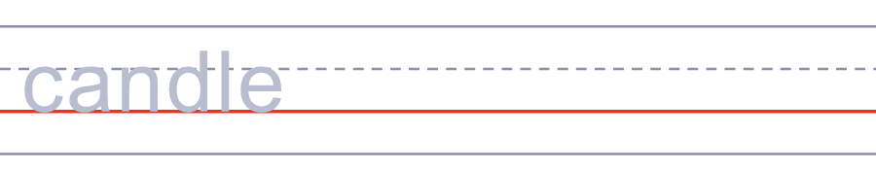

🍩 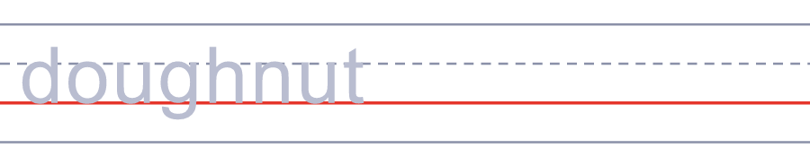
🥔 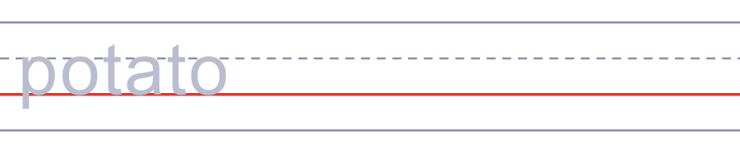
🪙 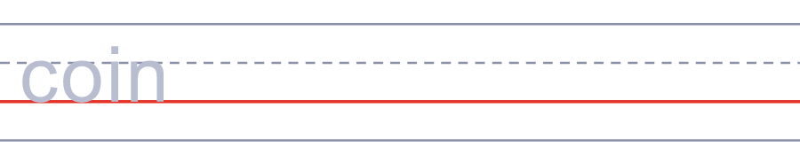
🫒 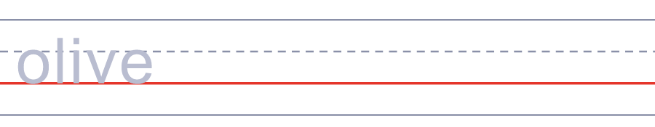
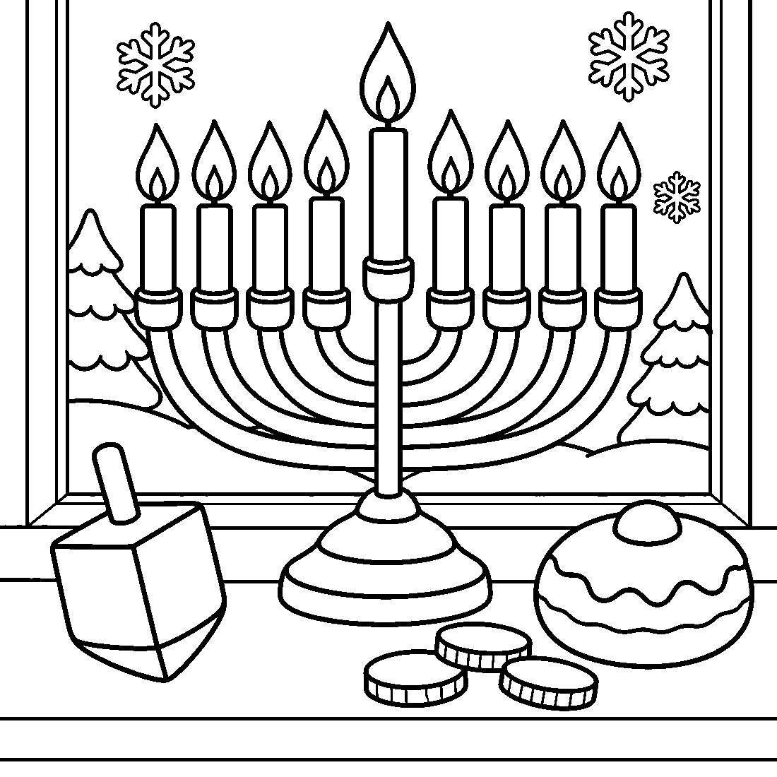

🕎 Hanukkah Worksheet
Answer Key 解答
Reading Check: 1.A 2.C 3.B 4.D 5.A 6.A 7.B 8.D
True or False: 1.T 2.F 3.T 4.F 5.T 6.F
Match: 🕯=candle 🍩=doughnut 🥔=potato 🪙=coin 🫒=olive 🪟=window 🔥=fire 🎁=present
Unscramble: 1.CANDLE 2.LIGHT 3.TEMPLE 4.MIRACLE 5.WINTER 6.DREIDEL
Fill in the blanks: (1)night (2)dark (3)shamash (4)candle (5)window (6)fried (7)oil (8)dreidel (9)coins (10)nights
Sentence order: 1. Hanukkah is called the Festival of Lights. 2. We light one more candle every night. 3. The shamash lights the other candles. 4. My father makes potato pancakes in oil. 5. Children spin a dreidel after dinner.
Secret Code: A GREAT MIRACLE
Maze: LIGHT
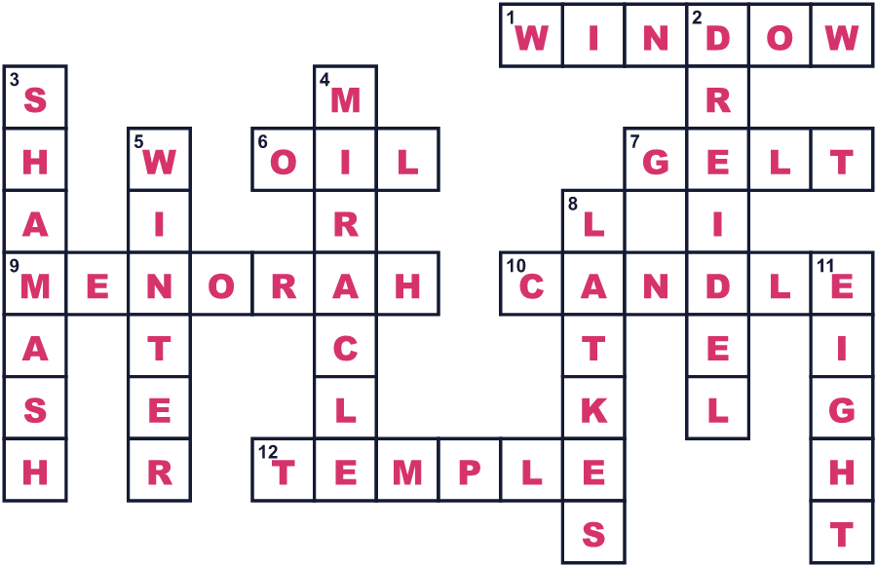
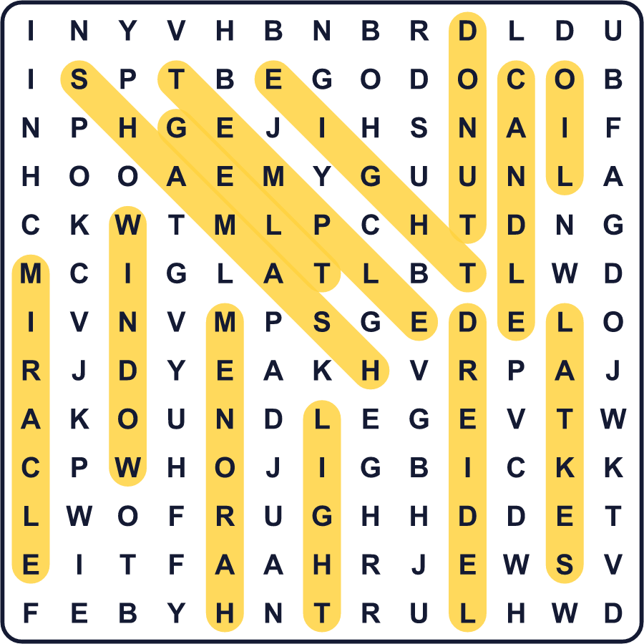
全訳
1 2100年以上前、ある王がエルサレムの神殿を奪いました。王は中にギリシアの神の祭壇を置き、ユダヤの人々に信仰をやめるよう命じました。マカバイ家と呼ばれる一家の小さな軍が、これを拒みました。彼らは約3年戦い、ついに神殿を取り戻しました。
2 マカバイ家は神殿を清め、もう一度神にささげました。ヘブライ語でこれをハヌカと言い、「奉献」という意味です。油についての有名な話もあります。神殿の灯りには清いオリーブ油が必要でしたが、見つかったのは小さな壺1つだけでした。1日分しかなかったのに、灯りは8日間燃え続けました。
3 だから今、ハヌカは8晩続きます。家族は9本の枝がある特別な燭台を使います。毎晩、前の晩より1本多くろうそくをともします。9本目のろうそくはシャマシュと呼ばれ、お手伝い役です。ほかのろうそくに火を分けるのです。多くの人は燭台を窓辺に置き、外の人にも光が見えるようにします。
4 ハヌカは遊びと食べ物の時間でもあります。子どもたちはドレイドルというコマを回し、チョコレートのコインをかけて遊びます。家族はラトケというジャガイモのパンケーキのような、油で揚げた料理を食べます。イスラエルではジャム入りドーナツが一番人気で、何百万個も食べられます。
5 ハヌカを「ユダヤ教のクリスマス」と呼ぶ人もいますが、それは正しくありません。ハヌカには独自の物語があり、クリスマスよりずっと前に始まりました。そのメッセージはシンプルで力強いものです。冬のいちばん暗い数週間に、小さな光は毎晩少しずつ明るくなっていけるのです。

