🌸 Hanami (Cherry Blossom Viewing) Worksheet
A Picnic Under Pink Clouds
Read the story. 英文を読もう。
Class ______ No. ____ Name ______________________________

🔊 音声を聞こう（スマホで読みとってね）
1 Every spring, parks in Japan turn pink. Thousands of cherry trees bloom at almost the same time. People spread blue sheets under the trees and have picnics with family, friends, and coworkers. This is called hanami, or flower viewing. Some people even come back at night to see the flowers under paper lanterns.
2 Hanami is a very old custom. But at first, people looked at plum flowers, not cherry blossoms. In 812, an emperor held a party under cherry trees in Kyoto. After that, cherry blossoms became the most loved flower in Japan. Later, in the 1700s, a shogun planted cherry trees in Edo so that ordinary people could enjoy them too.
3 Most cherry trees in Japan today are a kind called Somei-yoshino. All of them came from one single tree. Gardeners copied it again and again by joining its branches to other trees. That is why the trees in one city bloom together and fall together.
4 The blossoms move north like a wave. They open in Okinawa in January and in northern Hokkaido in May. In Tokyo, the best time is usually late March or early April. In 2026, the trees in Tokyo reached full bloom on March 28. The weather agency watches special sample trees and tells everyone when they open.
5 The flowers last only about a week before the petals fall like pink snow. So people stop, look up, and enjoy the moment. As an old saying goes, some people still like the dumplings more than the flowers.
Words 単語
cherry blossom（桜の花） / bloom（咲く、開花） / petal（花びら） / picnic（ピクニック） / plum（梅、すもも） / emperor（天皇、皇帝） / ordinary（ふつうの、一般の） / gardener（植木職人、庭師） / single（たった一つの） / wave（波） / last（続く、持つ） / dumpling（団子）

🌸 Hanami (Cherry Blossom Viewing) Worksheet
Reading Check
Choose the best answer. 正しいものを選ぼう。
Class ______ No. ____ Name ______________________________
1. What is the main idea of the passage?
(A) Hanami is a new festival from America. (B) Hanami is an old Japanese custom of enjoying cherry blossoms. (C) Hanami is a day to plant new trees. (D) Hanami is a national holiday in March.
2. What flowers did people look at first?
(A) Roses (B) Tulips (C) Plum flowers (D) Sunflowers
3. When did an emperor hold a party under cherry trees?
(A) In 712 (B) In 812 (C) In 1598 (D) In 1720
4. Why do Somei-yoshino trees in one city bloom together?
(A) Because people water them on the same day. (B) Because the weather agency tells them to. (C) Because they are all very young. (D) Because they all came from one single tree.
5. In paragraph 3, what does "copied" mean?
(A) Made more of the same tree (B) Took a photo of the tree (C) Wrote about the tree (D) Cut the tree down
6. Which is true according to the passage?
(A) Cherry trees in Okinawa bloom in May. (B) The flowers last about a month. (C) The weather agency watches sample trees. (D) Only children enjoy hanami.
7. What does the last sentence suggest about some people at hanami?
(A) They do not like sweets. (B) They care more about food than flowers. (C) They want to plant more trees. (D) They are afraid of snow.
8. In the dialogue, why should Ethan bring a jacket?
(A) Because it will snow on Saturday. (B) Because they will go to a shrine. (C) Because it gets cold in the evening. (D) Because the festival is in Washington.
True or False? T か F に○
1. Hanami means viewing flowers. T / F
2. At first, people in Japan looked at sunflowers. T / F
3. Cherry trees in Okinawa bloom earlier than in Hokkaido. T / F
4. Cherry blossoms usually last for three months. T / F
5. Tokyo gave cherry trees to Washington, D.C. T / F
6. Hanami day is a national holiday in Japan. T / F

🌸 Hanami (Cherry Blossom Viewing) Worksheet
Word Work
単語のれんしゅう
Class ______ No. ____ Name ______________________________
① Match the pictures and the words. 絵と単語を線でむすぼう。
🌸 | ● | ● | tree
🌳 | ● | ● | blossom
🍡 | ● | ● | lantern
🍱 | ● | ● | night
🏮 | ● | ● | camera
📷 | ● | ● | wind
🌙 | ● | ● | dango
💨 | ● | ● | lunch box
② Unscramble the words. 並べかえて単語にしよう。
1. R E R H Y C (桜) → ____________________
2. E T L A P (花びら) → ____________________
3. O M O L B (咲く) → ____________________
4. N I I C C P (ピクニック) → ____________________
5. N P R I G S (春) → ____________________
6. L A N N T R E (ちょうちん、ぼんぼり) → ____________________
③ Fill in the blanks. 語群から選んで入れよう。
[ dumplings / December / petals / sheet / evening / lunch / photos / again / bloom / wind / pumpkins / beach / park ]
On Saturday, Mei goes to the (1) __________ with her family. The cherry trees are in full (2) __________ . They spread a blue (3) __________ under a big tree. Her father opens a (4) __________ box, and her brother eats pink, white, and green (5) __________ . A soft (6) __________ blows, and pink (7) __________ fall like snow. Mei takes many (8) __________ . In the (9) __________ , lanterns light up the trees. Mei says, "I want to come (10) __________ next year!"

🌸 Hanami (Cherry Blossom Viewing) Worksheet
Crossword Puzzle
ヒントを読んでクロスワードを完成させよう。
Class ______ No. ____ Name ______________________________
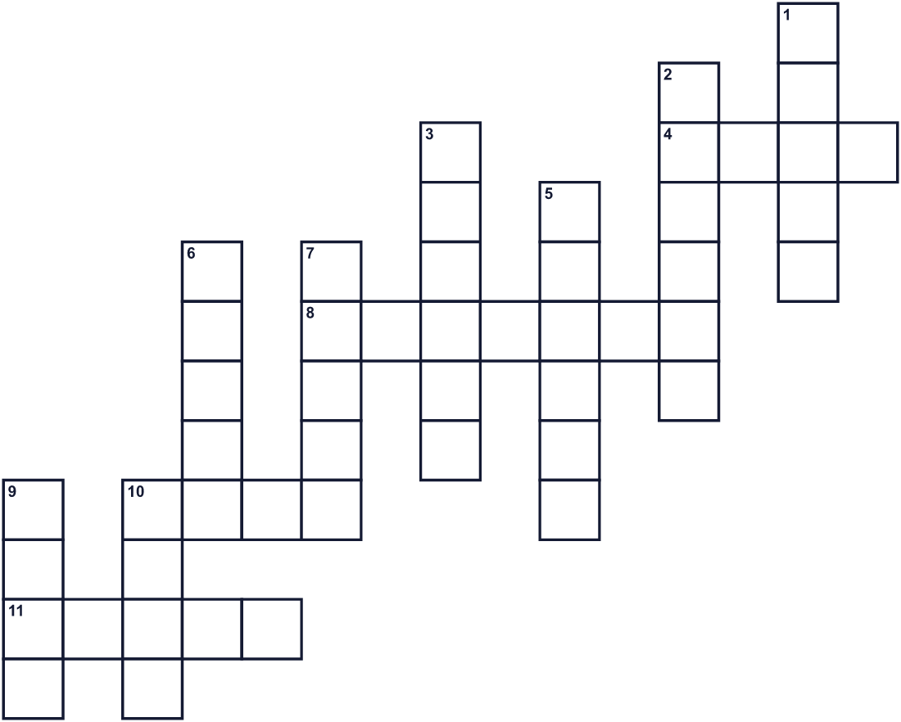
Across →
4. A light red color. (4)
8. A light with paper around it. It hangs in trees at night. (7)
10. Before cherry trees, people in Japan looked at this flower. (4)
11. The blossoms move in this direction in Japan. (5)
Down ↓
1. Round sweet rice balls on a stick. (5)
2. The season after winter. (6)
3. A meal you eat outside in a park. (6)
5. A tree with pink flowers in spring. Its red fruit is sweet. (6)
6. One small part of a flower. It can fall like snow. (5)
7. To open as a flower. (5)
9. Moving air. It makes the flowers fall. (4)
10. A green place in a city with trees and grass. (4)

🌸 Hanami (Cherry Blossom Viewing) Worksheet
Word Search
かくれた単語をさがそう（→ ↓ ↘ ↗）
Class ______ No. ____ Name ______________________________
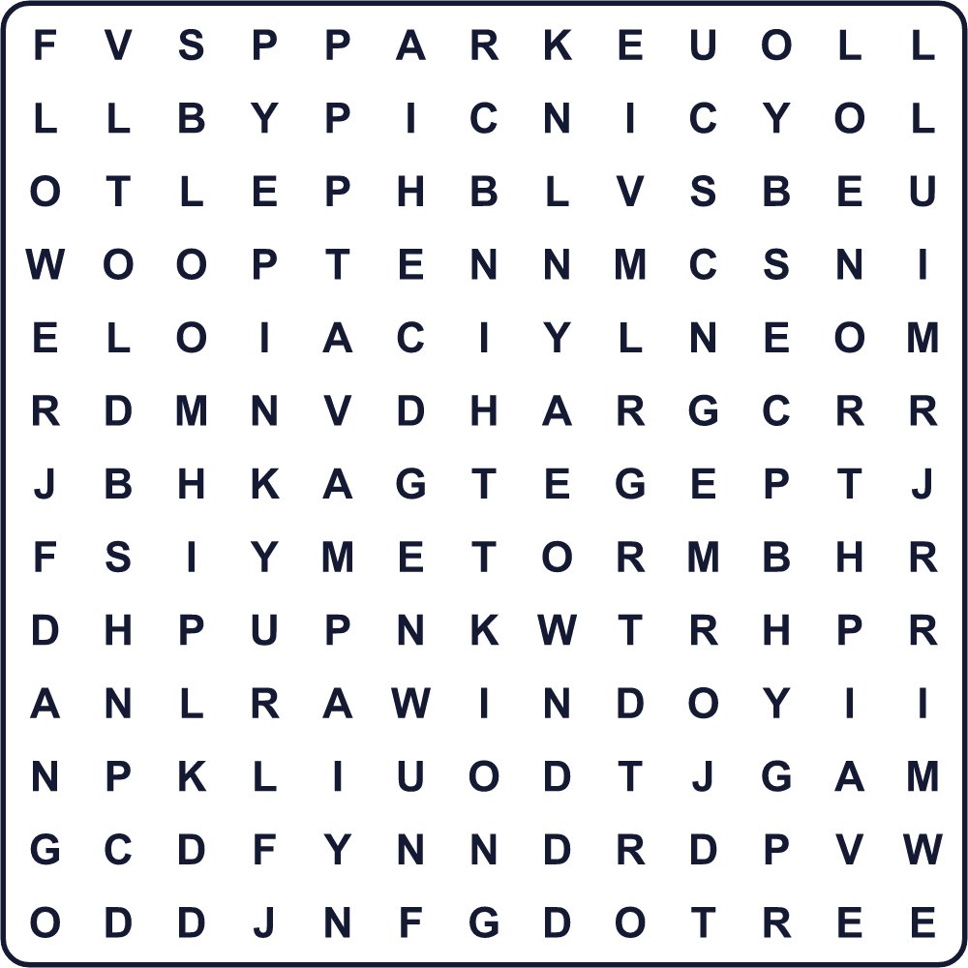
BLOOM CHERRY DANGO FLOWER LANTERN NORTH PARK PETAL PICNIC PINK PLUM SPRING TREE WIND
Secret Code 暗号を解こう
■=B ★=E ⚑=H ☂=L ◆=M ☎=O ⚓=S ◎=T
☂ ★ ◎ ⚓ ⚓ ★ ★ ◎ ⚑ ★ ■ ☂ ☎ ⚓ ⚓ ☎ ◆ ⚓
______________________________________________________________

🌸 Hanami (Cherry Blossom Viewing) Worksheet
Maze & Sentences
Class ______ No. ____ Name ______________________________
Help Sora find the biggest cherry tree! ソラがいちばん大きな桜の木を見つけられるように助けよう！
正しい道の文字を集めると、ひみつの言葉になるよ。 START 🧒 → GOAL 🌸
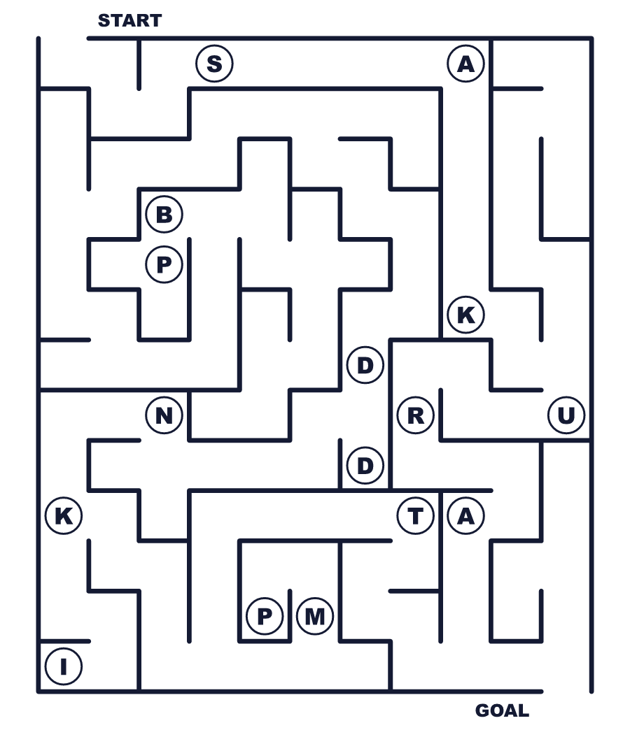
Secret word: ＿ ＿ ＿ ＿ ＿ ＿
Put the words in order. 並べかえよう。
1. under / trees / the / picnic / a / have / We . (私たちは木の下でピクニックをします。)
______________________________________________________________
2. blossoms / in / bloom / The / cherry / are / full . (桜が満開です。)
______________________________________________________________
3. petals / snow / fall / like / Pink / in / spring . (春、ピンクの花びらが雪のように散ります。)
______________________________________________________________
4. The / a / north / blossoms / like / wave / move . (桜は波のように北へ進みます。)
______________________________________________________________
5. People / with / friends / their / enjoy / hanami . (人々は友だちと花見を楽しみます。)
______________________________________________________________

🌸 Hanami (Cherry Blossom Viewing) Worksheet
Class Activity & Writing
Class ______ No. ____ Name ______________________________
Find Someone Who… クラスで聞いて回ろう！
Find someone who … | Name
… has gone to hanami this year 今年お花見に行った
… likes hanami dango 花見団子が好き
… has seen cherry blossoms at night 夜桜を見たことがある
… knows the name of a famous cherry blossom spot 桜の名所の名前を知っている
… can say cherry blossom in English 桜を英語で言える
… has eaten sakura mochi 桜餅を食べたことがある
… likes plum flowers 梅の花が好き
… has taken a photo of cherry blossoms 桜の写真を撮ったことがある
Let's Write! 英語で書いてみよう。
My favorite place to see cherry blossoms is ______ because ______.
桜を見るのにいちばん好きな場所は______です。なぜなら______だからです。
______________________________________________________________
______________________________________________________________
If I have hanami with my friends, I want to bring ______.
友だちとお花見をするなら、______を持っていきたいです。
______________________________________________________________
______________________________________________________________
To explain hanami to a friend from abroad, I would say, "______."
海外の友だちにお花見を説明するなら「______」と言います。
______________________________________________________________
______________________________________________________________

🌸 Hanami (Cherry Blossom Viewing) Worksheet
Trace & Color
なぞって書こう。絵に色をぬろう。
Class ______ No. ____ Name ______________________________
🌸 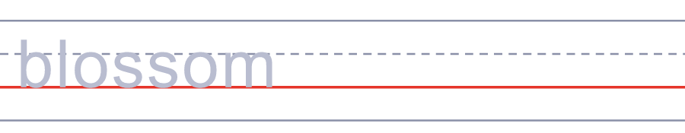

🌳 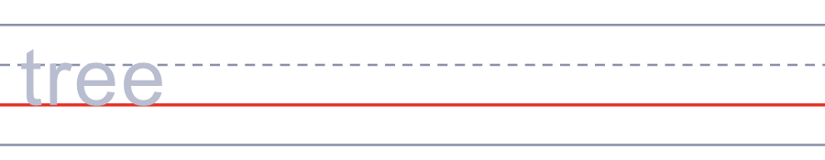
🍡 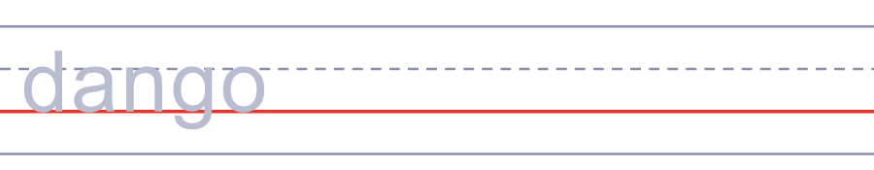
🍱 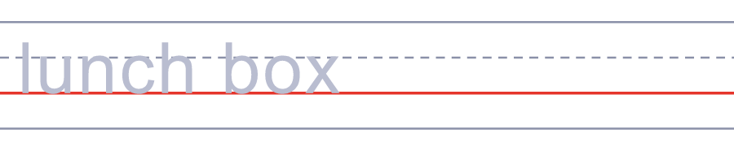
🏮 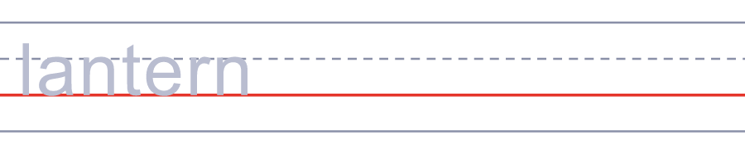
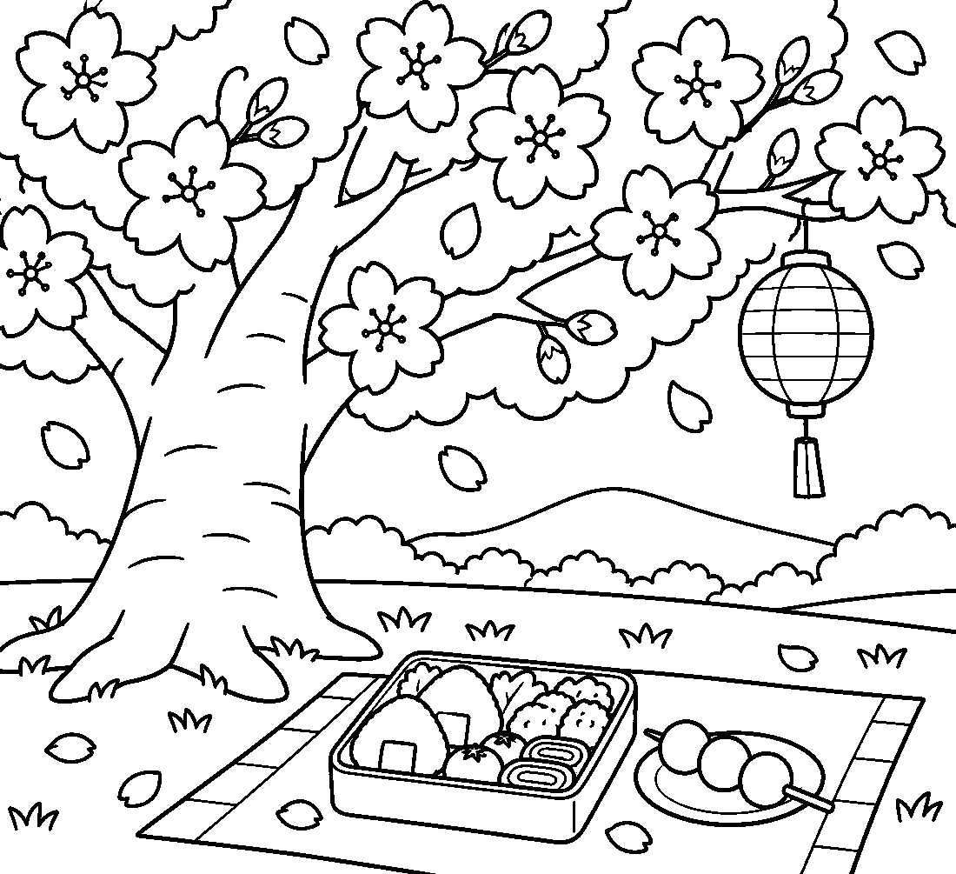

🌸 Hanami (Cherry Blossom Viewing) Worksheet
Answer Key 解答
Reading Check: 1.B 2.C 3.B 4.D 5.A 6.C 7.B 8.C
True or False: 1.T 2.F 3.T 4.F 5.T 6.F
Match: 🌸=blossom 🌳=tree 🍡=dango 🍱=lunch box 🏮=lantern 📷=camera 🌙=night 💨=wind
Unscramble: 1.CHERRY 2.PETAL 3.BLOOM 4.PICNIC 5.SPRING 6.LANTERN
Fill in the blanks: (1)park (2)bloom (3)sheet (4)lunch (5)dumplings (6)wind (7)petals (8)photos (9)evening (10)again
Sentence order: 1. We have a picnic under the trees. 2. The cherry blossoms are in full bloom. 3. Pink petals fall like snow in spring. 4. The blossoms move north like a wave. 5. People enjoy hanami with their friends.
Secret Code: LETS SEE THE BLOSSOMS
Maze: SAKURA
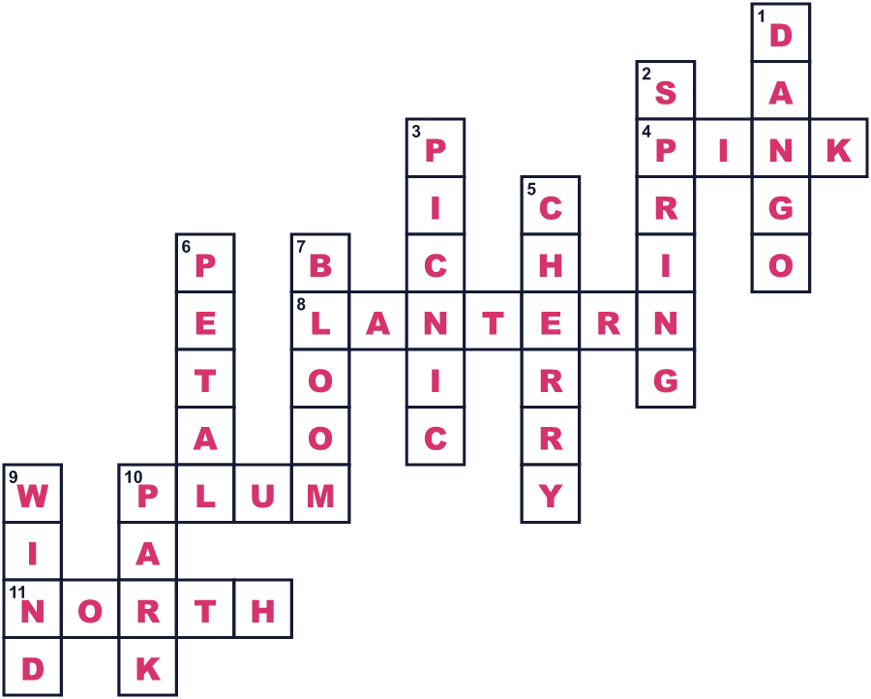
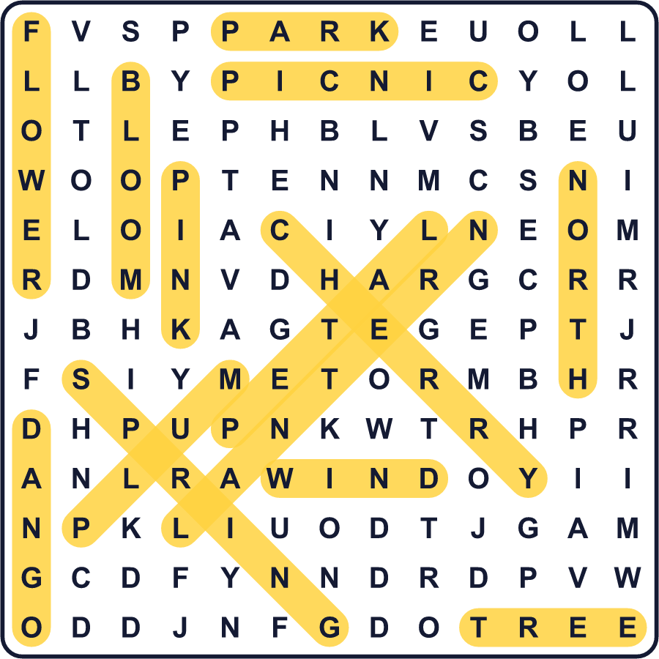
全訳
1 毎年春になると、日本の公園はピンク色に染まります。何千本もの桜がほぼ同時に咲くのです。人々は木の下に青いシートを広げ、家族や友だち、同僚とピクニックをします。これを花見、つまり花をながめることと言います。夜にもう一度来て、ぼんぼりの明かりの下で花を見る人もいます。
2 花見はとても古い習慣です。でも最初は、人々は桜ではなく梅の花を見ていました。812年、ある天皇が京都で桜の下の宴を開きました。それ以来、桜が日本でいちばん愛される花になりました。その後1700年代に、ある将軍が江戸に桜を植え、ふつうの人々も楽しめるようにしました。
3 今の日本の桜の多くは、ソメイヨシノという種類です。そのすべてが、たった1本の木から生まれました。植木職人たちは、その枝をほかの木につないで、何度も何度も増やしたのです。だから、ひとつの町の桜はいっしょに咲いて、いっしょに散るのです。
4 桜の花は、波のように北へ進んでいきます。沖縄では1月に、北海道の北部では5月に咲きます。東京では、ふつう3月下旬か4月上旬がいちばんの見ごろです。2026年、東京の桜は3月28日に満開になりました。気象庁は特別な標本木を観察し、咲いたらみんなに知らせます。
5 花びらがピンクの雪のように散るまで、花は1週間ほどしか持ちません。だから人々は立ち止まり、見上げて、その瞬間を楽しみます。昔のことわざのとおり、今でも花より団子という人もいますが。

