🎆 Summer Festivals & Fireworks Worksheet
Tamaya! A Summer Night by the River
Read the story. 英文を読もう。
Class ______ No. ____ Name ______________________________

🔊 音声を聞こう（スマホで読みとってね）
1 On the last Saturday of July, hundreds of thousands of people come to the Sumida River in Tokyo. Many of them wear yukata, light cotton kimono for summer. At seven o'clock, the first firework flies up. Boom! A huge flower of light opens in the dark sky. The sound shakes the ground, and the crowd says, "Ooh!"
2 These fireworks have a long story. In the Edo period, people watched fireworks over the river near Ryogoku Bridge. Two fireworks makers, Kagiya and Tamaya, tried to make the best show. When people loved a firework, they shouted, "Tamaya!" or "Kagiya!" Tamaya's business ended after a fire in 1843, but people still shout its name today.
3 The fireworks stopped after 1961 because of heavy traffic. Many years later, in 1978, they came back with a new name, the Sumida River Fireworks Festival. Now about 20,000 fireworks light up the sky in 90 minutes. Two teams launch them from two places on the river. In 2023, more than one million people came to watch.
4 Fireworks are only one part of a Japanese summer. Towns also have summer festivals with drums, dancing and food stalls. Some of these festivals are very old. People say the Gion Festival in Kyoto began in 869, when they prayed to stop a sickness. Children try to catch goldfish with paper scoops, and people eat shaved ice on the street. When the last firework fades, everyone walks home slowly. The sound of the drums is still in their ears.
Words 単語
firework（花火） / light（軽い） / shout（叫ぶ、大声で言う） / maker（作る人、メーカー） / traffic（交通、人や車の流れ） / stall（屋台、売店） / scoop（すくう道具、ひとすくい） / fade（（光・色・音が）しだいに消える）

🎆 Summer Festivals & Fireworks Worksheet
Reading Check
Choose the best answer. 正しいものを選ぼう。
Class ______ No. ____ Name ______________________________
1. What is the reading mainly about?
(A) How to make fireworks at home (B) Fireworks and summer festivals in Japan (C) A famous festival in the United States (D) Why people stopped wearing yukata
2. Why did the fireworks stop after 1961?
(A) Because of heavy traffic (B) Because of a big fire (C) Because of bad weather (D) Because people did not like them
3. About how many fireworks go up at the festival now?
(A) About 90 (B) About 1,978 (C) About 1 million (D) About 20,000
4. Why do people still shout "Tamaya!" today?
(A) Because Tamaya makes all the fireworks today (B) Because it means "Good night" in Japanese (C) Because it became a tradition from the Edo period (D) Because the government asks them to
5. In the dialogue, when do people in America usually watch fireworks, according to Sarah?
(A) On July 4 (B) All summer (C) On New Year's Day only (D) On the last Saturday of July
True or False? T か F に○
1. The Sumida River Fireworks Festival is on the last Saturday of July. T / F
2. The Tamaya shop still makes fireworks today. T / F
3. The fireworks stopped for many years after 1961. T / F
4. Yukata are heavy winter clothes. T / F

🎆 Summer Festivals & Fireworks Worksheet
Word Work
単語のれんしゅう
Class ______ No. ____ Name ______________________________
① Match the pictures and the words. 絵と単語を線でむすぼう。
🎆 | ● | ● | drum
👘 | ● | ● | fireworks
🏮 | ● | ● | fish
🥁 | ● | ● | lantern
🐟 | ● | ● | yukata
🍧 | ● | ● | shaved ice
③ Fill in the blanks. 語群から選んで入れよう。
[ river / July / yukata / coat / firework / stall / night / Tamaya / snow / morning / ice ]
It was a hot Saturday in (1) __________ . Grandma helped me put on a blue (2) __________ . We walked to the (3) __________ with Dad. At a food (4) __________ , I bought shaved (5) __________ . Then, boom! The first (6) __________ opened like a big flower. Dad shouted, " (7) __________ !" I shouted it too. It was the best (8) __________ of my summer.

🎆 Summer Festivals & Fireworks Worksheet
Crossword Puzzle
ヒントを読んでクロスワードを完成させよう。
Class ______ No. ____ Name ______________________________
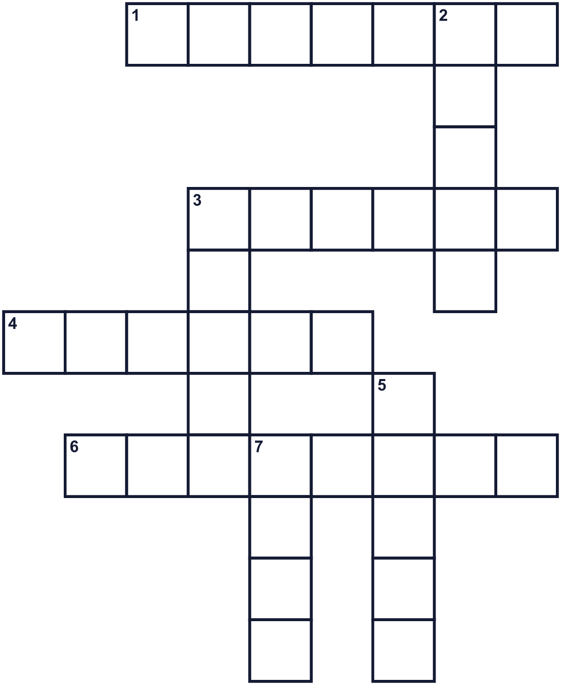
Across →
1. A paper light that hangs at a festival. (7)
3. The hot season after spring. (6)
4. A light cotton kimono for summer. (6)
6. A small orange pet that swims in water. (8)
Down ↓
2. Water that flows to the sea. The Sumida is one in Tokyo. (5)
3. A small shop on the street that sells food. (5)
5. The dark time after the sun goes down. (5)
7. You hit it to make a boom sound at a festival. (4)

🎆 Summer Festivals & Fireworks Worksheet
Word Search
かくれた単語をさがそう（→ ↓ ↘ ↗）
Class ______ No. ____ Name ______________________________
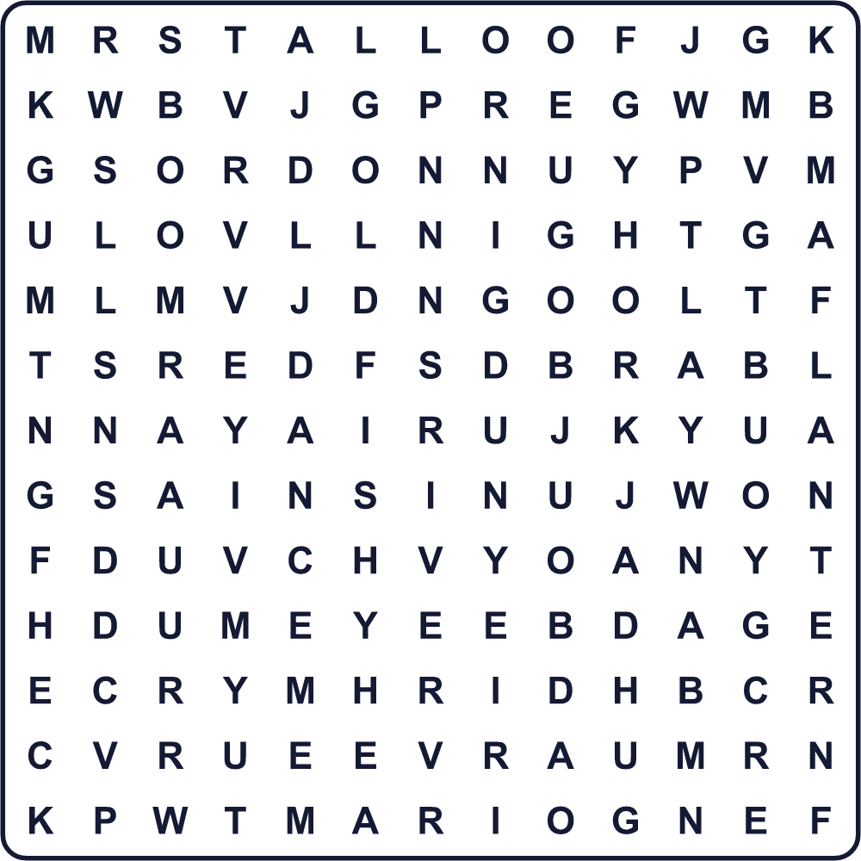
BOOM DANCE DRUM GOLDFISH LANTERN NIGHT RIVER STALL SUMMER YUKATA

🎆 Summer Festivals & Fireworks Worksheet
Maze & Sentences
Class ______ No. ____ Name ______________________________
Help Riku find a good spot for the fireworks! リクを花火のよく見える場所まで連れていこう！
正しい道の文字を集めると、ひみつの言葉になるよ。 START 🧒 → GOAL 🎆
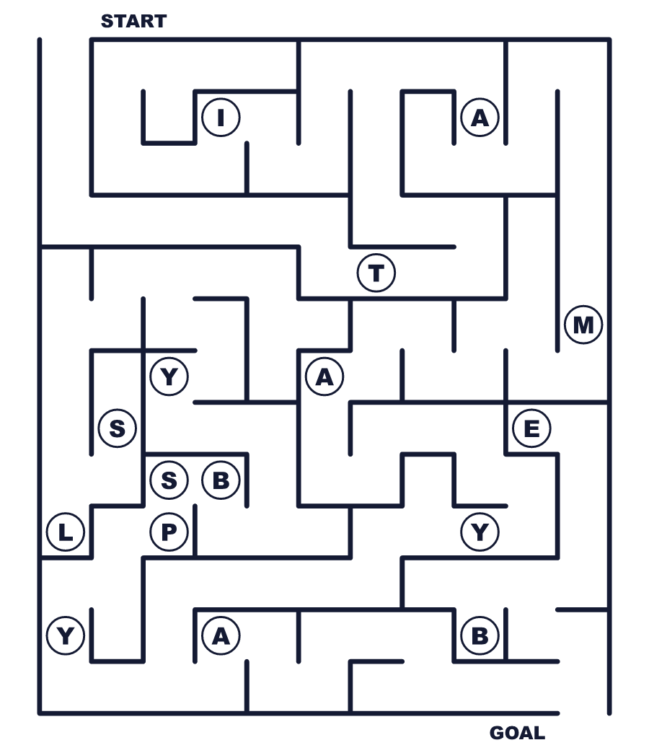
Secret word: ＿ ＿ ＿ ＿ ＿ ＿

🎆 Summer Festivals & Fireworks Worksheet
Class Activity & Writing
Class ______ No. ____ Name ______________________________
Let's Write! 英語で書いてみよう。
At a summer festival, I want to ______ because ______.
夏祭りで、私は＿＿したいです。なぜなら＿＿だからです。
______________________________________________________________
______________________________________________________________
If I make a new shout for fireworks, it will be "______!" because ______.
花火の新しいかけ声を作るなら「＿＿！」にします。なぜなら＿＿だからです。
______________________________________________________________
______________________________________________________________

🎆 Summer Festivals & Fireworks Worksheet
Trace & Color
なぞって書こう。絵に色をぬろう。
Class ______ No. ____ Name ______________________________
🎆 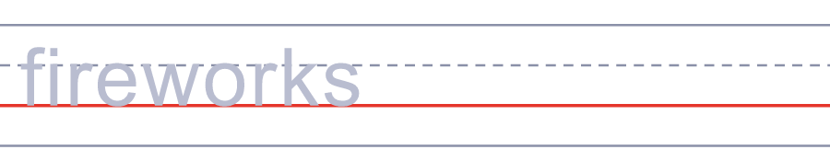

👘 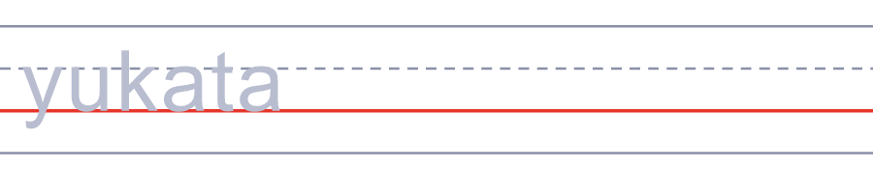
🏮 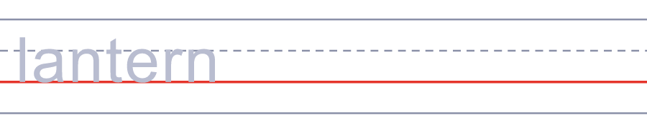
🥁 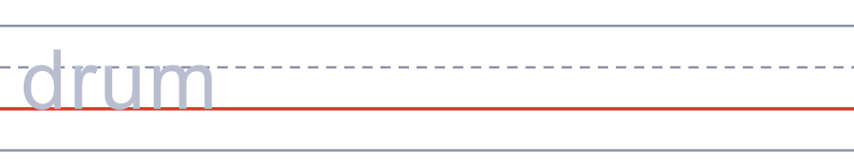
🐟 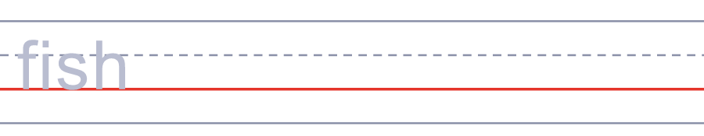

🎆 Summer Festivals & Fireworks Worksheet
Answer Key 解答
Reading Check: 1.B 2.A 3.D 4.C 5.A
True or False: 1.T 2.F 3.T 4.F
Match: 🎆=fireworks 👘=yukata 🏮=lantern 🥁=drum 🐟=fish 🍧=shaved ice
Fill in the blanks: (1)July (2)yukata (3)river (4)stall (5)ice (6)firework (7)Tamaya (8)night
Maze: TAMAYA
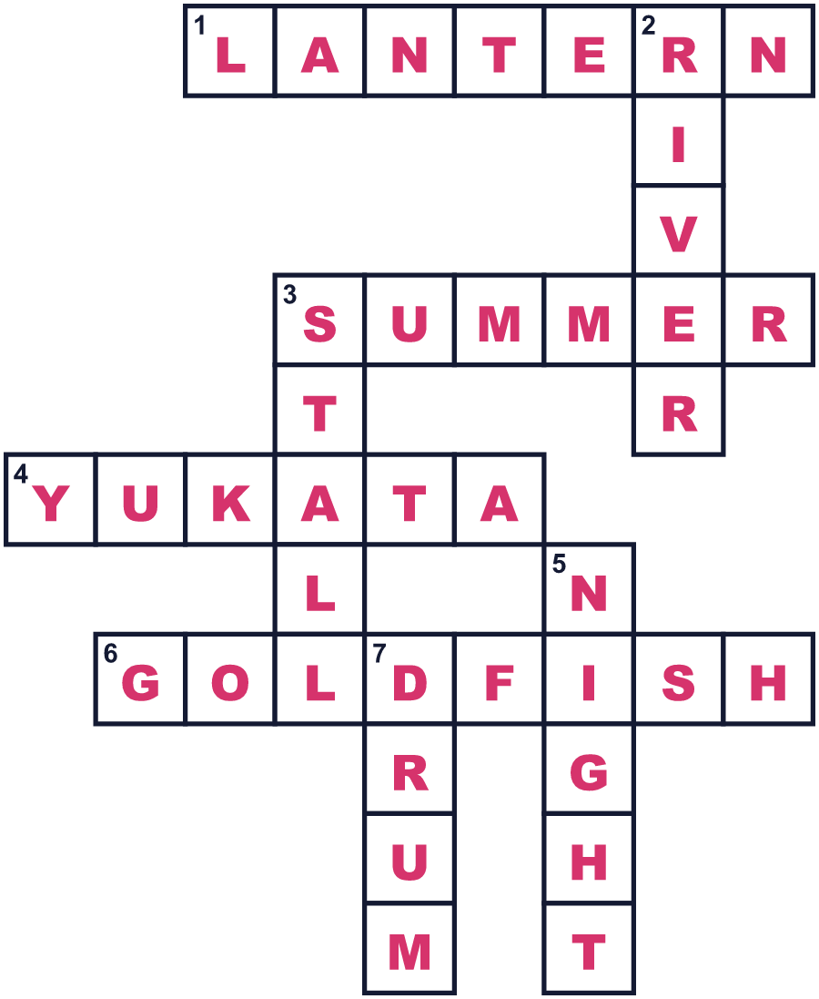
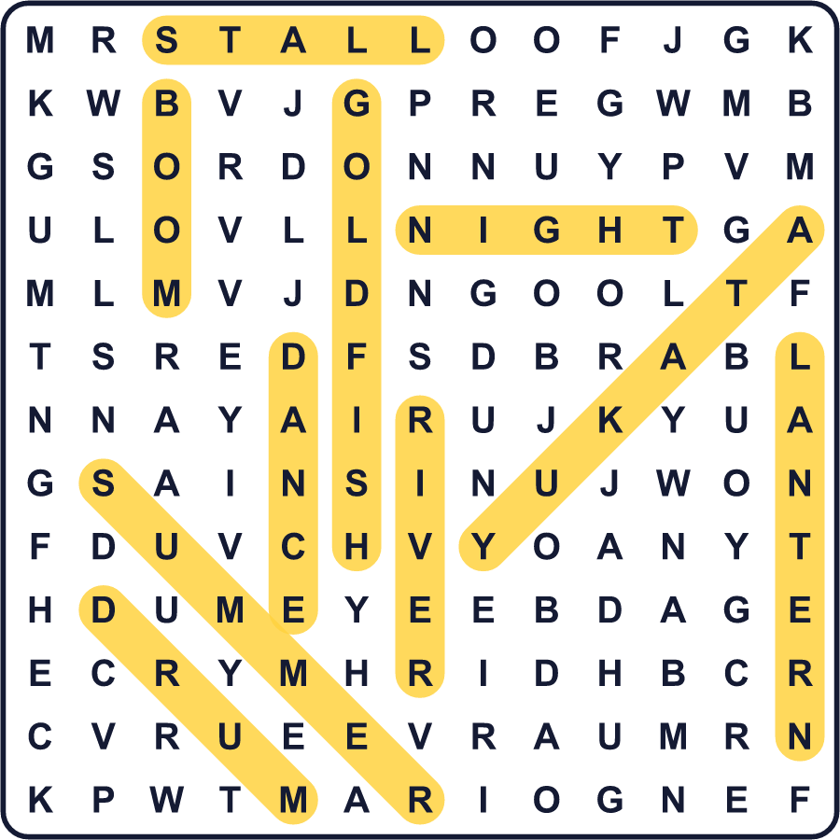
全訳
1 7月の最終土曜日、何十万もの人が東京の隅田川にやってきます。その多くが、夏用の軽い木綿の着物である浴衣を着ています。7時、最初の花火が打ち上がります。ドーン！暗い空に大きな光の花が開きます。音が地面をゆらし、観客は「おお〜！」と声を上げます。
2 この花火には長い物語があります。江戸時代、人々は両国橋の近くで川の上の花火を見ました。鍵屋と玉屋という二つの花火屋が、最高の花火を見せようと競いました。人々は花火が気に入ると「たまや！」「かぎや！」と叫びました。玉屋は1843年の火事のあと店を閉じましたが、人々は今もその名前を叫びます。
3 花火は、ひどい交通渋滞のために1961年を最後に中止されました。何年もたった1978年、隅田川花火大会という新しい名前で復活しました。今では、90分間に約2万発の花火が空を照らします。二つのチームが、川の二か所から打ち上げます。2023年には、100万人以上が見に来ました。
4 花火は日本の夏のほんの一部です。町には、太鼓や踊りや屋台のある夏祭りもあります。こうした祭りの中には、とても古いものもあります。京都の祇園祭は、人々が病気の流行を止めようと祈った869年に始まったと言われます。子どもたちは紙のすくい網で金魚をすくおうとし、人々は道でかき氷を食べます。最後の花火が消えると、みんなゆっくり歩いて家に帰ります。太鼓の音がまだ耳に残っています。

