🎃 Halloween Worksheet
From Turnips to Pumpkins
Read the story. 英文を読もう。
Class ______ No. ____ Name ______________________________
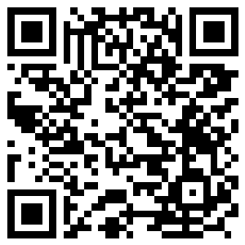
🔊 音声を聞こう（スマホで読みとってね）
1 The first jack-o'-lanterns were not made from pumpkins. They were made from turnips, a hard white vegetable. People in Ireland and Scotland carved scary faces into them and put a candle inside. Today, Halloween is on October 31, and people celebrate it all around the world.
2 Halloween began with an old festival called Samhain. It marked the end of the harvest and the start of the long, dark winter. On that night, people lit big fires. Many believed that spirits and fairies could visit our world. So they left food and drink outside to keep them happy.
3 Later, the church made November 1 a day for all the saints. In old English, a saint was called a hallow. So the night before became All Hallows' Eve. People in Scotland made the name shorter, and it became Halloween.
4 In the 1800s, many Irish and Scottish families moved to North America. They brought their Halloween games with them. In their new home, they found the pumpkin, which was big and easy to carve. In 1917, a newspaper in Canada wrote about children who shouted, Tricks or treats! It is the oldest record of those famous words.
5 Today, about three out of four Americans join the fun. Children knock on doors in costumes, and adults decorate their yards with ghosts and skeletons. In 2026, Americans are expected to spend 13.5 billion dollars on Halloween. But the heart of the night is still the same as long ago. It is a little fear, a lot of fun, and a small light in the dark.
Words 単語
turnip（カブ） / carve（彫る、刻む） / festival（祭り） / harvest（収穫、取り入れ） / spirit（霊、精霊） / fairy（妖精） / saint（聖人） / costume（仮装、衣装） / decorate（飾る） / skeleton（骸骨、骨格） / celebrate（祝う） / expect（予想する、見込む）

🎃 Halloween Worksheet
Reading Check
Choose the best answer. 正しいものを選ぼう。
Class ______ No. ____ Name ______________________________
1. What is the main idea of the passage?
(A) Halloween is a new holiday from America. (B) Halloween grew from old Irish and Scottish customs. (C) Pumpkins are the best vegetable for cooking. (D) People in Canada do not like Halloween.
2. What were the first jack-o'-lanterns made from?
(A) Pumpkins (B) Apples (C) Paper (D) Turnips
3. What did Samhain mark?
(A) The end of the harvest and the start of winter (B) The first day of spring (C) The birthday of a famous saint (D) The day people moved to America
4. Where and when do we find the oldest record of the words trick or treat?
(A) In Ireland in 1785 (B) In a Canadian newspaper in 1917 (C) In Scotland in the 1800s (D) In an American book in 2026
5. In paragraph 4, the word carve is closest in meaning to ___.
(A) to cook (B) to buy (C) to cut a shape into (D) to paint
6. Which is true according to the passage?
(A) Hallow was an old word for saint. (B) People in Samhain times never lit fires. (C) Halloween is on November 1. (D) Only children celebrate Halloween in America.
7. Why did people probably leave food outside on Samhain?
(A) Because they had too much food (B) Because they were afraid of the spirits and wanted to stay safe (C) Because they wanted to feed their pets (D) Because the church told them to
8. In the dialogue, why is Sota surprised?
(A) Because the fireworks are very loud (B) Because Aoife is from America (C) Because he does not like turnips (D) Because he found a ring in his bread
True or False? T か F に○
1. The first jack-o'-lanterns were made from turnips. T / F
2. Halloween started in Mexico. T / F
3. The word hallow is an old word for saint. T / F
4. Halloween is a national holiday in the United States. T / F
5. The oldest record of the words trick or treat comes from Canada. T / F
6. In Australia, Halloween comes in autumn. T / F

🎃 Halloween Worksheet
Word Work
単語のれんしゅう
Class ______ No. ____ Name ______________________________
① Match the pictures and the words. 絵と単語を線でむすぼう。
🎃 | ● | ● | pumpkin
👻 | ● | ● | candle
🦇 | ● | ● | ghost
🕷️ | ● | ● | bat
🍬 | ● | ● | spider
🕯️ | ● | ● | moon
🍎 | ● | ● | candy
🌙 | ● | ● | apple
② Unscramble the words. 並べかえて単語にしよう。
1. C E O S U T M (仮装) → ____________________
2. T I P U N R (カブ) → ____________________
3. O T G S H (おばけ) → ____________________
4. A N T L E R N (ちょうちん) → ____________________
5. S P I T R I (霊) → ____________________
6. R E T A T (ごほうび、お菓子) → ____________________
③ Fill in the blanks. 語群から選んで入れよう。
[ candy / dark / snow / rice / pumpkin / summer / Halloween / candle / carve / treat / hat / smile / witch ]
Mia lives in Chicago. This is her first (1) __________ in America. She wants to be a (2) __________ , so she makes a black (3) __________ . In the afternoon, her dad buys a big orange (4) __________ . They (5) __________ a funny face into it and put a (6) __________ inside. When it gets (7) __________ , Mia goes from door to door with her friends. At each house, they say, Trick or (8) __________ ! A kind old man gives them chocolate. Mia comes home with a bag full of (9) __________ and a very happy (10) __________ .

🎃 Halloween Worksheet
Crossword Puzzle
ヒントを読んでクロスワードを完成させよう。
Class ______ No. ____ Name ______________________________
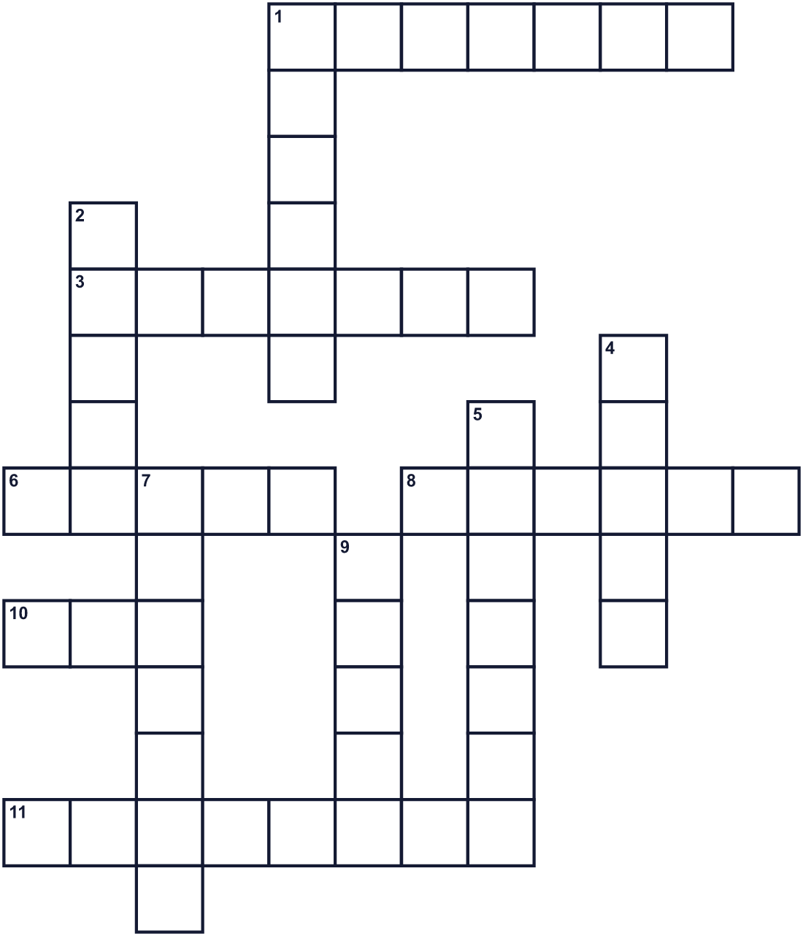
Across →
1. Special clothes you wear to look like someone else. (7)
3. The island country where Halloween began. (7)
6. The spirit of a dead person. It often looks white. (5)
8. A hard white vegetable. It was used for the first lanterns. (6)
10. A small animal with wings. It flies at night. (3)
11. All the bones of a body. People hang it on their doors in October. (8)
Down ↓
1. You light it, and it gives a small light inside a lantern. (6)
2. A woman in stories who can do magic. She flies on a broom. (5)
4. Sweet food that children get at many doors. (5)
5. A big orange vegetable. People cut faces in it. (7)
7. The month of Halloween. It comes after September. (7)
9. A very good and holy person. In old English, a hallow. (5)

🎃 Halloween Worksheet
Word Search
かくれた単語をさがそう（→ ↓ ↘ ↗）
Class ______ No. ____ Name ______________________________
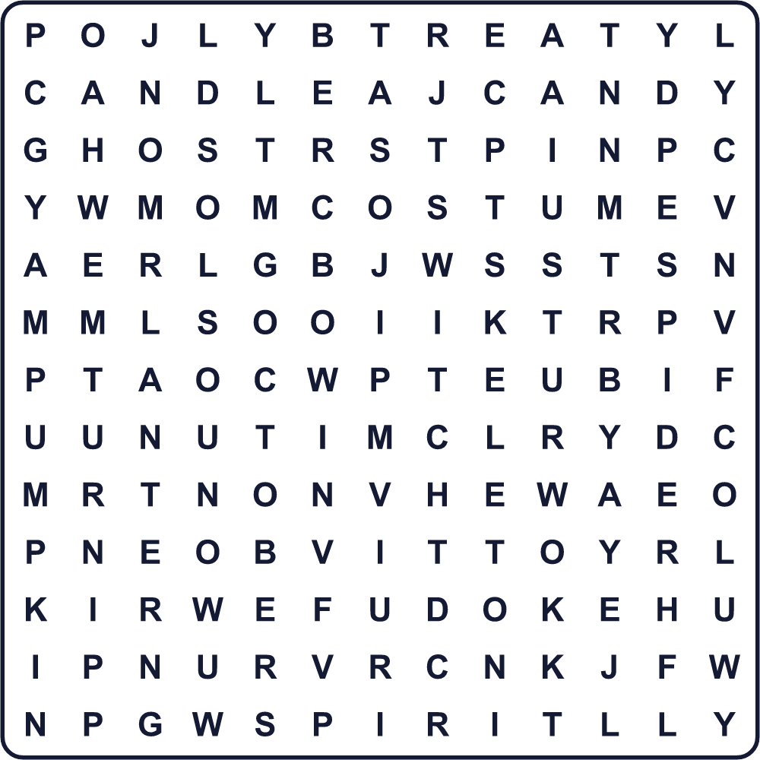
BAT CANDLE CANDY COSTUME GHOST LANTERN OCTOBER PUMPKIN SKELETON SPIDER SPIRIT TREAT TURNIP WITCH
Secret Code 暗号を解こう
✎=A ☂=C ☎=E ⚑=I ✉=K ✂=O ♪=R ☾=T
☾ ♪ ⚑ ☂ ✉ ✂ ♪ ☾ ♪ ☎ ✎ ☾
______________________________________________________________

🎃 Halloween Worksheet
Maze & Sentences
Class ______ No. ____ Name ______________________________
Help Mia get to the candy! ミアをお菓子のところまで連れていこう！
正しい道の文字を集めると、ひみつの言葉になるよ。 START 🧒 → GOAL 🍬
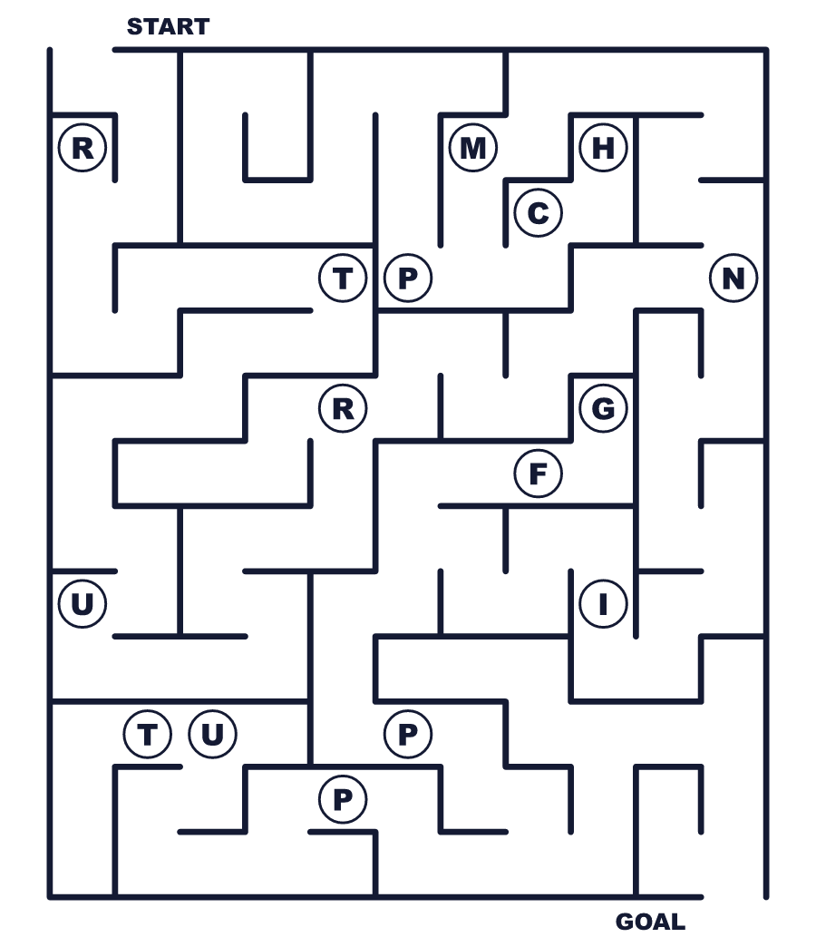
Secret word: ＿ ＿ ＿ ＿ ＿ ＿
Put the words in order. 並べかえよう。
1. to / from / door / door / go / Children . (子どもたちは家から家へ回ります。)
______________________________________________________________
2. Scotland / Ireland / Halloween / started / in / and . (ハロウィンはアイルランドとスコットランドで始まりました。)
______________________________________________________________
3. long / carved / into / People / faces / turnips / ago . (昔、人々はカブに顔を彫りました。)
______________________________________________________________
4. costume / My / this / year / cat / black / is / a . (今年の私の仮装は黒ネコです。)
______________________________________________________________
5. the / candle / put / pumpkin / a / We / inside . (私たちはかぼちゃの中にろうそくを入れます。)
______________________________________________________________

🎃 Halloween Worksheet
Class Activity & Writing
Class ______ No. ____ Name ______________________________
Find Someone Who… クラスで聞いて回ろう！
Find someone who … | Name
… has worn a costume 仮装したことがある
… has carved a pumpkin かぼちゃを彫ったことがある
… likes scary movies こわい映画が好き
… can say Happy Halloween in another language ハッピーハロウィンを別の言語で言える
… knows the meaning of the word hallow hallow の意味を知っている
… has been to a haunted house お化け屋敷に入ったことがある
… likes candy corn or caramel apples キャンディーコーンかキャラメルアップルが好き
… knows where Halloween started ハロウィンがどこで始まったか知っている
Let's Write! 英語で書いてみよう。
If I could be anything on Halloween, I would be ______ because ______.
ハロウィンに何にでもなれるなら、私は＿＿＿になりたい。なぜなら＿＿＿だから。
______________________________________________________________
______________________________________________________________
The most surprising fact about Halloween is ______.
ハロウィンについていちばんおどろいた事実は＿＿＿です。
______________________________________________________________
______________________________________________________________
If I explain Halloween to a child in Japan, I will say, ______.
日本の子どもにハロウィンを説明するなら、私は＿＿＿と言います。
______________________________________________________________
______________________________________________________________

🎃 Halloween Worksheet
Trace & Color
なぞって書こう。絵に色をぬろう。
Class ______ No. ____ Name ______________________________
🎃 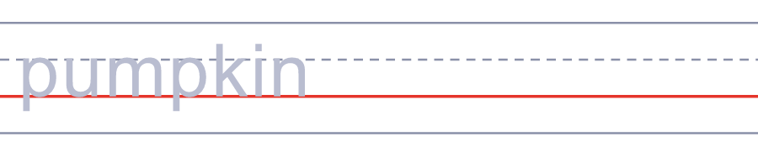

👻 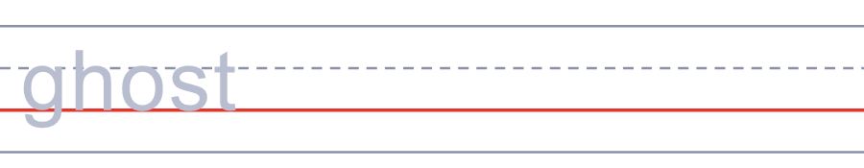
🦇 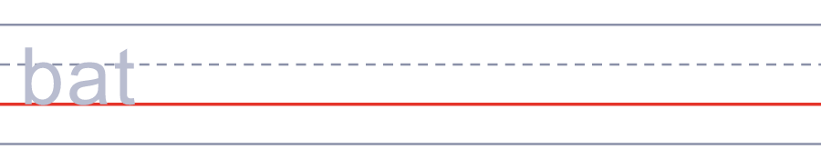
🕷️ 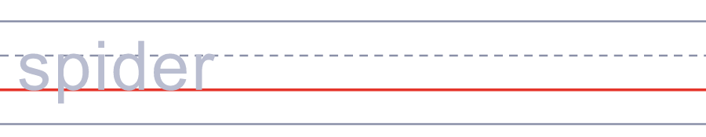
🍬 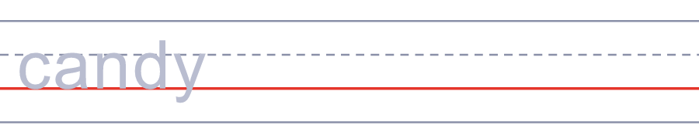
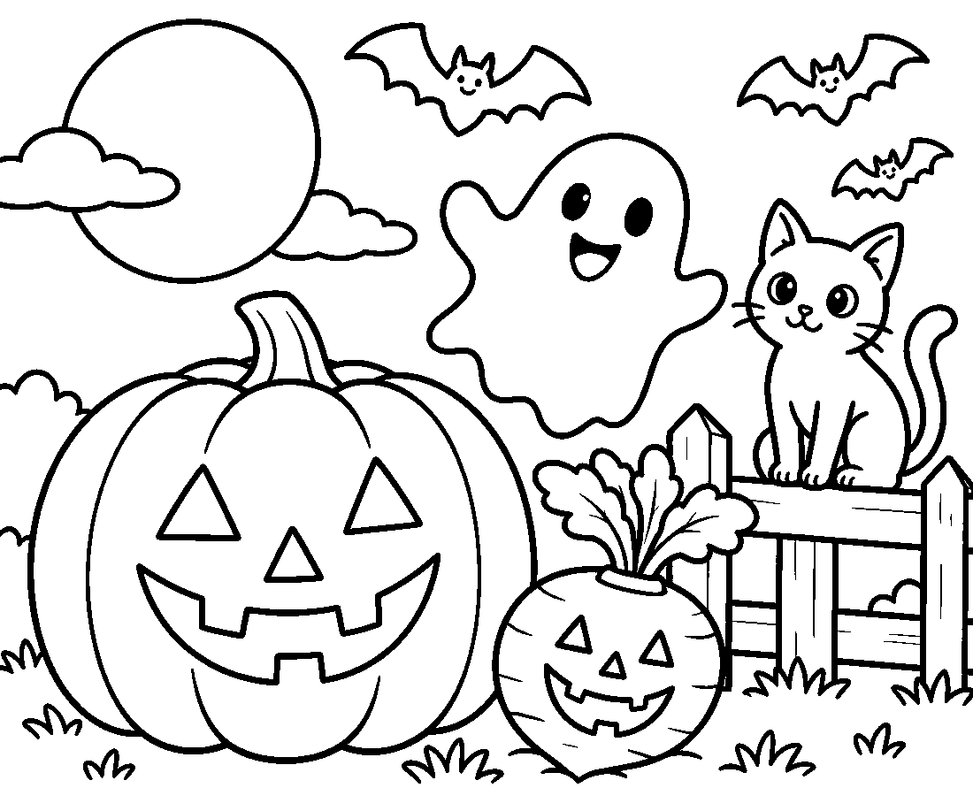

🎃 Halloween Worksheet
Answer Key 解答
Reading Check: 1.B 2.D 3.A 4.B 5.C 6.A 7.B 8.D
True or False: 1.T 2.F 3.T 4.F 5.T 6.F
Match: 🎃=pumpkin 👻=ghost 🦇=bat 🕷️=spider 🍬=candy 🕯️=candle 🍎=apple 🌙=moon
Unscramble: 1.COSTUME 2.TURNIP 3.GHOST 4.LANTERN 5.SPIRIT 6.TREAT
Fill in the blanks: (1)Halloween (2)witch (3)hat (4)pumpkin (5)carve (6)candle (7)dark (8)treat (9)candy (10)smile
Sentence order: 1. Children go from door to door. 2. Halloween started in Ireland and Scotland. 3. People carved faces into turnips long ago. 4. My costume is a black cat this year. 5. We put a candle inside the pumpkin.
Secret Code: TRICK OR TREAT
Maze: TURNIP
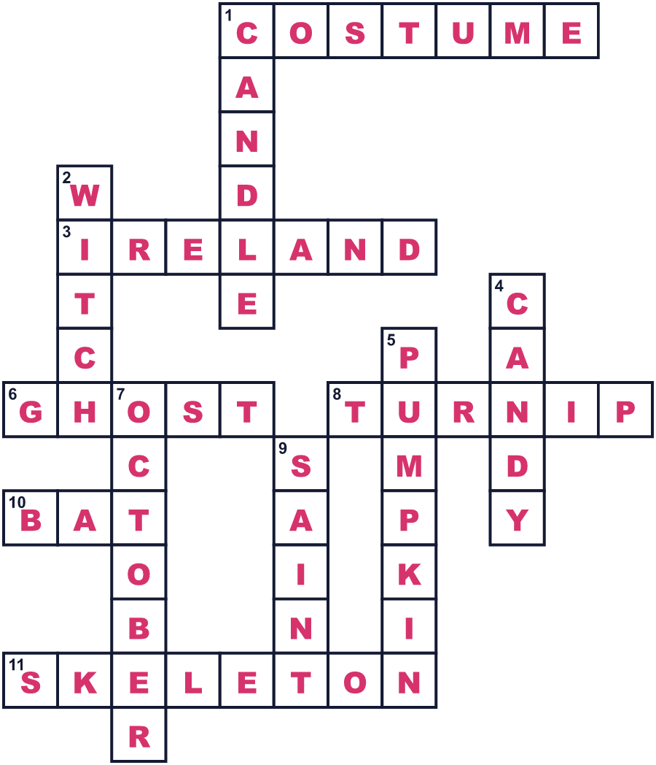
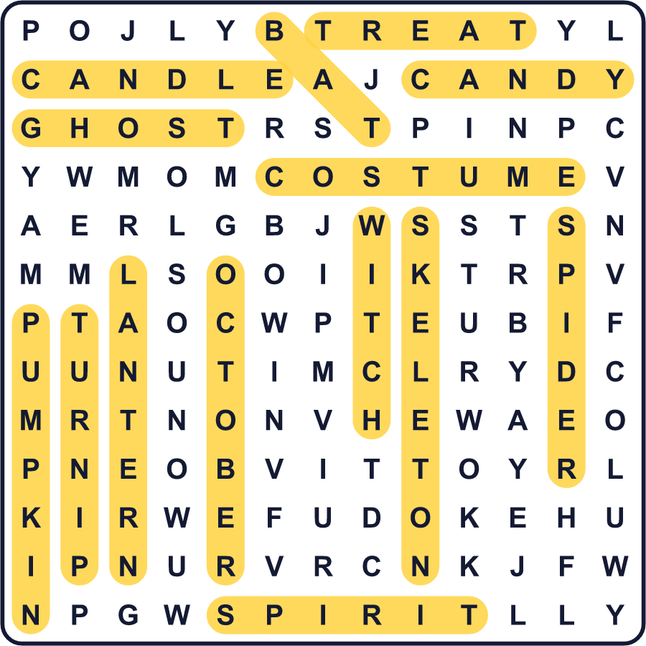
全訳
1 最初のジャック・オー・ランタンは、かぼちゃでできてはいませんでした。カブという、かたくて白い野菜でできていたのです。アイルランドやスコットランドの人々は、カブにこわい顔を彫り、中にろうそくを入れました。今、ハロウィンは10月31日にあり、世界中で祝われています。
2 ハロウィンは、サウィンという古い祭りから始まりました。それは収穫の終わりと、長く暗い冬の始まりを示す日でした。その夜、人々は大きな火をたきました。多くの人が、精霊や妖精がこの世に来られると信じていました。そこで、ごきげんをとるために、食べ物や飲み物を外に置いておきました。
3 のちに、教会は11月1日をすべての聖人のための日にしました。古い英語では、聖人は hallow と呼ばれていました。そこで、その前の晩は All Hallows' Eve（すべての聖人の日の前夜）になりました。スコットランドの人々がその名前を短くして、Halloween になりました。
4 1800年代、多くのアイルランドやスコットランドの家族が北アメリカへ移り住みました。彼らはハロウィンの遊びもいっしょに持ってきました。新しい土地で彼らが見つけたのが、大きくて彫りやすいかぼちゃでした。1917年、カナダの新聞が「お菓子をくれなきゃいたずらするぞ！」と叫ぶ子どもたちのことを書きました。それが、あの有名な言葉のいちばん古い記録です。
5 今では、アメリカ人のおよそ4人に3人がこの楽しみに加わります。子どもたちは仮装して家々のドアをノックし、大人は庭をおばけや骸骨で飾ります。2026年、アメリカ人はハロウィンに135億ドルを使うと予想されています。でも、この夜のいちばん大事なところは、昔と変わっていません。それは、ちょっぴりのこわさと、たくさんの楽しさと、暗やみの中の小さな明かりです。

