💐 Mother's Day & Father's Day in Japan Worksheet
How Mother's Day and Father's Day Came to Japan
Read the story. 英文を読もう。
Class ______ No. ____ Name ______________________________

🔊 音声を聞こう（スマホで読みとってね）
1 Many people in Japan think Mother's Day came from America after World War II. But the first event was much earlier, in 1913. An American teacher at Aoyama Gakuin, a school in Tokyo, held it. Her name was Myra Draper. America had its first Mother's Day only five years before.
2 The idea did not spread quickly. In 1931, a big women's group chose March 6 for Mother's Day. It was the birthday of the empress. But in 1932, people in Tokyo held a large Mother's Day event in May. In 1937, a candy company held a big Mother's Day party at an amusement park in Tokyo. Around 1949, the second Sunday of May became Mother's Day across Japan. Today, children give their mothers red carnations.
3 Father's Day came much later. In 1980, a Japanese businessman went to a meeting in New York and learned about it. At that time, Japan had almost no events for fathers. In 1982, his group started the Yellow Ribbon Campaign. They asked people to give presents to fathers with a yellow ribbon.
4 So in Japan, the color of Father's Day is yellow. Many people give yellow roses or sunflowers. Every June, the group also chooses famous Best Fathers of the year. Children also draw pictures of their fathers for a contest. Both days came from America, but Japan made them its own.
Words 単語
spread（広まる、広げる） / event（行事、イベント） / empress（皇后、女帝） / carnation（カーネーション） / businessman（実業家、会社員） / campaign（（社会的な）運動、キャンペーン） / ribbon（リボン） / sunflower（ヒマワリ）

💐 Mother's Day & Father's Day in Japan Worksheet
Reading Check
Choose the best answer. 正しいものを選ぼう。
Class ______ No. ____ Name ______________________________
1. What is the main idea of the passage?
(A) Mother's Day and Father's Day came from America and changed in Japan. (B) Mother's Day started in Japan and moved to America. (C) Father's Day is older than Mother's Day in Japan. (D) Japan does not celebrate Father's Day.
2. When was the first Mother's Day event in Japan?
(A) in 1908 (B) in 1913 (C) in 1931 (D) in 1949
3. Why did a women's group choose March 6 in 1931?
(A) It was the first day of spring. (B) It was the day of the first event. (C) It was a Sunday that year. (D) It was the empress's birthday.
4. In paragraph 2, what does spread mean in the idea did not spread quickly?
(A) to be forgotten (B) to become known by many people (C) to be sold in shops (D) to be written in a book
5. What will Chloe probably do?
(A) Buy red carnations for her mother. (B) Go back to America in June. (C) Give her father a yellow rose. (D) Start a new campaign in Japan.
True or False? T か F に○
1. The first Mother's Day event in Japan was in 1913. T / F
2. Mother's Day in Japan was always in May. T / F
3. In Japan, yellow is the color of Father's Day. T / F
4. Father's Day came to Japan before Mother's Day. T / F

💐 Mother's Day & Father's Day in Japan Worksheet
Word Work
単語のれんしゅう
Class ______ No. ____ Name ______________________________
① Match the pictures and the words. 絵と単語を線でむすぼう。
🌹 | ● | ● | sunflower
🌻 | ● | ● | present
🎁 | ● | ● | cake
💌 | ● | ● | letter
👔 | ● | ● | rose
🎂 | ● | ● | tie
③ Fill in the blanks. 語群から選んで入れよう。
[ winter / happy / black / you / card / June / carnations / yellow ]
In May, Saki buys red (1) __________ for her mother. She writes a (2) __________ that says, "Thank you for everything." Her mother smiles and puts the flowers in a vase. In (3) __________ , it is Father's Day. Saki gives her father a (4) __________ rose. He is very (5) __________ . Saki thinks, "I want to say thank (6) __________ more often."

💐 Mother's Day & Father's Day in Japan Worksheet
Crossword Puzzle
ヒントを読んでクロスワードを完成させよう。
Class ______ No. ____ Name ______________________________
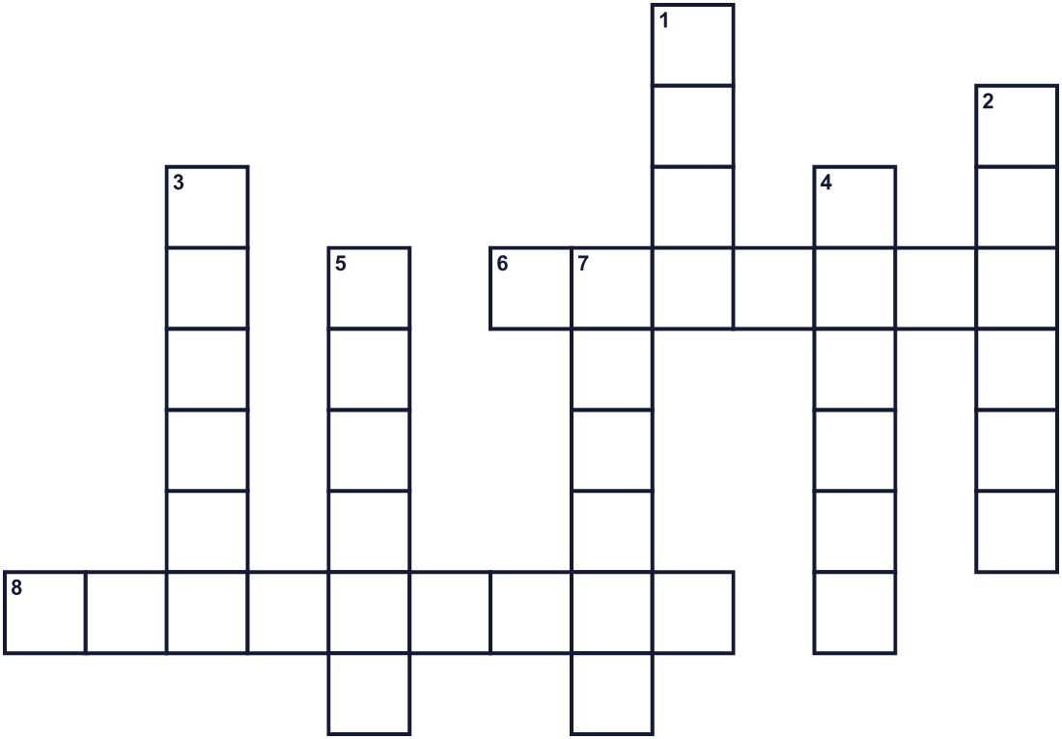
Across →
6. A gift for someone. (7)
8. A red flower for moms in May. (9)
Down ↓
1. The sixth month of the year. (4)
2. Your mom. (6)
3. Your dad. (6)
4. The color of a lemon. (6)
5. The first day of the week. There is no school. (6)
7. You tie it on a present. (6)

💐 Mother's Day & Father's Day in Japan Worksheet
Word Search
かくれた単語をさがそう（→ ↓ ↘ ↗）
Class ______ No. ____ Name ______________________________
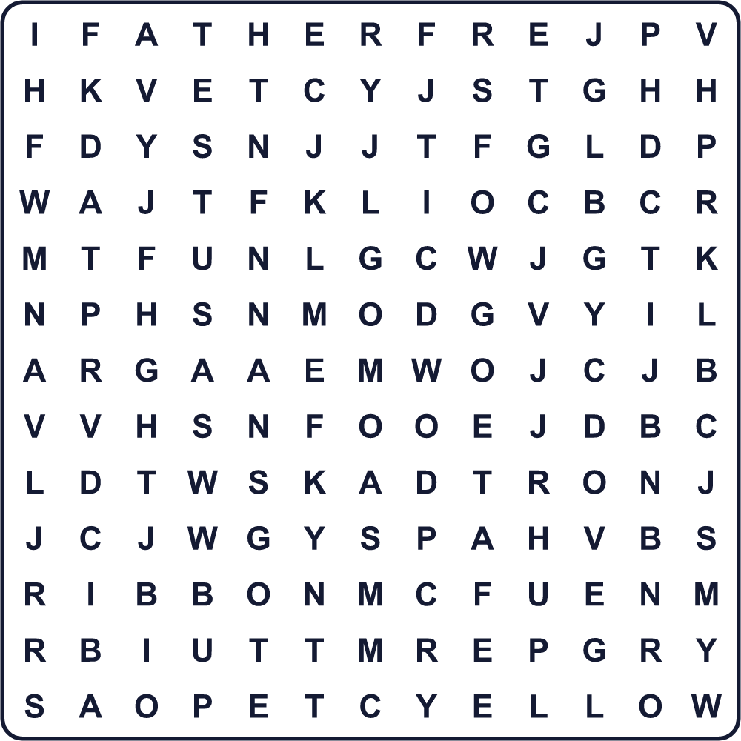
CARD FATHER FLOWER GIFT JUNE MAY MOTHER RIBBON THANKS YELLOW

💐 Mother's Day & Father's Day in Japan Worksheet
Maze & Sentences
Class ______ No. ____ Name ______________________________
Help Ken bring the flowers to his mom! ケンがお母さんに花を届けられるように助けよう！
正しい道の文字を集めると、ひみつの言葉になるよ。 START 👦 → GOAL 💐
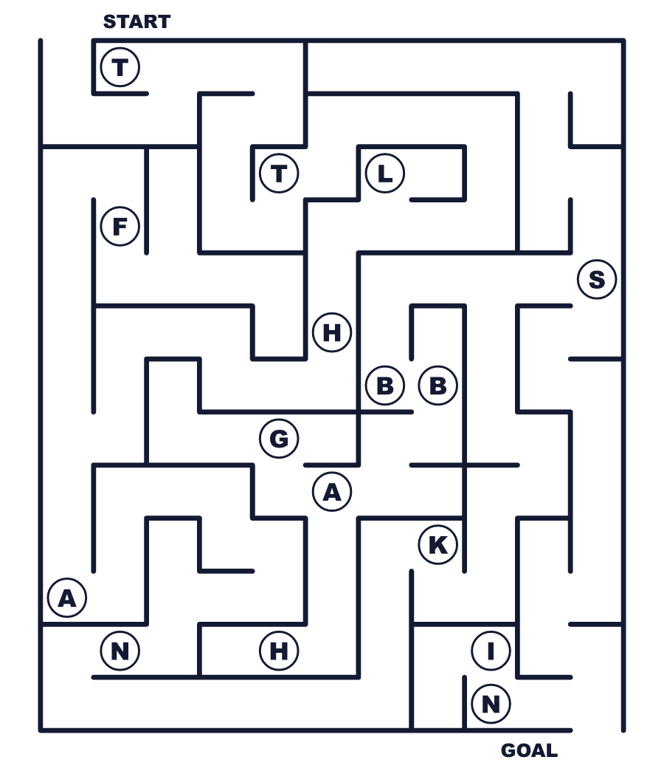
Secret word: ＿ ＿ ＿ ＿ ＿ ＿

💐 Mother's Day & Father's Day in Japan Worksheet
Class Activity & Writing
Class ______ No. ____ Name ______________________________
Let's Write! 英語で書いてみよう。
I want to thank my ______ because ______.
私は______に感謝したいです。なぜなら______だからです。
______________________________________________________________
______________________________________________________________
On Mother's Day or Father's Day, I will ______.
母の日か父の日に、私は______します。
______________________________________________________________
______________________________________________________________

💐 Mother's Day & Father's Day in Japan Worksheet
Trace & Color
なぞって書こう。絵に色をぬろう。
Class ______ No. ____ Name ______________________________
🌹 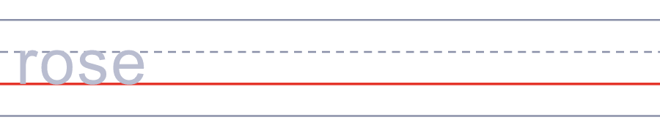

🌻 
🎁 
💌 
👔 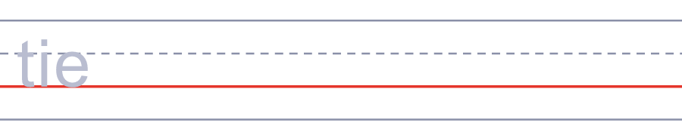

💐 Mother's Day & Father's Day in Japan Worksheet
Answer Key 解答
Reading Check: 1.A 2.B 3.D 4.B 5.C
True or False: 1.T 2.F 3.T 4.F
Match: 🌹=rose 🌻=sunflower 🎁=present 💌=letter 👔=tie 🎂=cake
Fill in the blanks: (1)carnations (2)card (3)June (4)yellow (5)happy (6)you
Maze: THANKS
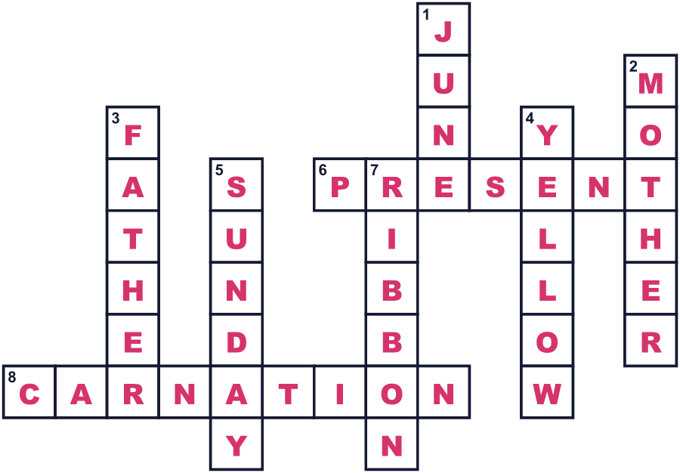
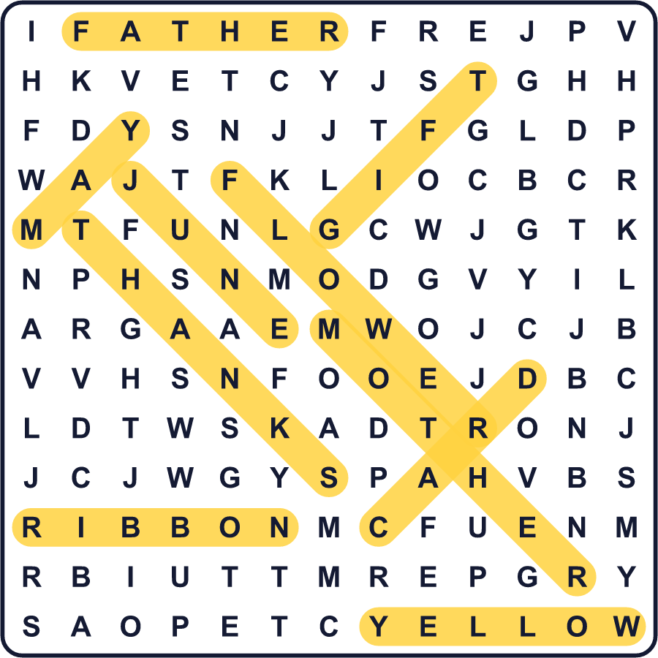
全訳
1 日本の多くの人は、母の日は第二次世界大戦のあとにアメリカから来たと思っています。でも、最初の行事はずっと早く、1913年でした。東京の学校、青山学院のアメリカ人の先生が開きました。その人の名前はマイラ・ドレーパーです。アメリカで最初の母の日が開かれたのは、そのわずか5年前でした。
2 この考えはすぐには広まりませんでした。1931年、大きな女性の団体が3月6日を母の日に選びました。それは皇后の誕生日でした。でも1932年、東京の人々は5月に大きな母の日の行事を開きました。1937年には、お菓子の会社が東京の遊園地で大きな母の日の集まりを開きました。1949年ごろ、5月の第2日曜日が日本中で母の日になりました。今では、子どもたちは母親に赤いカーネーションを贈ります。
3 父の日はずっと遅れてやって来ました。1980年、ある日本の実業家がニューヨークの会議に行き、父の日のことを知りました。そのころ、日本には父親のための行事がほとんどありませんでした。1982年、彼のグループは黄色いリボンキャンペーンを始めました。黄色いリボンをつけてお父さんに贈り物をしようと呼びかけたのです。
4 だから日本では、父の日の色は黄色なのです。黄色いバラやヒマワリを贈る人がたくさんいます。毎年6月、そのグループはその年の有名なベスト・ファーザーも選びます。子どもたちがお父さんの絵を描くコンテストもあります。どちらの日もアメリカから来ましたが、日本は自分たちのやり方に変えてきました。

