🎆 Guy Fawkes Night Worksheet
The Man in the Cellar
Read the story. 英文を読もう。
Class ______ No. ____ Name ______________________________

🔊 音声を聞こう（スマホで読みとってね）
1 Just after midnight on November 5, 1605, guards with lanterns walked into a dark room under Parliament in London. There, they found a man next to a big pile of wood. Under the wood were 36 barrels of gunpowder. The man's name was Guy Fawkes.
2 Fawkes was part of a secret group of 13 men. They were angry because Catholics were not treated fairly in England. Their plan was to blow up Parliament when King James the First was inside. But someone sent a letter to a lord and warned him to stay away. The king's men searched the building, and the plan failed.
3 That same night, people in London lit bonfires to celebrate. The king was safe! Soon, November 5 became a special day every year. Later, children began to make a doll of Fawkes, called a guy, and burn it on the fire. This is where the English word guy comes from.
4 Today, Bonfire Night is a cold, bright evening in Britain. Families wear warm hats and gloves and go to big fireworks shows in parks. They eat toffee apples and a sticky ginger cake called parkin. In the small town of Lewes, thousands of people march with burning torches.
5 It is a strange holiday when you think about it. People remember a plan that never happened, and they use gunpowder to do it. Every year, children still learn an old rhyme that begins with these famous words. Remember, remember the fifth of November.
Words 単語
plot（陰謀、たくらみ） / gunpowder（火薬） / barrel（樽） / Parliament（（イギリスの）議会） / bonfire（（屋外の）大きなたき火） / fireworks（花火） / lantern（ランタン、手さげランプ） / warn（警告する） / search（（場所を）捜索する、調べる） / fail（失敗する） / torch（たいまつ） / rhyme（わらべ歌、韻をふむ詩）

🎆 Guy Fawkes Night Worksheet
Reading Check
Choose the best answer. 正しいものを選ぼう。
Class ______ No. ____ Name ______________________________
1. What is the main idea of the passage?
(A) Bonfire Night remembers a failed plot from 1605. (B) Guy Fawkes was a famous king of England. (C) Fireworks were invented in London in 1605. (D) Lewes is the capital city of Britain.
2. What did the guards find under the wood?
(A) A secret letter (B) 36 barrels of gunpowder (C) A doll of the king (D) A big cake
3. Why were the men in the group angry?
(A) Because they had no money for fireworks (B) Because the king was too young (C) Because Catholics were not treated fairly (D) Because Parliament was too small
4. How did the plan fail?
(A) The gunpowder was too wet to use. (B) Guy Fawkes told the king about it. (C) It rained, and the fire went out. (D) Someone sent a warning letter, and the king's men searched the building.
5. In paragraph 3, the word celebrate is closest in meaning to ___.
(A) to be sad about something (B) to do something happy for a special event (C) to hide something (D) to build something
6. Which is true according to the passage?
(A) Bonfire Night is a hot summer evening. (B) The word guy comes from a doll of Guy Fawkes. (C) The plot happened in 1805. (D) Only adults can go to Bonfire Night.
7. Why does the writer call it a strange holiday?
(A) Because people celebrate a plan that did not happen, using gunpowder (B) Because it is held in the morning (C) Because nobody knows the date (D) Because it started in Japan
8. In the dialogue, why is Kenta surprised at the end?
(A) Because the parkin is too hot (B) Because the bonfire is very small (C) Because he uses the word guys every day (D) Because Olivia is from Japan
True or False? T か F に○
1. Guy Fawkes Night is on November 5. T / F
2. Guy Fawkes was the leader of the plot. T / F
3. The plotters wanted to blow up Parliament. T / F
4. Bonfire Night is a public holiday in Britain. T / F
5. The English word guy comes from Guy Fawkes. T / F
6. The plan worked, and the king died. T / F

🎆 Guy Fawkes Night Worksheet
Word Work
単語のれんしゅう
Class ______ No. ____ Name ______________________________
① Match the pictures and the words. 絵と単語を線でむすぼう。
🔥 | ● | ● | king
🎆 | ● | ● | apple
👑 | ● | ● | letter
✉️ | ● | ● | night
🏮 | ● | ● | fire
🍎 | ● | ● | gloves
🧤 | ● | ● | lantern
🌙 | ● | ● | fireworks
② Unscramble the words. 並べかえて単語にしよう。
1. F R E I N O B (たき火) → ____________________
2. T P L O (陰謀) → ____________________
3. R R A L B E (樽) → ____________________
4. A N E T R N L (ランタン) → ____________________
5. Y E R H M (わらべ歌) → ____________________
6. H O R C T (たいまつ) → ____________________
③ Fill in the blanks. 語群から選んで入れよう。
[ apple / guy / sky / bonfire / November / hat / rhyme / beach / fireworks / summer / ice cream / smiles / park ]
It is the fifth of (1) __________ . Amy puts on her warm (2) __________ and gloves. She walks to the (3) __________ with her dad. In the middle, there is a huge (4) __________ . On top of it sits a (5) __________ made of old clothes. Amy buys a toffee (6) __________ . It is sweet and sticky. At seven o'clock, the (7) __________ begin. Red and gold lights fill the dark (8) __________ . Everyone shouts, Wow! On the way home, Amy sings the old (9) __________ . Remember, remember, she sings, and her dad (10) __________ .

🎆 Guy Fawkes Night Worksheet
Crossword Puzzle
ヒントを読んでクロスワードを完成させよう。
Class ______ No. ____ Name ______________________________
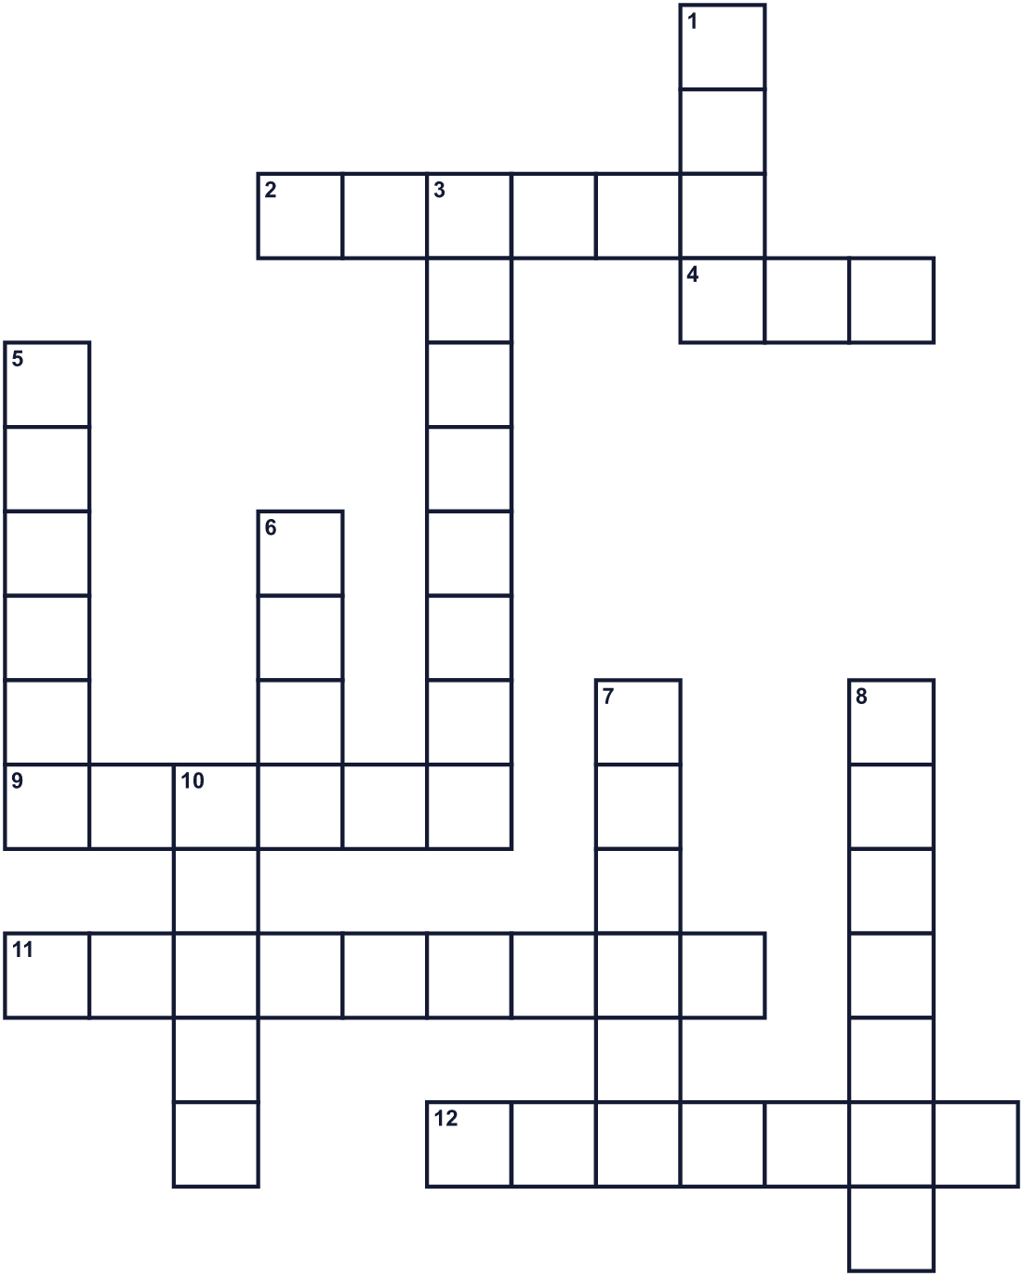
Across →
2. The capital city of England. (6)
4. A doll for the fire. Today it also means a man. (3)
9. A message on paper. One warned a lord to stay away. (6)
11. Bright lights that explode in the night sky. (9)
12. A light you can carry. The guards had one. (7)
Down ↓
1. James the First was this. He ruled England. (4)
3. The eleventh month of the year. (8)
5. A big round wooden container. There were 36 under Parliament. (6)
6. A secret plan to do something bad. (4)
7. A sticky ginger cake from the north of England. (6)
8. A big fire outside. People light one on November 5. (7)
10. A stick with fire on the end. People march with it in Lewes. (5)

🎆 Guy Fawkes Night Worksheet
Word Search
かくれた単語をさがそう（→ ↓ ↘ ↗）
Class ______ No. ____ Name ______________________________
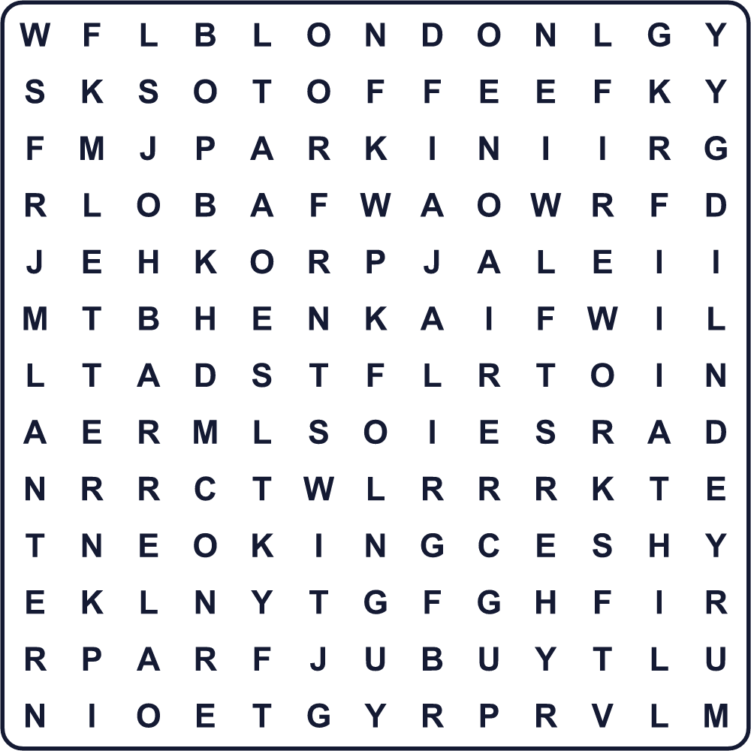
BARREL BONFIRE FIREWORKS GUY KING LANTERN LETTER LONDON PARKIN PLOT SMOKE SPARKLER TOFFEE TORCH
Secret Code 暗号を解こう
⚑=B ☘=E ♣=M ●=N ◎=O ♪=R ☃=V
♪ ☘ ♣ ☘ ♣ ⚑ ☘ ♪ ● ◎ ☃ ☘ ♣ ⚑ ☘ ♪
______________________________________________________________

🎆 Guy Fawkes Night Worksheet
Maze & Sentences
Class ______ No. ____ Name ______________________________
Help the guard find the gunpowder! 見張りを火薬のところまで連れていこう！
正しい道の文字を集めると、ひみつの言葉になるよ。 START 💂 → GOAL 🛢️
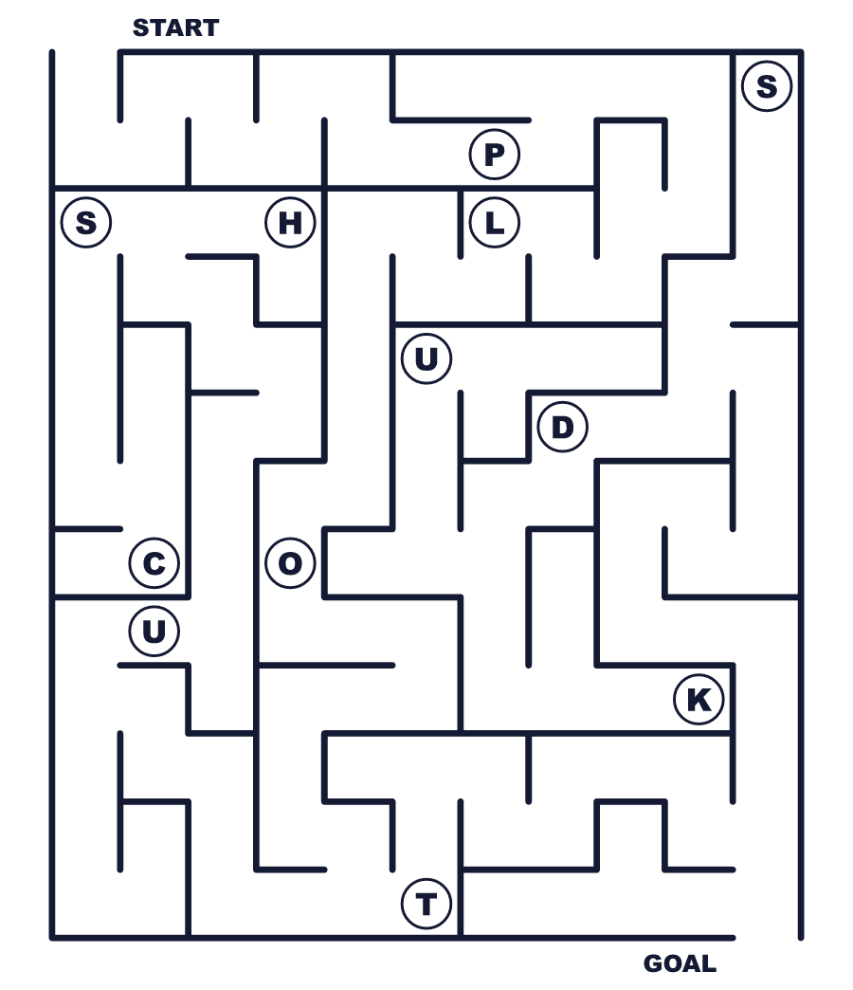
Secret word: ＿ ＿ ＿ ＿
Put the words in order. 並べかえよう。
1. Parliament / blow / wanted / up / They / to . (彼らは議会を爆破しようとしました。)
______________________________________________________________
2. The / found / guards / of / barrels / gunpowder . (見張りは火薬の樽を見つけました。)
______________________________________________________________
3. lit / bonfires / king / safe / was / the / People / because . (国王が無事だったので、人々はたき火をたきました。)
______________________________________________________________
4. We / on / fireworks / the / of / watch / fifth / November . (私たちは11月5日に花火を見ます。)
______________________________________________________________
5. comes / from / word / The / name / his / guy . (guy という言葉は彼の名前から来ています。)
______________________________________________________________

🎆 Guy Fawkes Night Worksheet
Class Activity & Writing
Class ______ No. ____ Name ______________________________
Find Someone Who… クラスで聞いて回ろう！
Find someone who … | Name
… has seen fireworks this year 今年、花火を見た
… likes ginger cake or ginger cookies ショウガのケーキかクッキーが好き
… can name the capital of the United Kingdom イギリスの首都を言える
… knows the meaning of the word plot plot という言葉の意味を知っている
… has been to a bonfire or a fire festival たき火や火祭りに行ったことがある
… uses the word guys in English 英語で guys という言葉を使う
… knows a famous event from 1605 1605年の有名な出来事を知っている
… likes toffee apples or candy apples トフィー・アップルかりんごあめが好き
Let's Write! 英語で書いてみよう。
If I went to Bonfire Night, I would ______ because ______.
もしボンファイア・ナイトに行ったら、私は＿＿＿したい。なぜなら＿＿＿だから。
______________________________________________________________
______________________________________________________________
I think people still remember the Gunpowder Plot because ______.
人々が今も火薬陰謀事件を覚えているのは＿＿＿だからだと思います。
______________________________________________________________
______________________________________________________________
One word I learned today is ______. It means ______.
今日覚えた言葉の1つは＿＿＿です。意味は＿＿＿です。
______________________________________________________________
______________________________________________________________

🎆 Guy Fawkes Night Worksheet
Trace & Color
なぞって書こう。絵に色をぬろう。
Class ______ No. ____ Name ______________________________
🔥 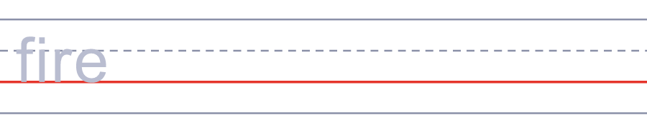

🎆 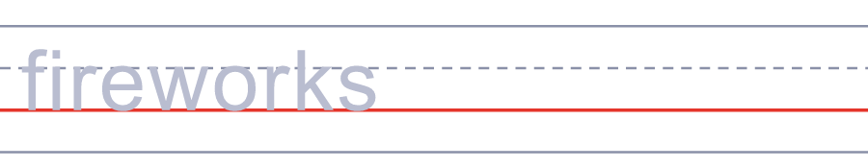
👑 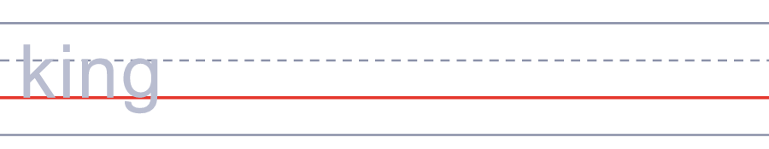
✉️ 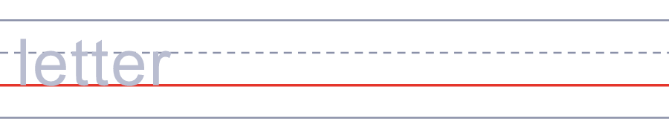
🏮 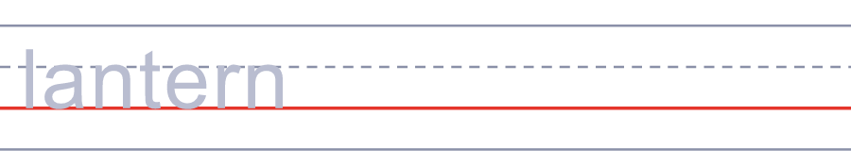
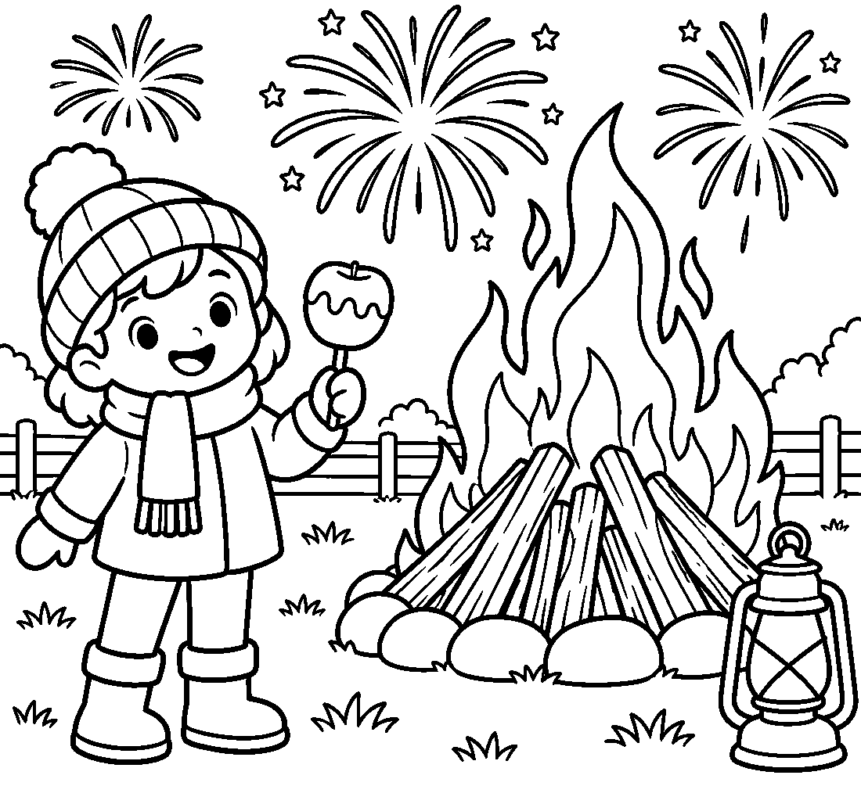

🎆 Guy Fawkes Night Worksheet
Answer Key 解答
Reading Check: 1.A 2.B 3.C 4.D 5.B 6.B 7.A 8.C
True or False: 1.T 2.F 3.T 4.F 5.T 6.F
Match: 🔥=fire 🎆=fireworks 👑=king ✉️=letter 🏮=lantern 🍎=apple 🧤=gloves 🌙=night
Unscramble: 1.BONFIRE 2.PLOT 3.BARREL 4.LANTERN 5.RHYME 6.TORCH
Fill in the blanks: (1)November (2)hat (3)park (4)bonfire (5)guy (6)apple (7)fireworks (8)sky (9)rhyme (10)smiles
Sentence order: 1. They wanted to blow up Parliament. 2. The guards found barrels of gunpowder. 3. People lit bonfires because the king was safe. 4. We watch fireworks on the fifth of November. 5. The word guy comes from his name.
Secret Code: REMEMBER NOVEMBER
Maze: PLOT
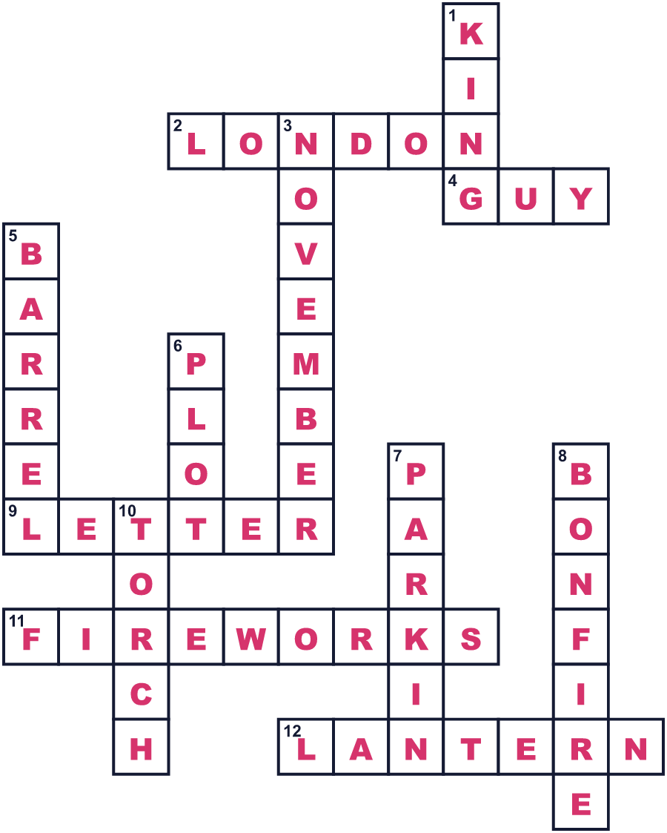
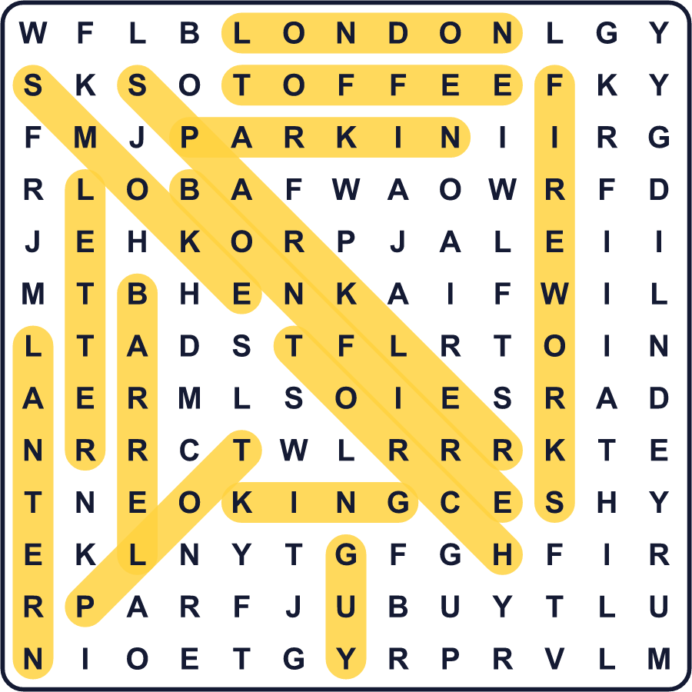
全訳
1 1605年11月5日の真夜中すぎ、ランタンを持った見張りたちが、ロンドンの国会議事堂の地下にある暗い部屋に入っていきました。そこで彼らは、大きなまきの山の横にいる1人の男を見つけました。まきの下には、36樽の火薬がありました。男の名前はガイ・フォークスでした。
2 フォークスは13人の秘密のグループの一員でした。彼らは、イングランドでカトリック教徒が公平にあつかわれていないことに怒っていました。彼らの計画は、国王ジェームズ1世が中にいるときに議会を爆破することでした。しかし、だれかがある貴族に手紙を送り、近づかないよう警告しました。国王の部下たちが建物を調べ、計画は失敗しました。
3 その日の夜、ロンドンの人々はお祝いにたき火をたきました。国王は無事だったのです！やがて、11月5日は毎年の特別な日になりました。のちに、子どもたちはガイと呼ばれるフォークスの人形を作り、火で燃やすようになりました。英語の guy という言葉は、ここから来ています。
4 今、ボンファイア・ナイトはイギリスの寒くて明るい夜です。家族は暖かい帽子と手袋をつけて、公園の大きな花火大会に出かけます。トフィー・アップルや、パーキンというしっとりしたショウガのケーキを食べます。小さな町ルイスでは、何千人もの人が燃えるたいまつを持って行進します。
5 考えてみると、これは不思議な行事です。人々は、起こらなかった計画を思い出し、しかもそのために火薬を使うのです。毎年、子どもたちは今も、こんな有名な言葉で始まる古いわらべ歌を覚えます。覚えておけ、覚えておけ、11月5日を。

