🐿️ Groundhog Day Worksheet
The Groundhog Who Is Never Wrong
Read the story. 英文を読もう。
Class ______ No. ____ Name ______________________________

🔊 音声を聞こう（スマホで読みとってね）
1 Every year on February 2, thousands of people stand in the cold in a small town in Pennsylvania. Many of them arrive in the dark, hours before sunrise. They are waiting for a groundhog. His name is Punxsutawney Phil, and people say he can tell the future.
2 The rule is simple. If Phil sees his shadow, winter will last six more weeks. If he does not see it, spring will come early. Men in tall black hats bring Phil out in front of the crowd. Their leader listens to Phil, and then another man reads the forecast to everyone.
3 This idea came from Germany. Long ago, German farmers watched a badger on February 2, a church holiday called Candlemas. When some of them moved to Pennsylvania, they used the groundhog instead. The first official Groundhog Day in Punxsutawney was in 1887.
4 Is Phil a good weather forecaster? Not really. Scientists at a U.S. government weather agency checked his forecasts. In the last ten years, he was right only about 30 percent of the time. But his fans have a funny answer. They say Phil is never wrong. The people who translate his words make the mistakes!
5 Phil is famous for another reason, too. In 1993, a movie called Groundhog Day came out. In the movie, a TV weatherman has to live February 2 again and again. And the weatherman in the movie is also named Phil! Today, people say "It's like Groundhog Day" when the same thing happens every day. So a small town's tradition gave the English language a brand-new expression.
Words 単語
groundhog（グラウンドホッグ、ウッドチャック） / shadow（影） / last（続く） / crowd（群衆、人だかり） / forecast（予報／予報する） / badger（アナグマ） / Candlemas（キャンドルマス、聖燭祭） / official（公式の） / agency（（政府の）機関） / percent（パーセント） / translate（翻訳する、通訳する） / expression（言い回し、表現）

🐿️ Groundhog Day Worksheet
Reading Check
Choose the best answer. 正しいものを選ぼう。
Class ______ No. ____ Name ______________________________
1. What is the reading mainly about?
(A) How to take care of a groundhog (B) Why winter is long in Pennsylvania (C) A groundhog tradition and why it is famous (D) How to make a weather app
2. What happens if Phil sees his shadow?
(A) Spring will come early. (B) Winter will last six more weeks. (C) There will be a big party. (D) Phil will get a new name.
3. Which animal did German farmers watch long ago?
(A) A badger (B) A deer (C) A rabbit (D) A cat
4. When was the first official Groundhog Day in Punxsutawney?
(A) In 1993 (B) In 1840 (C) In 1961 (D) In 1887
5. In paragraph 4, what does "agency" mean?
(A) A kind of animal (B) A group that does work for the government (C) A cold morning (D) A type of hat
6. Which sentence is true about the reading?
(A) Phil is right about 90 percent of the time. (B) The men around Phil wear tall black hats. (C) Groundhog Day started in France. (D) The movie came out in 1887.
7. Why do fans say the translators make the mistakes?
(A) Because the translators do not speak English (B) Because Phil cannot hear well (C) Because they want to keep the fun idea that Phil is never wrong (D) Because the government told them to say it
8. In the dialogue, how does Sota feel about Phil's accuracy?
(A) He thinks it is worse than a weather app. (B) He thinks Phil is always right. (C) He thinks it is better than the news. (D) He does not care at all.
True or False? T か F に○
1. Groundhog Day is on February 2. T / F
2. If the groundhog sees its shadow, spring will come early. T / F
3. The idea came from an old German custom. T / F
4. Phil is right almost every year. T / F
5. A famous movie about Groundhog Day came out in 1993. T / F
6. Groundhogs are a kind of pig. T / F

🐿️ Groundhog Day Worksheet
Word Work
単語のれんしゅう
Class ______ No. ____ Name ______________________________
① Match the pictures and the words. 絵と単語を線でむすぼう。
🎩 | ● | ● | snow
❄️ | ● | ● | sun
🌷 | ● | ● | top hat
☀️ | ● | ● | candle
☁️ | ● | ● | flower
🕯️ | ● | ● | movie
🎬 | ● | ● | cloud
📅 | ● | ● | calendar
② Unscramble the words. 並べかえて単語にしよう。
1. H D A S W O (影) → ____________________
2. E N T I R W (冬) → ____________________
3. I S G N P R (春) → ____________________
4. O W R U B R (巣穴) → ____________________
5. D O C U L Y (くもりの) → ____________________
6. R H A E E W T (天気) → ____________________
③ Fill in the blanks. 語群から選んで入れよう。
[ picture / noisy / coming / beach / wait / sleeps / cocoa / cloudy / hole / shadow / head / pumpkin / early ]
Lily lives in Ohio. A groundhog lives in a (1) __________ under her backyard tree. All winter, the groundhog (2) __________ deep in the ground. On the morning of February 2, Lily wakes up (3) __________ . The sky is (4) __________ and gray. She waits by the window with a cup of hot (5) __________ . Suddenly, a small brown (6) __________ comes out of the hole! The groundhog looks around. There is no (7) __________ on the snow. "Spring is (8) __________ !" Lily shouts. Her mother laughs and says, "Let's (9) __________ and see." Lily draws a (10) __________ of the groundhog for school.

🐿️ Groundhog Day Worksheet
Crossword Puzzle
ヒントを読んでクロスワードを完成させよう。
Class ______ No. ____ Name ______________________________
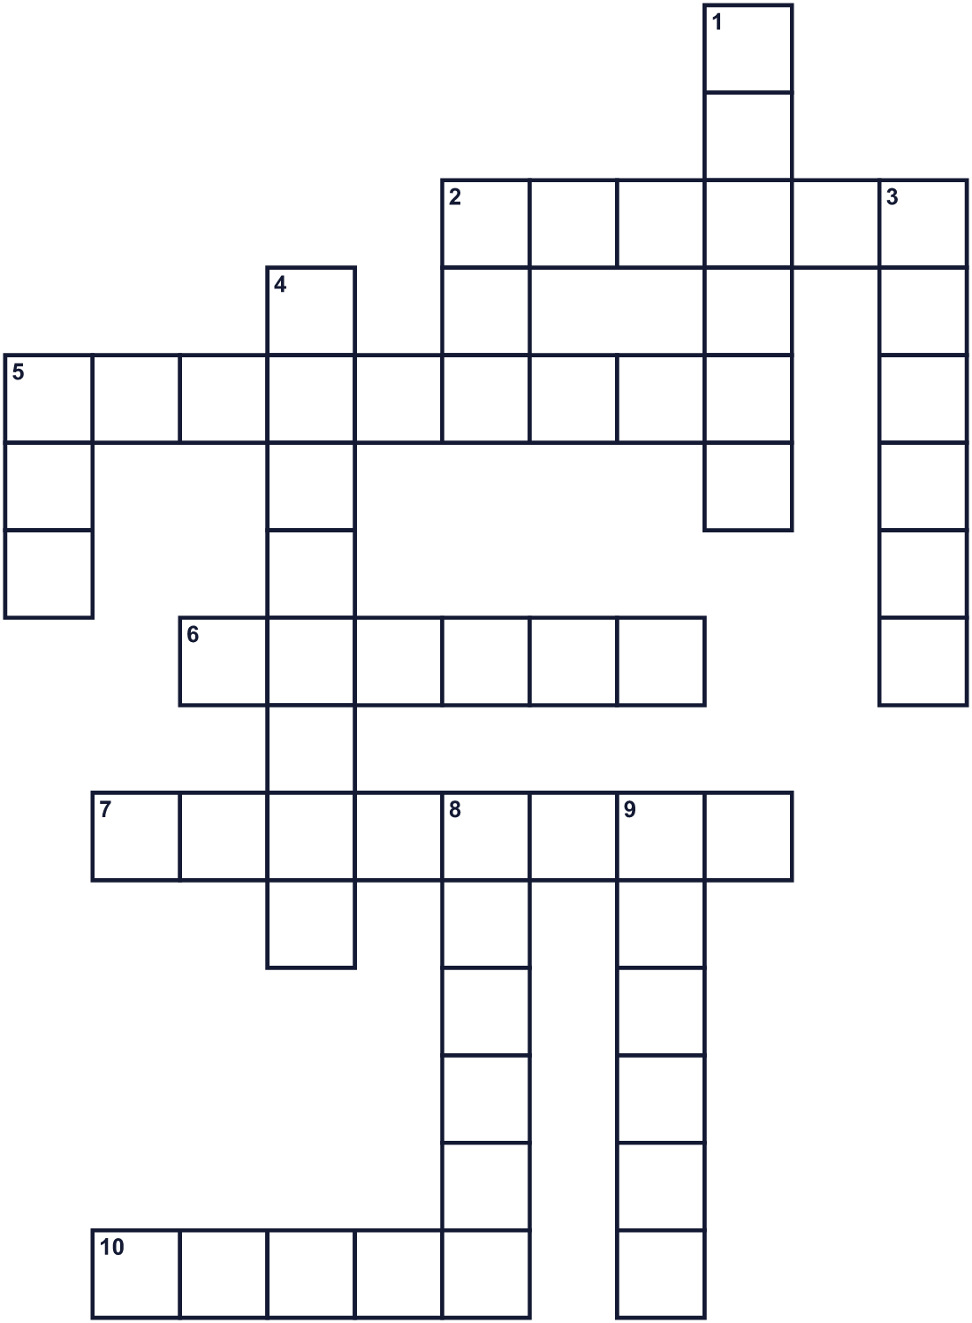
Across →
2. A dark shape on the ground when the sun shines. (6)
5. To sleep all winter, like a bear. (9)
6. A hole in the ground where an animal lives. (6)
7. What the weather will be like tomorrow, told on TV. (8)
10. A film. Bill Murray was in a famous one in 1993. (5)
Down ↓
1. German farmers watched this animal long ago. (6)
2. The bright star in the sky. Without it, there is no shadow. (3)
3. The cold season. It may last six more weeks. (6)
4. The second month of the year. (8)
5. Men in the Inner Circle wear a tall black one on their heads. (3)
8. A stick of wax that gives light. Churches bless them on February 2. (6)
9. The season after the cold one. Flowers bloom. (6)

🐿️ Groundhog Day Worksheet
Word Search
かくれた単語をさがそう（→ ↓ ↘ ↗）
Class ______ No. ____ Name ______________________________
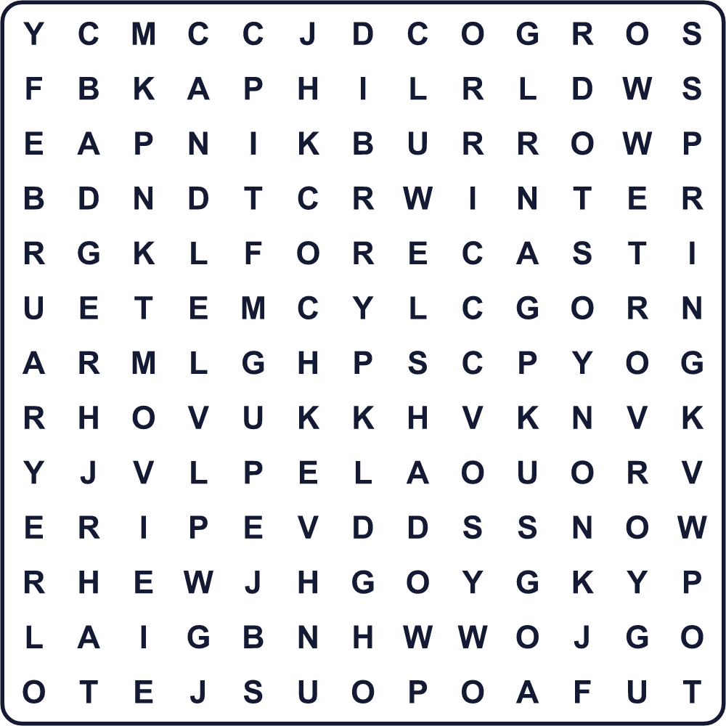
BADGER BURROW CANDLE FEBRUARY FORECAST HAT MOVIE PHIL SHADOW SNOW SPRING SUN WEEKS WINTER
Secret Code 暗号を解こう
◆=E ☾=I ◎=K ✚=M ☘=O ★=R ⚑=S ♣=W ■=X
⚑ ☾ ■ ✚ ☘ ★ ◆ ♣ ◆ ◆ ◎ ⚑
______________________________________________________________

🐿️ Groundhog Day Worksheet
Maze & Sentences
Class ______ No. ____ Name ______________________________
Help the groundhog get back to its burrow! グラウンドホッグを巣穴まで帰してあげよう！
正しい道の文字を集めると、ひみつの言葉になるよ。 START 🐿️ → GOAL 🕳️
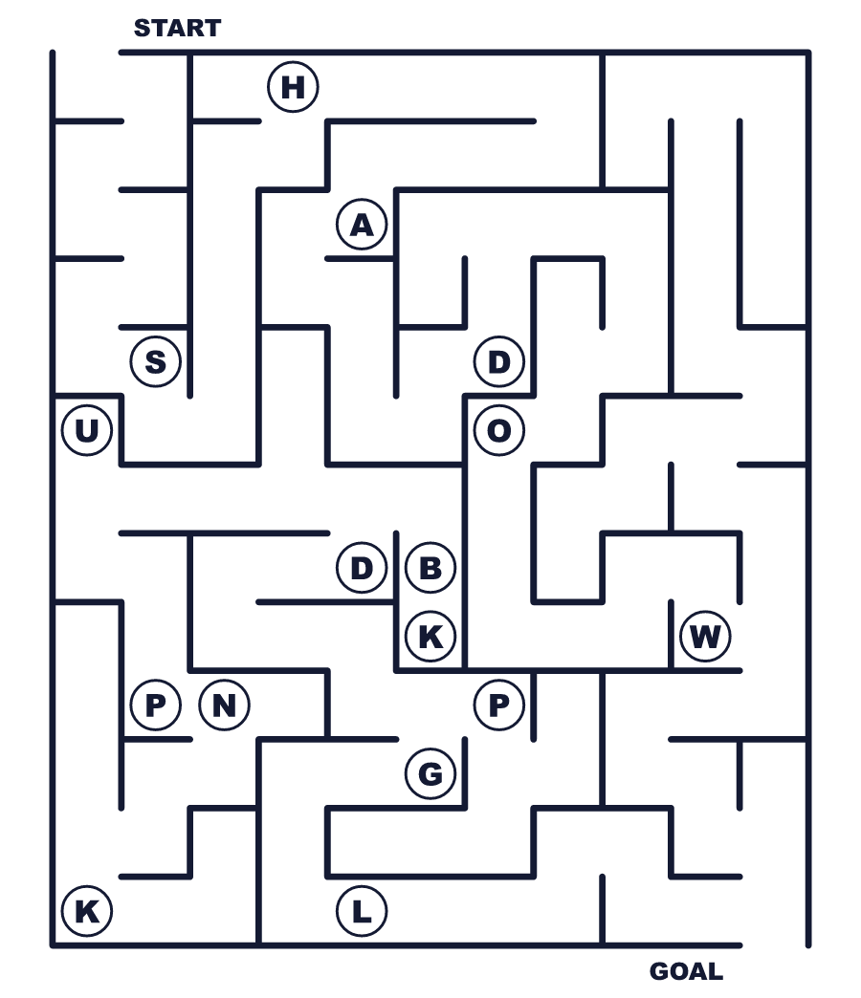
Secret word: ＿ ＿ ＿ ＿ ＿ ＿
Put the words in order. 並べかえよう。
1. groundhog / The / its / hole / out / comes / of . (グラウンドホッグが穴から出てきます。)
______________________________________________________________
2. weeks / six / more / last / Winter / will . (冬はあと6週間続きます。)
______________________________________________________________
3. in / Thousands / the / people / of / wait / cold . (何千人もの人が寒さの中で待ちます。)
______________________________________________________________
4. idea / an / came / old / The / custom / German / from . (この考えはドイツの古い習慣から来ました。)
______________________________________________________________
5. not / weather / good / Phil / is / a / forecaster . (フィルはよい天気予報士ではありません。)
______________________________________________________________

🐿️ Groundhog Day Worksheet
Class Activity & Writing
Class ______ No. ____ Name ______________________________
Find Someone Who… クラスで聞いて回ろう！
Find someone who … | Name
… likes winter more than summer 夏より冬が好き
… has seen a squirrel in a park 公園でリスを見たことがある
… checks the weather forecast every morning 毎朝天気予報を見る
… knows the meaning of shadow shadow の意味を知っている
… has thrown beans on Setsubun 節分に豆をまいたことがある
… can say the four seasons in English 英語で四季が言える
… has watched a movie about time travel タイムトラベルの映画を見たことがある
… likes to sleep late on winter mornings 冬の朝はおそくまで寝ていたい
Let's Write! 英語で書いてみよう。
If I were Phil, I would say "______" this year because ______.
もし私がフィルなら、今年は「＿＿＿」と言います。なぜなら＿＿＿だからです。
______________________________________________________________
______________________________________________________________
If I had to live the same day again and again, I would ______.
もし同じ日を何度もくり返さなければならないなら、私は＿＿＿します。
______________________________________________________________
______________________________________________________________
In my town, people know spring is coming when ______.
私の町では、＿＿＿と春が近いとわかります。
______________________________________________________________
______________________________________________________________

🐿️ Groundhog Day Worksheet
Trace & Color
なぞって書こう。絵に色をぬろう。
Class ______ No. ____ Name ______________________________
🎩 

❄️ 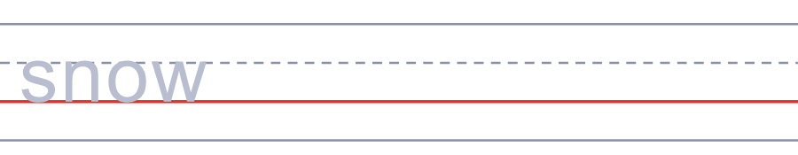
🌷 
☀️ 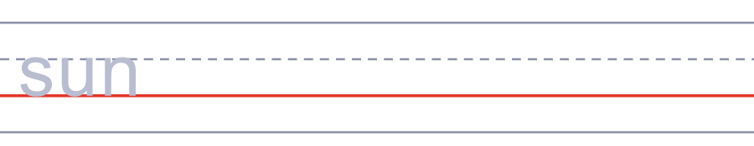
☁️ 
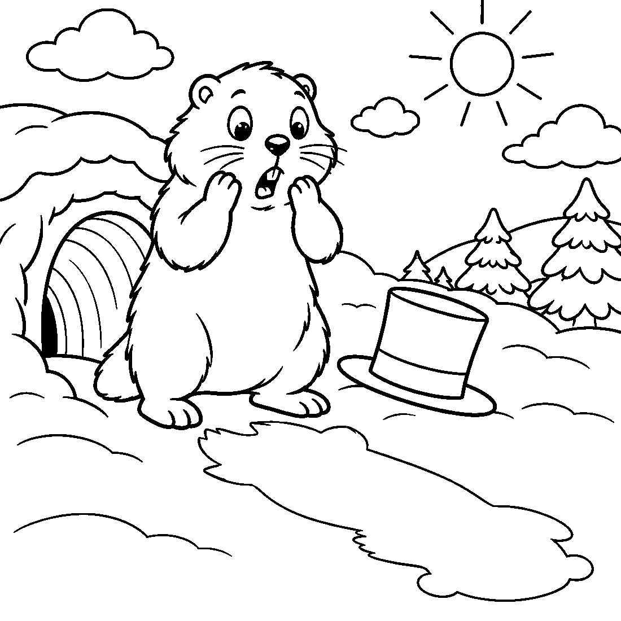

🐿️ Groundhog Day Worksheet
Answer Key 解答
Reading Check: 1.C 2.B 3.A 4.D 5.B 6.B 7.C 8.A
True or False: 1.T 2.F 3.T 4.F 5.T 6.F
Match: 🎩=top hat ❄️=snow 🌷=flower ☀️=sun ☁️=cloud 🕯️=candle 🎬=movie 📅=calendar
Unscramble: 1.SHADOW 2.WINTER 3.SPRING 4.BURROW 5.CLOUDY 6.WEATHER
Fill in the blanks: (1)hole (2)sleeps (3)early (4)cloudy (5)cocoa (6)head (7)shadow (8)coming (9)wait (10)picture
Sentence order: 1. The groundhog comes out of its hole. 2. Winter will last six more weeks. 3. Thousands of people wait in the cold. 4. The idea came from an old German custom. 5. Phil is not a good weather forecaster.
Secret Code: SIX MORE WEEKS
Maze: SHADOW
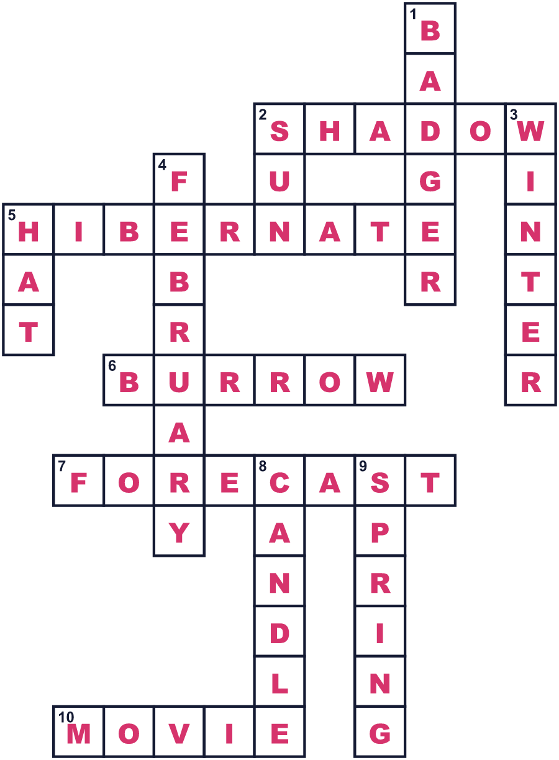
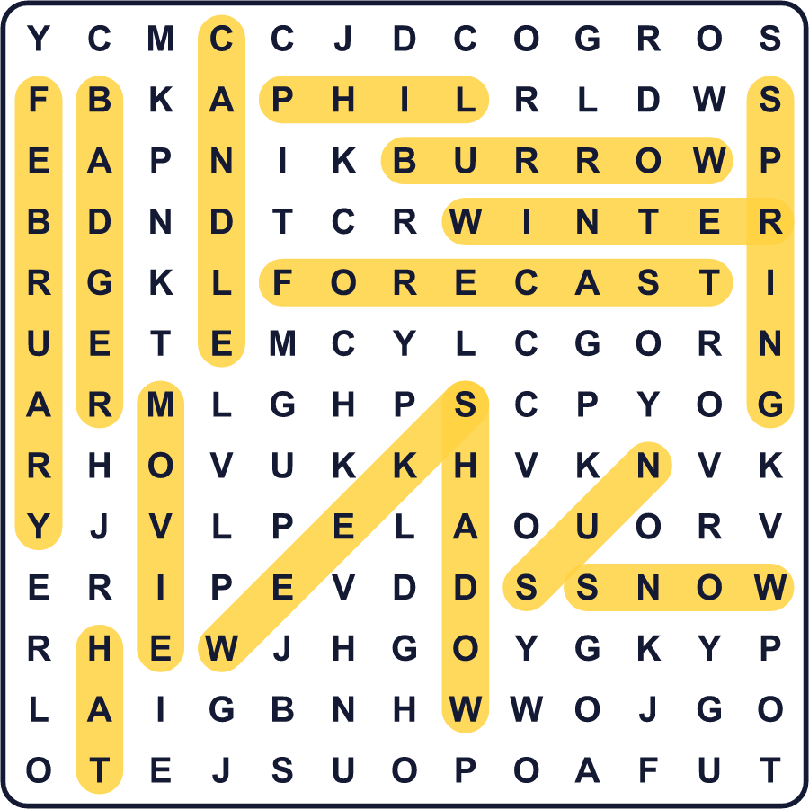
全訳
1 毎年2月2日、何千人もの人がペンシルベニア州の小さな町で寒さの中に立っています。その多くは、日の出の何時間も前、まだ暗いうちにやってきます。彼らは1匹のグラウンドホッグを待っているのです。名前はパンクサトーニー・フィル。未来がわかると言われています。
2 ルールはかんたんです。フィルが自分の影を見たら、冬はあと6週間続きます。見なかったら、春が早くやってきます。背の高い黒い帽子をかぶった男性たちが、フィルを群衆の前に連れ出します。リーダーがフィルの言葉を聞き、それから別の男性がみんなに予報を読み上げます。
3 この考えはドイツから来ました。昔、ドイツの農民たちは、キャンドルマスという教会の祝日の2月2日にアナグマを観察していました。その一部がペンシルベニアに移り住んだとき、彼らは代わりにグラウンドホッグを使いました。パンクサトーニーで最初の公式なグラウンドホッグデーが開かれたのは1887年でした。
4 フィルはよい天気予報士でしょうか。そうでもありません。アメリカ政府の気象機関の科学者たちが、彼の予報を調べました。直近の10年で、当たったのはわずか約30パーセントでした。でも、ファンにはおもしろい答えがあります。フィルは決してまちがえない、と言うのです。まちがえるのは、彼の言葉を通訳する人たちなのです！
5 フィルが有名なのには、もう一つ理由があります。1993年、『グラウンドホッグデー』という映画が公開されました。映画の中で、テレビの天気予報士は2月2日を何度もくり返し生きなければなりません。しかも、映画の天気予報士の名前もフィルなのです！今では、毎日同じことが起こるとき、人々は「まるでグラウンドホッグデーだ」と言います。こうして、小さな町の伝統が英語に真新しい言い回しを贈ったのです。

