🔢 Japan's Pun Days (Goroawase Anniversaries) Worksheet
When Numbers Turn into Words
Read the story. 英文を読もう。
Class ______ No. ____ Name ______________________________

🔊 音声を聞こう（スマホで読みとってね）
1 In Japanese, every number can be read in more than one way. The number 2 can be ni or fu. The number 8 can be hachi, ha, or ya. Japanese people play with these sounds and make words out of numbers. This word game is called goroawase.
2 Goroawase has given Japan many special days. February 22 is Cat Day, because 2-2-2 can sound like nyan nyan nyan. That is how cats say meow in Japanese. August 7 is Banana Day, because 8 and 7 can be read as ba and nana. And November 22 is Good Couples Day, because 11-22 sounds like ii fufu, a good couple.
3 Some of these days are quite old. In 1928, Japanese dentists chose June 4 as a day to protect teeth. The numbers 6 and 4 can be read as mu and shi. Mushi means bug, and a bad tooth in Japanese is mushiba, a bug tooth. The police use goroawase, too, so January 10 is 110 Day, for the emergency number.
4 Today, companies and groups often create their own pun days. A company can pick a date that sounds like its product and use it in ads. English speakers play this game, too. May 4 is Star Wars Day, because May the Fourth sounds like May the Force. But in Japanese, numbers have so many sounds that puns can fill the whole calendar.
Words 単語
pun（ダジャレ、語呂合わせ） / sound like（～のように聞こえる） / read（読む） / protect（守る） / dentist（歯医者） / emergency（緊急事態） / product（商品、製品） / calendar（カレンダー、暦）

🔢 Japan's Pun Days (Goroawase Anniversaries) Worksheet
Reading Check
Choose the best answer. 正しいものを選ぼう。
Class ______ No. ____ Name ______________________________
1. What is the main idea of the passage?
(A) Japanese numbers can be read as sounds, so many special days come from puns. (B) Japan has only one special day for cats. (C) All special days in Japan are national holidays. (D) Goroawase started in the United States.
2. Why is August 7 Banana Day?
(A) Because bananas are yellow. (B) Because summer starts on August 7. (C) Because 8 and 7 can be read as ba and nana. (D) Because monkeys were born on that day.
3. When did Japanese dentists choose June 4 as a day to protect teeth?
(A) In 1987. (B) In 1999. (C) In 1956. (D) In 1928.
4. In paragraph 4, why does a company pick a date that sounds like its product?
(A) To close its stores. (B) To use the date in ads. (C) To make a national holiday. (D) To change its name.
5. In the dialogue, what example from English does Lucas give?
(A) Cat Day. (B) Banana Day. (C) May the Fourth. (D) Pi Day.
True or False? T か F に○
1. Cat Day in Japan is on February 22. T / F
2. All goroawase days are national holidays. T / F
3. June 4 is a day to protect teeth. T / F
4. August 7 is Apple Day in Japan. T / F

🔢 Japan's Pun Days (Goroawase Anniversaries) Worksheet
Word Work
単語のれんしゅう
Class ______ No. ____ Name ______________________________
① Match the pictures and the words. 絵と単語を線でむすぼう。
🐱 | ● | ● | cat
🍌 | ● | ● | nose
🦷 | ● | ● | tooth
👂 | ● | ● | banana
👃 | ● | ● | ninja
🥷 | ● | ● | ear
③ Fill in the blanks. 語群から選んで入れよう。
[ cafe / cats / dog / rice / pun / summer / photo / 22 / lap / nyan ]
Today is February (1) __________ . Riku's sister loves (2) __________ . She says, "In Japanese, two can sound like (3) __________ !" So today is Cat Day. They visit a cat (4) __________ after school. A small white cat sits on Riku's (5) __________ . His sister takes a (6) __________ . On the way home, Riku says, "Let's make our own (7) __________ day!"

🔢 Japan's Pun Days (Goroawase Anniversaries) Worksheet
Crossword Puzzle
ヒントを読んでクロスワードを完成させよう。
Class ______ No. ____ Name ______________________________
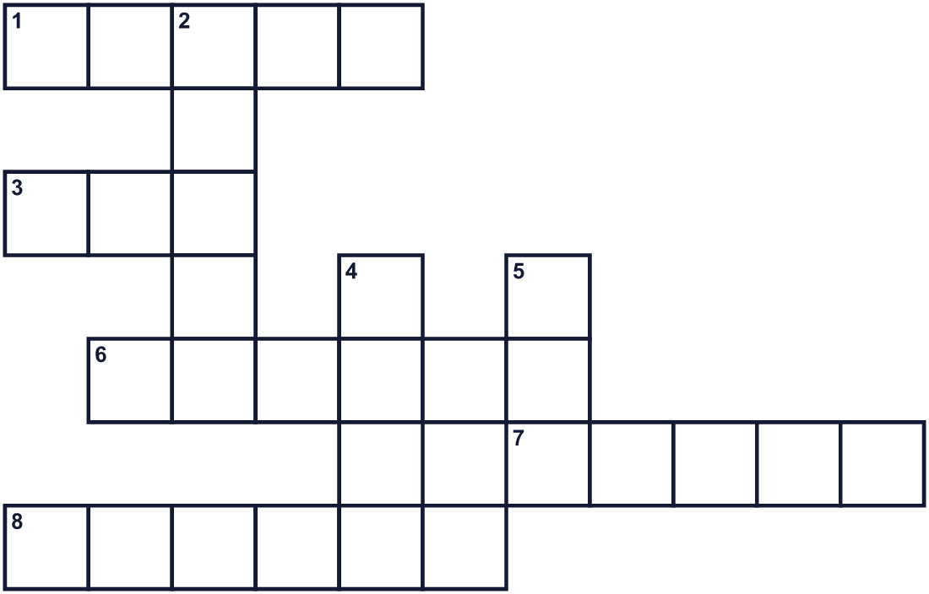
Across →
1. Chinese characters used in Japanese writing. (5)
3. A funny use of words that sound the same. (3)
6. A long yellow fruit. (6)
7. You brush this to keep it white and strong. (5)
8. One, two, and three are examples. (6)
Down ↓
2. A secret fighter and spy in old Japan. (5)
4. February 22 is one. It is on the calendar. (4)
5. A pet that says meow. (3)

🔢 Japan's Pun Days (Goroawase Anniversaries) Worksheet
Word Search
かくれた単語をさがそう（→ ↓ ↘ ↗）
Class ______ No. ____ Name ______________________________
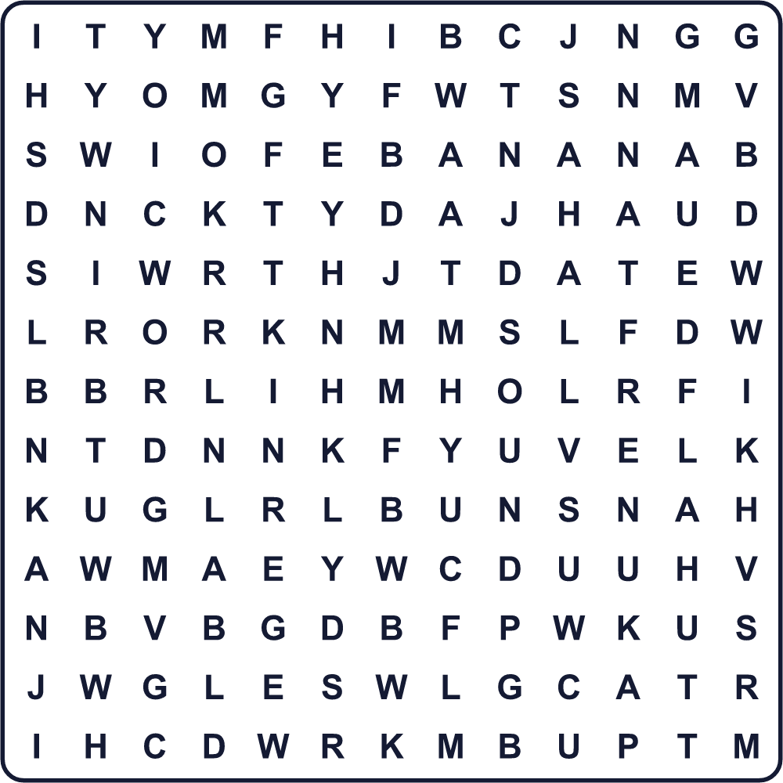
BANANA CAT DATE KANJI NINJA NUMBER PUN SOUND TOOTH WORD

🔢 Japan's Pun Days (Goroawase Anniversaries) Worksheet
Maze & Sentences
Class ______ No. ____ Name ______________________________
Help the cat find the number 2! 猫が数字の2を見つけられるように助けよう！
正しい道の文字を集めると、ひみつの言葉になるよ。 START 🐱 → GOAL 🔢
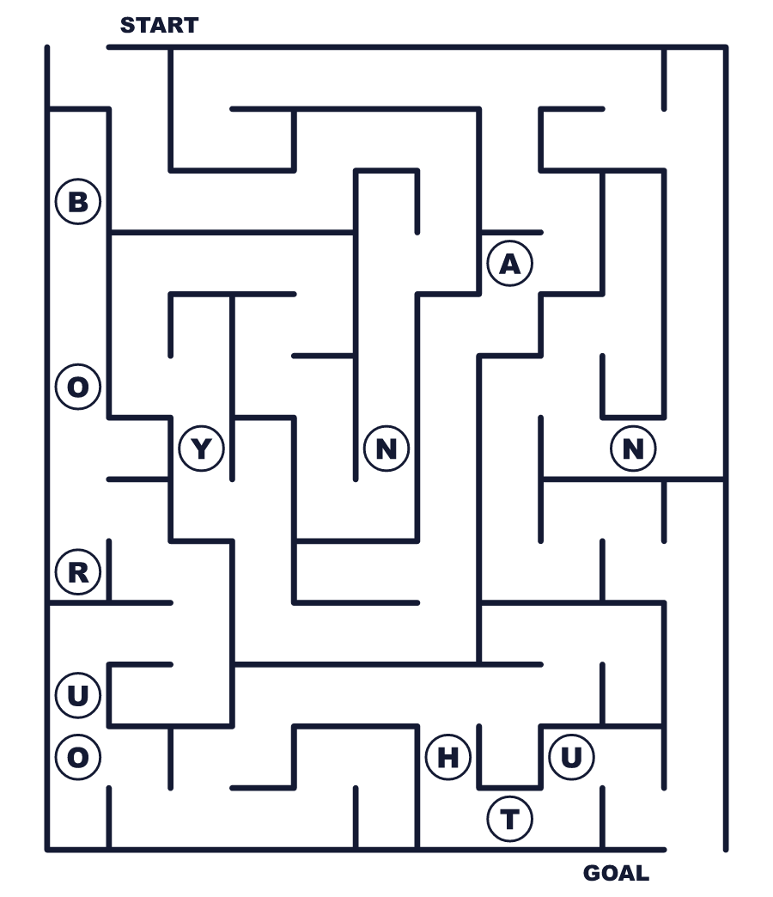
Secret word: ＿ ＿ ＿ ＿

🔢 Japan's Pun Days (Goroawase Anniversaries) Worksheet
Class Activity & Writing
Class ______ No. ____ Name ______________________________
Let's Write! 英語で書いてみよう。
If I made a pun day, it would be on ______ because the numbers sound like ______.
語呂合わせの記念日を作るなら______にします。なぜなら数字が______に聞こえるからです。
______________________________________________________________
______________________________________________________________
My favorite pun day is ______ because ______.
わたしのお気に入りの語呂合わせ記念日は______です。なぜなら______だからです。
______________________________________________________________
______________________________________________________________

🔢 Japan's Pun Days (Goroawase Anniversaries) Worksheet
Trace & Color
なぞって書こう。絵に色をぬろう。
Class ______ No. ____ Name ______________________________
🐱 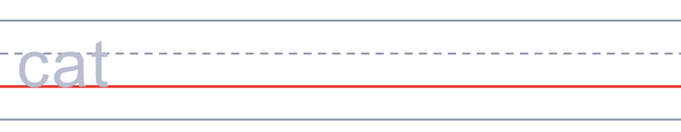

🍌 
🦷 
👂 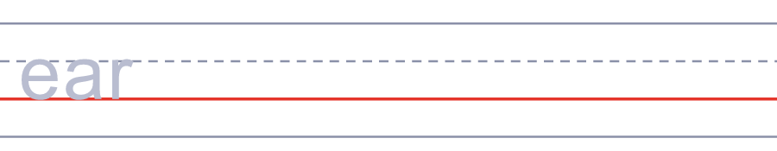
👃 

🔢 Japan's Pun Days (Goroawase Anniversaries) Worksheet
Answer Key 解答
Reading Check: 1.A 2.C 3.D 4.B 5.C
True or False: 1.T 2.F 3.T 4.F
Match: 🐱=cat 🍌=banana 🦷=tooth 👂=ear 👃=nose 🥷=ninja
Fill in the blanks: (1)22 (2)cats (3)nyan (4)cafe (5)lap (6)photo (7)pun
Maze: NYAN
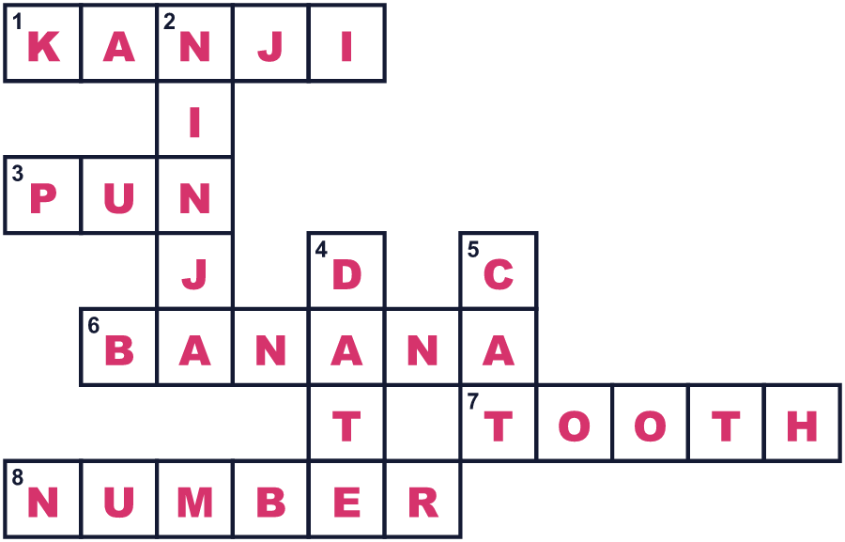
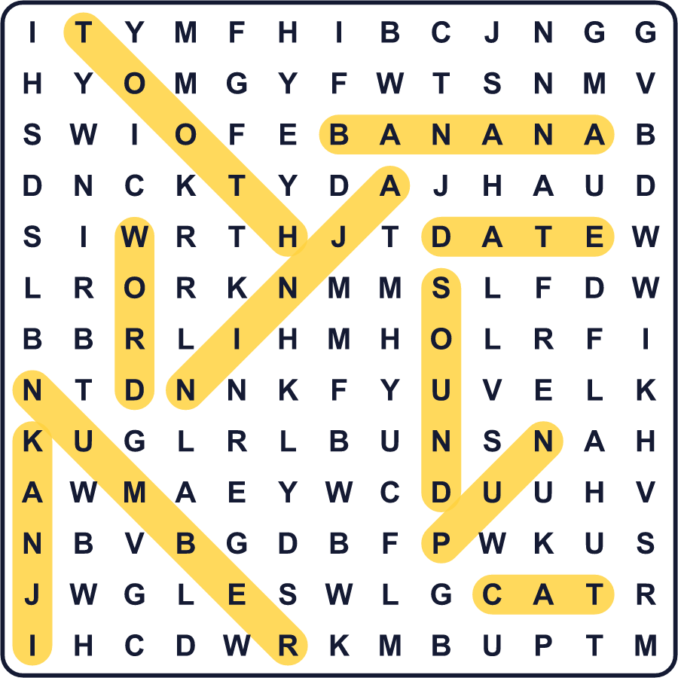
全訳
1 日本語では、どの数字も2通り以上の読み方ができます。2は「に」とも「ふ」とも読めます。8は「はち」「は」「や」と読めます。日本人はこうした音で遊び、数字から言葉を作ります。この言葉遊びを「語呂合わせ」と言います。
2 語呂合わせは、日本にたくさんの記念日を生み出してきました。2月22日は猫の日です。222が「ニャンニャンニャン」に聞こえるからです。これは日本語の猫の鳴き声です。8月7日はバナナの日です。8と7を「バ」と「ナナ」と読めるからです。そして11月22日は、1122が「いいふうふ」に聞こえるので、いい夫婦の日です。
3 こうした日の中には、かなり古いものもあります。1928年、日本の歯医者さんたちは6月4日を歯を守る日に選びました。6と4は「む」と「し」と読めます。「むし」は虫という意味で、日本語で悪い歯は「虫歯」、つまり虫の歯なのです。警察も語呂合わせを使っていて、1月10日は緊急通報の番号にちなんだ「110番の日」です。
4 今では、企業や団体が自分たちで語呂合わせの日をよく作ります。会社は自分の商品のように聞こえる日付を選んで、宣伝に使えるのです。英語を話す人たちも、この遊びをします。5月4日はスター・ウォーズの日です。May the Fourth が May the Force に聞こえるからです。でも日本語では数字の読み方がとても多いので、ダジャレがカレンダー全体をうめつくすほどなのです。

