🎏 Golden Week Worksheet
A Golden Name from the Movies
Read the story. 英文を読もう。
Class ______ No. ____ Name ______________________________

🔊 音声を聞こう（スマホで読みとってね）
1 Every spring, Japan takes a long break. From late April to early May, there are four national holidays in one week. People call this time Golden Week. It sounds like English, but the name was made in Japan.
2 The story starts at the movies. On May 5, 1951, two movies of the same popular story opened on the same day. Both did well, and one movie company sold more tickets than at New Year or in summer. So the company named the week Golden Week to bring in even more people. Some people say the idea came from golden time, the radio hours with the most listeners. The name became popular across Japan in the next few years.
3 The holidays are Showa Day on April 29 and Constitution Day on May 3. Then come Greenery Day on May 4 and Children's Day on May 5. Many families travel, visit their hometowns, or go to the mountains. Trains and highways get very crowded. In 2019, Golden Week was 10 days long because Japan welcomed a new emperor.
4 But you will not often hear the name on NHK, Japan's public TV. NHK usually says long holidays instead. One reason is that the name started as a movie ad. Another reason is that many people still have to work during this time. Golden or not, most people in Japan count the days until it starts!
Words 単語
break（休み、休憩） / national holiday（国民の祝日） / company（会社） / ticket（切符、チケット） / constitution（憲法） / crowded（混雑した） / ad（広告、宣伝） / public（公共の）

🎏 Golden Week Worksheet
Reading Check
Choose the best answer. 正しいものを選ぼう。
Class ______ No. ____ Name ______________________________
1. What is the passage mainly about?
(A) How to make a popular movie (B) Where to travel in Japan in summer (C) Why Japanese TV shows are long (D) Where the name Golden Week came from and what people do
2. What happened on May 5, 1951?
(A) Two movies of the same story opened. (B) Japan got a new emperor. (C) NHK started its first TV show. (D) Greenery Day became a holiday.
3. Which holiday is on May 4?
(A) Showa Day (B) Greenery Day (C) Constitution Day (D) Children's Day
4. In paragraph 3, what does crowded mean?
(A) empty (B) cheap (C) full of people (D) very fast
5. Why does Yuka tell Jack to book his train early?
(A) Because trains stop during Golden Week. (B) Because tickets are free in May. (C) Because many people travel at the same time. (D) Because Jack has to work on May 3.
True or False? T か F に○
1. Golden Week is from late April to early May. T / F
2. The name Golden Week was made in the United States. T / F
3. A movie company made the name. T / F
4. NHK always uses the name Golden Week. T / F

🎏 Golden Week Worksheet
Word Work
単語のれんしゅう
Class ______ No. ____ Name ______________________________
① Match the pictures and the words. 絵と単語を線でむすぼう。
🎬 | ● | ● | tree
🚄 | ● | ● | suitcase
🎏 | ● | ● | movie
🌳 | ● | ● | train
🧳 | ● | ● | car
🚗 | ● | ● | carp streamer
③ Fill in the blanks. 語群から選んで入れよう。
[ holiday / school / May / golden / train / snow / Day / crowded / streamer ]
It is the start of (1) __________ . Kai's family has a long (2) __________ . They take the (3) __________ to Grandma's house. The train is very (4) __________ . At Grandma's house, a big carp (5) __________ swims in the sky. On May 5, they eat rice cakes for Children's (6) __________ . Kai says, "This is a (7) __________ week!"

🎏 Golden Week Worksheet
Crossword Puzzle
ヒントを読んでクロスワードを完成させよう。
Class ______ No. ____ Name ______________________________
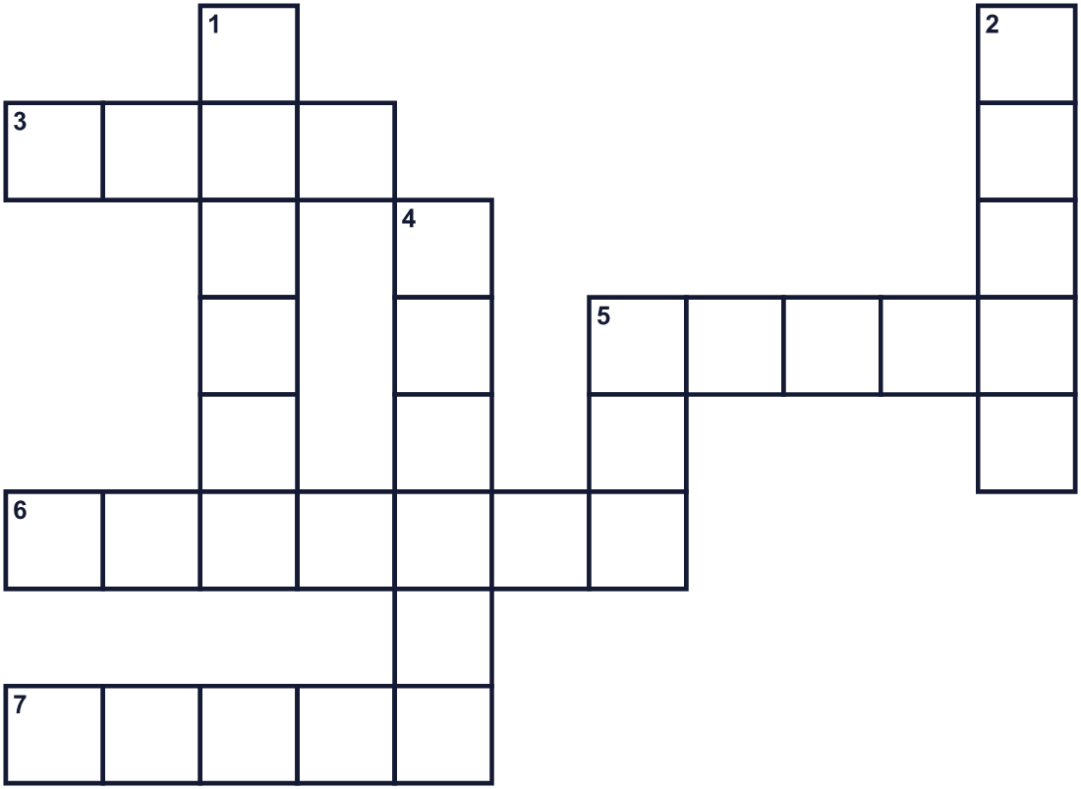
Across →
3. A big fish. Children's Day streamers look like it. (4)
5. You watch it on a big screen in a theater. (5)
6. A day with no school or work. (7)
7. It runs on rails. The shinkansen is one. (5)
Down ↓
1. To go to a faraway place. (6)
2. The color of new leaves. (5)
4. The color of gold. It also means very good. (6)
5. The fifth month of the year. (3)

🎏 Golden Week Worksheet
Word Search
かくれた単語をさがそう（→ ↓ ↘ ↗）
Class ______ No. ____ Name ______________________________
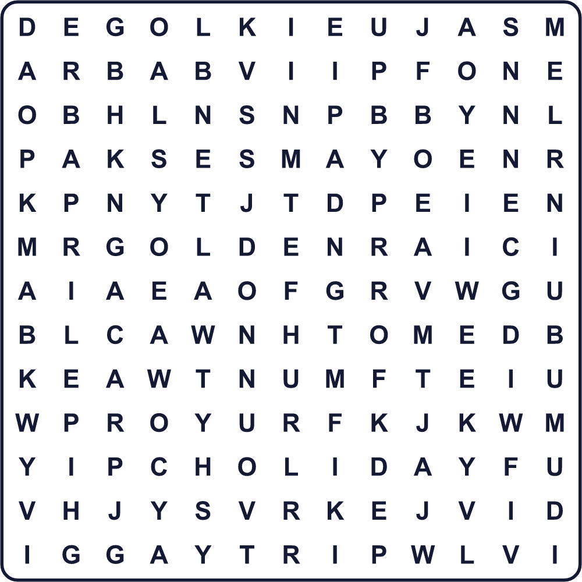
APRIL CARP GOLDEN GREEN HOLIDAY MAY MOVIE TRAIN TRIP WEEK

🎏 Golden Week Worksheet
Maze & Sentences
Class ______ No. ____ Name ______________________________
Help Kai find the way to Grandma's house! カイがおばあちゃんの家に行けるように助けよう！
正しい道の文字を集めると、ひみつの言葉になるよ。 START 👦 → GOAL 🏠
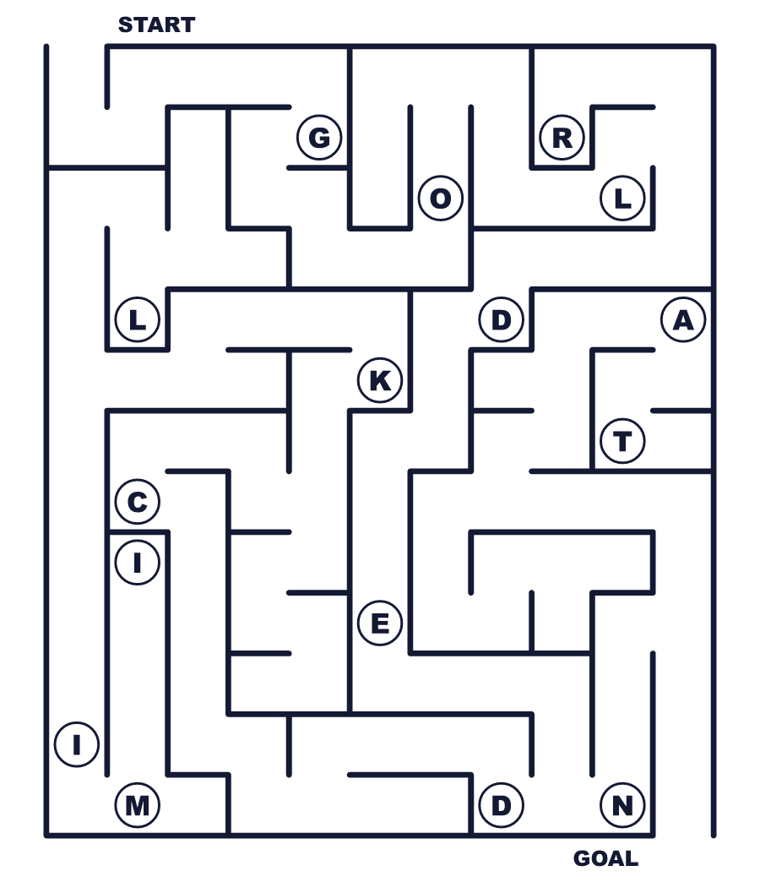
Secret word: ＿ ＿ ＿ ＿ ＿ ＿

🎏 Golden Week Worksheet
Class Activity & Writing
Class ______ No. ____ Name ______________________________
Let's Write! 英語で書いてみよう。
During Golden Week, I want to go to ______ because ______.
ゴールデンウィークには______に行きたいです。なぜなら______だからです。
______________________________________________________________
______________________________________________________________
If I could name a holiday, I would call it ______ Week because ______.
もし連休に名前をつけられるなら、______ウィークと呼びます。なぜなら______だからです。
______________________________________________________________
______________________________________________________________

🎏 Golden Week Worksheet
Trace & Color
なぞって書こう。絵に色をぬろう。
Class ______ No. ____ Name ______________________________
🎬 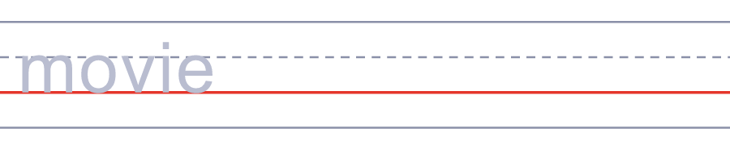

🚄 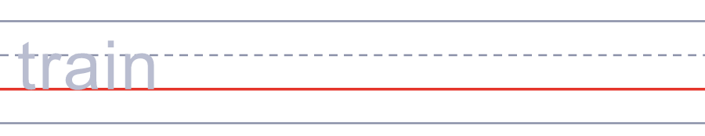
🎏 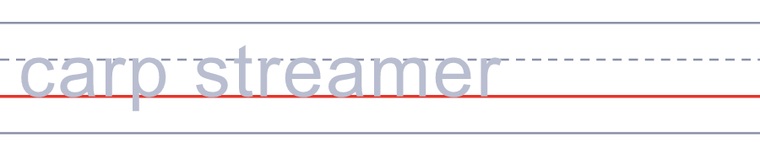
🌳 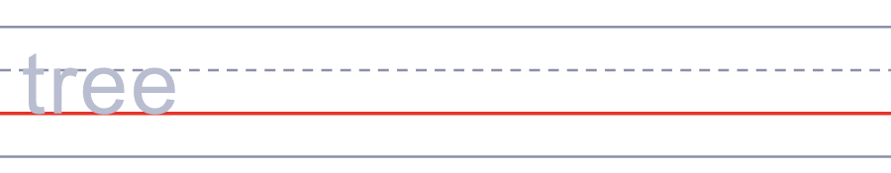
🧳 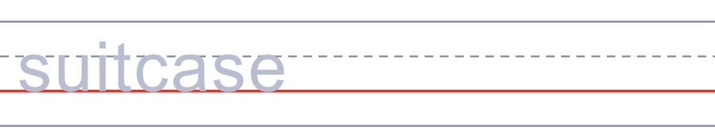

🎏 Golden Week Worksheet
Answer Key 解答
Reading Check: 1.D 2.A 3.B 4.C 5.C
True or False: 1.T 2.F 3.T 4.F
Match: 🎬=movie 🚄=train 🎏=carp streamer 🌳=tree 🧳=suitcase 🚗=car
Fill in the blanks: (1)May (2)holiday (3)train (4)crowded (5)streamer (6)Day (7)golden
Maze: GOLDEN
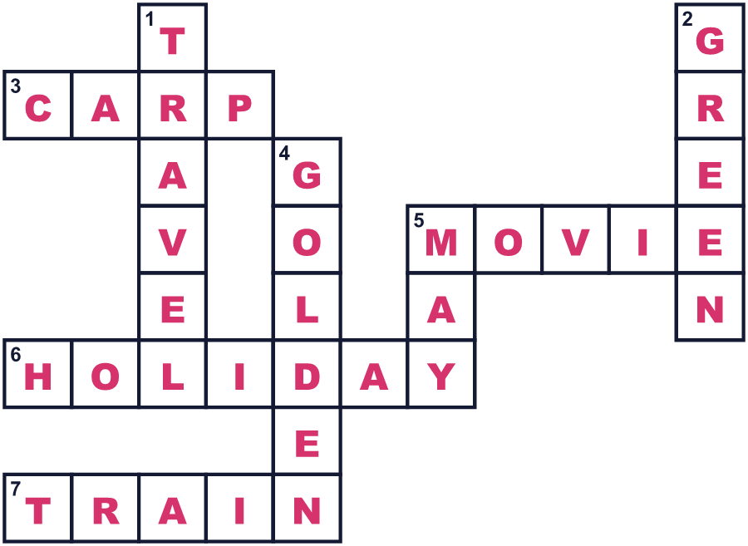
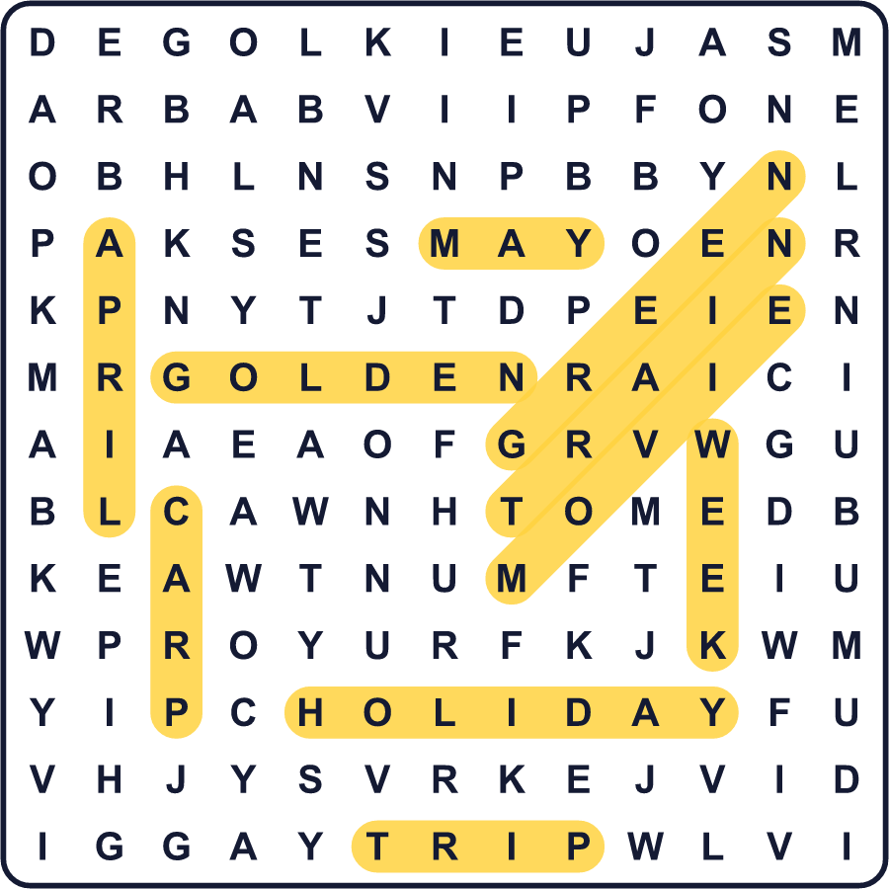
全訳
1 毎年春、日本は長いお休みをとります。4月の終わりから5月のはじめにかけて、1週間に4つの国民の祝日があります。人々はこの時期をゴールデンウィークと呼びます。英語のように聞こえますが、この名前は日本で作られました。
2 話は映画館から始まります。1951年5月5日、同じ人気の物語をもとにした2本の映画が同じ日に公開されました。どちらもヒットし、ある映画会社は、お正月や夏よりもたくさんのチケットを売りました。そこでその会社は、さらに多くの人を呼ぶためにこの週をゴールデンウィークと名づけました。ラジオを聞く人がいちばん多い時間帯「ゴールデンタイム」から思いついた、と言う人もいます。その名前は、その後の数年で日本中に広まりました。
3 祝日は、4月29日の昭和の日と5月3日の憲法記念日です。そして5月4日のみどりの日、5月5日のこどもの日が続きます。多くの家族が旅行したり、故郷を訪ねたり、山へ出かけたりします。電車や高速道路はとても混雑します。2019年は、日本が新しい天皇を迎えたため、ゴールデンウィークが10日間になりました。
4 でも、日本の公共放送であるNHKでは、この名前をあまり聞きません。NHKはふつう、代わりに「大型連休」と言います。理由の一つは、この名前が映画の宣伝から始まったことです。もう一つの理由は、この時期にも働かなければならない人がたくさんいることです。ゴールデンでもそうでなくても、日本のほとんどの人は始まる日を指折り数えて待っています！

